MILESTONE 4 REPORT
Intelligent Cognitive Alarm Platform
(WakeWise)
Analytics, Testing & Deployment
Prepared by: g.saisoumyasri
Week 7 – Week 8

Table of Contents
1. Project Description 3
2. Tech Stack Used 3
3. Environment Setup 3
4. System Architecture 4
5. Milestone Progress Summary 4
6. Milestone 4: Analytics, Testing & Deployment 5
6.1 Tasks Completed 5
6.2 Application Workflow 5
6.3 Cross-Platform Availability 8
7. Testing & Deployment 10
8. Evaluation Criteria — Milestone 4 11
9. Conclusion 11

1. Project Description
The Intelligent Cognitive Alarm Platform (branded to end users as WakeWise) is an AI-powered alarm system that requires users to solve a short cognitive challenge — a math problem, logic puzzle, riddle, or memory task — before an alarm can be dismissed. The platform adapts challenge difficulty to each user's wake-up behaviour, snooze patterns, and sleep schedule, with the goal of reducing oversleeping and building consistent, healthy wake-up habits.
The project was delivered across an eight-week, four-milestone plan. Milestones 1 through 3 established authentication, alarm scheduling, the cognitive challenge and wake-up verification engine, and the adaptive difficulty / habit-scoring system. This report covers Milestone 4: Analytics, Testing & Deployment — the final integration of the dashboards and reporting layer, end-to-end testing of the complete wake-up workflow, and production deployment of the platform.

2. Tech Stack Used
Layer | Technologies
Frontend (Web) | React.js, Tailwind CSS
Frontend (Mobile) | React Native
API Gateway / Backend | FastAPI (Python), JWT & OAuth2 authentication
AI / ML Engine | Scikit-learn, XGBoost, TensorFlow, PyTorch
Database Layer | PostgreSQL, MongoDB
Notifications | Firebase Cloud Messaging, Android Alarm Manager, iOS Local Notifications
Deployment & DevOps | Docker, AWS / Azure, GitHub Actions

3. Environment Setup
Development was carried out with Python (FastAPI) on the backend and Node.js / React on the frontend, using Visual Studio Code as the primary IDE. Backend dependencies are isolated in a Python virtual environment; the frontend and mobile clients use npm-managed package trees. Version control is maintained on GitHub, with Postman used for API validation during integration testing.

4. System Architecture
The platform follows a layered, service-oriented architecture: client applications communicate through a FastAPI-based API Gateway into a microservices layer, which in turn calls the AI/ML intelligence engine and the data layer. This separation keeps the cognitive challenge engine, adaptive difficulty engine, and analytics services independently testable and deployable.
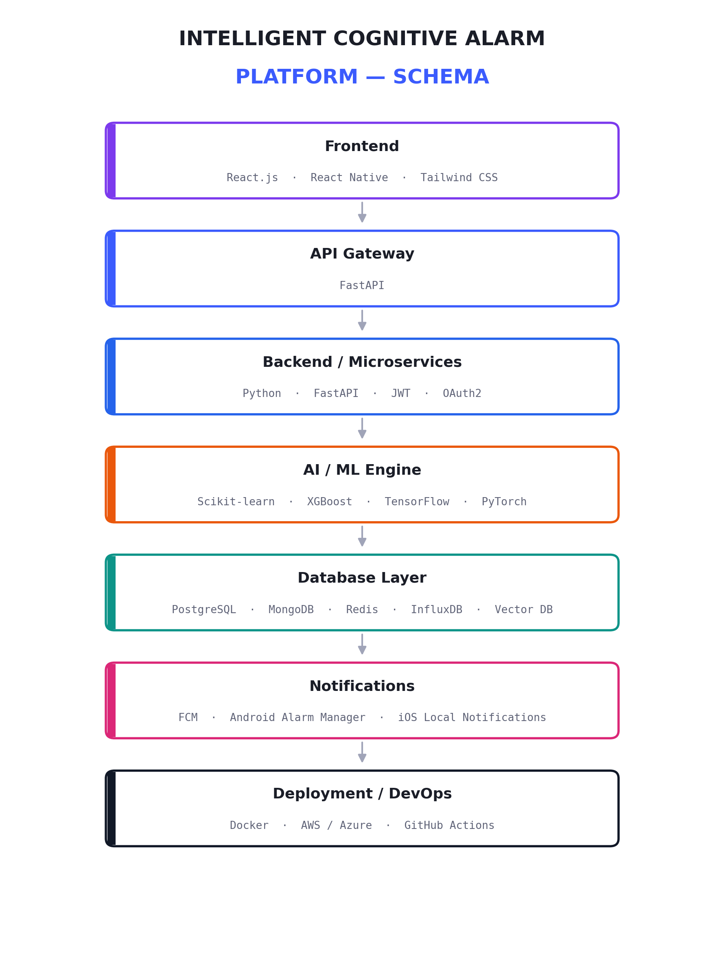
Figure 1: Intelligent Cognitive Alarm Platform — System Architecture

5. Milestone Progress Summary
The table below summarises what was delivered in each milestone leading into this final phase.
Milestone | Focus | Status
Milestone 1 (Week 2) | Authentication, role-based access, alarm scheduling, user profile management | Completed
Milestone 2 (Week 4) | Cognitive challenge engine, wake-up verification workflows | Completed
Milestone 3 (Week 6) | Adaptive difficulty engine, habit scoring, recommendation engine | Completed
Milestone 4 (Week 8) | Dashboards & analytics, end-to-end testing, production deployment | Completed

6. Milestone 4: Analytics, Testing & Deployment

6.1 Tasks Completed
- Built the user dashboard with sleep summary, next-alarm status, and recent activity feed.
- Implemented the Analytics view: weekly sleep-hours chart, average sleep quality, sleep score, and AI-generated recommendations.
- Implemented the Calendar History view for habit tracking, showing on-time, snoozed, and missed wake-ups by day.
- Completed end-to-end workflow testing across alarm creation, alarm ring, challenge verification, and dismissal.
- Verified the anti-snooze and retry flow when a challenge is answered incorrectly.
- Containerised the backend with Docker and validated a clean production build and startup.
- Prepared final documentation covering setup, architecture, and user workflows.

6.2 Application Workflow
The screenshots below walk through the complete, integrated wake-up flow as delivered in this milestone: scheduling an alarm, the alarm firing, solving a cognitive challenge to dismiss it, and the resulting habit tracking.
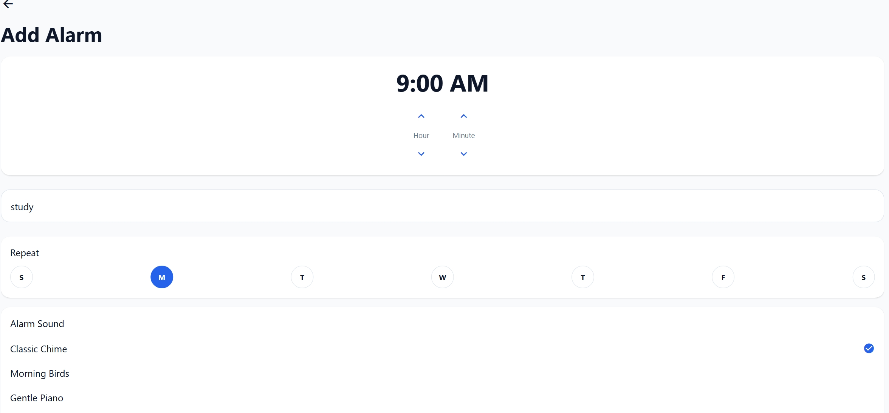
Figure 2: Alarm creation — time, label, repeat days, and alarm sound
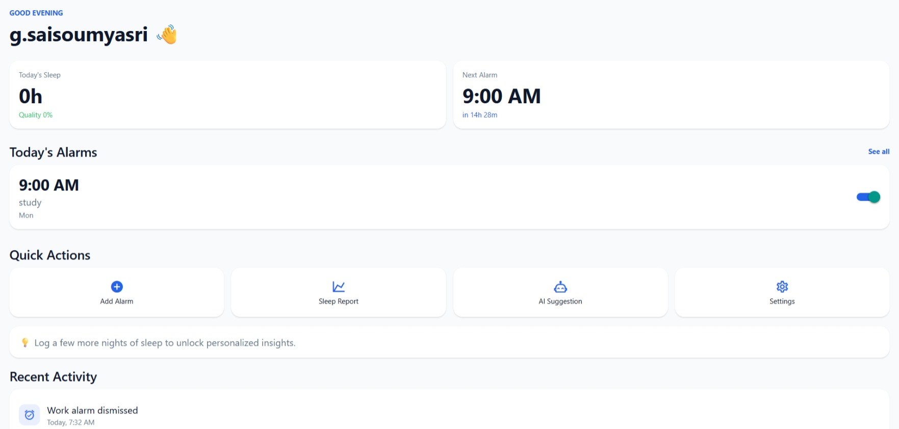
Figure 3: Home dashboard — today's sleep, next alarm, and quick actions
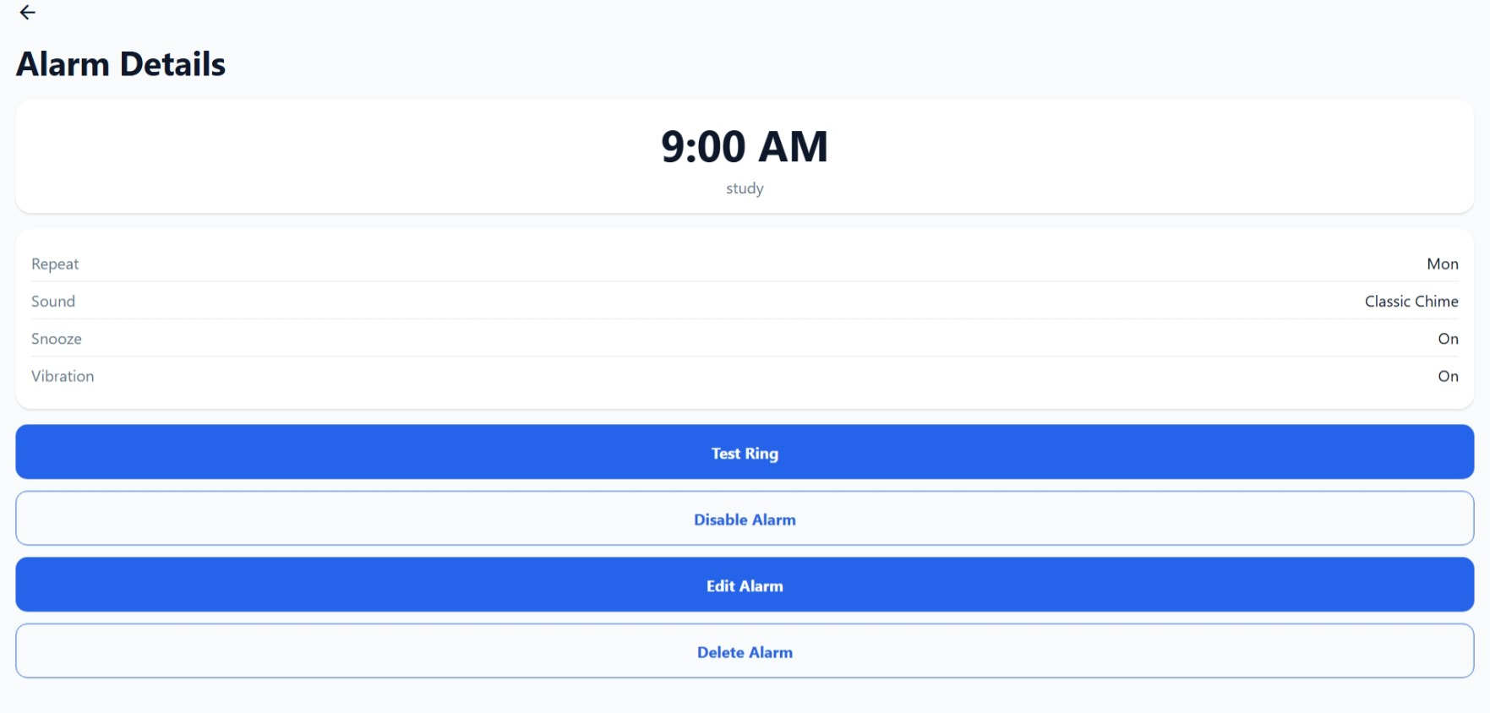
Figure 4: Alarm details — test ring, disable, edit, and delete controls


Figure 5: Alarm ring screen prompting dismissal via cognitive challenge
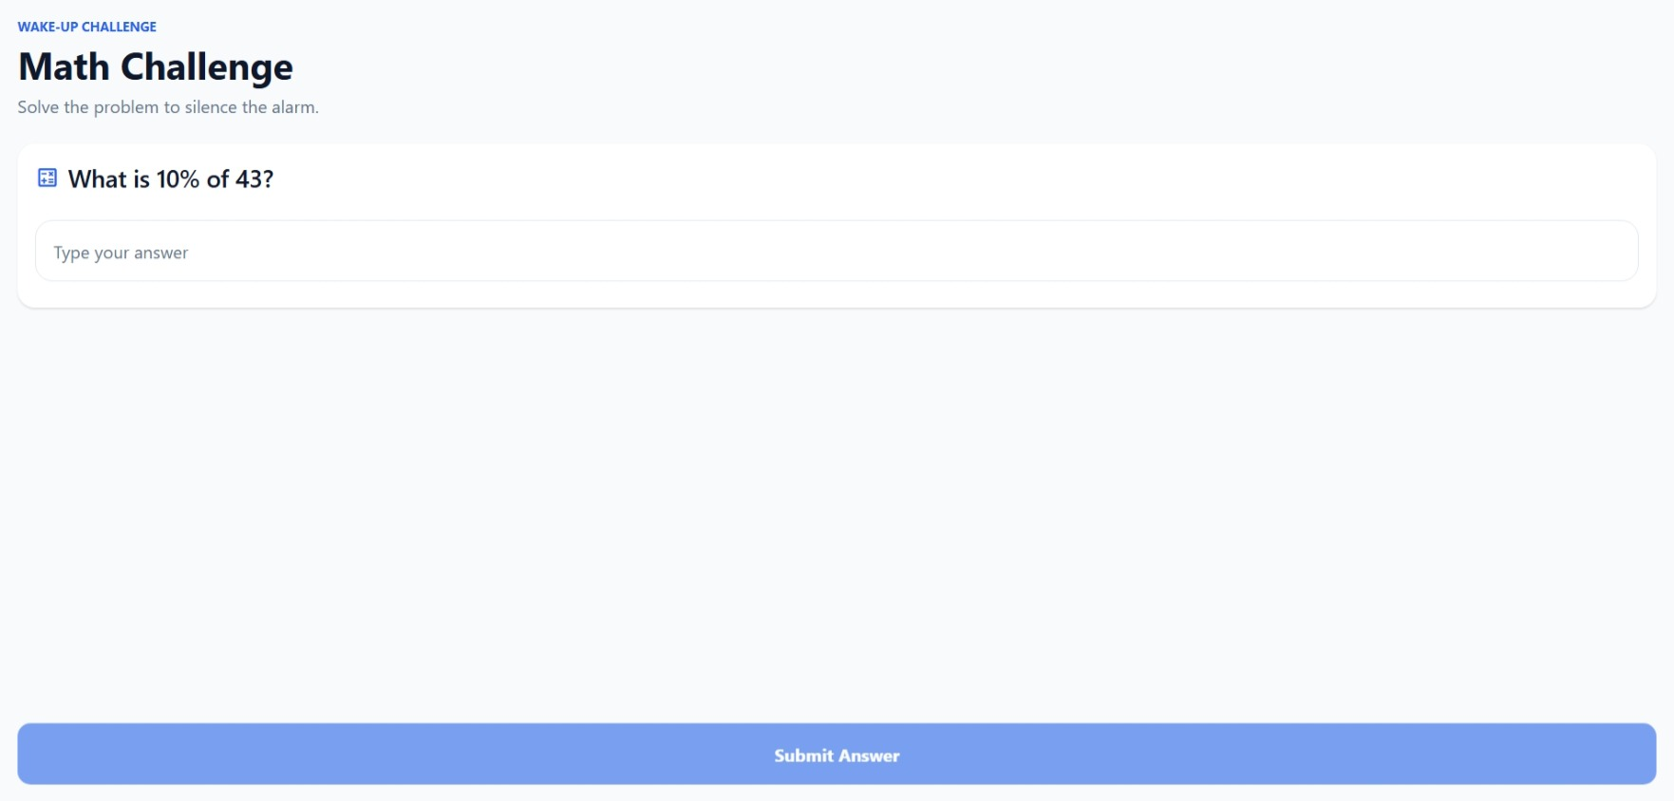
Figure 6: Math challenge presented at wake-up
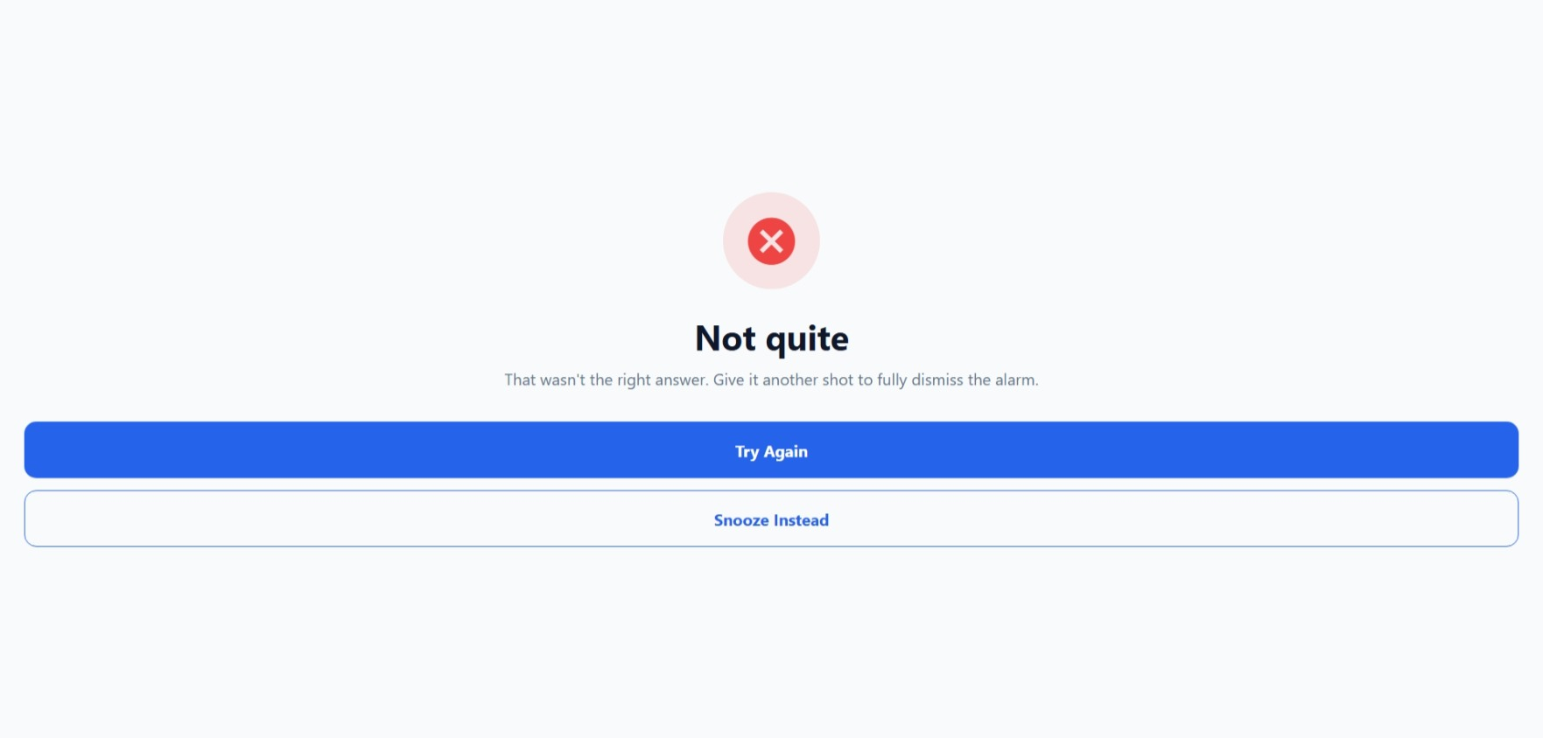
Figure 7: Incorrect-answer state, offering retry or snooze

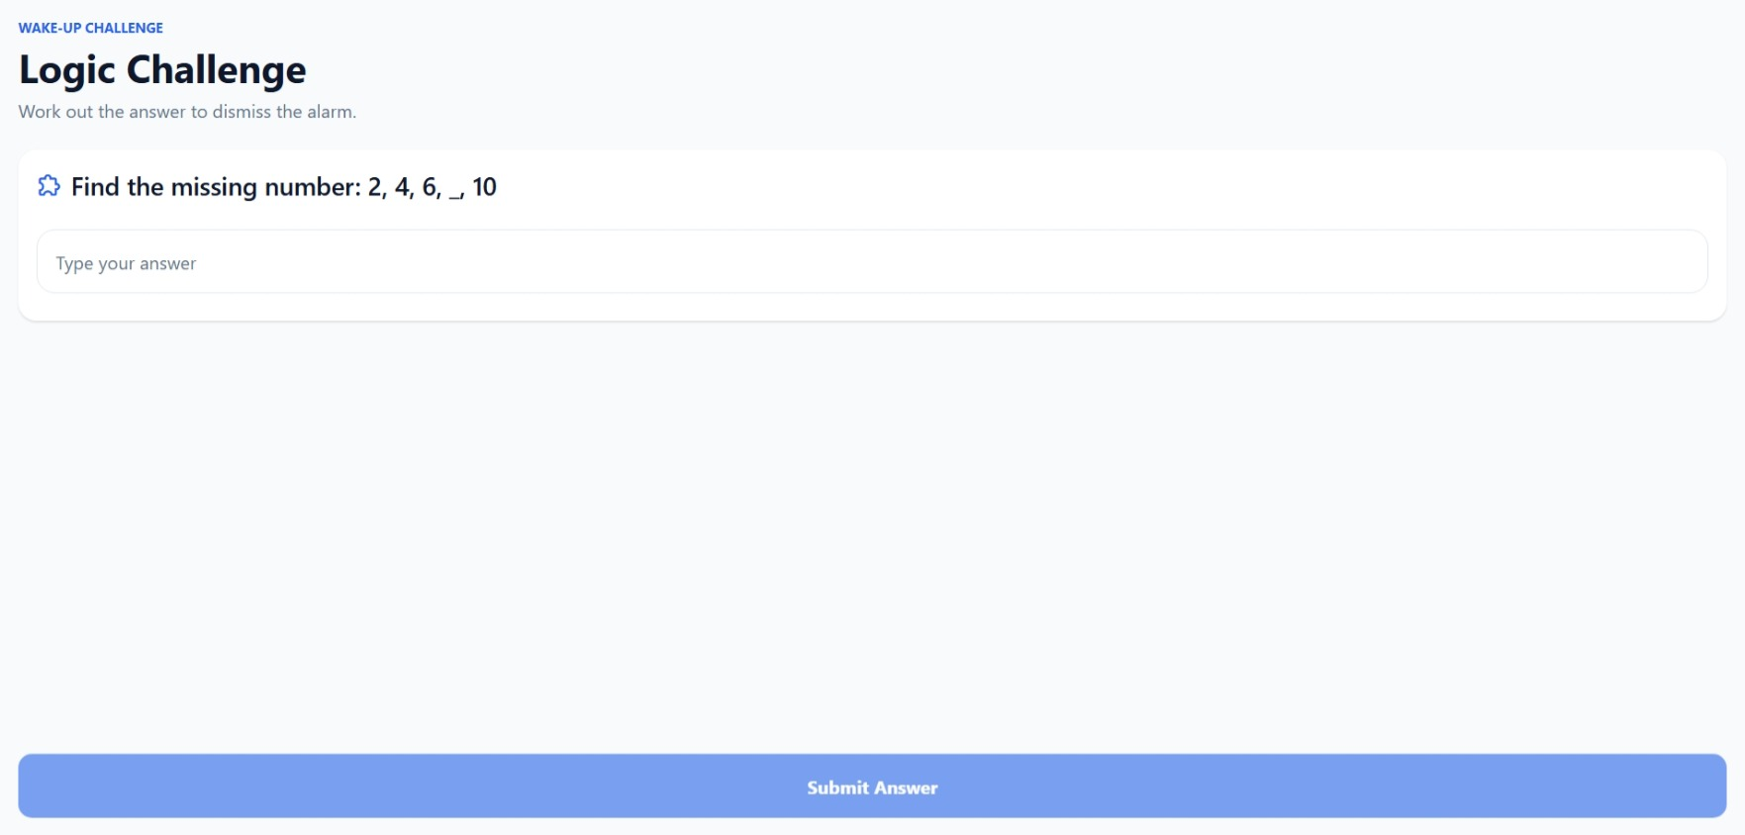
Figure 8: Logic challenge as an alternate challenge type
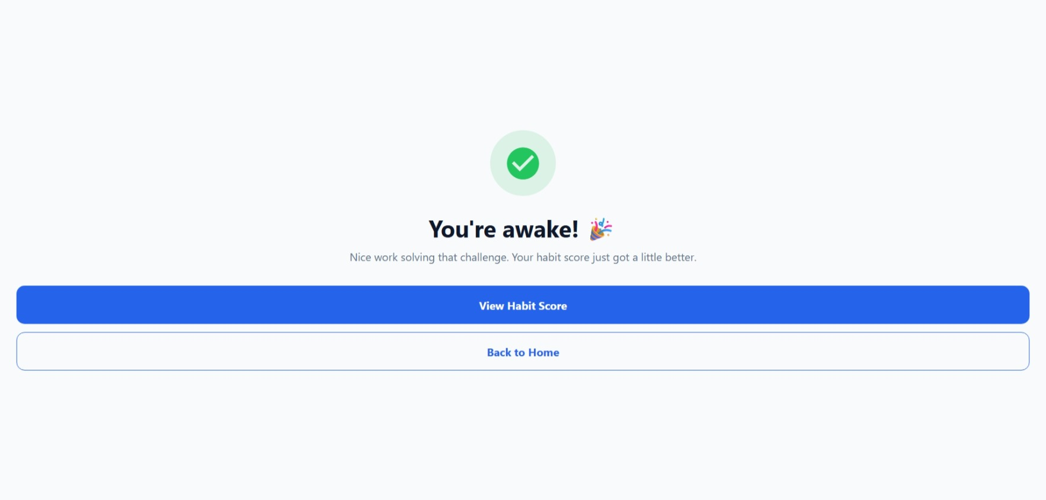
Figure 9: Successful dismissal confirmation and habit score update
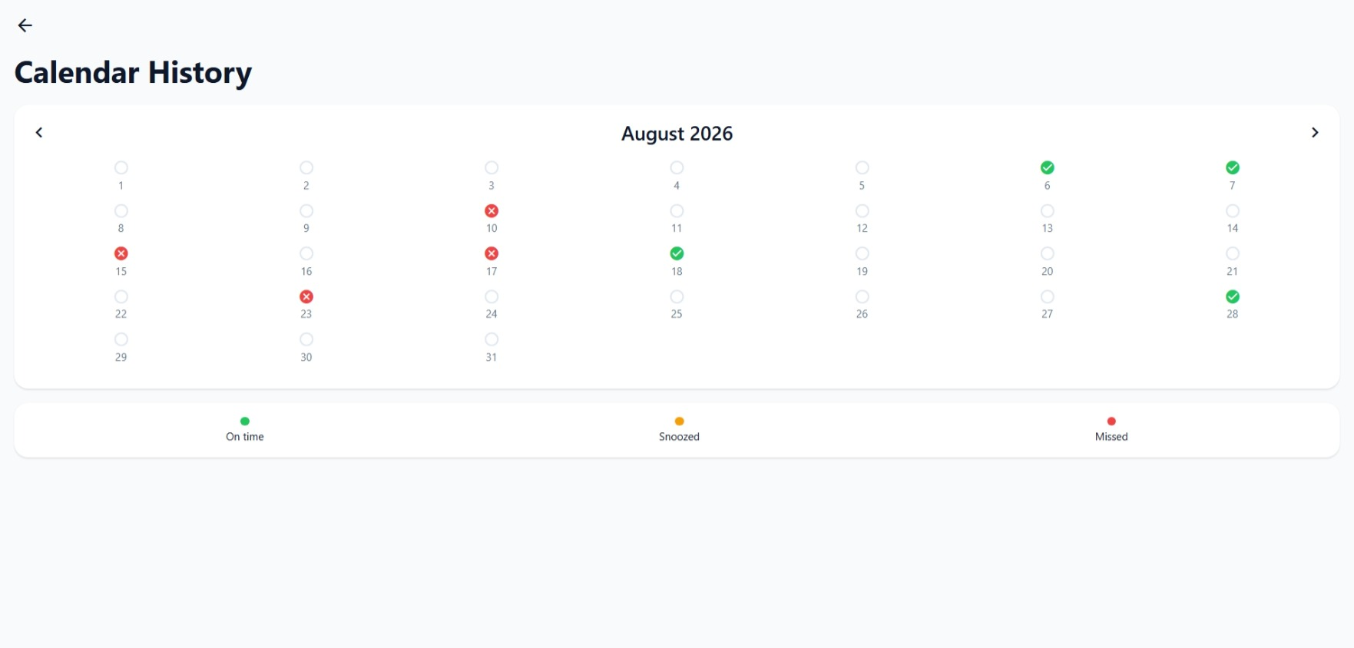
Figure 10: Calendar history showing on-time, snoozed, and missed wake-ups

6.3 Cross-Platform Availability
Alongside the web client, the platform is also available as a mobile application, giving users the same alarm, analytics, and habit-tracking experience on the go.

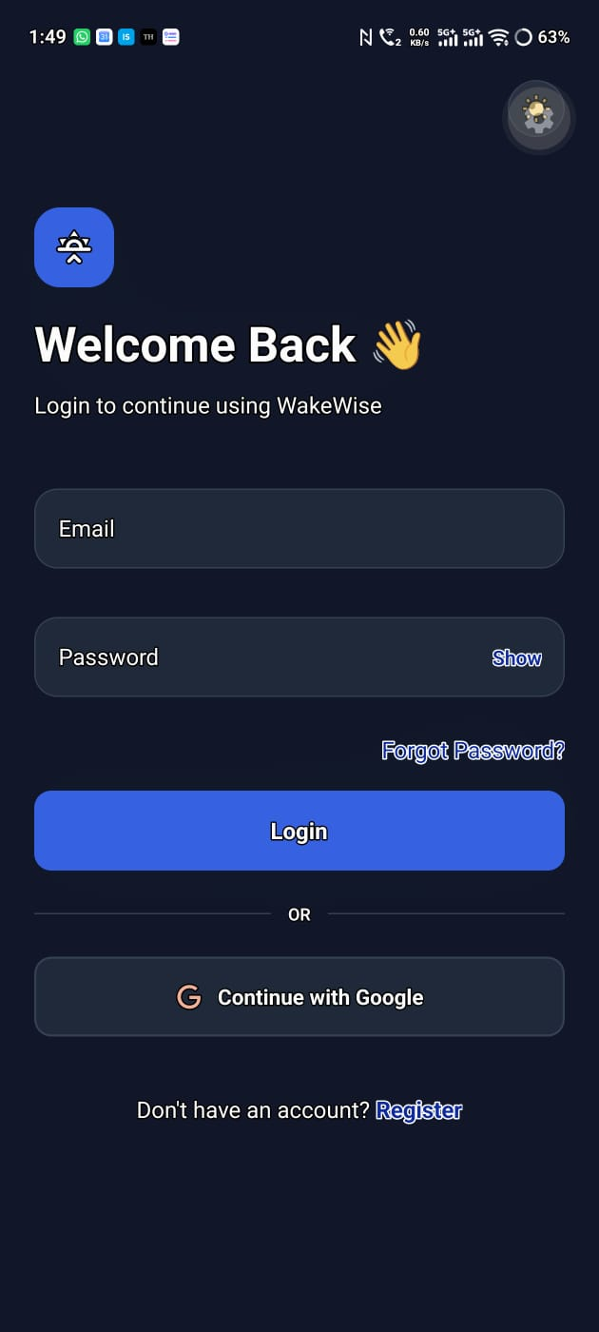  Figure 11: Mobile login screen | 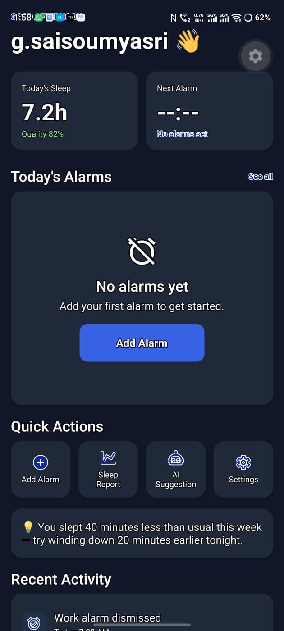  Figure 12: Mobile home dashboard

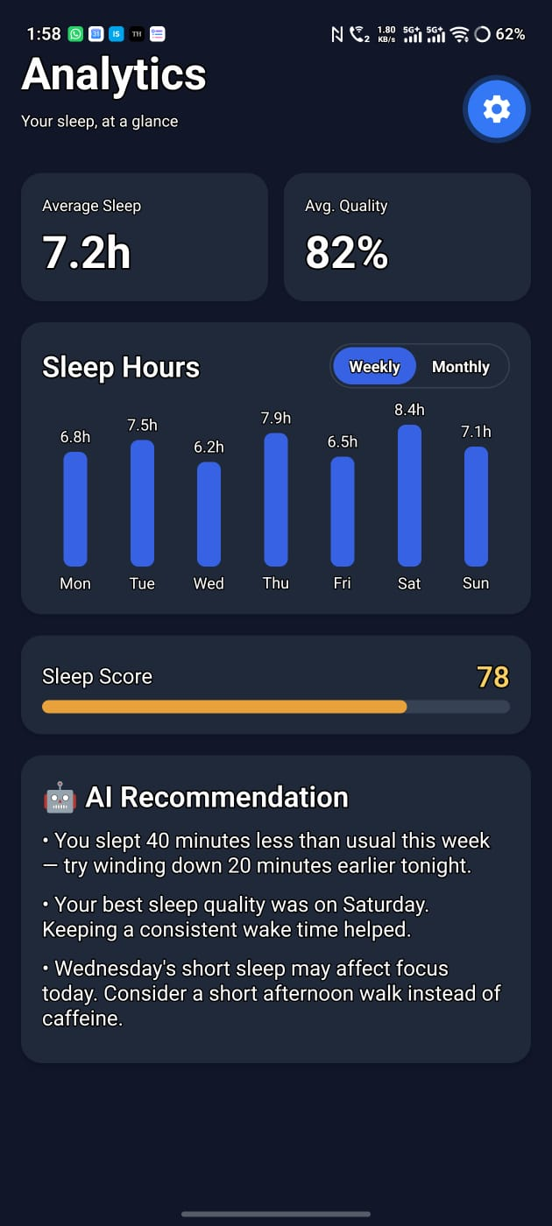  Figure 13: Mobile analytics — sleep hours & AI recommendations | 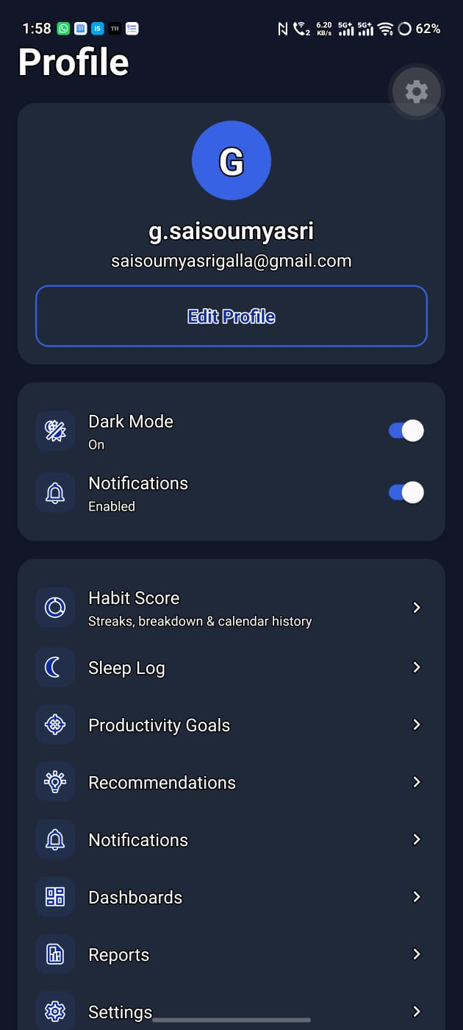  Figure 14: Mobile profile & settings menu

7. Testing & Deployment

7.1 Testing Performed
- API validation and endpoint testing using Postman.
- End-to-end workflow testing of the alarm lifecycle: creation → scheduling → ring → challenge → verification → habit score update.
- Functional testing of both supported challenge types (math and logic) and of the incorrect-answer / retry / snooze path.
- Cross-platform verification across the web client and the mobile application.
- Security testing of authentication and role-based access control.

7.2 Deployment
The backend was containerised with Docker to ensure a consistent, reproducible runtime, with the platform targeted for cloud deployment on AWS or Azure. Monitoring and logging were configured to track application health and surface errors in production.

8. Evaluation Criteria — Milestone 4
Criterion | Status
Fully deployed frontend and backend | Met
Dashboards and reporting systems operational | Met
End-to-end cognitive alarm workflow demonstrated | Met

9. Conclusion
Milestone 4 completes the Intelligent Cognitive Alarm Platform's planned eight-week build. With the dashboard and analytics layer in place, the wake-up verification flow tested end to end across web and mobile, and the backend containerised for deployment, the platform now delivers the complete

