Intelligent Cognitive Alarm Platform
Member 1 — Backend & Authentication
Milestone 2: Profile Expansion, Access Hardening & Admin APIs
Shrutipriya Hosmani

Table of Contents
1. Project Description
2. Scope of Milestone 2
3. Environment Setup
4. System Design
5. Database Schema Changes
6. Implementation Details
7. API Endpoints
8. Testing & Verification
9. Compatibility Notes for the Team
10. Conclusion

1. Project Description
This document covers Milestone 2 of Member 1's Backend and Authentication module for the Intelligent Cognitive Alarm Platform. It builds directly on the authentication foundation delivered in Milestone 1 -- user registration, login, and JWT issuance -- and extends it with the profile, security, and administrative capabilities the rest of the platform depends on.
Per the project's official milestone plan, Milestone 2 corresponds to Week 3-4: Profile Expansion, Access Hardening & Admin APIs. The focus shifts from "can a user log in" to "can the system verify who a user is, expand what it knows about them, and control what different types of users are allowed to do."

2. Scope of Milestone 2
- In scope: Extended user/habit profile fields, refresh-token-based session management, admin-only user management APIs, rate limiting on authentication endpoints, and an automated test suite.
- Out of scope (Milestone 3): Password-reset flow, account lockout after failed attempts, audit logging, and CORS configuration for the frontend.
A schema-compatibility decision made in this milestone is worth noting: the project plan specifies three roles -- User, Wellness Coach, and Administrator. To avoid a risky rename of data already stored from Milestone 1, the underlying database value 'admin' was kept as-is (representing "Administrator"), and 'wellness_coach' was added as a new role value.

3. Environment Setup
Milestone 2 builds on the same environment as Milestone 1, with three additional dependencies:
slowapi==0.1.9 # rate limiting on /auth/register and /auth/login
pytest==8.2.2 # automated test suite
httpx==0.27.0 # required by FastAPI's TestClient
A new environment variable was also introduced: REFRESH_TOKEN_EXPIRE_DAYS, controlling how long a refresh token remains valid before it must be re-issued via login.

4. System Design

4.1 Refresh Token Architecture
Milestone 1 issued a single, stateless JWT access token per login. This works for short-lived sessions, but has one limitation: a stateless JWT cannot be revoked once issued -- it simply remains valid until it expires, even if the user logs out.
To address this, Milestone 2 introduces a server-side refresh_tokens table. On login, the server now issues two tokens: a short-lived access token (as before), and a longer-lived, opaque refresh token that is recorded in the database. The refresh token can be exchanged for a new access token via POST /auth/refresh, and explicitly revoked via POST /auth/logout -- giving the system real, revocable sessions rather than a purely stateless one.
- On refresh, the old refresh token is revoked and a new one is issued (rotation) -- this limits how long a leaked refresh token could be replayed.
- On logout, the specific refresh token provided is marked revoked, so it can no longer be exchanged for new access tokens.

4.2 Role-Based Access Control Hardening
Role checks were refactored from a single hardcoded require_admin dependency into a generic require_role(role) dependency factory. This keeps role-checking logic in one place and makes it trivial to add coach-only or other role-restricted routes later without duplicating logic.

4.3 Rate Limiting
The /auth/register and /auth/login endpoints are now rate-limited per client IP address, using the slowapi library. This is a first line of defense against brute-force credential guessing and automated account-creation abuse.

5. Database Schema Changes

5.1 Extended users Table
The following fields were added to the existing users table to support the Alarm (Member 2) and AI/Analytics (Member 3) modules:
Column | Type | Purpose
is_active | Boolean | Allows admins to deactivate an account without deleting it
preferred_wake_up_time | Time | Used by the Alarm module for scheduling
sleep_duration_minutes | Integer | User's typical sleep duration
timezone | String(50) | User's local timezone, for correct alarm scheduling
difficulty_preference | String(20) | Used by the AI module to calibrate challenge difficulty
productivity_goals | Text | Free-text user goal, for AI/analytics context
habit_preferences | JSON | Flexible key-value store for habit-related settings

5.2 New refresh_tokens Table
Column | Type | Description
id | Integer (PK) | Auto-incrementing primary key
user_id | Integer (FK) | References users.id
token | String(255) | The opaque refresh token value, unique
expires_at | DateTime | When this refresh token becomes invalid
revoked | Boolean | Set true on logout or rotation
created_at | DateTime | Timestamp set automatically on issue

5.3 Migration Note
Because the users table already existed from Milestone 1, SQLAlchemy's automatic table creation does not retroactively add new columns to it. A migration.sql script was written and run manually via pgAdmin's Query Tool to apply the schema changes above to the existing database without data loss.

6. Implementation Details

6.1 Bug Fix: 401 vs. 403 Status Codes
While testing, an issue was identified in the authentication dependency inherited from Milestone 2's earlier Swagger-compatibility fix: FastAPI's HTTPBearer security scheme returns 403 Forbidden by default when no token is provided at all, rather than 401 Unauthorized. This blurred an important distinction the system is meant to enforce.
- 401 Unauthorized: "The system does not know who you are" -- missing or invalid token.
- 403 Forbidden: "The system knows who you are, but you are not allowed to do this" -- valid token, insufficient role.
This was corrected by setting auto_error=False on the HTTPBearer scheme and explicitly raising 401 within the get_current_user dependency when no credentials are supplied, restoring the correct distinction between the two error codes across every protected route.

6.2 Refresh Token Rotation
Each successful call to /auth/refresh immediately revokes the refresh token that was used, and issues a new one alongside the new access token. This means a given refresh token can only be used exactly once, significantly limiting the impact of a leaked or stolen token.

6.3 Habit Profile Updates
The PUT /users/me/habits endpoint uses partial updates -- only fields explicitly included in the request body are modified, leaving all other profile fields untouched. This makes the endpoint safe for the frontend to call repeatedly with partial form data.

7. API Endpoints
Method | Endpoint | Description | Access
POST | /auth/register | Create a new user account | Public, rate-limited
POST | /auth/login | Authenticate and receive access + refresh tokens | Public, rate-limited
POST | /auth/refresh | Exchange a refresh token for a new token pair | Requires valid refresh token
POST | /auth/logout | Revoke a refresh token | Requires valid access token
GET | /users/me | View own profile | Authenticated
PUT | /users/me | Update own username/email | Authenticated
PUT | /users/me/habits | Update own habit/wake-up profile | Authenticated
GET | /admin/users | List all users | Administrator only
PATCH | /admin/users/{id}/status | Activate/deactivate a user | Administrator only
PATCH | /admin/users/{id}/role | Change a user's role | Administrator only

8. Testing & Verification
Two layers of testing were performed for this milestone: an automated Pytest suite (12 tests, all passing) covering the core logic in isolation, and a manual end-to-end verification pass through Swagger UI against the real development database. Screenshots for each manual test case are included below.

8.1 Automated Test Suite Summary
The following automated tests were written and executed via pytest, covering authentication, profile management, and admin access flows:
Test File | Coverage
test_auth.py | Register, login, duplicate rejection, wrong password, refresh rotation, logout revocation
test_users.py | Auth requirement on /users/me, profile update, habit profile update
test_admin.py | Admin routes blocked for normal users, admin routes require auth, admin list/status/role management

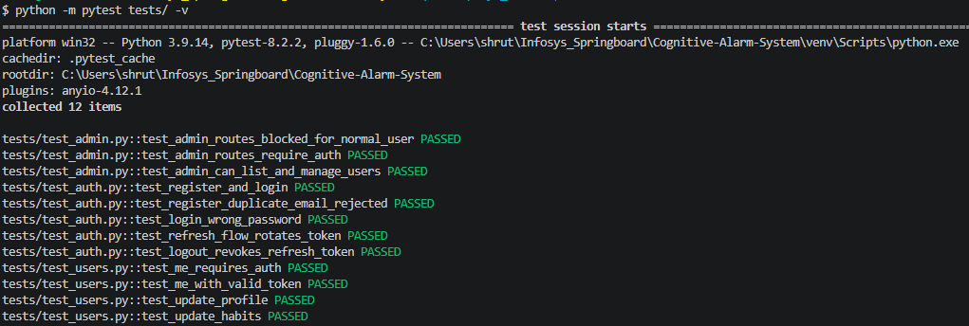

8.2 Manual Testing (Swagger UI)
Each of the following was manually verified against the local development environment.

Test 1: Register a New User
Called POST /auth/register with a new username, email, and password.
- Expected result: 201 Created, with the new user's profile returned (no password field).
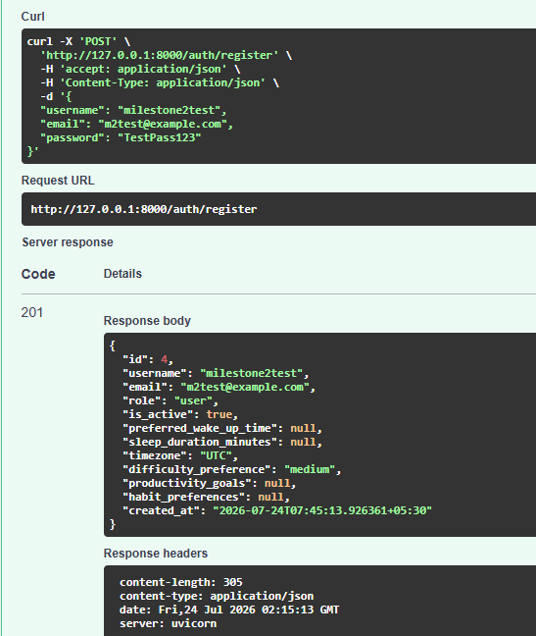

Test 2: Login Returns Both Tokens
Called POST /auth/login with the registered user's credentials.
- Expected result: 200 OK, response includes both access_token and refresh_token (new in Milestone 2).
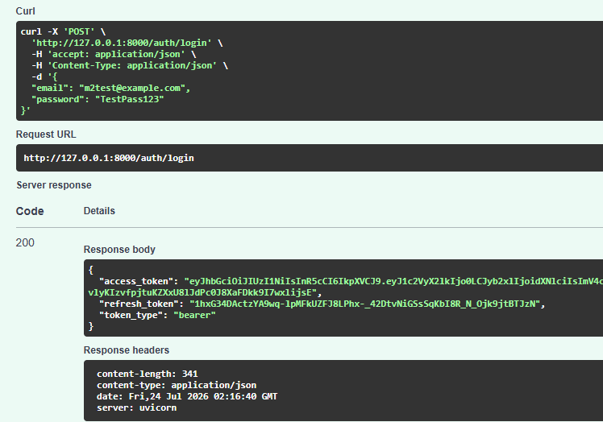

Test 3: Missing Token Returns 401
Called GET /users/me without authorizing / attaching a token.
- Expected result: 401 Unauthorized

Test 4: Authenticated Profile Access
Authorized Swagger with a valid access token, then called GET /users/me.
- Expected result: 200 OK, returns the user's profile including new fields (is_active, timezone, etc.).
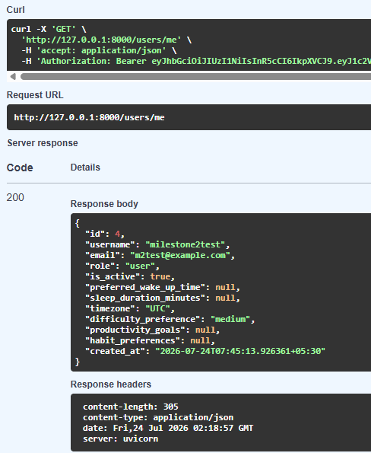

Test 5: Update Habit Profile
Called PUT /users/me/habits with sleep_duration_minutes, timezone, and difficulty_preference.
- Expected result: 200 OK, response reflects the updated values; confirmed persisted in the database.
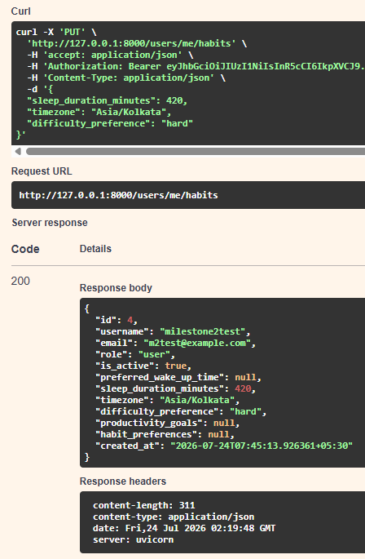

Test 6: Refresh Token Exchange
Called POST /auth/refresh with a valid refresh token.
- Expected result: 200 OK, a new access_token and refresh_token pair is returned.
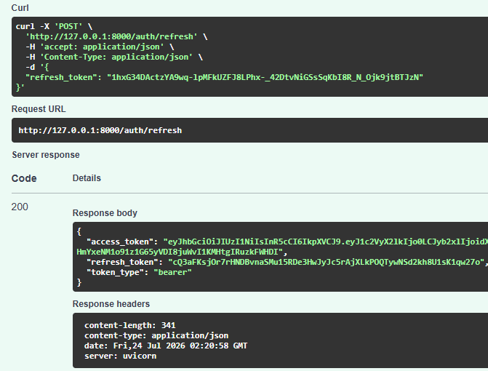

Test 7: Refresh Token Rotation (Reuse Rejected)
Immediately re-called POST /auth/refresh using the same (now-old) refresh token from Test 6.
- Expected result: 401 Unauthorized -- confirms the old refresh token was correctly revoked after use.
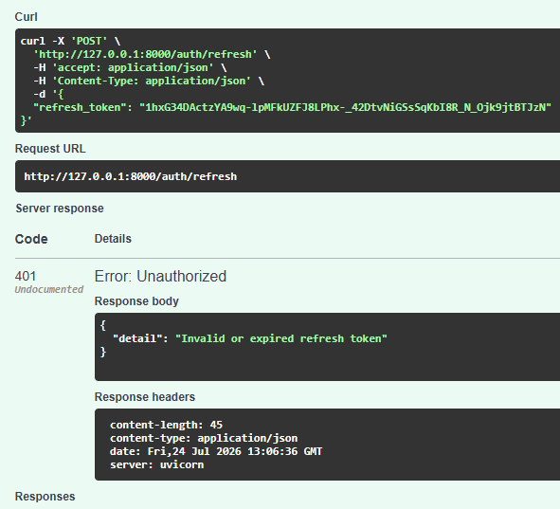

Test 8: Logout Revokes Refresh Token
Called POST /auth/logout (authenticated) with a currently valid refresh token.
- Expected result: 204 No Content; a subsequent /auth/refresh call with that same token returns 401.
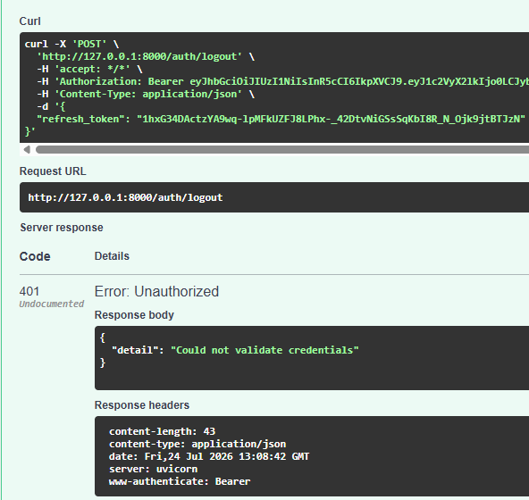

10. Compatibility Notes for the Team
- Member 2 (Alarm & Challenge System): user_id remains stable and unchanged; preferred_wake_up_time and timezone are now available on every user for scheduling logic.
- Member 3 (AI & Analytics): difficulty_preference and the flexible habit_preferences JSON field are now available per-user via GET /users/me, or in aggregate via the admin-only GET /admin/users.
- Member 4 (Frontend & Deployment): CORS configuration is scoped to Milestone 3 per the project plan; flagged here in case earlier local-dev access is needed.

11. Conclusion
Milestone 2 extends the authentication foundation from Milestone 1 into a hardened, feature-complete backend module: users now carry the full habit/wake-up profile the rest of the platform depends on, sessions are managed through revocable refresh tokens rather than a purely stateless JWT, and administrators have dedicated APIs to manage user accounts and roles.
All functionality was verified through both an automated Pytest suite (12/12 passing) and a full manual walkthrough via Swagger UI against the live development database, with results documented in Section 8. This module is now ready to support integration with the Alarm, AI/Analytics, and Frontend modules being developed in parallel by the rest of the team.

