Project Name: AI Intelligent Cognitive Alarm Platform

Milestone 1

System Architecture
The project is designed using a modern client-server architecture, where different functionalities are separated into independent environments and modules. The frontend is a cross-platform mobile application built with React Native (Expo) and TypeScript. The backend is a high-performance REST API powered by FastAPI (Python), utilizing MongoDB Atlas for scalable document storage. This structure improves code readability, reusability, and maintainability, making the project scalable and easier to extend for future AI features.

User Interaction and Input Handling
The program interacts with the user through a polished mobile graphical user interface built with React Native Paper. When the application starts, the user is presented with authentication screens to log in or register. The program includes robust input validation using controlled React components on the frontend and strict Pydantic schema validation on the backend. This ensures smooth execution and prevents the application from crashing due to invalid user input.

1. Authentication and User Profile Management
The process of authenticating users and managing profiles is handled by the auth.py and users.py modules in the backend. This handles secure password hashing and JWT token generation to keep user sessions secure across app restarts.
backend/app/api/v1/endpoints/auth.py – API Interaction Layer
login_access_token() Detailed Behavior:
- Authenticates email and password against MongoDB
- Generates secure JWT access and refresh tokens
- Returns token payloads to the client
Why JWT token logic is good:
- Prevents users from having to log in repeatedly
- Shows production-ready thinking regarding API security

2. Alarm Creation and Management
Once authenticated, alarms are created, edited, and toggled. They are displayed in the UI using Redux Toolkit to manage global state. Displaying the active alarms clearly helps users evaluate their upcoming schedules.
mobile/src/store/alarmSlice.ts
Function Role:
- Iterates over fetched alarms and stores them in global state
- Handles adding, updating, and removing alarms instantly from the UI
Key Concepts Used:
- Redux Reducers and Actions
- Global state synchronization
Importance:
- Clean UI updates without needing to constantly refresh
- Improves application responsiveness

3. Background Alarm Scheduling
The project allows users to set specific times for their alarms. The alarmScheduler.ts service constantly runs in the background, retrieving live alarm data from the Redux store. When a time matches the current system clock, the scheduler triggers the alarm screen, enabling users to wake up reliably.
start() Detailed Behavior:
- Sets up an interval to poll the current time
- Evaluates active days (Daily, Weekday, Weekend, One-Time)
- Compares live time against the alarm list and navigates to the Ring screen This shows:
- Understanding of background Javascript execution
- Time and date manipulation

4. Audio Playback Engine
After an alarm is scheduled and triggered, the audio must play to wake the user. This is handled by the audioService.ts module. This file generates audio tones using the Web Audio API and ensures browser autoplay policies do not block the alarm sound.
mobile/src/services/audioService.ts – Audio Engine File This file handles playing, stopping, and unlocking audio contexts.
forceUnlock() Purpose: Forces the audio engine to unlock during a user interaction and plays a silent loop. Simple explanation: Prevents mobile browsers from putting the audio engine to sleep, ensuring the alarm always rings.
startAlarm(soundName) Purpose: Starts playing the selected sound pattern (e.g. 'radar', 'birds'). What it does:
- Converts configuration into sine/square wave frequencies
- Loops the audio indefinitely

5. Cognitive Wake Up Challenge
To successfully dismiss an alarm, the user must prove they are awake by completing a cognitive challenge. The challenges.py endpoint dynamically generates these problems and verifies the user's answers.
generate_challenge() Purpose: Generates a math problem based on the requested difficulty. Simple explanation: Creates randomized math questions like "18 + 37" so the user can't just memorize the answer.
submit_challenge() Purpose:
- Verifies the user's answer against the correct answer
- Logs the attempt in the database
Key Concepts:
- Database relations (linking attempts to alarms)
- Secure answer verification on the server-side

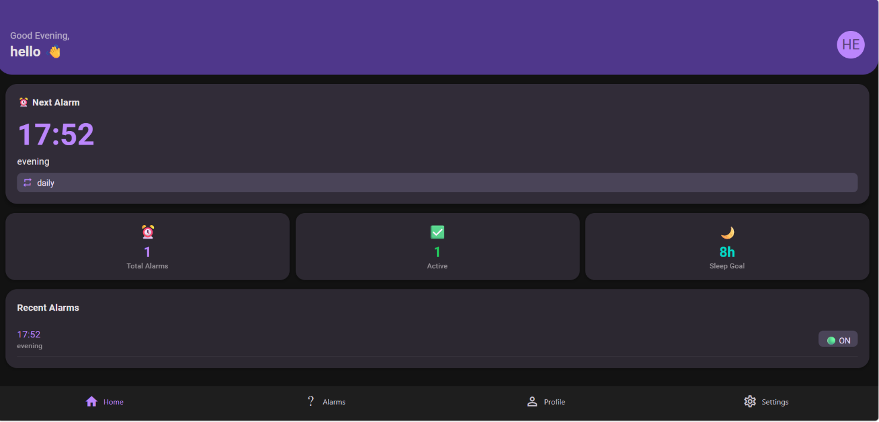
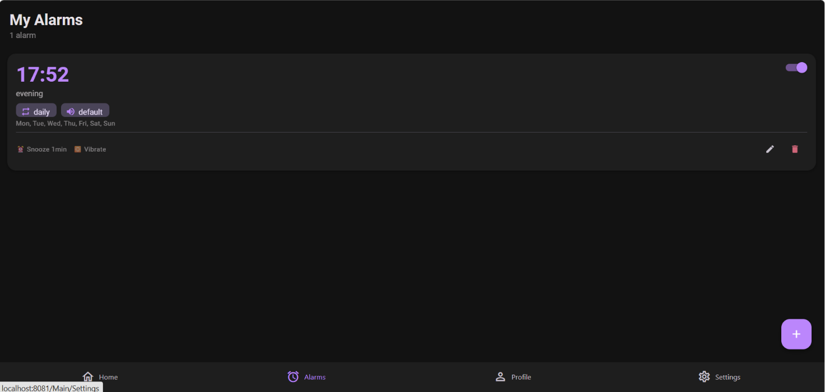

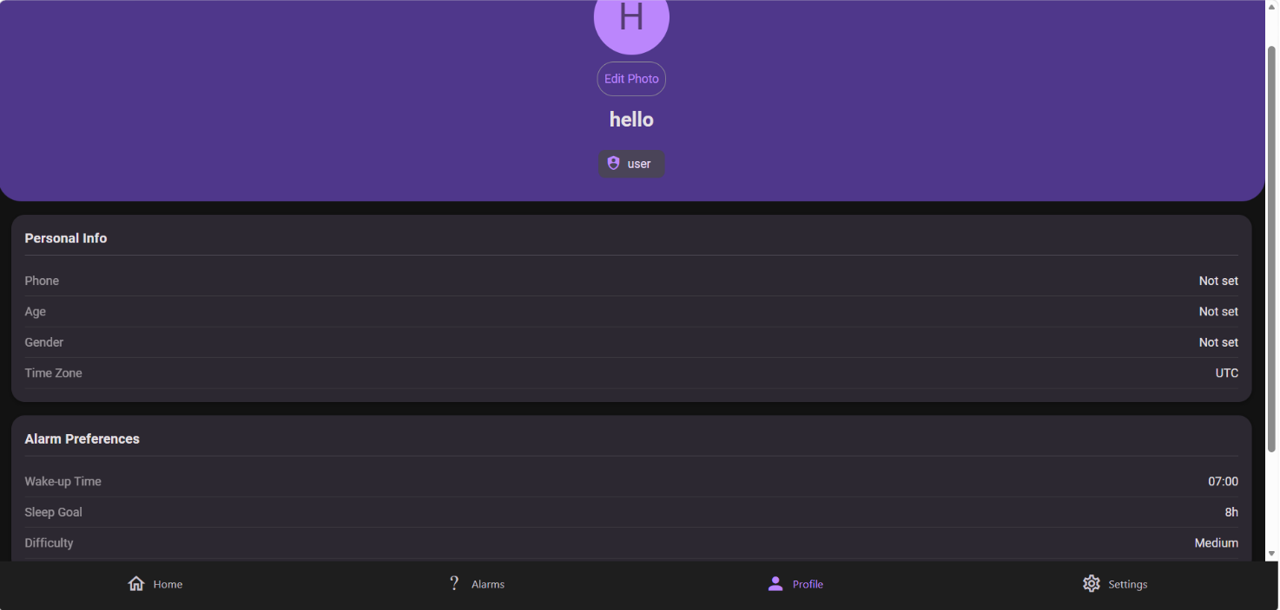

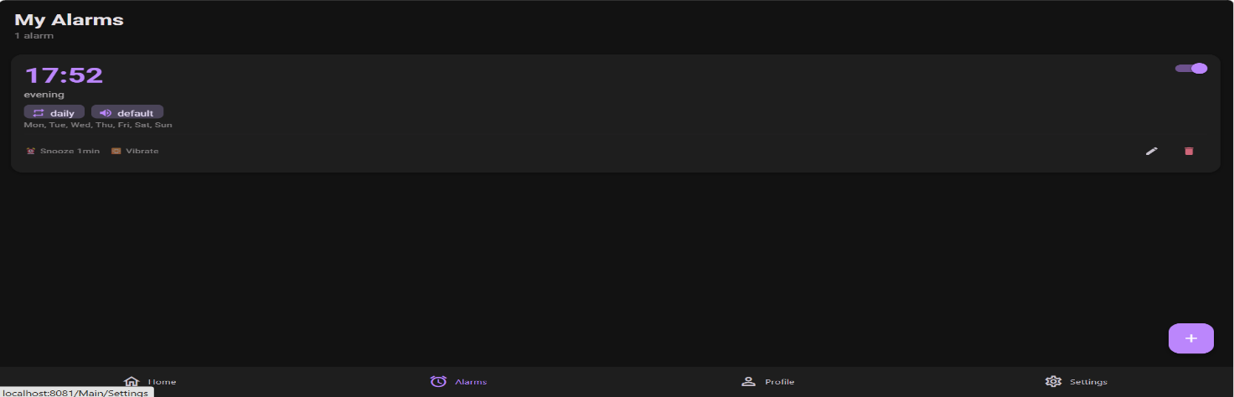



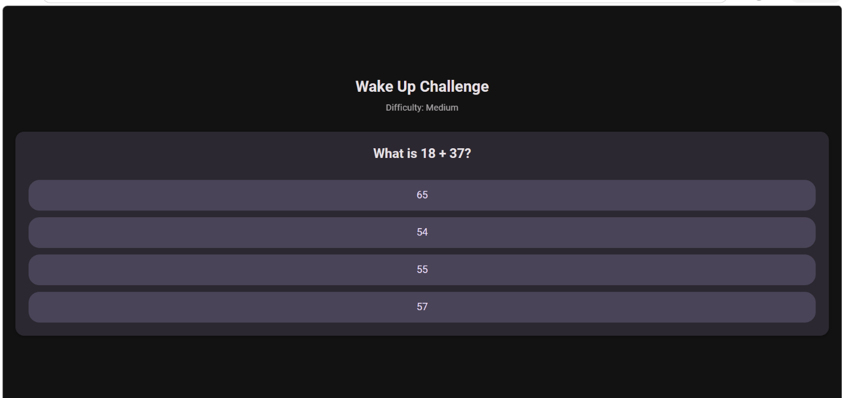

Submitted by
Bommisetty Tejaswa

