US Natural Disaster Temporal Analysis & Visualization

Milestone 4: Incident Analysis & Federal Assistance Correlation
Prepared By: Yash Aggarwal Date: April 2, 2026

Table of Contents

Section | Page
1. Introduction | 3
2. Theory: Modules & Libraries Used | 3-4
3. Visualization Catalog | 5-12
4. Conclusion | 13

US Natural Disaster Temporal Analysis & Visualization

Incident Type Analysis — Theory, Modules & Visualizations

- Introduction
Milestone 4 focuses on analyzing the distribution and behavior of Incident Types within the FEMA dataset, understanding their relationship with Assistance Programs, and synthesizing findings from all four project milestones into a coherent narrative. This document provides the theoretical background for the
modules/libraries used and a compilation of all visualizations produced across the project.

Theory: Modules & Libraries Used

Pandas (pandas)
Purpose: Data loading, cleaning, manipulation, and aggregation.
Pandas provides the DataFrame structure — a 2D labeled data structure similar to a spreadsheet or SQL table.
Key operations used:
pd.read_csv() — Loads CSV files into DataFrames.
pd.to_datetime() — Converts string dates to datetime objects for time-based analysis.
.groupby() — Groups data by one or more columns for aggregation (e.g., counting declarations per state).
.pivot_table() — Reshapes data from long to wide format for heatmaps.
.value_counts() — Counts unique values in a column, sorted by frequency.
.fillna() — Fills missing values with a specified value.

NumPy (numpy)
Purpose: Numerical computing foundation.
NumPy provides the ndarray data structure and mathematical functions used internally by Pandas, Matplotlib, and Seaborn.
Key operations used:
np.linspace() — Creates evenly spaced arrays for color gradients.
np.polyfit() / np.poly1d() — Polynomial curve fitting for trend lines.
np.arange() — Creates integer index arrays for bar chart positioning.

Matplotlib (matplotlib.pyplot)
Purpose: The foundational plotting library in Python.
Matplotlib provides low-level control over every aspect of a chart — axes, ticks, labels, colors, annotations.
Key chart types used:

plt.bar() / plt.barh() — Vertical and horizontal bar charts.
plt.plot() — Line charts for time-series trends.
plt.fill_between() — Filled area under curves.
plt.annotate() — Adds text annotations with arrows pointing to data points.
plt.savefig() — Exports charts as high-resolution PNG images.

Seaborn (seaborn)
Purpose: Statistical visualization built on top of Matplotlib.
Seaborn simplifies the creation of complex statistical charts with cleaner syntax and better default aesthetics.
Key chart types used:
sns.heatmap() — Creates annotated heatmaps for cross-tabulated data (e.g., State × Incident Type, Month × Disaster Type).
sns.boxplot() — Box-and-whisker plots to show distributions and outliers (e.g., disaster duration by type).
sns.set_theme() — Sets a global visual theme for all subsequent plots.

Plotly Express (plotly.express)
Purpose: Interactive, web-based visualizations.
Unlike Matplotlib (which produces static images), Plotly generates interactive HTML charts with hover tooltips, zooming, and panning.
Key chart types used:
px.choropleth() — Creates interactive geographic choropleth maps colored by data values.
px.treemap() — Creates proportional Treemap visualizations showing hierarchical data.
.write_html() — Saves interactive charts as standalone HTML files.

Jupyter Notebook
Purpose: Interactive development environment.
Jupyter allows combining executable code, visualizations, and explanatory markdown text in a single document (.ipynb file).
Each "cell" can be either Markdown (for narrative) or Code (for Python execution). Output from code cells (charts, text, tables) is stored inline within the notebook.

Visualization Catalog
Below is the complete, ordered list of all visualizations produced across Milestones 1–4.

Milestone 1: Data Acquisition, Cleaning & Initial Exploration

Selected Figures

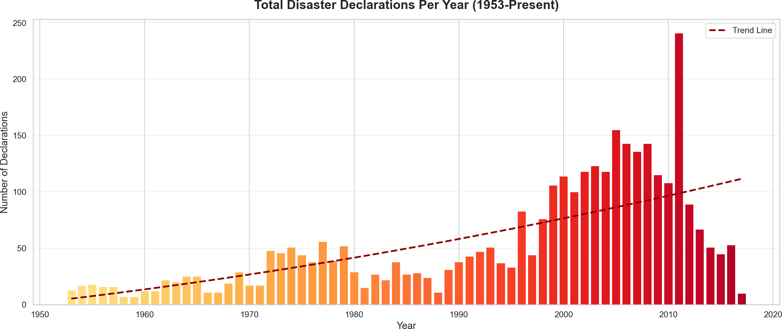
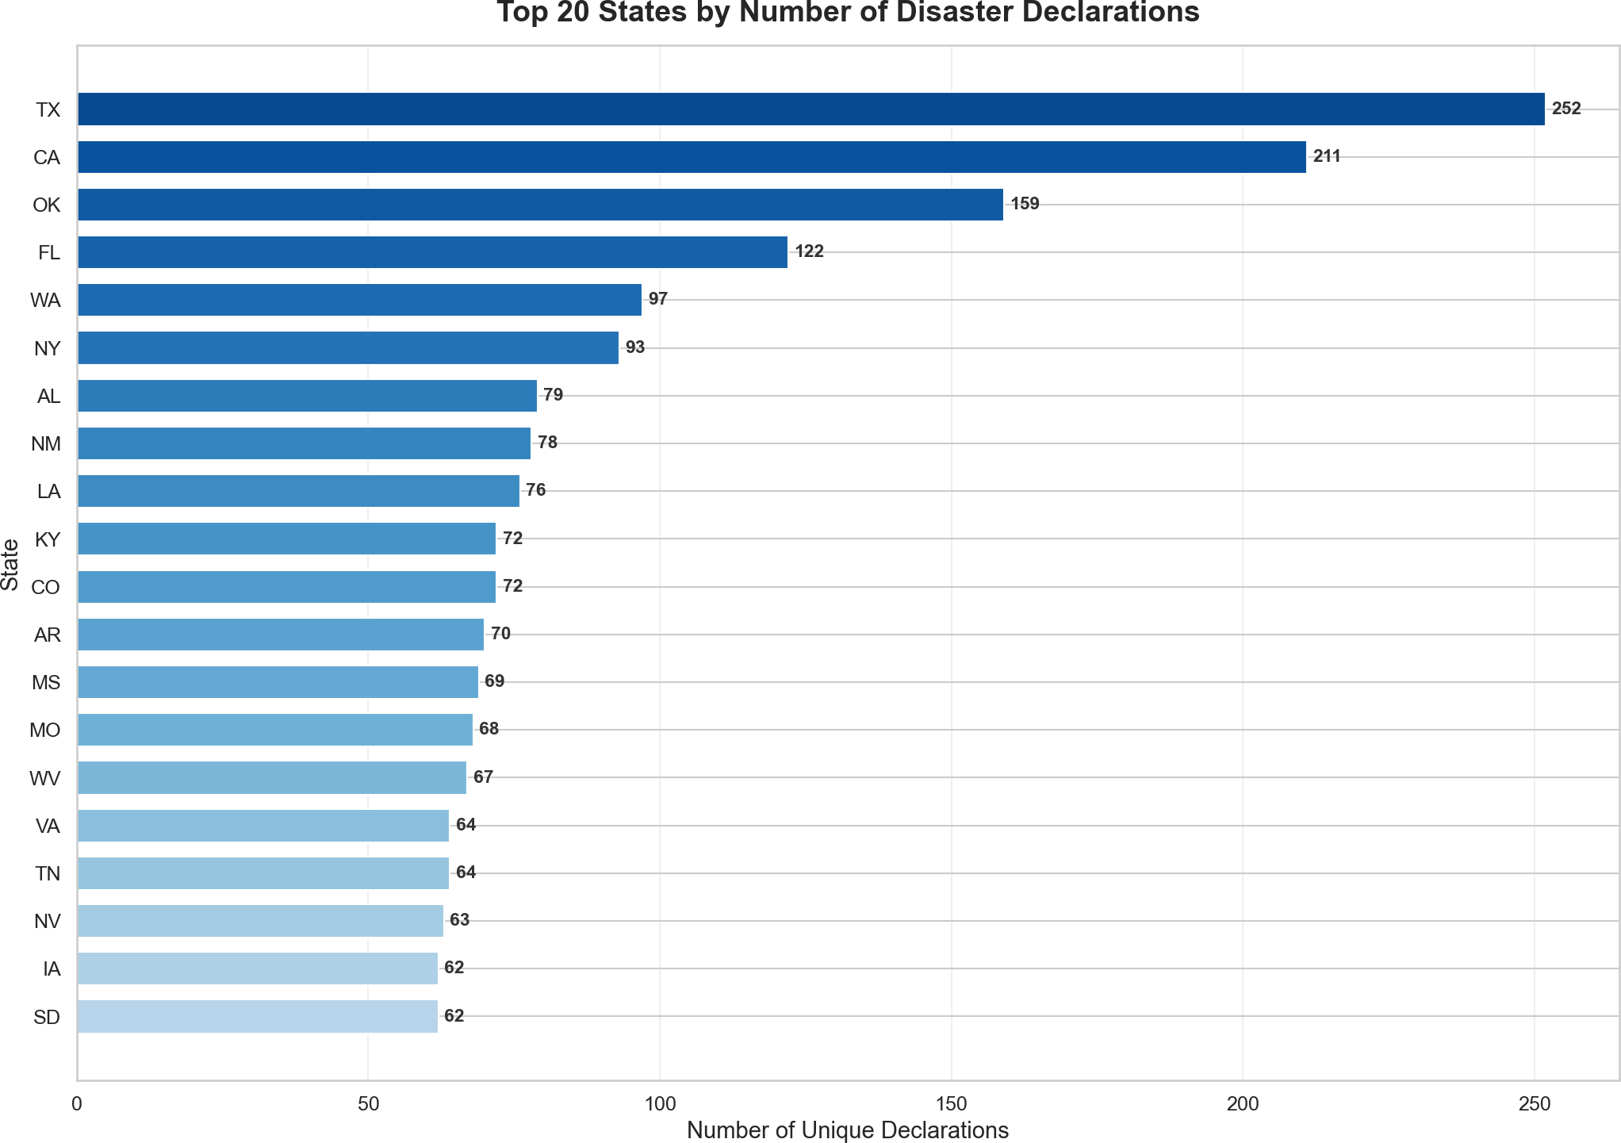

# Plot File Description

Total Declarations Per
- Year (Bar Chart) plots/01_declarations_per_year.png

Top 20 States
- (Horizontal Bar) plots/02_top_states.png
Yearly bar chart with
gradient coloring and a quadratic trend line
Horizontal bar chart of the 20 most disaster-prone
states

Milestone 2: Temporal Trend Visualization

Selected Figures
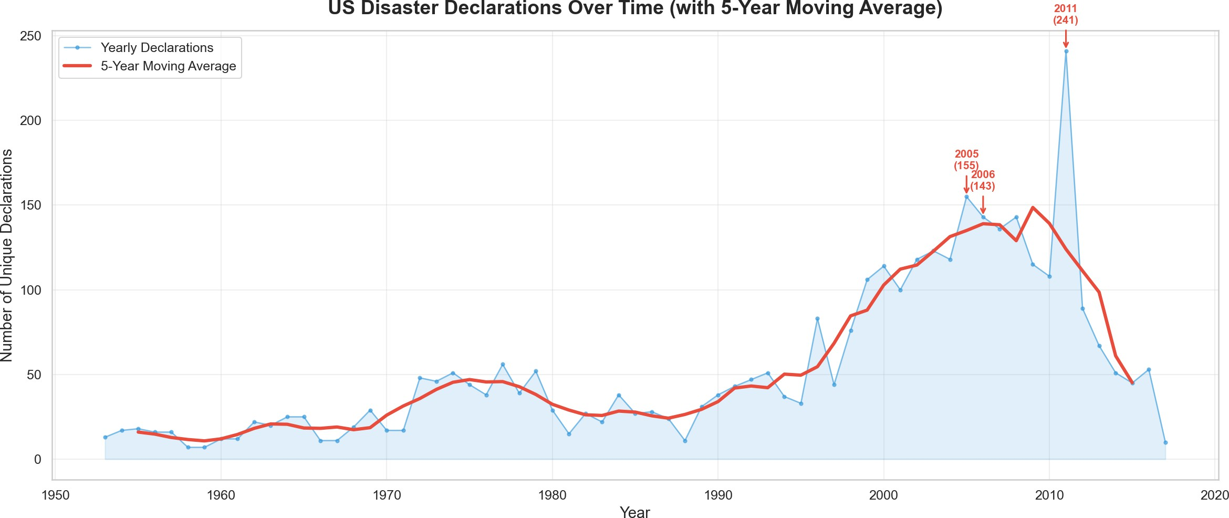
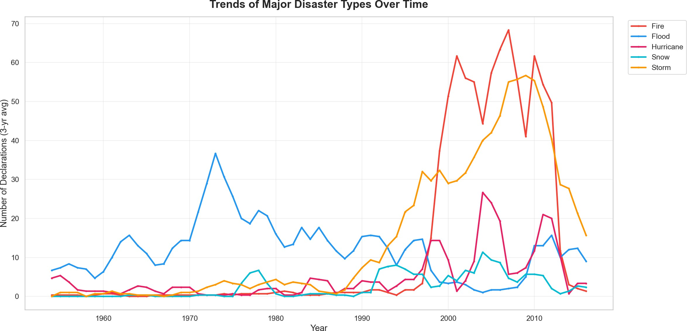

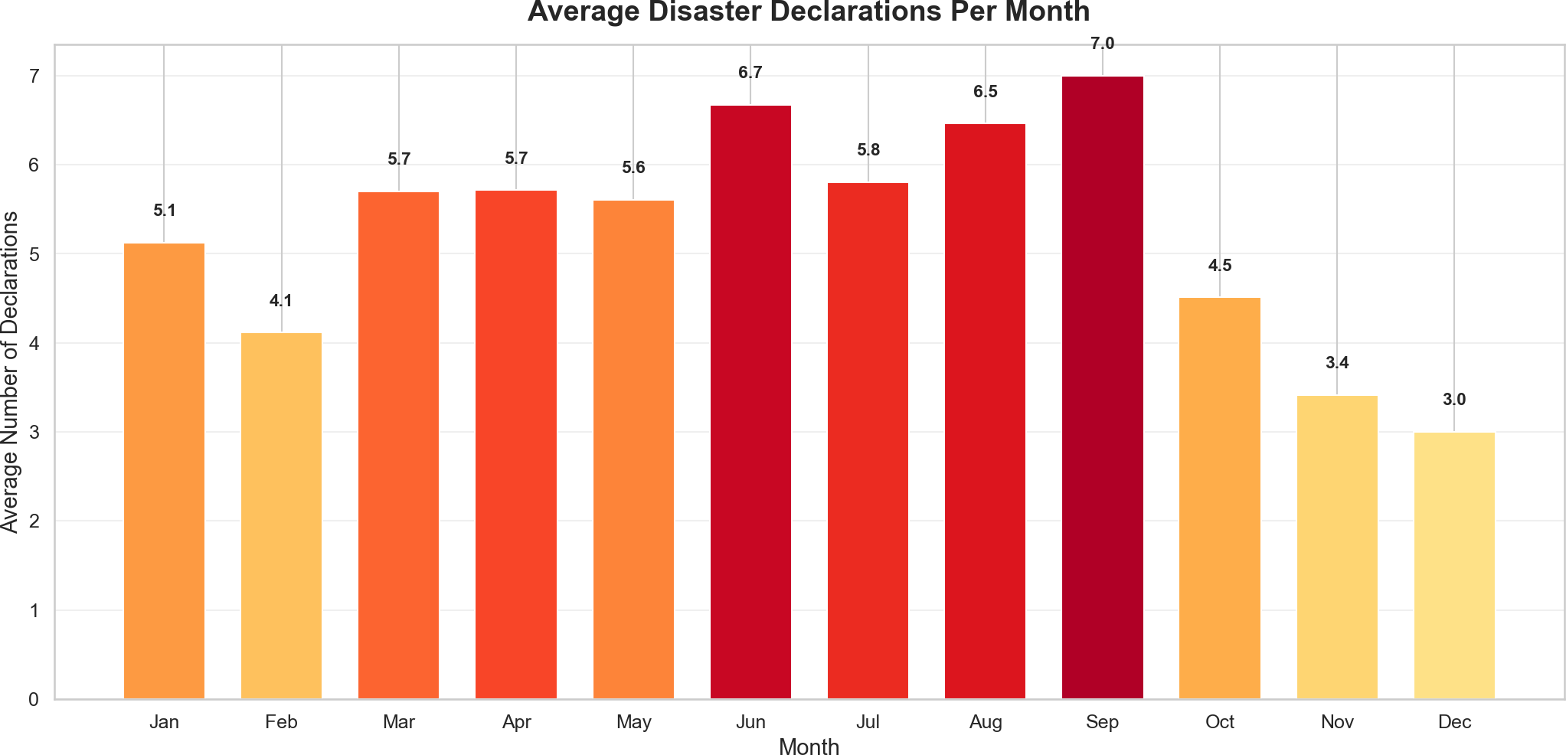
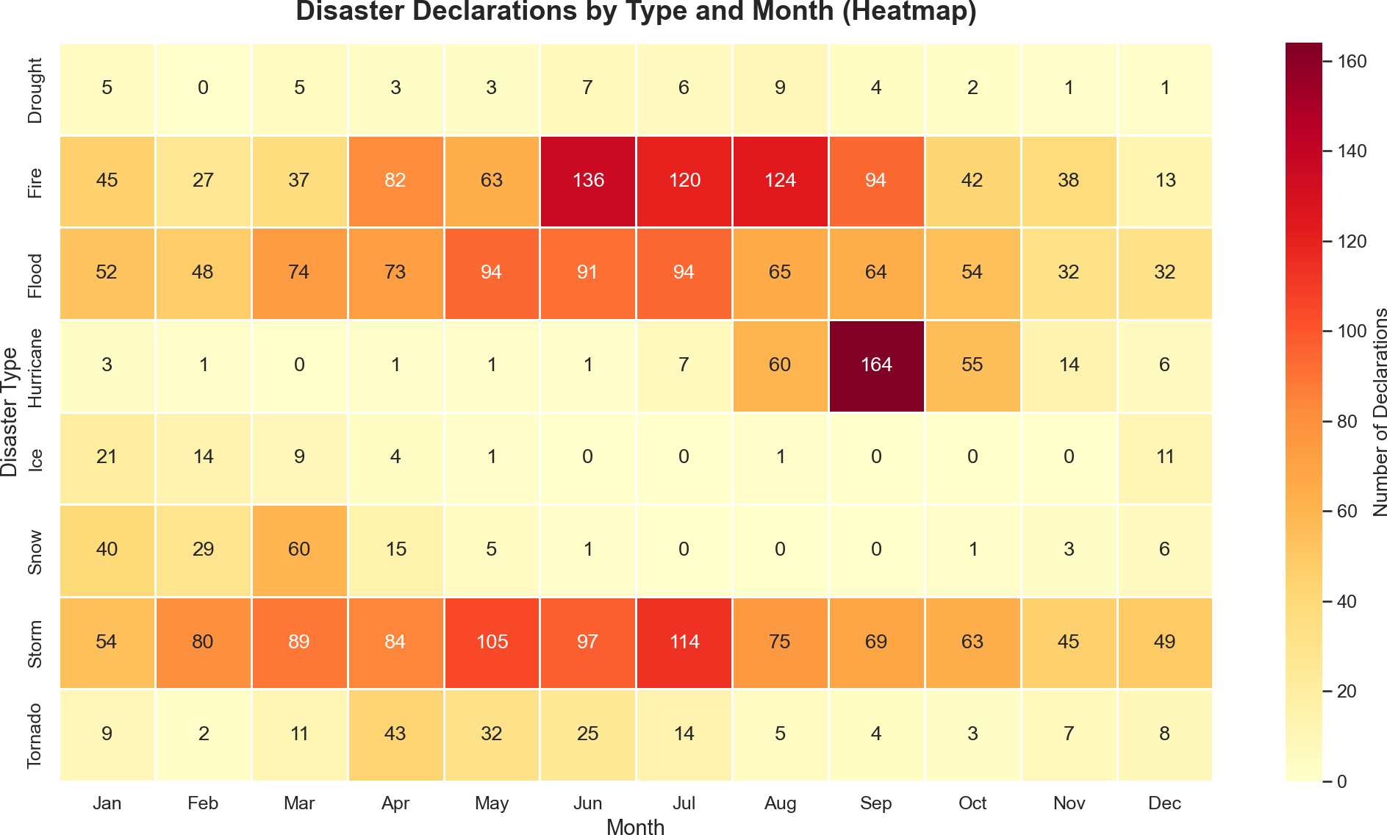

# Plot File Description

Refined Yearly Trend
- (Moving Average) plots/03_refined_yearly_trend.png
Line chart with 5-year
moving average and top-3 year annotations

- Disaster Type Trends (Multi-line)
Multi-line chart showing top
plots/04_disaster_type_trends.png 5 disaster types over time

- Stacked Area Chart plots/05_stacked_area.png Stacked area chart of disaster
types over time

comparison across decades
# | Plot | File Description
6 | Monthly Seasonality | Average declarations per  plots/06_monthly_seasonality.png month bar chart
7 | Type × Month Heatmap | Heatmap showing disaster  plots/07_type_month_heatmap.png types vs. months
8 | Duration Box Plot | Box plot showing duration  plots/08_duration_boxplot.png distribution by disaster type
9 | Duration by Decade | Mean vs. Median duration  plots/09_duration_by_decade.png

Milestone 3: Geographical Pattern Visualization

Selected Figures

The choropleth map and hotspot map were generated as interactive HTML files, so they are referenced in the table below instead of being embedded as static images.
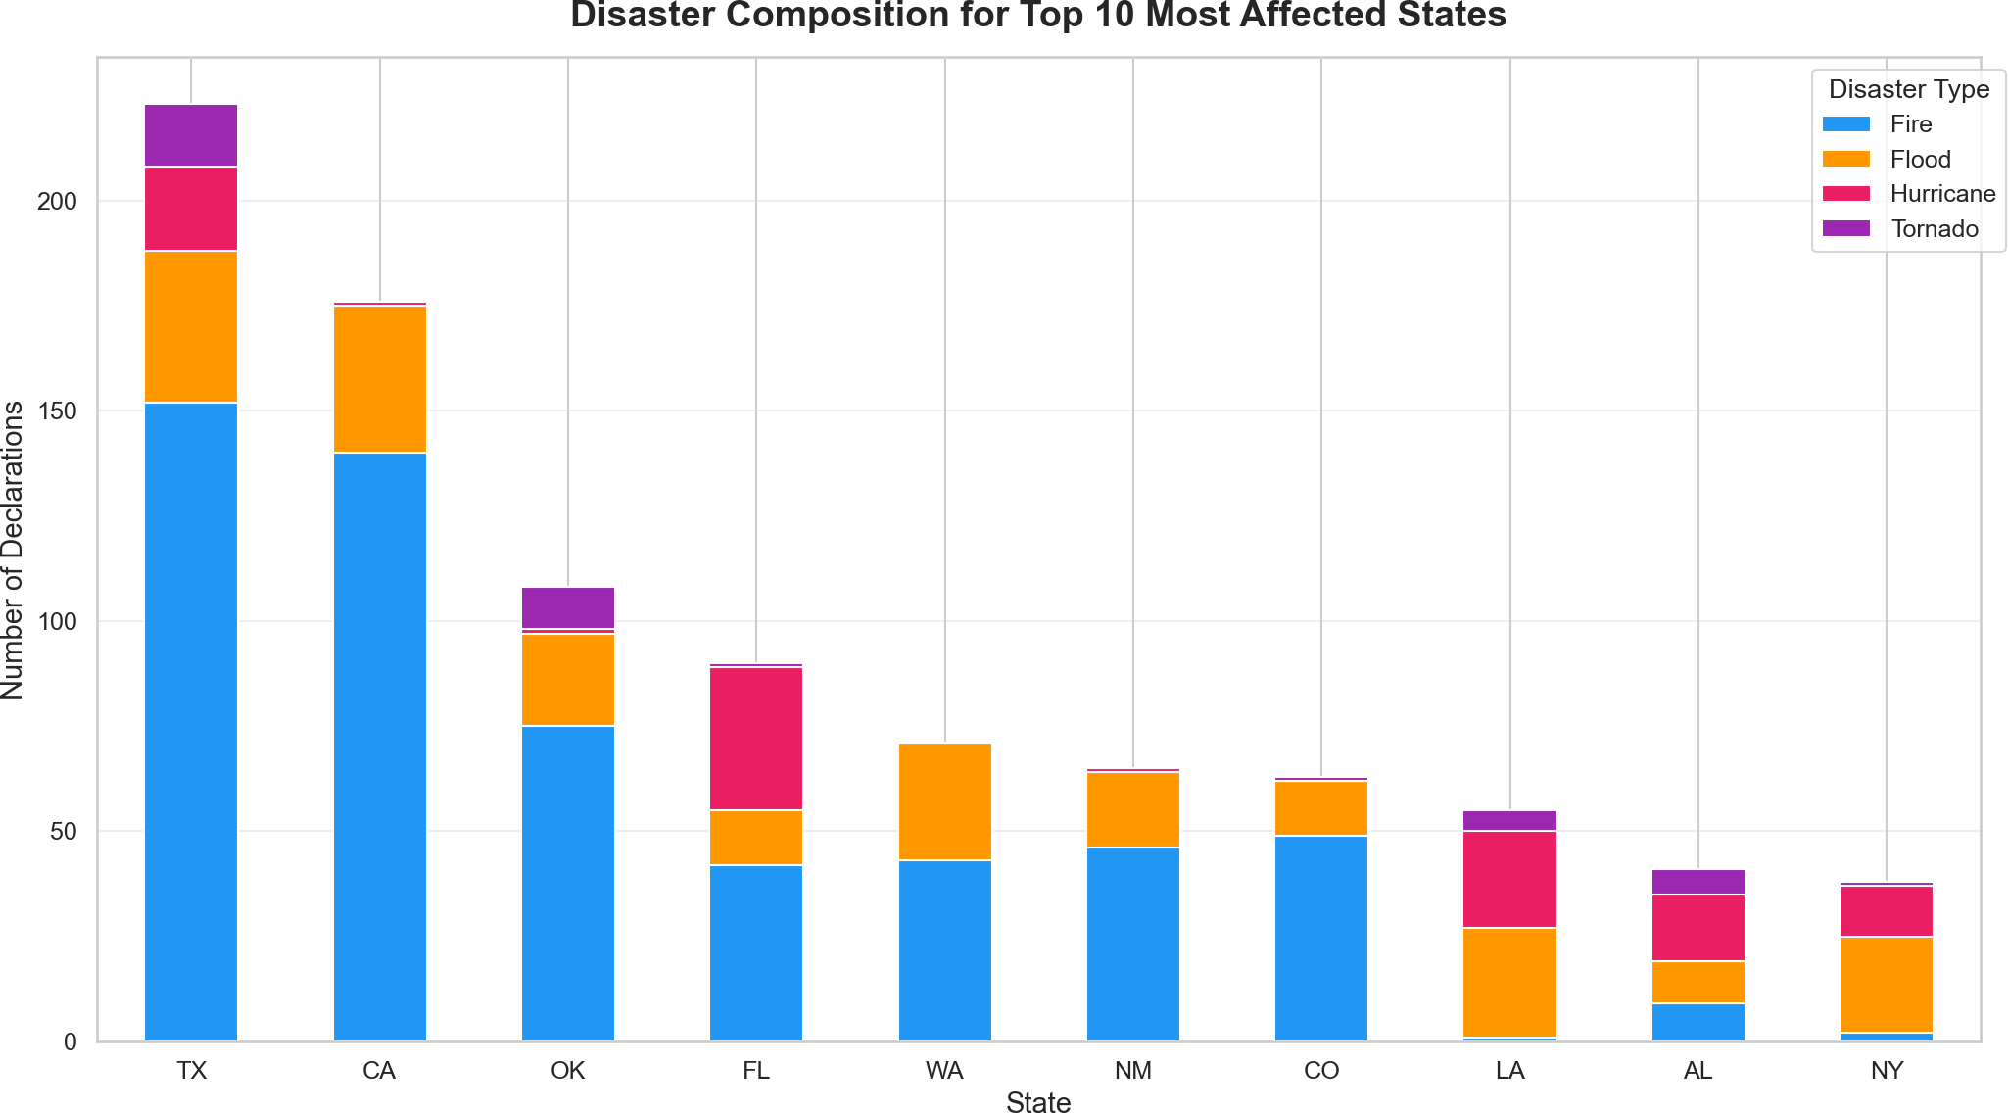

# Plot File Description

Total Declarations
- Choropleth Map plots/10_total_declarations_map.html

Disaster Hotspot
- Maps (Faceted) plots/11_disaster_hotspots.html
Interactive Plotly
choropleth of total
declarations per state
Faceted maps for
Hurricanes, Fires, and Tornadoes

# Plot File Description

State Composition
- (Stacked Bar) plots/12_state_composition.png
Stacked bar chart of top 10 states by disaster type composition

Milestone 4: Incident Type Analysis & Final Synthesis

Selected Figures

The disaster-type treemap was also exported as interactive HTML, so it remains listed in the table below.
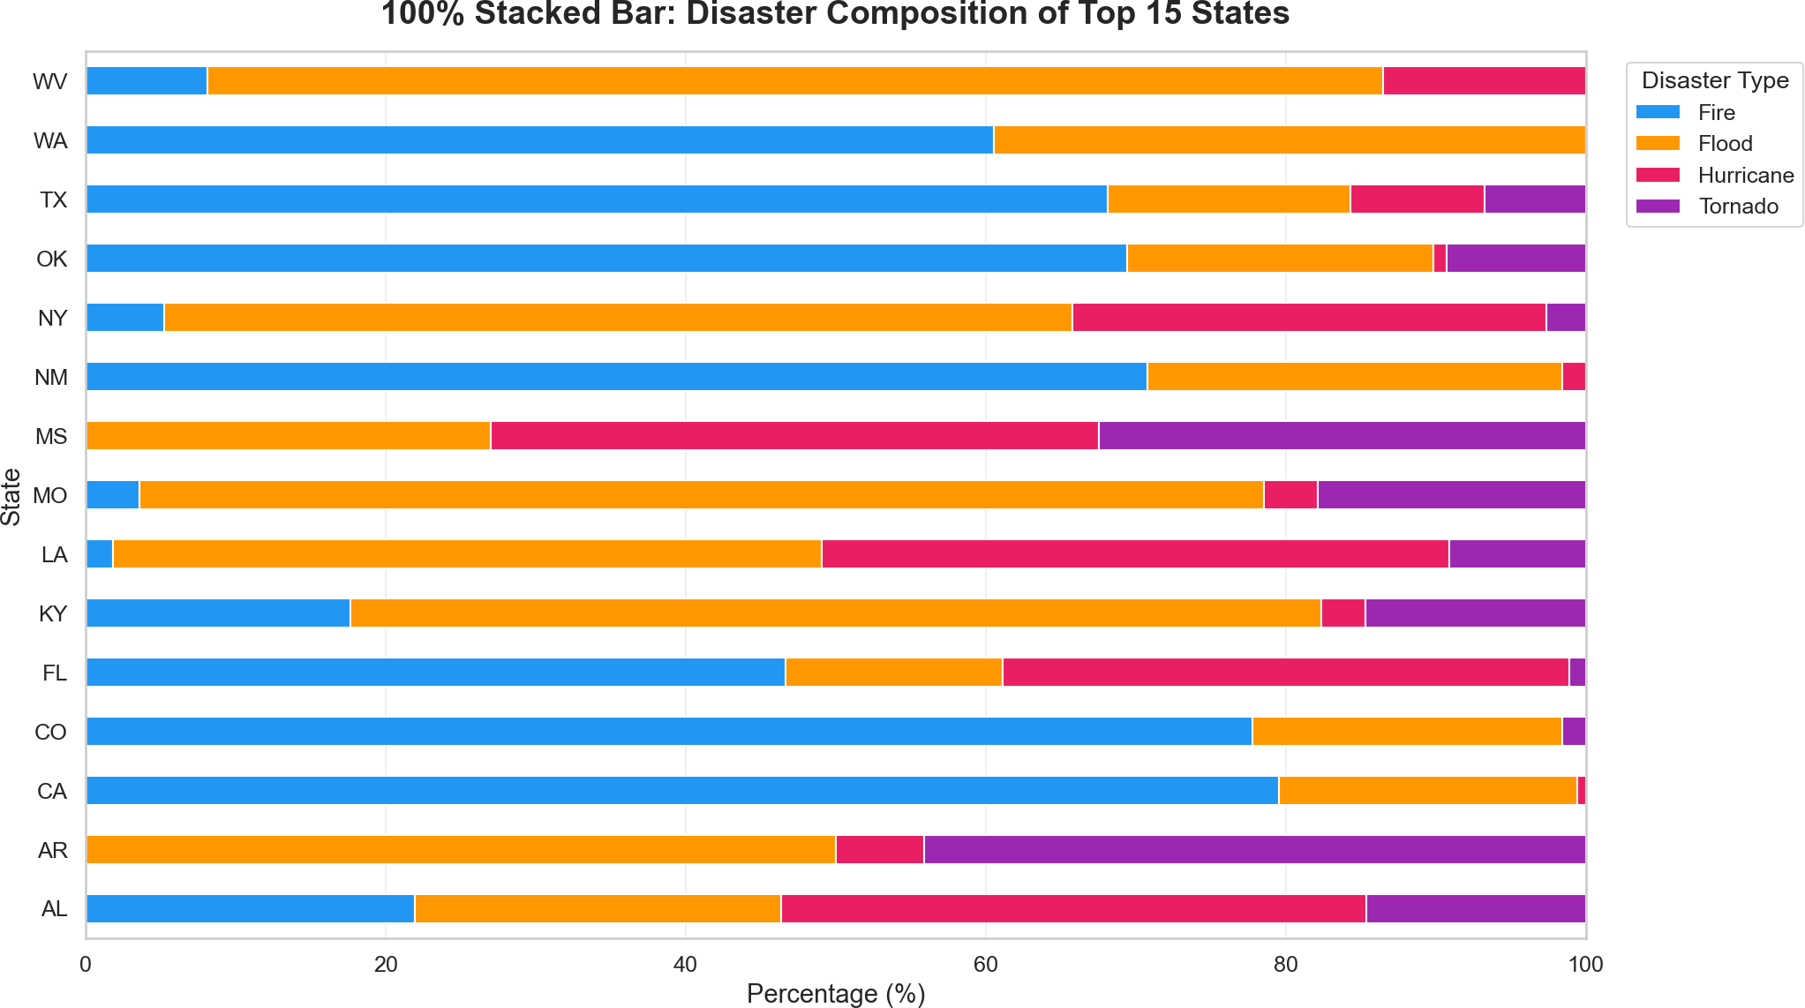

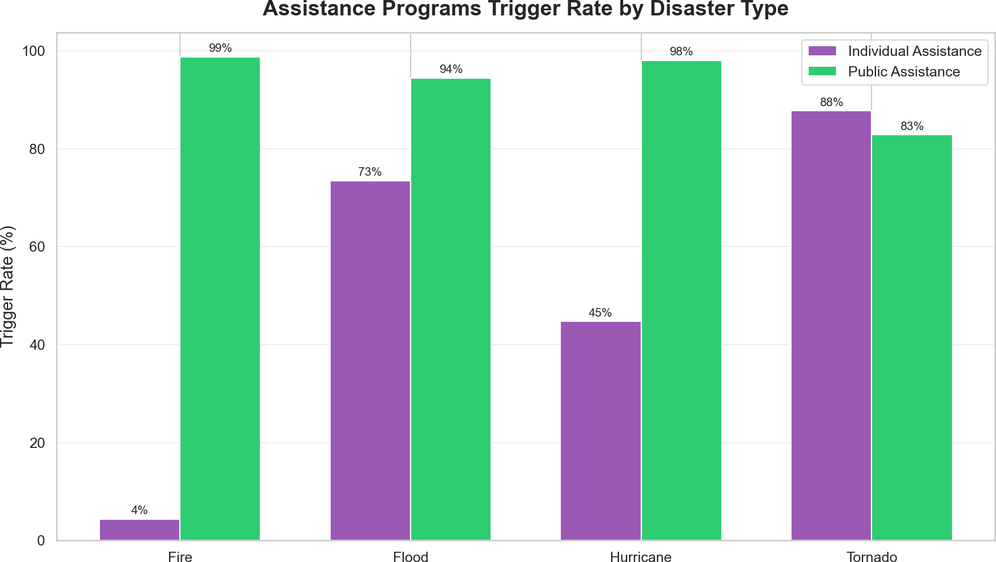
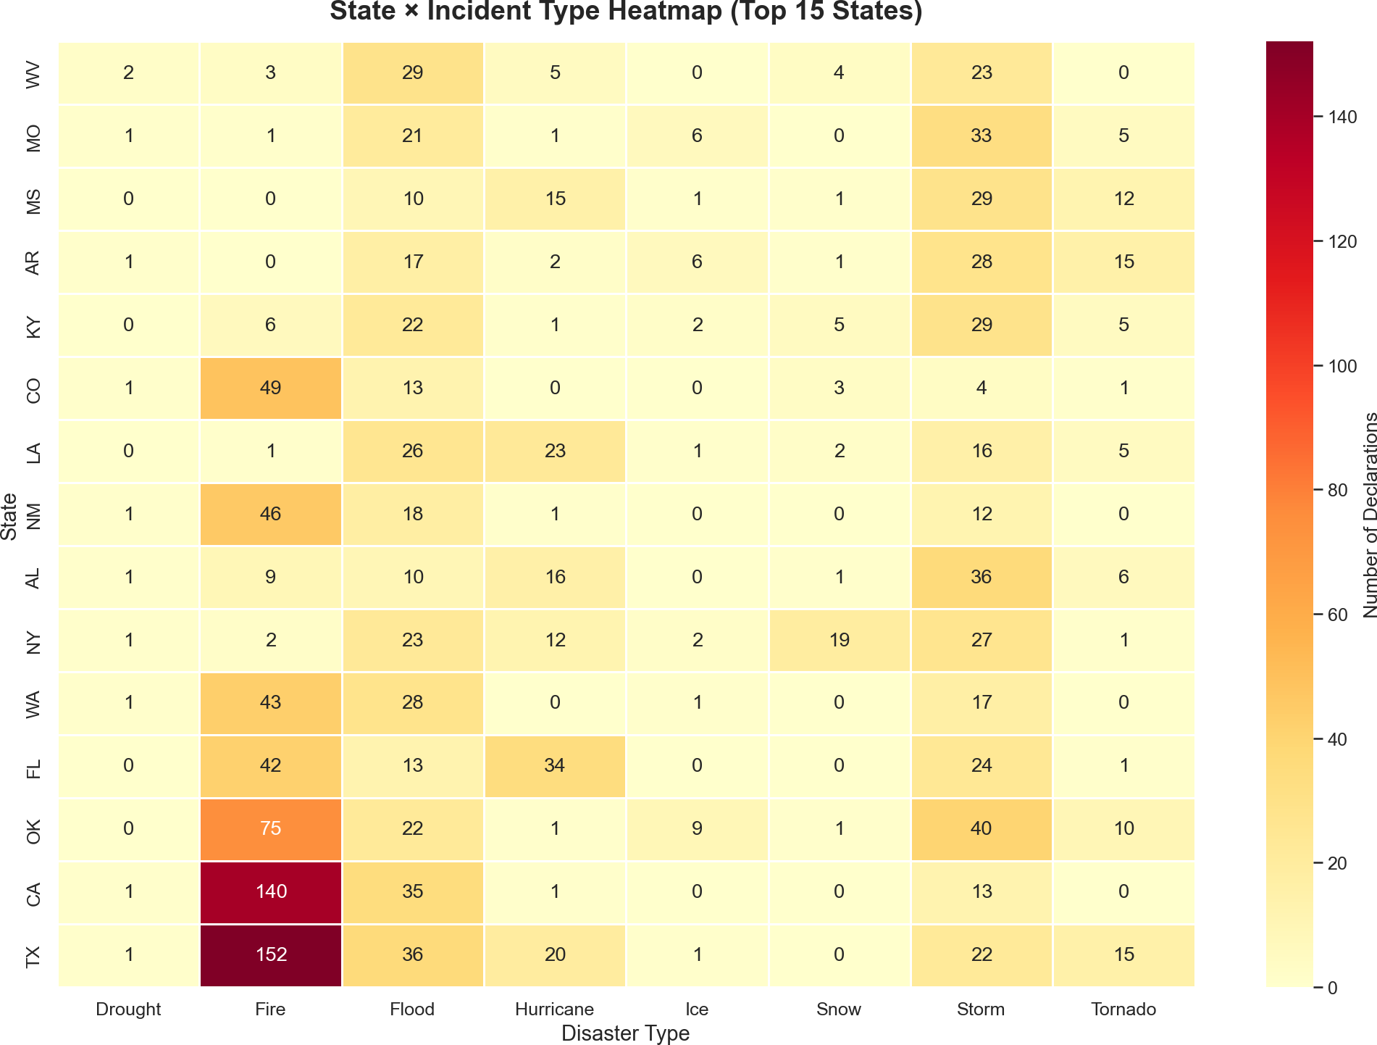

# Plot File Description

# Plot File Description

Interactive Plotly treemap

- Disaster Type Treemap plots/13_disaster_treemap.html

- 100% Stacked Bar plots/14_state_100pct_stacked.png
(State Composition)

- Assistance Programs plots/15_assistance_triggers.png
Trigger Rate

- State × Incident Type plots/16_state_incident_heatmap.png
Heatmap
of disaster types by frequency
Normalized composition of top 15 states by disaster
type
Grouped bar chart
comparing Individual vs. Public Assistance triggers
Annotated heatmap of top 15 states vs. top 8 disaster types

Conclusion
This project demonstrates a comprehensive data analysis workflow: from raw data ingestion and cleaning,
through multi-dimensional exploratory analysis (temporal, geographic, and categorical), to insight synthesis and professional visualization. The combination of Pandas for data wrangling, Seaborn/Matplotlib for static charts, and Plotly for interactive maps provides a powerful toolkit for deriving actionable insights from
complex real-world datasets.

Document prepared for Milestone 4 submission — USND Visualization Project.

