It is a programming methodology in which the programs are organized as collections of objects.Each object represents an instance of some class.The classes can be interrelated to each other through inheritance

**Table of Contents**

1. Class
2. Object
3. Variable
4. Method
5. Access Modifiers
6. Encapsulation
7. Abstraction
8. Inheritance
9. Polymorphism
10. Abstract Class/Method
11. Virtual Method
12. Sealed Class/Method
13. Static Class/Method
14. Interface

**Introduction**There are many explanations to be found in the internet about C# OOP, but here in my article I will provide a very simple example. In this article, I will use a “House" (like the houses we live in) as a realistic example for a better understanding of OOP in C#.  
  
**1. Class**  
A **Class** is a like a blueprint.  
  
What is a blueprint?  
  
A blueprint is an outline drawing of our actual plan. For example, if we plan to build our new home, the engineer will explain our new house plan with a blueprint as shown in the image below. Once we have finalized the plan the engineer will start building the house with the same plan.  
  
The same as for a blueprint class is an outline of a program. Using the class we can write our own method and declare the variables and using the objects we can access the class method and variables. The class will be complete with variables, methods and objects.  
  
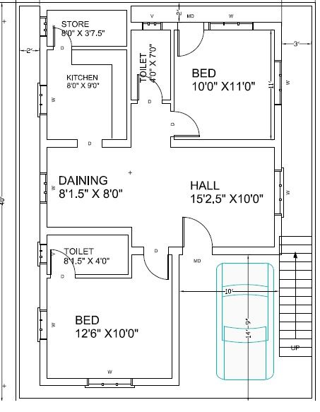  
  
For a better understanding of OOP using a realistic example here I have explained a class for a House. We can imagine a House as an example for a class. In a house, we will have rooms like a living room, bedroom, kitchen and items like TV, refrigerator and so on. The house owner can access and use all the rooms and room's items. The same as for a class with a group of methods and variables. Rooms and each room's items are examples of **methods** and **variables**. So we now have a complete house with all its rooms and room's items. The house owner can access and use all the rooms and room's items. To access and use a class, methods and variables here we use **Objects**. Objects are an instance of a class. We will see the details about objects in the next section.  
  
What will happen if there are no rooms and items in a house? It will be empty and no one can use the house until it has all the rooms and items. See the following image as an example for the empty house.  
  
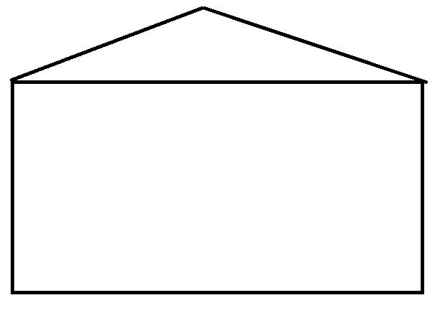  
  
Now this empty house is a class. So what is the use of a class without methods and variables?  
  
Now let's see an example for a complete house with rooms and items.  
  
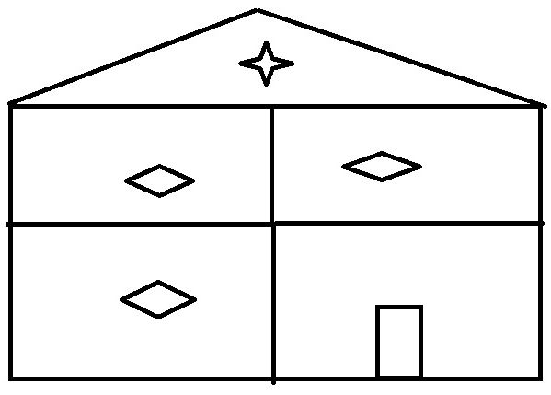  
  
So here, we have a complete house. Similarly, the class will be complete with a group of variables, methods and objects. We can see the details of all this in the next sections of this article.  
  
Classes and objects are the fundamental concept of Object Oriented Programming (OOP).  
  
Here is an example of a class. The class should be started with the keyword "class" and next we provide the name for our class. We can provide any meaningfull name for the class name. Next we will have the open and close brackets.

1. **class** ShanuHouseClass1
2. {
3. }

**2. Object**  
As we have already seen, the house owner can access and use all the rooms of the house and its items. Similarly, to access all the class's method and variables we use objects. We can create one or more objects for the same class. Foe example we can say for a house there might be one or many owners.  
  
Here is an example of an object. Here “objHouseOwner” is the object of a class that will be used to access all the variables and methods of a class.

1. ShanuHouseClass1 objHouseOwner = **new** ShanuHouseClass1();

**3.Variable**  
Variables are used to store our values. Our value can be numeric or text. For example to store a phone number we can use an “int” type variable and to store our name we can use a string type variable with a name for each variable.  
  
Variables can be local or global. For example, we can say if we buy a new TV, TV cable guy will come and set up the TV in our home. He will provide his contact number for future contacts. Usually what we do is take a memo paper and write his contact number and keep it in a common place or in a wallet of ours. If we keep the memo in a common place then everyone visiting our house can see that contact number. Global or public variables are similar to this. If we declare the variable as global then all the methods inside the class can access the variable. If we store the memo only in our wallet then we can see the contact number. Local private variables are similar to this.  
  
**Syntax for variable:**

*Access-Modifiers Data-Type Variable-Name*

By default the access modifiers are private, we can also use public for a variable.  
  
Example of variable:

1. **int** noOfTV = 0;
2. **public** String yourTVName;
3. **private** Boolean doYouHaveTV = **true**;
5. / Example Program
7. **class** ShanuHouseClass
8. {
9. **int** noOfTV = 2;
10. **public** String yourTVName = "SAMSUNG";
12. **static** **void** Main(**string**[] args)
13. {
14. ShanuHouseClass objHouseOwner = **new** ShanuHouseClass();

17. Console.WriteLine("You Have total " + objHouseOwner.noOfTV + " no of TV :");
18. Console.WriteLine("Your TV Name is :" + objHouseOwner.yourTVName);
20. }
21. }

In the preceding example program I have declared two variables inside a class. In the main method I created an object of a class. Here we can see the use of the object. We can access the variable of a class and display the output.  
  
The Main method is the default method of C#, where every console and Windows application will start the program execution. In the Main method, we can declare the object for the class and use the object and we can access all the variables and methods of a class. For example, we can say there will be an entrance gate for every house. Using the entrance gate we can enter inside our house. Similarly, to run our program there should be some default program execution starting method. The Main method will be useful in this program execution starting point. Whenever we run our C# Console or windows application, the Main method will first be executed. From the main method we can create an object for our other classes and call their methods.  
  
**4. Method or Functions**  
A method is a group of code statements. Now here we can see the preceding example program with a method.

1. **class** ShanuHouseClass
2. {
3. **int** noOfTV = 2;
4. **public** String yourTVName = "SAMSUNG";
6. **public** **void** myFirstMethod()
7. {
8. Console.WriteLine("You Have total " + noOfTV + "no of TV :");
9. Console.WriteLine("Your TV Name is :" + yourTVName);
10. Console.ReadLine();
11. }
13. **static** **void** Main(**string**[] args)
14. {
15. ShanuHouseClass objHouseOwner = **new** ShanuHouseClass();
16. objHouseOwner.myFirstMethod();
17. }
18. }

**Note:** Most developers were wondering about what the difference is between methods and functions. Both methods and functions are the same. Here in my article, I will use methods instead of functions. However, there is one difference in methods and functions. In OOP languages like C#, Java and so on we use the term method while for non-OOP programming like “C” and so on we use the term function.  
 **The use of methods**  
  
Another realistic example. Let's take our mobile phone, we can say that we have a mobile phone and store many songs in it. However, we always like to listen to the selected songs. It will be boring and hard for us to select our favorite song every time and play it. Instead of doing the same work repeatedly, we use the playlist. In the playlist, we can add all our favorite songs. Just click on the playlist of our collections and listen to the music. This will make our work easier and we don't need to do the same thing repetitively. Methods are used like a playlist where we can write all our repeated code in one method and just call the method wherever we needed to.  
  
Here we can see more details about the method.  
  
In a house, there might be one big room or multiple rooms but each room will have different facilities. Similarly in a class we can write one or multiple methods. In a house, there might be two or three bedrooms. Here the room name is Bedroom, but each bedroom can be different by size, color and so on. This means the same rooms with a different type. Similarly, in a class we can create more than one method with the same name but different parameter. In OOP it's called “Polymorphism”. We can see the details about Polymorphism later on in this article.  
  
The following is the syntax for the functions:  
  
*Access-Modifiers Return-Type Method-Name (Parameter-List)*

* **Access-Modifiers:** We will see more details about this topic later on.
* **Return-Type:** If our method returns a value then we use the return type with any data type as string, int and so on. If our method does not return a value then we use the type “Void”.
* **Method-Name:** Here we give our name for every method that we create.
* **Parameter-List:** Parameter-List or Arguments that we pass to the function.  
    
  Here is an example of a method.
* **Method with Void Type:**Void is a keyword that will not return any data from the method, for example we can see the following method with void type. Here in this method we display all our output using “Console.WriteLine” and have used “Console.ReadLine());” to get the Input. This method has all input and output operations but this method doesn't return a value.
  1. // Function with void and no parameter -- here void means no return type
  2. **public** **void** veranda()
  3. {
  4. Console.WriteLine("Welcome to Veranda");
  5. Console.WriteLine("How Many Chairs Do you have in your Veranda");
  6. NoofChair = Convert.ToInt32(Console.ReadLine());
  7. Console.WriteLine("I have total " + NoofChair + " Chairs in my Veranda");
  8. }
* **Method with Return Type:** The method's with return type will return in some result that can be used in our program. For example, here we have a method TVNAME with return type “String”. We can say in our home we might have a TV in our LivingROOM and in the parent's bedroom and also in a child's bedroom. We might have a different TV brand in each room. Suppose we want to know the TV brand name in each room, then we need to enter the same code 3 times. Instead of writing the same code again, we can use a method with return type.
  1. // Function with Return type as String
  2. **public** **string** TVNAME()
  3. {
  4. Console.WriteLine("Enter Your TV Brand NAME");
  5. YOURTVName = Console.ReadLine();
  6. **return** YOURTVName;
  7. }
* **Method with Parameter-List:** So far, we have seen methods without arguments. Arguments are used to pass some data to the method to do our process in a better way. For example, we can say we want to do a painting, to our bedrooms. We need to get the opinions of all the members of the house to understand their choices of color for each bedroom. We can pass the member name and their favorite color as parameter to a method.
  1. //Function with parameter
  2. **public** **void** BedRoom(String nameandColor)
  3. {
  4. Console.WriteLine(nameandColor);
  5. }

The same method name with different arguments are called method overloading, here we can see an example of that below. Both methods have the same name but it has different arguments.

* 1. // Same Function Name with Different Paramenter
  2. **public** **void** BedRoom(String MemberName,String Color)
  3. {
  4. Console.WriteLine(MemberName + " Like " + Color + "Color");
  5. }

The complete class with Main method example:

* 1. **class** ShanuHouseClass1
  2. {
  3. **int** NoofChair = 0;
  4. **public** String YOURTVName;
  5. **private** Boolean DoyouHaveTV = **true**;


  9. // Function with void and no parameter  -- here void means no return type
  10. **public** **void** veranda()
  11. {
  12. Console.WriteLine("Welcome to Veranda");
  13. Console.WriteLine("How Many Chairs Do you have in your Veranda");
  14. NoofChair = Convert.ToInt32(Console.ReadLine());
  15. Console.WriteLine("I have total " + NoofChair + " Chairs in my Veranda");
  16. }

  19. // Function with Return type as String
  20. **public** **string** TVNAME()
  21. {
  22. Console.WriteLine("Enter Your TV Brand NAME");
  23. YOURTVName = Console.ReadLine();
  24. **return** YOURTVName;
  25. }
  27. //Function with parameter
  28. **public** **void** BedRoom(String nameandColor)
  29. {
  30. Console.WriteLine(nameandColor);
  31. }
  33. // Same Function Name with Different Paramenter
  34. **public** **void** BedRoom(String MemberName,String Color)
  35. {
  36. Console.WriteLine(MemberName + " Like " + Color + "Color");
  37. }

  40. **static** **void** Main(**string**[] args)
  41. {
  42. ShanuHouseClass1 objHouseOwner = **new** ShanuHouseClass1();

  45. objHouseOwner.veranda();
  46. String returnvalue = objHouseOwner.TVNAME();
  47. Console.WriteLine("Your TV BRAND NAME IS: "+returnvalue);
  48. objHouseOwner.BedRoom("My Name is Shanu I like Lavender color");
  49. objHouseOwner.BedRoom("My Name is Afraz I like Light Blue color");
  50. objHouseOwner.BedRoom("SHANU", "Lavender");
  51. Console.ReadLine();

  54. }
  55. }

The output of the preceding class is here:  
  
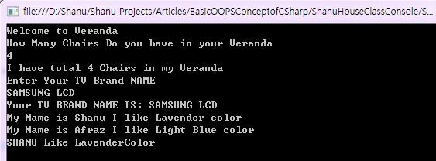

**5. Access Modifiers**  
Access Modifiers are nothing but the usage and limitation of our type like variables, methods and class. For example we can say it as a security limit.

* private
* public
* internal
* protected
* protected internal

This six are the basic access modifiers we used in our C# class and method and in variables.  
  
**Private**  
Let's take our House example. We will have a security guard in the House, his duty is to guard the entrance to the house. He cannot go inside the house and access all the things. In this case we can create a SecurityGuardClass and declare the variable and method for Security as private.  
  
**Public**  
House owners are public to the class where they can access all the classes related to the House. They have no restrictions to access their house.  
  
**Protected**  
  
Only the main class and derived classes can have access to protected variables and methods. For example servants and guests are example of protected. For example Servants can go to every room and do cleaning and other activates. However, they have limited access to the house, since they cannot take rest in a bed of the house owner.  
  
**Internal**  
  
An access limit of a variable or method is within a project. For example let's consider that in our project we have more than one class and we have declared a variable as internal in one class. Let's see an example program for an internal variable.

1. **public** **class** sampleInternalClass
2. {
3. **internal** String myInternal = "Iam Internal Variable";
4. }
5. **class** ShanuHouseClass
6. {
7. **int** noOfTV = 2;
8. **public** String yourTVName = "SAMSUNG";
10. **public** **void** myFirstMethod()
11. {
12. Console.WriteLine("You Have total " + noOfTV + "no of TV :");
13. Console.WriteLine("Your TV Name is :" + yourTVName);
15. }
17. **static** **void** Main(**string**[] args)
18. {
19. ShanuHouseClass objHouseOwner = **new** ShanuHouseClass();
20. objHouseOwner.myFirstMethod();
21. sampleInternalClass intObj = **new** sampleInternalClass();
23. Console.WriteLine("Internal Variable Example :" + intObj.myInternal);
24. Console.ReadLine();
26. }
27. }

**Protected Internal**A Protected Internal variable or method has a limitation within a project of a class or a derived class. Here is a sample program for a Protected Internal Variable. In this example I used inheritance. We will see in detail about Inheritance; there are more details in this article.

1. **public** **class** sampleProtectedInternalClass
2. {
3. **protected** **internal** String myprotectedInternal = "Iam Protected Internal Variable";
5. **public** **void** protectedInternalMethod()
6. {
7. Console.WriteLine("Protected Internal Variable Example :" + myprotectedInternal);
8. }
9. }
10. **public** **class** derivedClass : sampleProtectedInternalClass
11. {
12. **public** **void** derivedprotectedInternal()
13. {
14. Console.WriteLine("Derived Protected Internal Variable Example :" + myprotectedInternal);
15. }
16. }
17. **class** ShanuHouseClass
18. {
19. **int** noOfTV = 2;
20. **public** String yourTVName = "SAMSUNG";
22. **public** **void** myFirstMethod()
23. {
24. Console.WriteLine("You Have total " + noOfTV + "no of TV :");
25. Console.WriteLine("Your TV Name is :" + yourTVName);
27. }
29. **static** **void** Main(**string**[] args)
30. {
31. ShanuHouseClass objHouseOwner = **new** ShanuHouseClass();
32. objHouseOwner.myFirstMethod();
33. sampleProtectedInternalClass intObj = **new** sampleProtectedInternalClass();
35. intObj.protectedInternalMethod();
37. derivedClass proIntObj = **new** derivedClass();
38. proIntObj.derivedprotectedInternal();
39. Console.ReadLine();
41. }
42. }

**Note:**The main and major things we need to understand about OOP are Encapsulation, Abstraction, Polymorphism and Inheritance. We will explain them in detail in this article.  
  
**6. Encapsulation**  
Encapsulation hides the members or variables from outside the class. In our house example, I have already said that a House security guard limitation is at the entrance of the house. The security guard doesn't need to be aware of what is happening inside the house. Therefore, the House Owner will hide everything that happens inside from the security guard for greater safety. The hiding and limitation are called Encapsulation.  
  
For example, we have two classes, the first one is “Houseclass” and the other class “houseSecurityClass”.  
  
Here we can see all the variables are wrapped into a class where “houseSecurityClass” is set to public, so the “Houseclass” can access that, but “houseClass” has both a public and private variable where the private variable of the class cannot be accessed outside of the class.

1. **public** **class** houseSecurityClass
2. {
3. **public** **int** noofSecurity;
4. **public** String SecurityName = String.Empty;
5. }
7. **public** **class** Houseclass
8. {
9. **private** **int** noofLockerinHosue = 2;
10. **public** **string** OwnerName = String.Empty;
11. }

**7. Abstraction**  
Abstraction shows to and shares some common information with the user. Let's take our House example. In our house we will have a servant. Servants can go to all rooms and do cleaning and other work. The house owner can give full rights or some partial rights to the servant for accessing his house. Here we can see an example program as private declared variables and the methods are not shared with the servant but the public variable and methods are shared with the servant.

1. **public** **class** HouseServerntClass
2. {
4. **private** **int** SaftyLoackerKeyNo = 10001;
5. **public** String roomCleanInstructions = "Clean All rooms";
7. **private** **void** saftyNos()
8. {
9. Console.WriteLine("My SaftyLoackerKeyNo is" + SaftyLoackerKeyNo);
10. }
12. **public** **void** roomCleanInstruction()
13. {
14. Console.WriteLine(roomCleanInstructions);
15. }
17. }

**8. Inheritance**  
Inheritance is used to reuse the code. In the Protected Internal Access modifier section we have already seen an example program for Inheritance. Inheritance is nothing but accessing and using all base class variables and methods in the derived class. Inheritance can be any of the following.  
  
**Single level Inheritance:** With one base class and one derived class for example.

1. **public** **class** baseClass
2. {
3. **private** **void** privateMethod()
4. {
5. Console.WriteLine("private Method");
6. }
8. **public** **void** publicMethod()
9. {
10. Console.WriteLine("This Method Shared");
11. }
12. }
13. **public** **class** DerivedClass : baseClass
14. {
15. **static** **void** Main(**string**[] args)
16. {
17. DerivedClass obj = **new** DerivedClass();
18. obj.publicMethod();
19. //obj.privateMethod(); //This will be error as private method can not be accessed in Derived Class
20. }
22. }

**Note:** Sometimes users might be unclear about what a base class is and what a derived class is. A base class is the super-class and a derived class is the class(es) that inherit the base class.  
  
Here we can see a simple inheritance where the base class is the “GuestVist” and the derived class is “**HouseOwnerClass**”. Here the “HouseOwnerClass” class inherits the base class of “**GuestVist**”.  
  
Here the HouseOwnerClass class inherits the base class GuestVist:

1. HouseOwnerClass.Here HouseOwnerClass **class** inherits the **base** **class** of GuestVist
2. **class** GuestVist
3. {
4. **public** **void** Guestwelcomemessage()
5. {
6. Console.WriteLine("Welcome to our Home");
7. }
8. **public** **void** GuestName()
9. {
10. Console.WriteLine("Guest name is: Shanu");
11. }
13. }
14. **class** HouseOwnerClass : GuestVist
15. {
16. **static** **void** Main(**string**[] args)
17. {
18. HouseOwnerClass obj = **new** HouseOwnerClass();
19. obj.Guestwelcomemessage();
20. obj.GuestName();
21. Console.ReadLine();
22. }
23. }

**Multi level Inheritance:** With more than one Derived Class for example. Here we can see an example. The first base class is derived in DerivedClass1 and then the DerivedClass1 is derived in DerivedClass2. Now from DerivedClass2 we can access both **BaseClass's** and DerivedClass1's variabled and methods.

1. **public** **class** baseClass
2. {
3. **private** **void** privateMethod()
4. {
5. Console.WriteLine("private Method");
6. }
8. **public** **void** publicMethod()
9. {
10. Console.WriteLine("This Method Shared");
11. }
12. }
13. **public** **class** DerivedClass1 : baseClass
14. {
15. **public** **void** DerivedClass1()
16. {
17. Console.WriteLine("Derived Class 1");
18. }
19. }
20. **public** **class** DerivedClass2 : DerivedClass1
21. {
22. **static** **void** Main(**string**[] args)
23. {
24. DerivedClass2 obj = **new** DerivedClass2();
25. obj.publicMethod();
26. obj.DerivedClass1();
27. //obj.privateMethod(); //This will be error as private method can not be accessed in Derived Class
28. }
30. }

**Multiple Inheritance:**  
**Will .Net Support Multiple Inheritance?**  
  
The answer to this question is No. In C#, it's not possible to use Multiple Inheritance in a class.  
  
What is Multiple Inheritance? Multiple Inheritance is nothing but having more than one class and we can inherit both classes in our derived class.  
  
**What will happen if I write a Multiple Class Inheritance Using C#?**  
  
Let's take our example House. Here we have the derived class “HouseOwnerClass” with the two additional classes “GuestVist” and “FriendsandRelationsClass”.  
  
Now suppose for our house both Guest and Friend have visited. For this, we write the preceding three classes and inherit the two classes in our derived class.  
  
When I write the Multiple Inheritance in C #, it will display the warning message during our code and execute our program. The Warning message will be “Expected and interface”.  
  
See the following image that shows the warning error message while I write Multiple Inheritance.  
  
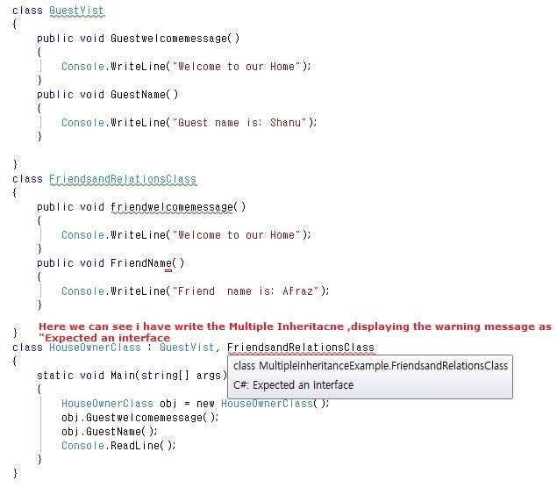  
  
**Then how can we use Multiple Inheritance?**  
**Interface** will be used for Multiple Inheritance.  
  
**9. Polymorphism**  
Poly means more than one form. In the beginning of the article in the Method Section, we have already seen an example of Polymorphism. The same method name with a different parameter is an example of polymorphism.  
  
**Method Overloading** and **Method Overriding**will be used in polymorphism. Polymorphism has the two types of execution, one is Compile Time Polymorphism and the other one is called Run time Polymorphism.

* **Method Overloading**  
  Method overloading is nothing but the same method name used for more than one method with different argument(s).  
    
  Here is an example program of Method Overloading. As we can see here, the method name “BedRoom” has been used for two methods but the parameter for both methods are different.
  1. **class** HouseOwnerClass
  2. {
  3. //Function with parameter
  4. **public** **void** BedRoom(String nameandColor)
  5. {
  6. Console.WriteLine(nameandColor);
  7. }
  9. // Same Function Name with Different Paramenter
  10. **public** **void** BedRoom(String MemberName, String Color)
  11. {
  12. Console.WriteLine(MemberName + " Like " + Color + "Color");
  13. }
  15. **static** **void** Main(**string**[] args)
  16. {
  17. HouseOwnerClass objHouseOwner = **new** HouseOwnerClass();
  19. objHouseOwner.BedRoom("My Name is Shanu I like Lavender color");
  20. objHouseOwner.BedRoom("My Name is Afraz I like Light Blue color");
  21. objHouseOwner.BedRoom("SHANU", "Lavender");
  22. Console.ReadLine();
  24. }
  25. }
* **Method Overriding**  
  The difference between Method Overloading and Overriding are that in Method Overloading we will have the same method name with a different argument.  
    
  In Method Overriding we will have the same Method Name and same argument and same type but method overriding can only be used in the derived class. Method Overriding cannot be done in the same class.  
    
  We will see how Method Overriding can be used in **Abstract Method**, **Virtual Method** and in a **Sealed Method**. Kindly refer to that section in this article.

**10. Abstract Class/Method**  
**Abstract Class: An**Abstract class will have the keyword “abstract”.

1. **abstract** **class** GuestVist
2. {
3. }

The Abstract class will be a super class for all our classes. An Abstract class cannot be accessed by an object. That means we cannot create an object for an abstract class.  
  
**What will happen when we create an object for an Abstract Class**  
Here we can see the error warning message “An instance of an abstract class cannot be created” when I try to create an object for my abstract class.  
  
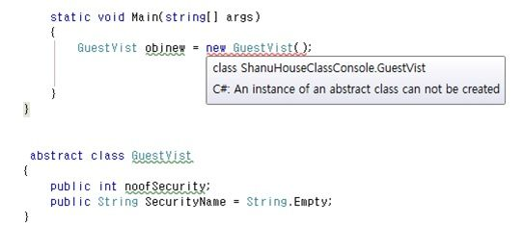  
  
An Abstract class can have both an Abstract Method and a normal method. In an Abstract Class at least one Abstract Method should be declared. In addition, the derived class should override the abstract method. To access the abstract method we should use the “override” keyword in our derived class.  
 **What will happen if we create an abstract method not overriden in the derived class?**  
  
Here we can see an abstract class with an abstract method, but the abstract method is not overriden in the derived class. See the following image for the warning message displaying as class must implement the abstract member.  
  
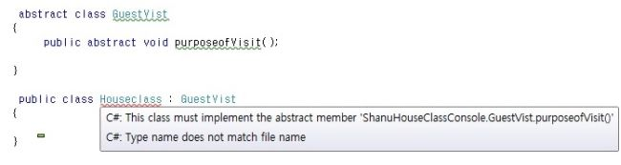  
  
Here we can see an example of an Abstract class and an Abstract method in detail.  
  
In this example, we can see an Abstract class that has a normal method and Abstract method. Abstract methods do not have a body part in the Abstract class that means we can only declare an Abstract method in an Abstract class. There should be a minimum of one Abstract Method in an Abstract Class.

1. **abstract** **class** GuestVist
2. {
3. **public** **void** Guestwelcomemessage()
4. {
5. Console.WriteLine("Welcome to our AbstractHome");
6. }
7. **public** **void** GuestName()
8. {
9. Console.WriteLine("Guest name is: Abstract");
10. }
11. **public** **abstract** **void** purposeofVisit();
13. }
14. // derived class to inherit the abstract class
15. **public** **class** Houseclass : GuestVist
16. {
17. **static** **void** Main(**string**[] args)
18. {
19. Houseclass objHouse = **new** Houseclass();
20. objHouse.Guestwelcomemessage();
21. }
23. **public** **override** **void** purposeofVisit()
24. {
25. Console.WriteLine("Abstract just came for a Meetup and spend some time ");
26. }
27. }

**11. Virtual Class/Method**  
A Virtual method is very useful in our day-to-day programming.  
  
**What a Virtual method is and what the use of a Virtual method is**  
Take our House example. A guest confirms, since today a total of five people will visit your home. For this, we write a function to display a message since there are five guests visiting our home. Once a guest visits, we see there are a total of 20 persons that have visited. In some cases it might increase or decrease; we will know when they reach us.  
  
In that case, the guest will be a separate class and House will be a separate class. Without changing the message in the Guest class, how can we change the data in our Derived class?  
  
**The difference between an Abstract method and a Virtual method**  
Both similarities use the override keyword. An Abstract Method can only be declared in an Abstract Class. That means no body part for an abstract method in an Abstract class. However, for virtual it can have a body part.  
  
See the example program below. Here we have both an Abstract Method and a Virtual Method. In the Abstract class, the virtual method says total five guests but in the derived Class program, the message was overriden as 20 guests. See the final output in the following. Guess what will be displayed for the Virtual method? Will the result be 5 Guests or 20 Guests? Check the output below the program.

1. **abstract** **class** GuestVist
2. {
3. **public** **abstract** **void** purposeofVisit();  // Abstract Method
5. **public** **virtual** **void** NoofGuestwillvisit()  // Virtual Method
6. {
7. Console.WriteLine("Total 5 Guest will Visit your Home");
8. }
9. }
10. **class** AbstractHouseClass : GuestVist
11. {
12. **public** **override** **void** purposeofVisit()  // Abstract method Override
13. {
14. Console.WriteLine("Abstract just for a Meetup and spend some time ");
15. }
17. **public** **override** **void** NoofGuestwillvisit() // Virtual method override
18. {
19. Console.WriteLine("Total 20 Guest Visited our Home");
20. }
22. **static** **void** Main(**string**[] args)
23. {
24. AbstractHouseClass objHouse = **new** AbstractHouseClass();
26. objHouse.purposeofVisit();
27. objHouse.NoofGuestwillvisit();
28. Console.ReadLine();
29. }
31. }

**The Complete Program**

1. **abstract** **class** GuestVist
2. {
3. **public** **void** Guestwelcomemessage()
4. {
5. Console.WriteLine("Welcome to our AbstractHome");
6. }
7. **public** **void** GuestName()
8. {
9. Console.WriteLine("Guest name is: Abstract");
10. }
11. **public** **abstract** **void** purposeofVisit();  // Abstract Method
12. **public** **virtual** **void** NoofGuestwillvisit()  // Virtual Method
14. {
15. Console.WriteLine("Total 5 Guest will Visit your Home");
16. }
17. }
18. **class** AbstractHouseClass : GuestVist
19. {
20. **public** **override** **void** purposeofVisit()  // Abstract method Override
21. {
22. Console.WriteLine("Abstract just for a Meetup and spend some time ");
23. }
25. **public** **override** **void** NoofGuestwillvisit() // Virtual method override
26. {
27. Console.WriteLine("Total 20 Guest Visited our Home");
28. }
30. **static** **void** Main(**string**[] args)
31. {
32. AbstractHouseClass objHouse = **new** AbstractHouseClass();
33. objHouse.Guestwelcomemessage();
34. objHouse.purposeofVisit();
35. objHouse.NoofGuestwillvisit();
36. Console.ReadLine();
37. }
38. }

**Output  
  
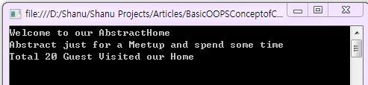**  
  
**12. Sealed Class/Method**  
**Sealed Class:** As the name indicates, this class cannot be inherited by other classes.  
  
Take our House example. In a house, the house owner can have a secret room, perhaps an official or a financial room. The owner doesn't want others to access his official room. The sealed class will be useful in those cases.  
  
A Sealed class can be declared using the keyword Sealed. If one class is declared Sealed, it cannot be inherited in other derived classes.  
  
**What will happen when we inherit a sealed class in our derived class**  
Let's see an example of attempting to inherit my sealed class from my derived class. It shows me the following warning message.  
  
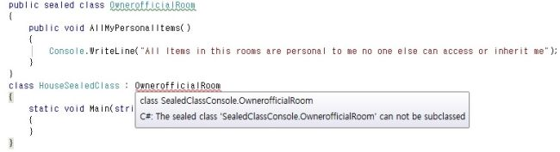  
  
Here we can see an example program of the Sealed Class.

1. **public** **sealed** **class** OwnerofficialRoom
2. {
3. **public** **void** AllMyPersonalItems()
4. {
5. Console.WriteLine("All Items in this rooms are personal to me no one else can access or inherit me");
6. }
7. }
8. **class** HouseSealedClass
9. {
10. **static** **void** Main(**string**[] args)
11. {
12. OwnerofficialRoom obj = **new** OwnerofficialRoom();
13. obj.AllMyPersonalItems();
14. Console.ReadLine();
15. }
16. }

**Sealed Method:**If we declared a method as sealed then that specific method cannot be overriden in the derived class.  
  
Let's see our house class here I have base class with Virtual Method and virtual Sealed methods.  
  
The Virtual method can be overriden in the derived class. But the Virtual Sealed Method cannot be overriden in the sealed class.

1. //Base Class with Sealed Method
2. **public** **class** OwnerOfficialroomwithrestriction
3. {
4. **public** **virtual** **void** message()
5. {
6. Console.WriteLine("Every one belongs to this house can access my items in my room except my sealed Item");
8. }
10. **public** **virtual** **sealed** **void** myAccountsLoocker()
11. {
12. Console.WriteLine("This Loocker can not be inherited by other classes");
13. }
14. }
15. //Deraived method which inherits Selaed Method class
16. **class** HouseSealedClass : OwnerOfficialroomwithrestriction
17. {
18. **public** **override** **void** message()
19. {
20. Console.WriteLine("overrided in the derived class");
21. }
23. **public** **override** **void** myAccountsLoocker()
24. {
25. Console.WriteLine("The sealed method Overrides");
26. }
27. }

**13. Static Class/Method**  
We have already learned about what a Sealed Class is in this article. Now let's see what a Static class and Static method are.  
Both Static and Sealed Class cannot be inherited.  
  
**The Difference between a Static Class and a Sealed Class**  
We can create an object (instance) of the Sealed Class. We can see in my sealed class section I have created a sample Sealed class and in the Main Method I created an object to access the sealed Class. And in a Sealed Class both Static and non-Static methods can be written.  
  
But for a Static Class it's not possible to create an Object. In a Static Class only Static members are allowed. That means in a static class it's not possible to write non-static methods.  
  
We can say our Main method is an example of a Static method. When we create a console application in C# we can see each class has a default Main method. In my article I have explained that when a Console or Windows application begins execution, first the Main method will be executed. There is no need to create an object of the Main method since it was been declared as a static method.

1. **static** **void** Main(**string**[] args)
2. {
3. }

Something interesting about a Static class is that memory will be allocated for all static variables and methods during execution but for non-static variables and methods memory will be allocated only when the object for the class is created.  
  
Let's take our same sealed class example for our static class and method.  
  
**What happens when we inherit a Static class in a derived class**  
Let's see an example when I try to inherit my static class from my derived class. It shows me the following warning message.  
  
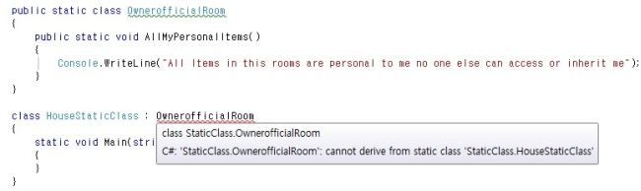  
  
**What will happen when we declare a non-Static method in a Static class**  
Let's see an example of attemting to create a non-Static method at my Static Class.  
  
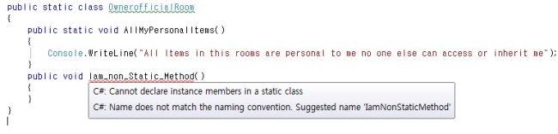  
  
**What will happen when we create an object for the Static class**  
Let's see an example of attemting to create an object for my Static Class.  
  
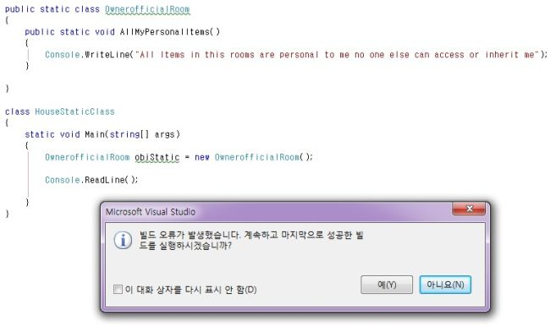  
  
When we run the program we get the error message as “Cannot create an instance of a static class”. Sorry, I'm using the Korean Version of Visual Studio so the error message is in the Korean language.  
  
**How to call the Static Class Method and variable without creating the Object**  
It's simple. We can just use the “ClassName.Variable or Method Name” for example “OwnerofficialRoom.AllMyPersonalItems();”  
See the following example with a Static class:

1. **public** **static** **class** OwnerofficialRoom
2. {
3. **public** **static** **void** AllMyPersonalItems()
4. {
5. Console.WriteLine("All Items in this rooms are personal to me no one else can access or inherit me");
6. }
8. }
10. **class** HouseStaticClass
11. {
12. **static** **void** Main(**string**[] args)
13. {
14. OwnerofficialRoom.AllMyPersonalItems();
15. Console.ReadLine();
17. }
18. }

The output for the preceding program is as in the following:  
  
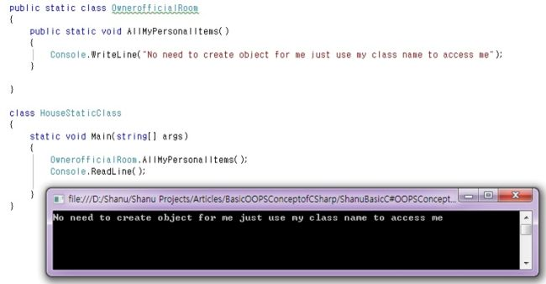  
 **It is possible to create a Static Method in a non-Static Class**  
Yes, we can create a Static Method to the non Static class. No need to create an object to access the static method(s) in a non-static class. We can directly use the class name to access the Static method.  
  
See the following example with Static method in a non-static Class.

1. **public**  **class** OwnerofficialRoom
2. {
3. **public** **static** **void** AllMyPersonalItems()
4. {
5. Console.WriteLine("No need to create object for me just use my class name to access me :)");
6. }
8. **public** **void** non_staticMethod()
9. {
10. Console.WriteLine("You need to create an Object to Access Me :(");
11. }

14. }
16. **class** StaticmethodClass
17. {
18. **static** **void** Main(**string**[] args)
19. {
20. // for statci method no need to create object just call directly using the classname.
21. OwnerofficialRoom.AllMyPersonalItems();
23. // for non-static method need to create object to access the method.
24. OwnerofficialRoom obj = **new** OwnerofficialRoom();
25. obj.non_staticMethod();
26. Console.ReadLine();
28. }
29. }

The output of the preceding program is the following:  
  
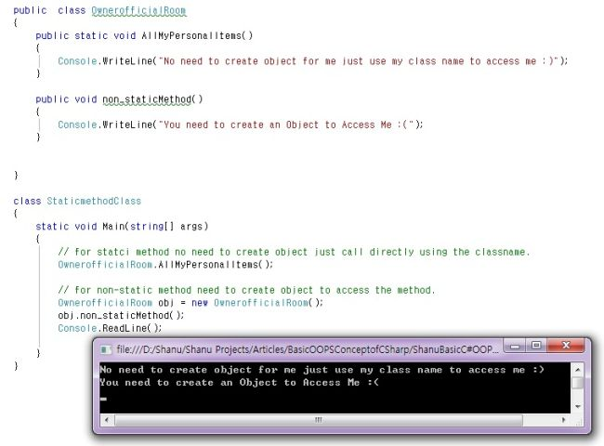  
  
**14. Interface**  
An interface is same like an abstract class but in an interface we only have a method declaration. In an abstract class however we can have both, a method declaration and a method definition. Methods of an interface must be implemented in an implementing class.  
  
See the following example program for a interface. All the methods of the interface have been implemented in the class. As I have already said, C# doesn't support multiple inheritance. To get multiple inheritance we can use an interface. This following program is an example for multiple inheritance using interface.

1. **interface** GuestInterface
2. {
3. **void** GuestWelcomeMessage();
4. **void** NoofGuestes();
5. }
6. **interface** FriendsandRelationsInterface
7. {
8. **void** friendwelcomemessage();
9. **void** FriendName();
10. }
12. **class** HouseOwnerClass : GuestInterface, FriendsandRelationsInterface
13. {
14. **public** **void** GuestWelcomeMessage()
15. {
16. Console.WriteLine("All guests are well come to our home");
17. }
19. **public** **void** NoofGuestes()
20. {
21. Console.WriteLine("Total 15 Guestes has visited");
22. }
24. **public** **void** friendwelcomemessage()
25. {
26. Console.WriteLine("Welcome to our Home");
27. }
28. **public** **void** FriendName()
29. {
30. Console.WriteLine("Friend  name is: Afraz");
31. }
32. **static** **void** Main(**string**[] args)
33. {
34. HouseOwnerClass obj = **new** HouseOwnerClass();
35. obj.GuestWelcomeMessage();
36. obj.NoofGuestes();
37. obj.friendwelcomemessage();
38. obj.FriendName();
39. Console.ReadLine();
40. }
41. }

The output will be like this.  
  
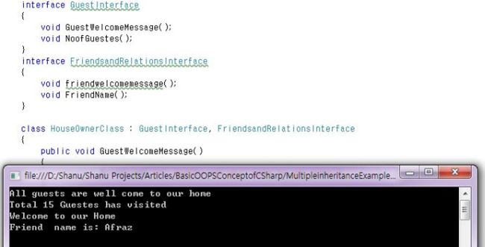  
  
In some cases we need to have certain methods that will be used in many derived classes. Each derived can implement different functionality for those Methods. In These cases, we can use the Interface.  
  
We can use our Guest and House example. For the Guest the “Welcome Message” and “No of Guest” Functions are common, but it will be different for different owners in the same house. A Guest might a fathers guest, a Mothers Guest, a Children's Guest or a Family Guest. Each guest can have a different welcome message subject, but the functions are the same as a message. Let's consider now that Father is a class, Mother is a class and Children are one class. Both the guestWelcome Message and Noofguest method are the same for all. In this case, we can create an interface and declare both methods in the interface. All father, mother and children, classes can inherit the interface and write their own method details.  
  
An interface is similar to an Abstract class but the major difference between the Abstract Class and the Interface are that in an Abstract class there can be both an Abstract method and Non-Abstract methods. But in an interface all methods are abstract by default. That means there is not a non-Abstract type method in the interface. All the Methods declared in the interface should be overriden in the derived class.  
  
**What will happen when non-abstract methods with body parts are declared in an Interface**  
It will display the warning message as “**unexpected modifier**” in the Access modifier part and the “**Unexpected Method body**” error warning in the message body. See the following image for the details.  
  
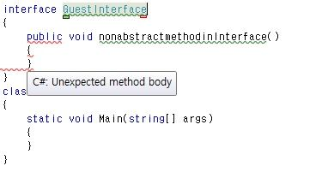  
  
Example program for interface:

1. **interface** GuestInterface
2. {
3. **void** GuestWelcomeMessage();
4. **void** NoofGuestes();
5. }
6. **class** HouseOwnerClass: GuestInterface
7. {
8. **public**  **void** GuestWelcomeMessage()
9. {
10. Console.WriteLine("All guests are well come to our home");
11. }
13. **public**  **void** NoofGuestes()
14. {
15. Console.WriteLine("Total 15 Guestes has visited");
16. }
18. **static** **void** Main(**string**[] args)
19. {
20. HouseOwnerClass obj = **new** HouseOwnerClass();
22. obj.GuestWelcomeMessage();
23. obj.NoofGuestes();
24. Console.ReadLine();
25. }
26. }