ZilaLens
Women’s Financial Inclusion and Empowerment Across Indian Districts, NFHS-4 (2015-16) to NFHS-5 (2019-21)
Kanishk Gupta
https://github.com/GKanishk16
DESCRIPTIVE FINDINGS | 18 OCTOBER 2026
  - Descriptive analysis • 18 October 2026
This report presents descriptive district comparisons from NFHS-4 and NFHS-5, with explicit screens for changed geography and incompatible indicators.

Contents
- Executive summary
- Background and research questions
- Data and methods
- District harmonisation and quality
- RQ1 Change in financial inclusion
- RQ2 Fast improvers and district typologies
- RQ3 Aspirational Districts comparison
- RQ4 Uttar Pradesh deep dive
- RQ5 Policy evidence
- Discussion and recommendations
- Limitations
- References
- Annexes

Executive summary
ZilaLens compares women’s financial inclusion and related empowerment indicators across Indian districts between NFHS-4 (2015-16) and NFHS-5 (2019-21). “Zila” means district in Hindi; the project views women’s financial inclusion through a district lens.
The NFHS-4 source contains 59,241 district-indicator rows, and the NFHS-5 workbook contains 75,649 rows. (Sources: data/raw/nfhs_district-wise.csv; data/raw/NFHS_5_India_Districts_Factsheet_Data.xls.)
The user supplied the official NFHS-5 workbook. Four comparable indicators were analyzed. Across 555 name-matched districts, literacy rose 6.5 percentage points on average, schooling 6.3 points, clean cooking fuel 15.9 points, and marriage before age 18 fell 3.8 points. (Source: outputs/tables/district_changes.csv; n=555 per indicator.)
The descriptive Aspirational District contrast is mixed: the cohort showed a 1.99 pp larger literacy increase (95% bootstrap interval 0.76 to 3.14), while differences for the other three indicators include zero. These are associations, not causal effects. (Source: outputs/tables/aspirational_comparison.csv; matched n=388 overall.)
The requested bank-account-use and mobile-phone indicators are absent from both factsheet sources, so the finance-linked index is unavailable. The four-indicator cluster typology and NFHS-5 UP descriptive rankings are provided separately. (Source: data_quality_report.md; outputs/tables/analysis_status.md.)

Background and research questions
Women’s bank account ownership does not by itself establish active use, control over transactions, or the ability to use digital services safely. The proposed comparison focuses on indicators that are present in both NFHS rounds and retains their source definitions.
The research questions cover district change, fast improvers and lagging districts, descriptive differences between Aspirational and comparable non-aspirational districts, Uttar Pradesh district patterns, and policy drivers and barriers.
NFHS district estimates are survey estimates. District boundaries and names changed between rounds, so comparisons require an explicit crosswalk. This interim report distinguishes direct source observations, computed project status, and unanswered questions.

Data and methods
NFHS-4 district factsheet data were downloaded from HindustanTimesLabs/nfhs-data. The source file contains district, state, census codes, total/rural/urban estimates, indicator number, indicator name, and category. (Source: data/raw/nfhs_district-wise.csv.)
The user supplied the official NFHS-5 workbook on 18 October 2026; it is stored at data/raw/NFHS_5_India_Districts_Factsheet_Data.xls. The catalog direct URL returned HTTP 403; provenance is recorded in docs/DATA_SOURCES.md.
The pipeline harmonizes state/district labels and screens the 130 changed/new geographies listed in Harvard Appendix A. The appendix does not specify every parent, so those observations are excluded rather than imputed. The remaining 555 matches are normalized-name candidates, not proof of identical boundaries. (Source: data/processed/harvard_changed_geographies.csv; data/processed/district_crosswalk.csv.)
Changes are reported in percentage points and relative percent change. The financial index and its sensitivity analysis are withheld because no bank/mobile indicator is present. The descriptive typology uses baseline levels and changes in four common indicators; Aspirational comparisons use bootstrap intervals and are non-causal. (Source: outputs/tables/district_changes.csv; analysis_status.md.)

District harmonisation and data quality
The NFHS-4 file has 59,241 district-indicator rows and 93 district-level indicators according to its source README. The parsed panel currently contains NFHS-4 only. (Source: HindustanTimesLabs/nfhs-data, README.md and nfhs_district-wise.csv.)
The crosswalk screens 130 changed/new geography entries from Harvard Appendix A. The remaining 555 directly matched district-name candidates are present in both rounds. The NITI 112-district roster retains unresolved matches as unknown. (Sources: data/processed/district_crosswalk.csv; data/processed/harvard_changed_geographies.csv; data/processed/aspirational_districts_112.csv.)
The current GeoJSON contains 645 features. Baseline maps join 563 NFHS-4 district estimates by normalized district and state name. (Source: data/raw/india_districts.geojson; map join counts in figure notes.) This geography is illustrative and not confirmed as boundary-equivalent to the survey rounds.

RQ1 Change in financial inclusion
Across 555 screened matches, the four paired indicators changed by the following average percentage points: women’s literacy +6.5; schooling +6.3; marriage before age 18 −3.8; clean cooking fuel +15.9. Each indicator has a distinct valid n=555. (Source: outputs/tables/district_changes.csv.)
The four comparable indicators are women’s literacy, schooling (10+ years), marriage before age 18, and clean cooking fuel. Sanitation is excluded because the rounds use different denominators. Bank-account-use and mobile-phone measures are absent in both source files. (Sources: data/raw/nfhs_district-wise.csv; NFHS_5_India_Districts_Factsheet_Data.xls.)
District changes and state summaries are in outputs/tables/district_changes.csv and change_state_summary.csv. They are descriptive survey estimate differences and should not be interpreted as causal programme effects.

RQ2 Fast improvers and typologies
The screened paired file contains 2,220 district-indicator changes (555 districts × four indicators). Top and bottom 20 tables are in outputs/tables/district_rankings.csv. The four-indicator baseline-plus-change typology uses silhouette-selected k; see outputs/tables/district_clusters.csv and analysis_status.md.
Each district change is calculated as NFHS-5 minus NFHS-4 in percentage points and relative percent. The typology clusters four baseline levels and their changes; it does not use account-use or phone indicators.
The clusters are descriptive and should not be called financial inclusion typologies because account-use and mobile-use indicators are unavailable.

RQ3 Aspirational Districts comparison
The requested design is a descriptive difference-in-differences comparison, not a causal evaluation. The analysis reports average changes for Aspirational Districts and other districts, a baseline-bottom-quartile comparison, and bootstrap intervals.
The NITI Aayog PDF provides the requested 112-district roster. It was published in 2022 and is used here as the project’s specified cohort. The exact-match roster coverage is 96 of 112 NFHS-4 district names; unmatched names require boundary and naming review. (Sources: data/raw/docs/aspirational_112.pdf; data/processed/aspirational_districts_112.csv.)
The 8 reported contrasts cover four indicators and two comparison groups. For the all-district literacy comparison, the Aspirational cohort change exceeded the comparison group by 1.99 pp (95% bootstrap interval 0.76 to 3.14; n=94 versus 294). The baseline-bottom-quartile contrast was −0.04 pp (interval −1.67 to 1.54; n=53 versus 45). Estimates are descriptive; roster mapping gaps and selection bias limit comparability. (Source: outputs/tables/aspirational_comparison.csv.)

RQ4 Uttar Pradesh deep dive
All 75 Uttar Pradesh districts are ranked on a mean rank across NFHS-5 literacy, schooling, early marriage (reversed), and clean-fuel levels. Ghaziabad ranks 1 and Gautam Buddha Nagar ranks 6 on this descriptive composite. The five lowest ranked are Shrawasti, Lalitpur, Bahraich, Balrampur, and Sitapur. This is not a financial inclusion index. (Source: outputs/tables/up_district_rankings.csv.)
NFHS-4 maps provide baseline context. The separate UP ranking table shows all districts and the two requested callouts. The public boundary file is from a different vintage; maps are illustrative and are not used to calculate the rankings.
The UP cross-section includes all 75 NFHS-5 district records. Changed geography may still affect comparison with NFHS-4, so the level ranking is kept separate from matched change estimates.
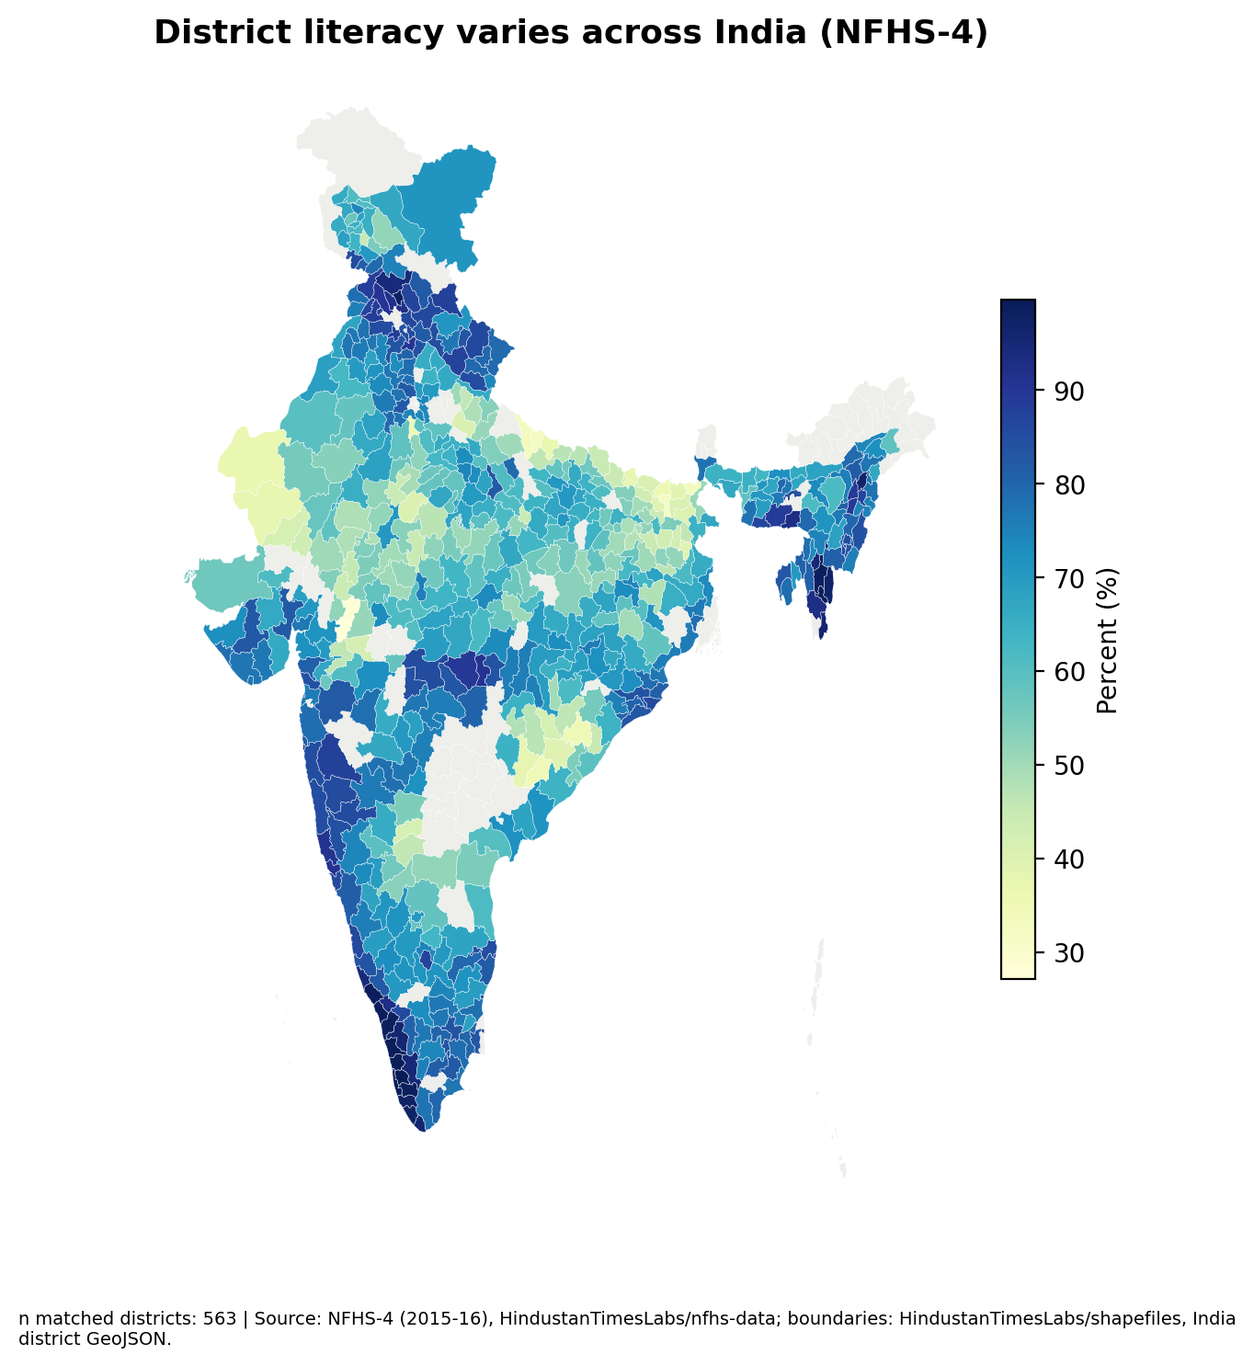
Figure 1. NFHS-4 women literacy baseline by district. Source and n are stated on the map.

RQ5 Public policy evidence
The review covers the PMJDY Mission Document/Brochure and the NITI Aayog/UNDP Aspirational Districts Programme appraisal. Seven paraphrased passages with physical page references are recorded in the coding workbook.
The PMJDY brochure describes expansion of branches and Bank Mitra service points (physical p. 18), transaction interoperability and access (p. 20), and unreliable telecom networks in tribal and hilly areas (p. 30). These are policy design statements, not district outcome estimates.
The ADP appraisal discusses district technical and administrative capacity (physical p. 15), the programme’s convergence, collaboration and competition model (p. 20), and its use of pre-pandemic observations in its own analysis (p. 28). (Sources: data/raw/docs/pmjdy_brochure.pdf; data/raw/docs/adp_appraisal.pdf.)

Discussion and recommendations
The available sources point to a useful distinction between access infrastructure and actual use. The proposed field instrument asks about personal account use, transaction frequency, decision control, phone access, service reliability, and support needs.
For programme planning, first confirm the district-level pattern; then validate whether low reported use reflects account access, service reliability, skills, safety, or household decision constraints. Avoid selecting districts from a name-only comparison.
Build the final intervention around local service mapping, practical assisted account use, digital safety, grievance referral, and routine monitoring. Treat these as design options pending district validation, not proven effects.

Limitations
Indicator coverage: requested bank-account-use and mobile-phone measures are absent from both factsheet sources. Index construction and finance-specific RQs remain unanswered by these data.
Aspirational District selection: districts were selected because of pre-existing deprivation and differ from other districts. Descriptive differences and baseline matching cannot remove all selection bias; results will not be interpreted causally.
Boundary changes: Harvard Appendix A lists 130 changed/new NFHS-5 geography entries. Because the available appendix does not list all parent districts, affected areas are excluded; normalized-name matches elsewhere still need boundary validation.
Survey sampling error: district estimates are subject to sampling variability. The available factsheet estimates do not provide a complete basis for conventional significance testing of all district changes.
NFHS-5 fieldwork occurred during the COVID-19 period (2019-21), which may affect timing and interpretation. Policy documents also reflect their publication period and do not measure current local service quality.

References
International Institute for Population Sciences (IIPS) and Ministry of Health and Family Welfare (MoHFW). National Family Health Survey-4 district factsheet data, 2015-16. Dataset compilation by HindustanTimesLabs, data/raw/nfhs_district-wise.csv; https://github.com/HindustanTimesLabs/nfhs-data.
NITI Aayog. List of 112 Aspirational Districts. 2022. data/raw/docs/aspirational_112.pdf; https://www.niti.gov.in/sites/default/files/2022-09/List-of-Aspirational-Districts.pdf.
Department of Financial Services, Ministry of Finance. PMJDY Mission Document/Brochure. data/raw/docs/pmjdy_brochure.pdf; https://pmjdy.gov.in/files/E-Documents/PMJDY_BROCHURE_ENG.pdf.
NITI Aayog and United Nations Development Programme. Aspirational Districts Programme: An Appraisal. data/raw/docs/adp_appraisal.pdf; https://www.niti.gov.in/sites/default/files/2023-03/Aspirational-Districts-Programme-An-Appraisal.pdf.
Harvard Geographic Insights Lab. NFHS Policy Tracker for Districts: User Guide and Technical Notes, 7 February 2022. Appendix A (changed/new district list). Archived PDF: data/raw/docs/harvard_nfhs_policy_tracker_technical_notes.pdf; source page: https://geographicinsights.iq.harvard.edu/.
HindustanTimesLabs. India district boundaries GeoJSON. data/raw/india_districts.geojson; https://github.com/HindustanTimesLabs/shapefiles/tree/master/india.

Annexes
Crosswalk method: normalized exact names form provisional identifiers. Candidate fuzzy matches are suggestions only. Every approved name or parent/child mapping must be written to data/processed/district_name_overrides.csv and documented in data/processed/district_crosswalk.csv.
Indicator definitions available in NFHS-4 include “Women who are literate (%)”, “Women with 10 or more years of schooling (%)”, “Women age 20-24 years married before age 18 years (%)”, “Households using clean fuel for cooking”, and “Households using improved sanitation facility”. (Source: data/raw/nfhs_district-wise.csv.)
The logframe, theory of change, bilingual field tool, and sampling plan are included as separate editable outputs. Baselines and targets that depend on selected districts are labeled pending.
Table 1. Core source indicator definitions currently identified in NFHS-4. Source: HindustanTimesLabs nfhs_district-wise.csv.
Indicator | NFHS-4 source name | Round status
Literacy | Women who are literate (%) | Comparable definition used
Schooling | Women with 10 or more years of schooling (%) | Comparable definition used
Early marriage | Women age 20-24 years married before age 18 years (%) | Comparable definition used
Cooking fuel | Households using clean fuel for cooking | Comparable definition used
Sanitation | Households using improved sanitation facility | Comparable definition used

