ZilaLens
Women’s Financial Inclusion and Empowerment Across Indian Districts, NFHS-4 (2015-16) to NFHS-5 (2019-21)
Kanishk Gupta
https://github.com/GKanishk16
INTERIM EVIDENCE BRIEF | COMPARATIVE FINDINGS PENDING

The district comparison is ready to run; NFHS-5 is the missing input
The current evidence supports building the comparison and validating district definitions. It does not yet support claims about which districts improved or whether Aspirational Districts moved faster.

What is verified so far
Data readiness measure | Value | Source
NFHS-4 district-indicator rows | 59,241 | HindustanTimesLabs nfhs_district-wise.csv
NFHS-4 district indicators | 93 | HindustanTimesLabs repository README
Exact-name ADP list matches in NFHS-4 | 96 of 112 | NITI 112 list + NFHS-4 source; project crosswalk
The NITI 112-district PDF is published in 2022. Sixteen listed names are not found as exact NFHS-4 state–district names and need geography review. No outcome comparison has been computed.

Three actions for a responsible district programme
- Place the official data.gov.in workbook at data/raw/NFHS_5_India_Districts_Factsheet_Data.xls and rerun the documented pipeline.
- Approve a parent/child district crosswalk before publishing rankings or selecting low-performing districts.
- Measure independent use, transaction control, phone access and service reliability alongside account ownership.
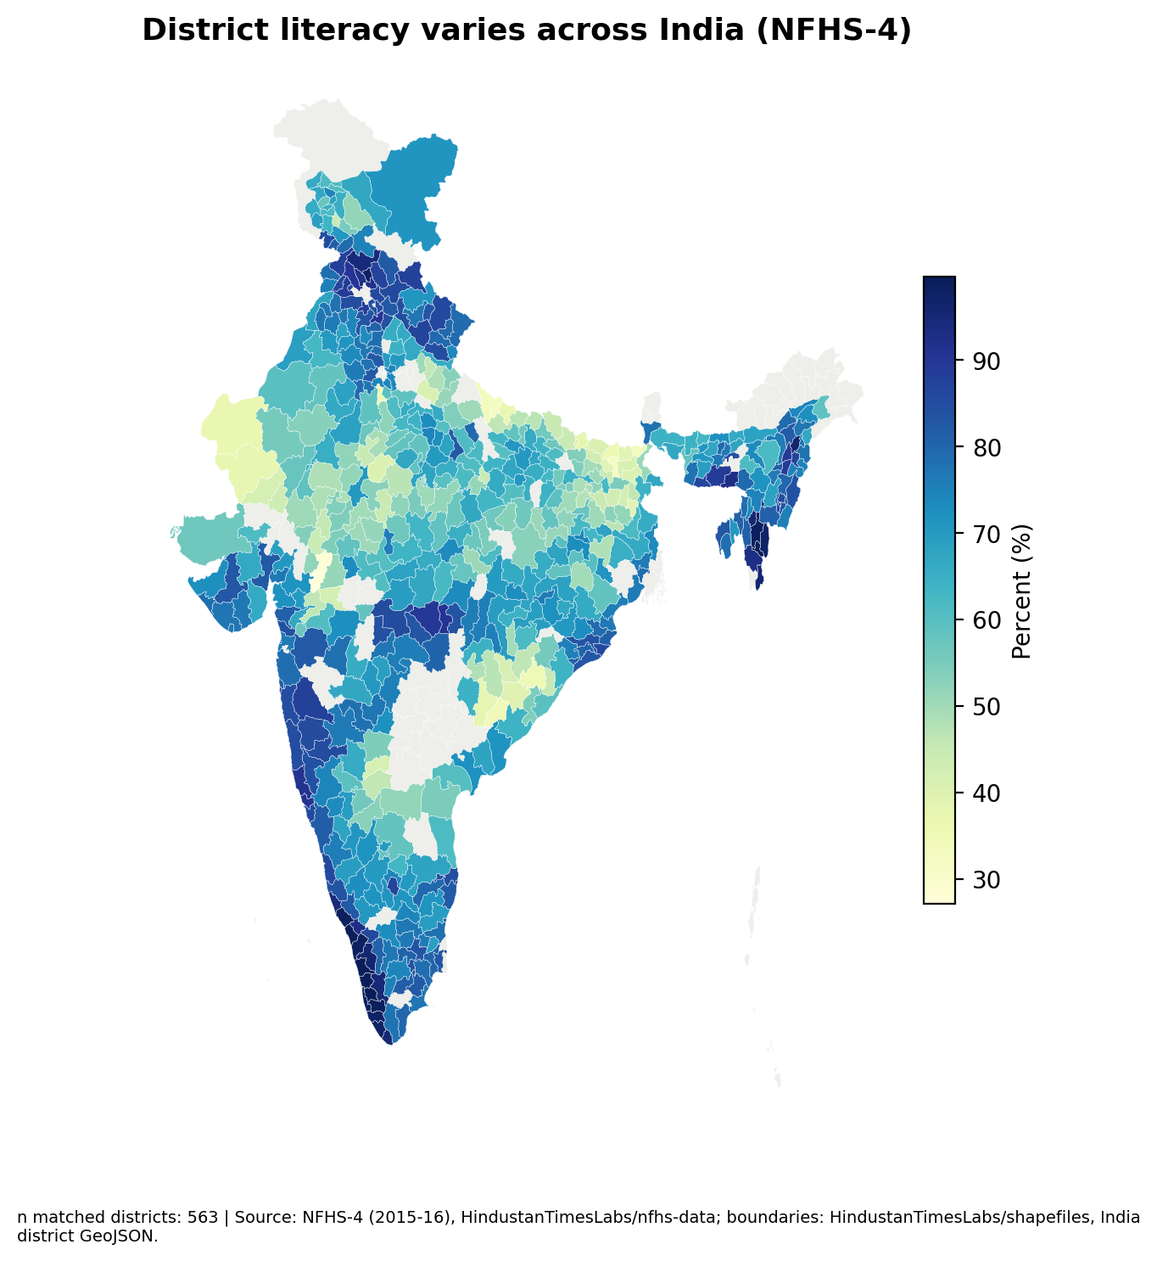
Interim map: NFHS-4 women literacy baseline only; 563 district geometries matched. It does not show change. Source and boundary note appear on the map.
Kanishk Gupta | https://github.com/GKanishk16

