Readme – Azure Databricks Workshop

1. Import the dbc file to create the lab folders.
2. Click the **Workspace** button Workspace Icon or the **Home** button Home Icon in the sidebar. Do one of the following:
   * Next to any folder, click the Menu Dropdown on the right side of the text and select **Import**.
   * In the Workspace or a user folder select Down Caret **Import**.

[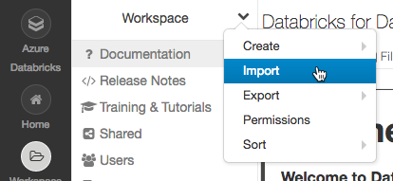](https://docs.azuredatabricks.net/_images/import-notebook.png)

1. Specify the URL to or browse a file containing a supported external format.

aka.ms/adbworkshop

1. Click **Import**.

4. You should see folder structure like this

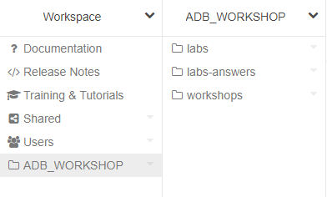

**Labs** is used for students

**Lab-answers** is the answers

**Workshops** is used by instructor

The workshops are self contained, workshop 3 mounts the directory that contains all required datasets.

For instructor only or if time allows and you want to demo “OPTIONAL - 04 Streaming with Event Hubs” follow the SetupEventHubGBBWorkshop.doc

**PLEASE DON’T FORGET TO SHUTDOWN CLUSTERS AFTER WORKSHOP!**

**!!!!!!!STREAMING CLUSTERS DO NOT AUTO-SHUTDOWN!!!!!**

**Note:** Future version of this workshop will have instructions for creating multi-user, groups and clusters labs.