BEACON
Database design for BMS energy data
This document describes how the BMS data for the energy efficiency dashboard is organised and stored: which tables there are, what each one holds, how they connect, and how the data moves from a building's controllers to the dashboard and the PDF reports.
It is a design on paper. Nothing has been built yet. It is based on the BMS data requirements document (BEACON: BMS data requirements) and the demo dashboard, and uses the same systems, names and KPIs.
Item | Detail
Document | Database design for BMS energy data
Version | 1.0 (design)
Date | 10 October 2026
Status | Design only, not implemented
Related documents | BMS data requirements for the energy efficiency dashboard; BEACON demo dashboard
Recommended database | PostgreSQL 16 with the TimescaleDB extension

Contents

Right-click the table of contents in Word and choose Update Field if page numbers are missing.

1. Purpose and scope
The energy hypervision collects readings from the BMS of many buildings every 15 minutes, turns them into energy, cost, KPIs and waste findings, and shows them on a live dashboard and in reports. The database must:
- store every reading from every building, with its time, unit and quality, without losing any data during network outages;
- know what each reading is: which building, floor, zone, system and equipment it belongs to;
- keep calculated results (energy by system, cost, KPIs, waste) so the dashboard is fast and reports match the screen;
- record faults, alarms and data gaps;
- control who can see which building;
- grow from a few buildings to many without a redesign.
In scope: energy efficiency data, as listed in the data requirements document. Out of scope for now: the maintenance data marked "Kept for future maintenance use". The design leaves room for it: maintenance points can be added as new data points later without changing any table.

Why PostgreSQL with TimescaleDB
Need | How it is met
Very many time-stamped readings | TimescaleDB stores them in time-based chunks and compresses old chunks (typically by 90% or more), so the database stays small and fast
Master data with relationships (building, floor, equipment) | Standard PostgreSQL tables with foreign keys keep the asset register consistent
Hourly and daily summaries | Continuous aggregates keep them up to date automatically
One database for both | Readings can be joined directly with buildings, equipment and tariffs in one query
Cost and support | Both are open source and widely supported; managed cloud versions exist

2. Design principles
- One reading = one data point + one time + one value. All systems use the same reading table. Adding a new system or sensor means adding rows to the data point list, not new tables.
- Master data is separate from readings. What a sensor is (building, equipment, unit) is stored once in the asset register. Readings carry only a small point number.
- Raw readings are never changed or deleted during their retention period. Corrections and estimates are stored as calculated values, so the original can always be checked.
- Calculated results are stored, with their source marked (metered, estimated or calculated), so everyone sees the same numbers.
- Times are stored in UTC and shown in each building's local time. Every reading keeps the time it was measured, not the time it arrived.
- Every value has one fixed unit. Units are converted at ingest, never in the dashboard.
- Missing is not zero. Gaps and bad values are flagged, never filled with 0.
- Read-only from the BMS. The platform never writes back to the BMS.
- Access is enforced in the database, by building, so a building manager can only ever read their own building.

3. How the data is organised

3.1 The building hierarchy
Every reading is filed under a fixed chain, from the portfolio down to the single value:
Level | Example | Stored in
Portfolio (owner) | Your company | core.organization
Building | GRH: Grand Residency Hotel, Chennai | core.building
Floor | Level 3 | core.floor
Zone / room | Room 1204, Floor 3 east wing, Car park B1 | core.zone
System | AHU: Air Handling Units | core.system_type
Equipment | AHU03 (ballroom AHU), part of the air-side system | core.equipment
Data point | GRH-AHU-AHU03-KW: fan power in kW | core.data_point
Reading | 10 Oct 2026 14:15, 18.4 kW, quality good | ts.reading

Meters sit beside this chain: a meter measures a plant, a panel or a whole building, and its readings are data points like any other. The meter tree (main incomer and sub-meters) is held in core.meter.

3.2 How data flows into the database
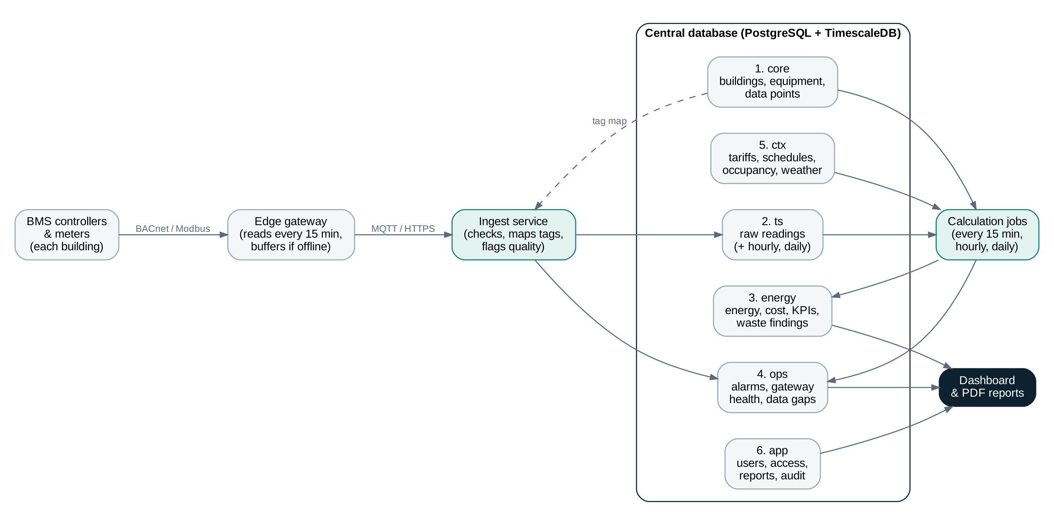
Figure 1. From the BMS controllers to the dashboard
- The edge gateway in each building reads the BMS controllers and meters every 15 minutes (BACnet or Modbus), and stores readings locally if the internet link is down.
- It sends them to the central ingest service (MQTT or HTTPS). The ingest service looks up each tag in core.data_point, converts units, checks ranges and saves the readings in ts.reading with a quality flag.
- Calculation jobs run every 15 minutes, hourly and daily. They combine readings with tariffs, schedules, occupancy and weather, and write energy, cost, KPIs and waste findings to the energy tables, and data gaps and platform alarms to the ops tables.
- The dashboard and reports read only the calculated tables, plus ts summaries for detailed charts.

3.3 Six groups of tables
The tables are grouped into six PostgreSQL schemas (folders). Each group has a different job and changes at a different pace.
Schema | Holds | Changes | Main tables
core | Asset register: buildings, floors, zones, systems, equipment, meters, data points, gateways | Rarely (commissioning, new equipment) | building, equipment, meter, data_point
ts | Raw readings and their hourly / daily summaries | Every 15 minutes, very large | reading, ingest_batch
energy | Calculated energy, cost, KPIs, targets, waste findings | Every 15 minutes | energy_interval, energy_daily, kpi_value, waste_finding
ops | Alarms and faults, gateway health, data gaps | When events happen | alarm_event, gateway_status, data_gap
ctx | Context from outside the BMS: tariffs, schedules, holidays, occupancy, weather, baseline | Monthly or hourly | tariff, schedule, occupancy, weather
app | Users, roles, building access, report log, audit log | When users act | app_user, user_building_access, report_log

3.4 How the main tables connect
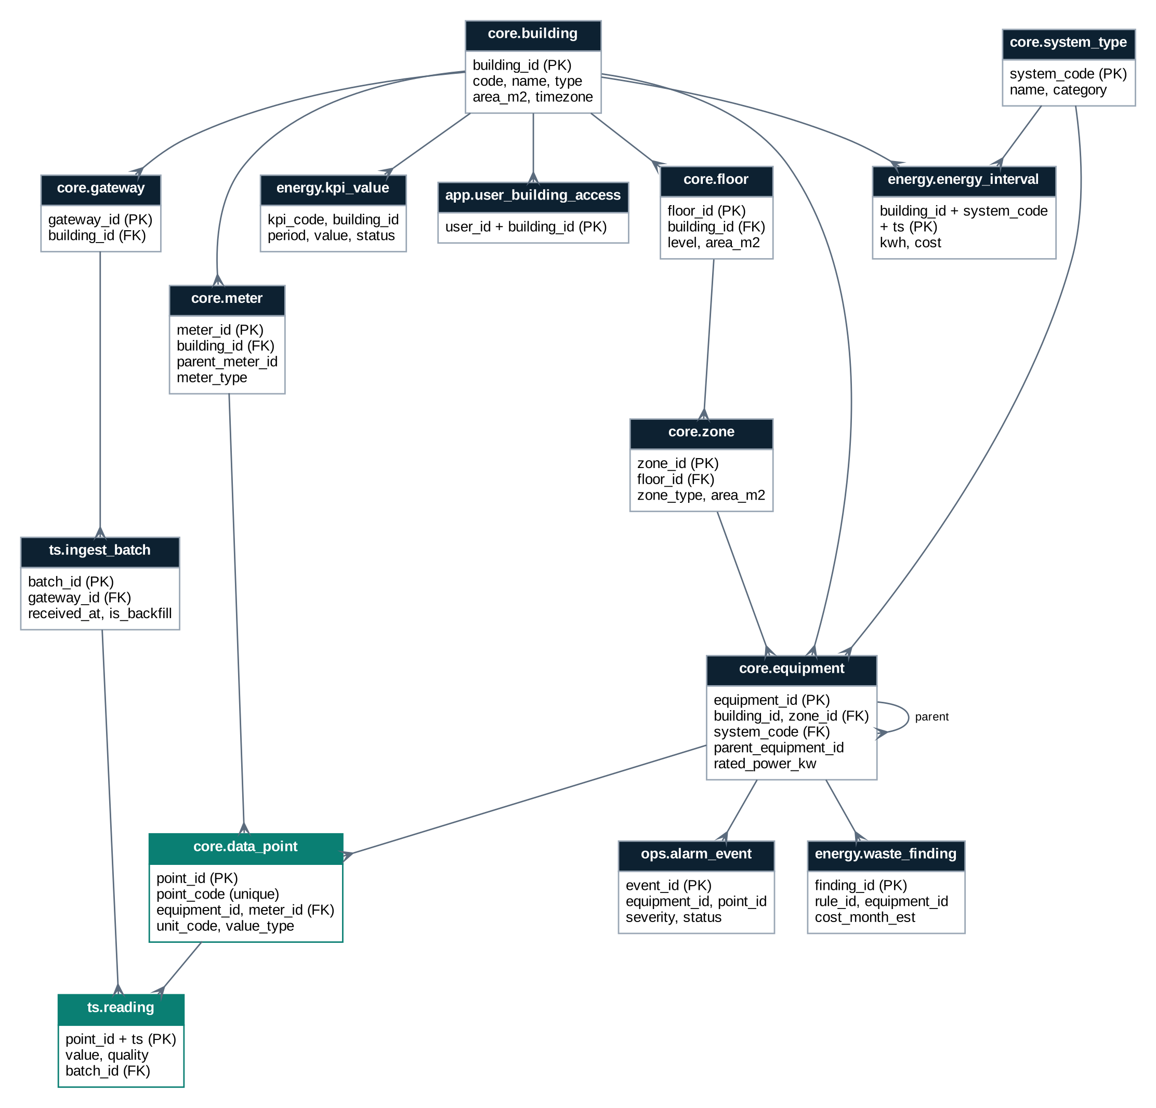
Figure 2. Main tables and relationships (the forked end means "many": one building has many floors)
core.data_point is the link between the asset register and the readings. ts.reading has only four columns, so billions of rows stay compact; everything else about a reading is found by following point_id.

4. Naming convention for data points
Every data point gets one standard tag, whatever the BMS calls it. The BMS name is kept in data_point.bms_name for traceability. The standard tag makes points readable, sortable and the same across all buildings.

4.1 Tag format
BUILDING - SYSTEM - EQUIPMENT - POINT
Tag | Means
TPA-CHL-CH01-KW | Tech Park Tower A, chiller plant, chiller 1, power (kW)
TPA-CHL-PLANT-TRH | Tech Park Tower A, chiller plant, BTU meter, cooling energy (TRh)
GRH-AHU-AHU03-SAT | Grand Residency Hotel, AHU 3, supply air temperature
GRH-FCU-R1204-ZTSP | Grand Residency Hotel, fan coil unit in room 1204, room setpoint
CSM-VEN-JF07-ST | City Square Mall, car park jet fan 7, run status
CSM-ELE-MAIN-KWH | City Square Mall, main incomer energy register

Building codes are 3 letters, unique in the portfolio. Equipment tags have no spaces or hyphens (CH01, AHU03, R1204, F3E). PLANT, MAIN or GROUP are used when the point belongs to a whole plant, a main meter or a group of items.

4.2 System codes
One code per system from the data requirements document. Loaded once into core.system_type.
Code | System | Category
CHL | Chiller Plant | Consumer
AHU | Air Handling Units / TFA | Consumer
FCU | Fan Coil Units | Consumer
LTG | Lighting Control (indoor and external) | Consumer
VEN | Ventilation and Exhaust | Consumer
VTR | Elevators and Escalators | Consumer
BLR | Boiler / Heating / Heat Pumps | Consumer
HWS | Hot Water System | Consumer
WSP | Water Supply (pumping) | Consumer
CLD | Cold Room / Refrigeration | Consumer
UPS | UPS System | Consumer
STP | Sewage Treatment Plant | Consumer
WTP | Water Treatment Plant | Consumer
IAQ | Indoor Air Quality Monitoring | Context
FAS | Fire Alarm | Life safety (context)
SMK | Smoke Control | Life safety (context)
GLD | Gas Leak Detection | Life safety (context)
ACS | Access Control | Security (context)
CCT | CCTV | Security (context)
IDS | Intrusion Alarm | Security (context)
ELE | Electrical Distribution and Energy Metering | Supply / metering
DGS | Diesel Generator | Supply / metering
SOL | Solar / Renewable Energy | Supply / metering
GAS | Gas Supply and Metering | Supply / metering
KIT | Kitchen Equipment | Building-type specific
LDY | Laundry Equipment | Building-type specific
POL | Swimming Pool and Spa | Building-type specific
GRM | Guest Room Management (GRMS) | Building-type specific

4.3 Point codes
The last part of the tag says what is measured. The list grows as needed; the most common are:
Code | Measures | Unit
KW | Power | kW
KWH | Energy register (cumulative) | kWh
KVA | Apparent power | kVA
PF | Power factor | -
ST | Run status | 0 = off, 1 = on
RH | Run hours (counter) | hours
ALM | Alarm / trip | 0 / 1
MODE | Operating mode | multistate
SPD | Fan / pump speed | %
SAT / SATSP | Supply air temperature / setpoint | °C
RAT | Return air temperature | °C
CHWS / CHWR | Chilled water supply / return temperature | °C
CHWSP | Chilled water setpoint | °C
FLOW | Water flow | m³/h
TR / TRH | Cooling load / cooling energy (BTU meter) | TR / TRh
ZT / ZTSP | Zone (room) temperature / setpoint | °C
RHUM | Relative humidity | %RH
CO2 / CO | Carbon dioxide / carbon monoxide | ppm
OCC | Occupancy | 0 / 1
LUX | Light level | lux
DIM | Dimming level | %
TRIPS | Elevator trips (counter) | count
VOL | Water / gas / diesel volume (counter) | m³ or litres

5. Table definitions
Column types are PostgreSQL types. Key: PK = primary key, FK = foreign key (link to another table), UQ = unique. Columns marked created_at / updated_at exist on all master data tables for change tracking.

5.1 core: asset register

core.organization
The company that owns the buildings. One row in most installations; kept so the platform can serve more than one owner later.
Column | Type | Key | Description
org_id | integer | PK | Identifier
name | text |  | Company name, as printed on reports
logo | bytea |  | Company logo (PNG) for reports
default_timezone | text |  | e.g. Asia/Kolkata

core.building
One row per building (site). Everything else hangs off this table.
Column | Type | Key | Description
building_id | integer | PK | Identifier
org_id | integer | FK | Owner, core.organization
code | varchar(6) | UQ | Short code used in tags, e.g. TPA, GRH, CSM
name | text |  | e.g. Grand Residency Hotel
building_type | text |  | Office, Hotel, Mall, Hospital, ...
city, address | text |  | Location
timezone | text |  | Local time zone for schedules and reports
gross_area_m2 | numeric(10,1) |  | Floor area, used for EUI and kWh/m²
conditioned_area_m2 | numeric(10,1) |  | Air-conditioned area (optional)
room_count | integer |  | Hotels: number of keys, for kWh per occupied room
contract_demand_kva | numeric(8,1) |  | Sanctioned demand, for peak demand alerts
is_active | boolean |  | Building included in the portfolio
created_at | timestamptz |  | When the row was created
updated_at | timestamptz |  | When the row last changed

core.floor
Floors (levels) of a building, including basements and roof.
Column | Type | Key | Description
floor_id | integer | PK | Identifier
building_id | integer | FK | core.building
level | smallint |  | -2 = basement 2, 0 = ground, 1, 2, ...
name | text |  | e.g. B2, Ground, Roof
area_m2 | numeric(10,1) |  | Floor area

core.zone
Areas inside a floor that are controlled or metered together: a room, an office wing, a corridor, a car park, a plant room.
Column | Type | Key | Description
zone_id | integer | PK | Identifier
floor_id | integer | FK | core.floor
code | varchar(20) |  | e.g. F3-EAST, R1204, CP-B1
zone_type | text |  | Guest room, Office, Corridor, Lobby, Car park, Kitchen, Plant room, ...
area_m2 | numeric(10,1) |  | Zone area, used for lighting power density
lighting_load_kw | numeric(8,2) |  | Connected lighting load (static data)

core.system_type
The fixed list of BMS systems from the data requirements document (see Section 4.2). Loaded once.
Column | Type | Key | Description
system_code | varchar(4) | PK | e.g. CHL, AHU, LTG
name | text |  | e.g. Chiller Plant
category | text |  | Consumer, Supply / metering, Building-type specific, Context (IAQ, safety)
energy_rank | smallint |  | Rank by typical energy use (1 = chiller plant)
dashboard_group | text |  | Band in the stacked load chart (Chiller, AHU / FCU, Lighting, ...)

core.equipment
Every physical item the BMS knows about: chillers, pumps, AHUs, FCUs, lighting circuits, lifts, meters' parent panels, and so on. Equipment can belong to other equipment, e.g. a pump belongs to the chiller plant.
Column | Type | Key | Description
equipment_id | integer | PK | Identifier
building_id | integer | FK | core.building
zone_id | integer | FK | Where it is, or which zone it serves (optional)
system_code | varchar(4) | FK | core.system_type
parent_equipment_id | integer | FK | Plant or group it belongs to (self reference)
tag | varchar(20) | UQ* | e.g. CH01, CHWP02, AHU03 (*unique per building)
name | text |  | e.g. Chiller 1 (water-cooled, 300 TR)
equipment_type | text |  | Chiller, Pump, Cooling tower, AHU, FCU, Lighting circuit, Elevator, ...
rated_power_kw | numeric(8,2) |  | Nameplate power; used to estimate energy where there is no meter
rated_capacity | numeric(10,2) |  | e.g. 300
capacity_unit | text |  | TR, kW, m³/h, kVA, passengers, ...
design_efficiency | numeric(6,3) |  | e.g. design kW/TR, UPS efficiency
manufacturer, model | text |  | Make and model
installed_on | date |  | Installation date
is_active | boolean |  | Still in service
created_at | timestamptz |  | When the row was created
updated_at | timestamptz |  | When the row last changed

core.meter
Energy and utility meters, arranged as a tree: main incomer at the top, sub-meters below. The tree lets the system check that sub-meters add up to the main meter and shows unmetered ("other") energy.
Column | Type | Key | Description
meter_id | integer | PK | Identifier
building_id | integer | FK | core.building
parent_meter_id | integer | FK | Upstream meter (self reference); empty for a main incomer
code | varchar(20) |  | e.g. EM-MAIN, EM-CHL, BTU-01
meter_type | text |  | Electricity, BTU (thermal), Gas, Diesel, Water, Solar generation
serves_equipment_id | integer | FK | Equipment or plant the meter measures (optional)
serves_system_code | varchar(4) | FK | System the meter's energy belongs to
multiplier | numeric(10,4) |  | CT / PT ratio applied to raw values
is_virtual | boolean |  | Calculated meter (e.g. main minus sub-meters)

core.data_point
The heart of the design. Every value the BMS sends (a temperature, a kW, an on/off status, a meter register) is one data point with a fixed unit. Every reading points to exactly one data point.
Column | Type | Key | Description
point_id | integer | PK | Identifier (small integer keeps the reading table compact)
point_code | varchar(60) | UQ | Standard tag, e.g. TPA-CHL-CH01-KW (see Section 4)
building_id | integer | FK | core.building
equipment_id | integer | FK | Equipment the point belongs to
meter_id | integer | FK | Set when the point is a meter value
gateway_id | integer | FK | Gateway that reads it
bms_address | text |  | Source address: BACnet device + object, or Modbus register
bms_name | text |  | Name used in the BMS, kept for traceability
quantity | text |  | Power, Energy, Temperature, Flow, Status, Speed, CO₂, ...
unit_code | varchar(12) | FK | core.unit, e.g. kW, kWh, degC
value_type | text |  | Analog, Binary, Multistate, Counter (cumulative register)
state_map | jsonb |  | Meaning of binary / multistate values, e.g. {0: Off, 1: On}
requirement | text |  | Required, Good to have, Maintenance (future), as in the data requirements
valid_min, valid_max | double precision |  | Plausible range; values outside are flagged
interval_min | smallint |  | Expected reading interval (15)
is_active | boolean |  | Point still being read
created_at | timestamptz |  | When the row was created
updated_at | timestamptz |  | When the row last changed

core.unit
The list of allowed units, so every value has a defined unit.
Column | Type | Key | Description
unit_code | varchar(12) | PK | kW, kWh, kVA, degC, pct, m3h, TR, TRh, ppm, lux, Pa, hours, count, ...
name | text |  | Full name
quantity | text |  | What it measures

core.gateway
The edge gateway (industrial PC) in each building that reads the BMS and sends data to the central database.
Column | Type | Key | Description
gateway_id | integer | PK | Identifier
building_id | integer | FK | core.building
code | varchar(20) | UQ | e.g. GW-TPA-01
protocols | text |  | BACnet/IP, Modbus TCP, ...
firmware_version | text |  | Software version on the gateway
buffer_capacity_days | smallint |  | How long it can store readings while offline

5.2 ts: readings

ts.reading
Every reading received, at its original 15-minute timestamp. This is the only table that grows fast. It is a TimescaleDB hypertable, split into one chunk per week and compressed after 7 days.
Column | Type | Key | Description
point_id | integer | PK, FK | core.data_point
ts | timestamptz | PK | Time of the reading at the source (stored in UTC, shown in local time)
value | double precision |  | The reading. Status values stored as numbers (0 = off, 1 = on), meaning in data_point.state_map
quality | smallint |  | 0 = good, 1 = estimated, 2 = suspect, 3 = bad (see Section 7)
batch_id | bigint | FK | ts.ingest_batch the value arrived in

Primary key (point_id, ts) means a reading sent twice is stored once, so a gateway can safely resend its buffer.

ts.ingest_batch
One row per message received from a gateway. Shows when data arrived and whether it was live or buffered (late) data.
Column | Type | Key | Description
batch_id | bigint | PK | Identifier
gateway_id | integer | FK | core.gateway
received_at | timestamptz |  | When the central system received it
first_ts, last_ts | timestamptz |  | Time range of the readings inside
record_count | integer |  | Number of readings
rejected_count | integer |  | Readings rejected (unknown tag, bad format)
is_backfill | boolean |  | True when the gateway is sending buffered readings after an outage

ts.reading_hourly and ts.reading_daily
Summaries kept up to date automatically (TimescaleDB continuous aggregates). Charts over weeks or months read these, not the raw table.
Column | Type | Key | Description
point_id | integer | PK | core.data_point
bucket | timestamptz | PK | Start of the hour or day
avg_value, min_value, max_value | double precision |  | For analog points
last_value | double precision |  | Last reading in the bucket (meter registers)
delta_value | double precision |  | Last minus first: energy used in the bucket for counters
on_minutes | integer |  | Minutes in On state, for status points (run hours)
samples, good_samples | smallint |  | Readings received and readings of good quality

5.3 energy: calculated results

energy.energy_interval
Energy per building, per system, per 15 minutes. The main table behind the dashboard's load profile, energy by system and cost. Filled by a calculation job from meter readings; where a system has no meter, the energy is estimated and marked.
Column | Type | Key | Description
building_id | integer | PK, FK | core.building
system_code | varchar(4) | PK, FK | core.system_type
ts | timestamptz | PK | Start of the 15-minute interval
kwh | numeric(12,3) |  | Energy in the interval
kw_avg | numeric(10,2) |  | Average power
source | text |  | Metered, Estimated (rated power × run time), Calculated (main minus sub-meters)
supply_mix | jsonb |  | kWh from grid, DG and solar
cost | numeric(12,2) |  | Cost in rupees at the tariff band of that interval
tariff_band | text |  | Normal, Peak, Off-peak
waste_kwh | numeric(12,3) |  | Part of the energy flagged as avoidable

energy.energy_daily
One row per building per day. Feeds daily totals, comparisons, reports and the data completeness figure.
Column | Type | Key | Description
building_id, day | integer, date | PK | Building and local date
kwh_total, kwh_grid, kwh_dg, kwh_solar | numeric(12,1) |  | Energy by source
cost_total | numeric(12,2) |  | Energy cost
peak_kva, peak_kva_at | numeric, timestamptz |  | Highest 15-minute demand and when
cooling_trh | numeric(12,1) |  | Cooling delivered (for kW/TR)
avg_outdoor_temp | numeric(4,1) |  | For weather-normalised comparison
occupancy | numeric(8,1) |  | Occupied rooms or headcount
readings_received, readings_expected | integer |  | Data completeness

energy.kpi_definition
The list of KPIs and how each is calculated, taken from the "KPIs the dashboard calculates" tables in the data requirements document.
Column | Type | Key | Description
kpi_code | varchar(30) | PK | e.g. CHL_PLANT_KW_PER_TR
name | text |  | e.g. Chiller plant efficiency
system_code | varchar(4) | FK | System it belongs to
unit_code | varchar(12) | FK | e.g. kW/TR
formula | text |  | Plain-language formula, e.g. plant kWh ÷ TRh
better | text |  | Lower or Higher
periods | text[] |  | 15min, Hour, Day, Month

energy.kpi_target
Targets and alert limits. A building-specific row overrides the portfolio default; rows are dated so past results keep the target that applied at the time.
Column | Type | Key | Description
target_id | integer | PK | Identifier
kpi_code | varchar(30) | FK | energy.kpi_definition
building_id | integer | FK | Empty = default for all buildings
target_value | numeric |  | e.g. 0.65
warning_value, critical_value | numeric |  | Limits for amber and red status
valid_from, valid_to | date |  | Period the target applies

energy.kpi_value
Calculated KPI results. Storing them (instead of recalculating on every page load) keeps the dashboard fast and means reports show the same numbers as the screen.
Column | Type | Key | Description
kpi_code | varchar(30) | PK, FK | energy.kpi_definition
building_id | integer | PK, FK | core.building
equipment_id | integer | PK, FK | Set for equipment-level KPIs (0 = whole building or system)
period_type | text | PK | 15min, Hour, Day, Month
period_start | timestamptz | PK | Start of the period
value | numeric |  | Result
target_value | numeric |  | Target that applied
status | text |  | Good, Warning, Critical, No data

energy.waste_rule
The checks that find waste, e.g. "chiller running outside schedule" or "lights on in an empty zone".
Column | Type | Key | Description
rule_id | integer | PK | Identifier
code | varchar(40) | UQ | e.g. CHL_AFTER_HOURS
system_code | varchar(4) | FK | System checked
description | text |  | What the rule looks for
default_action | text |  | Recommended fix shown to the user
severity | text |  | Warning or Critical

energy.waste_finding
Each problem found, from first detection until it is fixed. This is the "Savings opportunities" list on the dashboard and in the reports.
Column | Type | Key | Description
finding_id | bigint | PK | Identifier
rule_id | integer | FK | energy.waste_rule
building_id, equipment_id | integer | FK | Where it was found
first_detected, last_detected | timestamptz |  | When it started and was last seen
kwh_per_day, cost_per_month_est | numeric |  | Size of the waste
detail | text |  | Evidence, e.g. "Plant at 0.84 kW/TR against 0.65"
status | text |  | Open, In progress, Fixed, Dismissed
owner_user_id | integer | FK | Person responsible (app.app_user)
closed_at, closed_note | timestamptz, text |  | How it was resolved; used to confirm savings

5.4 ops: alarms, gateways and gaps

ops.alarm_event
Faults and alarms: equipment trips, gateway offline, grid outage and DG running, stuck sensors. Includes alarms that come from the BMS and those raised by the platform's own checks.
Column | Type | Key | Description
event_id | bigint | PK | Identifier
building_id | integer | FK | core.building
equipment_id, point_id | integer | FK | Source of the alarm (optional)
system_code | varchar(4) | FK | System affected
category | text |  | Equipment, Communication, Power, Data quality
severity | text |  | Info, Warning, Critical
title, detail, action | text |  | What happened and what to do
raw_text | text |  | Original BMS alarm text, e.g. AHU-03 TRIP DI=1
source | text |  | BMS or Platform
start_ts, end_ts | timestamptz |  | Start and return to normal
status | text |  | Open, Acknowledged, Resolved
ack_by, ack_at, ack_note | integer, timestamptz, text |  | Who acknowledged it and when

ops.gateway_status
Heartbeat from each gateway (every 5 minutes). Drives the online/offline indicator.
Column | Type | Key | Description
gateway_id, ts | integer, timestamptz | PK | Gateway and time
online | boolean |  | Gateway reachable
buffered_records | integer |  | Readings waiting to be sent
cpu_pct, disk_free_pct | numeric(5,1) |  | Basic health of the industrial PC

ops.data_gap
Periods with missing readings, so gaps are visible and never read as zero consumption.
Column | Type | Key | Description
gap_id | bigint | PK | Identifier
gateway_id or point_id | integer | FK | Whole gateway or a single point
gap_start, gap_end | timestamptz |  | Missing period
reason | text |  | Gateway offline, Point not responding, Value stuck, Out of range
filled_by_backfill | boolean |  | True when buffered readings later filled the gap

5.5 ctx: context data

ctx.tariff and ctx.tariff_band
Prices for electricity (time-of-day), demand charges, diesel, gas and water, dated so that past costs stay correct when tariffs change.
Column | Type | Key | Description
tariff_id | integer | PK | Identifier
building_id | integer | FK | Building the tariff applies to
energy_type | text |  | Electricity, Diesel, Gas, Water
valid_from, valid_to | date |  | Period
demand_charge_per_kva | numeric(8,2) |  | Monthly demand charge
band (tariff_band) | text |  | Normal, Peak, Off-peak
start_time, end_time, days | time, time, text |  | When the band applies, e.g. 18:00 to 22:00, all days
rate | numeric(8,3) |  | Price per unit (₹/kWh, ₹/litre, ...)

ctx.schedule and ctx.holiday
Operating hours per building, zone or system, plus holidays. Used to detect equipment running after hours.
Column | Type | Key | Description
schedule_id | integer | PK | Identifier
building_id, zone_id, system_code | integer, integer, varchar | FK | What the schedule applies to
day_of_week | smallint |  | 1 = Monday ... 7 = Sunday
start_time, end_time | time |  | Occupied hours
holiday_date, name | date, text |  | Holiday table: days treated as closed

ctx.occupancy
Occupancy from the hotel PMS / GRMS, access control or people counters.
Column | Type | Key | Description
building_id, zone_id, ts | integer, integer, timestamptz | PK | Where and when
occupied_rooms | integer |  | Hotels
headcount | integer |  | Offices, malls (footfall)
source | text |  | PMS, GRMS, Access control, Counter

ctx.weather
Outdoor conditions per building, from the BMS outdoor sensor or a weather service.
Column | Type | Key | Description
building_id, ts | integer, timestamptz | PK | Where and when
temp_c, rh_pct | numeric(4,1) |  | Temperature and humidity
source | text |  | BMS sensor or Weather service

ctx.baseline and ctx.savings_target
The reference to measure savings against: at least 12 months of past consumption, and the savings goal.
Column | Type | Key | Description
building_id, system_code, month | integer, varchar, date | PK | Scope and month
baseline_kwh | numeric(14,1) |  | Consumption in the reference year
target_pct | numeric(5,2) |  | Savings goal, e.g. 10% below baseline

5.6 app: users, access and reports

app.app_user and app.role
People who use the dashboard, and their role.
Column | Type | Key | Description
user_id | integer | PK | Identifier
name, email | text |  | Name and login (or company single sign-on ID)
role_code | text | FK | PORTFOLIO_MANAGER, BUILDING_MANAGER, OPERATOR, ADMIN
is_active, last_login_at | boolean, timestamptz |  | Account status

Passwords are not stored in this database when company single sign-on is used; otherwise only a salted hash is stored.

app.user_building_access
Which buildings each user may see. The database itself enforces this (row-level security), not only the website.
Column | Type | Key | Description
user_id, building_id | integer | PK, FK | One row per user per building

app.report_log
Every PDF report generated, so a report number can be traced back to who made it and with which settings.
Column | Type | Key | Description
report_no | varchar(30) | PK | e.g. BCN-20261010-0115-PF
report_type | text |  | Portfolio, Building, System, Comparison
scope | jsonb |  | Buildings, system and sections chosen
period_start, period_end | timestamptz |  | Period covered
generated_by, generated_at | integer, timestamptz |  | Who and when
file_sha256 | text |  | Fingerprint of the PDF, to prove a copy is unchanged

app.audit_log
Record of changes to master data, targets, tariffs and alarm acknowledgements.
Column | Type | Key | Description
audit_id | bigint | PK | Identifier
ts, user_id | timestamptz, integer |  | When and who
action | text |  | Create, Update, Delete, Acknowledge, Login, Export
table_name, row_key | text |  | What was changed
old_value, new_value | jsonb |  | Before and after

6. Worked example: chiller plant efficiency
How one KPI travels through the tables, using the Tech Park Tower A chiller plant (the plant the demo flags for low efficiency).
Step | Table | What is stored
1. Readings arrive | ts.reading | Every 15 min: TPA-ELE-CHLPLANT-KWH (plant energy register, e.g. 4,812,350.2 kWh) and TPA-CHL-PLANT-TRH (BTU meter, e.g. 6,120,880.5 TRh), plus CH01-ST, CHWS, CHWR, FLOW
2. Energy per interval | energy.energy_interval | Register difference: 162.4 kWh in 14:00 to 14:15 for system CHL; cost ₹1,461.60 at the normal band (₹9.00/kWh)
3. Cooling per interval | ts.reading | BTU meter register difference: 193.3 TRh in the same interval (daily total kept in energy_daily.cooling_trh)
4. KPI | energy.kpi_value | CHL_PLANT_KW_PER_TR = 162.4 ÷ 193.3 = 0.84 kW/TR; target 0.65 from kpi_target; status Critical
5. Waste | energy.waste_finding | Rule CHL_LOW_EFFICIENCY opens a finding: 0.84 against 0.65, chilled water ΔT 3.4 °C, estimated ₹2.5 L per month; action: rebalance valves, reset pump setpoint
6. Shown | Dashboard and PDF report | System Detail card, Energy Insights list and the report's Savings opportunities table all read the same rows

Figures are illustrative, in the style of the demo's simulated data.

Example KPI definitions
kpi_code | KPI | Formula | Better
CHL_PLANT_KW_PER_TR | Chiller plant efficiency | Plant kWh ÷ TRh | Lower
CHL_DELTA_T | Chilled water ΔT | Average CHWR − CHWS while running | Higher
AHU_AFTER_HOURS_KWH | AHU after-hours energy | AHU kWh outside schedule | Lower
LTG_LPD | Lighting power density | Lighting kW × 1000 ÷ zone area | Lower
LTG_VACANT_KWH | Lights on in vacant zones | Lighting kWh while OCC = 0 | Lower
UPS_EFFICIENCY | UPS efficiency | Output kW ÷ input kW | Higher
BLD_EUI | Energy use intensity | Annual kWh ÷ gross area | Lower
BLD_KWH_PER_ROOM | Energy per occupied room | Daily kWh ÷ occupied rooms | Lower
BLD_PEAK_KVA | Peak demand | Highest 15-minute kVA | Lower
BLD_DATA_COMPLETENESS | Data completeness | Readings received ÷ expected | Higher

7. Data quality and late data

7.1 Quality flag on every reading
Code | Meaning | Set when | Used in calculations
0 | Good | Value received and passes all checks | Yes
1 | Estimated | Value filled in by the platform (e.g. interpolated for a short gap of one reading) | Yes, marked as estimated
2 | Suspect | Outside the plausible range, a sudden jump, or unchanged for too long (stuck sensor) | No; raises a Data quality alarm
3 | Bad | BMS reports a fault, or the value cannot be read | No

7.2 Rules
- Unknown tags are not saved as readings; they are counted in ingest_batch.rejected_count and listed for the commissioning team to map.
- Meter registers (cumulative kWh) are the source of energy. If a reading is missing, the next register value still gives the correct total over the gap.
- Register resets (meter replaced or rolled over) are detected when the register goes down, and the interval is marked so energy is not counted as negative.
- Stuck values: an analog point that reports the same value for longer than its limit (e.g. CO₂ fixed at 412 ppm for 31 hours) is flagged Suspect and opens a Data quality alarm.
- Late data: when a gateway reconnects, its buffered readings are saved with their original times (is_backfill = true). The calculation jobs then recalculate the affected intervals, so the dashboard fills in the gap, exactly as the demo shows.
- Completeness = readings received ÷ readings expected, per building per day, stored in energy_daily and shown in reports.

8. Data volume, retention and performance

8.1 Size estimate
Example: 10 hotels, about 2,500 data points each (around 300 rooms with FCU and occupancy points, plus the plant, lighting, meters and other systems), read every 15 minutes.
Item | Calculation | Result
Readings per day | 10 buildings × 2,500 points × 96 readings | 2.4 million
Readings per year | 2.4 million × 365 | about 876 million
Raw size, uncompressed | about 90 bytes per reading including index | about 80 GB per year
Raw size, compressed (TimescaleDB) | typically 90% smaller after compression | about 8 to 10 GB per year
Hourly summaries | 10 × 2,500 × 24 × 365 | about 219 million rows per year
Daily summaries | 10 × 2,500 × 365 | about 9 million rows per year
Calculated energy (energy_interval) | 10 buildings × 28 systems × 96 × 365 | about 10 million rows per year

Estimates only. Actual compression depends on the data; it should be measured with real readings during the pilot.

8.2 How long data is kept
Data | Kept | Why
Raw readings (ts.reading) | 2 years online, compressed after 7 days; then exported to archive storage | Detailed investigation and recalculation
Hourly summaries | 5 years | Trends, seasonal comparison
Daily and monthly results, KPIs | Permanently | Baselines, year-on-year savings, audits
Alarms and waste findings | 5 years | Fault history, proof of savings
Gateway heartbeats | 90 days | Recent connectivity only
Audit log and report log | At least 3 years (per company policy) | Traceability

8.3 Performance
- ts.reading is a hypertable with weekly chunks; queries for "today" or "last 7 days" touch only one or two chunks.
- Index on (point_id, ts DESC) answers "latest value of each point" for live tiles.
- The dashboard reads energy_interval, energy_daily, kpi_value and the hourly summaries, never scanning raw readings for long periods.
- Indexes on alarm_event (building_id, status, start_ts) and waste_finding (building_id, status) keep the Faults and Insights pages fast.

9. Security and access
Role | Sees | Can change
Portfolio Manager | All buildings: energy, cost, KPIs, findings, reports | Finding status and owner, targets
Building Manager | Only assigned buildings (e.g. GRH) | Finding status for own buildings; acknowledge alarms
Control Room Operator | All buildings: live data, alarms, gateway health | Acknowledge alarms
Administrator | Everything | Master data, data points, tariffs, users
Ingest service (system account) | - | Insert readings and batches only; cannot read user data
Calculation jobs (system account) | Readings, context, master data | Write energy, KPI, finding, gap and alarm tables only

- Row-level security on every table that has a building_id: a user's queries return only rows for buildings listed in app.user_building_access.
- Encryption: TLS for all connections (gateways and users); disk encryption at the data centre.
- Gateways authenticate with their own certificate or key; a gateway can only send data for its own building.
- No writes to the BMS: the gateways have read-only access to the BMS network.
- Backups: daily full backup plus continuous write-ahead log archiving (point-in-time recovery), with a restore test every quarter.
- Audit: every change to master data, targets, tariffs, and every alarm acknowledgement and report export is recorded in app.audit_log.

10. How the dashboard and reports use the tables
Dashboard page / feature | Reads from
Portfolio Overview: tiles, building table, combined load profile | energy_interval, energy_daily, kpi_value, waste_finding, alarm_event, core.building
Building View: load profile by system, energy by system, system cards | energy_interval, kpi_value, reading (latest values), core.equipment
System Detail: equipment list, trend, KPIs | reading (latest), reading_hourly, kpi_value, waste_finding, core.equipment, core.data_point
Faults & Alerts: alarms, acknowledge, gateway health | alarm_event, gateway_status, data_gap
Energy Insights: heatmap, findings ranked by ₹/month | energy_interval (hour × day), waste_finding, waste_rule
Raw data view | reading, reading_hourly (BMS values without KPIs)
Reports (PDF) | energy_daily, energy_interval, kpi_value, waste_finding, alarm_event, energy_daily completeness; each report logged in app.report_log
Login and building selector | app.app_user, app.user_building_access

In the demo, the simulator plays the part of the gateways and the calculation jobs. Replacing it with the real database changes the data source only; the pages stay the same.

11. Next steps
- Get the BMS point list from each building (BACnet / Modbus export) and map every point to a standard tag and a data point row.
- Collect the static data: areas, equipment list with rated power and capacity, meter tree, schedules, tariffs, and 12 months of past bills for the baseline.
- Confirm the reading interval (15 minutes recommended) and the gateway buffer size with the provider.
- Pilot with one building: create the database, load its point list, run one month of data, and measure the real volume and compression.
- Agree retention periods and access roles with IT and management.
- Later phase: add the maintenance data points ("Kept for future maintenance use") as new data points; no table changes are needed.

