**HighGoInfo Solutions Private Limited**

**Summary:**

The Project aims to develop an CNG Promotions Web application.The application is all about the promotional schemes to offer the customers based on the type of the vehicle.The amount can be used once in a day.

Dealers maintain the intermediary relationship between the customers and the MDPL.

**List of Modules :**

1. Dashboard
2. Customers
3. Dealers
4. Promotional Schemes
5. Reports

* Transaction Report

1. Additional Modules
   * Geo Areas
   * States
   * Districts
   * Document Types

1. Admin Modules

* User Administration
* Roles
* Modules

1. Profile

* My Account
* Change Password
* Log Out

**Login Interface :**

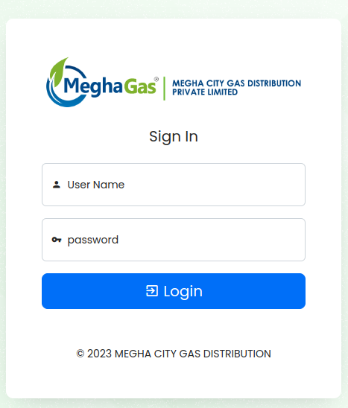

* The user should fill the details to login to the application.
* Username and password must be required to login.

**Dashboard Module :**

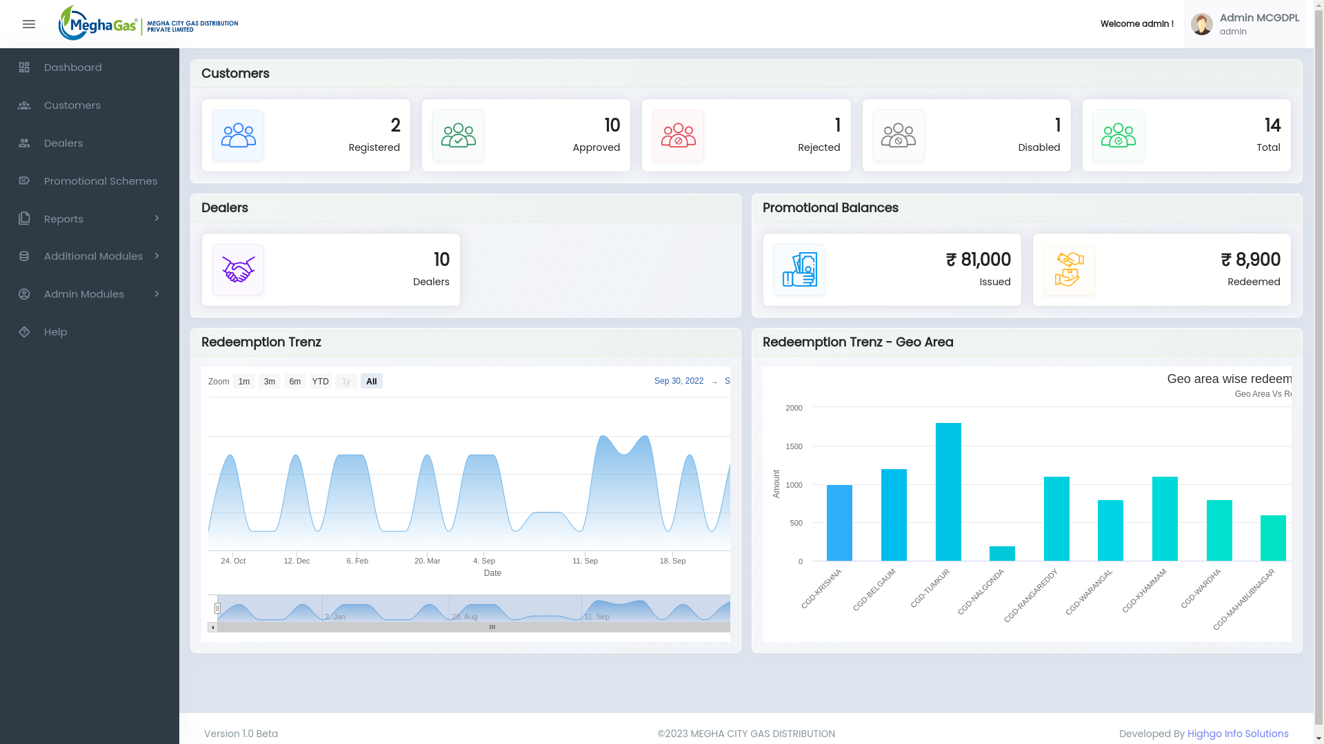

Dashboard consists of overall details of the application.The Graphical representation has been shown in the abvve Fig.

**Customers Module :**

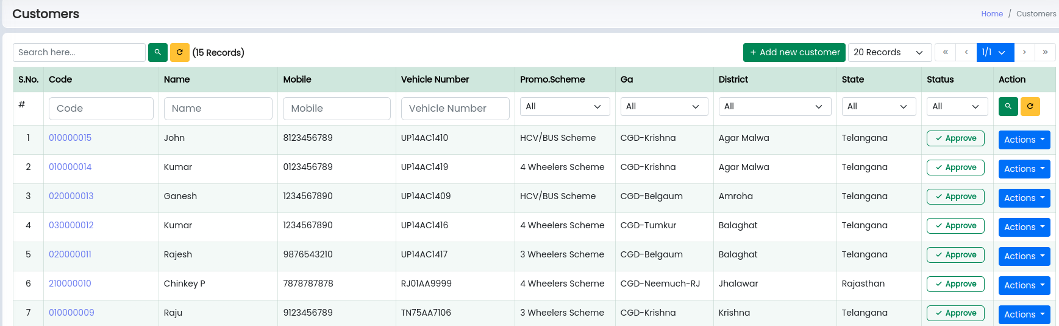

The Above Fig. consists of the list of consumers .In this Module, the customer’s personal details,vehicle details and promotional scheme will be shown.

* Actions Performed in this Module :
  + Add
  + Edit
  + View
  + Status Update
  + Reject
  + Disable

**Add Customer :**

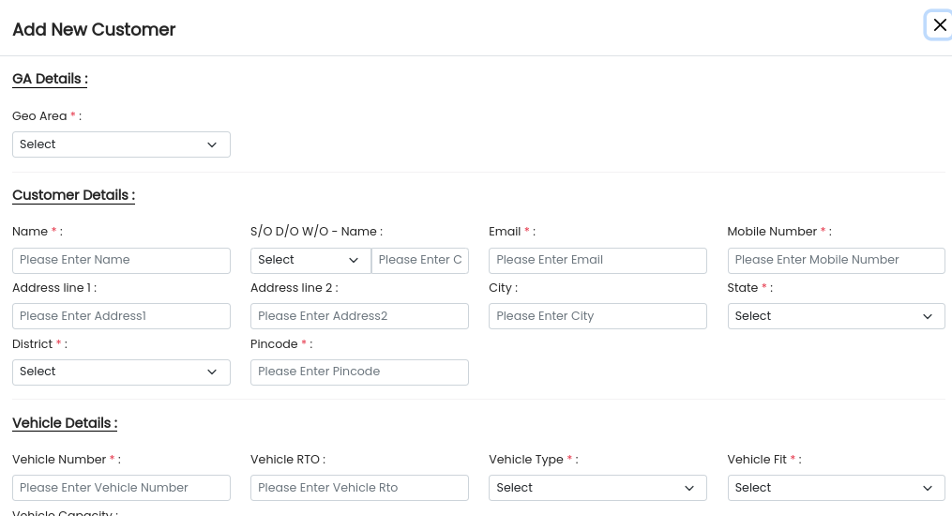

The Form contains GA,Customer,Vehicle,Promotional and document details.All mandatory fields must be required.

**View Customer :**

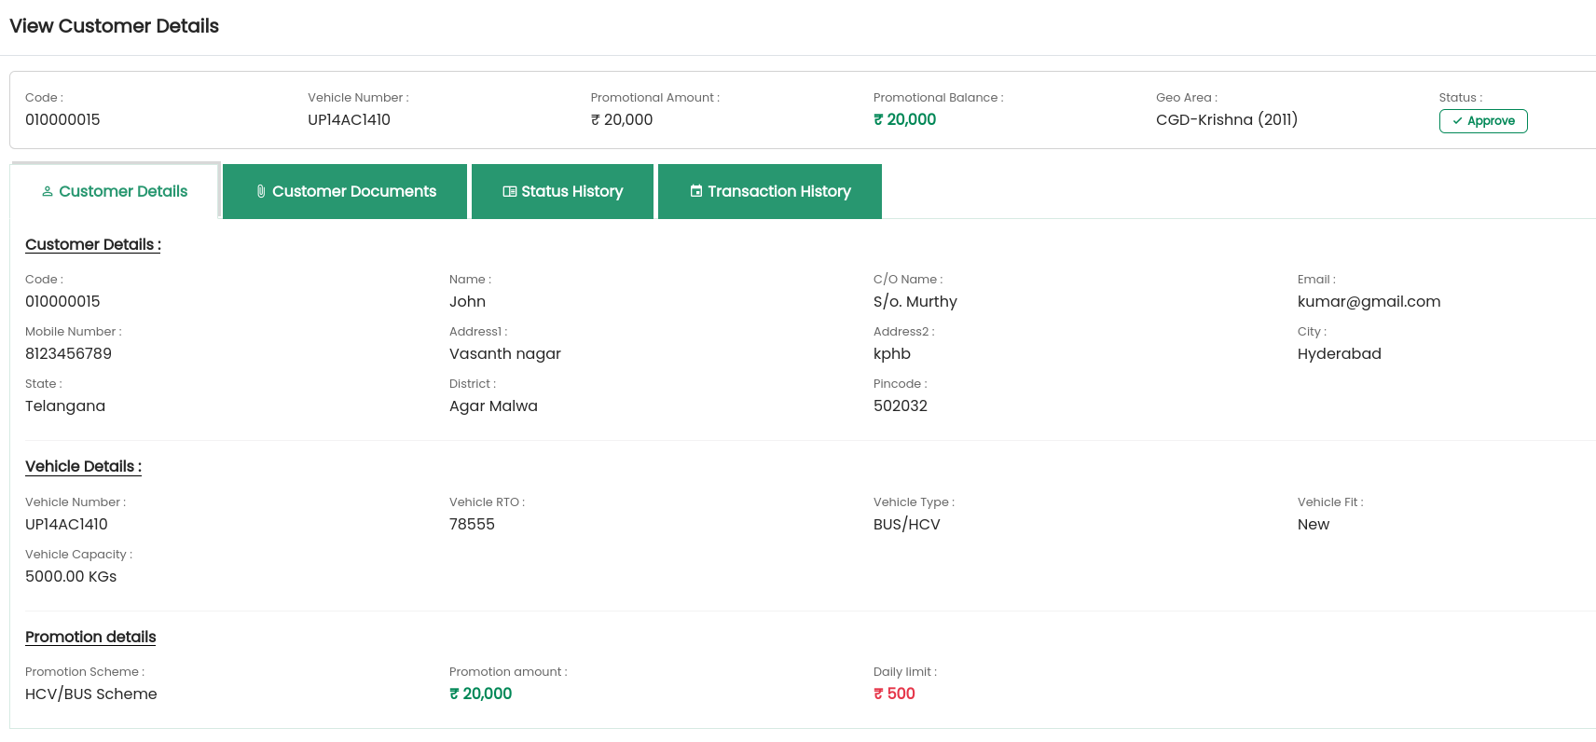

The view action contains all the customer details.In Addition, status history and Transaction history of the customer will be seen.

**Status Disable :**

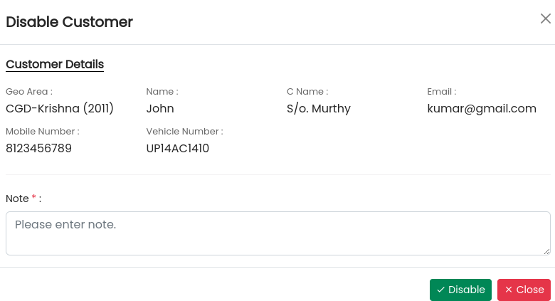

The Form is about the customer details and must have the valid reason to disable the customer.

**Dealers Module :**

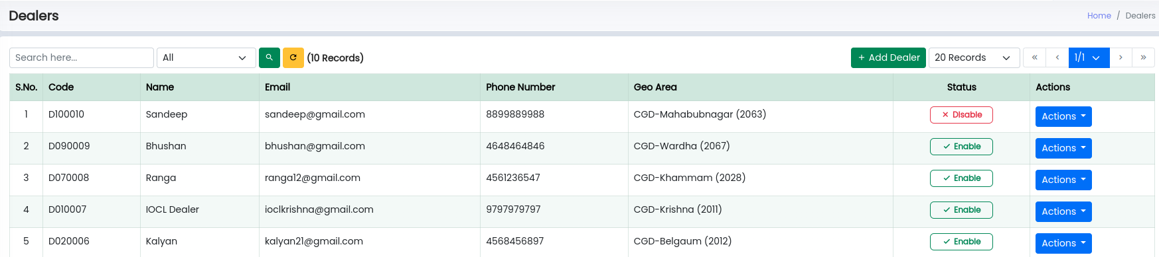

The dealers module consists of the list of dealers from all the geo areas.