**Capstone Project**

**mAadhar Application**

**Problem Statement :** Develop an application to automate the process of applying for an Aadhar Card by making it smoother for Indian citizens.

**Output -**

At first run the backend code, In the backend I had given the port number as 8080. Then run the front end angular project.

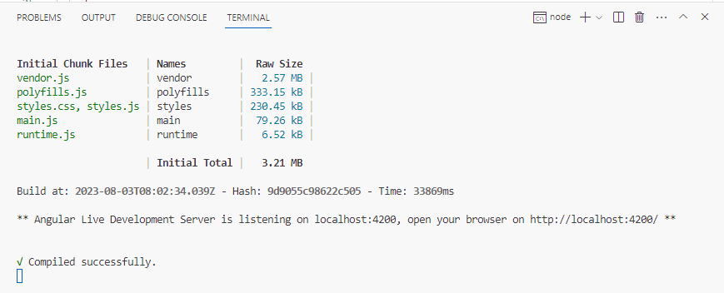

When ng serve is given it is compiled successfully

Home Page :

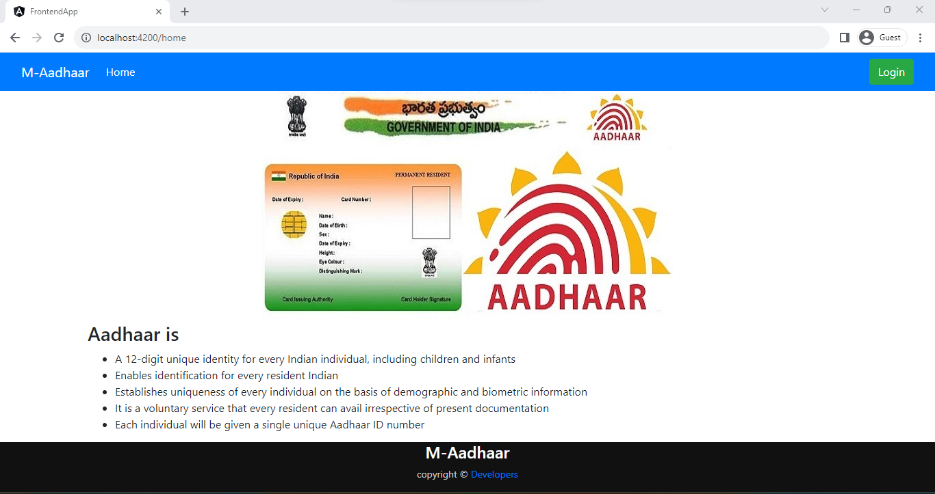

Then login,

At first give the admin detail in database :

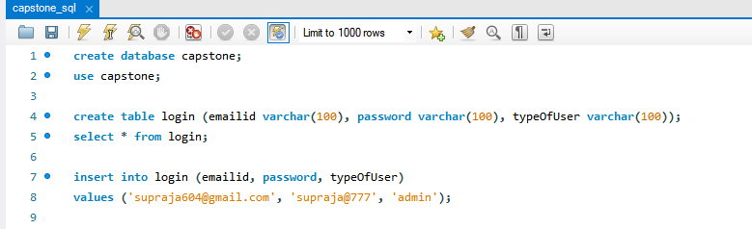

After clicking the Login button:

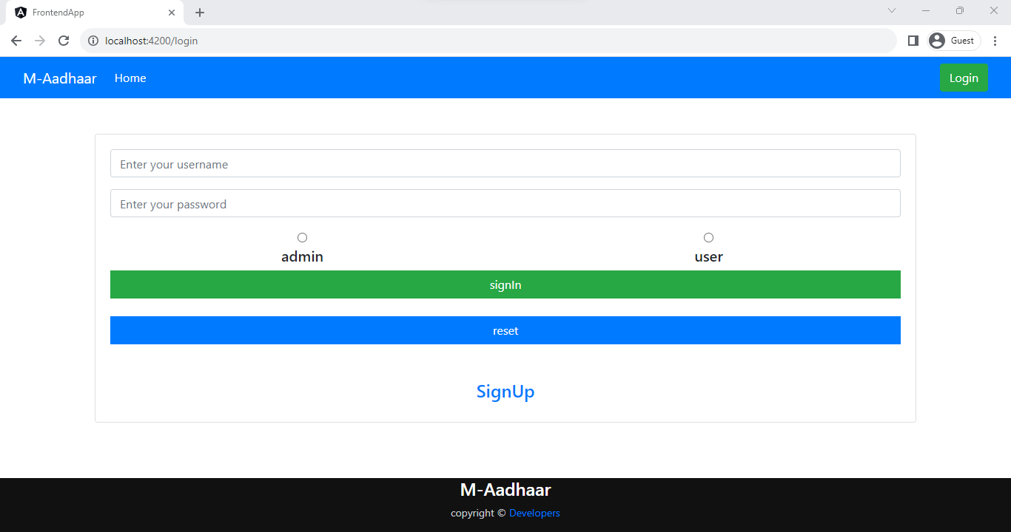

Give the admin login detail that are given in database :

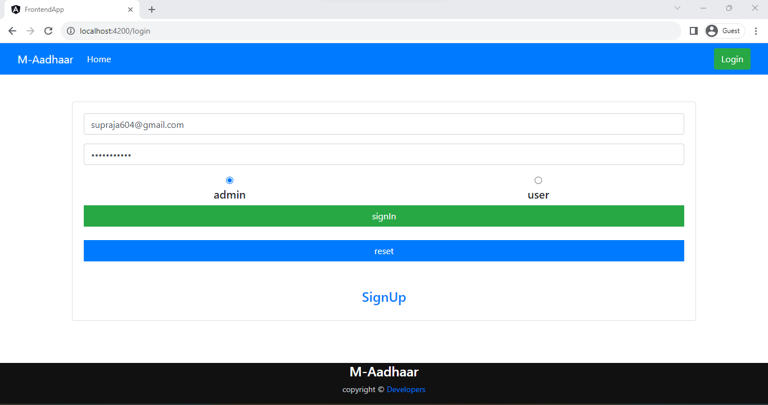

Now click signIn then it will display like this :

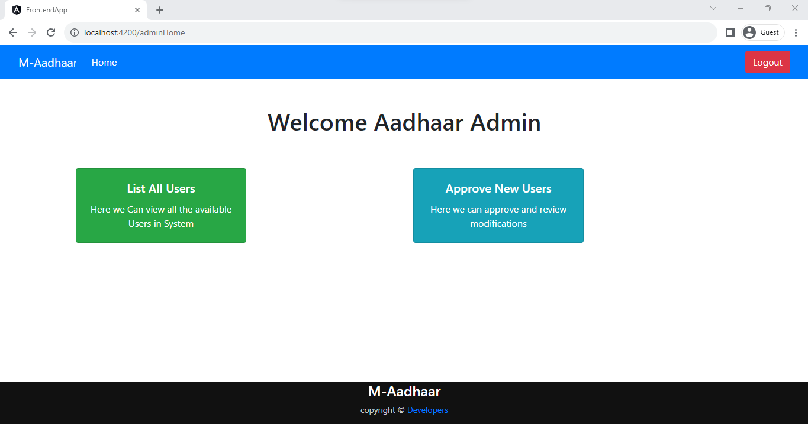

To check the users present click on list of users :

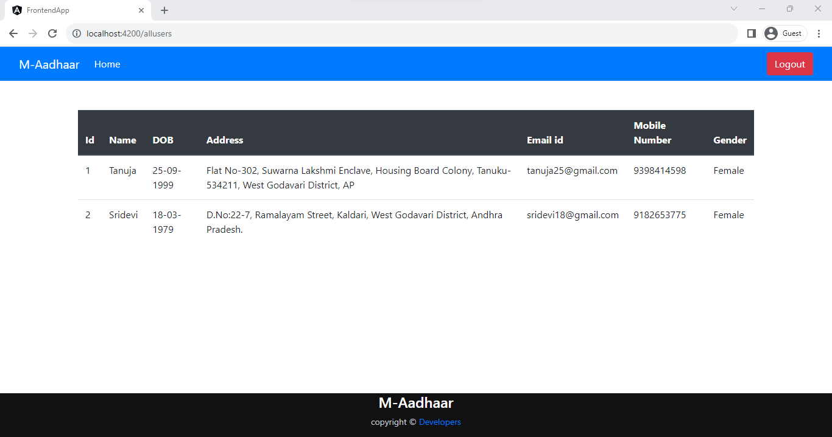

Details already given and if the admin want to approve it then in the above page click on approve new user :

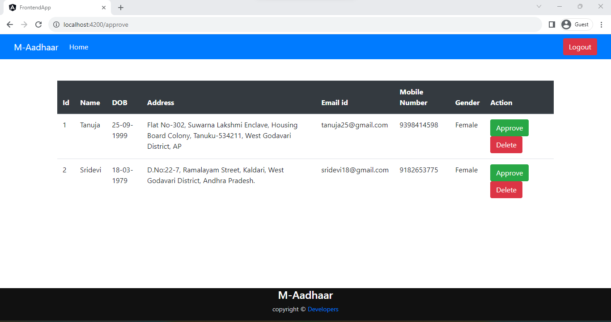

Now to register new user at second page click signUp with new details :

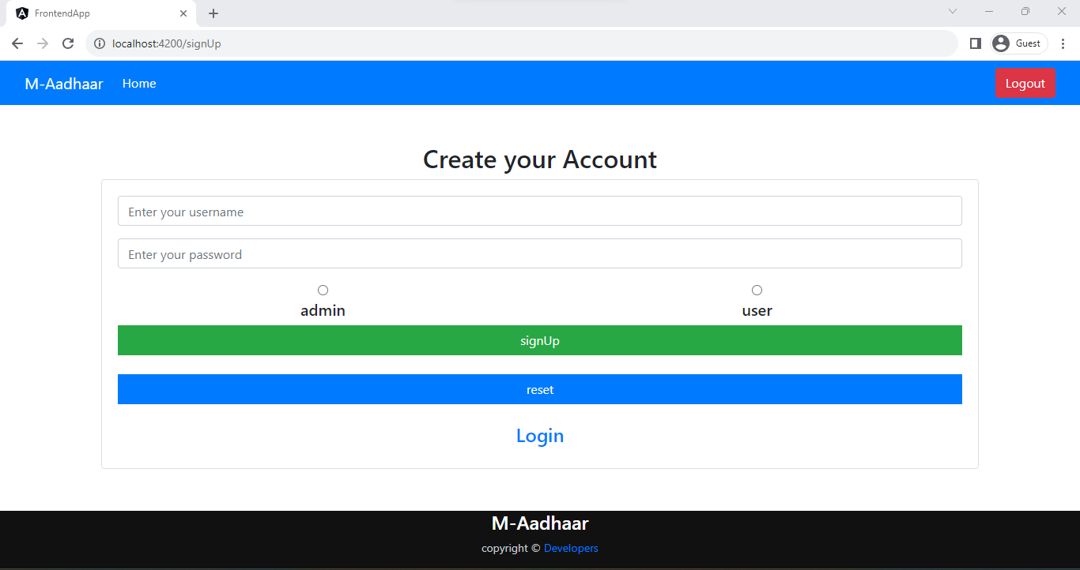

To create new account of Aadhar,

Give user details:

New user registration details :

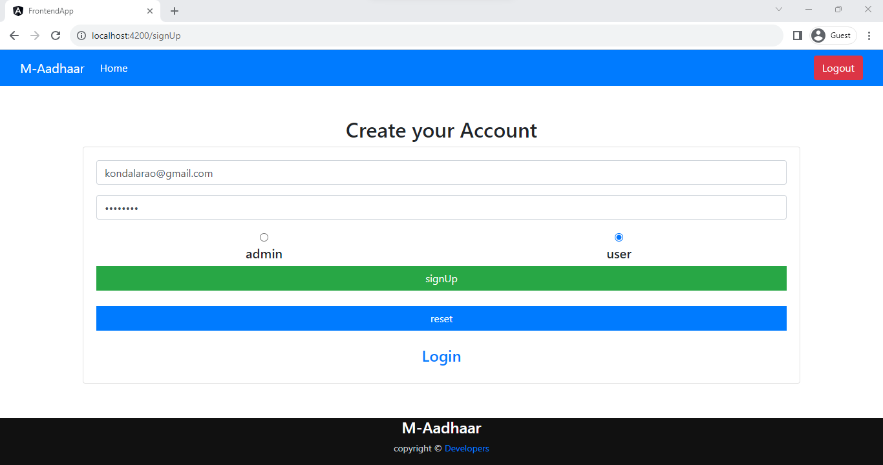

Then signUp and login :

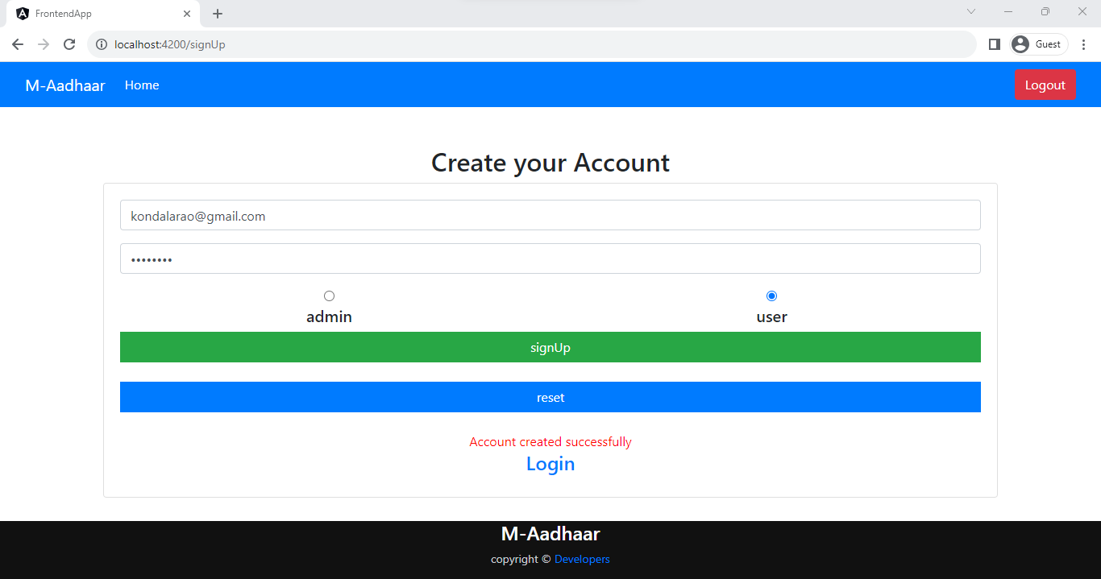

User login :

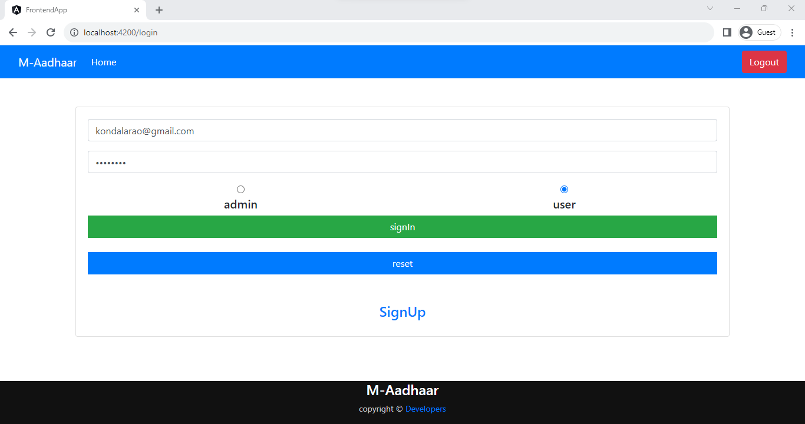

User home page :

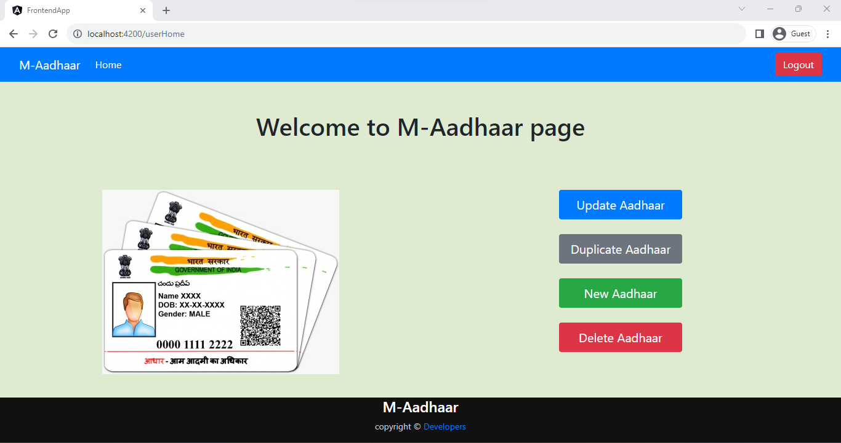

To Add new Aadhar :

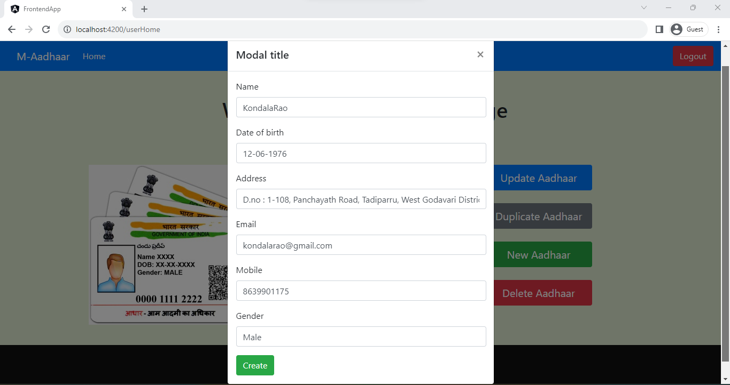

New Aadhar registration :

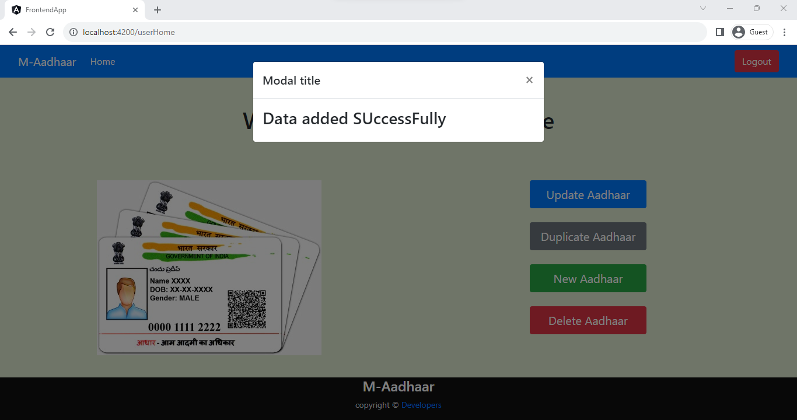

When we want to update it will update successfully :

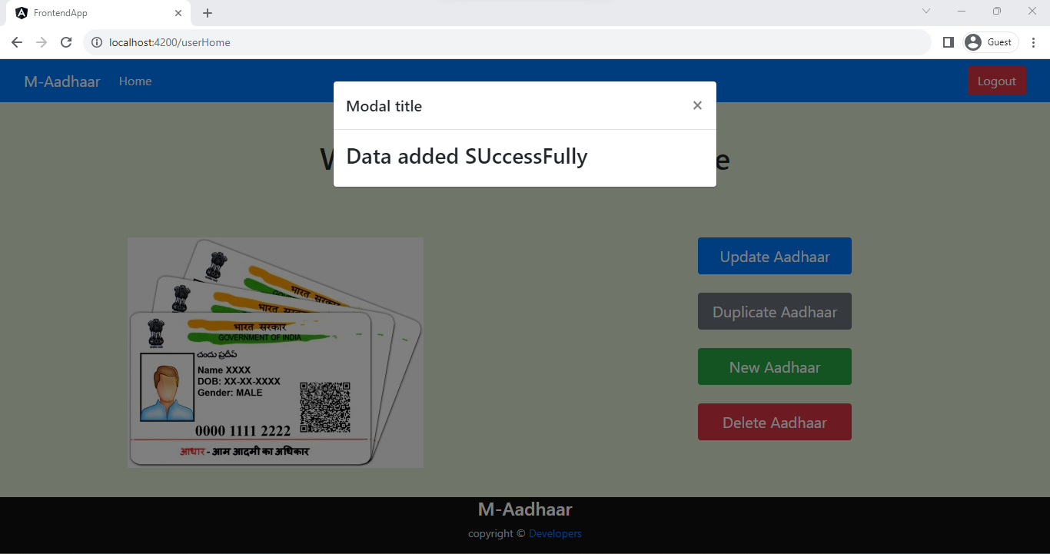

When any duplicate details are given :

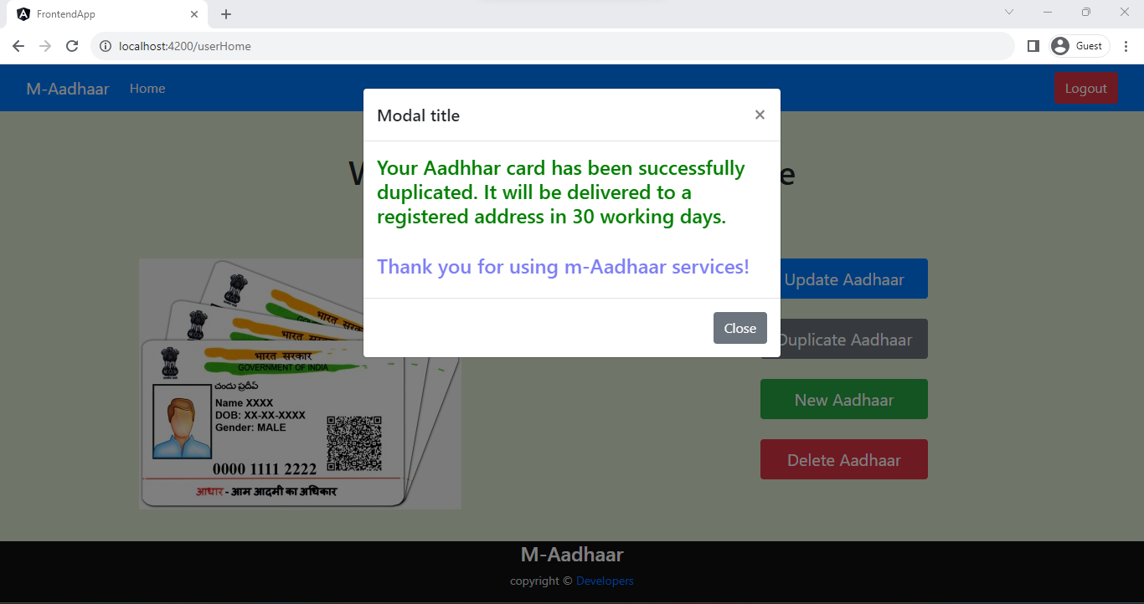

Delete :

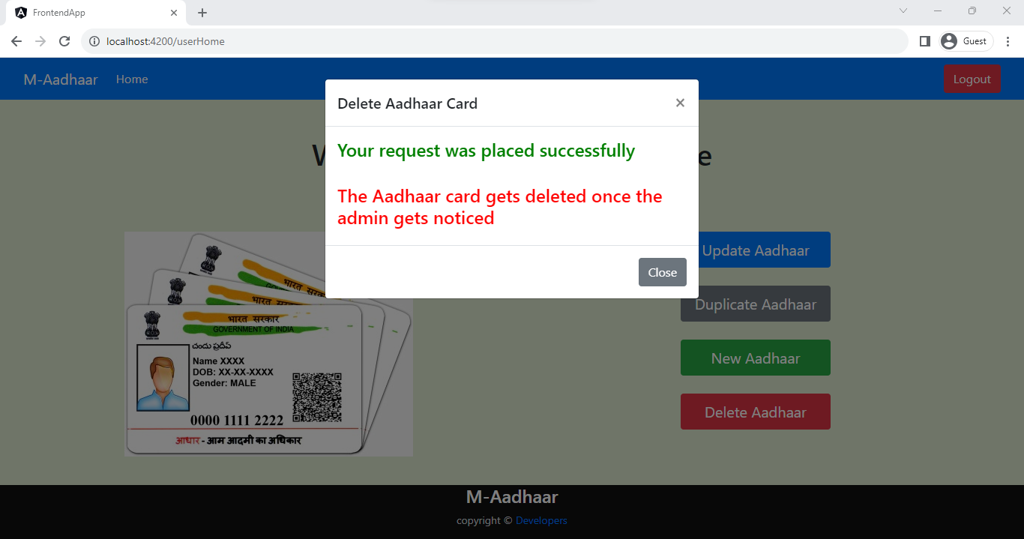

Now admin can check the details : List of users

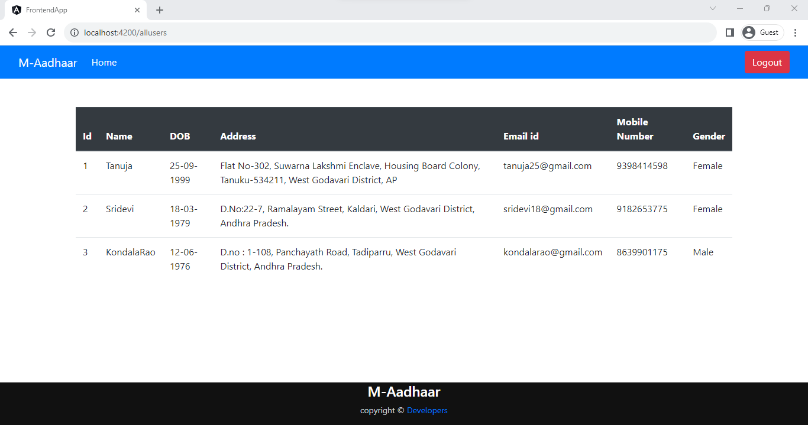

Now admin can check the details : approval of user

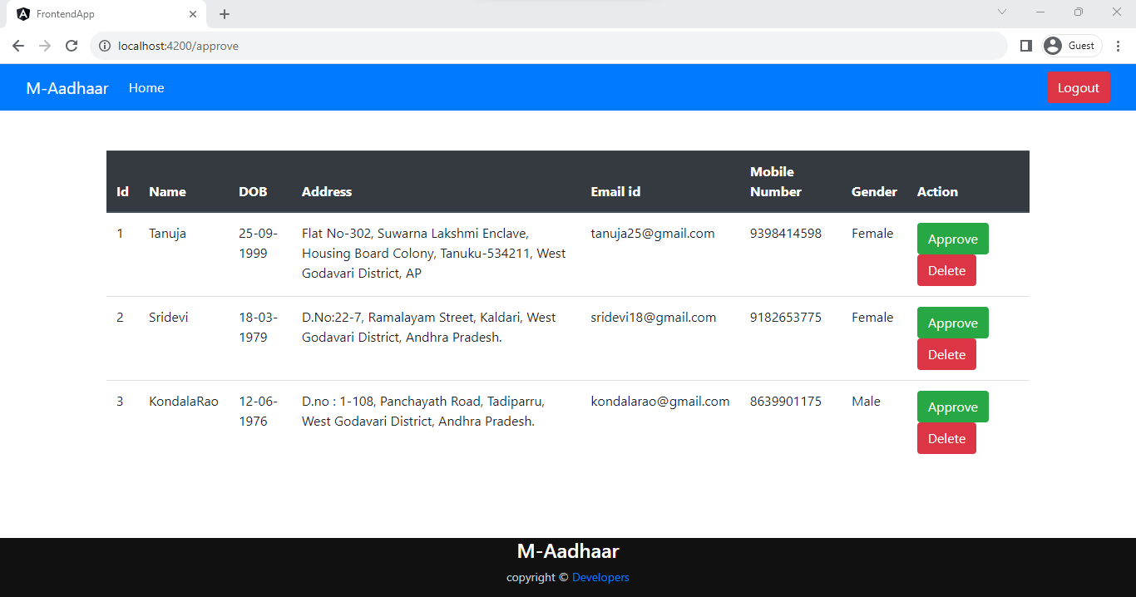

When admin approved :

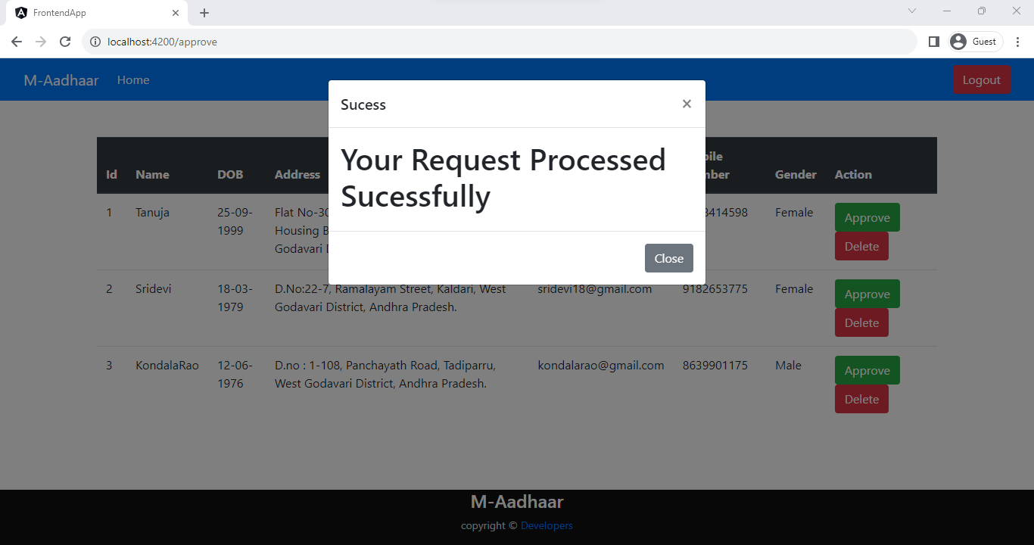

When admin want to delete the user :

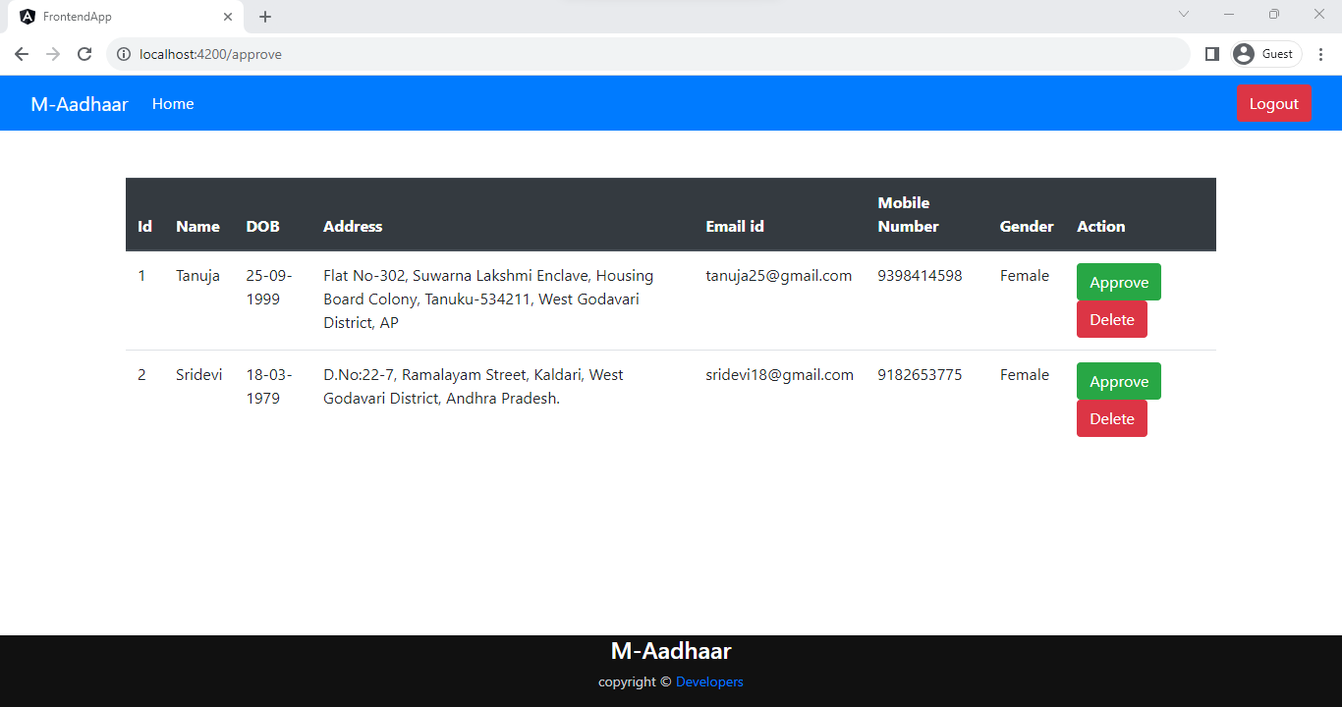

It will be deleted,

It can be checked in list of users :



Now logout,

Using the button present at top right corner :

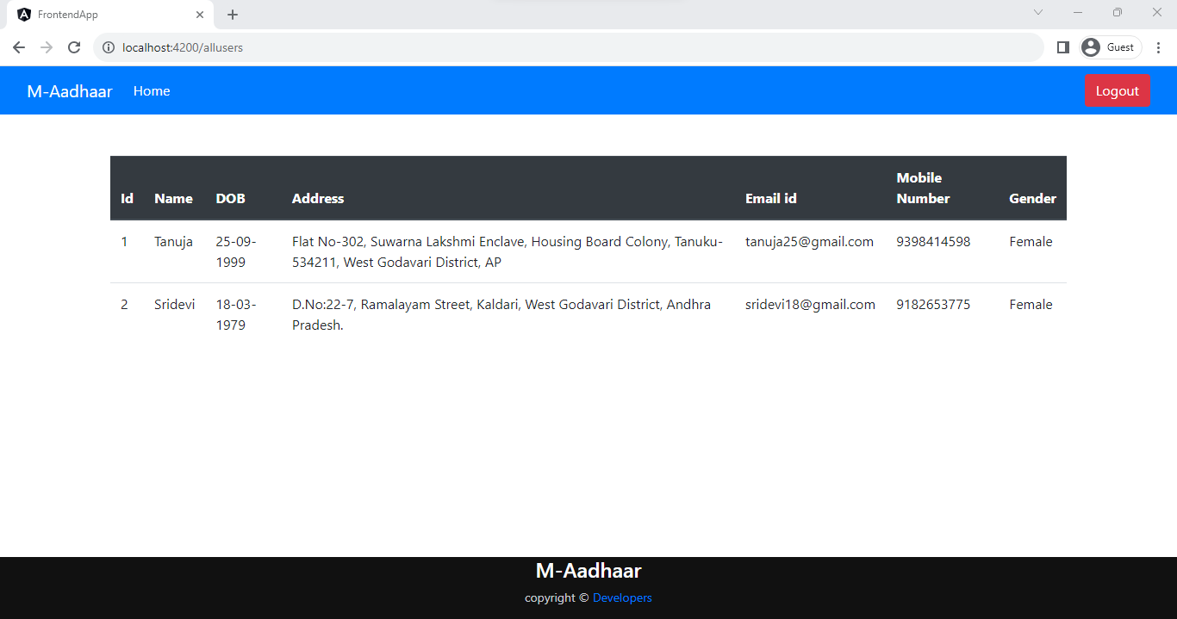

To test the application a test class is used :

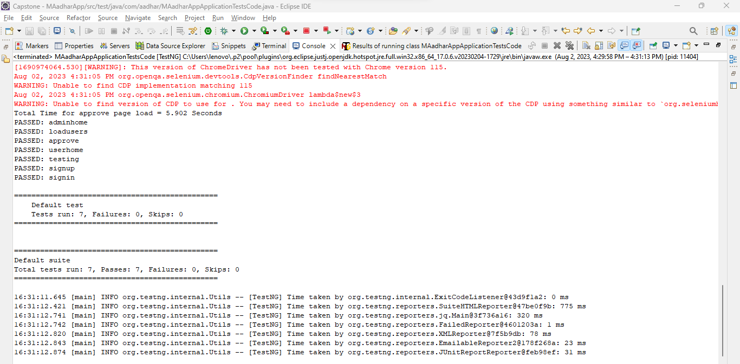

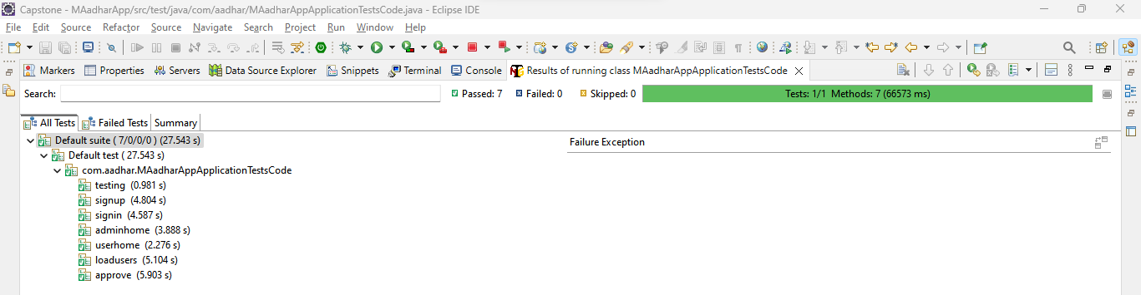

Priority - 0 :

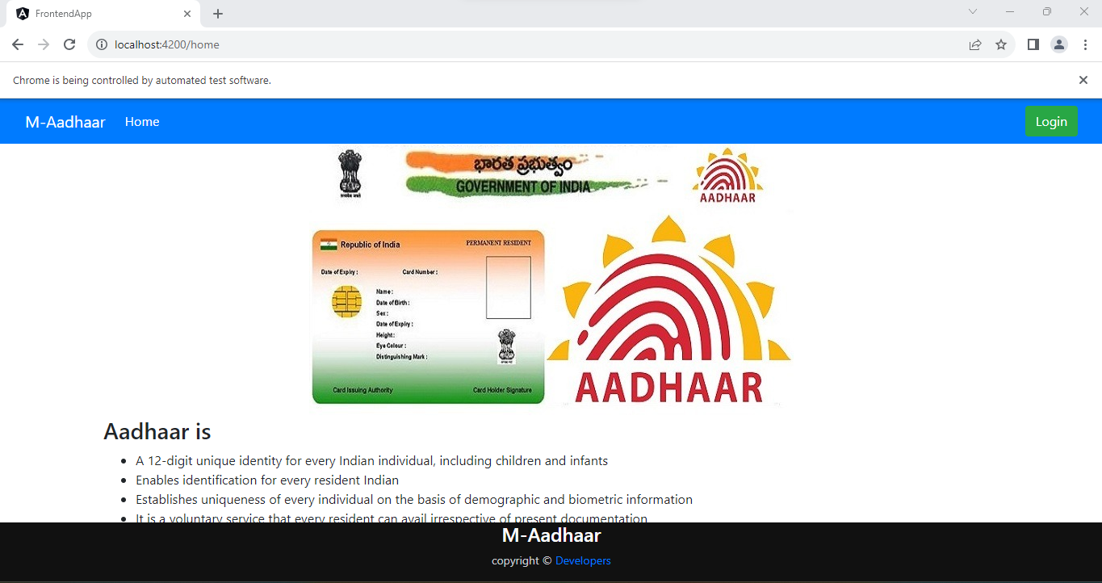

Priority - 1 :

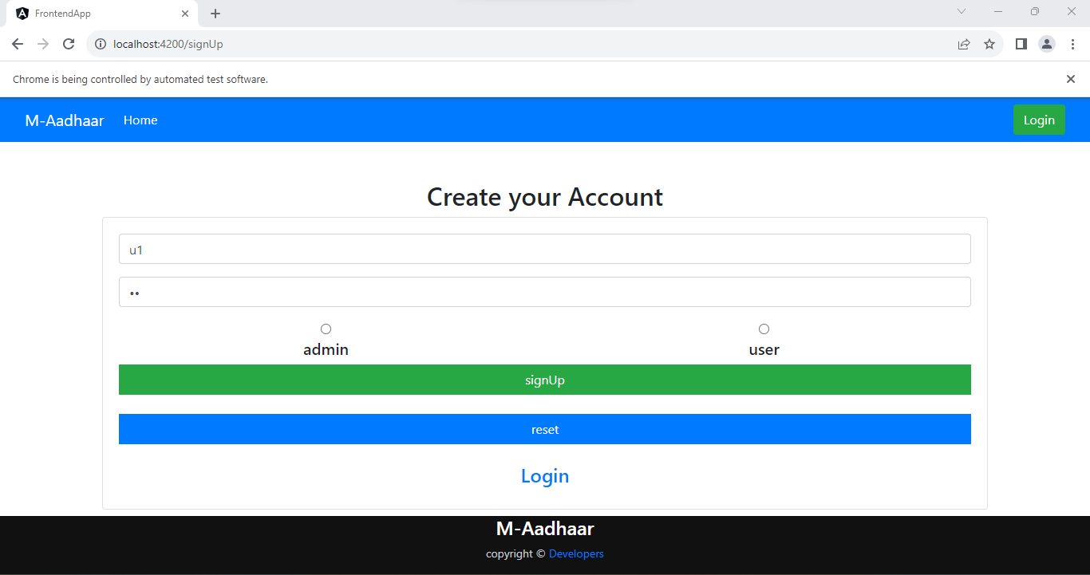

Login details of admin are wrong : priority-2

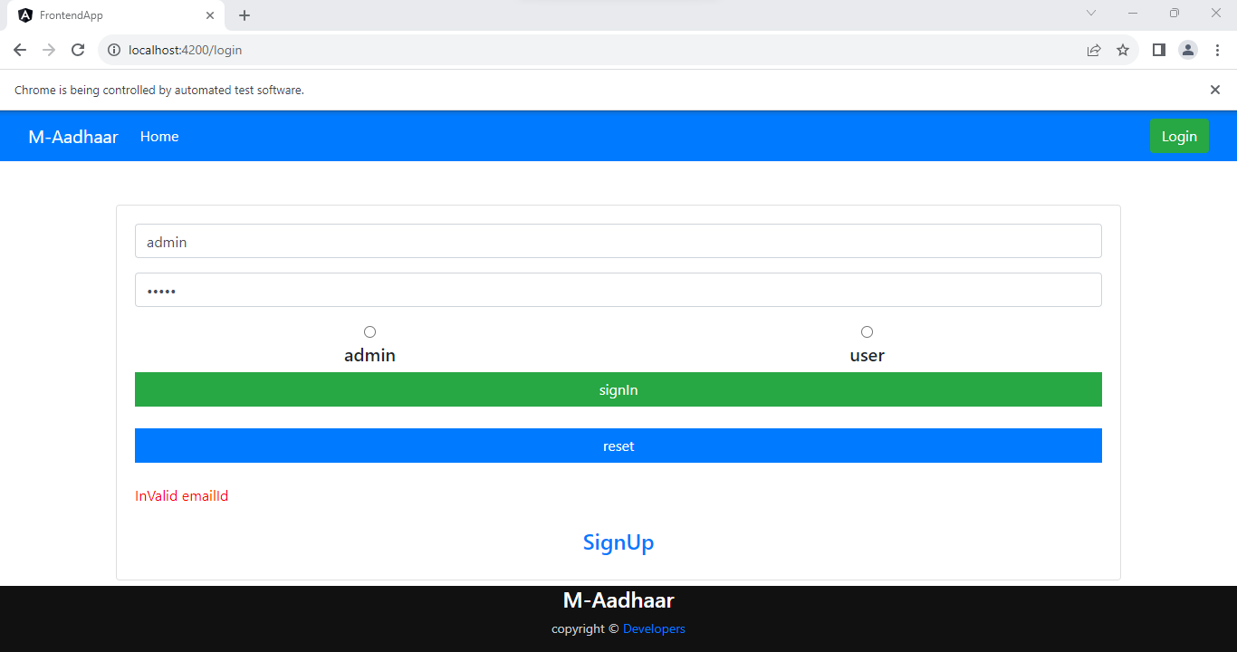

Priority - 3 :

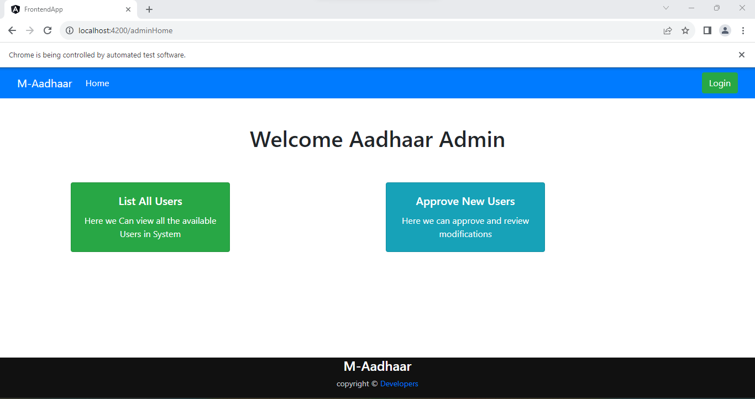

Priority - 4 :

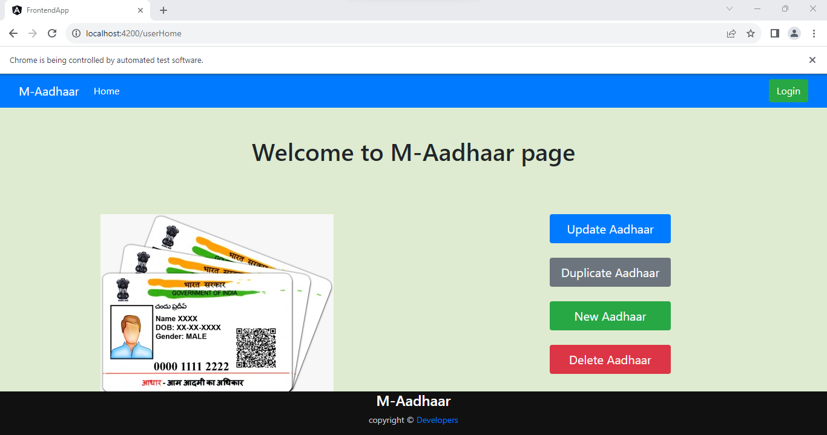

Priority - 5 :

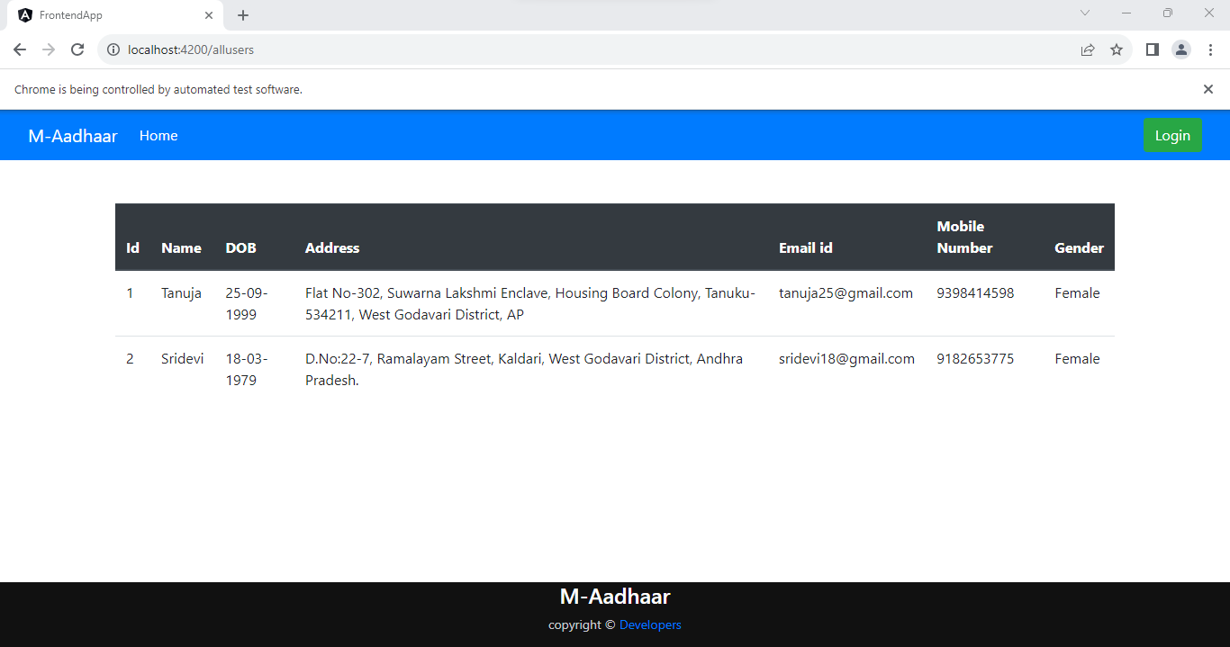

Priority - 6 :

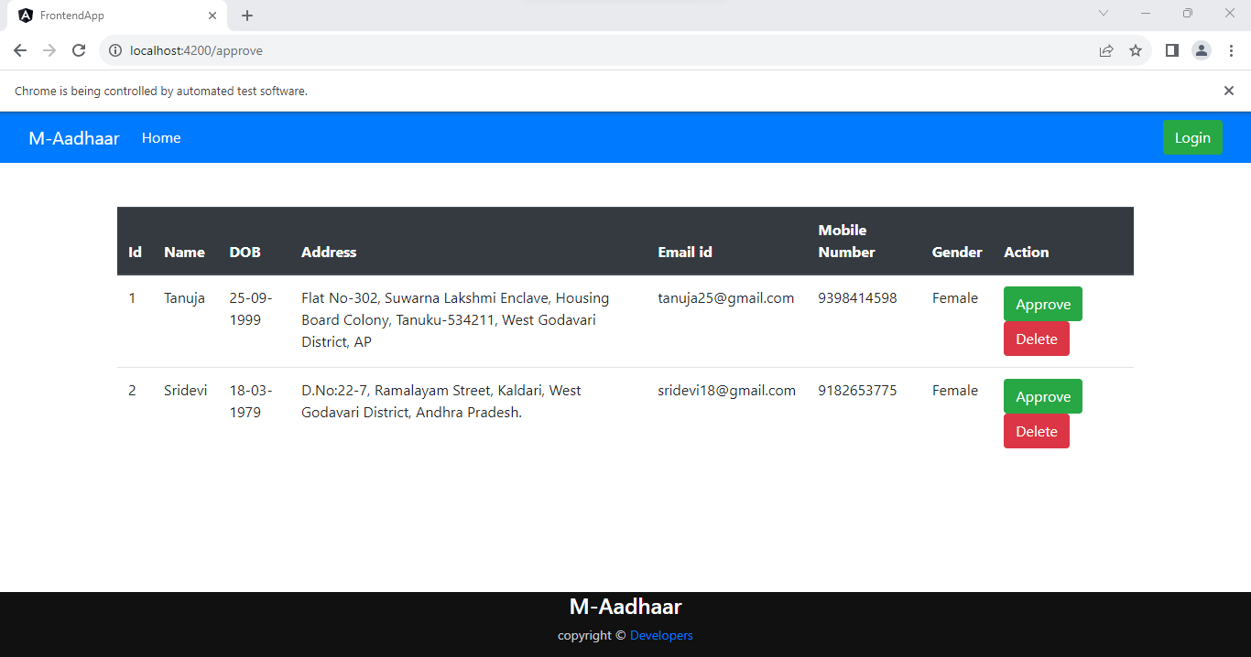

Now, Creating a JENKIN pipeline :

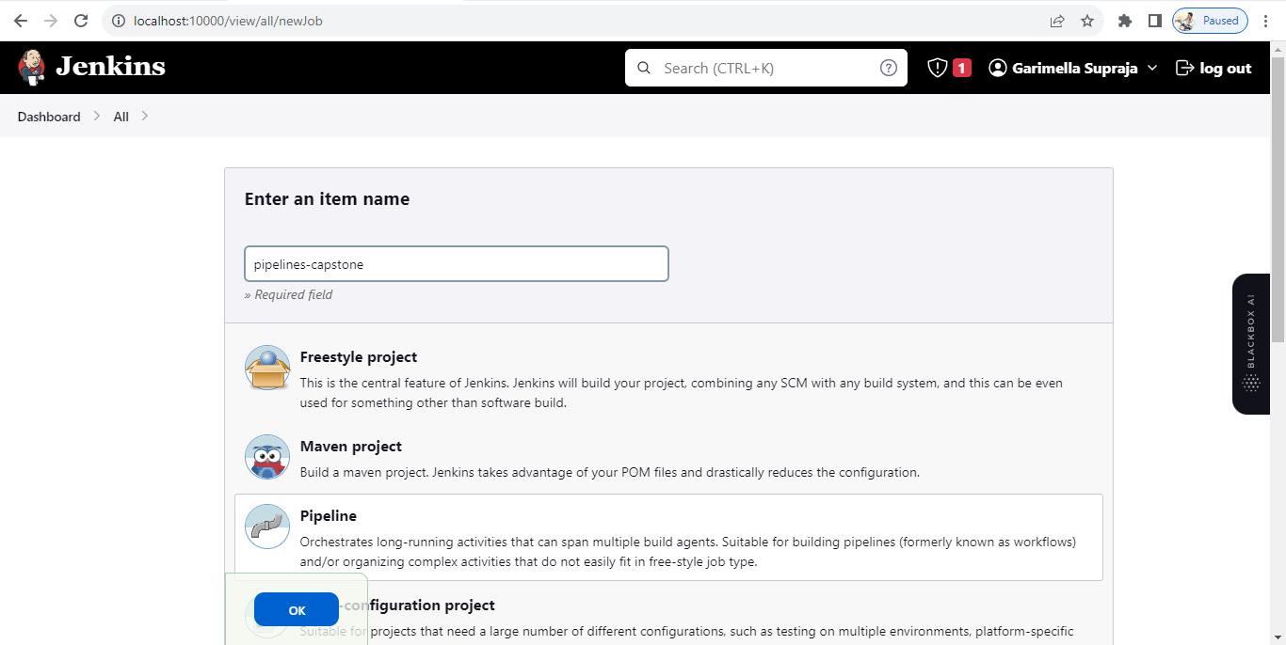

Configuring pipeline :

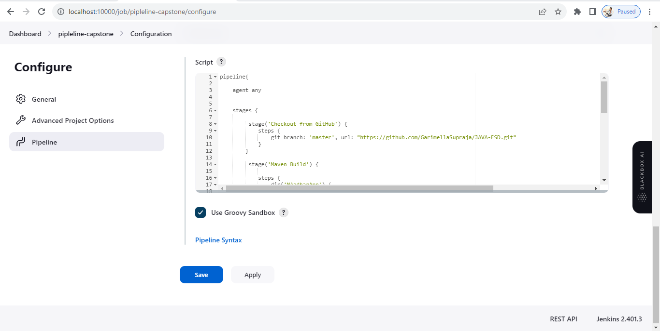

Console Output :

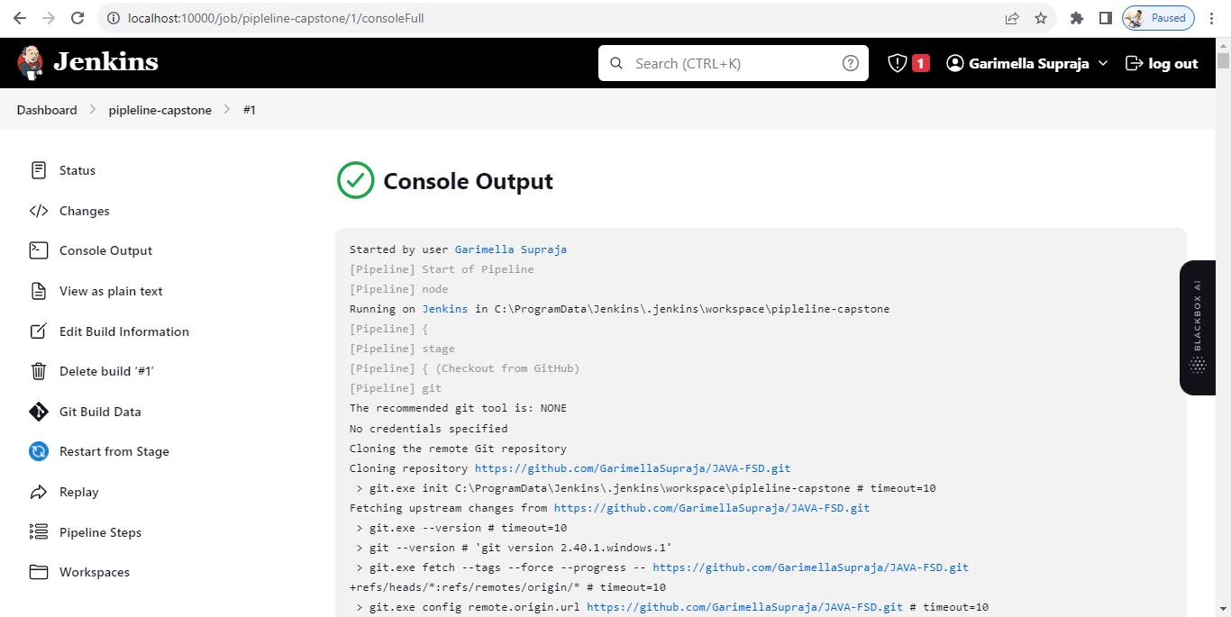

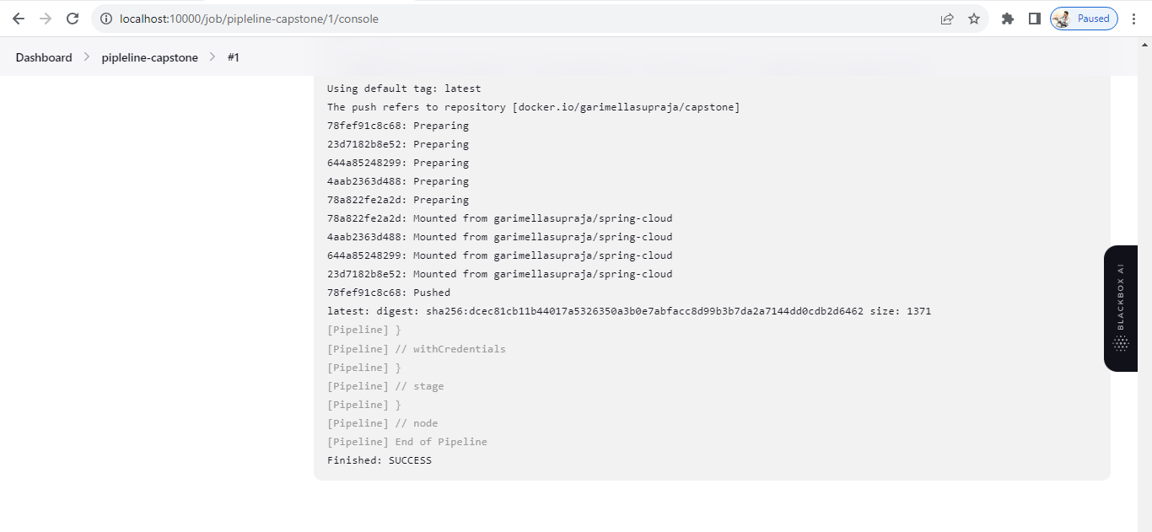

Build Status :

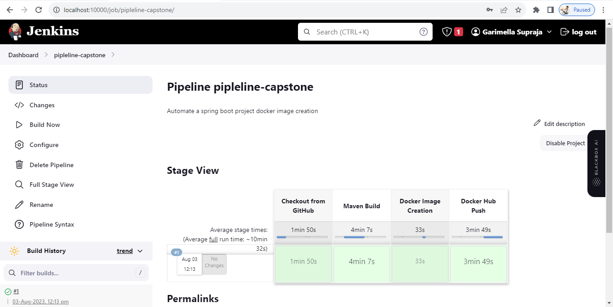

After pushing into Docker, status of Docker repository :

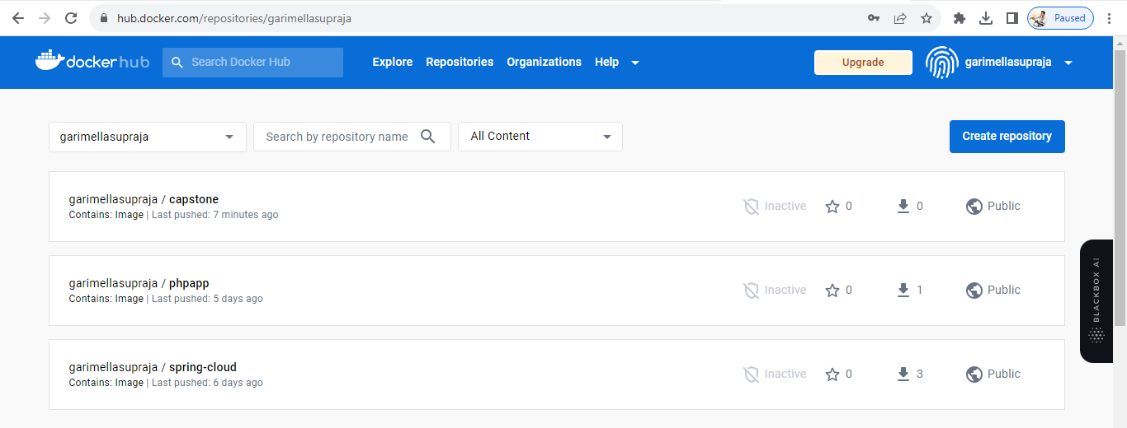

**Github Link :**

https://github.com/GarimellaSupraja/Capstone_Project.git