PES UNIVERSTIY

Personalized e-Portfolio Management System for PESU Students
Student Name: Kusumita
SRN: PES2UG22CS278
Department: CSE

STEP 1: CREATING DATABASE & TABLES

Screenshot 1.2: CREATE TABLE - STUDENT
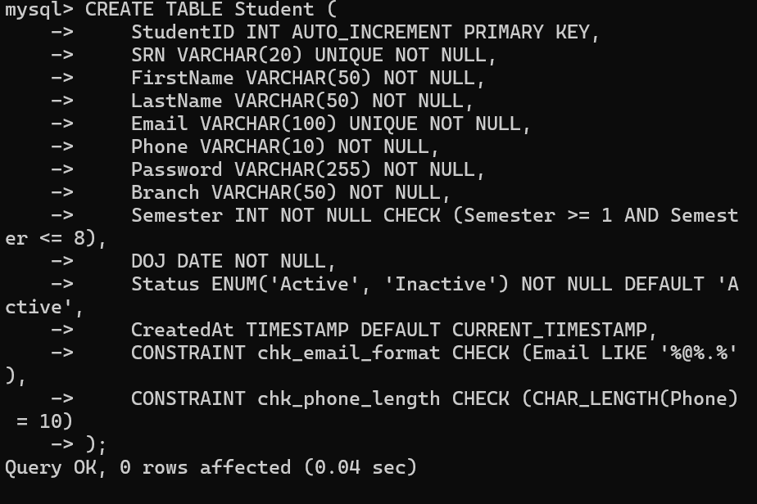
Constraints Highlighted:
- PRIMARY KEY: StudentID
- UNIQUE KEY: SRN, Email
- NOT NULL: All major fields
- CHECK: Semester range (1-8), Email format, Phone length (10 digits)
- DEFAULT: Status = 'Active', CreatedAt = CURRENT_TIMESTAMP

Screenshot 1.3: CREATE TABLE - ADMIN
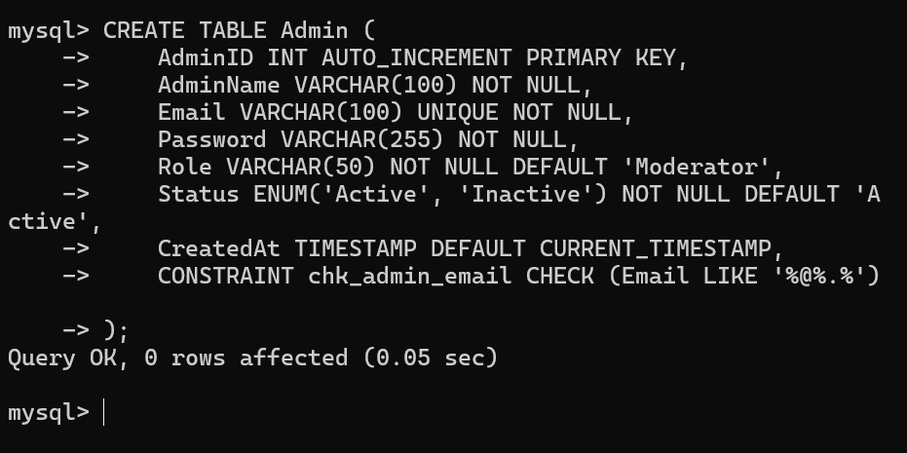
Constraints Highlighted:
- PRIMARY KEY: AdminID
- UNIQUE KEY: Email
- DEFAULT: Role = 'Moderator', Status = 'Active'
- CHECK: Email format validation

Screenshot 1.4: CREATE TABLE – PORTFOLIO
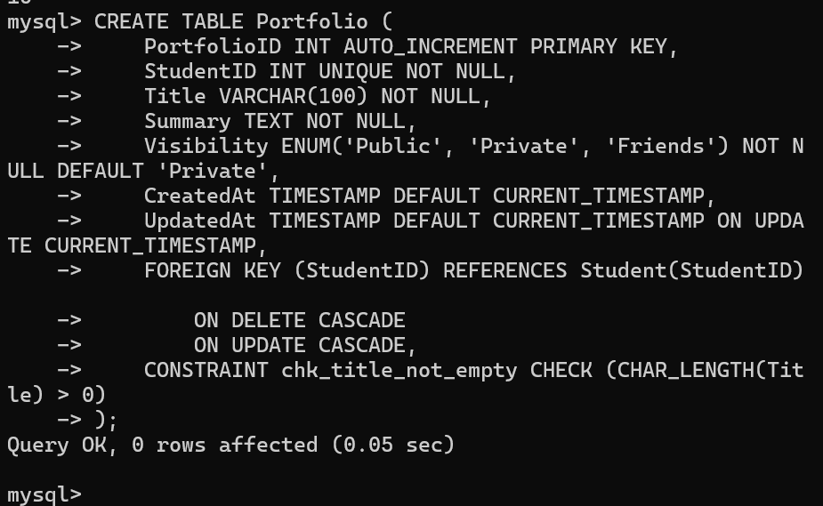
Constraints Highlighted:
- PRIMARY KEY: PortfolioID
- FOREIGN KEY: StudentID with ON DELETE CASCADE, ON UPDATE CASCADE
- UNIQUE KEY: StudentID (1:1 relationship with Student)
- DEFAULT: Visibility = 'Private', CreatedAt, UpdatedAt
- CHECK: Title not empty
- AUTO_UPDATE: UpdatedAt on every update

SCREENSHOT 1.5 :CREATE TABLE – PROJECT
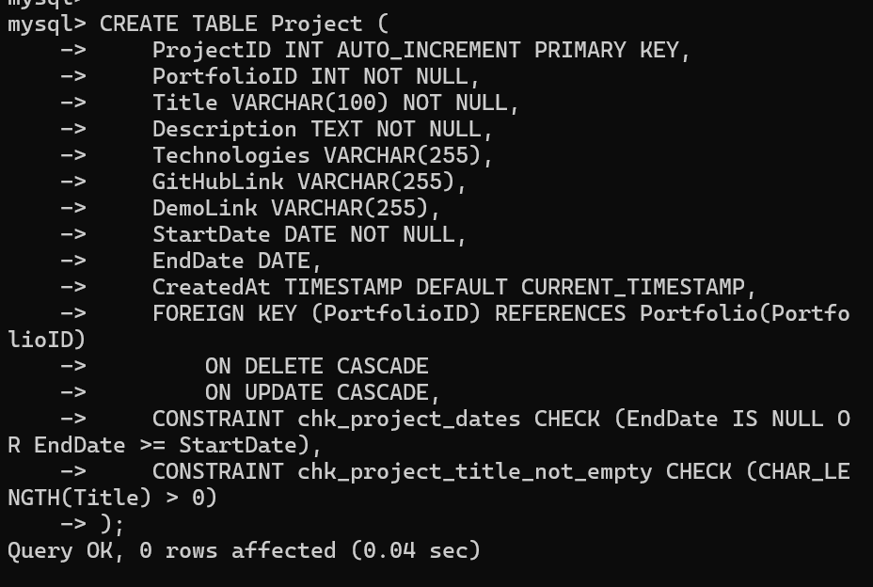
Constraints Highlighted:
- PRIMARY KEY: ProjectID
- FOREIGN KEY: PortfolioID with ON DELETE CASCADE, ON UPDATE CASCADE
- NOT NULL: Title, Description, StartDate
- CHECK: EndDate >= StartDate validation
- DEFAULT: CreatedAt

Screenshot 1.5: CREATE TABLE - CERTIFICATION
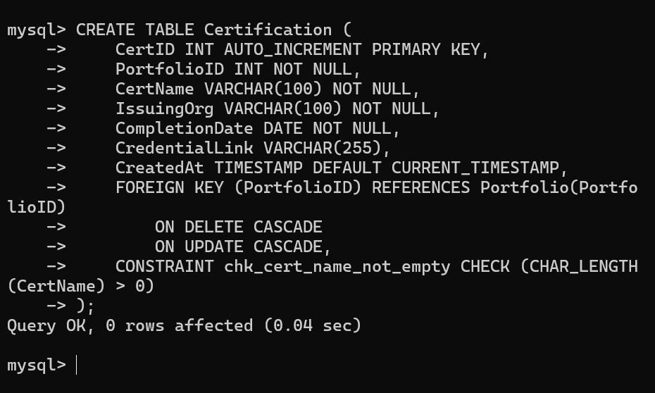
Constraints Highlighted:
- PRIMARY KEY: CertID
- FOREIGN KEY: PortfolioID with referential integrity
- NOT NULL: CertName, IssuingOrg, CompletionDate
- CHECK: CertName validation

Screenshot 1.6: CREATE TABLE - SKILL
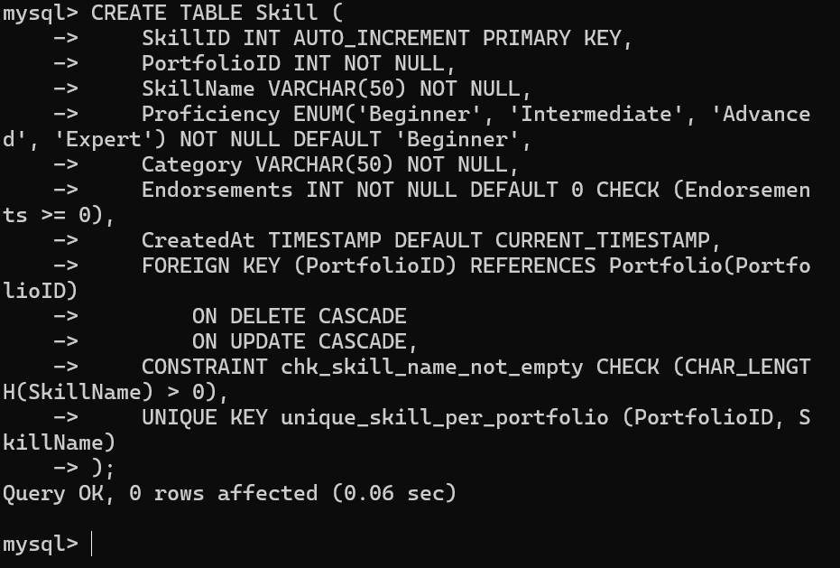
Constraints Highlighted:
- PRIMARY KEY: SkillID
- FOREIGN KEY: PortfolioID with ON DELETE CASCADE
- UNIQUE KEY: Composite (PortfolioID, SkillName) - prevents duplicate skills per portfolio
- DEFAULT: Proficiency = 'Beginner', Endorsements = 0
- CHECK: SkillName not empty, Endorsements >= 0

Screenshot 1.7: CREATE TABLE – COURSEWORK
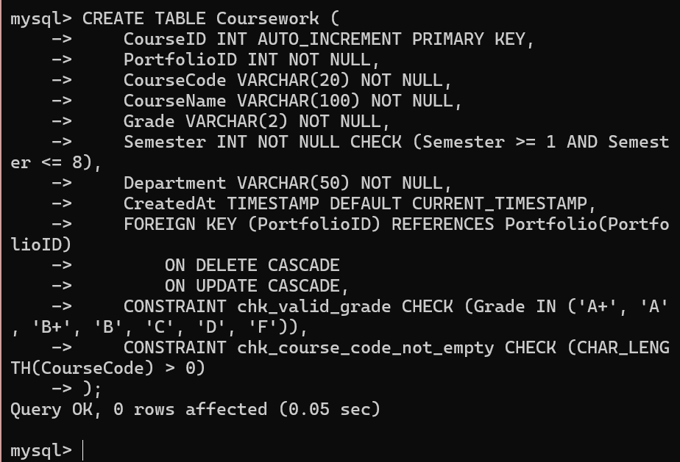
Constraints Highlighted:
- PRIMARY KEY: CourseID
- FOREIGN KEY: PortfolioID with CASCADE operations
- CHECK: Grade validation (only valid grades allowed)
- CHECK: Semester range (1-8)
- NOT NULL: CourseCode, CourseName, Grade

Screenshot 1.8: CREATE TABLE - ACHIEVEMENT

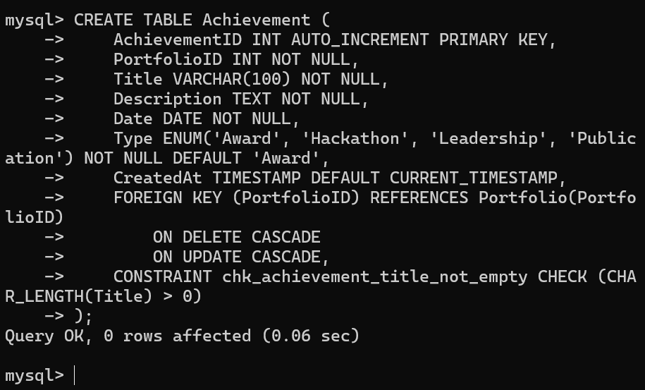
Constraints Highlighted:
- PRIMARY KEY: AchievementID
- FOREIGN KEY: PortfolioID with referential integrity
- ENUM: Type restricted to specific achievement types
- DEFAULT: Type = 'Award'
- CHECK: Title validation

Screenshot 1.9: CREATE TABLE - INTEREST
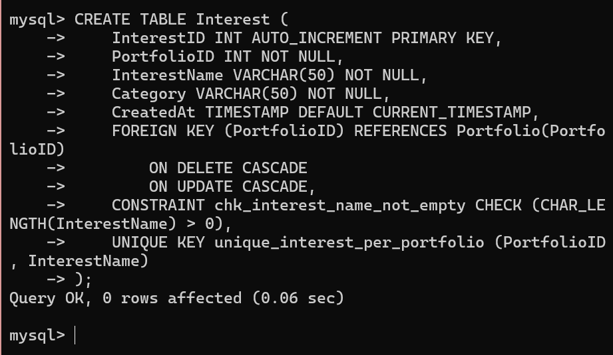
Constraints Highlighted:
- PRIMARY KEY: InterestID
- FOREIGN KEY: PortfolioID with CASCADE
- UNIQUE KEY: Composite key prevents duplicate interests
- CHECK: InterestName validation

Screenshot 1.11: CREATE TABLE – SKILLANAYTICS
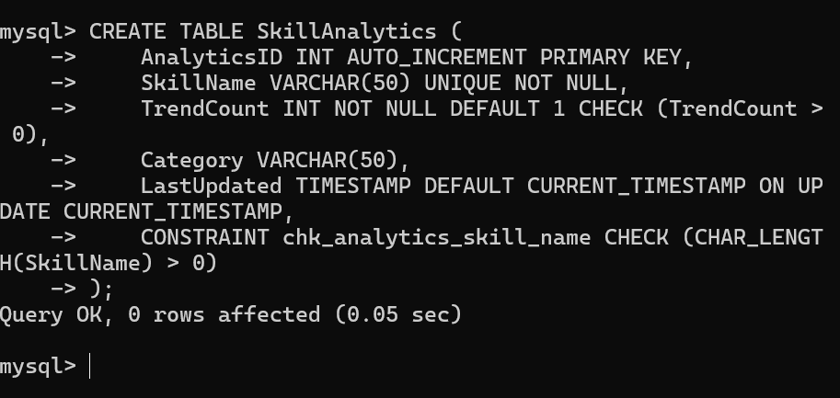
Constraints Highlighted:
- PRIMARY KEY: AnalyticsID
- UNIQUE KEY: SkillName
- DEFAULT: TrendCount = 1, LastUpdated auto-updates
- CHECK: SkillName not empty, TrendCount > 0

STEP 2: VERIFY ALL TABLES CREATED
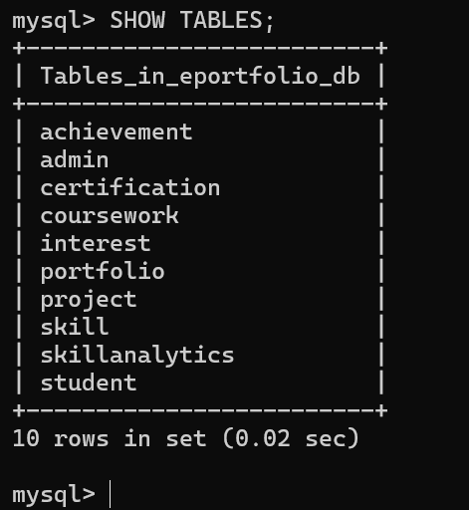

STEP 3: DATA INSERTION (DML)

Screenshot 3.1: Insert Student Data
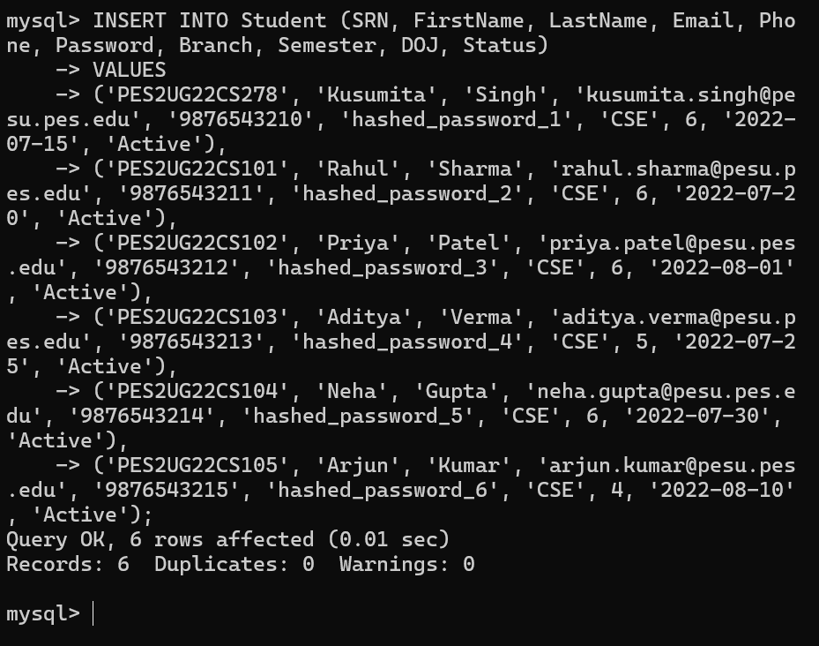

Screenshot 3.2: Insert Admin Data
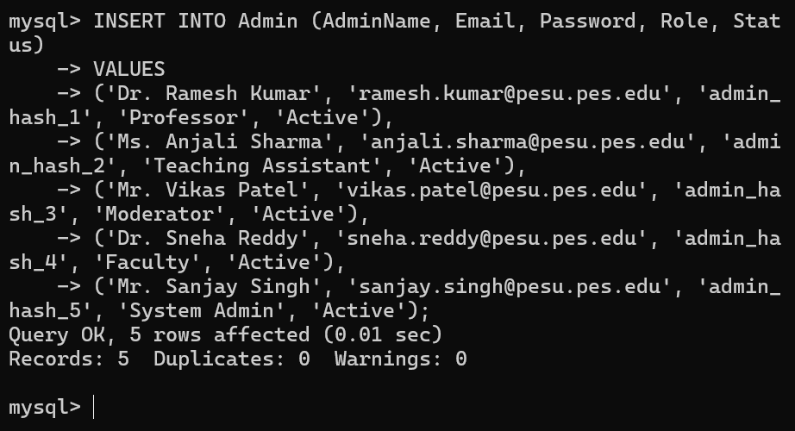

Screenshot 3.3: Insert Portfolio Data
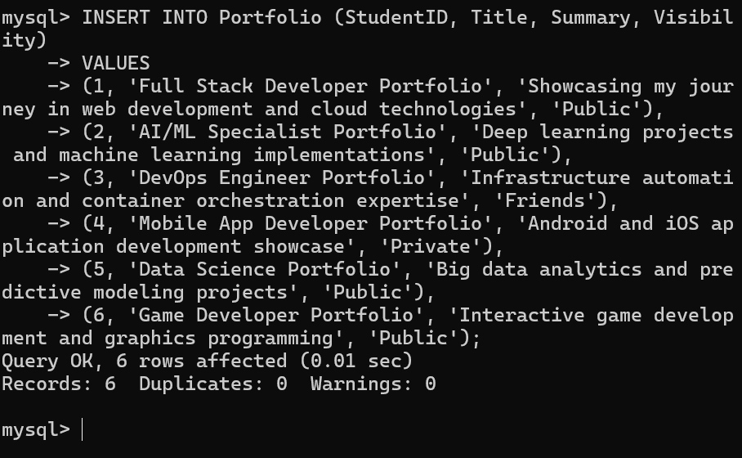

Screenshot 3.4: Insert Project Data
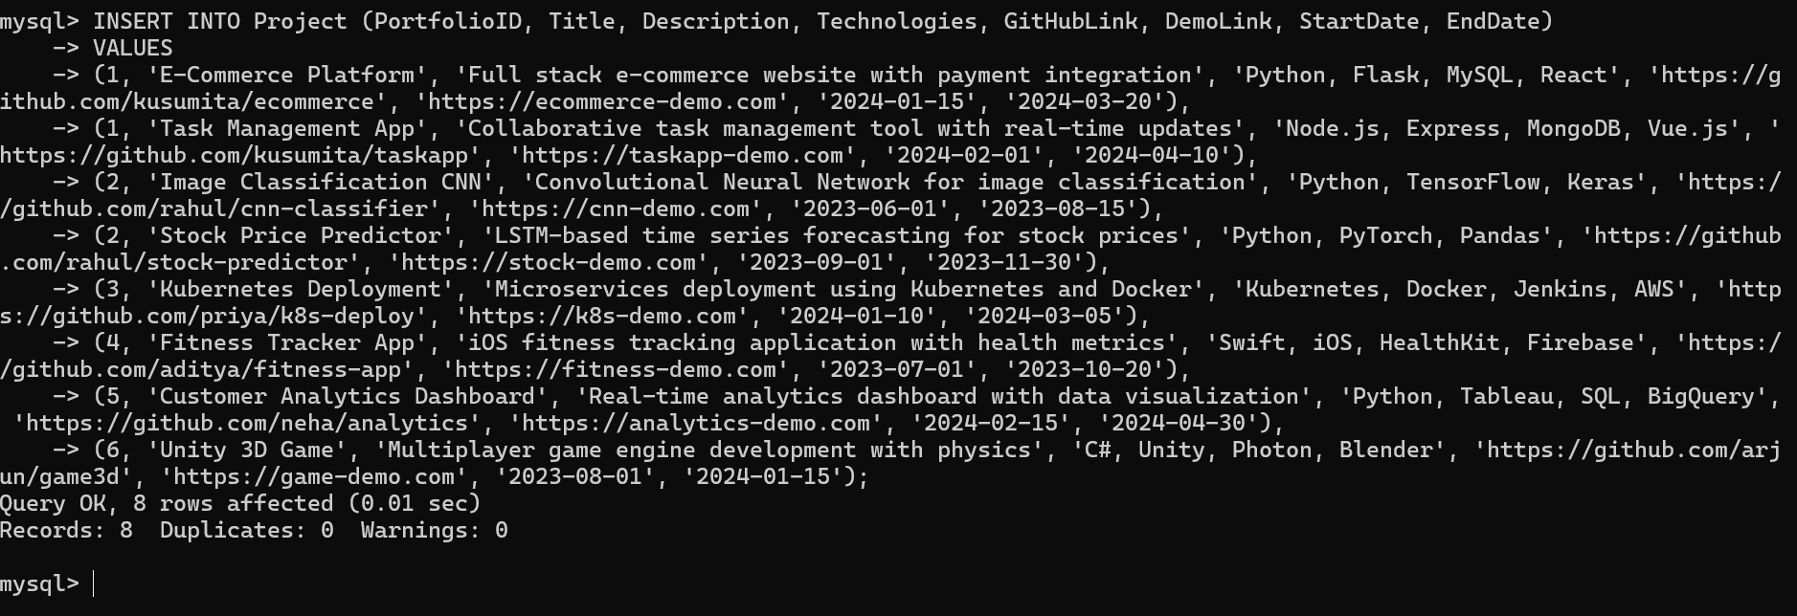

Screenshot 3.5: Insert Certification Data (6 rows)
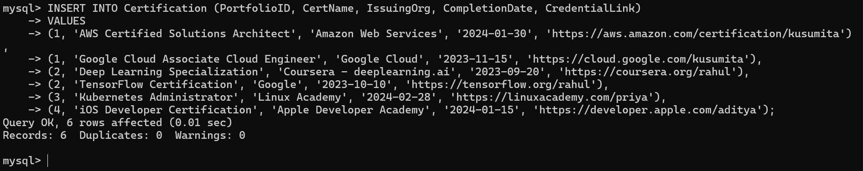

Screenshot 3.6: Insert Skill Data (6 rows)

]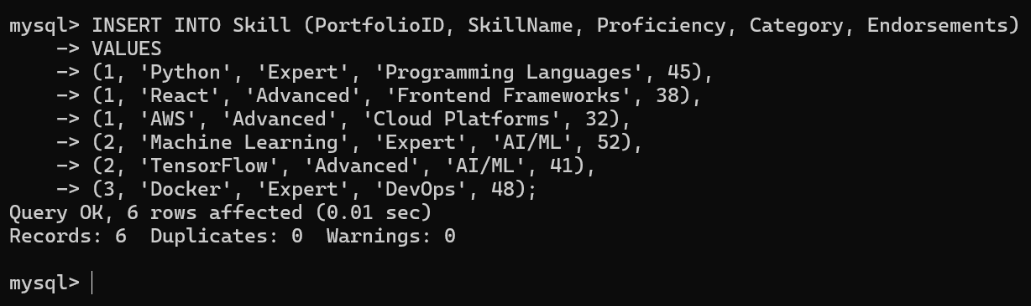

STEP 4: VERIFY DATA INSERTION

Screenshot 4.1: Select All Student Records
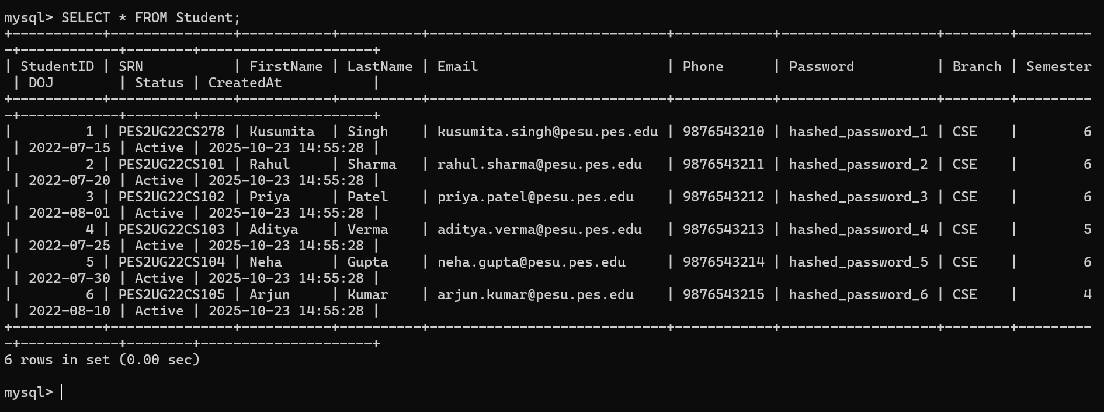

Screenshot 4.3: Select All Projects
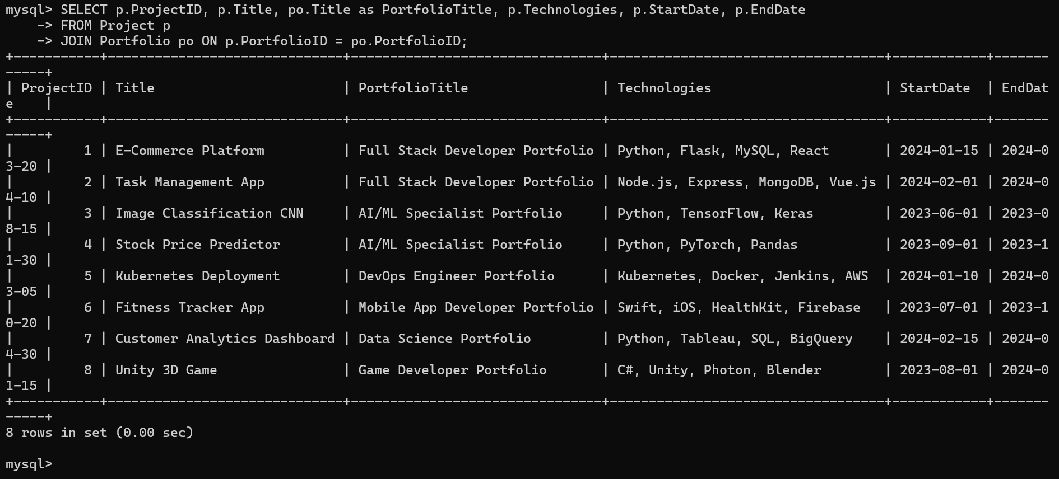

STEP 5: CONSTRAINT VALIDATION TESTS

Screenshot 5.1: Test UNIQUE Constraint (Should Fail)

Screenshot 5.2: Test NOT NULL Constraint (Should Fail)
Screenshot 5.3: Test CHECK Constraint on Email (Should Fail)

Screenshot 5.4: Test Phone Length CHECK (Should Fail)

