Title:
Personalized e-Portfolio Management System for PESU Students

Team Details:
Student Name: Kusumita
SRN: PES2UG22CS278
Department: CSE

1. Overview
This deliverable focuses on the backend logic of the application — implementing Triggers, Stored Procedures, and User-Defined Functions to automate processes, enforce data integrity, and streamline portfolio operations.

2. Objectives
- Maintain data consistency through triggers and constraints.
- Automate timestamp updates, status changes, and notifications.
- Support reusable logic for repetitive tasks using stored procedures and functions.
- Enable analytics and insights through SQL logic.

3. Triggers

Trigger 1: Auto-Update Portfolio UpdatedAt Field
Purpose: Automatically updates the UpdatedAt timestamp whenever a portfolio record changes.
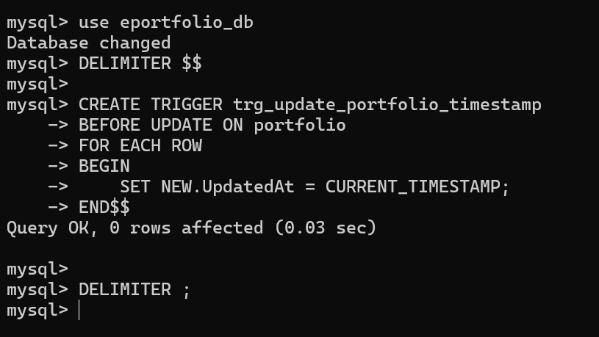
Effect: Whenever a record in portfolio is updated, its UpdatedAt column refreshes to the current timestamp.

Trigger 2: Auto-Deactivate Student
Purpose: If a student’s status changes to ‘Graduated’, deactivate their portfolio automatically.
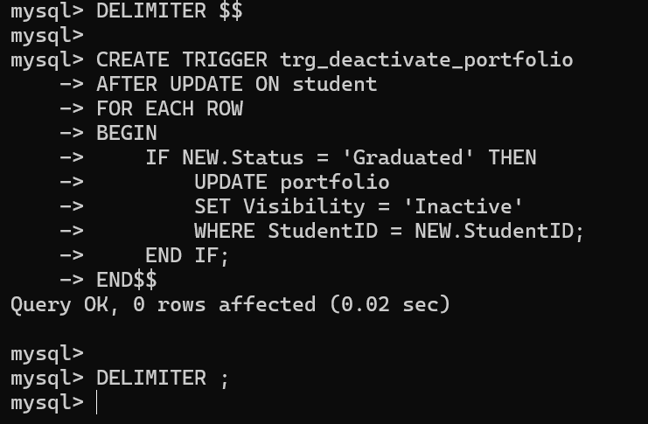
Effect: Keeps portfolio visibility consistent with student’s graduation status.

Trigger 3: Skill analytics counter update
Purpose: Increment skill trend count when a new skill is added.
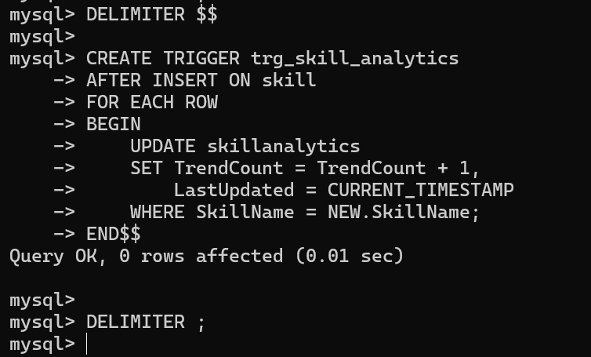
Effect: Tracks skill popularity dynamically.

2. STORED PROCEDURES

Procedure 1: Add a new project to a student portfolio
Purpose: Insert new project data safely and ensure valid dates.
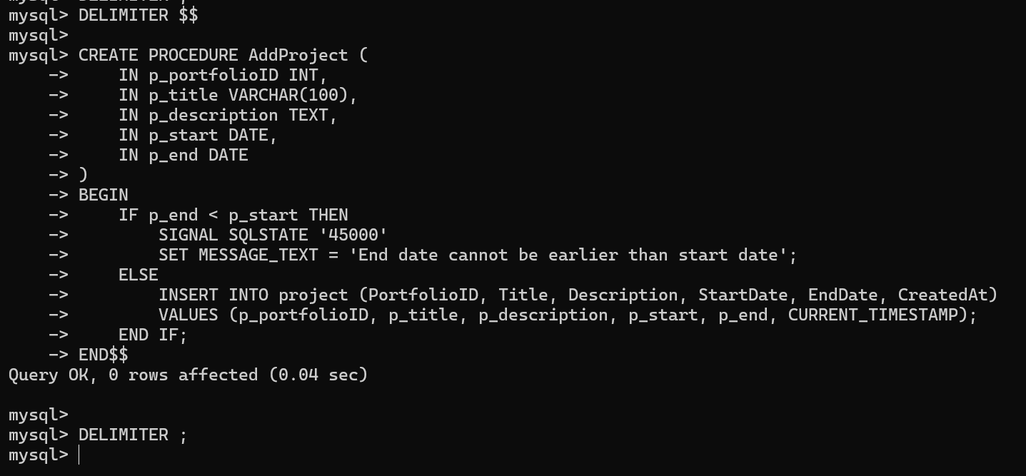
Test it:

Procedure 2: Generate a portfolio summary
Purpose: Returns a summary of student portfolio statistics.
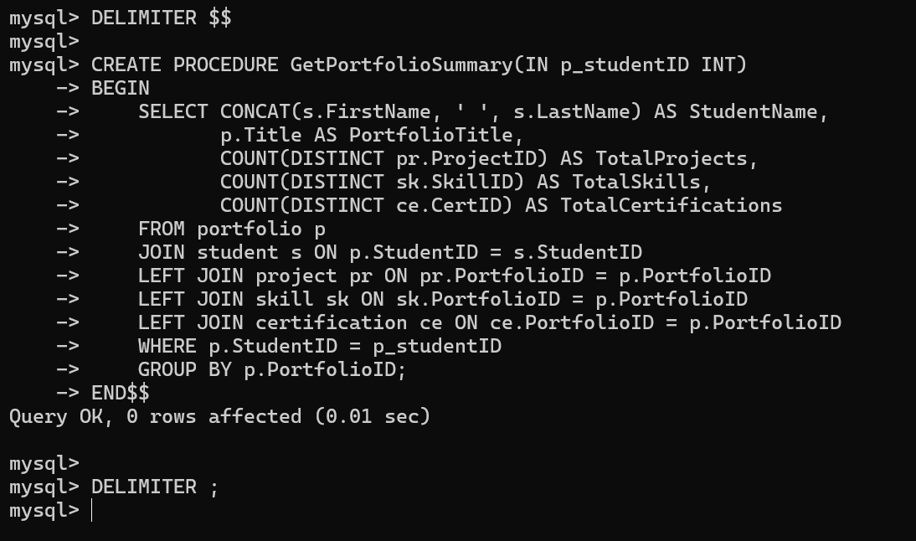
Test it:
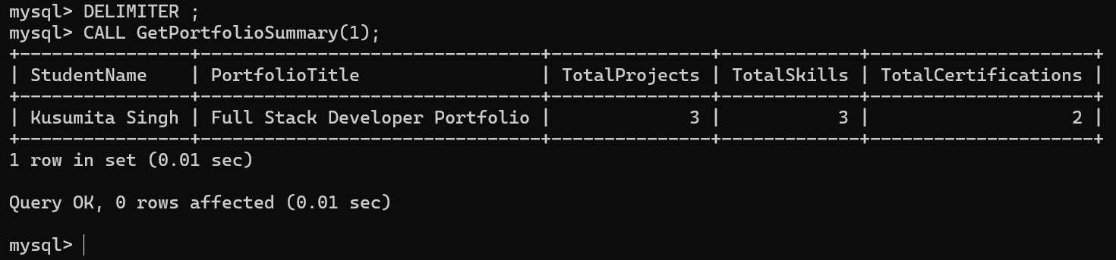

USER-DEFINED FUNCTIONS
for your database eportfolio_db (based on your real table structure — FirstName, LastName, StudentID, etc.).

Function 1 — Portfolio Completion Score
Purpose:
Calculates a percentage-like score from the number of projects, skills, and certifications linked to a given portfolio.
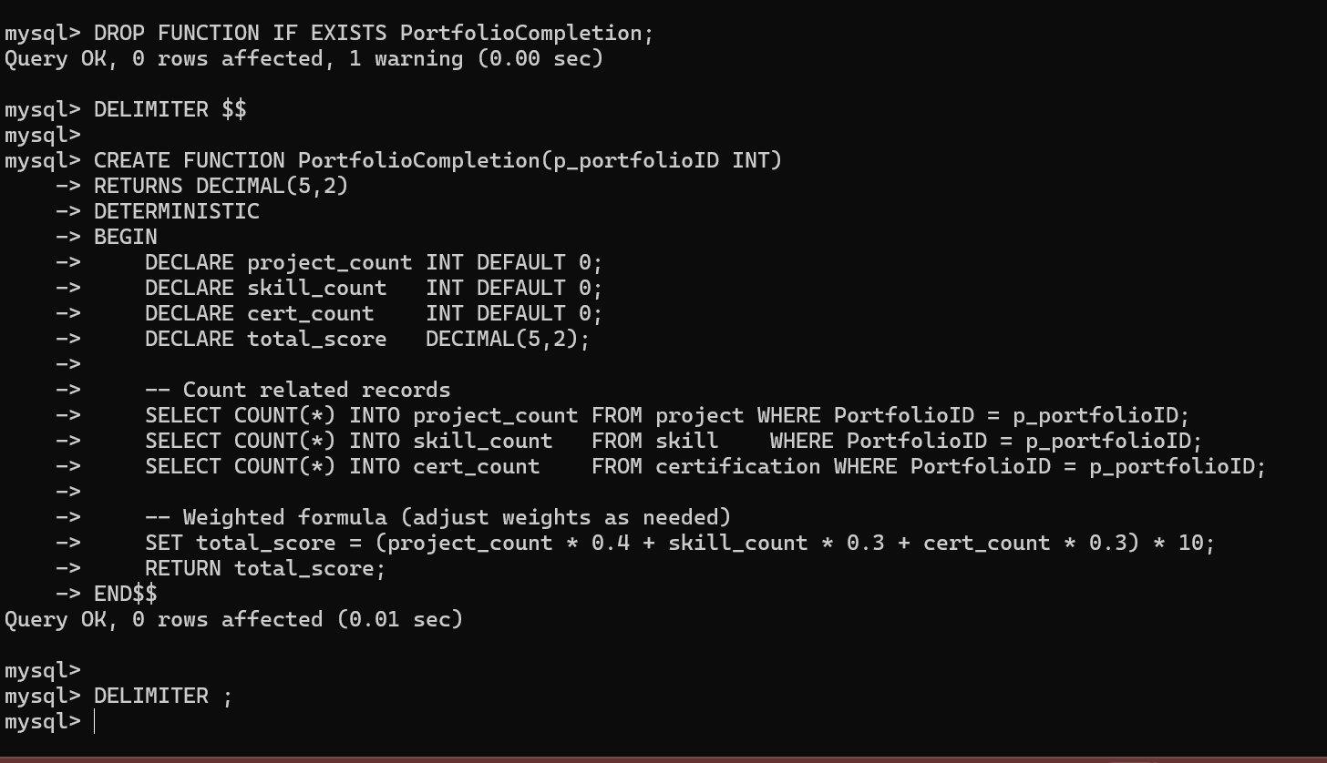
Test it
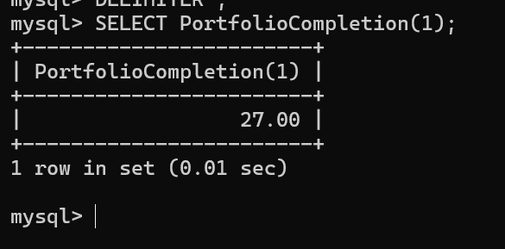

Function 2 — Student Status Summary
Purpose:
Returns a short, readable text summarizing a student’s status using their StudentID.
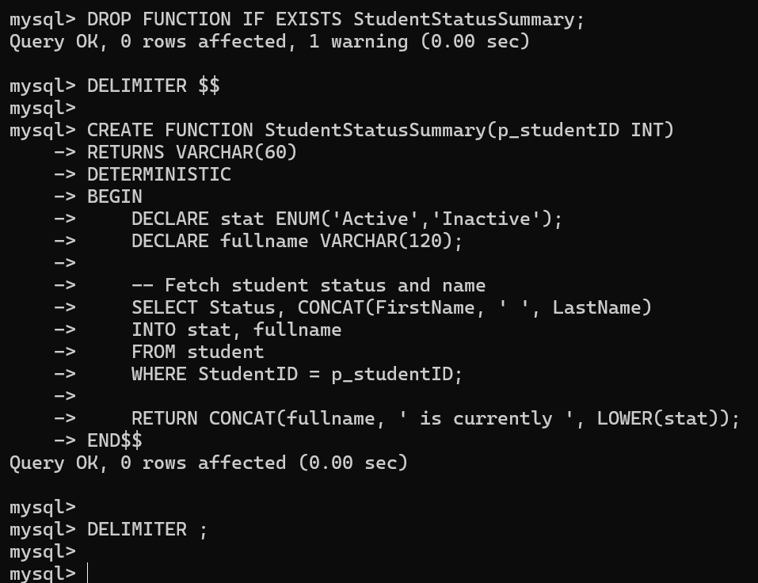
Test it
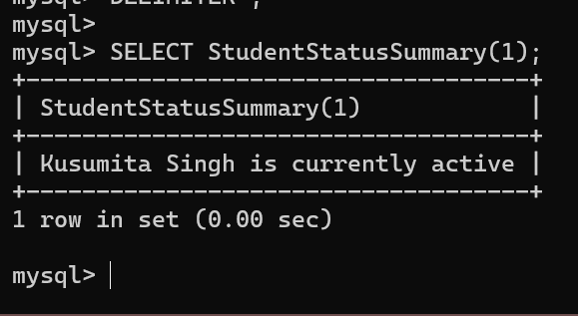

7. Summary
This deliverable establishes the logic layer of your database, enabling automation, analytics, and clean data management. With triggers, stored procedures, and functions now active, the database behaves intelligently, supporting CRUD operations seamlessly.

