METHODOLOGY FOR BUILDING A DIGITAL CORPUS AND ONTOLOGICAL REPOSITORY OF TECHNOLOGIES BASED ON CORPUS LINGUISTICS AND KNOWLEDGE GRAPHS
Abstract: This paper presents a corpus-linguistic and ontological methodology for designing a national digital corpus and repository of technologies (QazTechCorpus). The design adapts structural principles from computational corpus linguistics to scientific and technical knowledge engineering. Grounded in the three-level architecture of the National Corpus of the Kazakh Language (qazcorpus.kz) and an empirical statistical baseline of 170,747 running word tokens (23,383 distinct surface word forms) drawn from Kazakh technical texts, our approach extends subcorpus segmentation, metadata markup, and morphosyntactic normalization to unstructured outputs from state-funded research and development (R&D) projects. Functional requirements are derived from a comparative evaluation of six university technology transfer and repository platforms across the United States and Europe: Stanford University, Harvard University, the University of Oxford, Charles University, the Massachusetts Institute of Technology (MIT), and the Czech Technical University in Prague (CVUT). We then specify a five-layer software architecture that integrates OAI-PMH 2.0 metadata harvesting, agglutinative stem normalization, and trilingual named entity extraction across ten technical classes (TechNER) using encoder baselines alongside long-context foundation models (Gemini 4 Carbon and Argon). The framework also incorporates evidence-based verification of Technology Readiness Levels (TRL 1 to 9) under ISO 16290 and a Neo4j knowledge graph governed by the OWL 2 ontology OntoTech.
Keywords: corpus linguistics; specialized technical corpus; Kazakh language morphology; ontological engineering; knowledge graph; named entity recognition; technology readiness level.
1. Introduction
Universities and national research institutes generate large volumes of specialized scientific and technical texts during state-funded and grant-supported research and development (R&D) projects. These materials include final technical reports, patent specifications, utility model filings, software documentation, and laboratory test protocols. In Kazakhstan, more than 50,000 such historical and ongoing records sit in fragmented registries or local archives as unstructured PDF documents written in Kazakh, Russian, and English. Because these collections lack a shared corpus annotation schema and machine-readable domain metadata, engineers cannot easily search for existing solutions by quantitative operating parameters. Research administrators face similar difficulties when checking technology maturity from primary textual evidence, while industrial partners encounter high transaction costs when licensing academic inventions.
Applied corpus linguistics offers tried-and-tested principles for converting unstructured text archives into structured, queryable linguistic resources (Biber, Conrad, & Reppen, 1998; McEnery & Hardie, 2012; Friginal & Hardy, 2014). Recent contributions in Applied Corpus Linguistics have shown both the practical value of compiling specialized domain corpora (Chua, 2022) and the methodological promise of pairing corpus-assisted analysis with Large Language Models (LLMs) and automated annotation pipelines (Crosthwaite & Baisa, 2023; Curry, Baker, & Brookes, 2024; Uchida, 2024). In Kazakhstan, work in computational and corpus linguistics has centered on the National Corpus of the Kazakh Language (qazcorpus.kz), which brings together 13 specialized subcorpora, a multi-attribute metadata markup window, and dedicated morphological and lexicographical software modules (Zhubanov, 2014; Pirmanova & Karbozova, 2022; National Corpus of the Kazakh Language, 2026). At the same time, statistical lexicography of Kazakh engineering discourse has quantified the distribution of 170,747 word tokens and 23,383 unique surface word forms across technical university texts (Karbozova, 2024). General, literary, and pedagogical Kazakh corpora have grown steadily over the past decade. Even so, a dedicated trilingual corpus and ontological repository built specifically for engineering R&D reports, patents, and technology transfer does not yet exist.
The present study develops an architectural and ontological methodology for a national digital corpus and repository of technologies (QazTechCorpus) that brings together applied corpus linguistics, OWL 2 knowledge graphs (Khoroshevsky, 2008; World Wide Web Consortium, 2012), multi-agent LLM annotation workflows, and institutional repository practices from North American and European universities. Four specific tasks guide the study: (1) establishing methodological continuity between the three-level linguistic architecture of qazcorpus.kz, empirical frequency distributions of Kazakh technical word forms, and the proposed technical repository; (2) comparing the structural and licensing mechanisms of six international university platforms; (3) formalizing the OntoTech ontology, the morphosyntactic normalization and 10-class TechNER extraction pipeline, the ISO 16290 TRL verification protocol, and the hybrid retrieval ranking model; and (4) setting out a staged validation roadmap and corpus evaluation protocol from TRL 2 to TRL 7.
2. Empirical Baseline and Methodological Continuity with Corpus Linguistics Architecture
Our methodology rests on two domestic empirical foundations: the software and subcorpus architecture of the National Corpus of the Kazakh Language (qazcorpus.kz) (Zhubanov, 2014; Pirmanova & Karbozova, 2022) and the statistical analysis of Kazakh technical discourse compiled in the Frequency Dictionary of Word Forms in Kazakh Technical Texts (Karbozova, 2024).
In the database and resource manager architecture described by Pirmanova and Karbozova (2022) and implemented in qazcorpus.kz (National Corpus of the Kazakh Language, 2026), text organization operates across three connected levels. The first level partitions the collection into 13 functional and thematic subcorpora, including Main, Terminological, Scientific, Educational, Parallel, Historical, Dialectal, and Spoken divisions. At the second level, a structured metadata markup window assigns document-level extralinguistic attributes (author, title, functional style, publication chronology, target audience, medium, and domain rubric) alongside word-level morphological tags. The third level provides software utilities for Kazakh diacritic optical character recognition (tbiocr), electronic terminological dictionaries (tbisozdik), lexical card indices (tbikartoteka), concordance generation, and word-form frequency calculation.
Adapting this linguistic infrastructure to engineering R&D documentation requires close attention to the statistical and morphosyntactic properties of technical Kazakh. Evidence for this comes directly from Karbozova (2024), who compiled a word-form dictionary from engineering textbooks and manuals taught at technical universities in Kazakhstan. That collection spans N = 170,747 running words, yet those tokens fold into V = 23,383 distinct surface forms. From those two numbers, we get a Type-Token Ratio (TTR) of:
TTR = V / N = 23,383 / 170,747 ≈ 0.1370 (13.70%)
Two corpus-linguistic factors account for this high surface-form diversity in Kazakh scientific and technical writing. First, Kazakh is an agglutinative language in which a single technical stem or compound noun productively takes chains of plural, possessive, case, and relational suffixes. One underlying terminological concept can therefore appear in dozens of low-frequency surface forms. Second, comparison against the national terminology database (termincom.kz) points to frequent lexical variation, including morphological and phonetic doublets (zharyspaly sozder), calques from Russian and English technical nomenclature, and homonymous analytical units whose specialized meaning depends on collocation context (Karbozova, 2015, 2023, 2024).
Table 1 outlines how the QazTechCorpus methodology adapts each architectural layer of qazcorpus.kz for a trilingual (Kazakh, Russian, English) engineering environment.
Table 1 - Structural comparison between the linguistic corpus qazcorpus.kz and the proposed technical corpus QazTechCorpus
Architectural Element | Implementation in Linguistic Corpus (qazcorpus.kz) | Adaptation in Proposed Technical Corpus (QazTechCorpus)
Primary storage unit | Annotated text, sentence, and surface word token linked to a morphological lemma (Pirmanova & Karbozova, 2022) | Unified Digital Technology Passport linking an R&D report, patent specification, software repository, CAD drawing, and test protocol
Subcorpus segmentation | 13 linguistic subcorpora: Main, Terminological, Scientific, Parallel, Educational, Historical, Dialectal, etc. | 6 technical subcorpora: R&D and grant reports, patents and utility models, physical prototypes, software and AI models, datasets, industry R&D queries
Metadata markup schema | Author, title, functional style, audience, creation date, source type, thematic rubric (Zhubanov, 2014) | Authors (ORCID), rightsholder organization, IPC/CPC and OECD codes, maturity level TRL 1 to 9 (ISO, 2013), IP protection status, licensing terms
Lexical normalization | Morphological analyzer, frequency dictionary of 23,383 technical word forms (Karbozova, 2024), tbisozdik | Agglutinative stemmer, doublet resolver (zharyspaly sozder), and cross-lingual alignment (Kazakh, Russian, English) mapped to termincom.kz
Search engine core | Lexico-grammatical concordancer, query by word form, lemma, affix chain, and metadata filters | Hybrid retrieval engine combining BM25 lexical matching, dense cross-lingual embeddings (Wang et al., 2024), and Cypher / SPARQL graph queries
Service and processing modules | OCR module tbiocr, dictionary database tbisozdik, card index tbikartoteka, frequency analyzer | Scientific OCR cleaner, 10-class TechNER extractor (encoder baselines and Gemini 4 workflow), multi-agent TRL auditor, and license generator

Concrete examples from metallurgy, chemical engineering, and computing documentation show how morphological normalization stabilizes entity extraction before neural processing (Table 2). Each surface word form is segmented into its root and suffix chain, mapped to a canonical Kazakh lemma, and aligned with its Russian and English equivalents.
Table 2 - Morphosyntactic segmentation and lemma normalization of agglutinative Kazakh technical word forms prior to TechNER extraction
Surface Word Form in Kazakh R&D Text (Latin Transliteration) | Morpheme Segmentation and Grammatical Gloss | Normalized Technical Lemma (Kazakh) | Russian and English Terminological Equivalents | Mapped TechNER Class
gidrometallurgiialyq qondyrghylardaghy | gidrometallurgiia-lyq (ADJ) qondyrghy-lar-da-ghy (stem-PL-LOC-REL) | gidrometallurgiialyq qondyrghy | gidrometallurgicheskaia ustanovka / hydrometallurgical installation | EQUIPMENT
avtoklavtyq shaiushy eritindilerding | avtoklav-tyq (ADJ) shai-u-shy (PTCP) eritindi-ler-ding (stem-PL-GEN) | avtoklavtyq shaiushy eritindi | rastvor avtoklavnogo vyshchelachivaniia / autoclave leaching solution | MATERIAL
kontsentrattyng taza shyghymy 94,5%-gha | kontsentrat-tyng (GEN) taza (ADJ) shyghym-y (POSS.3) 94,5%-gha (DAT) | kontsentrattyng taza shyghymy (94,5%) | chistyi vykhod kontsentrata (94,5%) / net concentrate yield (94.5%) | QUANT_PARAM
neirondyq zhelilerdi oqytu algoritmderimen | neiron-dyq (ADJ) zheli-ler-di (PL-ACC) oqyt-u (VN) algoritm-der-i-men (PL-POSS.3-INS) | neirondyq zhelini oqytu algoritmi | algoritm obucheniia neironnoi seti / neural network training algorithm | TECH_METHOD
tote litsenziialau sharttarynda | tote (ADJ) litsenziia-la-u (VN) shart-tar-y-nda (PL-POSS.3-LOC) | tote litsenziialau sharty | dogovor priamogo litsenzirovaniia / direct licensing agreement | IP_STD

Stripping inflectional suffix chains (-lar-da-ghy, -ler-ding, -der-i-men) and mapping morphological doublets to canonical entries in the 23,383-form technical frequency dictionary (Karbozova, 2024) and tbisozdik substantially lowers out-of-vocabulary (OOV) token rates. As a result, Kazakh, Russian, and English mentions of the same engineering concept project onto the same node in the knowledge graph.
3. Comparative Analysis of University Technology Transfer Platforms and Repositories
Functional and metadata requirements for QazTechCorpus were informed by an analysis of six university repository and technology transfer infrastructures in the United States, the United Kingdom, and the European Union: Stanford University, Harvard University, the University of Oxford, Charles University, the Massachusetts Institute of Technology (MIT), and the Czech Technical University in Prague (CVUT). This group covers both high-volume Anglo-American patent licensing portals and European systems that connect institutional text repositories directly to national Current Research Information Systems (CRIS).
At Stanford University, the digital core of the Office of Technology Licensing (Stanford OTL) is the Stanford TechFinder portal (techfinder.stanford.edu) (Stanford Office of Technology Licensing, 2026). Every invention submitted through an Invention Disclosure Form (IDF) is published as a structured Non-Confidential Abstract. Readers can see what engineering problem an invention solves and where it might be used in industry, but proprietary formulas stay hidden until a patent is filed. Each page also hooks into Stanford Profiles and Visible Legacy topic maps through simple subject filters. By Stanford OTL's own count, the office tracks 1,014 active income-producing inventions, takes in 541 new disclosures a year, and signs up to 152 licenses or options annually (Stanford Office of Technology Licensing, 2026).
Harvard does not keep everything in one place; instead, it splits commercial patent work from open research data (King, 2007; Harvard Office of Technology Development, 2026). The commercial contour, run by the Office of Technology Development (Harvard OTD, otd.harvard.edu), oversees 5,710 active patents and 970 industry licenses across 670 corporate partners, supporting 90 spin-off startups over a five-year period. A practical procedural mechanism at Harvard OTD is the ExpressPath license template suite covering Engineering and Physical Sciences, Medical Devices, and Software, which sets standardized financial terms with deferred upfront fees for academic startups. The scholarly data contour runs on Harvard Dataverse (King, 2007), an open repository framework that assigns persistent DataCite DOIs at both the dataset and individual file levels in line with FAIR principles.
At the Massachusetts Institute of Technology (MIT), open scholarly archiving and commercial IP management work side by side through DSpace@MIT and the MIT Technology Licensing Office (TLO) showcase (Smith et al., 2003). Under the hood, DSpace@MIT relies on OAI-PMH 2.0 and Qualified Dublin Core tags. It now holds well over 60,000 theses, working papers, and lab reports that draw more than a million downloads every month (Smith et al., 2003), while the separate MIT TLO pages point from those papers to issued patents. Oxford took a more direct route for digital outputs. Through Oxford University Innovation (OUI), the university set up a Click-to-Licence portal and an online Software Store (process.innovation.ox.ac.uk) (Oxford University Innovation, 2026). Academic researchers can grab code libraries, model weights, or text corpora for free, whereas company buyers pay for a commercial license right in the browser.
Czech universities organize things around national reporting rules. At the Czech Technical University in Prague (CVUT), the digital library (dspace.cvut.cz) runs on DSpace-CRIS and exchanges records both ways with Czechia's state R&D register (V3S) using the OpenAIRE 3.0+ format (Czech Technical University in Prague, 2026). Alongside regular papers, CVUT logs utility models (uzitny vzor) and working hardware prototypes (funkcni vzorek). Over at Charles University, the central transfer office (CPPT UK) works hand in hand with a university-owned company, Charles University Innovations Prague (CUIP a.s.) (Charles University, 2026). Faculty-based Innovation Scouts spot promising TRL 3 to 5 lab results early on, long before anyone files a patent.
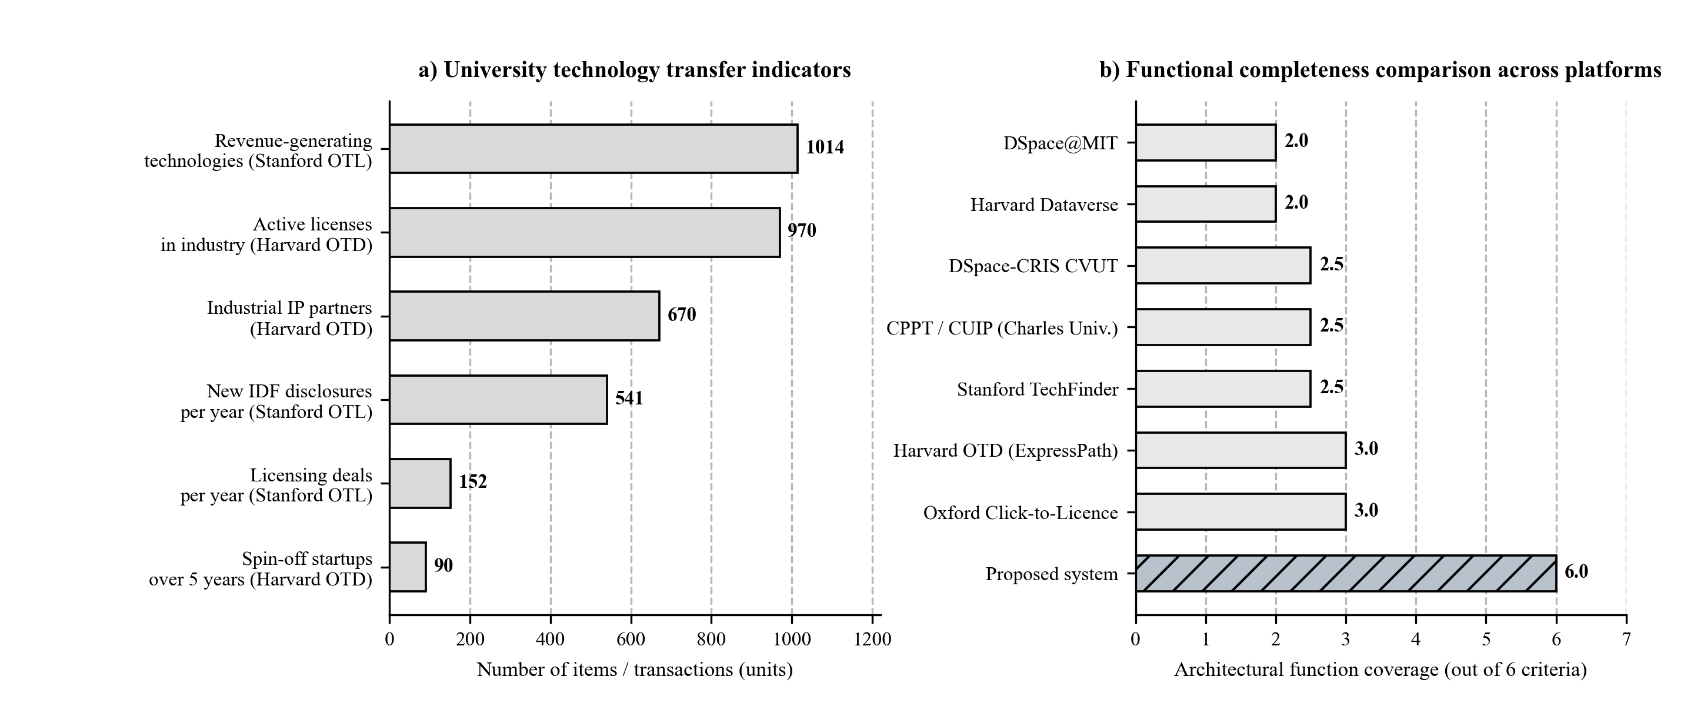
Figure 1 - Quantitative indicators of university technology transfer (a) and functional coverage of university platforms across six architectural criteria (b)
As Figure 1 and Table 3 show, comparing these six university infrastructures highlights a split between two software classes that rarely exchange data. Open scholarly repositories (DSpace@MIT, Harvard Dataverse, DSpace-CRIS CVUT) support OAI-PMH metadata harvesting, Dublin Core / DataCite schemas, and persistent DOI identifiers, yet offer no tools for verifying ISO 16290 TRL maturity or executing licensing contracts. Commercial technology transfer showcases (Stanford TechFinder, Harvard OTD, Oxford Click-to-Licence) simplify patent packaging and licensing, but depend on manual entry by licensing officers and cover only a small fraction of university R&D outputs. Bringing both contours together inside a single corpus architecture backed by automated linguistic and LLM extraction closes this gap.
Table 3 - Comparative analysis of architectural mechanisms across US and European university platforms
Platform and University | Core Technical and Procedural Mechanism | Functional Limitations | Adaptation in Proposed Technical Corpus
Stanford OTL & TechFinder (Stanford, USA) | Open Non-Confidential Abstracts, faceted taxonomy, Visible Legacy relationship graphs | Manual abstract drafting by OTL staff; no OAI-PMH harvesting or automated TRL scoring | Dual-contour technology passport: open abstract generated by NLP/LLM pipeline and restricted dossier under e-NDA
Harvard OTD & ExpressPath (Harvard, USA) | Standardized non-negotiable ExpressPath licenses across 3 industry tracks with deferred fees | No direct software link to primary R&D reports or source code repositories | Built-in generator for standardized licensing agreements covering software, instruments, and engineering methods
Harvard Dataverse (Harvard, USA) | Virtual institutional collections, dataset- and file-level DOI registration, FAIR compliance | Focused on open research data without know-how protection or commercial licensing workflows | Isolated virtual subcorpora for research institutes with DataCite DOI support for open test protocols
DSpace@MIT & MIT TLO (Cambridge, USA) | OAI-PMH 2.0 protocol, Qualified Dublin Core metadata, archive of 60,000+ reports and theses | Separation between open text archive in DSpace and commercial patent catalog in TLO | Automated OAI-PMH harvesting of university repositories with end-to-end links across paper, report, patent, and prototype
OUI Click-to-Licence (Oxford, UK) | Online OUI Software Store splitting Academic Use and Commercial Use licensing in one click | Applicable mainly to transferable digital assets (software, databases, assessment scales) | Dedicated module for instant licensing of scientific software, trained AI weights, and digital corpora
DSpace-CRIS CVUT & CPPT/CUIP UK (Prague, Czechia) | Repository integration with CRIS V3S (OpenAIRE), utility model tracking, faculty scouts, and PoC monitoring | Confined to a single institution; no neural full-text extraction of engineering parameters | Innovation scout workspace and early-stage R&D tracking (TRL 3 to 5) with automated passport pre-filling

4. Architectural-Ontological Model and Hybrid Corpus Annotation Pipeline
The QazTechCorpus platform is organized as a five-layer microservice architecture (Figure 2) covering the entire document lifecycle from harvesting unstructured PDFs to running hybrid semantic queries and generating digital license agreements. Layer 1 manages asynchronous data ingestion under Apache Airflow. On a set schedule, OAI-PMH 2.0 collectors query university DSpace and Dataverse servers (Smith et al., 2003; King, 2007). Patent filings come in through custom scripts that check national and WIPO registries; once a record arrives, we link its authors to their ORCID profiles and publication histories in CrossRef and OpenAlex. Many older Kazakh and Russian R&D reports only exist as scanned PDFs, so we pass them through an OCR cleaner built on top of tbiocr to fix broken Kazakh diacritics, table grids, and math formulas (Pirmanova & Karbozova, 2022; National Corpus of the Kazakh Language, 2026).
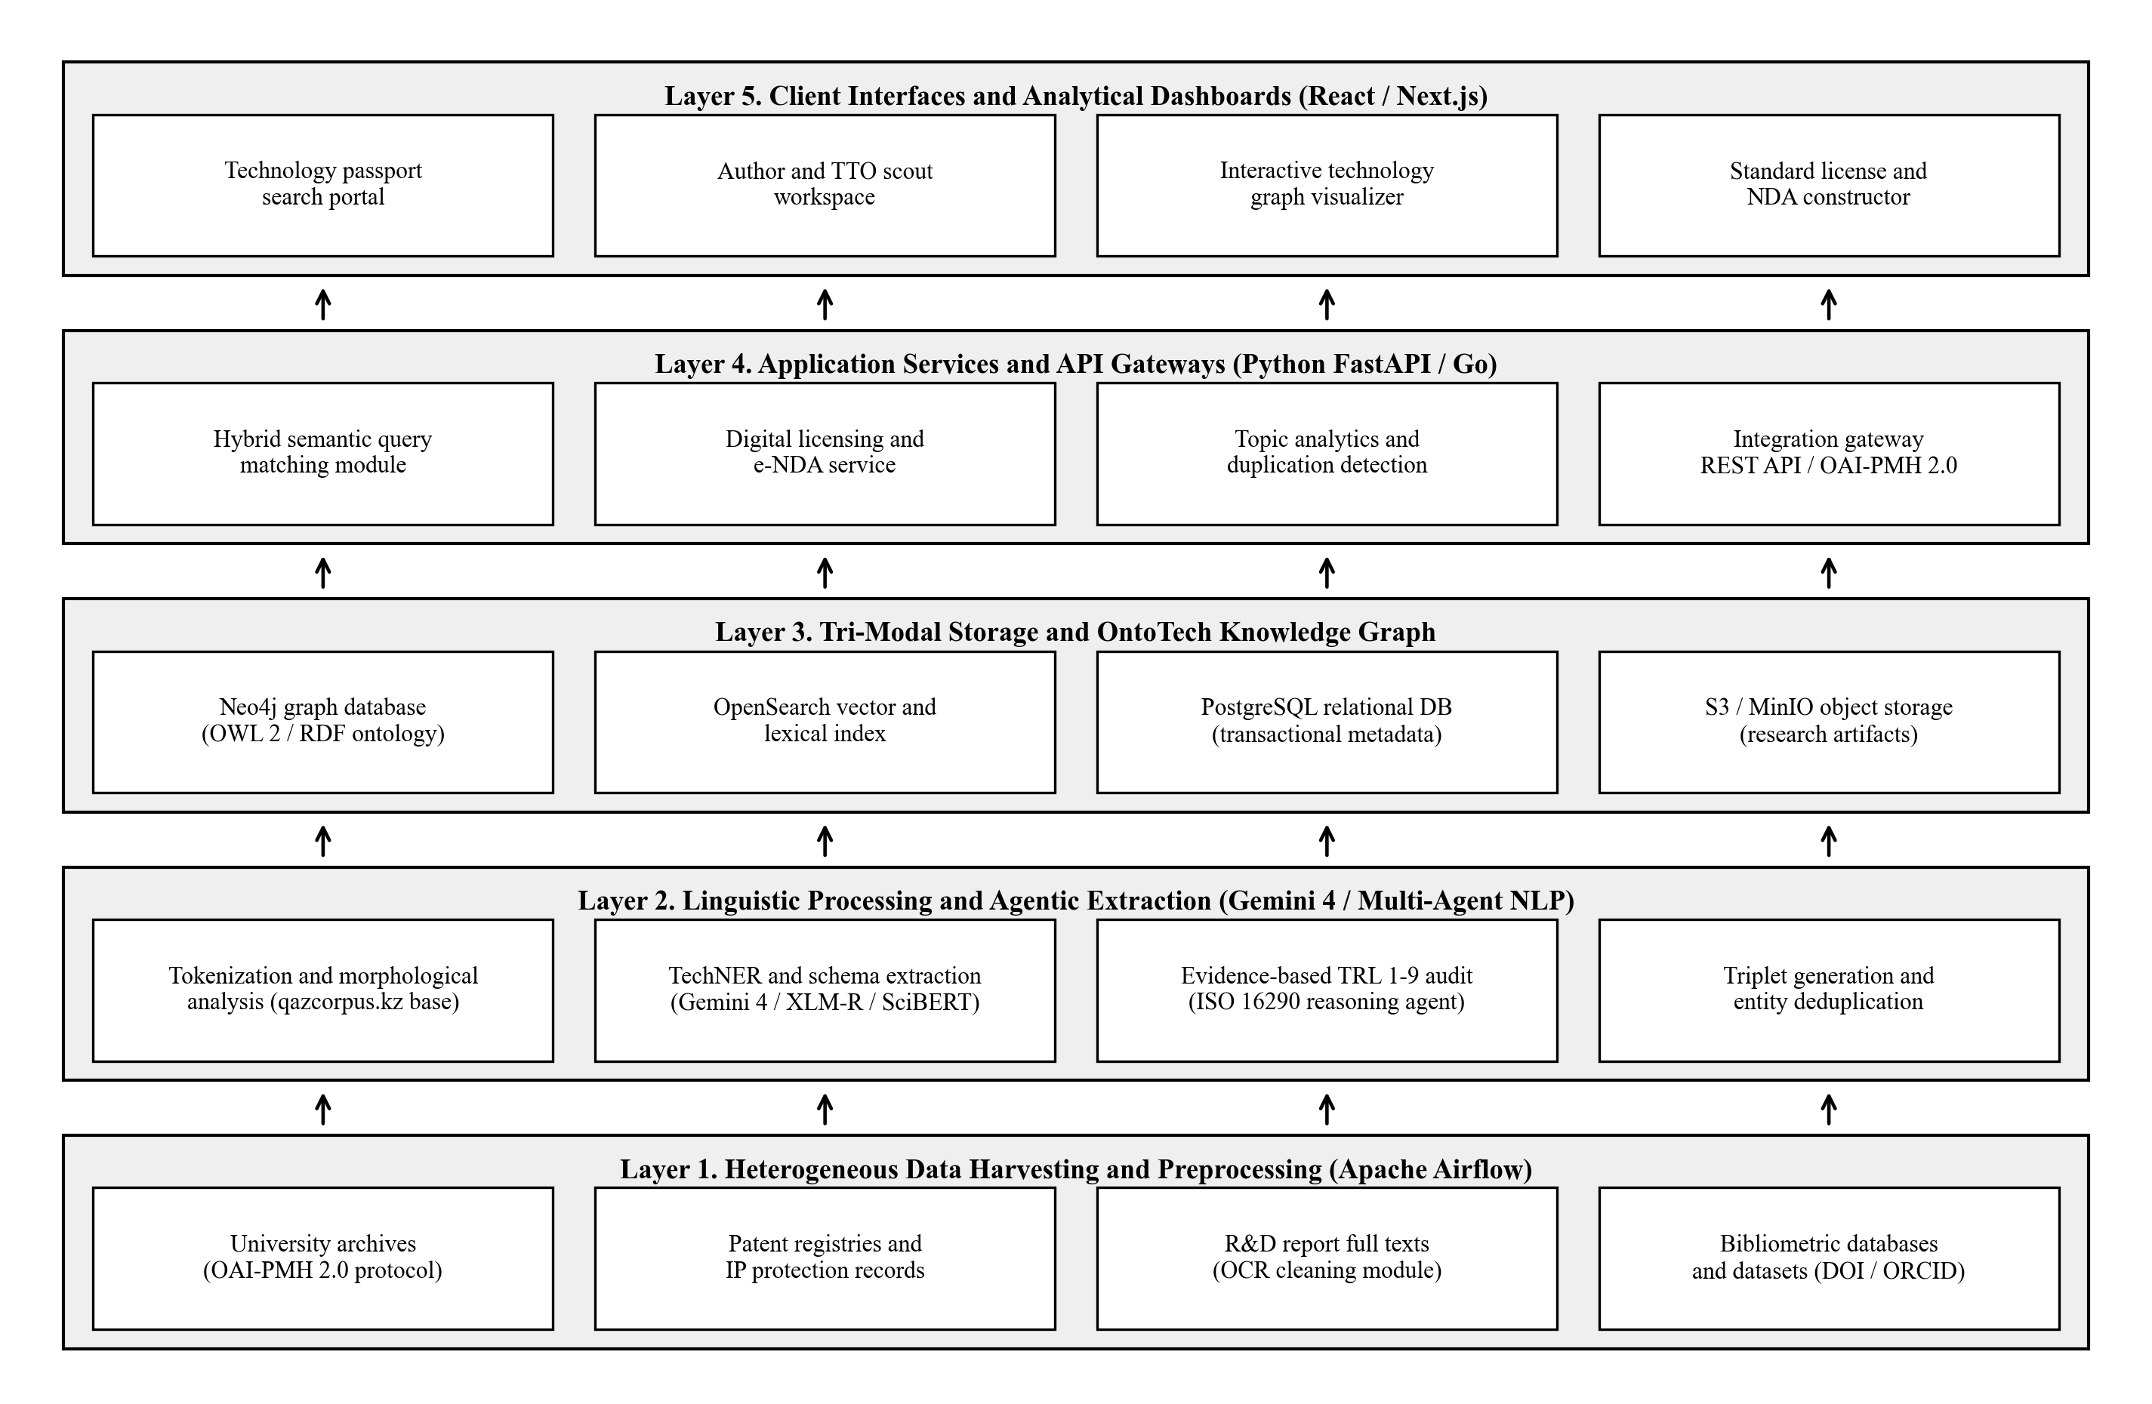
Figure 2 - Five-layer software architecture of the digital corpus and ontological repository of technologies
Layers 2 and 3 transform normalized trilingual text streams into a formal knowledge graph (Khoroshevsky, 2008). The semantic core of the repository is the domain ontology OntoTech, defined in OWL 2 DL (World Wide Web Consortium, 2012) as an ordered five-tuple:
O = < C, R, A, I, X >, (1)
where C is the finite set of domain concept classes (TechnologyPassport, RnDReport, PatentDocument, SoftwareModule, TestProtocol, Researcher, Organization, Equipment, IndustryDomain, TRLLevel); R is the set of directed object properties linking classes (developedAt, authoredBy, protectedByDocument, documentedInReport, verifiedByProtocol, hasReadinessLevel, applicableInIndustry); A specifies the set of typed data attributes (doiIdentifier, stateRegistrationIndex, ipcCode, oecdFosCode, nonConfidentialAbstractEN, trlScore, trlConfidence, orcidId); I represents the concrete passport and entity instances stored in the corpus; and X contains description logic axioms used by the OWL 2 reasoner to check metadata consistency during ingestion.
Within the OntoTech ontology, every engineering record in the corpus is stored as a unified Digital Technology Passport divided into six faceted metadata blocks (Table 4). This layout combines bibliographic metadata standards (Dublin Core, DataCite 4.5) with patent and subject classifications (IPC/CPC, OECD Fields of Science) and licensing attributes adapted from Stanford TechFinder, Harvard ExpressPath, and Oxford Click-to-Licence.
Table 4 - Structure of the six faceted metadata blocks of the Digital Technology Passport in the OntoTech ontology
Passport Facet Block | Key Metadata Attributes and Entities | Supported Standards and Protocols
1. Identification block | Persistent passport identifier (DOI / Handle), R&D project registration number, trilingual title (Kazakh, Russian, English), record version, linked publications | DataCite Metadata Schema 4.5, Qualified Dublin Core, OAI-PMH 2.0 (Smith et al., 2003; King, 2007)
2. Engineering and industry taxonomy | International and Cooperative Patent Classification codes (IPC / CPC), OECD Fields of Science (FOS) rubrics, applied industrial domain tags | WIPO IPC / CPC, OECD Frascati Manual classification, OWL 2 RDF Schema (World Wide Web Consortium, 2012)
3. Technical specification and open abstract | Non-confidential summary, engineering problem solved, quantitative physical or algorithmic performance metrics, hardware and software stack | Stanford TechFinder Non-Confidential Abstract model (Stanford Office of Technology Licensing, 2026)
4. Maturity verification (TRL) | Assessed readiness level from TRL 1 to TRL 9, confidence score, direct citations to supporting evidence (calculation, bench prototype, lab test protocol) | ISO 16290:2013 international standard (TRL 1 to 9 scale) (International Organization for Standardization, 2013)
5. Legal status and IP protection | IP object type (invention patent, utility model, software or database certificate, trade secret), registry number, rightsholders, and authors (ORCID) | WIPO ST.9 bibliographic patent data standards
6. Transfer and licensing profile | Available transfer mode: academic or commercial Click-to-Licence, ExpressPath startup package, sponsored research contract, e-NDA data room mode | Oxford OUI Software Store and Harvard ExpressPath protocols

Automated corpus annotation and draft passport synthesis at Layer 2 operate across unstructured Kazakh, Russian, and English R&D documents through a hybrid encoder and multi-agent LLM pipeline. Recent studies in Applied Corpus Linguistics show that LLMs yield much more consistent annotations when constrained by explicit linguistic schemas and human-verified taxonomies (Crosthwaite & Baisa, 2023; Curry, Baker, & Brookes, 2024; Uchida, 2024). Following this principle, our pipeline first runs morphosyntactic stem normalization using the 23,383-form technical frequency dictionary (Karbozova, 2024) and tbisozdik (Table 2). Token-level span extraction baselines built on multilingual XLM-RoBERTa (Conneau et al., 2020) and scientific SciBERT (Beltagy, Lo, & Cohan, 2019) with a Conditional Random Field (CRF) layer then work alongside long-context foundation models (Google Gemini 4 Carbon and Gemini 4 Argon). Encoder baselines handle fast span tagging on short abstracts, whereas Gemini 4 models read full 50- to 100-page R&D reports, experimental tables, and patent claims in a single context window to produce schema-validated JSON records conforming to OntoTech. Table 5 lists the ten target entity classes of the TechNER annotation scheme together with representative trilingual corpus spans.
Table 5 - Taxonomic specification of the 10-class TechNER corpus annotation scheme with trilingual examples
TechNER Class Code | Semantic Definition in OntoTech | Representative Corpus Span (Kazakh / Russian / English) | Target Passport Block
TECH_ARTIFACT | Created device, substance, alloy, catalyst, or software system | nanokurylymdy sorbent / nanostrukturnyi sorbent / nanostructured sorbent | Block 1 & Block 3
TECH_METHOD | Technological process, synthesis route, or computational algorithm | avtoklavtyq shaiu adisi / metod avtoklavnogo vyshchelachivaniia / autoclave leaching method | Block 3
QUANT_PARAM | Numerical operating parameter, yield, purity, latency, or bound | shyghymy 94,5%, T = 180 C / vykhod 94,5%, T = 180 C / yield 94.5% at 180 C | Block 3 & Block 4
MATERIAL | Raw ore, chemical reagent, precursor, or input linguistic dataset | polimetalldy ken / polimetallicheskaia ruda / polymetallic ore | Block 3
EQUIPMENT | Laboratory instrument, reactor, sensor, or compute cluster | rentgendik difraktometr / rentgenovskii difraktometr / X-ray diffractometer | Block 3 & Block 4
SOFTWARE_STACK | Programming language, neural architecture, database, or protocol | Neo4j graf bazasy, OWL 2 / grafovaia SUBD Neo4j / Neo4j graph database, OWL 2 | Block 3 & Block 6
DOMAIN | Industrial application sector aligned with OECD FOS and IPC/CPC | tusti metallurgiia / tsvetnaia metallurgiia / non-ferrous metallurgy | Block 2
IP_STD | Patent number, state registration index, GOST/ISO standard, license | KR Patenti No. 35841, ISO 16290 / Patent RK No. 35841 / KZ Patent No. 35841 | Block 1 & Block 5
TRL_EVIDENCE | Documentary proof of maturity (lab protocol, bench act, pilot test) | zertkhanalyq synaq aktisi / akt laboratornykh ispytanii / laboratory test protocol | Block 4
ORG | University, research institute, funding body, or industrial partner | Satbayev University / KazNITU im. K.I. Satpaeva / Satbayev University | Block 1 & Block 5

Multi-class extraction accuracy across the K = 10 entity categories is measured on held-out expert-annotated documents via macro-averaged F1:
F_1 = (1 / K) * Σ [ (2 * P_k * R_k) / (P_k + R_k) ], (2)
where P_k and R_k denote Precision and Recall for the $k$-th entity class.
Self-reported technology maturity scores along the nine-level ISO 16290 scale (TRL 1 to 9) (International Organization for Standardization, 2013) often suffer from subjective inflation. Our architecture replaces unverified self-reporting with deterministic OWL 2 production rules paired with an adversarial multi-agent verification workflow powered by Gemini 4 Carbon. Deterministic rules first check whether the mandatory documentary evidence spans (TRL_EVIDENCE) required for a claimed level exist in the corpus record: analytical calculations for TRL 2 to 3, laboratory test protocols and bench setups for TRL 4, patent filings and relevant-environment test acts for TRL 5 to 6, and industrial pilot acts for TRL 7. An independent Evidence Auditor agent then cross-checks the extracted claims against quantitative tables in the primary PDF report and outputs a calibrated probability distribution over TRL 1 to 9 with verbatim quotes and page numbers.
At Layer 3, no single database handles everything. Instead, we split storage across three engines according to what each does best. Neo4j is used purely for the OntoTech graph triples, whereas OpenSearch takes care of full-text lookup alongside the 1024-dimensional vectors from Multilingual-E5 (Wang et al., 2024). Everyday relational data, such as user logins, file versions, and license logs, stays in PostgreSQL backed by S3/MinIO object buckets. When someone types a search query q, each candidate passport $d$ gets a combined score from three signals:
S(q, d) = α · S_BM25(q, d) + β · cos(v_q, v_d) + γ · S_graph(q, d), (3)
The first part, S_BM25(q, d), looks for exact word and stem matches, which is essential when searching for part numbers, IPC codes, or chemical formulas. Next, cos(v_q, v_d) takes the cosine similarity between dense embeddings so a question phrased in Kazakh can still pull up reports written in Russian or English. The third piece, S_graph(q, d), gives extra weight to passports that are well connected in Neo4j (for example, records backed by signed test protocols or granted patents), with positive weights summing to α + β + γ = 1.
Layers 4 and 5 deal with a recurring legal headache in technology transfer: how to show an invention to industry buyers without giving away unpatented know-how. The public catalog exposes only sanitized Non-Confidential Abstracts modeled on Stanford TechFinder (Stanford Office of Technology Licensing, 2026), while full technical dossiers (raw laboratory logs, blueprints, and source code) remain inside a virtual data room gated by an electronic non-disclosure agreement (e-NDA), alongside automated Click-to-Licence and ExpressPath contract generators. The reference implementation of the six-block passport schema, the TechNER validator, the deterministic ISO 16290 consistency checker, and the hybrid scoring function is available in our open repository ([Anonymized Repository Link for Peer Review]).
5. Staged Development Roadmap and Corpus Validation Protocol
Practical implementation and empirical validation of QazTechCorpus are organized into six connected modules (Modules 1 to 6) across three sequential stages, taking the platform from an initial methodological specification (TRL 2) to an operationally validated repository prototype (TRL 7 under ISO 16290) (Figure 3).
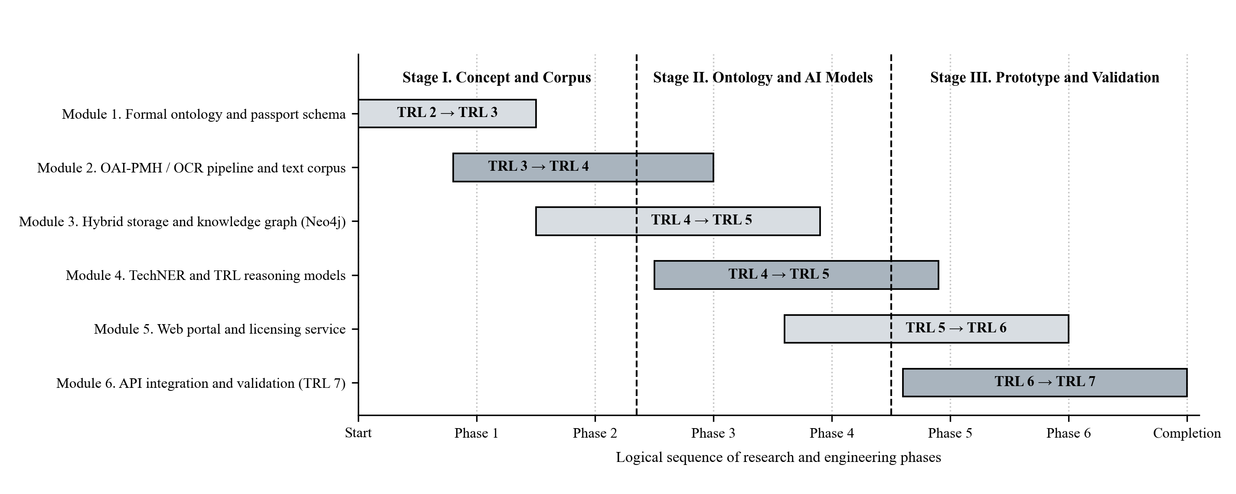
Figure 3 - Staged research and development roadmap (Modules 1 to 6) and system maturity trajectory (TRL 2 to TRL 7)
Work in Stage I (TRL 2 to TRL 4, covering Modules 1 through 3) begins in Protege, where we define the 250+ OWL 2 DL classes and 80 object properties of OntoTech. At the same time, we plug the 23,383-entry Kazakh technical frequency dictionary (Karbozova, 2024) and the tbisozdik stemmer into the text ingestion pipeline and turn on the OAI-PMH 2.0 collectors. During this stage, the team compiles an initial verified trilingual subcorpus of 15,000 R&D reports and patent specifications inside the containerized tri-modal cluster (Neo4j, OpenSearch, PostgreSQL, S3), reaching 25,000 nodes and 120,000 semantic triples with query latency below 150 ms.
Stage II (TRL 4 to TRL 5, Module 4) carries out a corpus-linguistic validation protocol. Computational linguists and domain engineers annotate an open gold benchmark dataset of 5,000 scientific and technical texts in Kazakh, Russian, and English across the 10 TechNER entity classes and ISO 16290 TRL levels. Annotation reliability is measured in accordance with standard corpus linguistics practice (McEnery & Hardie, 2012; Friginal & Hardy, 2014): dual independent human annotation is checked using Cohen's kappa (κ >= 0.80) for token-level entity spans and Krippendorff's alpha (α >= 0.78) for document-level TRL assignments. Fine-tuned encoder baselines (XLM-RoBERTa, SciBERT-CRF) are then evaluated against the multi-agent Gemini 4 Carbon and Argon workflow, targeting a macro-averaged F1 >= 0.86 on TechNER extraction and >= 0.82 accuracy on automated TRL verification.
Stage III (TRL 5 to TRL 7, Modules 5 and 6) launches the trilingual web portal with faceted concordancing and semantic search, interactive subgraph visualization, innovation scout workspaces (adapted from Charles University), e-NDA virtual data rooms, and one-click academic/commercial licensing modules. At full scale, the repository reaches 50,000 Digital Technology Passports and 250,000 semantic triples connected to university CRIS platforms.
6. Conclusions
1. Combining computational corpus linguistics with OWL 2 knowledge engineering provides a replicable methodology for building a national digital corpus and ontological repository of technologies (QazTechCorpus). Grounding the text preprocessing pipeline in the three-level architecture of the National Corpus of the Kazakh Language (qazcorpus.kz) and an empirical statistical baseline of 170,747 running tokens (23,383 unique surface word forms) from Kazakh technical texts resolves agglutinative suffix sparsity and terminological doublet variation across trilingual R&D documentation.
2. Comparative evaluation of six university platforms (Stanford, Harvard, Oxford, Charles University, MIT, and CVUT) shows a clear functional split between open scholarly archives (OAI-PMH, FAIR, DataCite DOI) and commercial licensing portals (Non-Confidential Abstracts, ExpressPath, Click-to-Licence). Our five-layer architecture and two-tier Digital Technology Passport connect both contours within a single system while protecting pre-patent know-how under electronic NDA.
3. The formal OWL 2 ontology OntoTech, the 10-class TechNER annotation taxonomy pairing encoder baselines with multi-agent long-context reasoning (Gemini 4 Carbon and Argon), the deterministic and neural ISO 16290 TRL auditing protocol, and the hybrid lexical-vector-graph ranking model establish a complete technical blueprint from TRL 2 to TRL 7 alongside an open 5,000-document trilingual benchmark for the applied corpus linguistics community.
References
Beltagy, I., Lo, K., & Cohan, A. (2019). SciBERT: A pretrained language model for scientific text. In Proceedings of the 2019 Conference on Empirical Methods in Natural Language Processing and the 9th International Joint Conference on Natural Language Processing (EMNLP-IJCNLP) (pp. 3615-3620). Association for Computational Linguistics. https://doi.org/10.18653/v1/D19-1371
Biber, D., Conrad, S., & Reppen, R. (1998). Corpus linguistics: Investigating language structure and use. Cambridge University Press. https://doi.org/10.1017/CBO9780511804489
Charles University. (2026). Centre for Knowledge and Technology Transfer of Charles University (CPPT UK) and Charles University Innovations Prague (CUIP). https://cppt.cuni.cz/CPPTNEN-79.html
Chua, S.-M. (2022). Compiling and analysing a large corpus of online discussions to explore users' interactions. Applied Corpus Linguistics, 2(2), Article 100017. https://doi.org/10.1016/j.acorp.2022.100017
Conneau, A., Khandelwal, K., Goyal, N., Chaudhary, V., Wenzek, G., Guzman, F., Grave, E., Ott, M., Zettlemoyer, L., & Stoyanov, V. (2020). Unsupervised cross-lingual representation learning at scale. In Proceedings of the 58th Annual Meeting of the Association for Computational Linguistics (ACL) (pp. 8440-8451). Association for Computational Linguistics. https://doi.org/10.18653/v1/2020.acl-main.747
Crosthwaite, P., & Baisa, V. (2023). Generative AI and the end of corpus-assisted data-driven learning? Not so fast! Applied Corpus Linguistics, 3(3), Article 100066. https://doi.org/10.1016/j.acorp.2023.100066
Curry, N., Baker, P., & Brookes, G. (2024). Generative AI for corpus approaches to discourse studies: A critical evaluation of ChatGPT. Applied Corpus Linguistics, 4(1), Article 100082. https://doi.org/10.1016/j.acorp.2023.100082
Czech Technical University in Prague. (2026). Digital Library of the Czech Technical University in Prague (DSpace CVUT) and CTU Open Science Strategy. https://dspace.cvut.cz/
Friginal, E., & Hardy, J. A. (2014). Corpus-based sociolinguistics: A guide for students. Routledge. https://doi.org/10.4324/9780203114827
Harvard Office of Technology Development. (2026). Harvard ExpressPath licenses and available technologies. https://otd.harvard.edu/researchers/licensing-startup-formation/harvard-expresspath-licenses/
International Organization for Standardization. (2013). Space systems: Definition of the Technology Readiness Levels (TRLs) and their criteria of assessment (ISO Standard No. 16290:2013).
Karbozova, B. (2015). Research of structural and semantic meanings of homonymous units. The Social Sciences, 10(6), 1072-1075. https://doi.org/10.3923/sscience.2015.1072.1075
Karbozova, B. D. (2023). Omonimderdi oqytu tekhnologiiasynda qazaq tili zhiilik sozdikterining mani [The significance of frequency dictionaries of the Kazakh language in the technology of teaching homonyms]. Foundations and Trends in Modern Learning, (1), 14-21.
Karbozova, B. D. (2024). Qazaq tekhnikalyq matinder sozformalarynyng zhiilik sozdigi [Frequency dictionary of word forms in Kazakh technical texts]. Jogary bilim.
Khoroshevsky, V. F. (2008). Knowledge spaces on the Internet and Semantic Web. Artificial Intelligence and Decision Making, (1), 80-97.
King, G. (2007). An introduction to the Dataverse Network as an infrastructure for data sharing. Sociological Methods & Research, 36(2), 173-199. https://doi.org/10.1177/0049124107306660
McEnery, T., & Hardie, A. (2012). Corpus linguistics: Method, theory and practice. Cambridge University Press. https://doi.org/10.1017/CBO9780511981395
National Corpus of the Kazakh Language. (2026). Subcorpus structure, metadata markup window, and software modules (qazcorpus.kz). https://qazcorpus.kz/indexru.php
Oxford University Innovation. (2026). Click-to-Licence portal and OUI Software Store. https://process.innovation.ox.ac.uk/software/
Pirmanova, K. K., & Karbozova, B. D. (2022). O programmnom obespechenii bazy dannykh elektronnogo korpusa kazakhskikh tekstov [On the database software for an electronic corpus of Kazakh texts]. Foundations and Trends in Research, (9), 45-53. https://ojs.publisher.agency/index.php/FTR/issue/view/9
Smith, M., Barton, M., Bass, M., Branschofsky, M., McClellan, G., Stuve, D., Tansley, R., & Walker, J. H. (2003). DSpace: An open source dynamic digital repository. D-Lib Magazine, 9(1), 1-14. https://doi.org/10.1045/january2003-smith
Stanford Office of Technology Licensing. (2026). Stanford OTL annual report and TechFinder portal. https://techfinder.stanford.edu/
Uchida, S. (2024). Using early LLMs for corpus linguistics: Examining ChatGPT's potential and limitations. Applied Corpus Linguistics, 4(1), Article 100089. https://doi.org/10.1016/j.acorp.2024.100089
Wang, L., Yang, N., Huang, X., Yang, L., Majumder, R., & Wei, F. (2024). Multilingual E5 text embeddings: A technical report. arXiv preprint arXiv:2402.05672. https://doi.org/10.48550/arXiv.2402.05672
World Wide Web Consortium. (2012). OWL 2 Web Ontology Language document overview (Second Edition). W3C Recommendation. https://www.w3.org/TR/owl2-overview/
Zakharov, V. P., & Bogdanova, S. Y. (2020). Korpusnaia lingvistika [Corpus linguistics] (3rd ed.). St. Petersburg State University Press.
Zhubanov, A. K. (2014). Korpusnaia lingvistika kak novoe napravlenie v kazakhskom iazykoznanii [Corpus linguistics as a new direction in Kazakh linguistics]. Bulletin of KazNU. Philological Series, 149(3), 18-24.

