1. Create private app.

* <https://misthub-dev.myshopify.com/admin/apps/private/56441187>

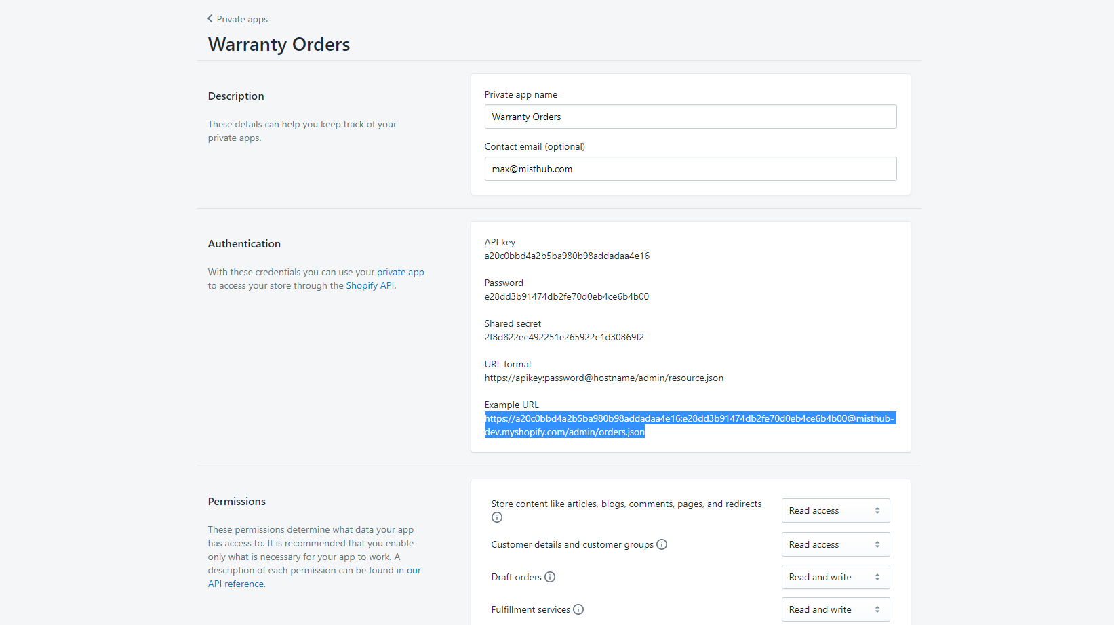

* Modify the lines of 402th and 403th in application/config/config.php with your private app’s info.

1. Register Webhooks

<https://misthub-dev.myshopify.com/admin/settings/notifications>

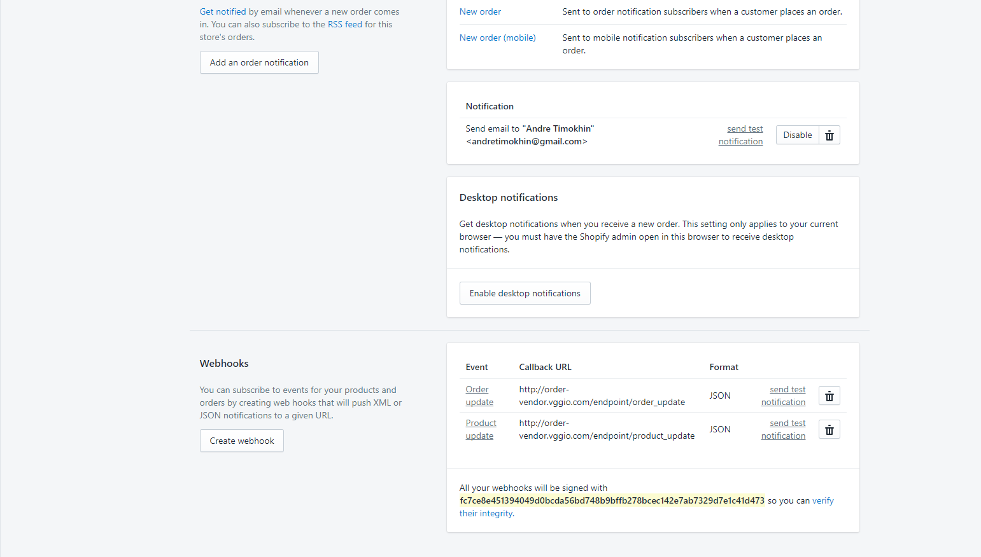

1. Create Cron-Job.

<https://gator4004.hostgator.com:2083/cpsess0591954659/frontend/hostgator/cron/index.html>

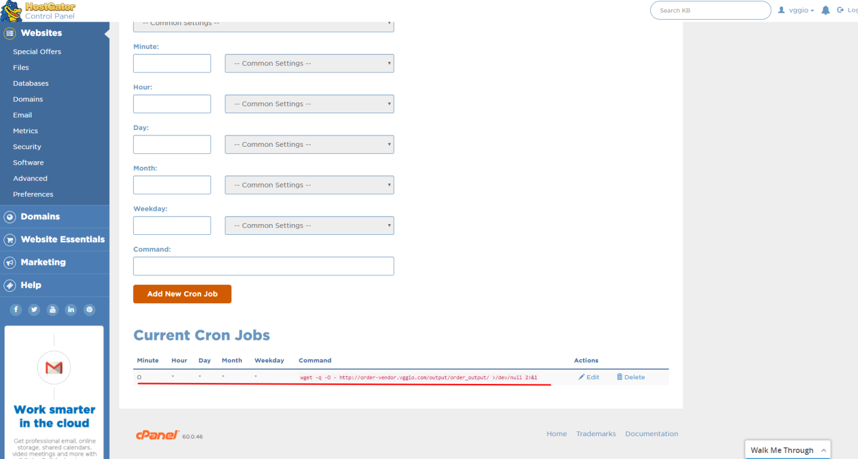

* To migrate:
* You will need only modify the files such as / application/config/config.php, database.php
* Look at the lines of 18, 19th in config.php, and 52th ~ … in database.php