Finsight – Loan/Credit Risk Analyzer

A Project Report Submitted in
the partial fulfillment of the requirements for the award of the degree of

BACHELOR OF TECHNOLOGY
in

DEPARTMENT OF CSE
By
G. HASINI | :2420030421
P. MOUKSHITHA | :2420030164

Under the Esteemed Guidance of

Dr. N. Sunanda
Associate Professor

Department of CSE

AY: 2026-2027

Semester: Odd Semester




K L (Deemed to be) University DEPARTMENT OF COMPUTER SCIENCE AND ENGINEERING

Declaration

The Project Report entitled “Finsight – Loan/Credit Risk Analyzer” is a record of Bonafide work of G. HASINI – 2420030421, P. MOUKSHITHA – 2420030164 submitted in partial fulfillment for the award of B. Tech in CSE to the K L University. The results embodied in this report have not been copied from any other departments/University/Institute.

G. HASINI – 2420030421
P. MOUKSHITHA – 2420030164

K L (Deemed to be) University DEPARTMENT OF COMPUTER SCIENCE AND ENGINEERING

CERTIFICATE

This is to certify that the project report entitled "FINSIGHT-LOAN/CREDIT RISK ANALYZER" is a Bonafide work carried out and submitted by Moukshitha (Reg. No: 2420030164) and Hasini (Reg. No: 2420030421) in partial fulfilment of the requirements for the award of the degree of BACHELOR OF TECHNOLOGY in Department of Computer Science and Engineering, K L (Deemed to be) University, during the academic year 2026–2027.

Signature of the Guide
Dr. N. Sunanda
Associate Professor, CSE

Signature of the Course Coordinator Signature of the HOD
Dr. N. Sunanda Dr.P. Venkateswara Rao Department of CSE Department of CSE

ACKNOWLEDGEMENT
The success in this project would not have been possible but for the timely help and guidance rendered by many people. Our wish to express my sincere thanks to all those who has assisted us in one way or the other for the completion of my project.

Our greatest appreciation to my guide Dr.N.SUNANDA. Department of CSE which cannot be expressed in words for her tremendous support, encouragement and guidance for this project.

We express our gratitude to Dr.P.VENKATESWARA RAO, Head of the Department of CSE for providing us with adequate facilities, ways and means by which we are able to complete this project-based Lab.

We thank all the members of teaching and non-teaching staff members, and also who have assisted me directly or indirectly for successful completion of this project. Finally, I sincerely thank my parents, friends and classmates for their kind help and cooperation during my work.

G. HASINI – 2420030421
P. MOUKSHITHA – 2420030164

Abstract
The expansion of digital lending platforms has created both opportunities and challenges in the financial sector. While access to credit has become more inclusive, the risk of loan defaults and non-performing assets has also increased. Traditional credit evaluation methods often fail to capture the complexity of borrower behavior, leading to inaccurate risk assessments. This project, Finsight – Loan/Credit Risk Analyzer, addresses these challenges by applying data science methodologies to enhance the accuracy and reliability of credit risk evaluation.

The system leverages historical loan datasets and borrower information to uncover patterns in repayment behavior, income stability, and credit history. Using machine learning algorithms such as logistic regression, decision trees, and ensemble models, the analyzer predicts the probability of loan default and classifies applicants into risk categories. Data preprocessing, feature engineering, and model evaluation are integral steps in ensuring robust performance. By integrating financial indicators like debt-to-income ratio, transaction history, and demographic attributes, the analyzer provides lenders with actionable insights for decision-making.

Finsight demonstrates how data-driven approaches can significantly reduce financial risk while promoting responsible lending practices. The analyzer empowers banks, fintechs, and microfinance institutions to minimize non-performing assets, improve profitability, and extend credit to deserving borrowers. Beyond predictive accuracy, the project emphasizes scalability and adaptability, making it suitable for diverse lending environments. Ultimately, Finsight showcases the transformative potential of data science in balancing financial inclusion with sustainable risk management.

Keywords: Credit Risk, Loan Default Prediction, Machine Learning, Logistic Regression, Decision Tree, Ensemble Models, Feature Engineering, Risk Classification, Financial Inclusion

Index
S. No. | Chapters | Topics | Page.no
 |  | Acknowledgement
 |  | Abstract
1 | Introduction | 1.1 Background of the project  1.2 Problem statement  1.3 Scope of the project  1.4 Objective(s)  1.5 Importance of the application  1.6 Target users/audience | 1-3
2 | System Requirements | 2.1 Hardware requirements  2.2 Software requirements  2.3 Development tools and frameworks | 4-5
3 | Technology Stack | 3.1 Front-end (e.g., React.js, Angular, HTML/CSS)  3.2 Back-end (e.g., Node.js, Django, Spring Boot)  3.3 Database (e.g., MongoDB, MySQL, PostgreSQL)  3.4 Version Control (e.g., Git, GitHub)  3.5 APIs or External services (e.g., Firebase, Stripe) | 6-7
4 | System Architecture | 4.1 High-level architecture diagram  4.2 Description of each layer (frontend, backend, database)  4.3 Deployment architecture (e.g., cloud, local, CI/CD pipelines) | 8-10
5 | Design | 5.1 Wireframes or mockups  5.2 ER Diagram / Database schema | 11-13
6 | Implementation | 6.1 Module-wise implementation  6.2 Front-end logic (UI rendering, state management)  6.3 Backend logic (routes, controllers, business logic)  6.4 Database connectivity  6.5 API integration  6.6 Authentication & Authorization | 14-16
7 | Features | 7.1 List of main features  7.2 How each feature works (user perspective + technical description) | 17-18
8 | Testing | 8.1 Postman testing (frontend/backend)  8.2 Integration testing  8.3 Tools used for testing  8.4 Test cases and results | 19-20
9 | Deployment | 9.1 Steps to deploy  9.2 Environment configuration  9.3 Hosting of frontend and backend | 21-22
10 | Challenges & Limitations | 10.1 Issues faced during development  10.2 Solutions applied  10.3 Current limitations or known bugs | 23-24
11 | Future Enhancements | 11.1 Planned features  11.2 Possible integrations or optimizations | 25
12 | Conclusion | 12.1 Summary of the project  12.2 What was achieved  12.3 Skills learned during development | 26-27
13 | References | - Books, tutorials, APIs, documentation sites used
14 | Appendices | - Screenshots of the app  - Sample code snippets  - Installation/setup instructions  - User manual or guide  -certifications

CHAPTER 1
Introduction

1.1 Background of the project
Lending is the core business of banks, non-banking financial companies (NBFCs), fintech platforms and microfinance institutions. Over the last decade, digital lending platforms have made loans faster, cheaper and easier to obtain, which has extended credit to many people who were earlier outside the formal financial system. This growth, however, has also increased exposure to credit risk, the possibility that a borrower fails to repay a loan on time or at all.
When loans are not repaid they turn into non-performing assets (NPAs), which reduce a lender's profitability, tie up capital and, at scale, threaten financial stability. Evaluating every applicant carefully before sanctioning a loan is therefore one of the most important activities in the lending process. Historically this evaluation relied on manual underwriting, fixed rules and simple scorecards. Such methods are slow, subjective and often unable to capture the many interacting factors that decide whether a borrower will repay.
Data science offers a better alternative. Lenders already hold large volumes of historical loan records that show who repaid and who defaulted. Machine learning algorithms can learn the patterns hidden in this data and use them to estimate the risk of new applicants. Finsight – Loan/Credit Risk Analyzer is built on this idea.
1.2 Problem statement
Traditional credit evaluation methods often fail to capture the complexity of borrower behavior, leading to inaccurate risk assessments. Applicants who would have repaid may be rejected, while risky applicants may be approved. Both outcomes are costly: the first reduces financial inclusion and lost business, and the second increases defaults and non-performing assets.
The problem addressed in this project is: how can historical loan and borrower data be used to predict the probability that an applicant will default, and to classify the applicant into a meaningful risk category, so that lenders can take faster and more reliable decisions?
1.3 Scope of the project
The scope of Finsight covers the complete data science workflow for credit risk analysis:
- Collection and understanding of historical loan and borrower data.
- Data preprocessing: handling missing values, outliers, encoding of categorical data and scaling.
- Feature engineering using financial indicators such as debt-to-income ratio, transaction history and demographic attributes.
- Training and comparing machine learning models: logistic regression, decision trees and ensemble models.
- Prediction of the probability of default and classification of applicants into Low, Medium and High risk categories.
- A simple interface that lets a lender enter applicant details and view the risk assessment.

The project is a decision-support tool. It does not replace the lender's final judgement, and it does not handle disbursement, repayment collection or other core banking functions.
1.4 Objective(s)
- To study the factors that influence loan repayment and default, such as repayment behavior, income stability and credit history.
- To build a clean, reusable data preprocessing and feature engineering pipeline.
- To develop and compare machine learning models that predict the probability of loan default.
- To classify applicants into risk categories that are easy for non-technical users to understand.
- To evaluate the models with suitable metrics (accuracy, precision, recall, F1-score and ROC-AUC) and select the most reliable one.
- To provide a scalable and adaptable analyzer that can be used by banks, fintechs and microfinance institutions.

1.5 Importance of the application
- Reduces financial risk: early identification of high-risk applicants helps lenders minimize non-performing assets.
- Improves profitability: better decisions mean fewer losses and better pricing of risk.
- Promotes responsible lending: loans are matched to the borrower's real repayment capacity.
- Supports financial inclusion: deserving borrowers with limited traditional credit history can be assessed fairly using wider data.
- Saves time: automated scoring speeds up the approval process compared with fully manual review.
- Consistent decisions: the same model is applied to every applicant, reducing subjectivity.

1.6 Target users/audience
User | How Finsight helps
Banks | Strengthen loan underwriting and reduce NPAs in retail and personal loan portfolios.
Fintech / digital lending platforms | Provide instant risk scoring for online applications.
Microfinance institutions | Assess small-ticket borrowers fairly and extend credit to deserving applicants.
Credit analysts and loan officers | View default probability, risk category and key risk factors for each applicant.
Students and researchers | Use the project as a reference for applying data science to financial risk.

CHAPTER 2
System Requirements

2.1 Hardware requirements
The hardware needed for development and for running the analyzer is modest, because the datasets used for credit risk modelling are tabular and of moderate size.
Component | Minimum requirement | Recommended
Processor | Intel Core i3 / AMD Ryzen 3 (dual core) | Intel Core i5 / AMD Ryzen 5 or higher
RAM | 4 GB | 8 GB or more
Storage | 10 GB free disk space | 256 GB SSD
Display | 1366 x 768 resolution | 1920 x 1080 resolution
Network | Broadband connection for package installation and deployment | Stable high-speed internet
GPU | Not required | Optional, only for experiments with deep learning

2.2 Software requirements
Software | Details
Operating system | Windows 10/11, Ubuntu 20.04 or later, or macOS
Programming language | Python 3.10 or later
Data science libraries | NumPy, pandas, scikit-learn, XGBoost, imbalanced-learn, SHAP
Visualization libraries | Matplotlib, Seaborn, Plotly
Web / API frameworks | Streamlit (dashboard), FastAPI (REST API)
Database | SQLite for development; PostgreSQL / MySQL for production
Web browser | Google Chrome, Microsoft Edge or Mozilla Firefox (latest version)
Other tools | Git and GitHub, Postman, Jupyter Notebook

2.3 Development tools and frameworks
- Jupyter Notebook / Google Colab: exploratory data analysis, experimentation and model comparison.
- Visual Studio Code / PyCharm: writing and debugging the production Python modules.
- scikit-learn: preprocessing pipelines, logistic regression, decision trees, random forest and evaluation metrics.
- XGBoost: gradient-boosted tree ensemble used as a high-performance model.
- Streamlit: rapid construction of the interactive dashboard in pure Python.
- FastAPI: a fast, well-documented framework for the prediction REST API.
- Git and GitHub: version control and collaboration between the team members.

CHAPTER 3
Technology Stack

3.1 Front-end (e.g., React.js, Angular, HTML/CSS)
The user interface of Finsight is built with Streamlit, an open-source Python framework for data applications. Streamlit renders HTML, CSS and JavaScript automatically from Python code, so the team can build forms, tables and charts without a separate JavaScript code base. Plotly is used inside the dashboard for interactive charts such as risk distribution and feature importance.
3.2 Back-end (e.g., Node.js, Django, Spring Boot)
The back-end is written in Python. The core is a machine learning pipeline built with pandas, NumPy and scikit-learn, with XGBoost as an additional ensemble model. The trained model is saved with joblib and exposed through a FastAPI service, which validates the input, calls the model and returns the default probability and risk category in JSON format.
3.3 Database (e.g., MongoDB, MySQL, PostgreSQL)
Applicant records, loan applications, credit history, transactions and prediction results are stored in a relational database. SQLite is used during development because it needs no installation, and the same schema can be migrated to PostgreSQL or MySQL for a production deployment. Relational storage suits this project because the data is structured and the entities (applicants, loans, predictions) are naturally linked by keys.
3.4 Version Control (e.g., Git, GitHub)
The source code, notebooks and documentation are maintained in a Git repository hosted on GitHub. Feature branches and pull requests are used so that both team members can work in parallel, and the commit history provides a record of how the project evolved.
3.5 APIs or External services (e.g., Firebase, Stripe)
- Finsight REST API (internal): the /predict endpoint used by the dashboard and by any external system that wants to call the model.
- Postman: used to design and test the API requests.
- Public loan datasets (Kaggle / UCI repository): the source of historical loan data for training.
- Cloud hosting (Render / Streamlit Community Cloud / similar): hosts the API and dashboard.
- Credit bureau APIs (future scope): to fetch live credit scores in a production environment.

CHAPTER 4
System Architecture

4.1 High-level architecture diagram
Finsight follows a layered architecture in which each layer has a single responsibility. The presentation layer talks only to the API layer, the API layer calls the machine learning layer, and the machine learning layer reads and writes the data layer.
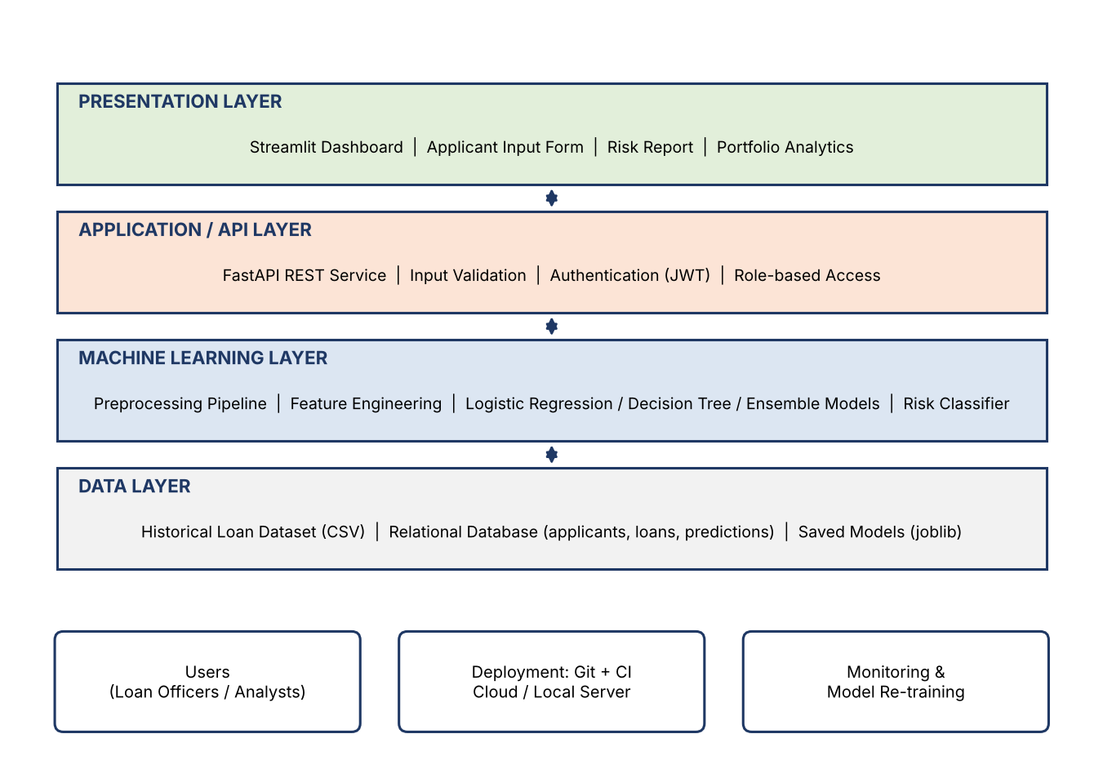
Fig No. 4.1 High-level architecture of Finsight
The overall data science workflow that runs inside the machine learning layer is shown below.
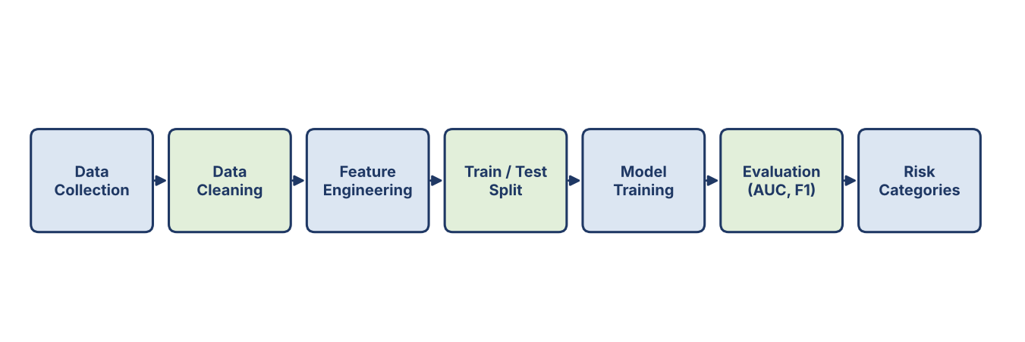
Fig No. 4.2 Machine learning workflow
4.2 Description of each layer (frontend, backend, database)
Presentation layer (front-end)
This layer contains the Streamlit dashboard. It offers the applicant input form, shows the predicted default probability and risk category, lists the key factors that influenced the decision and displays portfolio-level analytics. It contains no business logic; it only collects input and displays results.
Application / API layer (back-end)
The FastAPI service receives requests from the dashboard, validates every field (type, range and required values), authenticates the caller, passes the data to the model and stores the outcome. Keeping this layer separate makes it possible to connect other systems, such as a bank's loan origination software, to the same model.
Machine learning layer
This layer holds the preprocessing pipeline (imputation, encoding, scaling), the feature engineering steps and the trained classifiers (logistic regression, decision tree and ensemble models). It outputs the probability of default, which is converted into a Low, Medium or High risk category using configurable thresholds.
Data layer (database)
The data layer stores the historical loan dataset used for training, the relational database with operational records and predictions, and the serialized model files. Every prediction is saved with the model version so that decisions can be audited later.
4.3 Deployment architecture (e.g., cloud, local, CI/CD pipelines)
During development the application runs locally. For deployment, code is pushed to GitHub, an automated pipeline runs the tests, and the passing build is deployed to a cloud host where the API and dashboard are served to users through a web browser.
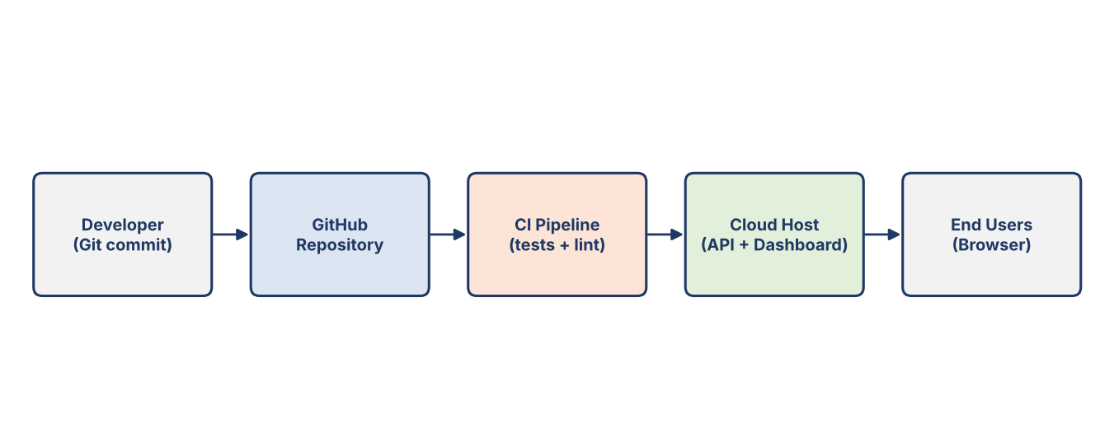
Fig No. 4.3 Deployment architecture

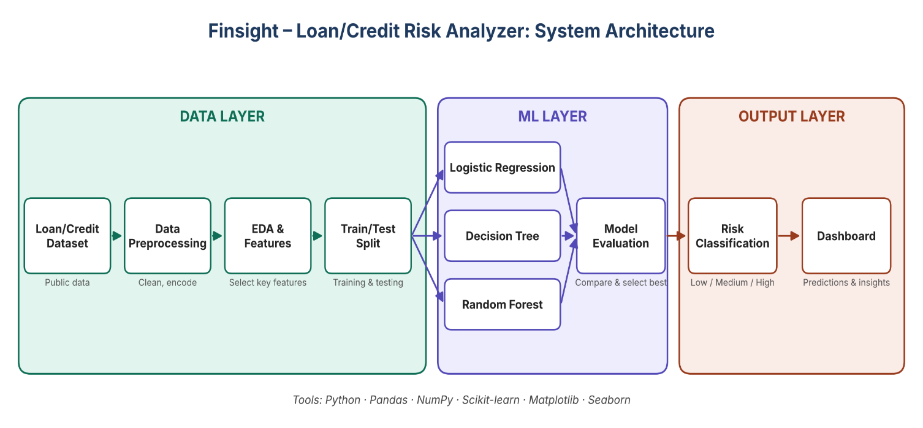

CHAPTER 5
Design

5.1 Wireframes or mockups
The dashboard is designed as a single screen so that a loan officer can enter the applicant details on the left and immediately see the result on the right. The wireframe below shows the intended layout.
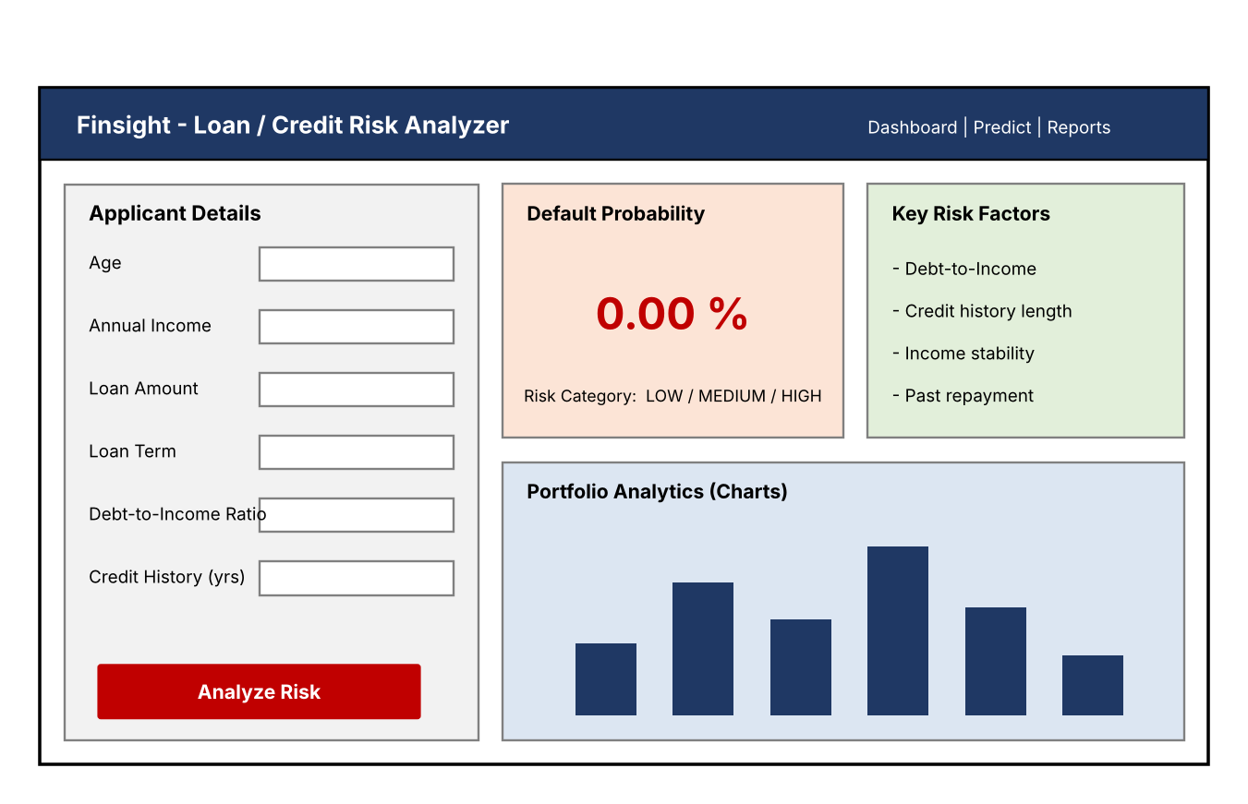
Fig No. 5.1 Wireframe of the risk analysis dashboard
The screen has four areas: (1) the Applicant Details form; (2) the Default Probability card with the risk category; (3) the Key Risk Factors panel explaining which inputs pushed the score up or down; and (4) Portfolio Analytics charts for managers.
Data Flow Diagram
At the highest level, the loan officer supplies applicant details to Finsight and receives a risk score and category. Finsight reads the historical dataset to train and uses the model store to save and load the trained model.
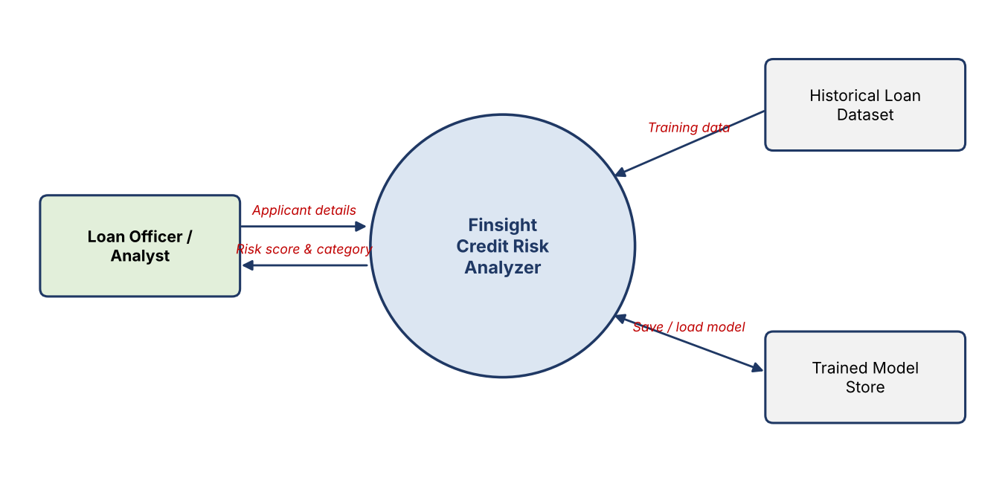
Fig No. 5.2 DFD Level-0 of Finsight
5.2 ER Diagram / Database schema
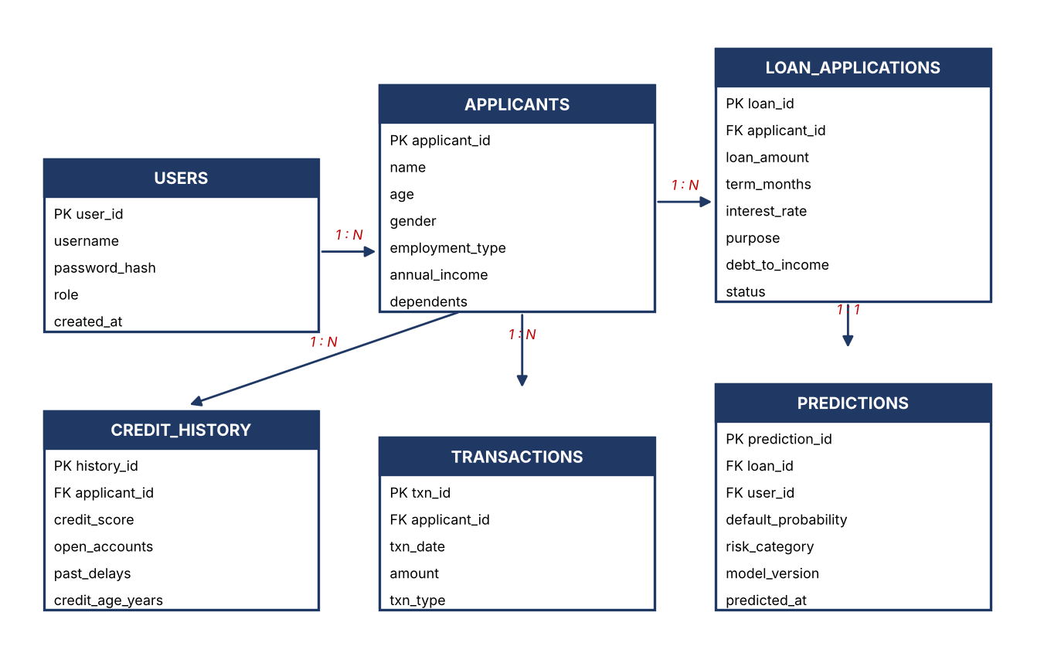
Fig No. 5.3 Entity-Relationship diagram
The main tables of the schema are listed below. PK denotes the primary key and FK a foreign key.
Table | Important columns | Purpose
users | user_id (PK), username, password_hash, role, created_at | Login accounts for loan officers, analysts and admins
applicants | applicant_id (PK), name, age, gender, employment_type, annual_income, dependents | Basic and demographic details of each borrower
loan_applications | loan_id (PK), applicant_id (FK), loan_amount, term_months, interest_rate, purpose, debt_to_income, status | Details of each loan requested
credit_history | history_id (PK), applicant_id (FK), credit_score, open_accounts, past_delays, credit_age_years | Past credit behaviour
transactions | txn_id (PK), applicant_id (FK), txn_date, amount, txn_type | Transaction history used for behavioural features
predictions | prediction_id (PK), loan_id (FK), user_id (FK), default_probability, risk_category, model_version, predicted_at | Stored model outputs for audit and analytics

CHAPTER 6
Implementation

6.1 Module-wise implementation
Finsight is divided into independent modules, each implemented as a Python module or notebook section.
Module | Description
Data collection | Loads the historical loan dataset (CSV) and the borrower attributes into pandas data frames; checks the structure, data types and the proportion of defaults.
Data preprocessing | Handles missing values (median for numeric, most frequent for categorical), treats outliers, removes duplicates, encodes categorical variables with one-hot encoding and scales numeric features.
Feature engineering | Creates derived indicators such as debt-to-income ratio, loan-to-income ratio, credit history length, number of past delays and transaction-based features such as average monthly inflow.
Model training | Trains logistic regression (baseline, interpretable), decision tree and ensemble models (random forest, gradient boosting) using a scikit-learn Pipeline so that preprocessing and model are saved together.
Model evaluation | Uses stratified train/test split and cross-validation; compares models on accuracy, precision, recall, F1-score and ROC-AUC; selects the final model.
Risk classification | Converts the default probability into Low, Medium or High risk using configurable thresholds.
Dashboard and reporting | Streamlit pages for prediction, explanation and portfolio analytics.

The default probability is converted into a risk category as follows (thresholds can be tuned by the lender according to its risk appetite):
Default probability | Risk category | Suggested action
Below 0.20 | Low | Approve under standard terms
0.20 to 0.50 | Medium | Manual review, possibly adjust amount, rate or collateral
Above 0.50 | High | Reject or require strong collateral / guarantor

6.2 Front-end logic (UI rendering, state management)
The Streamlit script collects the applicant details through input widgets (number inputs, select boxes and sliders), packs them into a dictionary, and sends them to the prediction API when the user presses the Analyze Risk button. Streamlit's session state keeps the latest result so that the page does not lose data when widgets are changed. The returned probability is shown in a metric card, the risk category is colour coded (green, amber, red) and Plotly charts render the portfolio analytics.
6.3 Backend logic (routes, controllers, business logic)
- POST /predict: validates the input, builds a one-row data frame, calls model.predict_proba, maps the probability to a risk category, stores the record and returns JSON.
- GET /history: returns earlier predictions for a user, with filters for date and risk category.
- GET /metrics: returns the evaluation metrics and model version.
- POST /login: authenticates the user and returns an access token.
- Business logic: feature creation (such as debt-to-income ratio) is performed inside the pipeline so that training and prediction always use identical transformations.

6.4 Database connectivity
The API connects to the database through SQLAlchemy, which allows the same code to run on SQLite during development and on PostgreSQL or MySQL in production by changing only the connection string. Parameterized queries are used everywhere to prevent SQL injection.
6.5 API integration
The dashboard calls the prediction API over HTTP using the requests library, sending JSON and receiving JSON. Because the model is behind a documented REST interface, other applications can integrate with Finsight in the same way. FastAPI automatically provides interactive API documentation, which also helps in testing.
6.6 Authentication & Authorization
Users log in with a username and password. Passwords are stored only as salted hashes, never in plain text. After login the API issues a JSON Web Token (JWT) which must accompany every request. Role-based authorization separates the permissions of an Admin (manage users, retrain models), an Analyst (view analytics and history) and a Loan Officer (submit applications and view results).
CHAPTER 7
Features

7.1 List of main features
- Prediction of the probability of loan default for each applicant.
- Classification of applicants into Low, Medium and High risk categories.
- Support for multiple models (logistic regression, decision tree, ensemble) with side-by-side comparison.
- Use of financial indicators such as debt-to-income ratio, transaction history and demographic attributes.
- Explanation of the key factors behind each prediction.
- Portfolio analytics dashboard showing risk distribution and trends.
- History of all assessments with the model version used.
- Secure login with role-based access.
- REST API for integration with other lending systems.

7.2 How each feature works (user perspective + technical description)
Feature | User perspective | Technical description
Default prediction | The user enters applicant details and presses Analyze Risk to see the probability of default. | The input is validated, passed through the saved preprocessing pipeline and classifier; predict_proba returns the probability of the default class.
Risk categories | The result is shown as Low, Medium or High with a colour. | The probability is compared with configurable thresholds.
Model comparison | An analyst can see accuracy, precision, recall, F1 and ROC-AUC of each model. | Metrics are calculated on a held-out test set and with cross-validation, and stored with the model version.
Risk factor explanation | The user sees which inputs increased or decreased the risk. | Coefficients for logistic regression and feature importance for tree-based models; SHAP can be added for per-applicant explanations.
Portfolio analytics | Managers see the share of applicants in each risk band and trends over time. | Aggregated queries on the predictions table, rendered as Plotly charts.
History and audit | Past assessments can be searched and reviewed. | Each prediction is stored with user, time and model version.
Secure access | Users log in and see only what their role allows. | Hashed passwords, JWT tokens and role checks in the API.

CHAPTER 8
Testing

8.1 Postman testing (frontend/backend)
Every API endpoint was designed to be tested with Postman. For each endpoint a request collection is prepared containing valid input, missing fields, wrong data types, out-of-range values and unauthorized access. The expected response codes are 200 for success, 422 for invalid input and 401 for missing or invalid tokens. The Streamlit front-end is tested manually by entering sample applicants and checking that the displayed result matches the API response.
8.2 Integration testing
Integration testing checks that the modules work correctly together: the dashboard sends data to the API, the API loads the saved pipeline, the prediction is stored in the database and the result returns to the screen. A key check is that the same preprocessing is applied in training and in prediction, which is guaranteed by saving the full scikit-learn Pipeline.
8.3 Tools used for testing
- Postman: API request testing.
- pytest: automated unit tests for preprocessing functions, feature engineering and the API.
- scikit-learn metrics and cross-validation: model performance testing.
- Jupyter Notebook: exploratory validation of data quality and model behaviour.
- GitHub Actions (optional): runs the tests automatically on every commit.

8.4 Test cases and results
The functional test cases for the system are listed below. The Actual result and Status columns are to be filled in after the tests are executed on the final build.
ID | Test case | Expected result | Status
TC01 | Submit a valid applicant through /predict | Returns probability between 0 and 1 and a risk category | [ ]
TC02 | Submit input with a missing required field | Returns 422 with a clear error message | [ ]
TC03 | Submit negative income or age | Input rejected by validation | [ ]
TC04 | Applicant with very high debt-to-income ratio | Probability is higher than for a comparable low-ratio applicant | [ ]
TC05 | Call /predict without a token | Returns 401 Unauthorized | [ ]
TC06 | Loan Officer opens an admin-only function | Access denied | [ ]
TC07 | Prediction is saved | A new row appears in the predictions table with model version | [ ]
TC08 | Dashboard shows result after pressing Analyze Risk | Probability and category are displayed and match the API | [ ]
TC09 | Load dataset with missing values | Pipeline imputes values without error | [ ]
TC10 | Unseen category value in input | Handled safely by the encoder and does not crash | [ ]

The model performance results obtained on the test set are to be recorded in the following table:
Model | Accuracy | Precision | Recall | F1-score | ROC-AUC
Logistic Regression | [ ] | [ ] | [ ] | [ ] | [ ]
Decision Tree | [ ] | [ ] | [ ] | [ ] | [ ]
Random Forest | [ ] | [ ] | [ ] | [ ] | [ ]
Gradient Boosting (XGBoost) | [ ] | [ ] | [ ] | [ ] | [ ]

For credit risk, recall of the default class and ROC-AUC are given more importance than plain accuracy, because defaulters are usually a small share of all borrowers and a model can show high accuracy while missing most of them.

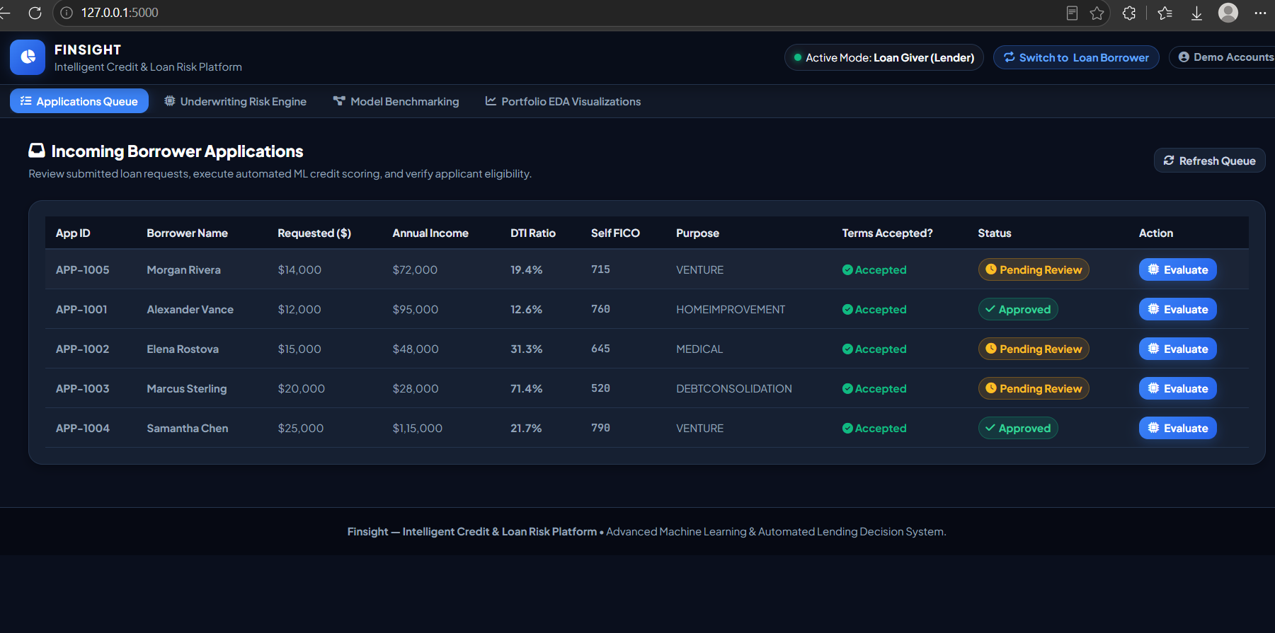
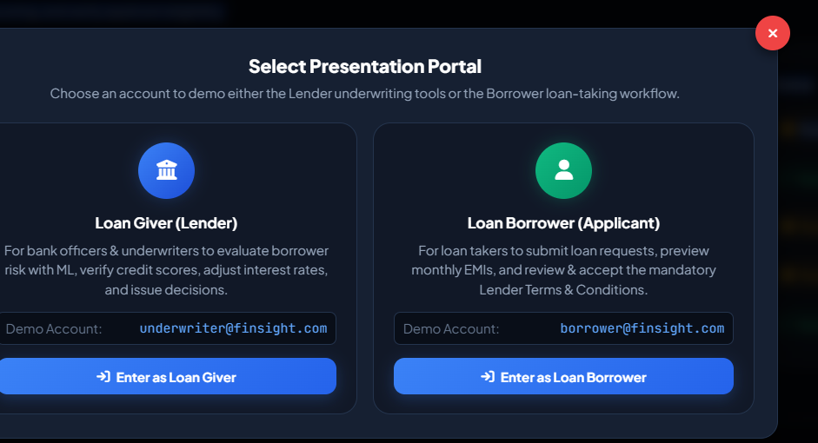

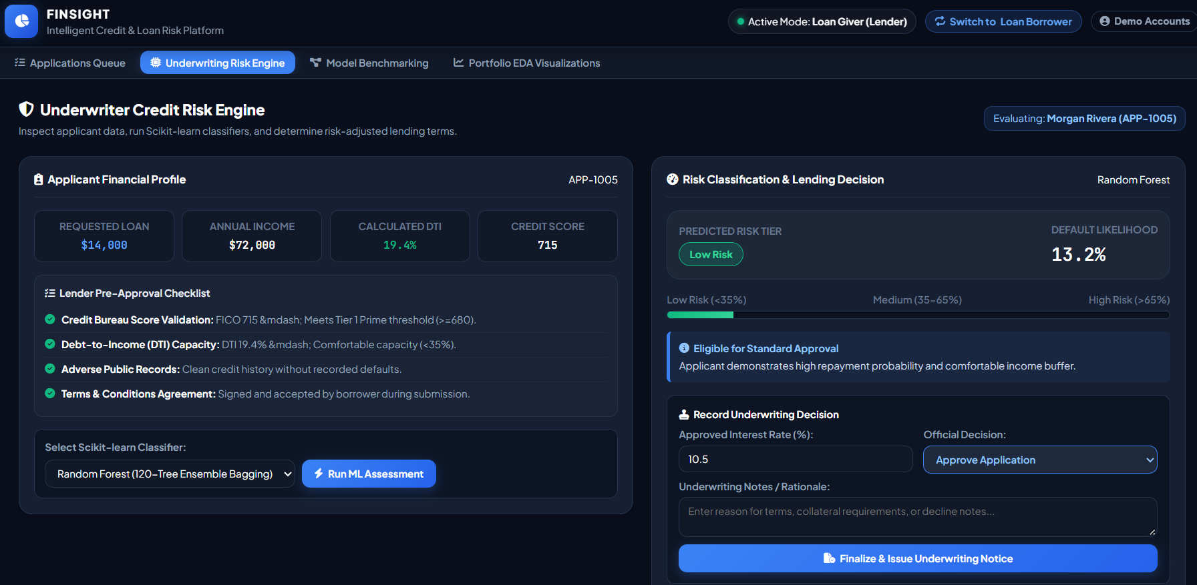
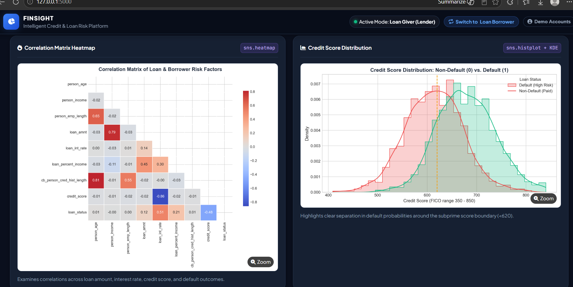

CHAPTER 9
Deployment

9.1 Steps to deploy
- Push the final code to the GitHub repository.
- Run the automated tests; proceed only if all tests pass.
- Train the final model and save it as models/finsight_model.joblib.
- Create a requirements.txt listing the exact package versions.
- Create the production database (PostgreSQL / MySQL) and run the schema script.
- Deploy the FastAPI service to the cloud host and set the environment variables.
- Deploy the Streamlit dashboard and configure it with the API URL.
- Open the public URL and run a smoke test with a sample applicant.

9.2 Environment configuration
Variable | Purpose
DATABASE_URL | Connection string of the production database
SECRET_KEY | Key used to sign JWT tokens (never committed to Git)
MODEL_PATH | Location of the saved model file
API_URL | Address of the API used by the dashboard
RISK_LOW / RISK_HIGH | Probability thresholds for the risk categories

Secrets are stored as environment variables on the host and are kept out of the source code. A virtual environment is used so that package versions are identical in development and production.
9.3 Hosting of frontend and backend
The back-end API and the Streamlit front-end are hosted as two services on a cloud platform (for example Render, Railway or Streamlit Community Cloud for the dashboard). The database runs as a managed PostgreSQL instance. HTTPS is enabled on both services so that applicant data is encrypted in transit.
CHAPTER 10
Challenges & Limitations

10.1 Issues faced during development
- Class imbalance: defaulters form a small fraction of loans, so models tend to predict “no default” for everyone.
- Missing and noisy data: income, employment and credit history fields were incomplete or inconsistent.
- Data leakage: some columns in public loan datasets are recorded after the loan outcome is known and would give the model an unfair hint.
- Interpretability: complex ensemble models are accurate but harder to explain to lenders and regulators.
- Fairness: demographic attributes can introduce bias if used carelessly.
- Choice of threshold: the cut-off between the risk categories changes the balance between approvals and defaults.

10.2 Solutions applied
- Used stratified splitting, class weights and resampling (for example SMOTE) and judged models by recall and ROC-AUC instead of accuracy alone.
- Built a preprocessing pipeline with median/most-frequent imputation and outlier treatment.
- Removed post-outcome columns and split the data before any fitting step to prevent leakage.
- Kept logistic regression as an interpretable baseline and used feature importance to explain ensemble models.
- Reviewed the effect of demographic features and kept the model's use of them transparent.
- Made thresholds configurable so that each lender can set its own risk appetite.

10.3 Current limitations or known bugs
- The model is only as good as the historical data it is trained on; it may not generalise to a very different lending market.
- Predictions are estimates of probability and not a guarantee about an individual borrower.
- Live credit bureau data is not yet integrated.
- The model has to be retrained periodically, because borrower behaviour and the economy change over time.
- The decision-support output must be reviewed by a human before a final lending decision.

CHAPTER 11
Future Enhancements

11.1 Planned features
- Per-applicant explanations with SHAP values shown directly on the dashboard.
- Fairness audit reports that compare outcomes across demographic groups.
- Automatic model monitoring for data drift and scheduled re-training.
- Loan pricing support, suggesting the interest rate that matches the predicted risk.
- Bulk upload of applicant files (CSV/Excel) with downloadable risk reports.
- Multi-language interface for wider use in diverse lending environments.

11.2 Possible integrations or optimizations
- Integration with credit bureau and account aggregator APIs for real-time data.
- Connection to a bank's loan origination or core banking system through the REST API.
- Experiments with deep learning and stacked ensembles for further improvement of accuracy.
- Containerization with Docker and orchestration for large-scale deployment.
- A mobile-friendly interface for field officers of microfinance institutions.

CHAPTER 12
Conclusion

12.1 Summary of the project
Finsight – Loan/Credit Risk Analyzer applies data science to one of the most important problems in lending: deciding whom to lend to. The system studies historical loan data, uses financial indicators such as debt-to-income ratio, transaction history and demographic attributes, and applies logistic regression, decision tree and ensemble models to predict the probability of default and to classify applicants into risk categories.
12.2 What was achieved
- Designed an end-to-end credit risk workflow from data collection to risk classification.
- Built a reusable preprocessing and feature engineering pipeline.
- Compared multiple machine learning models using metrics suitable for imbalanced credit data.
- Designed a layered architecture with a dashboard, REST API and database.
- Produced a tool that supports banks, fintechs and microfinance institutions in minimizing non-performing assets while extending credit to deserving borrowers.

Beyond predictive accuracy, the project emphasizes scalability and adaptability, which makes it suitable for diverse lending environments. Finsight shows how data-driven approaches can balance financial inclusion with sustainable risk management.
12.3 Skills learned during development
- Data cleaning, exploratory data analysis and feature engineering using Python.
- Supervised machine learning, model evaluation and handling of imbalanced data.
- Understanding of credit risk concepts such as default, NPA and debt-to-income ratio.
- Building REST APIs and dashboards and connecting them to a database.
- Version control with Git and GitHub, testing with Postman and pytest.
- Teamwork, documentation and technical report writing.

CHAPTER 13
References

The following books, tutorials and documentation sites are the main sources for this project:
- T. Hastie, R. Tibshirani and J. Friedman, The Elements of Statistical Learning, Springer.
- A. Géron, Hands-On Machine Learning with Scikit-Learn, Keras & TensorFlow, O'Reilly Media.
- N. Siddiqi, Credit Risk Scorecards: Developing and Implementing Intelligent Credit Scoring, Wiley.
- scikit-learn documentation – https://scikit-learn.org/stable/user_guide.html
- pandas documentation – https://pandas.pydata.org/docs/
- XGBoost documentation – https://xgboost.readthedocs.io/
- imbalanced-learn documentation – https://imbalanced-learn.org/stable/
- SHAP documentation – https://shap.readthedocs.io/
- Streamlit documentation – https://docs.streamlit.io/
- FastAPI documentation – https://fastapi.tiangolo.com/
- Git documentation – https://git-scm.com/doc
- Kaggle datasets for loan and credit risk – https://www.kaggle.com/datasets
- UCI Machine Learning Repository – https://archive.ics.uci.edu/

CHAPTER 14
Appendices

14.1 Screenshots of the app
[Insert screenshots here: (a) login page, (b) applicant input form, (c) prediction result with risk category, (d) portfolio analytics, (e) model comparison page.]
14.2 Sample code snippets
A. Training the model (train.py)
import pandas as pd, joblib
from sklearn.model_selection import train_test_split
from sklearn.compose import ColumnTransformer
from sklearn.pipeline import Pipeline
from sklearn.impute import SimpleImputer
from sklearn.preprocessing import StandardScaler, OneHotEncoder
from sklearn.ensemble import RandomForestClassifier
from sklearn.metrics import roc_auc_score, classification_report
df = pd.read_csv("data/loans.csv")
# Feature engineering
df["debt_to_income"] = df["monthly_debt"] / df["monthly_income"]
df["loan_to_income"] = df["loan_amount"] / df["annual_income"]
y = df["default"]
X = df.drop(columns=["default"])
num_cols = X.select_dtypes("number").columns
cat_cols = X.select_dtypes("object").columns
pre = ColumnTransformer([
("num", Pipeline([("imp", SimpleImputer(strategy="median")),
("sc", StandardScaler())]), num_cols),
("cat", Pipeline([("imp", SimpleImputer(strategy="most_frequent")),
("oh", OneHotEncoder(handle_unknown="ignore"))]), cat_cols),
])
model = Pipeline([
("pre", pre),
("clf", RandomForestClassifier(n_estimators=300, class_weight="balanced",
random_state=42)),
])
X_tr, X_te, y_tr, y_te = train_test_split(
X, y, test_size=0.2, stratify=y, random_state=42)
model.fit(X_tr, y_tr)
proba = model.predict_proba(X_te)[:, 1]
print("ROC-AUC:", roc_auc_score(y_te, proba))
print(classification_report(y_te, proba > 0.5))
joblib.dump(model, "models/finsight_model.joblib")
B. Prediction API (main.py)
from fastapi import FastAPI
from pydantic import BaseModel, Field
import joblib, pandas as pd
app = FastAPI(title="Finsight API")
model = joblib.load("models/finsight_model.joblib")
class Applicant(BaseModel):
age: int = Field(ge=18, le=100)
annual_income: float = Field(gt=0)
loan_amount: float = Field(gt=0)
monthly_income: float = Field(gt=0)
monthly_debt: float = Field(ge=0)
employment_type: str
def risk_category(p: float) -> str:
if p < 0.20:
return "Low"
if p <= 0.50:
return "Medium"
return "High"
@app.post("/predict")
def predict(a: Applicant):
data = a.model_dump()
data["debt_to_income"] = data["monthly_debt"] / data["monthly_income"]
data["loan_to_income"] = data["loan_amount"] / data["annual_income"]
p = float(model.predict_proba(pd.DataFrame([data]))[0, 1])
return {"default_probability": round(p, 4), "risk_category": risk_category(p)}
C. Dashboard (app.py)
import streamlit as st, requests
st.title("Finsight - Loan/Credit Risk Analyzer")
age = st.number_input("Age", 18, 100, 30)
income = st.number_input("Annual income", min_value=1.0)
amount = st.number_input("Loan amount", min_value=1.0)
m_income = st.number_input("Monthly income", min_value=1.0)
m_debt = st.number_input("Monthly debt payments", min_value=0.0)
emp = st.selectbox("Employment type", ["Salaried", "Self-employed", "Other"])
if st.button("Analyze Risk"):
payload = {"age": age, "annual_income": income, "loan_amount": amount,
"monthly_income": m_income, "monthly_debt": m_debt,
"employment_type": emp}
r = requests.post("http://localhost:8000/predict", json=payload, timeout=10)
out = r.json()
st.metric("Default probability", f"{out['default_probability']:.1%}")
st.write("Risk category:", out["risk_category"])
14.3 Installation/setup instructions
- Install Python 3.10 or later and Git.
- Clone the repository: git clone <repository-url> and open the project folder.
- Create a virtual environment: python -m venv venv and activate it.
- Install the dependencies: pip install -r requirements.txt
- Place the loan dataset in the data/ folder as loans.csv.
- Train the model: python train.py
- Start the API: uvicorn main:app --reload
- Start the dashboard in a second terminal: streamlit run app.py
- Open the URL shown by Streamlit in the browser.

14.4 User manual or guide
- Log in with the username and password given by the administrator.
- Open the Predict page and fill in the applicant's details.
- Press Analyze Risk.
- Read the default probability and the risk category (Low, Medium or High).
- Check the Key Risk Factors panel to understand the result.
- Use Reports to view earlier assessments and portfolio analytics.
- Treat the output as decision support and review borderline (Medium) cases manually.

