**AppendixS1**

**NOTE: moved offline by Ian on 11-12-17**

**Overview maps of lakes modeled in this study**

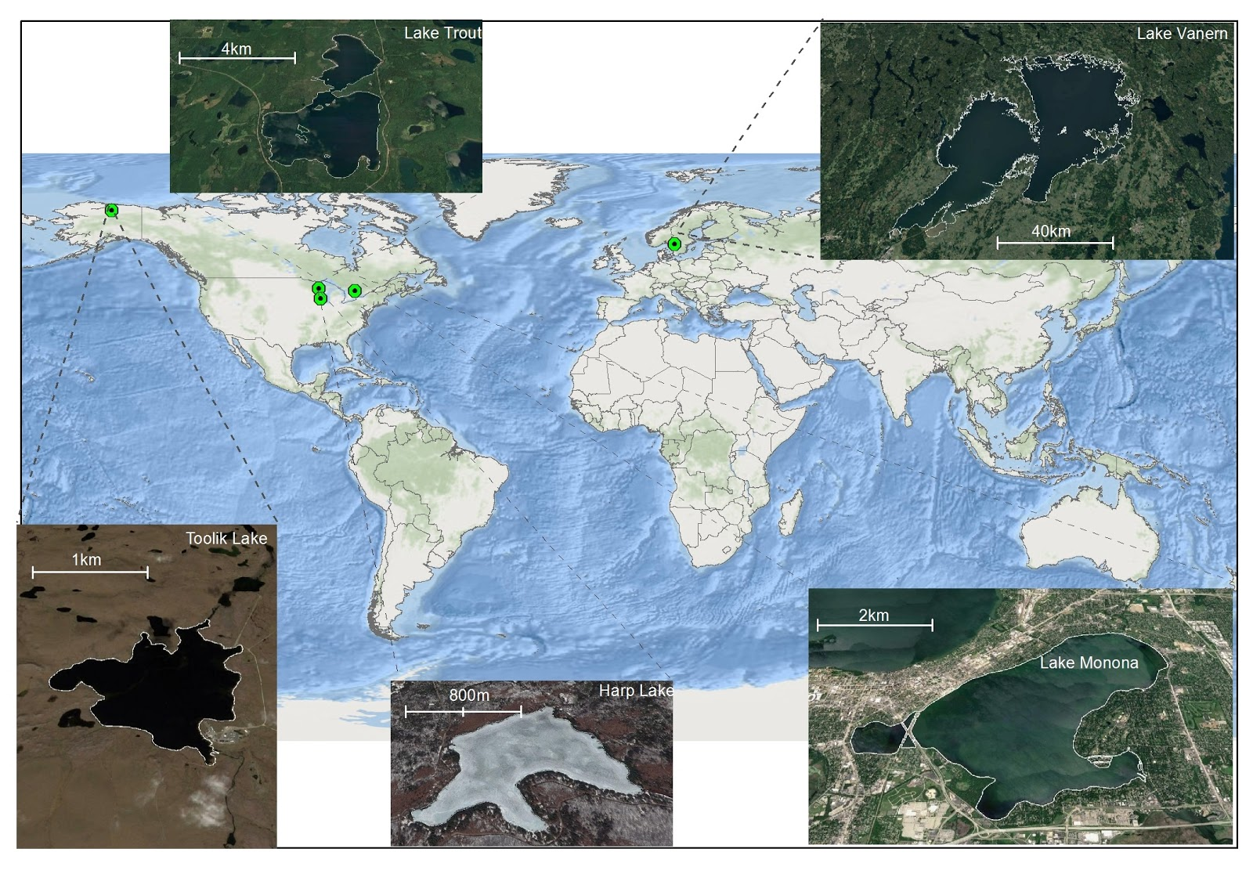

**Data sources**

*Harp Lake*

Input model data for Harp Lake were obtained from Ontario Ministry of the Environment and Climate Change Dorset Environmental Science Centre (<http://desc.ca/data>) Limnological data for the years 1991-2001 were provided. Inflow and lake data were sampled at “HARP INFLOW #3A, #6A, #6, #5, #4, #3 and "HARP LAKE” stations, respectively.   
Total inflow DOC was calculated by summing the DOC concentration of each tributary proportionally to the fraction each tributary contributed to total inflow volume. DOC data ("HARP LAKE") from 1991-2001 were used for model validation. Hypolimnion temperature was set to the bottom temperature in the bottom 2 m of the water profile, whereas epilimnion temperature was set to the temperature in the 1-2 m surface water. Precipitation data were obtained from daily weather records for the "HARP LAKE" meteorological station. Sediment mass accumulation rate was inferred from previous studies (Eimers et al. 2006, Mills et al. 2009). A Harp lake shapefile was hand digitized using ESRI aerial photographs (World Imagery) in ArcGIS (ESRI 2016). PCanopy was estimated using land cover data (15 m resolution) in the Ontario Land Cover Compilation V 2.0 (Ontario Ministry of Natural Resources and Forestry 2014). This dataset showed no adjacent wetlands to Harp Lake. The absence of adjacent wetlands was further verified using aerial photographs (ESRI 2016). As such, PCanopy was set to 1 and PWetland to 0.

*Toolik Lake*

Input model data for Toolik Lake were obtained from a variety of sources. Limnological data for the years 2001-2010 were freely downloaded from the Arctic LTER website (<http://arc-lter.ecosystems.mbl.edu/>). Inflow and lake data were sampled at “Toolik Inlet” and “Toolik Main”, respectively. Hypolimnion temperature was set to the bottom temperature in the bottom 2 m of the water profile, whereas epilimnion temperature was set to the Temp in the 1-2 m surface water. We made special requests for DOC data (Toolik Main) from 2005-2008 to be used for model validation. This request was generously handled by Dr. George Kling. Precipitation data were obtained from daily weather data records for the Toolik Field Station Meteorological Station. We downloaded a wetlands spatial polygon layer for calculating the percent of the shoreline covered by wetlands (PWetland) from the U.S. Fish and Wildlife Service and National Wetlands Inventory (U.S. Fish and Wildlife Service 2014). Due to the lack of forests at this high latitude, we set PCanopy to 0 and needed no other land cover datasets. We confirmed the lack of tree cover from aerial photography accessed via Arctic LTER. Sediment mass accumulation rate was inferred from previous studies (Cornwell 1985, Whalen and Cornwell 1985). A Toolik lake shapefile was also obtained from Arctic LTER.

A unique challenge associated with Toolik Lake was the relatively short ice-free period each year. Typically, complete input datasets for our model were only available from June - August. Normally, our model would linearly interpolate data gaps, but we sought to avoid interpolating over such a large portion of the year. We used date of ice-off for Toolik Inlet when available (2006-2010) to determine when inflow DOC would be near 0 due to ice. When ice-off dates were not available (2001-2005), we used the 2006-2010 average. Setting inflow DOC to 0 shut down the main input of DOC to the ecosystem and considerably improved model calibration.

*Trout Lake*

Data for the Trout Lake time series were obtained from a variety of publicly available sources. Water temperature and water chemistry data for the years 2004-2013 was downloaded from the North Temperate Lakes (NTL) LTER data catalog (<https://lter.limnology.wisc.edu/researchsite/trout-lake>). We defined hypolimnion temperature as the mean temperature below 15 m, whereas epilimnion temperature was the average water temperature above 2 m. Total unfiltered phosphorus (TP) and chlorophyll-a (Chl-*a*) data in the model were each averaged from all sampled depths on each sampling date, which was approximately monthly. Daily water outflow volume data were downloaded from USGS gauge data for the Trout River (USGS Station Number 05357245). While Trout Lake includes multiple surface inflows (Allequash Creek, Mann Creek, Stevenson Creek, North Creek), inflow volume was set equal to surface outflow to maintain constant lake volume. DOC from surface flows was approximated by weighting available surface flow DOC data (<https://lter.limnology.wisc.edu/data/filter/32483>) for individual streams by flow volume in that stream. Daily precipitation data were downloaded from the Climate and Hydrology Database Projects website (<http://www.fsl.orst.edu/climhy/>), using the NTL Minocqua meteorological station.

We obtained lake morphometry parameters from the online NTL Trout Lake profile (<https://lter.limnology.wisc.edu/researchsite/trout-lake>), and initial concentrations of in-lake DOC were obtained from previously published work on Trout Lake (Hanson et al. 2014, P. Hanson personal communication). Sediment mass accumulation rate was based on the average value of available NTL data for “areal flux of carbon to sediment trap”. PWetland for the lake perimeter was estimated using a vector layer obtained from the U.S. Fish and Wildlife Service National Wetlands Inventory (U.S. Fish and Wildlife Service 2014) and the Wisconsin DNR hydrography dataset (Wisconsin Department of Natural Resources 2011). PCanopy was estimated using the WISCLAND land cover raster dataset (30 m resolution) from Wisconsin DNR (Wisconsin Department of Natural Resources 1998). Although we recognize this is a relatively old land cover dataset based on 1993 Landsat imagery, it was only used to estimate forest cover, which is not likely to have changed considerably since 1993.

Model validation in-lake DOC data were obtained from the NTL database (2004-2013) and from unpublished data provided by Mark Gahler (2014; [gahler@wisc.edu](mailto:gahler@wisc.edu)). Validation data for in lake dissolved oxygen were obtained from the NTL database.

*Lake Vänern*

Model time series data for Lake Vänern were obtained primarily from publicly available Swedish Meteorological and Hydrological Institute (SMHI; <http://www.smhi.se>) and Swedish University of Agricultural Sciences (SLU; <http://info1.ma.slu.se/db.html>) databanks. Water temperature and water chemistry data for the years 2001-2013 were downloaded from the SLU databank (<http://info1.ma.slu.se/ma/www_ma.acgi$Project?ID=StationsList&P=V%C4N>), and was based on the “Megrundet N” sampling station only. We defined hypolimnion temperature as the mean temperature below 50 m, whereas epilimnion temperature was the average water temperature above 2 m. TP and chl-*a* data in the model were each averaged from all sampled depths on each sampling date, which was approximately monthly during ice-off (Apr-Nov) periods each year. Daily water outflow volume from the single outlet at Göta Älv dam was obtained from SMHI station 1954 ([http://vattenweb.smhi.se/station/#](http://vattenweb.smhi.se/station/)). Multiple inflows were set equal to outflow volume to maintain constant lake volume. DOC from surface flows was approximated by as 90% of measured total organic carbon (TOC; P. Hanson personal communication) from all sampled sites on all days data were available (<http://info1.ma.slu.se/ma/www_ma.acgi$ProjectP?ID=Intro&P=V%C4NTF>). The monitoring site Klarälven Norra Råda was omitted due to distance of sampling site from the lake. Daily precipitation data were downloaded from the SMHI website <http://opendata-download-metobs.smhi.se/explore/>) using the “Naven A” meteorological station. A data gap from 6/1/2008-7/23/2008 was assumed to be a period of zero precipitation.

We obtained lake morphometry parameters from the SMHI Lake Vänern profile page (<http://www.smhi.se/kunskapsbanken/hydrologi/fakta-om-vanern-1.4732>), and initial concentrations of in-lake DOC and POC were calaculated from SLU in-lake TOC data on the last date prior to the start of our time series (Oct 1999). Sediment mass accumulation rate was calculated based on previously published data for Lake Vänern sediment linear accumulation rate (Wihlborg and Danielsson 2006) and Lake Mälaren sediment % OC and bulk density data (Håkanson 2004), as those data were not available for Vänern. PWetland and PCanopy for the lake perimeter were approximated based on whole catchment land use data for “Marsh”, “Bog”, and “Woodland”, respectively, provided by SMHI.

Model validation in-lake DOC data were calculated from SLU TOC data for the Megrundet N station during ice-off season (Apr-Nov 2000-2013). Validation data for in lake dissolved oxygen was obtained from the SLU database for the Megrundet N station during ice-off season (Apr-Nov 2000-2013).

*Lake Monona*

Inflow discharge data to Lake Monona were downloaded from USGS gauge 05428500. All other time series data for Lake Monona were obtained from from the North Temperate Lakes (NTL) LTER data catalog (<https://lter.limnology.wisc.edu/data>). Inflow DOC was assumed to equivalent to surface DOC concentrations from upstream Lake Mendota, for which biweekly data were available. A time-series of thermocline depths in Lake Monona was calculated from in-lake temperature profiles via rLakeAnalyzer (Winslow et al. 2016). Epilimnion and hypolimnion temperatures were calculated as the mean temperatures above and below the thermocline depths, respectively. Chl-*a* was calculated as the mean concentration throughout the water column. Other parameter data were acquired from <https://lter.limnology.wisc.edu/researchsite/lake-monona> and Hanson et al. (2014). The parameters PCanopy and PWetland were estimated using the same spatial data as for Trout Lake.

*Other lakes*

We additionally acknowledge the efforts of numerous people who provided data for other lakes not ultimately used in this study. In these cases, either we could not obtain all necessary data inputs or a sufficient number of years. Specifically, Hilary Swain of Archbold Biological Station and Evelyn Gaiser provided a long term, curated dataset for Lake Annie, FL. Additionally, several years of discrete nutrient, chlorophyll, temperature, and dissolved oxygen data were provided for West Lake Okoboji, Silver, and Center Lakes in Dickinson County, Iowa, by the Cooperative Lakes Area Monitoring Project (CLAMP).

*References*

Cornwell, J. C. (1985). Sediment accumulation rates in an Alaskan arctic lake using a modified 210Pb technique. Canadian Journal of Fisheries and Aquatic Sciences, 42(4), 809-814.

Eimers, M. C., Paterson A. M., Dillon P. J., Schiff S. L. ,Cumming B. F. and Hall, R. I. (2006) Lake sediment core records of sulphur accumulation and sulphur isotopic composition in central Ontario, Canada lakes. Journal of Paleolimnology, 35, 99-109.

ESRI, DigitalGlobe, GeoEye, Earthstar Geographics, CNES/Airbus DS, USDA, USGS, AEX, Getmapping, Aerogrid, IGN, IGP, swisstopo, and the GIS User Community. (2016).

Hakanson, L. (2004). Internal loading: a new solution to an old problem in aquatic sciences. Lakes & Reservoirs: Research & Management, 9(1), 3-23.

Hanson, P. C., Buffam, I., Rusak, J. A., Stanley, E. H., and Watras, C. D. (2014) Quantifying lake allochthonous organic carbon budgets using a simple equilibrium model. Limnology and Oceanography 59, 167–181.

Mills, R. B., Paterson, A. M., Jules, M. B., Davis, R. S. L., John, P. S. and Greg, M. (2009). Factors influencing the achievement of steady state in mercury contamination among lakes and catchments of south-central Ontario. Canadian Journal of Fisheries and Aquatic Sciences, 66, 187-200.

Ontario Ministry of Natural Resources and Forestry. (2014). Ontario Land Cover Compilation V.2.0. <https://www.ontario.ca/data/ontario-land-cover-compilation-v20>.

U.S. Fish and Wildlife Service. (2014). National Wetlands Inventory. U.S. Department of the Interior, Fish and Wildlife Service, Washington, D.C. http://www.fws.gov/wetlands/.

Whalen, S. C., & Cornwell, J. C. (1985). Nitrogen, phosphorus, and organic carbon cycling in an arctic lake. Canadian Journal of Fisheries and Aquatic Sciences, 42(4), 797-808.

Wihlborg, P., & Danielsson, A. (2006). Half a century of mercury contamination in Lake Vanern (Sweden). Water, Air, and Soil Pollution, 170(1), 285-300.

Winslow, L. A., Read, J. S., Woolway, R., Brentrup, J., Leach, T. and Zwart, J. A. (2014). rLakeAnalyzer: package for the analysis of lake physics. *R package version*, *14*.

Wisconsin Department of Natural Resources. (1998). WISCLAND Land Cover (WLCGW930). <http://dnr.wi.gov/maps/gis/datalandcover.html>.

Wisconsin Department of Natural Resources. (2011). Surface water (hydrography) data. <ftp://dnrftp01.wi.gov/geodata/hydro_24k/>.