## Running head: Organic carbon fates in lakes

Dynamic modeling of organic carbon fates in lake ecosystems

Ian M. McCullough1*, Hilary A. Dugan2, Kaitlin J. Farrell3[1]∧, Ana M. Morales-Williams4, Zutao Ouyang5, Derek Roberts6, Facundo Scordo7, Sarah L. Bartlett8, Samantha M. Burke9, Jonathan P. Doubek10, Flora E. Krivak-Tetley11, Nicholas K. Skaff12, Jamie C. Summers13, Kathleen C. Weathers14 and Paul C. Hanson2

1 Bren School of Environmental Science and Management, University of California, 2400 Bren Hall, Santa Barbara, CA, 93106, US.

2 Center for Limnology, University of Wisconsin-Madison, 680 N Park St, Madison, WI, 53706, US.

3 Odum School of Ecology, University of Georgia, 140 E. Green Street, Athens, GA, 30602, US.

4 Rubenstein School of Environment and Natural Resources, University of Vermont, 81 Carrigan Drive, Burlington, VT, 05405.

5 Center for Global Change and Earth Observations, Michigan State University, 1405, S. Harrison Rd. East Lansing, MI, 48823, US.

6 Department of Civil & Environmental Engineering, University of California, 1 Shields Avenue, Davis, CA, 95616, US. UC Davis Tahoe Environmental Research Center, 291 Country Club Drive, Incline Village, NV, 89451, US.

7 Instituto Argentino de Oceanografía, Universidad Nacional del Sur - CONICET, 8000 Florida St, Bahía Blanca, B8000BFW, Buenos Aires, Argentina.

8 School of Freshwater Sciences, University of Wisconsin-Milwaukee, 600 E Greenfield Ave, Milwaukee, WI, 53204, US.

9 Department of Biology, University of Waterloo, 200 University Ave. W, Waterloo, ON, N2L 3G1, Canada.

10 Department of Biological Sciences, Virginia Tech, 926 West Campus Drive, Blacksburg, VA, 24061, US.

11 Department of Biological Sciences, Dartmouth College, Hanover, NH, 03755, US.

12 Department of Fisheries and Wildlife, Michigan State University, 13 Natural Resources Building, East Lansing, MI, 48824, US.

13 Department of Biology, Queen’s University, 99 University Ave, Kingston, ON, K7L 3N6, Canada.

14 Cary Institute of Ecosystem Studies, Box AB, Millbrook, NY, 12545, US.

*Corresponding author: Current address: Department of Fisheries and Wildlife, Michigan State University, 13 Natural Resources Building, East Lansing, MI, 48824, US. [immccull@gmail.com](mailto:immccull@gmail.com)

## **ABSTRACT**

Lakes are active processors of organic carbon (OC) and play important roles in landscape and global carbon cycling. Allochthonous OC loads from the landscape, along with autochthonous OC loads from primary production, are mineralized in lakes, buried in lake sediments, and exported via surface or groundwater outflows. Although these processes provide a basis for a conceptual understanding of lake OC budgets, few studies have integrated these fluxes under a dynamic modeling framework to examine their interactions and relative magnitudes. We developed a simple, dynamic mass balance model for OC, and applied the model to a set of five lakes. We examined the relative magnitudes of OC fluxes and found that long-term (> 10 year) lake OC dynamics were predominantly driven by allochthonous loads in four of the five lakes, underscoring the importance of terrestrially-derived OC in northern lake ecosystems. Our model highlighted seasonal patterns in lake OC budgets, with increasing water temperatures and lake productivity throughout the growing season corresponding to a transition from burial- to respiration-dominated OC fates. Ratios of respiration to burial, however, were also mediated by the source (autochthonous vs. allochthonous) of total OC loads. Autochthonous OC is more readily respired and may therefore proportionally reduce burial under a warming climate, but allochthonous OC may increase burial due to changes in precipitation. The ratios of autochthonous to allochthonous inputs and respiration to burial demonstrate the importance of dynamic models for examining both the seasonal and inter-annual roles of lakes in landscape and global carbon cycling, particularly in a global change context. Finally, we highlighted critical data needs, which include surface water DOC observations in paired tributary and lake systems, measurements of OC burial rates, groundwater input volume and DOC, and budgets of particulate OC.

Key words: carbon cycle, mass balance, dissolved organic carbon, particulate organic carbon, LTER, GLEON

## **INTRODUCTION**

Lakes are dynamic components of the landscape that actively process, store, and transport terrestrially derived organic carbon (OC) (Cole et al. 2007, Tranvik et al. 2009, Tanentzap et al. 2017), as well as emit inorganic carbon to the atmosphere (Arvola et al. 2002, Raymond et al., 2013, Weyhenmeyer et al. 2015), making them important in global carbon (C) cycling. Owing to few ecosystem-scale studies that fully balance OC budgets (Cole et al. 1989, Hanson et al. 2014, 2015), there remains a considerable knowledge gap in lake OC dynamics, and thus in fully understanding the role of lakes in the global C cycle. Global estimates of CO2 emissions (i.e., evasion) from lakes and reservoirs are 0.32 Pg (petagrams) C yr-1 (Raymond et al. 2013), whereas anywhere from 0.02-0.07 Pg C yr-1 (Tranvik et al. 2009) to 0.06–0.25 Pg C yr-1 are stored in sediments (Mendonca et al. 2017). These estimates, however, are highly uncertain, and models that dynamically account for major OC fluxes and storage terms in lakes and that explore uncertainties around those terms are needed to advance our understanding of lake OC cycling and their contribution to global C budgets (Hanson et al. 2015, Reed et al. 2018). Existing mass balance models are generally based on low spatio-temporal frequency data, confined to single lakes, and are often from boreal regions (Jonsson et al. 2001, Urban et al. 2005, Andersson and Sobek 2006, Cremona et al. 2014). In a first step in overcoming some of these limitations, we developed and applied a dynamic mass balance model to examine the relative magnitudes of OC fluxes across a set of five lakes with whole-ecosystem OC budget data. Our goal was to build a simple OC model that could be applied in a range of lake ecosystems to capture seasonal and annual variation in OC concentrations.

### *Overview of concepts of key OC fluxes in lake ecosystems*

For lakes, the term “mass balance” has been broadly used to quantify carbon or nutrient budgets as the combination of inputs, outputs, and changes to standing stocks in the water column and sediments (Pace and Lovett 2013). Inputs to lake ecosystem OC budgets are the sum of allochthonous (externally derived) dissolved (DOC) and particulate OC (POC) inflows from surface and groundwater sources, atmospheric deposition via precipitation, dry deposits, and litterfall, and autochthonous (internally derived) DOC and POC (Kawasaki and Benner 2006) and phytoplanktonic primary production. Outputs from the OC pool reflect mechanisms that mineralize (i.e., photo-oxidation and respiration) and export OC via surface and groundwater outflows. Here, for simplicity, all mineralization processes that convert OC to CO2 are collectively modeled as respiration. The mass change in OC in the water column and lake sediments is considered as change in storage. Outputs and storage are the fates of OC loads, and their balances define the role of lakes in broader C cycling (Box 1, Fig. 1).

***Box 1. Mass balance conceptual equations for organic carbon (OC) in lake ecosystems***

*OCALLOCHTHONOUS:* surface and groundwater inflows + litterfall + atmospheric deposition

*OCAUTOCHTHONOUS*: gross primary production - autotrophic respiration

*Full budget*: *OCALLOCHTHONOUS* + *OCAUTOCHTHONOUS* = respiration + burial + export+ ΔOC (in water column)

At the global scale, lakes are thought to be net sources of C to the atmosphere based on the mean CO2 (Kortelainen et al. 2006, Tranvik et al. 2009, Raymond et al. 2013) and methane (Bastviken et al. 2011) concentrations at higher than atmospheric levels in lake surface waters. OC export is less frequently considered, but equally important, in terms of the quality and quantity of OC ultimately reaching the ocean via tributaries (Raymond and Bauer 2001, Santoso et al. 2017). Because lakes store OC in sediments, they can also act as sinks in the global C cycle (Mulholland and Elwood 1982, Dillon and Molot 1997, Einsele et al. 2001, Einola et al. 2011).

We synthesized existing knowledge of lake OC budgets into a model that integrates these important mechanisms, including both in-lake as well as external (i.e., watershed) processes (Fig. 1). Below we described these processes in three main categories of the dominant processes that influence long-term lake OC budgets: 1) allochthonous inputs, 2) autochthonous inputs, and 3) storage and export.

### *Allochthonous inputs*

Allochthonous inputs include all externally derived OC, including terrestrial DOC and POC from surface and groundwater inflows, litterfall, and direct-fall precipitation (Box 1). Although surface water inflows regularly deliver DOC to lake ecosystems, the uncertainties around their sources and magnitudes are perhaps the most commonly overlooked aspect in OC budgets, largely owing to data limitations (Hanson et al. 2015, Duffy et al. 2018). Prior studies have included direct measurements of inflow stream concentrations of DOC when available (Schindler et al. 1997, Jonsson et al. 2001, Urban et al. 2005, Klump et al. 2009), but other approaches have included literature-derived input estimates (Striegl et al. 1998), equations based on watershed area (Sobek et al. 2006), watershed-wetland area ratios (O’Connor et al. 2009), precipitation (Hanson et al. 2004, Staehr et al. 2010), or GIS-based estimates based on land cover and distance-weighted hydrological flow paths (Canham et al. 2004). In lakes without surface inflows, including closed-basin and seepage lakes, groundwater can be the dominant hydrological input (e.g., Gaiser et al. 2009) and can deliver DOC to lakes, especially in organic-rich soils (Schindler and Krabennhoft 1998). Empirical measurements of groundwater discharge and DOC concentration, however, are rare and difficult to estimate (Hanson et al. 2014). POC inputs from litterfall, and wet and dry atmospheric deposition are typically small and are generally estimated as a function of lake size and literature- or expert-based loading coefficients (Hanson et al. 2004).

### *Autochthonous inputs*

Autochthonous DOC and POC originate within lakes through bacterial exudates and photosynthesis by primary producers. Since gross primary production (GPP) is difficult to measure at the ecosystem level, net primary production (NPP), considered the difference between GPP and autotrophic respiration, is measured instead (Pace and Lovett 2013; Box 1). Approaches to estimate NPP include bottle incubations (Urban 2005, Yang et al. 2008) and high frequency measurements of dissolved oxygen or CO2 concentrations (Cole et al. 2002, Staehr et al. 2010). Statistical relationships have also been developed to estimate NPP from lake temperature and total phosphorus (TP; Hanson et al. 2004), chlorophyll-a (chl-*a*; Jonsson et al. 2001, Ramlal et al. 2003), or static proportions of the overall OC pool (Åberg et al. 2004).

*Storage and export*

Long-term burial of POC in lake sediments is the mechanism by which lakes remove C from the global C cycle, and is therefore a critical component of our understanding of the fate of both allochthonous and autochthonous POC (Cole et al. 2002, Tranvik et al. 2009, Mendonca et al. 2017). POC burial in lakes is a product of in-lake POC concentrations, POC particle sizes and associated settling rates, sediment particle size and density that control resuspension, lake hydrodynamics that affect settling rates and resuspension, and benthic biogeochemistry (Downing et al. 2008, Xu et al. 2013). Methods for estimating sediment accumulation rates are diverse and commonly include functions based on lake area (Canham et al. 2004, Hanson et al. 2004), sediment cores (Yang et al. 2008, Klump et al. 2009, Heathcote & Downing 2012), sediment traps (Jonsson et al. 2001, Ramlal et al. 2003), or bathymetry (Downing et al. 2008). A challenge associated with estimating accumulation rates is the reliance on point measurements to characterize sediment accumulation rates that can vary widely over both space and time. Allochthonous and autochthonous POC that is not buried is exported directly, mineralized, or leached in the form of DOC and exported via surface or groundwater (Cole et al. 1984). Exports represent allochthonous inputs to downstream aquatic ecosystems and therefore contribute to landscape C cycling (Kling et al. 2000).

### *Objective and research question*

Our broad objectives were (1 to quantify long-term (i.e., > 10 year) dynamics and magnitudes of DOC fluxes through the development of a simple dynamic model, and (2 to use this model to reveal the dynamics of dominant divers of OC fates (allochthonous vs. autochtonous load, and burial vs. respiration). We applied the model to five lakes that encompass contrasts in morphology, hydrology, and trophic state to understand the relative influence of these lake characteristics on OC cycling, and to address our overarching research question: What are the magnitudes and uncertainties in processes governing lake OC cycling and how do these change through time?

## **METHODS**

### *Study lakes and data sources*

We modeled temporal dynamics of OC budgets for five lakes that span a range of limnological characteristics (e.g., hydrologic residence time, depth, trophic state; Table 1). Lakes were selected based on contrasting characteristics and availability of observational data. Required observational data included precipitation, hydrological inflow (discharge), inflow DOC concentration, and various in-lake measurements (surface water temperature, chl-*a* concentration, and Secchi depth). All lakes had a minimum of 10 years of limnological data used for model training and at least four years of in-lake DOC and DO measurements for model validation. See the appendix for detailed data descriptions and sources (Appendix 1). Our dataset included four oligotrophic lakes and one eutrophic lake. Lake areas ranged from 71.38 ha to 565000 ha and mean depths ranged from 7 m to 27 m. Hydrologic residence times ranged from 0.8 years to 6.3 years. In-lake mean annual DOC concentrations ranged from 3 g m-3 to 6 g m-3. Watersheds are primarily forested for Harp Lake, Trout Lake, and Lake Vänern, whereas Toolik Lake is in a tundra-dominated watershed, and Monona is in an agricultural and heavily developed watershed.

Table 1. Lake characteristics.

|  |  |  |  |  |  |
| --- | --- | --- | --- | --- | --- |
| **Lake** | **Harp** | **Monona** | **Toolik** | **Trout** | **Vänern** |
| Location | Ontario, Canada | Wisconsin, USA | Alaska, USA | Wisconsin, USA | Sweden |
| Lat, Long | 45.38, -79.14 | 43.06, -89.36 | 68.63, -149.61 | 46.04, -89.69 | 58.87, 13.41 |
| Data years | 1991-2001 | 2003-2014 | 2001-2010 | 2004-2013 | 2001-2013 |
| Lake area (ha) | 71 | 1326 | 149 | 1610 | 565000 |
| Perimeter (m) | 4000 | 35200 | 8104 | 25900 | 2007000 |
| zmean (m) | 12 | 8.3 | 7 | 14.6 | 27 |
| RT (yr) | 2.5 | 0.8 | 0.8 | 5.9 | 6.3 |
| Trophic state | oligotrophic | eutrophic | oligotrophic | oligotrophic | oligotrophic |
| Secchi (m) | 4.3 | 2.7 | 4.7 | 5.3 | 4.5 |
| Chl-*a*  (µg L-1) | 2.4 | 9.2 | 1.1 | 2.2 | 2.1 |
| SW DOC  (g m-3) | 9.9 | 5.2 | 6.8 | 5.1 | 9.4 |
| Lake DOC  (g m-³) | 4 | 6 | 5 | 3 | 4 |
| PCanopy | 1.000 | 0.167 | 0.000 | 0.780 | 0.615 |
| PWetlands | 0.000 | 0.026 | 0.133 | 0.011 | 0.037 |
| Burial rate  (g m-² yr-1) | 78 | 249 | 153 | 27 | 186 |
| References | Yao et al. 2011 | NTL LTER | Kling et al. 2000 | Webster et al. 1996, NTL LTER | Kvarnäs 2001 |

zmean = mean depth, RT = hydrologic residence time, Secchi = Secchi depth, Chl-*a* = chlorophyll-a, SW DOC = inflow dissolved organic carbon, Lake DOC = in-lake DOC (mean water column). All values are means from all available model calibration data or were derived from cited references. NTL LTER = [https://lter.limnology.wisc.edu](https://lter.limnology.wisc.edu/datacatalog/search). See Appendix 1 for sources of burial rates.

*General model approach*

We developed a relatively simple, dynamic mass balance model (Fig. 1, Tables 2-3), that included four state variables representing OC (Table 3, Eqs. 1-4) and one representing dissolved oxygen (DO, Eq. 5). Literature-based and calibrated parameters for the equations are in Table 2. We used literature-based parameters for processes generally described in previous studies and when lake-specific information was unavailable, and to prevent overfitting of the model. Allochthonous DOC and POC (Eqs. 1-2) for the lakes were modeled separately from autochthonous DOC and POC (Eqs. 3-4). Model complexity was commensurate with the number of observational variables available. We operated the model on a daily time step for 10-13 years, based on data availability.

As all five lakes are drainage lakes with outlet streams, lake levels are relatively stable. From 1995 to 2017, Trout Lake varied < 0.5 m, and Lake Monona varied < 1 m (N. Lottig, personal communication). Lake Vänern varied < 1 m from 2003 to 2009 (Tongal and Berndtsson 2014). Lake level, and therefore volume, was assumed static over the modeling period. Inflow discharge at a daily time step was available for all study lakes. DOC concentration of inflows was available at weekly or biweekly intervals. To model inflow DOC at a daily time step, we used the *loadflex* package in R to fit stream load models for each system (Appling et al. 2015). We first fit a regression model for each lake, which was then incorporated in a composite method, which uses model residuals from the regression model to adjust predictions based on observed data (Aulenbach 2013, Kelly et al. 2018). After testing the nine available regression models, model 9 was used for all lakes, except Trout Lake where model 4 returned the best fit (see Kelly et al. 2018 for full regression model equations). When inflow DOC concentrations were not available for all tributaries, DOC was scaled to equal total inflow volume.

**Figure 1.**

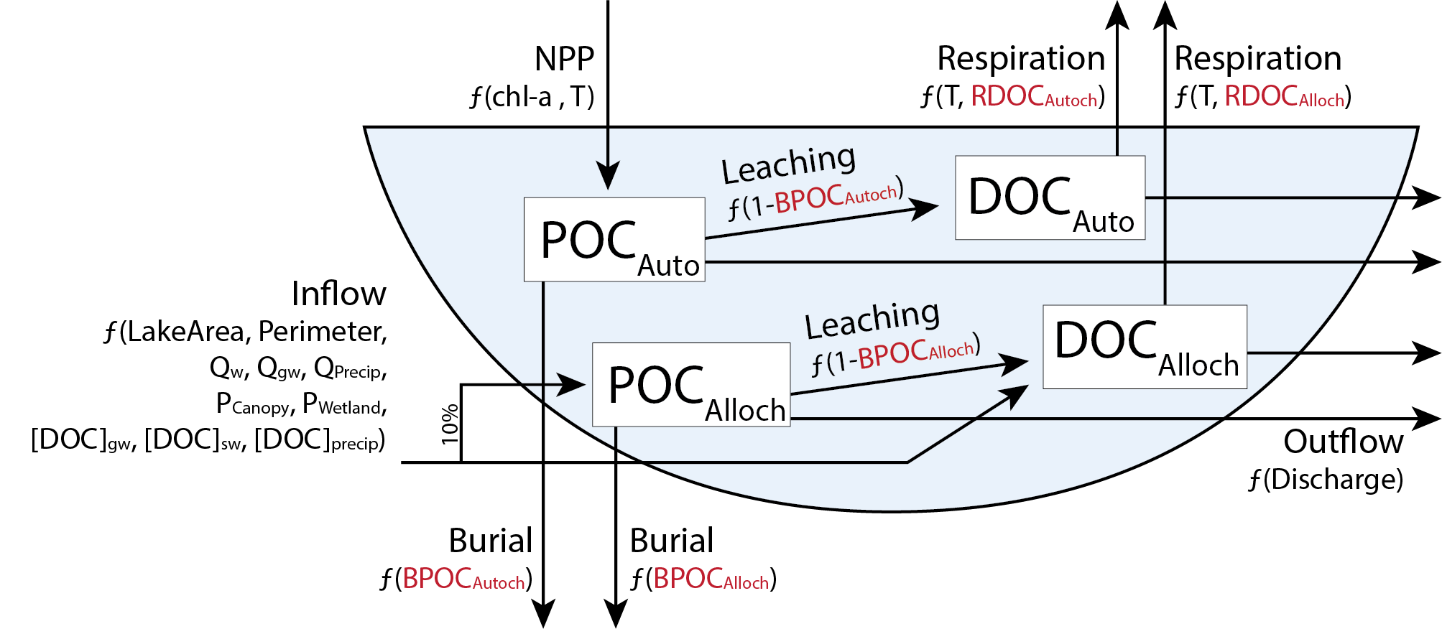

Figure 1. Conceptual diagram of the organic carbon lake model depicting fluxes based on allochthonous (alloch; externally derived) and autochthonous (autoch; internally derived; NPP) inputs of organic carbon, long-term burial, leaching of particulate organic carbon (POC) to dissolved organic carbon (DOC), respiration of DOC to CO2, and export via outflow. Four parameters (RDOCAlloch, RDOCAlloch, BPOCAutoch, and BPOCAlloch) were calibrated for each lake. Parameters and equations are defined in Tables 2 and 3.

Observational data of in-lake chl-*a*, Secchi depth, and temperature were available weekly or bi-weekly and were linearly interpolated to a daily time step. Precipitation was assumed zero for missing dates; however, precipitation data gaps were rare. To account for the absence of winter data at Toolik, we set inflow DOC to 0 when the main inflow (Toolik Inlet) was frozen (Appendix 1). The model was written and executed in R version 3.3.2 (R Core Team 2016). Model code and data are available here: <https://github.com/GLEON/SOS>.

**Table 2. Lake model parameters (calibrated parameters italicized, n = 4)**

|  |  |  |  |
| --- | --- | --- | --- |
| **Parameter** | **Description** | **Value** | **Units** |
| DOCGWconc | DOC concentration of groundwater | 10 | g m-3 |
| DOCPrecipConc | DOC concentration of precipitation | 2 | g m-3 |
| CDOCWetland | Loading rate of POC from wetlands | 1 | g m-shoreline-1 d-1 |
| CLAlloch | Proportion of allochthonous POC that is leached to DOC | 1- *BPOCAlloch* | Unitless |
| *RDOCAlloch* | *Decomposition rate of allochthonous DOC in heterotrophic respiration* | *Calibrated* | *d*-*1* |
| θ | Temperature multiplier | 1.08 | Unitless |
| CPOCFactor | Concentration of inflow POC relative to DOC | 0.10 | Unitless |
| CPOCAerial | Loading rate of aerial POC (i.e., leaflitter) | 1 | g m-shoreline-1 d-1 |
| *BPOCAlloch* | *Proportion of allochthonous POC buried in sediments* | *Calibrated* | Unitless |
| CLAutoch | Proportion of autochthonous POC that is leached to DOC | 1- *BPOCAutoch* | Unitless |
| *RDOCAutoch* | *Decomposition rate of autochthonous DOC in heterotrophic respiration* | *Calibrated* | *d*-*1* |
| *BPOCAutoch* | *Proportion of autochthonous POC buried in sediments* | *Calibrated* | Unitless |
| k | Gas flux coefficient | 0.7 | m d-1 |
| RAutotroph | Proportion of GPP respired by autotrophs | 0.8 | Unitless |

**Table 3. Model Equations**

|  |  |
| --- | --- |
| **No.** | **Equation** |
| 1  2  3  4  5 | DDOCAlloch/dt = IDOC + DDOC + LAlloch – MDOCAlloch – EDOCAlloch  DPOCAlloch/dt = IPOC + DPOC – LAlloch – BAlloch – EPOCAlloch  DDOCAutoch/dt = NPPDOC + LAutoch – MDOCAutoch – EDOCAutoch  DPOCAutoch/dt = NPPPOC – LAutoch – BAutoch – EPOCAutoch  dDO/dt = NEPOC + Fatm |
|  |  |
|  | **Allochthonous DOC** |
| 1.1 | IDOC = IDOC.SW + IDOC.GW |
| 1.11 | IDOC.SW = DOCSWconc * QSW |
| 1.12 | IDOC.GW = DOCGWconc * QGW |
| 1.2 | DDOC = DDOCPrecip + DDOCWetland |
| 1.21 | DDOCPrecip = DOCPrecipConc­ * QPrecip |
| 1.22 | DDOCWetland = PWetland * CDOCWetland * LakePerimeter |
| 1.3 | LAlloch = *C*L.Alloch * POCAlloch |
| 1.4 | MDOCAlloch = RDOCAlloch * DOCAlloch * θ(T- TBase) |
| 1.5 | EDOCAlloch = DOCAlloch * QOutflow |
|  |  |
|  | **Allochthonous POC** |
| 2.1 | IPOC = IDOC * CPOCFactor |
| 2.2 | DPOC = DPOCCanopy + DPOCWetland |
| 2.21 | DPOCCanopy = PCanopy * CPOCAerial * LakePerimeter |
| 2.22 | DPOCWetland = DDOCWetland * CPOCFactor |
| 2.3 | BAlloch = BPOCAlloch * POCAlloch |
| 2.4 | EPOCAlloch = POCAlloch * QOutflow |
|  |  |
|  | **Autochthonous DOC** |
| 3.1 | NPPTot = 10(1.18 + (0.92 * log10(chl-*a* * Zmix) + (0.014 * T)) * (1-RAutotroph) |
| 3.2 | NPPDOC = 0.2 * NPPTot * (chl-*a* * zmix)-0.22 * (0.714) |
| 3.3 | LAutoch = CLAutoch * POCAutoch |
| 3.4 | MDOCAutoch = RDOCAutoch * DOCAutoch * θ(T-TBase) |
| 3.5 | EDOCAutoch = DOCAutoch * QOutflow |
|  |  |
|  | **Autochthonous POC** |
| 4.1 | NPPPOC = NPPTot – NPPDOC |
| 4.2 | BAutoch = BPOCAutoch * POCAutoch |
| 4.3 | EPOCAutoch = POCAutoch * QOutflow |
|  |  |
|  | **DO** |
| 5.1 | NEPOC = Fatm = NPPTot – RHTot |
| 5.11 | NPPTot = NPPDOC + NPPPOC |
| 5.12 | RHTot = MDOCAlloch + MDOCAutoch |
| 5.2 | Fatm = *k* * (DO – DOSat) * Zmix-1 |
|  | Abbreviations: I = Inflow, E = Export, D = Deposition, L = Leaching, M = mineralization, R = Respiration, B = Burial, TBase = 20°C |

### *Allochthonous DOC and POC*

Changes in allochthonous DOC were modeled as a function of DOC load, deposition, leaching, mineralization, and export (DOCAlloch, Eq. 1). Allochthonous DOC load was calculated as the sum of inflows (IDOC, Eq. 1.1) from both surface (IDOC.SW, Eq. 1.11) and groundwater (IDOC.GW, Eq. 1.12), and deposition (DDOC, Eq. 1.2) from precipitation (DPrecip, Eq. 1.21) and adjacent wetlands (DWetland, Eq. 1.22). Mass loads were calculated as the product of DOC concentrations and flows, except for DWetland, which was the product of the proportion of lake perimeter that is wetland (PWetland), a parameter representing a transfer coefficient (CDOCWetland) of DOC from the wetland to the lake, and lake perimeter (LakePerimeter). The third input (LAlloch, Eq. 1.3) represented in-lake leaching of POCAlloch to DOCAlloch as the product of a first-order decay rate (CLAlloch; 1 - BPOCAlloch) and the POCAlloch concentration. There were two fates of DOCAlloch (Eq. 1). The first was mineralization (MDOCAlloch, Eq. 1.4), which was the product of a first-order decay rate (RDOCAlloch), the DOCAlloch concentration, and a Q10 temperature adjustment using a standard Arrhenius equation. A temperature multiplier (θ) of 1.08 was used for all lakes, equating to a Q10 ~ 2 (Reynolds and Irish 1997). The second was export downstream (EDOCAlloch, Eq. 1.5), which was the product of DOCAlloch and outflow (QOutflow).

Changes in allochthonous POC were modeled as a function of POC load, deposition, leaching, burial, and export (POCAlloch, Eq. 2). Allochthonous POC input (IPOC, Eq. 2.1) was modeled as a proportion of IDOC, (CPOCFactor). Deposition (DPOC, Eq. 2.2) was the sum of canopy (DPOCCanopy) and wetland (DPOCWetland) inputs, where DPOCCanopy (Eq. 2.21) was the product of the proportion of lake perimeter that is canopy (PCanopy), a parameter representing a transfer coefficient (CPOCAerial) of POC from the canopy to the lake, and LakePerimeter. DPOCWetland (Eq. 2.22) was assumed to scale with DDOCWetland by the proportion CPOCFactor. POCAlloch had a burial fate (BAlloch, Eq. 2.3), calculated as the product of a burial coefficient (BPOCAlloch) and POCAlloch. As with DOCAlloch, downstream export (EPOCAlloch, Eq. 2.4) was included as the product of POCAlloch and outflow.

Daily precipitation (QPrecip, mm) was based on measurements from the weather station nearest to each lake. The concentration of DOC in precipitation was set to 2 g m-3 (Hanson et al. 2014). Time series of lake-specific groundwater inflow volume (m3) and DOC concentration (g m-3) were not available. We estimated the proportion of inflow as groundwater in our study lakes based on literature values when available, but assumed no groundwater in the absence of data (Appendix 1). Resulting estimated groundwater proportions were 0% for all lakes except Trout Lake, which we estimated at 19% (Hanson et al. 2014). Groundwater DOC concentration was assumed to be 10 g m-3 (Table 2: DOCGWConc, Hanson et al. 2014). Shoreline-adjacent wetlands and forests were estimated from publicly available spatial datasets (Appendix 1). We focused on wetlands adjacent to the shoreline because they contribute most of wetland-derived DOC to lakes not already captured in Eq. 1.1 (Hanson et al. 2014). To account for potential misalignment among spatial wetland and forest data and lake boundaries, we defined adjacency as within 30 m of lake boundaries.

### *Autochthonous DOC and POC*

Our approach to modeling autochthonous inputs (Table 3, Eqs. 3-4) was generally similar to that of allochthonous inputs for leaching, mineralization, export, and burial (Eqs. 3.3-3.5, 4.2-4.3), but differed in the input terms: NPPDOC (Eq. 3.2) and NPPPOC(Eq. 4.1). Total autochthonous inputs (NPPTOT, Eq. 3.1) were the product of GPP, which was modeled as a function of chl-*a* (µg L-1), mixing depth (Zmix) (set to half of photic depth; m), and surface water temperature (T, °C) per Morin et al. (1999), and the proportion of GPP not respired by autotrophs (1-RAutotroph). The GPP function was calculated using observed temperature and chl-*a* data that ranged from 5-25 °C and 1-1000 mg m-2, respectively, across all lakes. Since models of GPP are not well constrained at low temperatures, we set GPP to zero if surface water temperatures were < 4 °C. Chl-*a* concentrations were converted from volumetric to areal units by multiplying by photic depth, which was estimated from Secchi depth (m; Wetzel 2001). The DOC fraction of total NPP (NPPDOC) was calculated using the Pace and Prairie (2005) negative exponential equation (Eq. 3.2). The remainder of NPPTOT was attributed to POC (NPPPOC, Eq. 4.1).

Water column dissolved oxygen (DO) was used to constrain net ecosystem production (NEPOC, Eq. 5.1), under the assumption that at short time scales and under pseudo-equilibrium conditions, atmospheric exchange (Fatm) approximated NEPOC. Fatm (Eq. 5.2) was calculated as a function of piston velocity (k), set to 0.7 m d-1 (with no wind speed data, this is a conservative estimate), DO and DO saturation, and mixing depth (Zmix). The saturation of DO (DOsat) is temperature dependent and was determined using the Garcia-Benson method in the LakeMetabolizer R package (Winslow et al. 2016). Heterotrophic respiration (RHTot) was calculated as a function of DOCAutoch and DOCAlloch concentration (g m-3) in the photic zone, epilimnion temperature (assumed to be uniform through the photic zone), and two calibrated parameters: RDOCAutoch and RDOCAlloch(Tables 2-3, Eqs. 1.4, 3.4, 5.12) (see Model calibration and uncertainty analysis). We determined epilimnion temperature by averaging observed temperatures throughout the photic zone when data were available from multiple depths, but otherwise used surface temperature (Appendix 1).

*Model calibration and uncertainty analysis*

The collinearity of the four free parameters in the model (respiration: RDOCAlloch, RDOCAutoch, burial: BPOCAlloch, and BPOCAutoch; Table 2) was tested using the *collin* function in the R package FME (Soetaert and Petzoldt 2010). In general, when the collinearity index is less than 20, linear independence is assumed (Brun et al. 2001, Omlin et al. 2001). Finding low collinearity, the four parameters were fit by minimizing the sum of the squared residuals of DOC and DO. DO residuals were weighted 0.25 that of DOC, and the total number of residuals was equally weighted between DO and DOC. The model was fit using a pseudo-random search algorithm in the FME package. Burial parameters were constrained in the model as a proportion between 0 (no burial of POC) and 1 (all POC is buried). RDOCAlloch was constrained between 0.0003 and 0.03 (d-1) based on the range of OC decomposition rates for inland waters with residence times between 1-10 years presented in Catalan et al. (2016). RDOCAutoch was constrained between 0.003 and 0.3 (d-1) (Hanson et al. 2004). Goodness of fit was evaluated with root mean square error (RMSE) and Nash-Sutcliffe efficiency (NSE) scores calculated for DOC and DO for each lake using the hydroGOF R package (Zambrano-Bigiarini 2017). Goodness of fits were reported for DOC and DO because the model was fit to both simultaneously rather than individually. A sensitivity analysis of each parameter was conducted by allowing the parameter to vary at 100 different values within the set bounds while fixing the other three parameters at their calibrated values.

We estimated parameter means and uncertainties using a bootstrapping routine (per Dugan et al. 2017). Using the bootstrapped parameters, we calculated residual errors between observed and modeled DOC and DO. We created 100 pseudo-observational datasets by randomizing these residuals 100 times and adding each randomized residual set to the observed data. We then re-fit the parameters to the pseudo-observational datasets to provide 100 new parameter estimates. Finally, we recorded parameter distribution characteristics and assessed correlations among parameters within each lake.

**Figure 2.**

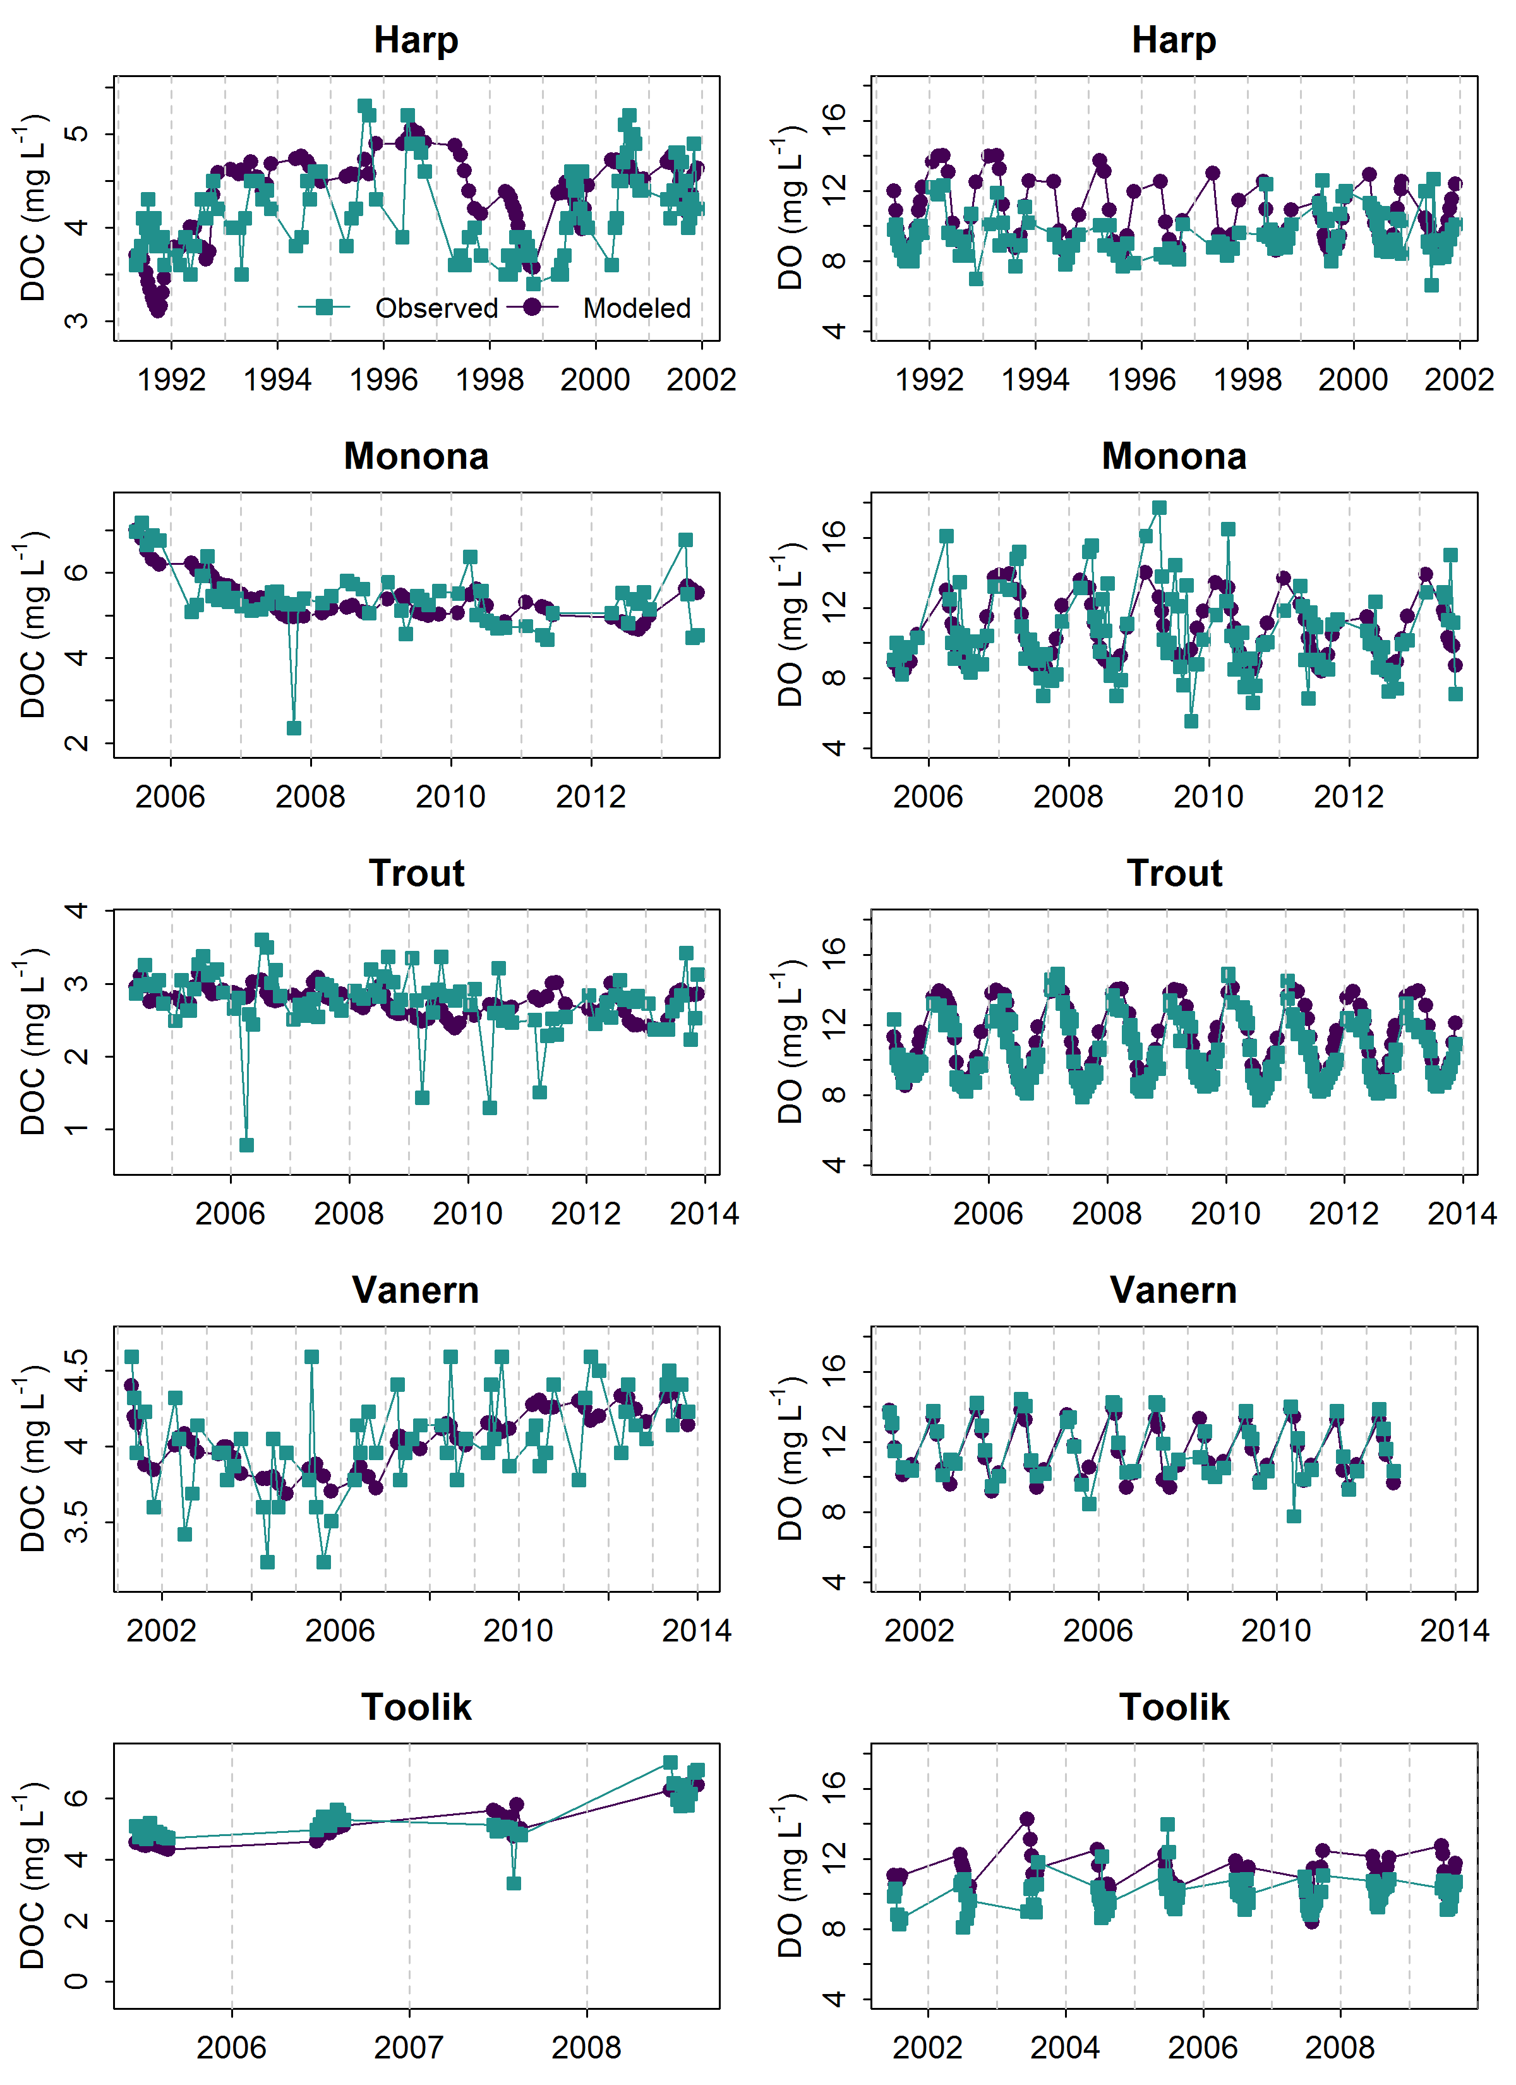

Figure 2. Observed dissolved organic carbon (DOC) and dissolved oxygen (DO) concentrations in each lake (teal squares) compared to modeled concentrations (purple circles) for the same date. For some lakes, years differed between DOC and DO based on availability of observed data (Appendix 1). Toolik data are temporally clustered due to the short ice-free season.

**Figure 3.**

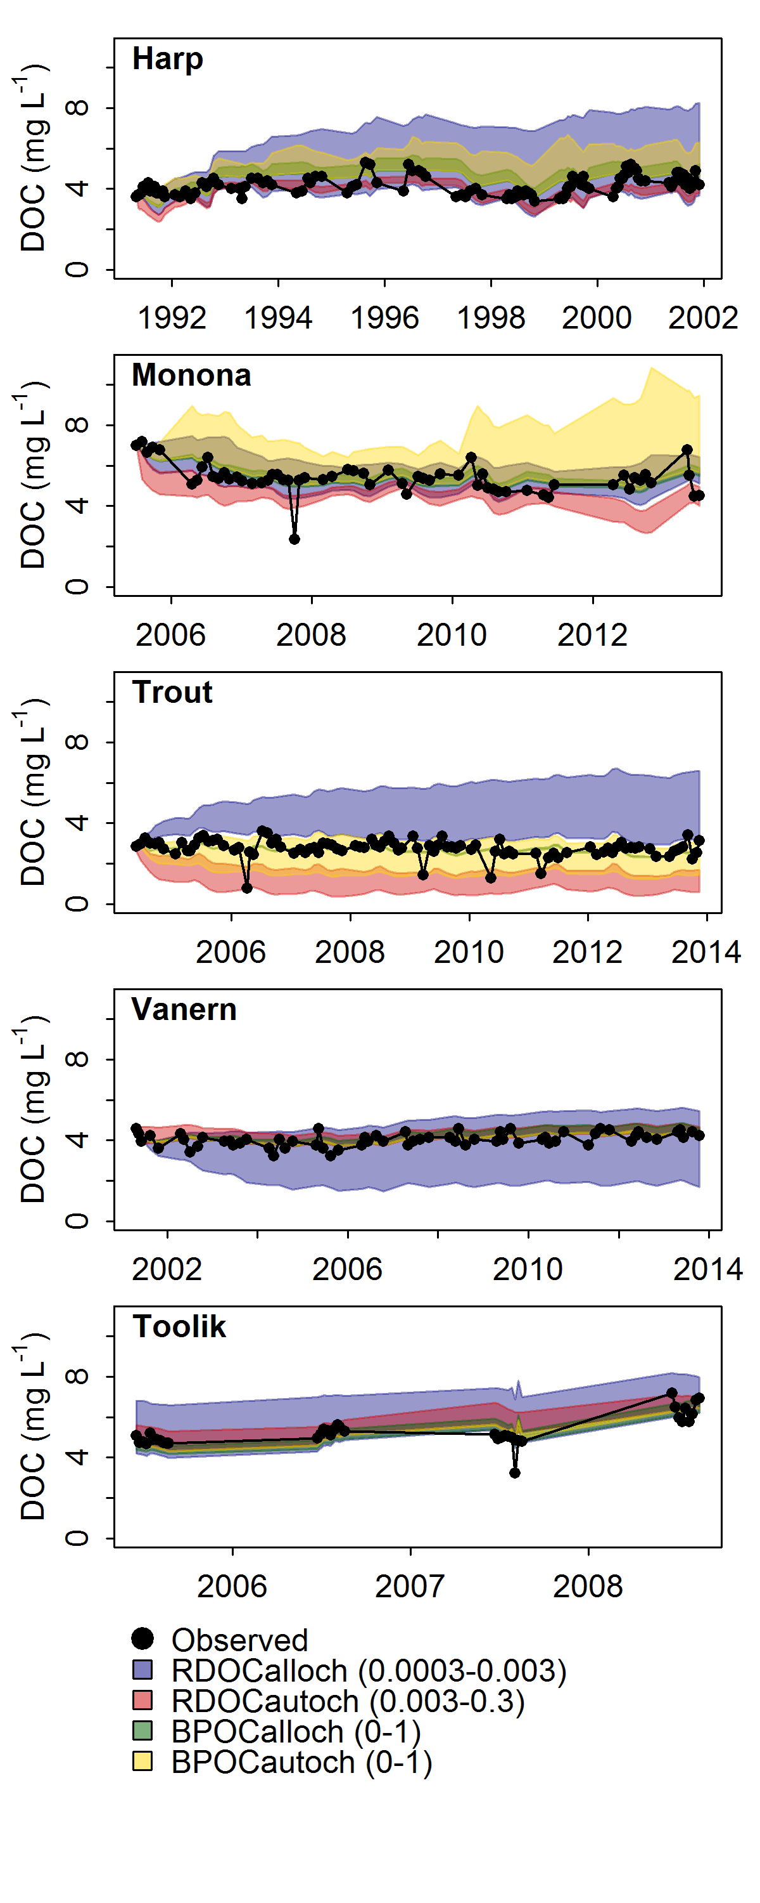

Figure 3. Sensitivity of modeled dissolved organic carbon (DOC) concentrations to free parameters in the model. Each parameter was varied across a given range (RDOCAlloch 0.0003-0.003 d-1, RDOCAutoch 0.003-0.3 d-1, BPOCAlloch, 0-1, BPOCAutoch, 0-1) while the other three parameters remained fixed at their calibrated values. Shaded areas represent the range of modeled DOC concentrations as each parameter was varied. Black circles represent observed in-lake DOC concentrations.

## **RESULTS**

### *Model performance, parameter estimates, and sensitivity analysis*

Modeled DOC and DO generally followed observed temporal patterns across years in each study lake (Fig. 2). The RMSE of the model fits for DOC and DO were below 0.6 mg L-1 and 1.7 mg L-1, respectively (Table 4). The NSE metric reveals if the modeled results are more accurate (NSE > 0) than the long-term mean. NSE reveals strong model fits for Lake Monona and Vänern for both DOC and DO (Table 4). Trout Lake and Harp Lake had poor fits for DOC (NSE < 0), and Toolik and Harp Lake had poor fits for DO (NSE < 0). In these lakes, the model captured annual and seasonal DOC and DO dynamics, but did not consistently characterize the magnitude of short-term spikes in DOC (i.e., days to weeks; Fig. 2). Nonetheless, long-term model performance indicated the ability to account for lake variability in DOC and DO at seasonal to inter-annual time scales.

Across all lakes, parameter estimates for the allochthonous components of the budget were generally more consistent and better constrained than those for autochthonous inputs (Table 4). Respiration of allochthonous DOC (RDOCAlloch) ranged from about 0.0011-0.0025 d-1 among lakes and SEM values were about two orders of magnitude lower, indicating tightly constrained mean values. In contrast, respiration of autochthonous DOC (RDOCAutoch) was higher and more

variable than RDOCAlloch among lakes, ranging from about 0.0034-0.4500 d-1. Burial rates for allochthonous inputs (BPOCAlloch) were high, with values at or near the upper limit (1.0000 d-1) for all lakes except Lake Monona. Burial of autochthonous inputs (BPOCAutoch) was comparatively lower and more variable, ranging from approximately 0.0310-0.8700 d-1. SEM values for burial tended to be about one order of magnitude smaller than corresponding parameter means across all lakes.

**Table 4. Model goodness of fit and estimates of the parameter means (parentheses include standard error of the mean estimate, SEM). All parameters had a collinearity < 20 and were assumed independent. RMSE = root mean square error (mg L-1), NSE = Nash-Sutcliffe Efficiency score.**

|  |  |  |  |  |  |  |  |  |
| --- | --- | --- | --- | --- | --- | --- | --- | --- |
| **Lake** | **RMSE (DOC)** | **NSE (DOC)** | **RMSE (DO)** | **NSE (DO)** | **RDOCAlloch (d-1)** | **RDOCAutoch (d-1)** | **BPOCAlloch** | **BPOCAutoch** |
| Harp | 0.55 | -0.46 | 1.52 | -0.64 | 0.0025 (2.1e-5) | 0.0034 (9.4e-5) | 1.0000 (4.2e-5) | 0.8400 (2.2e-2) |
| Monona | 0.61 | 0.31 | 1.74 | 0.45 | 0.0009 (9.3e-5) | 0.1600 (1.3e-2) | 0.4100 (3.2e-2) | 0.6800 (3.5e-2) |
| Toolik | 0.51 | 0.52 | 1.38 | -1.42 | 0.0025 (3.2e-5) | 0.0350 (5.6e-3) | 1.0000 (1.4e-5) | 0.0310 (1.7e-2) |
| Trout | 0.47 | -0.20 | 0.86 | 0.73 | 0.0014 (4.7e-5) | 0.0320 (7.6e-3) | 0.9300 (2.4e-2) | 0.8700 (2.8e-2) |
| Vänern | 0.28 | 0.23 | 1.01 | 0.65 | 0.0011 (5.1e-5) | 0.4500 (8.0e-2) | 0.9500 (1.8e-2) | 0.5900 (4.7e-2) |

Modeled DOC (mg L-1) was generally most sensitive to RDOCAlloch, except for Lake Monona, for which modeled DOC was most sensitive to BPOCAutoch (Fig. 3). The other four lakes were minimally affected by changes in BPOCAutoch (< 1 mg L-1 difference across the range of parameter values). Changes in BPOCAlloch had consistently small effects (< 2 mg L-1) on modeled DOC across all lakes. Trout Lake, Harp Lake and Lake Vänern were the most sensitive to RDOCAlloch, with modeled DOC ranging about 2-3 mg L-1 across the range of parameter values, whereas Toolik Lake and Lake Monona were moderately sensitive (1-1.5 mg L-1 differences) and Lake Vänern. Overall, parameter sensitivity was greatest for Harp Lake, Lake Monona, and Trout Lake, for which modeled DOC varied as much as 5-6 mg L-1 across the range of parameter values (Fig. 3). Conversely, modeled DOC varied no more than 2 and 3 mg L-1 for Toolik Lake and Lake Vänern, respectively.

**Figure 4.**

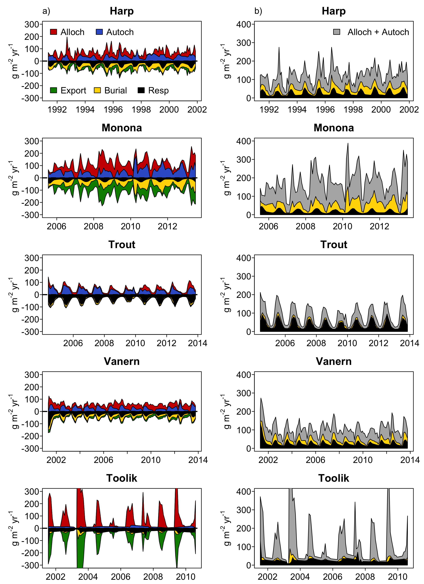

Figure 4. Time series of organic carbon fluxes and fates. a) Colored areas represent magnitudes of input (allochthonous and autochthonous) and output fluxes (export, burial, and respiration). All lines are stacked to show cumulative magnitudes. b) Absolute values of burial, respiration, and input fluxes. Vertical axes for Toolik Lake plots were truncated to enable visualization of relatively lower fluxes. Maximum allochthonous inputs and export for Toolik Lake were 1378 and -868 g m-2 y-1, respectively (May 2003).

### *Summary of fluxes and fates*

With the exception of Trout Lake, OC loads were primarily driven by allochthonous inputs, underscoring the importance of terrestrially derived OC in overall lake budgets (Table 5, Fig. 4). Additionally, respiration exceeded burial in all lakes but Lake Monona. Trout Lake also had the smallest total annual OC load of the five lakes (43.69 g m-2 yr-1), the lowest proportion of total load exported (0.09), and the largest proportional difference between respiration (0.76) and burial (0.17) among all lakes. Lake Monona had the largest total OC load (118.88 g m-2 yr-1) among lakes, lowest proportion respired (0.14) and second-greatest proportion buried (0.36). Lake Monona was the only lake dominated by burial long-term; on average, burial rates were greater than twice respiration rates across modeled years. In contrast, proportions of burial (0.36) and respiration (0.37) in Harp Lake were approximately equal. Harp Lake also exhibited proportions of allochthonous (0.55) and autochthonous inputs (0.45) that were approximately similar in Lake Monona and Lake Vänern. Toolik Lake had the second largest (mean = 87.33 g m-2 yr-1) but most variable (standard deviation; SD = 63.07 g m-2 yr-1) total OC load and was the most driven by allochthonous inputs (0.87) among all lakes. This inter-annual variability in total OC load for Toolik Lake was driven by highly variable allochthonous inputs (SD = 64.95 g m-2 yr-1), and also resulted in highly variable export (SD = 54.85 g m-2 yr-1). Compared to other lakes, Toolik Lake on average demonstrated the lowest proportion buried (0.07) and greatest proportion exported (0.64).

**Table 5. Summary of modeled mean annual mass balances (g m-2 y-1), including allochthonous (Alloch) and autochthonous (Autoch) loads, respiration (Resp), burial, and export. Standard deviations (SD) of the annual means are in parentheses.**

|  |  |  |  |  |  |  |
| --- | --- | --- | --- | --- | --- | --- |
| **Lake** | **Alloch** | **Autoch** | **Total Load** | **Resp** | **Burial** | **Export** |
| **Annual means** | |  |  |  |  |  |
| Harp | 40.05 (10.85) | 31.97 (8.01) | 72.01 (11.53) | 26.05 (3.01) | 26.60 (5.38) | 18.29 (4.76) |
| Monona | 64.79 (24.30) | 54.09 (17.98) | 118.88 (21.77) | 17.14 (0.97) | 43.13 (12.89) | 59.62 (20.06) |
| Toolik | 76.06 (64.95) | 11.27 (3.36) | 87.33 (63.07) | 24.60 (3.23) | 5.71 (3.73) | 55.68 (54.85) |
| Trout | 15.65 (3.70) | 28.05 (4.56) | 43.69 (5.75) | 33.04 (3.57) | 7.46 (1.12) | 3.96 (0.83) |
| Vänern | 31.95 (5.61) | 26.08 (4.60) | 58.03 (5.61) | 25.10 (1.87) | 19.96 (3.10) | 12.18 (2.47) |
|  | |  |  |  |  |  |
| **Proportion of total load** | |  |  |  |  |  |
| Harp | 0.55 | 0.44 | 1.00 | 0.36 | 0.37 | 0.25 |
| Monona | 0.54 | 0.46 | 1.00 | 0.14 | 0.36 | 0.50 |
| Toolik | 0.87 | 0.13 | 1.00 | 0.28 | 0.07 | 0.64 |
| Trout | 0.36 | 0.64 | 1.00 | 0.76 | 0.17 | 0.09 |
| Vänern | 0.55 | 0.45 | 1.00 | 0.43 | 0.34 | 0.21 |

### *Seasonal fates*

Seasonal patterns in OC fluxes were consistent across entire respective time series for each lake, with autochthonous inputs and respiration increasing to a summer maximum (Fig. 4). As water temperatures increased during the growing season (e.g., May – Aug.), the balance between allochthonous and autochthonous inputs generally shifted toward autochthonous inputs due to increases in NPP, whereas the ratio between respiration and burial generally shifted towards respiration (Figs. 4-5). There was high seasonal variability in the dominant fluxes in each lake (Fig. 5). Trout Lake remained dominated by respiration year-round, but respiration increased relative to burial as water temperatures warmed. Harp Lake and Lake Vänern were dominated by burial early in the growing season, but became dominated by respiration as temperatures warmed. Whereas respiration in Lake Monona exceeded burial late in the growing season, the lake remained dominated by burial when calculated on an annual basis (Table 5, Fig. 5). Toolik lake was dominated by respiration most of the year, and respiration increased as the ratio of autochthonous to allochthonous inputs increased. This distinct negative slope as the growing season progressed was unique to Toolik Lake, suggesting the importance of continued allochthonous inputs during summer months in the other lakes in addition to autochthonous inputs. Overall, these seasonal dynamics suggest that water temperatures are associated with changes in the balance between key OC fates (burial and respiration), but that such shifts are mediated by the balance between allochthonous and autochthonous inputs that vary across lake systems.

**Figure 5.**

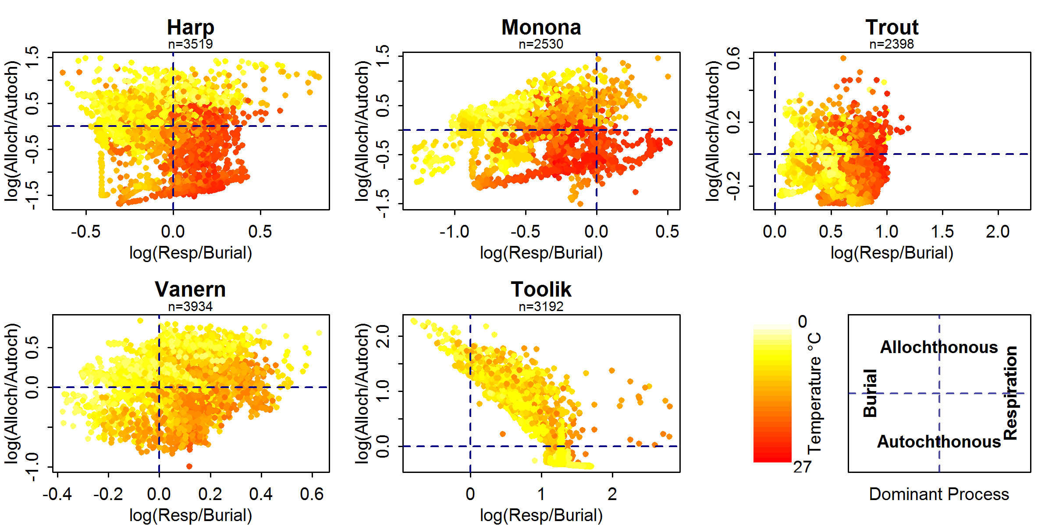

Figure 5. Relationship between log10-transformed allochthonous/autochthonous inputs and respiration/burial (g m-2 yr-1) of organic carbon, colored by epilimnion water temperature. The four quadrants in each figure represent the dominant processes in each lake (Vertical axis: dominant OC fate; horizontal axis: dominant OC input).

## **DISCUSSION**

### *Representing lake processes*

Although our model is not exhaustive in accounting for all OC pathways and relies on empirically-derived equations, our results indicated that a relatively simple, dynamic model can recreate long-term trends in DOC and represent the set of key biogeochemical, trophic, and landscape processes that combine to determine the fate of OC in lake ecosystems. Further, the fluxes we modeled were within the range of other published studies for these lakes based on steady-state models. Using much of the same LTER data, Hanson et al. (2014) provided similar estimates for Trout of allochthonous inputs (Hanson: 15.92 g m-2 yr-1, our model: 15.65 g m-2 yr-1), burial (Hanson: 3.66 g m-2 yr-1, our model: 7.46 g m-2 yr-1), and export (Hanson: 4.95 g m-2 yr-1, our model: 3.96 g m-2 yr-1), but not for respiration (Hanson: 7.31 g m-2 yr-1, our model: 33.04 g m-2 yr-1), likely because Hanson et al. (2014) did not account for autochthonous inputs. Similar to our study, Whalen and Cornwall (1985) demonstrated that Toolik Lake was driven by high proportional allochthonous inputs (Whalen and Cornwall 0.91, our study: 0.87) relative to autochthonous inputs and low burial (Whalen and Cornwall: 0.02, our study: 0.07). Our proportion exported (0.64) contrasted somewhat with Whalen and Cornwall (0.82), but much of this excess export was respired (0.28) in our model. Dillon and Molot’s (1997) proportional estimates for burial in Harp Lake were low compared to ours (Dillon and Molot: 0.01, our model: 26.60) and the magnitudes of allochthonous inputs were somewhat similar (Dillon and Molot: 28.9 g m-2 yr-1, our study: 40.05 g m-2 yr-1), but Dillon and Molot (1997) did not consider autochthonous inputs. Therefore, we are unable to compare total loads and differences in the proportion exported in Dillon and Molot (0.58) vs. our study (0.25), which may be explained by our inclusion of autochthonous inputs and respiration.

Differences in budget estimates may also be due to differences in study years (Dillon and Molot: 1981-1989, our study: 1991-2001). Although our results generally agreed with prior studies based on steady-state models, our estimated respiration rates were generally higher than those noted in the literature (Hanson et al. 2014, Dillon and Molot 1997). We offer that dynamic models better represent these processes by accounting for seasonal changes in temperature and chl-*a* concentrations. Therefore, although steady-state models may be sufficient for recreating some key ecological processes, dynamic models are needed for determining the relative magnitudes of OC fates in lake ecosystems, given the importance of autochthonous inputs and respiration.

*Key uncertainties in OC fates*

Well-constrained estimates of OC burial in lakes remain a challenge to model. Although our estimates for burial parameters have relatively low uncertainties (Table 4), burial may be underestimated for these lakes. The sensitivity analysis revealed that modeled DOC generally varied < 2 mg L-1 as a function of BPOCAlloch, which accounted for up to 50% of modeled DOC (except for Lake Monona, which was highly sensitive to BPOCAlloch). A key consideration is that our model buried close to 100% of POCAlloch in all lakes except Lake Monona (Table 4: BPOCAlloch); therefore, any increase in POCAlloch would be directly proportional to increases in burial. Owing to lack of observational data, we assumed POCAlloch was 10% of DOCAlloch (CPOCFactor), but this may be an underestimate, and does not account for potential seasonal variation in the DOC:POC ratio. Intense precipitation can increase POC concentration disproportionately to DOC concentration in streams (Jeong et al. 2012, Dhillon and Inamdar 2014), which could temporarily increase POCAlloch and thus burial. Wet years increase DOCAlloch inputs to lakes at regional scales by increasing connectivity among waterbodies (Rose et al. 2016) and mobilizing DOC from soils (Tank et al. 2018), and probably also increase POCAlloch; however, short-term spikes in POC are unlikely to have large effects on long-term OC budgets and ratios between POC and DOC. Although our burial estimates were somewhat uncertain due to underrepresentation of POCAlloch during precipitation events, burial would have to increase substantially over the course of the entire modeling period for burial to dominate over respiration, including three-fold or greater for Toolik Lake and Trout Lake (Table 5). Therefore, missing POCAlloch likely leads to underestimates of burial, but is unlikely to account for enough OC to affect long-term budgets and exceed the magnitudes of respiration in many lake ecosystems given the insensitivity of modeled DOC to BPOCAlloch across our five study lakes.

### *On-going research and data needs*

Our work is an important advance in quantifying the fates of OC across aquatic ecosystems; however, we encountered constraints associated with current data availability. If requisite data were collected for a larger number of lakes spanning wider environmental gradients (e.g., climate, watershed conditions, trophic state, water residence times), contributions of lakes to landscape carbon cycles could be better estimated at broad spatial scales (Hotchkiss et al. 2018, Jones et al. 2018, Seekel et al. 2018). Although we designed our modeling framework to be flexible across different lake ecosystems, our study contained four north-temperate lakes and one arctic lake, all of which were deep and dimictic (summer and winter stratification and spring and autumn mixing of the water column). Literature-based parameters were obtained from previous research on these lake ecosystems and may not apply in all other lake ecosystems. Future work should include additional high-latitude, tropical, or shallow lakes to test the generalizability of our model across a more diverse set of lake ecosystems than those included in this study. Nonetheless, part of our intention for including model data and code with this manuscript was so that future work can build off our model and make adjustments as more data across more diverse lake ecosystems become available.

During model development, we encountered a notable paucity of high-frequency measurements of inflow DOC concentration, of which broader collection would facilitate dynamic OC modeling in more lakes. Although collection of these data may be expensive and logistically challenging, the increasing availability of automated, high-frequency sensor equipment may alleviate long-term costs associated with sensor deployment and manual data retrieval. In addition, relatively little is currently known about POC budgets despite their key interactions with DOC (Einsele et al. 2001); we need more POC observational data for incorporation into dynamic models of OC, particularly in inflows for estimating POCAlloch. Such studies would help constrain POC parameters and improve estimates of the fates of POC within overall OC budgets. Finally, data limitations required us to make simplifying assumptions about the volume of groundwater inputs and the lakes themselves. Although these are common assumptions in similar mass balance studies, the inability to account for groundwater may lead to underestimates of allochthonous inputs and may complicate comparisons across lakes, particularly isolated lakes. The one lake with non-zero estimated groundwater volume, however, was Trout Lake, for which modeled allochthonous inputs were lowest across lakes in this study. Nonetheless, a key implication of our study is the need for more observational data, particularly pertaining to surface water and groundwater volume and DOC concentrations, POC cycling, and burial rates.

Additionally, data limitations may explain poor NSE scores (< 0) for DOC for Harp Lake and Trout Lake, which indicate that modeled DOC was no more accurate than long-term DOC means (Table 4). For Harp Lake, modeled DOC was generally lower than observed DOC (Fig. 3), potentially due to artificially low DO measurements, which reduced NSE for DO for Harp Lake. Underestimated DO would lead to underestimated respiration, which would reduce autochthonous inputs. For Trout Lake, the model did not capture short-term spring-time dips in DOC (Fig. 3), which may potentially be explained by ice melt dynamics not represented in interpolated inflow DOC data. In addition, NSE was also poor for DO for Toolik Lake; modeled DO was consistently higher than observations (Fig. 3). This suggests overestimated autochthonous inputs and therefore underestimated allochthonous inputs, which may be attributed to undetected pulses in inflow DOC in surface water or groundwater. Additionally, food web dynamics (e.g., grazing) may also help explain large fluctuations in allochthonous inputs or poor NSE values. In general, whereas short-term spikes are unlikely to affect long-term OC fate estimates, consistent biases in observations may skew model outputs. Therefore, dynamic models such as ours can be used to identify important sources of uncertainty in overall OC budgets that can be targeted in future monitoring and research.

*Lessons from a dynamic model: implications in a dynamic world*

Prior to our study, it was known that lakes actively process, emit, and store globally significant amounts of C (Cole et al. 2007, Tranvik et al. 2009, Raymond et al. 2013). Our results demonstrate that a dynamic model can considerably advance knowledge on the role of lakes in landscape and ultimately global C cycling by highlighting dominant inputs and fates of OC in individual systems. Lakes more readily respire more autochthonous than allochthonous OC (Wetzel 2001). In our study, our one lake dominated by autochthonous inputs (Trout Lake) exhibited the greatest respiration relative to burial (Table 5). Therefore, lakes as global C sources or sinks may depend both on the balances between 1) respiration and burial and 2) allochthonous and autochthonous inputs. The balance between respiration and burial can vary according to regional climate, and respiration is typically greater than burial in boreal lakes compared to those in higher latitudes (Anthony et al. 2014). This represents a potential negative feedback for the global C cycle under a warming climate with poleward boreal advance and thawing of frozen, high-latitude lakes (Anthony et al. 2014).

Our model identified another important global change implication associated with warming water temperatures. Across all lakes in our study, warm surface temperatures were generally associated with a shift toward autochthonous relative to allochthonous inputs, as well as an increase in respiration relative to burial (Fig. 5). This likely is due to elevated NPP during summer growing seasons accompanied by relatively high respiration rates of autochthonous relative to allochthonous inputs (Table 4). Although the balance between respiration and burial appears to shift toward respiration with increases in temperature, it is also possible for burial to increase with temperature if temperature increases coincide with greater OC loads (e.g., warm-season precipitation events increasing POCAlloch and consequently burial as a function of BPOCAlloch). As such, our results suggest that processes favoring allochthonous inputs will generally have a greater effect on OC burial than processes that drive autochthonous inputs.

More broadly, however, lakes have generally become more productive under recent climate warming (Kraemer et al. 2016), which our study suggests favors autochthonous over allochthonous inputs and respiration over burial. Therefore, changes in both precipitation (including magnitude, timing, duration, and form) (de Wit et al. 2018) and air temperature have key implications for the fate of OC in lake ecosystems under a changing climate (Reed et al. 2018); however, effects of warming will vary according to the balance between allochthonous and autochthonous inputs, which is mediated by precipitation due to its effect on the origin of the total OC load. Although our model was not designed as a predictive tool, our findings illustrate the usefulness of a dynamic mass balance model for highlighting key global change processes and interactions that ultimately influence the role of lakes in global C cycling. Improved estimates of the contribution of lakes to global C budgets should account for the source and degradability of total OC loads and consequent effects on respiration and burial.

## **ACKNOWLEDGMENTS**

This project was a product of the Global Lake Ecological Observatory Network (GLEON) Fellowship program supported by the US National Science Foundation’s MacroSystems Biology Program (Awards # EF1137353 and EF1137327). Logistical support was provided by the University of Wisconsin-Madison Center for Limnology, the Cary Institute of Ecosystem Studies, the University of Wisconsin Trout Lake Station, the Lake Sunapee Protective Association, and Grace Hong. Limnological data providers included the NSF Long-Term Ecological Research program (North Temperate Lakes DEB-1440297 and Arctic LTER), the Swedish Meteorological and Hydrological Institute, the Swedish University of Agricultural Sciences and the Canadian Dorset Environmental Science Centre. Additional details on data sources were included online in the appendix (Appendix 1). IMM, HAD, KJF, AMM, ZO, DR, FS and PCH acquired data, developed the model, and performed data analyses. All authors participated in conceiving and developing the project and writing the paper. We thank two reviewers for constructive comments on a draft of this manuscript. Analysis scripts and public data (LTER lakes and Lake Vänern) can be freely downloaded here: <https://github.com/GLEON/SOS>.

## **LITERATURE CITED**

Åberg, J., Bergström, A. K., Algesten, G., Söderback, K., & Jansson, M. (2004). A comparison of the carbon balances of a natural lake (L. Örträsket) and a hydroelectric reservoir (L. Skinnmuddselet) in northern Sweden. *Water Research*, *38*(3), 531-538.

Andersson, E., & Sobek, S. (2006). Comparison of a mass balance and an ecosystem model approach when evaluating the carbon cycling in a lake ecosystem. *AMBIO: A Journal of the Human Environment*, *35*(8), 476-483.

Anthony, K. W., Zimov, S. A., Grosse, G., Jones, M. C., Anthony, P. M., Chapin III, F. S., ... & Frolking, S. (2014). A shift of thermokarst lakes from carbon sources to sinks during the Holocene EPOCh. *Nature*, *511*(7510), 452-456.

Appling, A. P., Leon, M. C., & McDowell, W. H. (2015). Reducing bias and quantifying uncertainty in watershed flux estimates: the R package loadflex. *Ecosphere*, *6*(12), art269.

Arvola, L., Kortelainen, P. I. R. K. K. O., Bergström, I., Kankaala, P., Ojala, A., Pajunen, H. A. N. N. U., ... & Rantakari, M. I. I. T. T. A. (2002). Carbon pathways through boreal lakes: A multi-scale approach (CARBO). *Understanding the Global System, The Finnish Perspective, edited by Käyhkö J and Talve L*, 97-106.

Aulenbach, B. T. (2013). Improving regression-model-based streamwater constituent load estimates derived from serially correlated data. *Journal of Hydrology*, *503*, 55–66.

Bastviken, D., Tranvik, L. J., Downing, J. A., Crill, P. M., & Enrich-Prast, A. (2011). Freshwater

methane emissions offset the continental carbon sink. *Science*, *331*(6013), 50-50.

Brun, R., Reichert, P. and Kunsch, H. R., (2001). Practical Identifiability Analysis of Large Environmental Simulation Models. *Water Resources Research*. 37(4): 1015-1030.

Canham, C. D., Pace, M. L., Papaik, M. J., Primack, A. G., Roy, K. M., Maranger, R. J., ... & Spada, D. M. (2004). A spatially explicit watershed-scale analysis of dissolved organic carbon in Adirondack lakes. *Ecological Applications*, *14*(3), 839-854.

Catalán, N., Marcé, R., Kothawala, D. N., & Tranvik, L. J. (2016). Organic carbon

decomposition rates controlled by water retention time across inland waters. *Nature*

*Geoscience, 9*(7), 501-504.

Cole, J. J., Caraco, N. F., Strayer, D. L., Ochs, C., & Nolan, S. (1989). A detailed organic carbon

budget as an ecosystem‐level calibration of bacterial respiration in an oligotrophic lake

during midsummer. *Limnology and Oceanography*, *34*(2), 286-296.

Cole, J. J., McDowell, W. H., & Likens, G. E. (1984). Sources and molecular weight of" dissolved" organic carbon in an oligotrophic lake. *Oikos 42*(1), 1-9.

Cole, J. J., Carpenter, S. R., Kitchell, J. F., & Pace, M. L. (2002). Pathways of organic carbon utilization in small lakes: Results from a whole-lake 13C addition and coupled model. *Limnology and Oceanography*, *47*(6), 1664-1675.

Cole, J. J., Prairie, Y. T., Caraco, N. F., McDowell, W. H., Tranvik, L. J., Striegl, R. G., ... & Melack, J. (2007). Plumbing the global carbon cycle: integrating inland waters into the terrestrial carbon budget. *Ecosystems*, *10*(1), 172-185.

Cremona, F., Kõiv, T., Nõges, P., Pall, P., Rõõm, E. I., Feldmann, T., ... & Nõges, T. (2014). Dynamic carbon budget of a large shallow lake assessed by a mass balance approach. *Hydrobiologia*, *731*(1), 109-123.

de Wit, H. A., Couture, R. M., Jackson‐Blake, L., Futter, M. N., Valinia, S., Austnes, K., ... &

Lin, Y. Pipes or chimneys? For carbon cycling in small boreal lakes, precipitation matters

most. *Limnology and Oceanography Letters*, *3*(3), 275-284.

Dhillon, G. S., & Inamdar, S. (2013). Storm event patterns of particulate organic carbon (POC) for large storms and differences with dissolved organic carbon (DOC). *Biogeochemistry*, *118*(1-3), 61-81.

Dillon, P. J., & Molot, L. A. (1997). Dissolved organic and inorganic carbon mass balances in central Ontario lakes. *Biogeochemistry*, *36*(1), 29-42.

Downing, J. A., Cole, J. J., Middelburg, J. J., Striegl, R. G., Duarte, C. M., Kortelainen, P., ... & Laube, K. A. (2008). Sediment organic carbon burial in agriculturally eutrophic impoundments over the last century. *Global Biogeochemical Cycles*, *22*(1), GB1018, doi:10.1029/2006GB002854.

Duffy, C. J., Dugan, H. A., & Hanson, P. C. (2018). The age of water and carbon in lake‐

catchments: A simple dynamical model. *Limnology and Oceanography Letters*, *3*(3),

236-245.

Dugan, H. A., Bartlett, S. L., Burke, S. M., Doubek, J. P., Krivak-Tetley, F. E., Skaff, N. K., ... & Weathers, K. C. (2017). Salting our freshwater lakes. *Proceedings of the National Academy of Sciences*, *114*(17), 4453-4458.

Einola, E., Rantakari, M., Kankaala, P., Kortelainen, P., Ojala, A., Pajunen, H., ... & Arvola, L.

(2011). Carbon pools and fluxes in a chain of five boreal lakes: a dry and wet year

comparison. *Journal of Geophysical Research: Biogeosciences*, *116*(G03009, doi:10.1029/2010JG001636, 2011.

Einsele, G., Yan, J., & Hinderer, M. (2001). Atmospheric carbon burial in modern lake basins and its significance for the global carbon budget. *Global and Planetary Change*, *30*(3), 167-195.

Gaiser, E. E., Deyrup, N. D., Bachmann, R. W., Battoe, L. D., & Swain, H. M. (2009). Multidecadal climate oscillations detected in a transparency record from a subtropical Florida lake. *Limnology and Oceanography*, *54*(6), 2228-2232.

Hanson, P. C., Buffam, I., Rusak, J. A., Stanley, E. H., & Watras, C. (2014). Quantifying lake allochthonous organic carbon budgets using a simple equilibrium model. *Limnology and Oceanography*, *59*(1), 167-181.

Hanson, P. C., Hamilton, D. P., Stanley, E. H., Preston, N., Langman, O. C., & Kara, E. L. (2011). Fate of allochthonous dissolved organic carbon in lakes: a quantitative approach. *PLoS One*, *6*(7), e21884.

Hanson, P. C., Pace, M. L., Carpenter, S. R., Cole, J. J., & Stanley, E. H. (2015). Integrating landscape carbon cycling: research needs for resolving organic carbon budgets of lakes. *Ecosystems*, *18*(3), 363-375.

Hanson, P. C., Pollard, A. I., Bade, D. L., Predick, K., Carpenter, S. R., & Foley, J. A. (2004). A model of carbon evasion and sedimentation in temperate lakes. *Global Change Biology*, *10*(8), 1285-1298.

Heathcote, A. J., & Downing, J. A. (2012). Impacts of eutrophication on carbon burial in freshwater lakes in an intensively agricultural landscape. *Ecosystems*, *15*(1), 60-70.

Hotchkiss, E. R., Sadro, S., & Hanson, P. C. (2018). Toward a more integrative perspective on

carbon metabolism across lentic and lotic inland waters. *Limnology and Oceanography*

*Letters*, *3*(3), 57-63.

Jeong, J. J., Bartsch, S., Fleckenstein, J. H., Matzner, E., Tenhunen, J. D., Lee, S. D., ... & Park, J. H. (2012). Differential storm responses of dissolved and particulate organic carbon in a mountainous headwater stream, investigated by high‐frequency, in situ optical measurements. *Journal of Geophysical Research: Biogeosciences*, *117* (G03013, doi:10.1029/2012JG001999).

Jones, S. E., Zwart, J. A., Kelly, P. T., & Solomon, C. T. Hydrologic setting constrains lake

heterotrophy and terrestrial carbon fate. *Limnology and Oceanography Letters*, 3(3), 356-

264.

Jonsson, A., Meili, M., Bergström, A. K., & Jansson, M. (2001). Whole‐lake mineralization of allochthonous and autochthonous organic carbon in a large humic lake (Örträsket, N. Sweden). *Limnology and Oceanography*, *46*(7), 1691-1700.

Kawasaki, N., & Benner, R. (2006). Bacterial release of dissolved organic matter during cell

growth and decline: molecular origin and composition. *Limnology and Oceanography*,

*51*(5), 2170-2180.

Kling, G. W., Kipphut, G. W., Miller, M. M., & O'Brien, W. J. (2000). Integration of lakes and streams in a landscape perspective: the importance of material processing on spatial patterns and temporal coherence. *Freshwater Biology*, *43*(3), 477-497.

Kelly, P. T., Vanni, M. J., & Renwick, W. H. (2018). Assessing uncertainty in annual nitrogen,

phosphorus, and suspended sediment load estimates in three agricultural streams using a

21-year dataset. *Environmental Monitoring and Assessment*, *190*(2), 91.

Klump, J. V., Fitzgerald, S. A., & Waplesa, J. T. (2009). Benthic biogeochemical cycling, nutrient stoichiometry, and carbon and nitrogen mass balances in a eutrophic freshwater bay. *Limnology and Oceanography*, *54*(3), 692-712.

Kortelainen, P., Rantakari, M., Huttunen, J. T., Mattsson, T., Alm, J., Juutinen, S., ... &

Martikainen, P. J. (2006). Sediment respiration and lake trophic state are important

predictors of large CO2 evasion from small boreal lakes. *Global Change Biology*, *12*(8), 1554-1567.

Kraemer, B. M., Chandra, S., Dell, A. I., Dix, M., Kuusisto, E., Livingstone, D. M., ... & McIntyre, P. B. (2016). Global patterns in lake ecosystem responses to warming based on the temperature dependence of metabolism. *Global Change Biology 23*(5), 1881-1890.

Kvarnäs, H. (2001). Morphometry and hydrology of the four large lakes of Sweden. *AMBIO: A*

*Journal of the Human Environment*, *30*(8), 467-474.

Mendonça, R., Müller, R. A., Clow, D., Verpoorter, C., Raymond, P., Tranvik, L. J., & Sobek, S.

(2017). Organic carbon burial in global lakes and reservoirs. *Nature communications*, *8*(1), 1694.

Morin, A., Lamoureux, W., & Busnarda, J. (1999). Empirical models predicting primary

productivity from chlorophyll a and water temperature for stream periphyton and lake and ocean phytoplankton. *Journal of the North American Benthological Society*, *18*(3), 299-307.

Mulholland, P. J., & Elwood, J. W. (1982). The role of lake and reservoir sediments as sinks in the perturbed global carbon cycle. *Tellus*, *34*(5), 490-499.

O'Connor, E. M., Dillon, P. J., Molot, L. A., & Creed, I. F. (2009). Modeling dissolved organic carbon mass balances for lakes of the Muskoka River Watershed. *Hydrology Research*, *40*(2-3), 273-290.

Omlin, M., Brun, R. and Reichert, P., (2001). Biogeochemical Model of Lake Zurich: Sensitivity, Identifiability and Uncertainty Analysis. *Ecological Modelling*, *141*(1): 105-123.

Pace ML & Lovett G. (2013). Primary production: the foundation of ecosystems. In: Weathers K, Strayer D, Likens G, editors. Fundamentals of ecosystem science. Academic Press. p. 312.

Pace, M. L., & Prairie, Y. T. (2005). Respiration in lakes. *Respiration in aquatic ecosystems*, *1*,

103-122.

R Core Team (2016). R: A language and environment for statistical computing. R Foundation for

Statistical Computing, Vienna, Austria. URL: https://www.R-project.org/.

Ramlal, P. S., Hecky, R. E., Bootsma, H. A., Schiff, S. L., & Kingdon, M. J. (2003). Sources and fluxes of organic carbon in Lake Malawi/Nyasa. *Journal of Great Lakes Research*, *29*, 107-120.

Raymond, P. A., & Bauer, J. E. (2001). Riverine export of aged terrestrial organic matter to the North Atlantic Ocean. *Nature*, *409*(6819), 497-500.

Raymond, P. A., Hartmann, J., Lauerwald, R., Sobek, S., McDonald, C., Hoover, M., ... & Kortelainen, P. (2013). Global carbon dioxide emissions from inland waters. *Nature*, *503*(7476), 355-359.

Reed, D. E., Dugan, H. A., Flannery, A. L., & Desai, A. R. (2018). Carbon sink and source

dynamics of a eutrophic deep lake using multiple flux observations over multiple years.

*Limnology and Oceanography Letters*, *3*(3), 285-292.

Reynolds, C. S., & Irish, A. E. (1997). Modelling phytoplankton dynamics in lakes and

reservoirs: the problem of in-situ growth rates. *Hydrobiologia*, *349*(1-3), 5-17.

Rose, K. C., Greb, S. R., Diebel, M., & Turner, M. G. (2017). Annual precipitation regulates spatial and temporal drivers of lake water clarity. *Ecological Applications*, *27*(2), 632-643.

Santoso, A. B., Hamilton, D. P., Hendy, C. H., & Schipper, L. A. (2017). Carbon dioxide emissions and sediment organic carbon burials across a gradient of trophic state in eleven New Zealand lakes. *Hydrobiologia, 795*(1): 341-354.

Schindler, D. W., Curtis, P. J., Bayley, S. E., Parker, B. R., Beaty, K. G., & Stainton, M. P. (1997). Climate-induced changes in the dissolved organic carbon budgets of boreal lakes. *Biogeochemistry*, *36*(1), 9-28.

Schindler, J. E., & Krabbenhoft, D. P. (1998). The hyporheic zone as a source of dissolved organic carbon and carbon gases to a temperate forested stream. *Biogeochemistry*, *43*(2), 157-174.

Seekell, D. A., Lapierre, J. F., & Cheruvelil, K. S. (2018). A geography of lake carbon cycling.

*Limnology and Oceanography Letters*, *3*(3), 49-56.

Sobek, S., Söderbäck, B., Karlsson, S., Andersson, E., & Brunberg, A. K. (2006). A carbon budget of a small humic lake: an example of the importance of lakes for organic matter cycling in boreal catchments. *AMBIO: A Journal of the Human Environment*, *35*(8), 469-475.

Soetaert, K. and Petzoldt, T., (2010). Inverse Modelling, Sensitivity and Monte Carlo Analysis in R Using Package FME. *Journal of Statistical Software 33*(3) 1-28. <http://www.jstatsoft.org/v33/i03>

Staehr, P. A., Sand-Jensen, K., Raun, A. L., Nilsson, B., & Kidmose, J. (2010). Drivers of metabolism and net heterotrophy in contrasting lakes. *Limnology and Oceanography*, *55*(2), 817-830.

Striegl, R. G., & Michmerhuizen, C. M. (1998). Hydrologic influence on methane and carbon dioxide dynamics at two north-central Minnesota lakes. *Limnology and Oceanography*, *43*(7), 1519-1529.

Tanentzap, A. J., Szkokan-Emilson, E. J., Desjardins, C. M., Orland, C., Yakimovich, K., Dirszowsky, R., ... & Gunn, J. (2017). Bridging between litterbags and whole-ecosystem experiments: a new approach for studying lake sediments. *Journal of Limnology 76(2), 431-437*.

Tank, S. E., Fellman, J. B., Hood, E., & Kritzberg, E. S. Beyond respiration: Controls on lateral

carbon fluxes across the terrestrial‐aquatic interface. *Limnology and Oceanography*

*Letters*, *3*(3), 76-88.

Tongal, H., & Berndtsson, R. (2014). Phase-space reconstruction and self-exciting threshold

modeling approach to forecast lake water levels. *Stochastic environmental research and*

*risk assessment*, *28*(4), 955-971.

Tranvik, L. J., Downing, J. A., Cotner, J. B., Loiselle, S. A., Striegl, R. G., Ballatore, T. J., ... & Kortelainen, P. L. (2009). Lakes and reservoirs as regulators of carbon cycling and climate. *Limnology and Oceanography*, *54*(6part2), 2298-2314.

Urban, N. R., Auer, M. T., Green, S. A., Lu, X., Apul, D. S., Powell, K. D., & Bub, L. (2005). Carbon cycling in Lake Superior. *Journal of Geophysical Research: Oceans (1978–2012)*, *110* (C06S90), doi:10.1029/2003JC002230.

Vander Zanden, M. J., & Gratton, C. (2011). Blowin’in the wind: reciprocal airborne carbon fluxes between lakes and land. *Canadian Journal of Fisheries and Aquatic Sciences*, *68*(1), 170-182.

Webster, K. E., Kratz, T. K., Bowser, C. J., Magnuson, J. J., & Rose, W. J. (1996). The influence

of landscape position on lake chemical responses to drought in northern Wisconsin.

*Limnology and Oceanography*, *41*(5), 977-984.

Wetzel, R. G. (2001). *Limnology: lake and river ecosystems*. Gulf Professional Publishing.

Weyhenmeyer, G. A., Kosten, S., Wallin, M. B., Tranvik, L. J., Jeppesen, E., & Roland, F. (2015). Significant fraction of CO2 emissions from boreal lakes derived from hydrologic inorganic carbon inputs. *Nature Geoscience 8*(12), 933-936.

Whalen, S. C., & Cornwell, J. C. (1985). Nitrogen, phosphorus, and organic carbon cycling in an arctic lake. *Canadian Journal of Fisheries and Aquatic Sciences*, *42*(4), 797-808.

Winslow, L. A., Zwart, J. A., Batt, R. D., Dugan, H., Woolway, R. I., Corman, J., ... & Read, J. S. (2016). LakeMetabolizer: an R package for estimating lake metabolism from free-water oxygen using diverse statistical models. *Inland Waters*, *6*(4), 622-636.

Xu, H., Lan, J., Liu, B., Sheng, E., & Yeager, K. M. (2013). Modern carbon burial in Lake Qinghai, China. *Applied Geochemistry*, *39*, 150-155.

Yang, H., Xing, Y., Xie, P., Ni, L., & Rong, K. (2008). Carbon source/sink function of a subtropical, eutrophic lake determined from an overall mass balance and a gas exchange and carbon burial balance. *Environmental Pollution*, *151*(3), 559-568.

Yao, H., McConnell, C., Somers, K. M., Yan, N. D., Watmough, S., & Scheider, W. (2011).

Nearshore human interventions reverse patterns of decline in lake calcium budgets in

central Ontario as demonstrated by mass‐balance analyses. *Water Resources Research*,

*47*(W06521), doi:10.1029/2010WR010159.

Zambrano-Bigiarini, M. (2017). hydroGOF: Goodness-of-fit functions for comparison of

simulated and observed hydrological time series. R package version 0.3-10. URL

<http://hzambran.github.io/hydroGOF/>. DOI:10.5281/zenodo.8400

1. ∧ Current address: Department of Biological Sciences, Virginia Tech, 926 West Campus Drive, Blacksburg, VA, 24061, US.