## Top of Page: Running head: Source or sink?

Title: Source or sink? Integrating biogeochemical, trophic and landscape processes to model lake organic carbon budgets

Source or sink? Dominant processes in organic carbon cycling in lakes revealed by dynamic mechanistic modeling

Ian M. McCullough1*, Hilary A. Dugan2,14, Kaitlin J. Farrell3, Ana M. Morales-Williams4[1]^, Zutao Ouyang5, Derek Roberts6, Facundo Scordo7, Sarah L. Bartlett8, Samantha M. Burke9, Jonathan P. Doubek10, Flora E. Krivak-Tetley11, Nicholas K. Skaff12, Jamie C. Summers13, Paul C. Hanson2 and Kathleen C. Weathers14

1 Bren School of Environmental Science and Management, University of California, 2400 Bren Hall, Santa Barbara, CA, 93106, US.

2Center for Limnology, University of Wisconsin-Madison, 680 N Park St, Madison, WI, 53703, US.

3 Odum School of Ecology, University of Georgia, 140 E. Green Street, Athens, GA, 30602, US

4 Department of Ecology, Evolution and Organismal Biology, Iowa State University, 251 Bessey, Ames, IA, 50011, US.

5 Center for Global Change and Earth Observation, Michigan State University, 1405, S. Harrison Rd. East Lansing, MI, 48823, US

6 Department of Civil & Environmental Engineering, University of California, 1 Shields Avenue, Davis, CA, 95616, US. UC Davis Tahoe Environmental Research Center, 291 Country Club Drive, Incline Village, NV, 89451, US.

7 Instituto Argentino de Oceanografía, Universidad Nacional del Sur - CONICET, 8000 Florida St, Bahía Blanca Bs As, B8000BFW, Argentina.

8 School of Freshwater Sciences, University of Wisconsin-Milwaukee, 600 E Greenfield Ave, Milwaukee, WI, 53204, US.

9 Department of Biology, University of Waterloo, 200 University Ave. W, Waterloo, ON, N2L 3G1, Canada.

10 Department of Biological Sciences, Virginia Tech, 926 West Campus Drive, Blacksburg, VA, 24061, US.

11 Department of Biological Sciences, Dartmouth College, Hanover, NH, 03755, US.

12 Department of Fisheries and Wildlife, Michigan State University, 13 Natural Resources Building, East Lansing, MI, 48824, US.

13 Department of Biology, Queen’s University, 99 University Ave, Kingston, ON, K7L 3N6, Canada.

14 Cary Institute of Ecosystem Studies, Box AB, Millbrook, NY, 12545, US.

*Corresponding author: [immccull@gmail.com](mailto:immccull@gmail.com)

## **ABSTRACT**

Lakes are active processors of organic carbon (OC) and are thought to play important roles in landscape and global carbon cycles. Lakes integrate terrestrially derived OC from their surrounding watersheds, produce and consume OC during primary production and respiration, bury OC in lake bottom sediments and export OC via surface or groundwater outflows. Although these processes provide a basis for a conceptual understanding of lake OC budgets, few studies have integrated these various fluxes under a dynamic modeling framework to examine their interactions and relative magnitudes. We developed a flexible, dynamical mass balance model for OC rooted in our conceptual understanding of lake OC budgets and applied the model to 5 lakes that span a gradient of morphological characteristics. We examined the relative importance of OC fluxes and found that long-term lake OC dynamics were predominantly driven by allochthonous loads in 4 of the 5 lakes, underscoring the importance of terrestrially-derived OC in lake ecosystems. Burial, the main OC storage mechanism in lakes, represented a relatively small component of the total budget and was driven largely by autochthony. Respiration, the mechanism by which lakes export carbon to the atmosphere, ranged from 13.6-88.5% of total budgets. Given the relatively low rates of burial compared to respiration across lakes in 4 of the 5 lakes, we concluded that these lakes represented a net OC source. The exception was Lake Monona, Wisconsin, the most eutrophic lake in our dataset. Overall, we found that lakes generally transitioned seasonally from OC sinks to sources as water temperatures and lake productivity increased. Finally, we highlight critical research needs, which include the need for surface water DOC observations in paired river and lake settings, burial rates, and budgets of particulate OC. These data will help better constrain parameter estimates in future lake OC models and improve our understanding of landscape carbon cycling.

Key words: carbon cycle, limnology, mass balance, allochthony, autochthony, sedimentation, dissolved organic carbon, particulate organic carbon, LTER

## 

## **INTRODUCTION**

In this era of rapid environmental changes, understanding of the global carbon cycle is critically important for scientists, policymakers, and society as a whole. Whereas interests have largely focused on fossil fuel emissions, oceans, deforestation, and other land cover changes, we draw attention to the role of inland waters, particularly lakes, in the cycling of organic carbon (OC). Although it has been recognized that lakes actively process rather than simply transport terrestrially derived OC (Cole et al. 2007, Tranvik et al. 2009, Santoso et al. 2017), as well as emit inorganic carbon to the atmosphere (Arvola et al. 2002, Weyhenmeyer et al., 2015, Raymond et al., 2013), efforts to model the internal processing of OC in lakes that adequately incorporate all critical OC fluxes (i.e., “mass balances”) through time are still relatively uncommon. Further, mass balances that have been published are generally confined to single lakes, and tend to be concentrated in boreal regions (e.g., Jonsson et al. 2001, Urban et al. 2005, Andersson and Sobek 2006, Cremona et al. 2014).

### *Overview of concepts of key OC fluxes in lake ecosystems*

The term “mass balance” has been broadly used to describe attempts to quantify nutrient budgets (not strictly OC) of a lake as the combination of inputs, internal processes, and outputs. Inputs to lakes represent the sum of allochthonous (externally derived) dissolved (DOC) and particulate OC (POC) inflows from surface or groundwater sources, precipitation, and litterfall. Internal processes consist of autochthonous (in-lake) mechanisms that produce, consume, and store OC (i.e., primary production, respiration, burial in sediments). Outputs comprise DOC and POC pools that exit a lake via surface or groundwater exports. Importantly, a lake does not function as simply a “source” or “sink” of OC. Lakes are carbon sinks (via burial), while at the same time acting as a source of carbon to the atmosphere (via respiration).

Lakes described as carbon sources have generally been classified in terms of the flux of carbon dioxide (Striegl et al. 2001, Rantakari and Kortelainen 2005, Kortelainen et al. 2006, Tranvik et al. 2009, Raymond et al. 2013) or methane (Bastviken et al. 2011) across the air-water interface, and have not considered other carbon fluxes. Likewise, it has been recognized that lakes store OC in sediments, and therefore may act as important sinks in the global carbon cycle (Mulholland and Elwood 1982, Dillon and Molot 1997, Dean and Gorham 1998, Einsele et al. 2001, Kortelainen et al. 2004, Rantakari and Kortelainen 2005, Einola et al. 2011, Raymond et al. 2013). However, the magnitude of burial has not been adequately compared to other important fluxes in overall lake OC budgets (Hanson et al. 2015), precluding determination of net lake function in terms of OC. Here, we examined the dominant processes in lake OC cycling, and provided broad definitions of sources and sinks for lake OC to account for the interacting nature of fluxes (Box 1).

***Box 1. Mass balance conceptual equations for organic carbon in lake ecosystems***

*Allochthony:* surface and groundwater inflows + litterfall + atmospheric deposition

*Autochthony*: gross primary production - autotrophic respiration - heterotrophic respiration

*Pipe*:Export> Respiration + Burial

*Processor*: Export< Respiration + Burial

*Net Source*: Burial < Respiration

*Net Sink*: Burial > Respiration

*Full budget*: allochthony + autochthony = Respiration + Burial + Export+ ΔOC storage (in water column)

A limitation of many existing mass balance studies is oversimplification or inability to account for key carbon fluxes that constitute the full budget, which underscores the importance of a unified model framework. We synthesized existing knowledge of lake OC budgets into a conceptual model that integrates these important mechanisms, including both in-lake as well as external (i.e., watershed) processes. Below we described these mechanisms in three main categories 1) allochthony, 2) autochthony, and 3) storage and export.

### *Allochthony*

Allochthonous inputs include all terrestrially derived OC, including OC from surface and groundwater inflows, litterfall, and direct-fall precipitation. Although surface water inflows regularly deliver OC to lake ecosystems, the role of terrestrially derived OC is perhaps the most commonly overlooked set of processes in OC budgets, largely owing to data limitations (Hanson et al. 2015). Prior studies have included direct measurements of inflow stream concentrations of OC when available (Schindler et al. 1997, Jonsson et al. 2001, Ramlal et al. 2003, Aberg et al. 2004, Urban et al. 2005, Klump et al. 2009, Xu et al. 2013, Cremona et al. 2014, Hanson et al. 2014), but other approaches have included use of literature-derived input estimates (Striegl et al. 1998), equations based on watershed area (Sobek et al. 2006), watershed-wetland area ratios (O’Connor et al. 2009), precipitation (Hanson et al. 2004, Staehr et al. 2010), or GIS-based estimates based on land cover and distance-weighted hydrological flow paths (Canham et al. 2004). In lakes without surface inflows, including closed-basin and seepage lakes, groundwater can be the dominant hydrological input (e.g., Gaiser et al. 2009) and can deliver OC to lakes, especially in organic-rich soils (Schindler and Krabennhoft 1998). However, empirical measurements of groundwater discharge and OC concentration data are rare and difficult to estimate (Hanson et al. 2014). OC inputs from litterfall, and wet and dry atmospheric deposition are typically small and are generally estimated as a function of load parameters and lake area (Hanson et al. 2004).

### *Autochthony*

Autochthonous OC originates within lakes by primary producers through photosynthesis. Authochthonous OC is more labile than allochthnous OC, and therefore is more readily used by secondary consumers, affirming the importance of autochthonous OC in supporting aquatic food webs (Cole et al. 2000). Since gross primary production (GPP) is difficult to measure at the ecosystem level, net primary production (NPP), considered the difference between GPP and autotrophic respiration, is typically measured instead. Approaches previously employed to estimate NPP include using bottle incubations (Urban 2005, Yang et al. 2008), and more recently high frequency measurements of dissolved oxygen (Cole et al. 2002, Staehr et al. 2010, better citations?) or CO2 (citations). Derived from measurements across a gradient of lakes, statistical relationships have been built to estimate NPP from lake temperature and total phosphorus (TP) (Hanson et al. 2004) or chlorophyll-A (ChlA) (Jonsson et al. 2001, Ramlal et al. 2003), or static proportions of the overall OC pool (Aberg et al. 2004).

*Storage and export*

Long-term burial of OC in lake sediments is the only mechanism by which lakes permanently remove carbon from the global carbon cycle, and is therefore a critical flux in our understanding of source or sink dynamics of both allochthonous and autochthonous OC (Cole et al. 2002, Tranvik et al. 2009). Permanent OC burial in lakes is a product of in-lake POC concentrations, POC particle sizes and associated settling rates, sediment particle size and density that affect resuspension, lake hydrodynamics that affect settling rates and resuspension, and benthic biogeochemistry (citations to be added). The complexity associated with modeling each of these mechanisms cannot be well represented in a single-node model; uncertainties associated with each mechanism would likely yield questionable results. Methods for estimating sediment accumulation rates are diverse and have commonly included functions based on lake area, particularly for studies containing a large number of lakes (Canham et al. 2004, Hanson et al. 2004). Some studies have used historical accumulation rates measured from sediment cores (Yang et al. 2008, Klump et al. 2009, Xu et al. 2013), sediment traps (Jonsson et al. 2001, Ramlal et al. 2003), or estimates based on changing bathymetry (Downing 2008). A challenge associated with estimating accumulation rates is the reliance on sparsely distributed point measurements to characterize sediment accumulation rates that can vary dramatically over both space and time. Allochthonous and autochthonous POC that is not buried is leached to DOC or exported via surface water (Cole et al. 1984). Exports may serve as allochthonous inputs to other aquatic ecosystems including lakes and therefore play an important role in landscape carbon cycling (Kling et al. 2000).

### *Objective and research questions*

Our broad objective was to develop a flexible OC model for lakes that represented long-term dynamics and magnitudes of key OC fluxes. Here, we presented a simple dynamical mass balance model that incorporates the various OC fluxes described above, and parameterized the model for 5 lakes that span a gradient of morphological characteristics. We used the model to address the following questions:

1. What is the relative importance of mechanisms that drive lake OC budgets and lake function as net sources or sinks?
2. Under what conditions are lakes net sources or sinks of OC?
3. Something like, How do autochthony and allochthony contribute to the observed patterns in lakes and lake OC budgets?

## **METHODS**

### *Study lakes and data sources*

We modeled OC budgets for 5 lakes that spanned a range of environmental conditions and limnological characteristics (e.g., hydrological residence time, depth) (Table 1). Lakes were selected based on observational data availability. Lake Monona and Trout Lake (Wisconsin, USA), Lake Vanern (Sweden) and Harp Lake (Ontario, Canada) all are situated in north-temperate continental climates, whereas Toolik Lake (Alaska, USA), which sits 304 km north of the Arctic Circle, occurs in a subarctic climate based on Koppen classification (S1). Required observational data included daily precipitation, daily hydrological inflow (discharge), sub-annual inflow DOC concentration and various sub-annual in-lake measurements (surface temperature, ChlA, and Secchi depth). All lakes had a minimum of 10 years of limnological data used for model training (Table 1) and at least 4 years of in-lake DOC and DO measurements for model validation. Land cover datasets were used to calculate the proportion of lake shorelines occupied by forests and wetlands. See supplemental material for detailed data descriptions (S2).

*General model approach*

Given our objective to represent the relative contributions of individual fluxes to whole-system OC dynamics, an overly complex modeling approach would considerably hinder our ability to apply the model across multiple lakes with limited observational data. We therefore specifically aimed to minimize the need for driving data and maintain generalizability across lake systems, using our conceptual framework as the foundation for the mass balance model. We operated the model on a daily time step. Lake volume was assumed static and inflow volume was assumed equal to outflow volume. Because daily observational data of inflow DOC, in-lake ChlA, Secchi depth, and temperature were not always available (i.e, weekly to bi-weekly for some lakes), we gap-filled to a daily time step using linear interpolations, except for precipitation, which was assumed zero for missing data. A small amount of water relative to lake volume evaporates depending on seasonal weather conditions, but we did not account for this process. To account for the absence of winter data at Toolik, we set inflow DOC to 0 when the main inflow (Toolik Inlet) was frozen (S2). We summarized static and calibrated model parameters in Table 2. We developed the model using R version 3.3.2.

### *Allochthonous DOC and POC*

Allochthonous DOC load (DOCalloch) was calculated as a combined function of 1) stream load, 2) precipitation load, 3) wetland load, and 4) groundwater load. POCalloch (5) is the sum of an aerial load based on canopy cover and 10% of DOCalloch.

1) Daily surface water inflow discharge (m3 s-1) was generally available for the main tributaries of all lakes. Inflow DOC concentration (DOC SW; g m-3) was calculated as a product of discharge volume and measured concentration (Table 3: Eq. 1a). This variable was one of the least frequently measured variables for our study lakes. When inflow DOC data were not available for all tributaries, DOC contributions for each tributary were estimated based on the proportion of total inflow volume and the assumption that inflow DOC concentration was the same in all tributaries.

2) DOC loads from precipitation were calculated as the product of lake surface area (m2) and daily precipitation (mm) measured at the weather station nearest to each lake (Table 3: Eq. 1b-c). The concentration of DOC in precipitation was set to 2 g m-3 (Hanson et al. 2014) (Table 2: DOC_precip_conc).

3) Contributions of DOC from shoreline-adjacent wetlands were estimated using GIS and publicly available spatial datasets (S2). We focused on wetlands adjacent to the shoreline because they contribute the vast majority of wetland-derived DOC to lakes; distant wetlands contribute negligible DOC that is not transported via streams (Hanson et al. 2014). DOC contribution of wetlands was calculated by multiplying the proportion of lake shoreline covered by wetlands (Table 2: PropWetland) by lake perimeter (m), and then multiplying this value by a static parameter representing wetland DOC in g/m shoreline/day (Table 3: Eq. 1d).

4) Lake-specific groundwater inflow volume (m3) and DOC concentration (g m-3) were not available for any lake. The proportion of inflow resulting from groundwater in our study lakes ranged from (0-19%) (S2) and groundwater DOC concentration was assumed to be 10 g m-3 (Hanson et al. 2014) (Table 2: DOC_GW). The contribution of groundwater to the allochthonous DOC load was therefore calculated as the product of DOC concentration and a percentage of total surface inflow (groundwater inflow rate) (Table 3: Eq. 1e).

5) We calculated the contribution of all adjacent forests, including coniferous, deciduous, and mixed stands (POC canopy), to the OC budget via litterfall by multiplying the proportion of lake shoreline covered by forests (Table 2: PropCanopy) by lake perimeter (m), and multiplying this value by an aerial POC rate of 1 g m shoreline-1 day-1 (Table 3: Eq. 1f) (Hanson et al. 2014).

### *Autochthonous DOC and POC: primary production*

Autochthonous OC production as GPP was modeled as a function of ChlA (ug L-1) or TP (ug L-1) (if ChlA was unavailable) and surface water temperature (°C) per Morin et al. (1999) (Table 3: Eq. 2a). This empirical statistical model was based on observational temperature and ChlA data that ranged from 5-25 °C and 1-1000 mg m2, respectively. Since this model did not predict GPP well for winter-temperatures, we set GPP to zero if surface water temperatures were < 4 °C. ChlA and TP concentrations were converted from volume to areal units by multiplying by photic depth, which was estimated from Secchi depth (m; Wetzel 1975). Autotrophic respiration (Table 2: R_autotroph) was assumed to equal 80% of total GPP; therefore, net primary production (NPP) was set equal to 20% of GPP (Quay et al. 1986, Cole et al. 2002, Hanson et al. 2004) (Table 3: Eqs. 2b-2d). NPP was partitioned into DOCauto and POCauto fractions using the Pace and Prairie (2005) estimate that 40-70% (as a function of ChlA) of NPP is respired and therefore must be converted to DOC. The resulting rates of DOCauto and POCauto production were then applied to the whole-lake carbon balance by scaling with lake surface area (Table 3: Eqs. 2e-f).

Heterotrophic respiration was calculated as a function of DOCauto and DOCalloch concentration (g m-3) in the photic zone, epilimnion temperature, and two free parameters: Respiration_autoch and Respiration_alloch (Table 2, Table 3: Eqs. 2g-h). Respiration_alloch was constrained between 0.0003 and 0.03 (d-1) based on the range of OC decomposition rates for inland waters with residence times between 1-10 years presented in Catalan et al. (2016). Since DOCauto is more autochthonous than DOCalloch in lakes (add some citations), Respiration_autoch was constrained between 0.03 and 0.3 (d-1).

### *Burial of POC*

At each time step, a small proportion of POCauto and POCalloch was allowed to leave the lake via export, and the rest was either buried or leached to DOCauto based on the Burial_autoch and Burial_alloch parameters (Table 2, Table 3: Eqs. 3c-h). Given the uncertainty associated with estimating burial, burial parameters were treated as a free calibration parameter in the model and allowed to vary as a proportion between 0 (no burial of POC) and 1 (all POC is buried). This simple approach allowed burial to function as the expected feedback mechanism to high POC loads from inflows and/or primary production without the need for highly uncertain gross burial and resuspension estimates.

### *Model output and calibration*

All fluxes and loads of DOC and POC were tracked at a daily time step. Net ecosystem production (NEP) was calculated as the difference between NPP and heterotrophic respiration (Table 3: Eq. 4a). Fatm (atmospheric flux rate) was calculated as k × (DOconc - DOsat)/Zmix. The mixed depth (Zmix) was set equal to half the photic depth (m) and the piston velocity (k) was set at 0.7 m d-1 (Table 3: Eq. 4b) The saturation of DO (DOsat) is temperature dependent and was determined using the Garcia-Benson method in the LakeMetabolizer R package (Winslow et al. 2016). NEP, Fatm and DO were used to calculate the change in DO in the surface water (Table 3: Eq. 4c).

The four free parameters in the model (Respiration_autoch, Respiration_alloch, Burial_autoch and Burial_alloch; Table 2) were fit by minimizing the sum of the squared residuals of DOC and DO modeled minus DOC and DO observed (equally weighted by number of observations). The model was fit using a pseudo-random search algorithm in the R package FME (Soetaert and Petzoldt 2010). Modeled DOC and DO were compared to corresponding observed concentrations using RMSE (root mean square error) and Nash-Sutcliffe efficiency scores for each lake to determine model goodness of fit. A sensitivity analysis of each parameter was conducted by allowing the parameter to vary within the set bounds (n=100) while fixing the other three parameters at their calibrated values.

*Bootstrapping*

We assessed parameter uncertainty using bootstrapping...

## **RESULTS**

### *Model performance, parameter estimates and sensitivity analysis*

Modeled DOC and DO generally recreated observed temporal patterns across years and study lakes (Fig. 2). RMSE ranged 0.73-1.46 mg L-¹across lakes, demonstrating overall strong goodness of fit for both DOC and DO (Table 4). NSE values ranged 0.69-0.96, indicating that the model accounted for considerably more information than long-term means of DOC and DO. Although the model captured annual and seasonal DOC and DO dynamics, the model did not consistently characterize the magnitude of short-term spikes (i.e., days to weeks). Nonetheless, long-term model performance indicated the ability to account for lake variability in DOC and DO from seasonal to interannual time scales.

Burial_alloch, which represented the daily proportion of allochthonous POC buried in sediments, was 1 (i.e., 1=100% burial, 0% leached to DOC) for all lakes (Table 2). Similarly, Burial_autoch was near 1 for Monona, Vanern and Toolik; however, values were 0 for Harp and Trout, indicating nearly all autochthonous POC was leached to DOC in these two lakes and subsequently mineralized or exported. DOC respiration parameters were lower for allochthonous than autochthonous DOC across all lakes, indicating that autochthonous DOC was more readily used and respired than allochthonous DOC. Respiration_alloch was largely similar across lakes, ranging 0.001-0.003, whereas Respiration_autoch was more variable, ranging 0.015 (Trout) to 0.297 (Toolik).

Modeled DOC (mg L-1) was generally most sensitive to Respiration_alloch, except for Monona, for which modeled DOC was most sensitive to Burial_autoch (Fig. 3). The other 4 lakes were minimally affected by changes in this parameter (< 1 mg L-1 difference across the range of parameter values). Changes in Burial_alloch had consistently minimal effects on modeled DOC across lakes. Harp and Monona were the only lakes with considerable sensitivity to Respiration_autoch. Overall, parameter sensitivity was greatest for Vanern, Harp and Monona, for which modeled DOC varied as much as 5-6 mg L-1 across the range of parameter values. Conversely, modeled DOC varied no more than 2 and 3 mg L-1 for Toolik and Trout, respectively.

[Yep, we need a paragraph about parameter uncertainty, which will come from the bootstrap analysis. My expectation is that the burial factors for POC will not be well-constrained, and this will be an important take-home point from the manuscript.]

### *Summary of fluxes and fates*

OC inputs to Harp averaged 72 g m-2 yr-1, split nearly equally between allochthony and autochthony, and exported only 16 g m-2 yr-1 via surface water (Table 5). Therefore, Harp processed 75% of all OC input into the system, mostly via respiration (68%). Monona had the largest OC load of the five lakes (118 g m-2 yr-1), with OC input almost equally divided between allochthony and autochthony. In the later years, autochthony began to dominant over allochthony. Only 15% of the OC was respired, with 44% being buried and 59% being exported via surface water. Trout had the lowest OC load of the five lakes (43 g m-2 yr-1), which was predominantly autochthonous production (68%). Of Trout’s load, 88% was respired, with only 3% buried. Seasonal patterns in OC fluxes were very consistent across the entire time series, with autochthony and respiration increasing to a summer maximum (Fig. 4). Vanern had the second lowest average OC load (68 g m-2 yr-1), of which was 60% allochthonous load. Of this load, 52% was respired to the atmosphere, 30% was buried, and only 18% was exported downstream. The OC load in Toolik was 87% allochthonous and dominated by summertime peaks; 64% of this load was exported downstream, mostly during the summer.

The model fits showed variability in the magnitude of fluxes across years, demonstrating the ability of the model to account for interannual fluctuations. On average across years, with the exception of Trout, lake OC budgets were predominantly driven by allochthonous OC, underscoring the importance of terrestrially derived OC in overall lake budgets (Table 5, Fig. 4). Respiration consistently exceeded burial in all lakes but Monona, indicating that these lakes were net sources of OC (Table 5, Box 1). Monona was the only long-term net sink of OC due to its low rate of respiration relative to burial (Fig. 4).

### *Seasonal fates*

As water temperatures increased during the growing season, the ratio between allochthony and autochthony generally shifted in favor of autochthony (due to increases in NPP), whereas the ratio between respiration and burial generally shifted towards respiration and therefore source status (Fig. 5). The four quadrants in Fig. 5 demonstrate the seasonal variability in the dominant fluxes acting in each lake. Trout remained a source for the entire year, but became a greater source as the growing season progressed. Harp, Toolik and Vanern were sinks early in the growing season, but eventually became sources as temperatures warmed. Conversely, Monona remained a sink throughout most of the year and only became a source late in the growing season. Despite this late pulse in respiration, Monona remained a net sink on an annual basis (Table 5). Monona and Vanern also showed less of an increase in autochthony as the growing season progressed compared to other lakes, suggesting the importance of continued allochthonous inputs during summer months coinciding with increases in autochthony.

## **DISCUSSION**

### *Capturing lake processes*

Our results indicated that a relatively simple, dynamical model can represent the set of key biogeochemical, trophic, and landscape processes that combine to determine the fate of OC in lake ecosystems. Our model worked reasonably well for both eutrophic and oligotrophic lakes, temperate to subarctic climate zones, forested and agricultural watersheds, and orders of magnitude differences in lake morphometry, which demonstrated the generalizable nature of our modeling approach. A key inference is that a few processes are responsible for control over the OC dynamics. While postulated previously (Hanson et al. 2011), this is the first demonstration in a dynamical model applied to contrasting lake types. Further, the fluxes we produced were within the range of other published studies for these lakes based on steady-state models. Using much of the same LTER data, Hanson et al. (2014) provided similar estimates for Trout of allochthony (Hanson estimate: 15.92 g m-2 yr-1, our estimate: 13.77 g m-2 yr-1), burial and export, but not for respiration, because that study did not account for autochthony. Whalen and Cornwall (1985) modeled Toolik based on a different set of years from our study (1980-1981), but similarly demonstrated that the system contained high allochthony relative to autochthony, low burial and high export. Similar to Hanson et al. (2014), Dillon and Molot’s (1997) estimates for Harp of autochthony, burial (Dillon and Molot: 6.3 g m-2 yr-1, our estimate: 5.302 g m-2 yr-1) and export (Dillon and Molot: 16.9 g m-2 yr-1, our estimate: 17.415 g m-2 yr-1), but not respiration (based on field data from 1981-1989), were comparable to our results. Although our results generally agreed with prior studies based on steady-state models, this was not true for autochthony and respiration. We offer that dynamical models better represent these processes by accounting for seasonal changes in temperature and ChlA concentrations. Therefore, although steady-state models may be sufficient for recreating some key ecological processes, dynamical models are needed for determining the net source or sink function of lakes, given the importance of autochthony and respiration.

### *Under what conditions are lakes net sources or sinks of organic carbon?*

Although prior studies have identified lakes as important OC sinks owing to burial in lake sediments, our study showed that burial can be a relatively small component of overall lake OC budgets. Whereas this may have been assumed previously in empirical studies (e.g., Cole et al. 2007), we demonstrated how those ratios can be constrained by mass balance and inclusion of both allochthonous and autochthonous sources. Many lakes are net OC sources due to the ratio between burial and respiration. Our model buried 100% of allochthonous POC (Table 2: Burial_alloch); therefore, any increase in allochthonous POC would be directly proportional to increases in burial. For Harp, Trout and Toolik, however, burial would have to increase several-fold over the course of the entire modeling period to switch lake function to sink rather than source (Table 5). Intense precipitation increases POC disproportionately to DOC in streams (Jeong et al. 2012, Dhillon and Inamdar 2013), which could temporarily increase allocthonous POC inputs to lakes. We assumed a direct relationship between allochthonous DOC and POC due to lack of POC data, but failure to capture precipitation events could have led to underestimates of burial. Therefore, although our burial estimates were inherently conservative and uncertain in some capacity, the range of potential burial amounts essentially existed within the noise of the overall budget compared to other fluxes. Although lakes will continue to store carbon in lake sediments in the future, increases in water temperatures associated with climate warming could lead to increases in respiration and increase the net source capacity of lakes, particularly as lakes trend toward sources earlier in the growing season. Furthermore, autochthony is a relatively fast process that adds substantially to OC loads and fates. Therefore, OC cycling has important implications for broader ecosystem responses to climate change. [We could test and quantify this, which would add a little more meat to this paragraph.]

Our long-term and seasonal analyses have important implications for temporal scaling of lake function. Many previous mass balance studies were conducted over a single open-water season and therefore cannot represent longer term trends. As a post hoc analysis, we found overall consistency in lake function across all modeled years (using only complete years); however, differences between respiration and burial varied by orders of magnitude across years in some lakes (Fig. 6a). Over multi-year periods, weather may influence lake function, given that differences in precipitation across years drives variation in inflow DOC and POC (Jeong et al. 2012) and that warmer years increase autochthony. As such, single-year studies may not be representative of long-term conditions. In addition, our study allowed us to make a cautious comparison between annual and sub-annual OC budgets. Limnological studies are generally conducted during the summer, which may bias data by inadequately accounting for cold season burial (Fig. 5). Therefore, summer studies may overestimate the source capacity of lakes. As another post hoc analysis, we compared lake function over the entire year to lake function over May-August only, encountering similarly shaped patterns (Fig. 6b). The net source capacity of lakes increased by 12.5-41.8% on average across years for Harp, Trout and Vanern, reflecting the influence of cold season burial. Monona became a substantially lesser sink compared to the full year by 74.1%. Toolik became a dramatically smaller source (89.8%) during May-August alone. Although these results highlighted the importance of considering long-term dynamics in lake function beyond single summers, actual differences between annual and sub-annual lake function are still uncertain due to uncertainty associated with modeling metabolic activity outside the main growing season. We had little data outside summer months, but respiration rates can be significant during winter. For example, Karlsson et al. (2008) found that winter respiration accounted for 25% of annual respiration in an unproductive, subarctic lake.

[I think we need a paragraph about how POC dynamics are hidden in the noise of the overall OC budget. There are at least three scales of variability in this study – (1) the short-term (annual) represented by autochthony and calibrated by dissolved gas and a seasonal DOC hump; (2) Interannual, which appears to be represented by allochthonous load and most of the in-lake DOC signal; (3) burial, which is a long-slow process hidden in the noise of our model. Within the scope of our model, we have upper and lower bounds for burial, unless there is a hidden POC load, which there may very well be. I suspect that the distribution of our loads is pretty normal looking (we could check this). How wrong would we be if there were a long tail to the distribution?]

[Discussion about the loads. How much might we be off by? Looking at Table 2, we **way** underestimate the burial. Either we’re missing a bunch of POC input or those burial rates are way too high. How do our loads compare to loads in other studies?]

Lakes as net sources of OC additionally have important implications for landscape cycling of OC. When respiration exceeds burial, this excess OC exits the lake and provides OC inputs to other landscape features such as streams or lakes. As such, warming-induced increases in respiration could increase exports to other aquatic systems across the landscape. Allochthonous loads already appear to be the dominant forcing of OC budgets in most lakes, so lakes may experience increases in both allochthony and autochthony under climate warming. Further, the turnover rate of autochthonous OC in lakes is faster than for allochthonous OC (based on respective respiration parameters). As such, increases in lake productivity could rapidly increase allochthonous inputs to other lakes.

### *On-going research needs and future implications*

Although we believe this work is an important advance in terms of understanding the fates of OC across aquatic ecosystems and landscapes, we also encountered constraints associated with current data availability. If necessary data were collected for a larger number of lakes spanning wider environmental gradients (e.g., climate, watershed conditions), contributions of lakes to landscape carbon cycles based on net lake function could be estimated at broad spatial scales. Particularly necessary are high-frequency measurements of inflow DOC concentration. These data were among the most infrequently collected among lakes we considered for this study, yet without them, examining whole-lake OC budgets is prohibitively difficult. Our study generally used data collected at weekly or bi-weekly intervals; although data collection may be expensive and logistically challenging, the increasing availability of automated, high-frequency sensor equipment may alleviate long-term costs associated with sensor deployment and manual data retrieval (e.g., Porter et al. 2009). In addition, relatively little is currently known about POC budgets despite their key interactions with DOC (Einsele et al. 2001); we need more POC observational data for incorporation into dynamical models of OC. Such studies would help constrain POC parameters and improve estimates of the fates of POC within overall OC budgets. Finally, although burial is in many cases a relatively small OC flux in lake ecosystems, burial may be underestimated if large precipitation events are not included in meteorological observations and/or inflow volumes. Our model demonstrated responses to precipitation events when we had corresponding weather and inflow data, but we assumed no precipitation and linear changes in inflow volume (and DOC concentration) between observation points. Given the demonstrated importance of allochthony in lake OC budgets, the ability to characterize responses to large, infrequent precipitation events is therefore critical. Although future precipitation projections are variable within and across regions, wet years increase allochthonous DOC inputs to lakes at regional scales (Rose et al. 2016).

In conclusion, a key management implication of our study is the need for more observational data, particularly pertaining to surface water DOC concentrations, POC cycling and burial rates. Lake resource managers should be aware of the importance of allochthonous inputs derived from watershed sources in lake OC budgets; allochthony exceeded autochthony in 4 of the 5 lakes in this study. Allochthony not only strongly influences net ecosystem productivity, but also may increase as connected lakes and streams receive relatively labile autochthonous OC from upstream systems. Lakes have become increasingly productive under recent climate warming (Kraemer et al. 2016); this increases autochthony as well as the OC source capacity of lakes. As climates continue to warm, we would therefore expect lakes to become larger sources of OC over time.

## **ACKNOWLEDGMENTS**

This project was a product of the Global Lake Ecological Observatory Network (GLEON) Fellowship program supported by the US National Science Foundation’s Macrosystem Biology Program (Awards # EF1137353 and EF1137327). Logistical support was provided by the University of Wisconsin-Madison Center for Limnology, the Cary Institute for Ecosystem Studies, the University of Wisconsin Trout Lake Station, the Lake Sunapee Protective Association and Grace Hong of GLEON. Limnological data providers included the NSF Long-Term Ecological Research program (North Temperate Lakes DEB-1440297 and Arctic LTER), the Swedish Meteorological and Hydrological Institute, the Swedish University of Agricultural Sciences and the Dorset Environmental Science Centre. Additional details on data sources are included in supplementary material (S1). IMM, HAD, KJF, AMM, ZO, DR, FS and PCH acquired data, developed the model and performed data analyses. All authors participated in conceiving and developing the project and writing the paper.

## **LITERATURE CITED**

Åberg, J., Bergström, A. K., Algesten, G., Söderback, K., & Jansson, M. (2004). A comparison of the carbon balances of a natural lake (L. Örträsket) and a hydroelectric reservoir (L. Skinnmuddselet) in northern Sweden. *Water Research*, *38*(3), 531-538.

Algesten, G., Sobek, S., Bergström, A. K., Ågren, A., Tranvik, L. J., & Jansson, M. (2004). Role of lakes for organic carbon cycling in the boreal zone. *Global change biology*, *10*(1), 141-147.

Alin, S.R., and T.C. Johnson (2007), Carbon cycling in large lakes of the world: A synthesis of production, burial, and lake-atmosphere exchange estimates, *Global Biogeochem. Cycles, 21,* GB3002, doi:10.1029/2006GB002881.

Andersson, E., & Sobek, S. (2006). Comparison of a mass balance and an ecosystem model approach when evaluating the carbon cycling in a lake ecosystem. *AMBIO: A Journal of the Human Environment*, *35*(8), 476-483.

Arvola, L., Kortelainen, P. I. R. K. K. O., Bergström, I., Kankaala, P., Ojala, A., Pajunen, H. A. N. N. U., ... & Rantakari, M. I. I. T. T. A. (2002). Carbon pathways through boreal lakes: A multi-scale approach (CARBO). *Understanding the Global System, The Finnish Perspective, edited by Käyhkö J and Talve L*, 97-106.

Canham, C. D., Pace, M. L., Papaik, M. J., Primack, A. G., Roy, K. M., Maranger, R. J., ... & Spada, D. M. (2004). A spatially explicit watershed-scale analysis of dissolved organic carbon in Adirondack lakes. *Ecological Applications*, *14*(3), 839-854.

Cole, J. J., McDowell, W. H., & Likens, G. E. (1984). Sources and molecular weight of" dissolved" organic carbon in an oligotrophic lake. *Oikos*, 1-9.

Cole, J. J., Carpenter, S. R., Kitchell, J. F., & Pace, M. L. (2002). Pathways of organic carbon utilization in small lakes: Results from a whole‐lake 13C addition and coupled model. *Limnology and Oceanography*, *47*(6), 1664-1675.

Cole, J. J., Prairie, Y. T., Caraco, N. F., McDowell, W. H., Tranvik, L. J., Striegl, R. G., ... & Melack, J. (2007). Plumbing the global carbon cycle: integrating inland waters into the terrestrial carbon budget. *Ecosystems*, *10*(1), 172-185.

Cremona, F., Kõiv, T., Nõges, P., Pall, P., Rõõm, E. I., Feldmann, T., ... & Nõges, T. (2014). Dynamic carbon budget of a large shallow lake assessed by a mass balance approach. *Hydrobiologia*, *731*(1), 109-123.

Dhillon, G. S., & Inamdar, S. (2014). Storm event patterns of particulate organic carbon (POC) for large storms and differences with dissolved organic carbon (DOC). *Biogeochemistry*, *118*(1-3), 61-81.

Dillon, P. J., & Molot, L. A. (1997). Dissolved organic and inorganic carbon mass balances in central Ontario lakes. *Biogeochemistry*, *36*(1), 29-42.

Downing, J. A., Cole, J. J., Middelburg, J. J., Striegl, R. G., Duarte, C. M., Kortelainen, P., ... & Laube, K. A. (2008). Sediment organic carbon burial in agriculturally eutrophic impoundments over the last century. *Global Biogeochemical Cycles*, *22*(1).

Einsele, G., Yan, J., & Hinderer, M. (2001). Atmospheric carbon burial in modern lake basins and its significance for the global carbon budget. *Global and Planetary Change*, *30*(3), 167-195.

Gaiser, E. E., Deyrup, N. D., Bachmann, R. W., Battoe, L. D., & Swain, H. M. (2009). Multidecadal climate oscillations detected in a transparency record from a subtropical Florida lake.

Hanson, P. C., Buffam, I., Rusak, J. A., Stanley, E. H., & Watras, C. (2014). Quantifying lake allochthonous organic carbon budgets using a simple equilibrium model. *Limnol. Oceanogr*, *59*(1), 167-181.

Hanson, P. C., Hamilton, D. P., Stanley, E. H., Preston, N., Langman, O. C., & Kara, E. L. (2011). Fate of allochthonous dissolved organic carbon in lakes: a quantitative approach. *PLoS One*, *6*(7), e21884.

Hanson, P. C., Pace, M. L., Carpenter, S. R., Cole, J. J., & Stanley, E. H. (2015). Integrating landscape carbon cycling: research needs for resolving organic carbon budgets of lakes. *Ecosystems*, *18*(3), 363-375.

Hanson, P. C., Pollard, A. I., Bade, D. L., Predick, K., Carpenter, S. R., & Foley, J. A. (2004). A model of carbon evasion and sedimentation in temperate lakes. *Global Change Biology*, *10*(8), 1285-1298.

Jeong, J. J., Bartsch, S., Fleckenstein, J. H., Matzner, E., Tenhunen, J. D., Lee, S. D., ... & Park, J. H. (2012). Differential storm responses of dissolved and particulate organic carbon in a mountainous headwater stream, investigated by high‐frequency, in situ optical measurements. *Journal of Geophysical Research: Biogeosciences*, *117*(G3).

Jonsson, A., Meili, M., Bergström, A. K., & Jansson, M. (2001). Whole‐lake mineralization of allochthonous and autochthonous organic carbon in a large humic lake (Örträsket, N. Sweden). *Limnology and Oceanography*, *46*(7), 1691-1700.

Karlsson, J., Ask, J., & Jansson, M. (2008). Winter respiration of allochthonous and autochthonous organic carbon in a subarctic clear‐water lake. *Limnology and oceanography*, *53*(3), 948-954.

Kling, G. W., Kipphut, G. W., Miller, M. M., & O'Brien, W. J. (2000). Integration of lakes and streams in a landscape perspective: the importance of material processing on spatial patterns and temporal coherence. *Freshwater Biology*, *43*(3), 477-497.

Klump, J. V., Fitzgerald, S. A., & Waplesa, J. T. (2009). Benthic biogeochemical cycling, nutrient stoichiometry, and carbon and nitrogen mass balances in a eutrophic freshwater bay. *Limnology and Oceanography*, *54*(3), 692-712.

Kraemer, B. M., Chandra, S., Dell, A. I., Dix, M., Kuusisto, E., Livingstone, D. M., ... &

McIntyre, P. B. (2016). Global patterns in lake ecosystem responses to warming based on the temperature dependence of metabolism. *Global change biology*.

Lehner, B., & Döll, P. (2004). Development and validation of a global database of lakes, reservoirs and wetlands. *Journal of Hydrology* 296, 1-22.

O'Connor, E. M., Dillon, P. J., Molot, L. A., & Creed, I. F. (2009). Modeling dissolved organic carbon mass balances for lakes of the Muskoka River Watershed. *Hydrology Research*, *40*(2-3), 273-290.

Porter, J. H., Nagy, E., Kratz, T. K., Hanson, P., Collins, S. L., & Arzberger, P. (2009). New eyes on the world: advanced sensors for ecology. *BioScience*, *59*(5), 385-397.

Quay, P. D., Emerson, S. R., Quay, B. M., & Devol, A. H. (1986). The carbon cycle for Lake Washington-- a stable isotope study. *Limnology and Oceanography*, *31*(3), 596-611.

Ramlal, P. S., Hecky, R. E., Bootsma, H. A., Schiff, S. L., & Kingdon, M. J. (2003). Sources and fluxes of organic carbon in Lake Malawi/Nyasa. *Journal of Great Lakes Research*, *29*, 107-120.

Santoso, A. B., Hamilton, D. P., Hendy, C. H., & Schipper, L. A. Carbon dioxide emissions and

sediment organic carbon burials across a gradient of trophic state in eleven New Zealand lakes. *Hydrobiologia*, 1-14.

Schindler, D. W., Curtis, P. J., Bayley, S. E., Parker, B. R., Beaty, K. G., & Stainton, M. P. (1997). Climate-induced changes in the dissolved organic carbon budgets of boreal lakes. *Biogeochemistry*, *36*(1), 9-28.

Schindler, J. E., & Krabbenhoft, D. P. (1998). The hyporheic zone as a source of dissolved organic carbon and carbon gases to a temperate forested stream. *Biogeochemistry*, *43*(2), 157-174.

Sobek, S., Söderbäck, B., Karlsson, S., Andersson, E., & Brunberg, A. K. (2006). A carbon budget of a small humic lake: an example of the importance of lakes for organic matter cycling in boreal catchments. *AMBIO: A Journal of the Human Environment*, *35*(8), 469-475.

Soetaert, Karline and Petzoldt, Thomas, 2010. Inverse Modelling, Sensitivity and Monte Carlo Analysis in R Using Package FME. Journal of Statistical Software, 33(3), 1-28. DOI 10.18637/jss.v033.i03 URL http://www.jstatsoft.org/v33/i03/.

Staehr, P. A., Sand-Jensen, K., Raun, A. L., Nilsson, B., & Kidmose, J. (2010). Drivers of metabolism and net heterotrophy in contrasting lakes. *Limnology and Oceanography*, *55*(2), 817.

Striegl, R. G., & Michmerhuizen, C. M. (1998). Hydrologic influence on methane and carbon dioxide dynamics at two north-central Minnesota lakes. *Limnology and Oceanography*, *43*(7), 1519-1529.

Tranvik, L. J., Downing, J. A., Cotner, J. B., Loiselle, S. A., Striegl, R. G., Ballatore, T. J., ... & Kortelainen, P. L. (2009). Lakes and reservoirs as regulators of carbon cycling and climate. *Limnology and Oceanography*, *54*(6part2), 2298-2314.

Urban, N. R., Auer, M. T., Green, S. A., Lu, X., Apul, D. S., Powell, K. D., & Bub, L. (2005). Carbon cycling in Lake Superior. *Journal of Geophysical Research: Oceans (1978–2012)*, *110*(C6).

Verpoorter, C., Kutser, T., Seekell, D. A., & Tranvik, L.J. (2014). A global inventory of lakes based on high-resolution satellite imagery. *Geophysical Research Letters* 41(18), 6396-6402.

Weyhenmeyer, G. A., Kosten, S., Wallin, M. B., Tranvik, L. J., Jeppesen, E., & Roland, F. (2015). Significant fraction of CO2 emissions from boreal lakes derived from hydrologic inorganic carbon inputs. *Nature Geoscience*.

Whalen, S. C., & Cornwell, J. C. (1985). Nitrogen, phosphorus, and organic carbon cycling in an arctic lake. *Canadian Journal of Fisheries and Aquatic Sciences*, *42*(4), 797-808.

Winslow, L. A., Zwart, J. A., Batt, R. D., Dugan, H., Woolway, R. I., Corman, J., ... & Read, J. S. (2016). LakeMetabolizer: an R package for estimating lake metabolism from free-water oxygen using diverse statistical models. *Inland Waters*, *6*(4), 622-636.

Xu, H., Lan, J., Liu, B., Sheng, E., & Yeager, K. M. (2013). Modern carbon burial in Lake Qinghai, China. *Applied geochemistry*, *39*, 150-155.

Yang, H., Xing, Y., Xie, P., Ni, L., & Rong, K. (2008). Carbon source/sink function of a subtropical, eutrophic lake determined from an overall mass balance and a gas exchange and carbon burial balance. *Environmental Pollution*, *151*(3), 559-568.

|  |  |  |  |  |  |  |  |  |  |  |  |  |  |  |  |  |  |  |  |  |  |  |  |  |
| --- | --- | --- | --- | --- | --- | --- | --- | --- | --- | --- | --- | --- | --- | --- | --- | --- | --- | --- | --- | --- | --- | --- | --- | --- |
| **TABLES**  **Table 1. General lake characteristics** | | | |  | | |  | |  | |  | |  | |  | |  | |  |  | |  |  |  |
| **Lake** | **Location** | **N lat,**  **W lon** | **Data years** | | **zmean (m)** | **RT (yr)** | | **Trophic status** | | **Secchi (m)** | | **ChlA (µg L-1)** | | **SW DOC (g m-3)** | | **Lake DOC (g m-³)** | | **References** | | |
| Harp | Ontario, Canada | 45°38', 79°14' | 1991-2001 | | 12 | 2.5 | | oligotrophic | | 4.47 | | 2.07 | | 9.35 | | 4 | | Yao et al. 2011 | | |
| Monona | Wisconsin, USA | 43°11', 89°42' | 2003-2014 | | 8.3 | 0.8 | | eutrophic | | 3.03 | | 9.21 | | 5.09 | | 6 | | North Temperature Lakes LTER | | |
| Toolik | Alaska, USA | 68°63', 149°61' | 2001-2010 | | 7 | 0.8 | | oligotrophic | | 4.53 | | 1.41 | | 7.72 | | 5 | | Kling et al. 2000 | | |
| Trout | Wisconsin, USA | 46°02', 89°40' | 2004-2013 | | 14.6 | 5.9 | | oligotrophic | | 5.32 | | 2.23 | | 5.11 | | 3 | | Webster et al. 1996, North Temperature Lakes LTER | | |
| Vanern | Sweden | 59°06’, -13°62’ | 2001-2013 | | 27 | 6.3 | | oligotrophic | | 4.47 | | 2.07 | | 9.35 | | 4 | | Kvarnäs 2001 | | |

**zmean** = mean depth, RT = hydrologic residence time, Secchi = Secchi depth, ChlA = chlorophyll-a, SW DOC = inflow dissolved organic carbon, Lake DOC = in-lake DOC. All values calculated from model calibration data or derived from cited references

|  |  |  |  |  |  |  |  |
| --- | --- | --- | --- | --- | --- | --- | --- |
| **Table 2. Lake model parameters (free parameters italicized)** | | |  |  |  |  |  |
| **Parameter** | **Description** | **Harp** | | **Monona** | **Toolik** | **Trout** | **Vanern** |
| **General** |  |  | |  |  |  |  |
| Perimeter (m) | Lake perimeter | 4000 | | 35200 | 8104 | 25900 | 2007000 |
| Mean Depth (m) | Mean water depth | 12 | | 8.3 | 7 | 14.6 | 27 |
| Area (m²) | Lake surface area | 713800 | | 13260000 | 1.49E+06 | 16079000 | 5.65E+09 |
| Volume (m³) | Lake volume | 8320000 | | 1.10E+08 | 10566000 | 234753400 | 1.53E+11 |
| DOC_init (g m-3) | Initial lake water DOC concentration | 3.70 | | 7.00 | 5.00 | 2.90 | 4.40 |
| POC_init (g m-3) | Initial lake water POC concentration | 0.37 | | 0.10 | 0.50 | 0.29 | 0.40 |
| **Allochthony** |  |  | |  |  |  |  |
| PropCanopy | Proportion of shoreline with tree cover | 1.000 | | 0.167 | 0.000 | 0.780 | 0.615 |
| PropWetlands | Proportion of shoreline with wetlands | 0.000 | | 0.026 | 0.133 | 0.011 | 0.037 |
| WetlandLoad (g d-1) | Loading rate of POC from wetlands | 1 | | 1 | 1 | 1 | 1 |
| DOC_gw (g m-3) | DOC concentration of groundwater | 10 | | 10 | 10 | 10 | 10 |
| PropGW | Proportion of lake inflow as groundwater | 0.00 | | 0.00 | 0.00 | 0.19 | 0.20 |
| DOC_precip_conc (g m-3) | DOC concentration of precipitation | 2 | | 2 | 2 | 2 | 2 |
| AerialLoad (g d-1) | Influx of aerial POC (i.e., leaflitter) | 1 | | 1 | 1 | 1 | 1 |
| **Autochthony** |  |  | |  |  |  |  |
| *Respiration_alloch (d*-*1)* | *Decomposition rate of allochthonous DOC in heterotrophic respiration* | *0.002* | | *0.001* | *0.003* | *0.001* | *0.001* |
| *Respiration_autoch (d-1)* | *Decomposition rate of autochthonous DOC in heterotrophic respiration* | *0.092* | | *0.003* | *0.297* | *0.015* | *0.069* |
| R_autotroph | Proportion of GPP autotrophically respired | 0.8 | | 0.8 | 0.8 | 0.8 | 0.8 |
| **Burial** |  |  | |  |  |  |  |
| *Burial_alloch* | *Proportion of allochthonous POC buried in sediments* | *1.000* | | *1.000* | *1.000* | *1.000* | *1.000* |
| *Burial_autoch* | *Proportion of autochthonous POC buried in sediments* | *0.000* | | *1.000* | *0.968* | *0.000* | *1.000* |
| Observed_MAR (g m² yr-1) |  | 78 | | 249 | 153 | 27 | 186 |
| **Other** |  |  | |  |  |  |  |
| POClc_alloch | Proportion of allochthonous POC leached to | 0.000 | | 0.000 | 0.000 | 0.000 | 0.000 |
| POClc_autoch | Proportion of autochthonous POC leached to | 1.000 | | 0.000 | 0.032 | 1.000 | 0.000 |

|  |  |  |  |  |
| --- | --- | --- | --- | --- |
| **Table 3. Built model with equations** | | |  |  |
| **Allochthonous DOC and POC** | **Units** | **Reference** | | |
| 1a) DOC SW = surface water concentration * surface water inflow rate * 86400 | g d-1 | Hanson et al. 2014 | | |
| 1b) Daily precipitation = rainfall * 0.001 * Area | m3 d-1 | Hanson et al. 2014 | | |
| 1c) DOC precipitation = DOC_precip * Daily precipitation | g d-1 | Hanson et al. 2014 | | |
| 1d) DOC Wetland = PropWetland * WetlandLoad * Perimeter | g d-1 | Hanson et al. 2014 | | |
| 1e) DOC GW = groundwater concentration * groundwater inflow rate * 86400 | g d-1 | Hanson et al. 2014 | | |
| 1f) POC canopy = PropCanopy * AerialLoad * Perimeter | g d-1 | Hanson et al. 2014 | | |
| 1g) Inflow load DOC = DOC Wetland + DOC GW + DOC SW + DOC precipitation | g d-1 | Hanson et al. 2014 | | |
| 1h) Internal load POC = (DOC Wetland + DOC SW) * 0.1 | g d-1 | Hanson et al. 2014 | | |
| 1i) Inflow load POC = POC Aerial + Internal load POC | g d-1 | Hanson et al. 2014 | | |
| 1j) POC Aerial = AerialLoad * Perimeter | g m-1 d-1 | Hanson et al. 2014 | | |
| **Autochthonous DOC and POC: primary production** |  |  | | |
| 2a) GPP rate = 10^(1.18 + (0.92 * log10(ChlA* photic depth)) + (0.014 * epilimnion temperature)) | mg m-2 d-1 | Morin et al. 1999 | | |
| 2b) GPP percent DOC = 71.4 * (ChlA * photic depth)^(-0.22) | % | Pace and Prairie 2005 | | |
| 2c) GPP DOC rate = GPP rate * (GPP percent DOC/100) | mg m-2 d-1 |  | | |
| 2d) GPP POC rate = GPP rate * (1-(GPP percent DOC/100)) | mg m-2 d-1 |  | | |
| 2e) NPP DOC_autoch = GPP DOC_autoch * 0.2 * Area / 1000 | g d-1 |  | | |
| 2f) NPP POC_autoch = GPP POC_autoch * 0.2 * Area / 1000 | g d-1 |  | | |
| 2g) Autochthonous Respiration = GPP DOC rate * Respiration_autoch(1.08^(epilimnion temp - 20)) | g m-3 |  | | |
| 2h) Allochthonous Respiration = GPP DOC rate * Respiration_alloch(1.08^(epilimnion temp - 20)) | g m-3 |  | | |
| **Burial** |  |  | | |
| 3a) MAR_alloch = POC mass * Burial_alloch * 365/Area | g m-2 yr-1 |  | | |
| 3b) MAR_autoch = POC mass * Burial_autoch * 365/Area | g m-2 yr-1 |  | | |
| 3c) POC Burial_alloch = MAR_alloch * (1/365) * Area | g d-1 |  | | |
| 3d) POC Burial_autoch = MAR_autoch * (1/365) * Area | g d-1 |  | | |
| 3e) POC_alloch leached out = POC_alloch concentration * POClc_alloch * Volume | g d-1 |  | | |
| 3f) POC_autoch leached out = POC_autoch concentration * POClc_autoch * Volume | g d-1 |  | | |
| 3g) DOC_alloch leached in = POC_alloch leached out | g d-1 |  | | |
| 3h) DOC_autoch leached in = POC_autoch leached out | g d-1 |  | | |
| **NEP and Oxygen Flux** |  |  | | |
| 4a) NEP (as O2) = (NPP - DOCrespired) * 32/12 | g m-3 d-1 |  | | |
| 4b) Fatm = 0.7 * (DOconc - DOsat)/Zmix | g m-3 d-1 |  | | |
| 4c) DO(t+1) = DOconc + NEP - Fatm | g m-3 d-1 |  | | |

MAR = mass accumulation rate, Fatm = atmospheric flux rate, Zmix = mixed depth (m)

**Table 4. Model goodness of fit**

|  |  |  |
| --- | --- | --- |
| **Lake** | **RMSE\*** | **NSE\*\*** |
| Harp | 1.22 | 0.86 |
| Monona | 1.46 | 0.70 |
| Toolik | 1.19 | 0.79 |
| Trout | 0.80 | 0.95 |
| Vanern | 0.73 | 0.96 |
| * root mean square error (mg L-1) | | | |
| ** Nash-Sutcliffe efficiency | | | |

**Table 5. Summary of mean mass balances (g m-2 yr-1)**

|  |  |  |  |  |  |  |
| --- | --- | --- | --- | --- | --- | --- |
| **Lake** | **Alloch** | **Autoch** | **Resp** | **Burial** | **Export** | **Total Load** |
| Harp | 39.884 | 32.030 | -47.460 | -5.302 | -17.605 | 71.914 |
| Monona | 64.744 | 54.228 | -16.756 | -43.810 | -59.948 | 118.972 |
| Toolik | 76.185 | 11.268 | -23.680 | -6.670 | -55.592 | 87.453 |
| Trout | 13.351 | 28.166 | -37.450 | -1.195 | -3.954 | 41.517 |
| Vanern | 39.753 | 26.126 | -33.208 | -19.882 | -12.122 | 65.879 |
|  |  |  |  |  |  |  |
| **Proportion of total load** | | |  |  |  |  |
| Harp | 0.555 | 0.445 | -0.660 | -0.074 | -0.245 |  |
| Monona | 0.544 | 0.456 | -0.141 | -0.368 | -0.504 |  |
| Toolik | 0.871 | 0.129 | -0.271 | -0.076 | -0.636 |  |
| Trout | 0.322 | 0.678 | -0.902 | -0.029 | -0.095 |  |
| Vanern | 0.603 | 0.397 | -0.504 | -0.302 | -0.184 |  |

**FIGURE CAPTIONS**

**FIGURES**

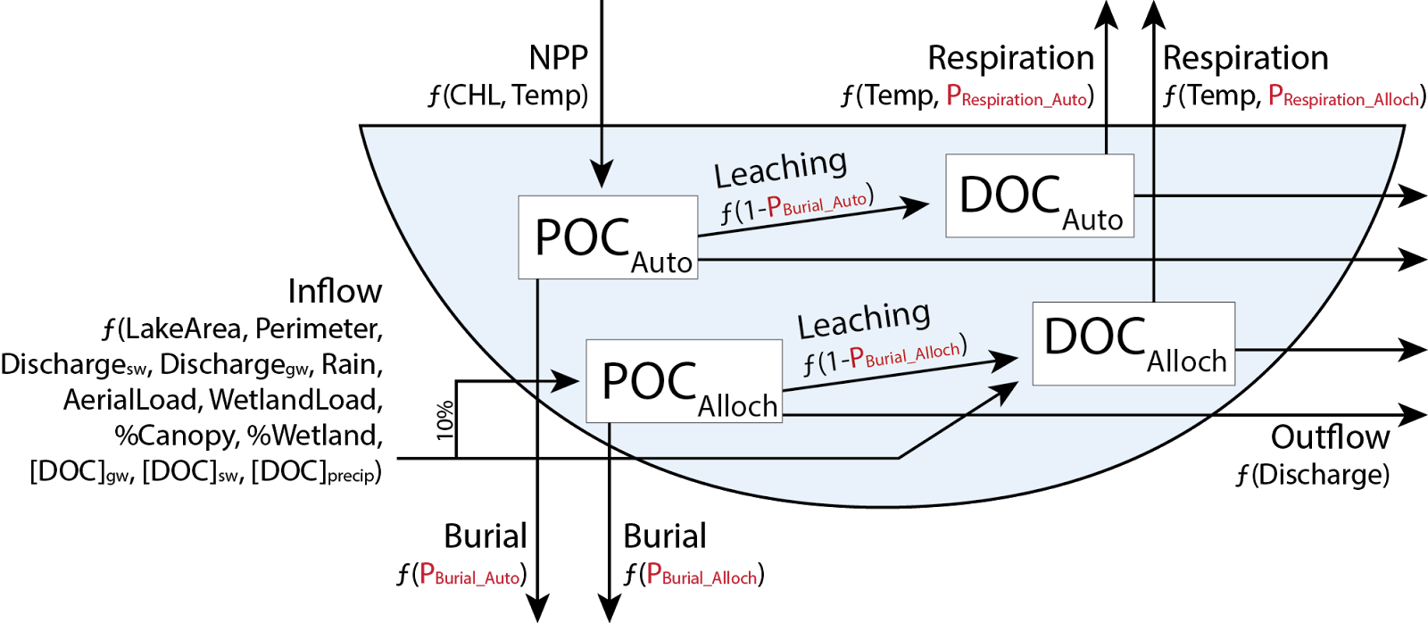

**Fig. 1.**

Fig. 1. Conceptual diagram of the organic carbon lake model depicting fluxes based on allocthonous (inflow) and autochthonous (NPP) inputs of organic carbon, long-term burial, leaching of particulate organic carbon (POC) to dissolved organic carbon (DOC), respiration of DOC to CO2, and export via outflow. Four parameters (Respiration_Auto, Respiration_Alloch, Burial_Auto, and Burial_Alloch) are treated as free parameters and optimized for each individual lake.

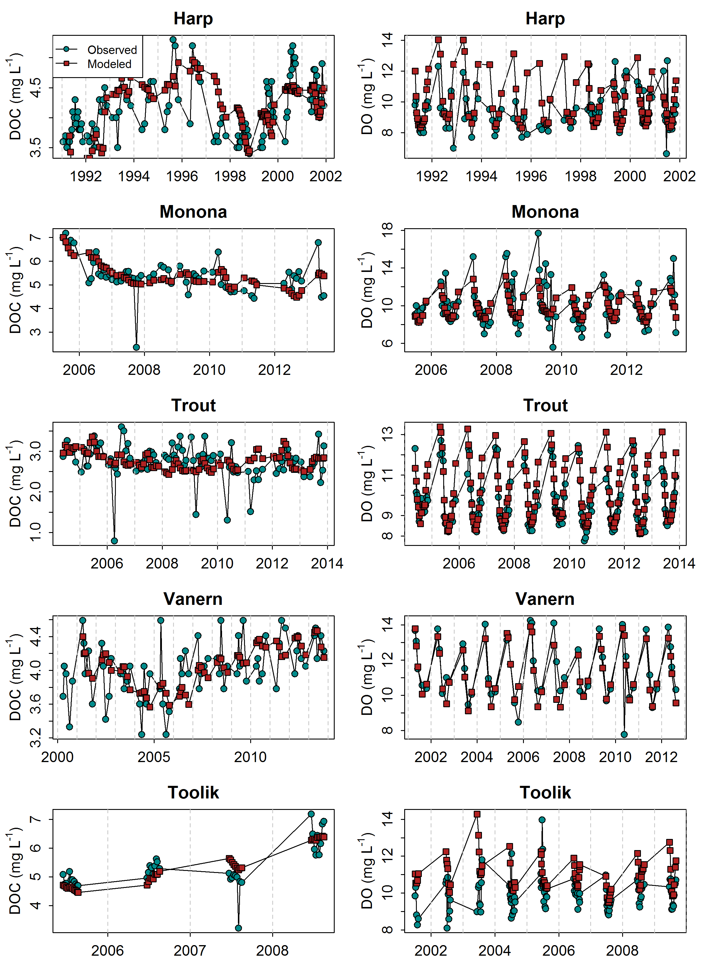

**Fig. 2.**

Fig. 2. Observed dissolved organic carbon (DOC) and dissolved oxygen (DO) concentrations in all lakes (blue circles) compared with modeled concentrations (red squares) on the same date.

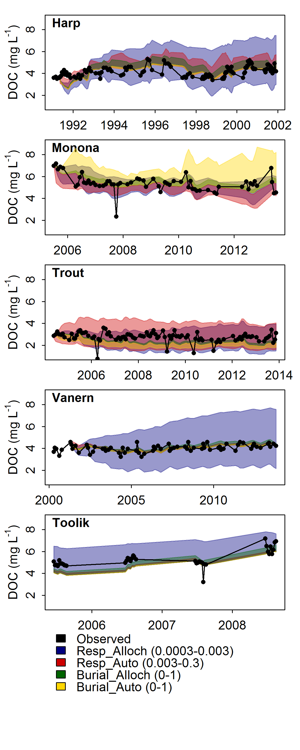

**Fig. 3.**

Fig. 3. Sensitivity of calibrated model parameters. Shaded areas represent the range of modeled DOC concentrations as a given parameter was varied across a specified range (see legend) while the three other parameters remained fixed at their calibrated value. Black circles represent the observed in-lake DOC concentrations.

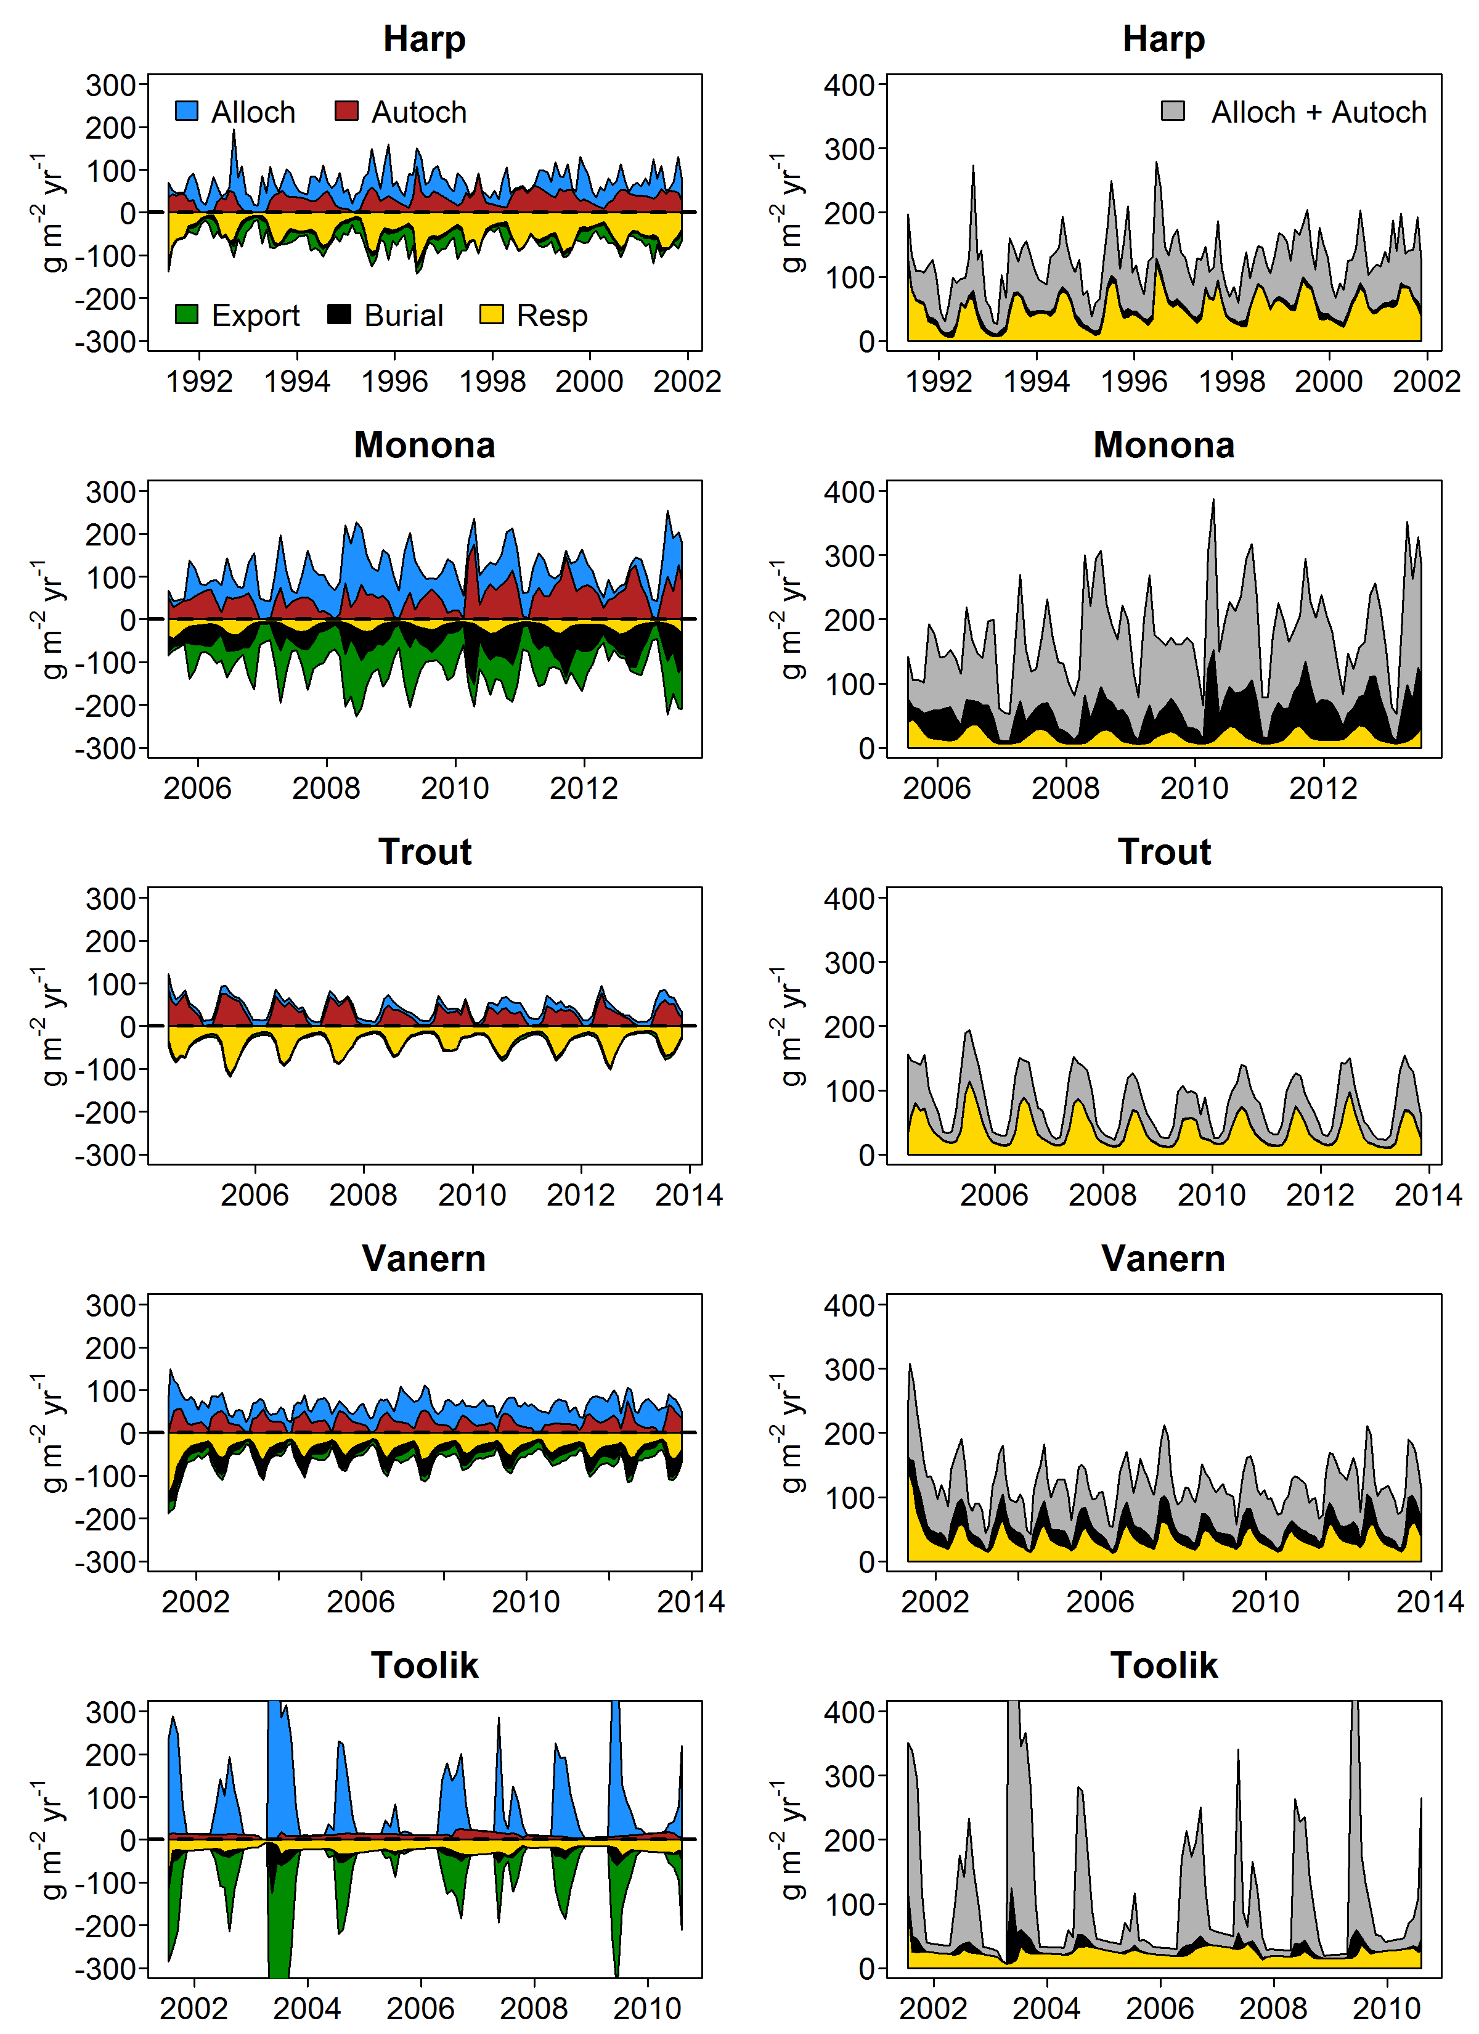

**Fig. 4.**

Fig. 4. Time series of organic carbon fluxes and fates. A) Colored areas represent relative magnitudes of input fluxes (allochthonous and autochthonous) and output fluxes (export, burial, and respiration). All lines are stacked to show cumulative magnitudes. b) Absolute values of export, burial and respiration. A lake is a net source when respiration exceeds burial.

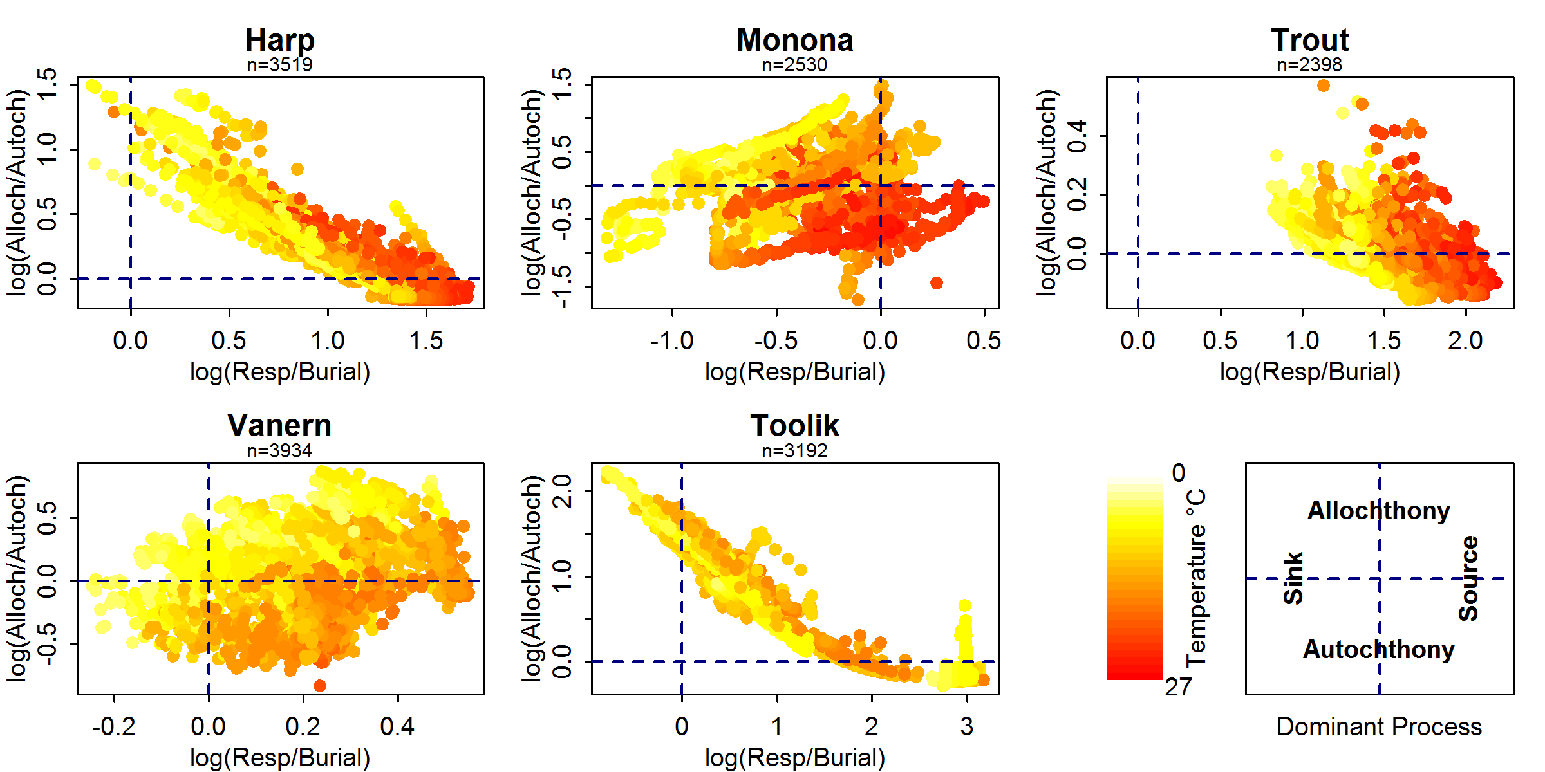

**Fig. 5.**

Fig. 5. Relationship between log-transformed (base 10) allochthony/autochthony and respiration/burial (g m-2 yr-1) of organic carbon. The four quadrants in each figure represent the dominant processes (either predominantly a source or sink, and either predominantly allochthonous driven or autochthonous driven) associated with each lake.

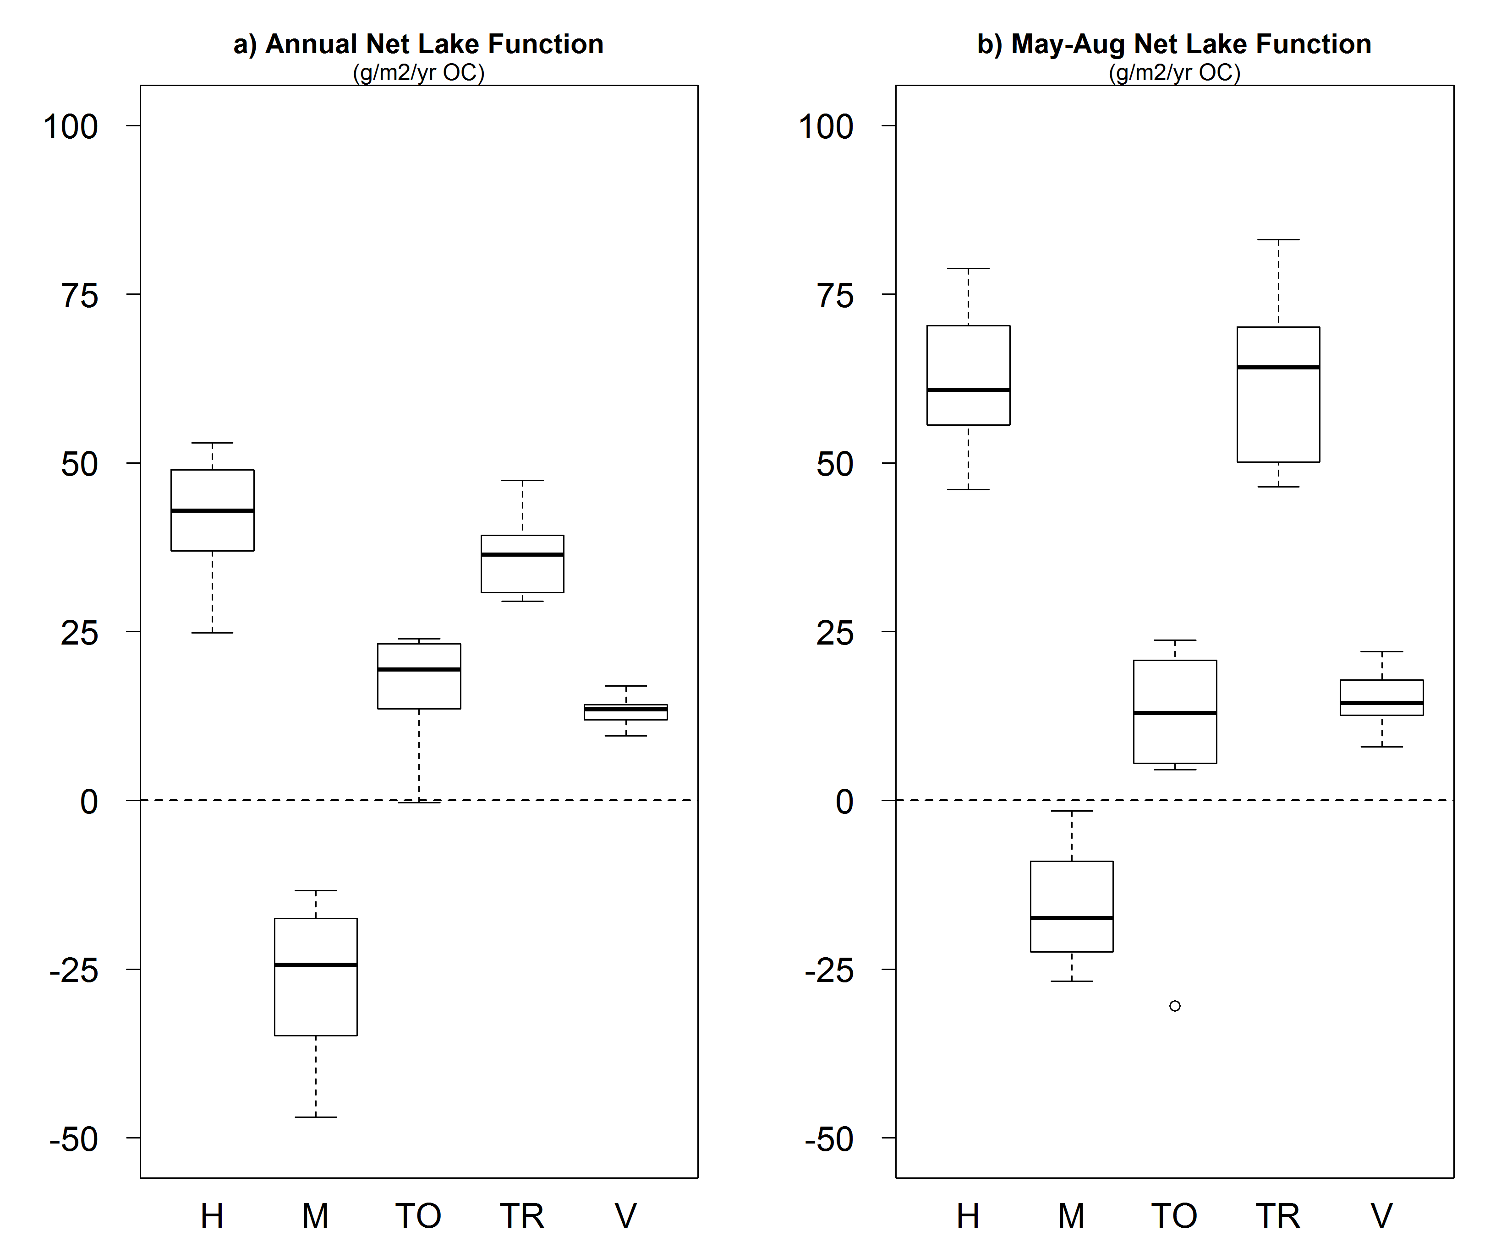

**Fig. 6.**

Fig. 6. Net lake function across a) full modeled years and b) May-August only for the same years. Net lake function is a source when the difference between respiration and burial is greater than zero. Summer increases in respiration drove lakes toward source status. H=Harp, M=Monona, TO=Toolik, TR=Trout, V=Vanern.

1. ^ Current address: Rubenstein School of Environment and Natural Resources, University of Vermont, 81 Carrigan Dr., Burlington, VT, 05405, US