## Running head: Organic carbon fates

Dominant processes in organic carbon cycling in lakes revealed by dynamic mechanistic modeling

Ian M. McCullough1*, Hilary A. Dugan2,14, Kaitlin J. Farrell3^, Ana M. Morales-Williams4^[1]^, Zutao Ouyang5, Derek Roberts6, Facundo Scordo7, Sarah L. Bartlett8, Samantha M. Burke9, Jonathan P. Doubek10, Flora E. Krivak-Tetley11, Nicholas K. Skaff12, Jamie C. Summers13, Kathleen C. Weathers14 and Paul C. Hanson2

1 Bren School of Environmental Science and Management, University of California, 2400 Bren Hall, Santa Barbara, CA, 93106, US.

2Center for Limnology, University of Wisconsin-Madison, 680 N Park St, Madison, WI, 53706, US.

3 Odum School of Ecology, University of Georgia, 140 E. Green Street, Athens, GA, 30602, US.

4 Department of Ecology, Evolution and Organismal Biology, Iowa State University, 251 Bessey, Ames, IA, 50011, US.

5 Center for Global Change and Earth Observations, Michigan State University, 1405, S. Harrison Rd. East Lansing, MI, 48823, US.

6 Department of Civil & Environmental Engineering, University of California, 1 Shields Avenue, Davis, CA, 95616, US. UC Davis Tahoe Environmental Research Center, 291 Country Club Drive, Incline Village, NV, 89451, US.

7 Instituto Argentino de Oceanografía, Universidad Nacional del Sur - CONICET, 8000 Florida St, Bahía Blanca, B8000BFW, Buenos Aires, Argentina.

8 School of Freshwater Sciences, University of Wisconsin-Milwaukee, 600 E Greenfield Ave, Milwaukee, WI, 53204, US.

9 Department of Biology, University of Waterloo, 200 University Ave. W, Waterloo, ON, N2L 3G1, Canada.

10 Department of Biological Sciences, Virginia Tech, 926 West Campus Drive, Blacksburg, VA, 24061, US.

11 Department of Biological Sciences, Dartmouth College, Hanover, NH, 03755, US.

12 Department of Fisheries and Wildlife, Michigan State University, 13 Natural Resources Building, East Lansing, MI, 48824, US.

13 Department of Biology, Queen’s University, 99 University Ave, Kingston, ON, K7L 3N6, Canada.

14 Cary Institute of Ecosystem Studies, Box AB, Millbrook, NY, 12545, US.

*Corresponding author: Current address: Department of Fisheries and Wildlife, Michigan State University, 13 Natural Resources Building, East Lansing, MI, 48824, US. [immccull@gmail.com](mailto:immccull@gmail.com)

## **ABSTRACT**

Lakes are active processors of organic carbon (OC) and play important roles in landscape and global carbon cycling. Allochthonous OC loads from the landscape, along with internal OC autochthonous loads from primary production, are mineralized in lakes, buried in lake sediments, and exported via surface or groundwater outflows. Although these processes provide a basis for a conceptual understanding of lake OC budgets, few studies have integrated these fluxes under a dynamic modeling framework to examine their interactions and relative magnitudes. We used our conceptual understanding of lake OC budgets to develop a simple, dynamical mass balance model for OC, and applied the model to a heterogeneous set of five lakes. We examined the relative magnitudes of OC fluxes and found that long-term lake OC dynamics were predominantly driven by allochthonous loads in four of the five lakes, underscoring the importance of terrestrially-derived OC in lake ecosystems. Burial, the main OC storage mechanism in lakes, represented a relatively small component of the total budget and was driven largely by autochthony in the model, although largely unaccounted allochthonous particulate OC likely increases burial. Respiration, the mechanism by which lakes convert OC to inorganic carbon, ranged from 14-90% of total OC loads (allochthony + autochthony), whereas burial accounted for 3-37% of total OC loads. Additionally, we found that lake OC budgets generally transitioned seasonally from burial- to respiration-dominated as water temperatures and lake productivity increased. Finally, we highlight critical research needs, which include surface water DOC observations in paired tributary and lake settings, measurements of OC burial rates, and budgets of particulate OC. These additional data will better constrain parameter estimates in future lake OC models and improve our understanding of the role of lakes in landscape carbon cycling.

Key words: carbon cycle, carbon flux, limnology, mass balance, allochthony, autochthony, sedimentation, dissolved organic carbon, particulate organic carbon, LTER

## 

## **INTRODUCTION**

Lakes are dynamic components of the landscape that actively process, store, and transport terrestrially derived organic carbon (OC) (Cole et al. 2007, Tranvik et al. 2009, Tanentzap et al. 2017), as well as emit inorganic carbon to the atmosphere (Arvola et al. 2002, Raymond et al., 2013, Weyhenmeyer et al., 2015), making them important in global carbon (C) cycling. Owing to a dearth of ecosystem-scale studies that fully account for OC budgets (Hanson et al. 2014, 2015), there remains a considerable knowledge gap in lake OC dynamics. Models that fully account for major OC fluxes and storage terms in lakes and that explore uncertainties around those terms are needed to advance our understanding of lake OC cycling, quantify the magnitudes of those fluxes under a diversity of conditions, and better integrate lake OC cycling into global C budgets (Hanson et al. 2015). Existing mass balance models are generally based on low frequency data, confined to single lakes, and tend to be concentrated in boreal regions (Jonsson et al. 2001, Urban et al. 2005, Andersson and Sobek 2006, Cremona et al. 2014). Here we developed and applied a dynamical mass balance model to examine the relative magnitudes of OC fluxes within a heterogeneous set of five lakes.

### *Overview of concepts of key OC fluxes in lake ecosystems*

For lakes, the term “mass balance” has been broadly used to quantify carbon or nutrient budgets as the combination of inputs, outputs, and changes to standing stocks in the water column and sediments. Inputs to lake ecosystem OC budgets are the sum of allochthonous (externally derived) dissolved (DOC) and particulate OC (POC) inflows from surface and groundwater sources, atmospheric deposition via precipitation and litterfall, and autochthonous (internally derived) DOC and POC from primary production. Outputs from the OC pool include mechanisms that mineralize OC (i.e., photo-oxidation and respiration) and export via surface and groundwater outflows. Here, for simplicity, all mineralization processes that convert OC to CO2 are collectively modeled as respiration. The mass change in OC in the water column and lake sediments is considered as change in storage. Outputs and storage are the fates of OC loads, and their balances define the role of lakes in broader C cycling. (Box 1, Fig. 1).

At the global scale, lakes are thought to be net sources of C to the atmosphere based on the super-saturation of CO2 (Kortelainen et al. 2006, Tranvik et al. 2009, Raymond et al. 2013) and methane (Bastviken et al. 2011) in lake surface waters. OC export is less frequently considered, but equally important, both in terms of burial and the quality and quantity of OC ultimately reaching the ocean via tributaries (Raymond and Bauer 2001, Santoso et al. 2017). Because lakes store OC in sediments, they can also act as sinks in the global C cycle (Mulholland and Elwood 1982, Dillon and Molot 1997, Einsele et al. 2001, Einola et al. 2011).

We synthesized existing knowledge of lake OC budgets into a model that integrates these important mechanisms, including both in-lake as well as external (i.e., watershed) processes (Fig. 1). Below we described these processes in three main categories 1) allochthony, 2) autochthony, and 3) storage and export.

***Box 1. Mass balance conceptual equations for organic carbon (OC) in lake ecosystems***

*OCALLOCHTHONOUS:* surface and groundwater inflows + litterfall + atmospheric deposition

*OCAUTOCHTHONOUS*: gross primary production - autotrophic respiration

*Full budget*: *OCALLOCHTHONOUS* + *OCAUTOCHTHONOUS* = respiration + burial + export+ ΔOC (in water column)

### *Allochthony*

Allochthonous inputs include all terrestrially derived OC, including DOC and POC from surface and groundwater inflows, litterfall, and direct-fall precipitation (Box 1). Although surface water inflows regularly deliver DOC to lake ecosystems, the uncertainties around the sources and magnitudes of terrestrially derived OC are perhaps the most commonly overlooked aspect in OC budgets, largely owing to data limitations (Hanson et al. 2015). Prior studies have included direct measurements of inflow stream concentrations of DOC when available (Schindler et al. 1997, Jonsson et al. 2001, Urban et al. 2005, Klump et al. 2009), but other approaches have included literature-derived input estimates (Striegl et al. 1998), equations based on watershed area (Sobek et al. 2006), watershed-wetland area ratios (O’Connor et al. 2009), precipitation (Hanson et al. 2004, Staehr et al. 2010), or GIS-based estimates based on land cover and distance-weighted hydrological flow paths (Canham et al. 2004). In lakes without surface inflows, including closed-basin and seepage lakes, groundwater can be the dominant hydrological input (e.g., Gaiser et al. 2009) and can deliver DOC to lakes, especially in organic-rich soils (Schindler and Krabennhoft 1998). Empirical measurements of groundwater discharge and DOC concentration, however, are rare and difficult to estimate (Hanson et al. 2014). POC inputs from litterfall, and wet and dry atmospheric deposition are typically small and are generally estimated as a function of lake size and literature- or expert-based loading coefficients (Hanson et al. 2004). While low in magnitude, these OC sources can be important for lakes with high perimeter to area ratios or with large surface areas and long hydrologic residence times.

### *Autochthony*

Autochthonous DOC and POC originate within lakes through photosynthesis by primary producers. Since gross primary production (GPP) is difficult to measure at the ecosystem level, net primary production (NPP), considered the difference between GPP and autotrophic respiration, is typically measured instead (Pace and Lovett 2013; Box 1). Approaches to estimate NPP include bottle incubations (Urban 2005, Yang et al. 2008) and high frequency measurements of dissolved oxygen or CO2 concentrations (Cole et al. 2002, Staehr et al. 2010). Statistical relationships have also been developed to estimate NPP from lake temperature and total phosphorus (TP; Hanson et al. 2004), chlorophyll-a (chl-*a*; Jonsson et al. 2001, Ramlal et al. 2003), or static proportions of the overall OC pool (Aberg et al. 2004).

*Storage and export*

Long-term burial of POC in lake sediments is the mechanism by which lakes remove Cfrom the global C cycle, and is therefore a critical flux in our understanding of sink dynamics of both allochthonous and autochthonous POC (Cole et al. 2002, Tranvik et al. 2009). POC burial in lakes is a product of in-lake POC concentrations, POC particle sizes and associated settling rates, sediment particle size and density that control resuspension, lake hydrodynamics that affect settling rates and resuspension, and benthic biogeochemistry (Downing et al. 2008, Xu et al. 2013). Methods for estimating sediment accumulation rates are diverse and commonly include functions based on lake area, particularly for studies containing multiple lakes (Canham et al. 2004, Hanson et al. 2004). Previous studies have estimated burial rates using sediment cores (Yang et al. 2008, Klump et al. 2009, Heathcote & Downing 2012), sediment traps (Jonsson et al. 2001, Ramlal et al. 2003), or bathymetry (Downing 2008). A challenge associated with estimating accumulation rates is the reliance on point measurements to characterize sediment accumulation rates that can vary widely over both space and time. Allochthonous and autochthonous POC that is not buried is mineralized directly or leached in the form of DOC and exported via surface or groundwater (Cole et al. 1984). In some lakes, there is carbon efflux in the form of insect production and emergence (Vander Zanden and Gratton 2011), though that flux is not included in this study. Exports represent allochthonous inputs to downstream aquatic ecosystems and therefore contribute to landscape C cycling (Kling et al. 2000).

### *Objective and research question*

Our broad objective was to quantify long-term dynamics and magnitudes of key DOC and POC fluxes using a simple model, and to use this model both to reveal key drivers of OC fates (burial, respiration and export) and quantify uncertainties associated with these processes in lakes. The balance between burial and respiration is particularly important, given that this represents the pathway by which lake OC enters long-term storage or effluxes to the atmosphere, primarily as CO2. We applied the model to five lakes that encompass high contrasts in morphology, hydrology, and trophic state to understand the relative influence of these lake characteristics on OC cycling (Hanson et al. 2011) and to address our overarching question: What are the magnitudes and uncertainties in processes governing lake OC cycling and how do these change through time?

## **METHODS**

### *Study lakes and data sources*

We modeled temporal dynamics of OC budgets for five lakes that span a range of limnological characteristics (e.g., hydrologic residence time, depth, trophic state; Table 1). Lakes were selected for contrast in characteristics and for availability of observational data. Required observational data included precipitation, hydrological inflow (discharge), inflow DOC concentration and various in-lake measurements (surface water temperature, chl-*a* concentration, and Secchi depth). All lakes had a minimum of 10 years of limnological data used for model training (Table 1) and at least four years of in-lake DOC and DO measurements for model validation. See the appendix for detailed data descriptions and sources (AppendixS1). Our dataset included four oligotrophic lakes and one eutrophic lake (Lake Monona, USA). Lake areas ranged from 71.38 ha (Harp Lake, Canada) to 565000 ha (Lake Vanern, Sweden) and mean depths ranged from 7 m (Toolik Lake, USA) to 27 m (Lake Vanern). Hydrologic residence times ranged from 0.8 years (Lake Monona and Toolik Lake) to 6.3 years (Lake Vanern). In-lake mean annual DOC concentrations ranged from 3 g m-3 (Trout Lake, USA) to 6 g m-3 (Lake Monona). Watersheds are primarily forested for Harp Lake, Trout Lake, and Lake Vanern; whereas Toolik Lake is in a tundra-dominated watershed and Monona is in an agricultural and heavily developed watershed. Although the lakes span a set of relatively wide environmental gradients, we did not include a formal analysis of OC fates along these gradients due to the small sample size.

*General model approach*

We designed a relatively simple, dynamic mass balance model (Fig. 1, Tables 2-3), that included four state variables representing OC (Table 3, Eqs. 1-4) and one representing dissolved oxygen (O2, Eq. 5). Static and calibrated parameters for the equations are in Table 2. Allochthonous DOC and POC (Eqs. 1-2) for the lakes were modeled separately from autochthonous DOC and POC (Eqs. 3-4). The model complexity is commensurate with the modest number of observational variables available. We operated the model on a daily time step. Lake volume was assumed static and inflow volume was assumed equal to outflow volume. Observational data of inflow DOC, in-lake chl-*a*, Secchi depth, and temperature were typically weekly or bi-weekly and were linearly interpolated to a daily time step. Precipitation was assumed zero for missing dates; however, precipitation data gaps were rare. Daily evaporative losses were assumed to be approximately equal to precipitation. To account for the absence of winter data at Toolik, we set inflow DOC to 0 when the main inflow (Toolik Inlet) was frozen (AppendixS1). The model was written in R version 3.3.2 (R Core Team 2016).

### *Allochthonous DOC and POC*

Allochthonous DOC load was calculated as the sum of inflows (IDOC, Eq. 1.1) from surface (IDOC.SW, Eq. 1.11) and groundwater (IDOC.GW, Eq. 1.12), and deposition (DDOC, Eq. 1.2) from precipitation (DPrecip, Eq. 1.21) and adjacent wetlands (DWetland, Eq. 1.22). Mass loads were calculated as the product of concentrations and flows, except for DWetland, which was the product of the proportion of lake perimeter that is wetland (PWetland), a parameter representing a transfer coefficient (CDOCWetland) of DOC from the wetland to the lake, and lake perimeter (LakePerimeter). The third input (LAlloch, Eq. 1.3) represents leaching of POCAlloch to DOCAlloch and is the product of a first-order decay rate (CLAlloch) and the POCAlloch concentration. There are two fates of DOCAlloch. The first is mineralization (MDOCAlloch, Eq. 1.4), which is the product of a first-order decay rate (RDOCAlloch), the DOCAlloch concentration, and a temperature adjustment using a standard Arrhenius equation. The second is export downstream (EDOCAlloch, Eq. 1.5), which is the product of DOCAlloch and outflow (QOutflow). Allochthonous POC load (POCAlloch, Eq. 2.1) was modeled similarly to DOCAlloch, but with the following differences. Deposition (DPOC, Eq. 2.2) is the sum of canopy (DPOCCanopy) and wetland (DPOCWetland) inputs, where DPOCCanopy was the product of the proportion of lake perimeter that is canopy (PCanopy), a parameter representing a transfer coefficient (CPOCAerial) of POC from the canopy to the lake, and LakePerimeter. DPOCWetland (Eq. 2.22) was assumed to scale with DDOCWetland by the proportion CPOCFactor. POCAlloch has a burial fate (BAlloch, Eq. 2.3), calculated as the product of a burial coefficient (BPOCAlloch) and POCAlloch. As with DOCAlloch, downstream export (EPOCAlloch, Eq. 2.4) is included as the product of POCAlloch and outflow.

Daily surface water inflow (m3 s-1) was generally available for the main tributaries of all study lakes. Inflow DOC concentration (mg L-1) was less frequently measured, and was linearly interpolated to a daily time step from sub-weekly to monthly data (AppendixS1). When inflow DOC concentrations were not available for all tributaries, DOC contributions for each tributary were estimated based on the proportion of total inflow volume and the assumption that inflow DOC concentration was equal across all tributaries. Daily precipitation (QPrecip, mm) was measured at the weather station nearest to each lake. The concentration of DOC in precipitation was set to 2 g m-3 (Hanson et al. 2014). Time series of lake-specific groundwater inflow volume (m3) and DOC concentration (g m-3) were not available. We estimated the proportion of inflow as groundwater in our study lakes based on literature values when available, but assumed no groundwater in the absence of data (AppendixS1). Resulting estimated groundwater proportions ranged from 0-19%. Groundwater DOC concentration was assumed to be 10 g m-3 (Table 2: DOCGWConc, Hanson et al. 2014). Shoreline-adjacent wetlands and forests were estimated from GIS and publicly available spatial datasets (AppendixS1). We focused on wetlands adjacent to the shoreline because they contribute most of wetland-derived DOC to lakes not already captured in Eq. 1.1 (Hanson et al. 2014). To account for potential spatial misalignment among spatial wetland and forest data and lake boundaries, we defined adjacency as within 30 m of lake boundaries.

### *Autochthonous DOC and POC*

Our approach to modeling autochthony (Table 3, Eqs. 3-4) was generally similar to that of allochthony for leaching, mineralization, export, and burial (Eqs. 3.3-3.5, 4.2), but differs in the input terms NPPDOC (Eq. 3.2) and NPPPOC (Eq. 4.1). Total autochthony (NPPTOT, Eq. 3.1) is the product of GPP, which is modeled as a function of chl-*a* (µg L-1), mixing depth (Zmix), and surface water temperature (T, °C) per Morin et al. (1999), and the proportion of GPP not respired by autotrophs (1-RAutotroph). The GPP function was calculated using observed temperature and chl-*a* data that ranged from 5-25 °C and 1-1000 mg m-2, respectively, across all lakes. Since models of GPP are not well constrained at low temperatures, we set GPP to zero if surface water temperatures were < 4 °C, as this is the maximum density of water and a point at which lakes would no longer be stratified. Chl-*a* concentrations were converted from volumetric to areal units by multiplying by photic depth, which was estimated from Secchi depth (m; Wetzel 2001). Eq. 3.2 determines the proportion of NPPTOT that is the DOC fraction (NPPDOC) using the Pace and Prairie (2005) negative exponential equation. The remainder of NPPTOT is attributed to POC (NPPPOC, Eq. 4.1).

Water column dissolved oxygen (O2) was used to constrain net ecosystem production (NEPOC, Eq. 5.1), under the assumption that at short time scales and under pseudo-equilibrium conditions, atmospheric exchange (Fatm) approximates NEPOC. Fatm was calculated as k × (O2 – O2sat)/Zmix (Eq. 5.2), where k is the piston velocity, set to 0.7 m d-1 and the mixing depth, Zmix,was set equal to half the photic depth (m). The saturation of DO (O2sat) is temperature dependent and was determined using the Garcia-Benson method in the LakeMetabolizer R package (Winslow et al. 2016). Heterotrophic respiration was calculated as a function of DOCAutoch and DOCAlloch concentration (g m-3) in the photic zone, epilimnion temperature (assumed to be uniform through the photic zone), and two calibrated parameters: RDOCAutoch and RDOCAlloch(Tables 2-3, Eqs. 1.4, 3.4, 5.12) (see Model calibration and uncertainty analysis). We determined epilimnion temperature by averaging observed temperatures throughout the photic zone when data were available from multiple depths, but otherwise used surface temperature (AppendixS1).

*Model calibration and uncertainty analysis*

The collinearity of the four free parameters in the model (respiration: RDOCAlloch, RDOCAutoch, burial: BPOCAlloch, and BPOCAutoch; Table 2) was tested using the *collin* function in the R package FME (Brun and Kunsch 2001, Omlin et al. 2001, Soetaert and Petzoldt 2010). In general, when the collinearity index is less than 20, linear independence is assumed. Finding low collinearity, the four parameters were fit by minimizing the sum of the squared residuals of DOC and DO (equally weighted by number of observations). The model was fit using a pseudo-random search algorithm in the R package FME (Soetaert and Petzoldt 2010). Burial parameters were constrained in the model as a proportion between 0 (no burial of POC) and 1 (all POC is buried). RDOCAlloch was constrained between 0.0003 and 0.03 (d-1) based on the range of OC decomposition rates for inland waters with residence times between 1-10 years presented in Catalan et al. (2016). RDOCAutoch was constrained between 0.003 and 0.3 (d-1). Metrics for goodness of fit were root mean square error (RMSE) and Nash-Sutcliffe Efficiency (NSE) scores calculated separately for DOC and DO for each lake. A sensitivity analysis of each parameter was conducted by allowing the parameter to vary at 100 different values within the set bounds while fixing the other three parameters at their calibrated values.

We estimated parameter means and uncertainties using a bootstrapping routine (per Dugan et al. 2017). Using the parameters returned from the optimization routine, residual errors between observed and modeled DOC as well as observed and modeled DO were calculated. We created 100 pseudo-observational datasets by randomizing 100 times these residuals and adding each randomized residual set to the observed data. We then re-fit the parameters to the pseudo-observational datasets to provide 100 new parameter estimates. Finally, we recorded parameter distribution characteristics and assessed correlations among parameters within each lake.

## **RESULTS**

### *Model performance, parameter estimates, and sensitivity analysis*

Modeled DOC and DO generally followed observed temporal patterns across years in each study lake (Fig. 2). There was an overall strong goodness of fit for both DOC and DO based on RMSE for each lake (0.80-1.46 mg L-¹; Table 4). The model also accounted for considerably more temporal variability than long-term means of DOC based on NSE values across lakes (0.70-0.96). Although the model captured annual and seasonal DOC and DO dynamics, the model did not consistently characterize the magnitude of short-term spikes in DOC (i.e., days to weeks). Nonetheless, long-term model performance indicated the ability to account for lake variability in DOC and DO from seasonal to inter-annual time scales.

Across all lakes, parameter estimates for the allochthonous components of the budget were generally more consistent and better constrained than those for autochthony (Table 4). Respiration of allochthonous DOC (RDOCAlloch) ranged from about 0.0011-0.0025 d-1 among lakes and SEM values were about two orders of magnitude lower, indicating tightly constrained mean values. In contrast, respiration of autochthonous DOC (RDOCAutoch) was more variable than RDOCAlloch among lakes, ranging from about 0.0034-0.4500 d-1. Burial rates for allochthony (BPOCAlloch) were high, with values at or near the upper limit (1.0000 d-1) for all lakes except Lake Monona. Burial of autochthony (BPOCAutoch) was comparatively lower, ranging from approximately 0.0310-0.8700 d-1. SEM values for burial tended to be about one order of magnitude smaller than corresponding parameter means across all lakes.

Modeled DOC (mg L-1) was generally most sensitive to RDOCAlloch, except for Lake Monona, for which modeled DOC was most sensitive to BPOCAutoch (Fig. 3). The other four lakes were minimally affected by changes in BPOCAutoch (< 1 mg L-1 difference across the range of parameter values). Changes in BPOCAlloch had consistently minimal effects (< 1 mg L-1) on modeled DOC across all lakes. Trout Lake was the most sensitive to RDOCAutoch, with modeled DOC ranging about 2-2.5 mg L-1 across the range of parameter values, whereas Toolik Lake and Lake Monona were moderately sensitive (1-1.5 mg L-1 differences) and Lake Vanern and Harp lake were minimally sensitive (< 1 mg L-1 differences). Overall, parameter sensitivity was greatest for Lake Vanern, Harp Lake and Lake Monona, for which modeled DOC varied as much as 5-6 mg L-1 across the range of parameter values (Fig. 3). Conversely, modeled DOC varied no more than 2 and 3 mg L-1 for Toolik Lake and Trout Lake, respectively.

### *Summary of fluxes and fates*

With the exception of Trout Lake, OC loads were primarily driven by allochthony, underscoring the importance of terrestrially derived OC in overall lake budgets (Table 5). Additionally, respiration exceeded burial in all lakes but Lake Monona. Trout Lake also had the smallest total annual OC load of the five lakes (41.52 g m-2 yr-1), the lowest proportion of total load exported (0.10), and the largest proportional difference between respiration (0.90) and burial (0.03) among all lakes. Lake Monona had the largest total OC load (118.97 g m-2 yr-1) among lakes, lowest proportion respired (0.14) and greatest proportion buried (0.37). Monona was the only lake dominated by burial long-term; on average, burial rates were greater than twice respiration rates across modeled years. Harp lake had the second lowest proportion buried (0.07) among all lakes and exhibited proportions of allocthony (0.55) and autocthony (0.45) that were approximately similar in Lake Monona and Lake Vanern. Similar to Trout Lake, Harp Lake demonstrated a relatively large proportional difference between respiration (0.66) and burial (0.07). Toolik Lake had the second largest (mean = 87.45 g m-2 yr-1) but most variable (standard deviation; SD = 62.91 g m-2 yr-1) total OC load and was the most driven by allochthony (0.87) among all lakes. This inter-annual variability in total OC load for Toolik Lake was driven by highly variable allochthony (SD = 64.78 g m-2 yr-1) and also resulted in highly variable export (53.53 g m-2 yr-1). Compared to other lakes, Toolik Lake on average demonstrated relatively low proportion buried (0.08) and relatively high proportion exported (0.64).

### *Seasonal fates*

Seasonal patterns in OC fluxes were consistent across entire respective time series for each lake, with autochthony and respiration increasing to a summer maximum (Fig. 4). As water temperatures increased during the growing season (e.g., May – Aug.), the balance between allochthony and autochthony generally shifted toward autochthony due to increases in NPP, whereas the ratio between respiration and burial generally shifted towards respiration (Figs. 4a, 5). There was high seasonal variability in the dominant fluxes in each lake (Fig. 5). Trout Lake remained dominated by respiration year-round, but respiration increased relative to burial as water temperatures warmed. Harp Lake, Toolik Lake, and Lake Vanern were dominated by burial early in the growing season, but were dominated by respiration on an annual basis due to increased respiration rates as temperatures warmed. Whereas respiration in Lake Monona exceeded burial late in the growing season, the lake remained dominated by burial when calculated on an annual basis (Table 5, Fig. 5). Lake Monona and Lake Vanern also showed less of a proportional increase in autochthony (i.e., negative slope in Fig. 5) as the growing season progressed compared to other lakes, suggesting the importance of continued allochthonous inputs during summer months in these lakes. In the other three lakes, the proportional shift toward autochthony was associated by a proportional shift from burial to respiration due to warmer water temperatures, but this association was relatively weaker in Lake Monona and Lake Vanern (Fig. 5).

## **DISCUSSION**

### *Representing lake processes*

Our results indicated that a relatively simple, dynamical model can recreate long-term trends in DOC and represent the set of key biogeochemical, trophic, and landscape processes that combine to determine the fate of OC in lake ecosystems. While postulated previously (Hanson et al. 2011), this is the first demonstration of a dynamical OC model applied to contrasting lake. Further, the fluxes we modeled were within the range of other published studies for these lakes based on steady-state models. Using much of the same LTER data, Hanson et al. (2014) provided similar estimates for Trout of allochthony (Hanson: 15.92 g m-2 yr-1, our model: 13.35 g m-2 yr-1), burial (Hanson: 3.66 g m-2 yr-1, our model: 1.19 g m-2 yr-1), and export (Hanson: 4.95 g m-2 yr-1, our model: 3.95 g m-2 yr-1), but not for respiration (Hanson: 7.31 g m-2 yr-1, our model: 37.45 g m-2 yr-1), because Hanson et al. (2014) did not account for autochthony. Similar to our study, Whalen and Cornwall (1985) demonstrated that Toolik Lake was driven by high proportional allochthony (Whalen and Cornwall 0.91, our study: 0.87) relative to autochthony (Whalen and Cornwall 0.09, our study 0.13) and low burial (Whalen and Cornwall: 0.02, our study: 0.08). Our proportion exported (0.64) contrasted somewhat with Whalen and Cornwall (0.82), but much of this excess export was respired (0.27) in our model. Dillon and Molot’s (1997) proportional estimates for burial in Harp Lake were low and similar to ours (Dillon and Molot: 0.01, our model: 0.07) and the magnitudes of allochthony were somewhat similar (Dillon and Molot: 28.9 g m-2 yr-1, our study: 39.88 g m-2 yr-1), but Dillon and Molot (1997) did not consider autochthony. Therefore, we are unable to compare total loads and differences in proportion exported in Dillon and Molot (0.58) vs. our study (0.24) may be explained by our inclusion of autochthony and respiration. Differences budget estimates may also be due to differences in study years (Dillon and Molot: 1981-1989, our study: 1991-2001). Although our results generally agreed with prior studies based on steady-state models, our estimated respiration rates were generally higher than those noted in the literature (Hanson et al. 2014, Dillon and Molot 1997). We offer that dynamical models better represent these processes by accounting for seasonal changes in temperature and chl-*a* concentrations. Therefore, although steady-state models may be sufficient for recreating some key ecological processes, dynamical models are needed for determining the relative magnitudes of OC fates in lake ecosystems, given the importance of autochthony and respiration.

*OC fates and global change implications*

Well-constrained estimates of OC burial in lakes remain a challenge to model. Although our estimates for burial parameters have relatively low uncertainties (Table 4), we believe burial may be underestimated for these lakes. A key consideration is that our model buried close to 100% of POCAlloch in four of five lakes (Table 4: BPOCAlloch); therefore, any increase in POCAlloch would be directly proportional to increases in burial. Owing to lack of observational data, we assumed POCAlloch was 10% of DOCAlloch (CPOCFactor), but this may be an underestimate, and does not account for potential seasonal variation in the DOC:POC ratio. Intense precipitation can increase POC concentration disproportionately to DOC concentration in streams (Jeong et al. 2012, Dhillon and Inamdar 2013), which could temporarily increase POCAlloch and thus burial. In addition, our model demonstrated DOC responses to precipitation events when we had corresponding weather and DOCAlloch data, but the assumed linear changes in inflow volume and DOCAlloch between observation points may also have underrepresented DOCAlloch, leading indirectly to underrepresentation of POCAlloch. Wet years increase DOCAlloch inputs to lakes at regional scales by increasing connectivity among waterbodies (Rose et al. 2016) and therefore probably also increase POCAlloch. Although our burial estimates were somewhat uncertain due to underrepresentation of POCAlloch during precipitation events, burial would have to increase substantially over the course of the entire modeling period for burial to dominate over respiration, including three-fold or greater for Harp Lake, Toolik Lake and Trout Lake (Table 5). Therefore, missing POCAlloch likely leads to underestimates of burial, but is unlikely to account for enough OC to exceed the magnitudes of respiration in many lake ecosystems.

Across all lakes in our study, warm surface temperatures, coincident with light, were generally associated with an increase in the proportion of autochthony in lakes (Fig. 5). Warm surface temperatures appear to drive lakes toward OC respiration rather than burial. This likely is due to elevated NPP during summer growing seasons accompanied by relatively high respiration rates of autochthonous OC relative to allochthonous OC (Table 4). Although the ratio of respiration to burial increases with temperature, it is also possible for burial to increase with temperature if temperature increases are associated with greater OC loads. Lakes have generally become more productive under recent climate warming (Kraemer et al. 2016), which increases autochthony; however, autochthonous OC is highly labile and readily respired. Furthermore, respiration rates for all C increase with temperature. Our results suggest that processes favoring allochthonous loading, such as the timing, form and magnitude of hydrologic events, will generally have a greater effect on OC burial than processes that drive autochthony.

### *On-going research needs and future implications*

Our work is an important advance in quantifying the fates of OC across aquatic ecosystems; however, we encountered constraints associated with current data availability. If requisite data were collected for a larger number of lakes spanning wider environmental gradients (e.g., climate, watershed conditions), contributions of lakes to landscape carbon cycles could be estimated at broad spatial scales. During model development, we encountered a notable paucity of high-frequency measurements of inflow DOC concentration, of which broader collection would facilitate dynamical OC modeling in more lakes. Although collection of these data may be expensive and logistically challenging, the increasing availability of automated, high-frequency sensor equipment may alleviate long-term costs associated with sensor deployment and manual data retrieval. In addition, relatively little is currently known about POC budgets despite their key interactions with DOC (Einsele et al. 2001); we need more POC observational data for incorporation into dynamical models of OC, particularly in inflows for estimating POCAlloch. Such studies would help constrain POC parameters and improve estimates of the fates of POC within overall OC budgets. Thus, a key implication of our study is the need for more observational data, particularly pertaining to surface water DOC concentrations, POC cycling, and burial rates. Despite these uncertainties, lake resource managers should be aware of the importance of allochthonous inputs derived from watershed sources in lake OC budgets; allochthony exceeded autochthony in 4 of the 5 lakes in this study. More broadly, development of a flexible model that quantifies OC fates across heterogeneous lake ecosystems represents an important step in better incorporating lakes into the global C cycle.

## **ACKNOWLEDGMENTS**

This project was a product of the Global Lake Ecological Observatory Network (GLEON) Fellowship program supported by the US National Science Foundation’s MacroSystems Biology Program (Awards # EF1137353 and EF1137327). Logistical support was provided by the University of Wisconsin-Madison Center for Limnology, the Cary Institute of Ecosystem Studies, the University of Wisconsin Trout Lake Station, the Lake Sunapee Protective Association, and Grace Hong. Limnological data providers included the NSF Long-Term Ecological Research program (North Temperate Lakes DEB-1440297 and Arctic LTER), the Swedish Meteorological and Hydrological Institute, the Swedish University of Agricultural Sciences and the Canadian Dorset Environmental Science Centre. Additional details on data sources were included online in the appendix (AppendixS1). IMM, HAD, KJF, AMM, ZO, DR, FS and PCH acquired data, developed the model and performed data analyses. All authors participated in conceiving and developing the project and writing the paper. Analysis scripts and data can be freely downloaded here: <https://github.com/GLEON/SOS>.

## **LITERATURE CITED**

Åberg, J., Bergström, A. K., Algesten, G., Söderback, K., & Jansson, M. (2004). A comparison of the carbon balances of a natural lake (L. Örträsket) and a hydroelectric reservoir (L. Skinnmuddselet) in northern Sweden. *Water Research*, *38*(3), 531-538.

Andersson, E., & Sobek, S. (2006). Comparison of a mass balance and an ecosystem model approach when evaluating the carbon cycling in a lake ecosystem. *AMBIO: A Journal of the Human Environment*, *35*(8), 476-483.

Arvola, L., Kortelainen, P. I. R. K. K. O., Bergström, I., Kankaala, P., Ojala, A., Pajunen, H. A. N. N. U., ... & Rantakari, M. I. I. T. T. A. (2002). Carbon pathways through boreal lakes: A multi-scale approach (CARBO). *Understanding the Global System, The Finnish Perspective, edited by Käyhkö J and Talve L*, 97-106.

Brun, R., Reichert, P. and Kunsch, H. R., 2001. Practical Identifiability Analysis of Large Environmental Simulation Models. Water Resour. Res. 37(4): 1015--1030.

Canham, C. D., Pace, M. L., Papaik, M. J., Primack, A. G., Roy, K. M., Maranger, R. J., ... & Spada, D. M. (2004). A spatially explicit watershed-scale analysis of dissolved organic carbon in Adirondack lakes. *Ecological Applications*, *14*(3), 839-854.

Cole, J. J., McDowell, W. H., & Likens, G. E. (1984). Sources and molecular weight of" dissolved" organic carbon in an oligotrophic lake. *Oikos*, 1-9.

Cole, J. J., Carpenter, S. R., Kitchell, J. F., & Pace, M. L. (2002). Pathways of organic carbon utilization in small lakes: Results from a whole‐lake 13C addition and coupled model. *Limnology and Oceanography*, *47*(6), 1664-1675.

Cole, J. J., Prairie, Y. T., Caraco, N. F., McDowell, W. H., Tranvik, L. J., Striegl, R. G., ... & Melack, J. (2007). Plumbing the global carbon cycle: integrating inland waters into the terrestrial carbon budget. *Ecosystems*, *10*(1), 172-185.

Cremona, F., Kõiv, T., Nõges, P., Pall, P., Rõõm, E. I., Feldmann, T., ... & Nõges, T. (2014). Dynamic carbon budget of a large shallow lake assessed by a mass balance approach. *Hydrobiologia*, *731*(1), 109-123.

Dhillon, G. S., & Inamdar, S. (2014). Storm event patterns of particulate organic carbon (POC) for large storms and differences with dissolved organic carbon (DOC). *Biogeochemistry*, *118*(1-3), 61-81.

Dillon, P. J., & Molot, L. A. (1997). Dissolved organic and inorganic carbon mass balances in central Ontario lakes. *Biogeochemistry*, *36*(1), 29-42.

Downing, J. A., Cole, J. J., Middelburg, J. J., Striegl, R. G., Duarte, C. M., Kortelainen, P., ... & Laube, K. A. (2008). Sediment organic carbon burial in agriculturally eutrophic impoundments over the last century. *Global Biogeochemical Cycles*, *22*(1).

Dugan, H. A., Bartlett, S. L., Burke, S. M., Doubek, J. P., Krivak-Tetley, F. E., Skaff, N. K., ... &

Weathers, K. C. (2017). Salting our freshwater lakes. *Proceedings of the National Academy of Sciences*, *114*(17), 4453-4458.

Einola, E., Rantakari, M., Kankaala, P., Kortelainen, P., Ojala, A., Pajunen, H., ... & Arvola, L.

(2011). Carbon pools and fluxes in a chain of five boreal lakes: a dry and wet year comparison. *Journal of Geophysical Research: Biogeosciences*, *116*(G3).

Einsele, G., Yan, J., & Hinderer, M. (2001). Atmospheric carbon burial in modern lake basins and its significance for the global carbon budget. *Global and Planetary Change*, *30*(3), 167-195.

Gaiser, E. E., Deyrup, N. D., Bachmann, R. W., Battoe, L. D., & Swain, H. M. (2009). Multidecadal climate oscillations detected in a transparency record from a subtropical Florida lake.

Hanson, P. C., Buffam, I., Rusak, J. A., Stanley, E. H., & Watras, C. (2014). Quantifying lake allochthonous organic carbon budgets using a simple equilibrium model. *Limnol. Oceanogr*, *59*(1), 167-181.

Hanson, P. C., Hamilton, D. P., Stanley, E. H., Preston, N., Langman, O. C., & Kara, E. L. (2011). Fate of allochthonous dissolved organic carbon in lakes: a quantitative approach. *PLoS One*, *6*(7), e21884.

Hanson, P. C., Pace, M. L., Carpenter, S. R., Cole, J. J., & Stanley, E. H. (2015). Integrating landscape carbon cycling: research needs for resolving organic carbon budgets of lakes. *Ecosystems*, *18*(3), 363-375.

Hanson, P. C., Pollard, A. I., Bade, D. L., Predick, K., Carpenter, S. R., & Foley, J. A. (2004). A model of carbon evasion and sedimentation in temperate lakes. *Global Change Biology*, *10*(8), 1285-1298.

Heathcote, A. J., & Downing, J. A. (2012). Impacts of eutrophication on carbon burial in

freshwater lakes in an intensively agricultural landscape. *Ecosystems*, *15*(1), 60-70.

Jeong, J. J., Bartsch, S., Fleckenstein, J. H., Matzner, E., Tenhunen, J. D., Lee, S. D., ... & Park, J. H. (2012). Differential storm responses of dissolved and particulate organic carbon in a mountainous headwater stream, investigated by high‐frequency, in situ optical measurements. *Journal of Geophysical Research: Biogeosciences*, *117*(G3).

Jonsson, A., Meili, M., Bergström, A. K., & Jansson, M. (2001). Whole‐lake mineralization of allochthonous and autochthonous organic carbon in a large humic lake (Örträsket, N. Sweden). *Limnology and Oceanography*, *46*(7), 1691-1700.

Karlsson, J., Ask, J., & Jansson, M. (2008). Winter respiration of allochthonous and autochthonous organic carbon in a subarctic clear‐water lake. *Limnology and oceanography*, *53*(3), 948-954.

Kling, G. W., Kipphut, G. W., Miller, M. M., & O'Brien, W. J. (2000). Integration of lakes and streams in a landscape perspective: the importance of material processing on spatial patterns and temporal coherence. *Freshwater Biology*, *43*(3), 477-497.

Klump, J. V., Fitzgerald, S. A., & Waplesa, J. T. (2009). Benthic biogeochemical cycling, nutrient stoichiometry, and carbon and nitrogen mass balances in a eutrophic freshwater bay. *Limnology and Oceanography*, *54*(3), 692-712.

Kraemer, B. M., Chandra, S., Dell, A. I., Dix, M., Kuusisto, E., Livingstone, D. M., ... &

McIntyre, P. B. (2016). Global patterns in lake ecosystem responses to warming based on the temperature dependence of metabolism. *Global change biology*.

Mulholland, P. J., & Elwood, J. W. (1982). The role of lake and reservoir sediments as sinks in

the perturbed global carbon cycle. *Tellus*, *34*(5), 490-499.

O'Connor, E. M., Dillon, P. J., Molot, L. A., & Creed, I. F. (2009). Modeling dissolved organic carbon mass balances for lakes of the Muskoka River Watershed. *Hydrology Research*, *40*(2-3), 273-290.

Omlin, M., Brun, R. and Reichert, P., 2001. Biogeochemical Model of Lake Zurich: Sensitivity,

Identifiability and Uncertainty Analysis. Ecol. Modell. 141: 105--123.

Pace ML & Lovett G. 2013. Primary production: the foundation of ecosystems. In: Weathers K,

Strayer D, Likens G, editors. Fundamentals of ecosystem science. Academic Press. p. 312.

Ramlal, P. S., Hecky, R. E., Bootsma, H. A., Schiff, S. L., & Kingdon, M. J. (2003). Sources and fluxes of organic carbon in Lake Malawi/Nyasa. *Journal of Great Lakes Research*, *29*, 107-120.

Raymond, P. A., & Bauer, J. E. (2001). Riverine export of aged terrestrial organic matter to the

North Atlantic Ocean. *Nature*, *409*(6819), 497-500.

Raymond, P. A., Hartmann, J., Lauerwald, R., Sobek, S., McDonald, C., Hoover, M., ... &

Kortelainen, P. (2013). Global carbon dioxide emissions from inland waters. *Nature*, *503*(7476), 355-359.

R Core Team (2016). R: A language and environment for statistical computing. R Foundation for

Statistical Computing, Vienna, Austria. URL: https://www.R-project.org/.

Santoso, A. B., Hamilton, D. P., Hendy, C. H., & Schipper, L. A. Carbon dioxide emissions and

sediment organic carbon burials across a gradient of trophic state in eleven New Zealand lakes. *Hydrobiologia*, 1-14.

Schindler, D. W., Curtis, P. J., Bayley, S. E., Parker, B. R., Beaty, K. G., & Stainton, M. P. (1997). Climate-induced changes in the dissolved organic carbon budgets of boreal lakes. *Biogeochemistry*, *36*(1), 9-28.

Schindler, J. E., & Krabbenhoft, D. P. (1998). The hyporheic zone as a source of dissolved organic carbon and carbon gases to a temperate forested stream. *Biogeochemistry*, *43*(2), 157-174.

Sobek, S., Söderbäck, B., Karlsson, S., Andersson, E., & Brunberg, A. K. (2006). A carbon budget of a small humic lake: an example of the importance of lakes for organic matter cycling in boreal catchments. *AMBIO: A Journal of the Human Environment*, *35*(8), 469-475.

Soetaert, K. and Petzoldt, T., 2010. Inverse Modelling, Sensitivity and Monte Carlo Analysis in R Using Package FME. Journal of Statistical Software 33(3) 1--28. <http://www.jstatsoft.org/v33/i03>

Staehr, P. A., Sand-Jensen, K., Raun, A. L., Nilsson, B., & Kidmose, J. (2010). Drivers of metabolism and net heterotrophy in contrasting lakes. *Limnology and Oceanography*, *55*(2), 817.

Striegl, R. G., & Michmerhuizen, C. M. (1998). Hydrologic influence on methane and carbon dioxide dynamics at two north-central Minnesota lakes. *Limnology and Oceanography*, *43*(7), 1519-1529.

Tanentzap, A. J., Szkokan-Emilson, E. J., Desjardins, C. M., Orland, C., Yakimovich, K.,

Dirszowsky, R., ... & Gunn, J. (2017). Bridging between litterbags and whole-ecosystem experiments: a new approach for studying lake sediments. *Journal of Limnology*.

Tranvik, L. J., Downing, J. A., Cotner, J. B., Loiselle, S. A., Striegl, R. G., Ballatore, T. J., ... & Kortelainen, P. L. (2009). Lakes and reservoirs as regulators of carbon cycling and climate. *Limnology and Oceanography*, *54*(6part2), 2298-2314.

Urban, N. R., Auer, M. T., Green, S. A., Lu, X., Apul, D. S., Powell, K. D., & Bub, L. (2005). Carbon cycling in Lake Superior. *Journal of Geophysical Research: Oceans (1978–2012)*, *110*(C6).

Vander Zanden, M. J., & Gratton, C. (2011). Blowin’in the wind: reciprocal airborne carbon fluxes between lakes and land. *Canadian Journal of Fisheries and Aquatic Sciences*, *68*(1), 170-182.

Wetzel, R. G. (2001). *Limnology: lake and river ecosystems*. Gulf Professional Publishing.

Weyhenmeyer, G. A., Kosten, S., Wallin, M. B., Tranvik, L. J., Jeppesen, E., & Roland, F. (2015). Significant fraction of CO2 emissions from boreal lakes derived from hydrologic inorganic carbon inputs. *Nature Geoscience*.

Whalen, S. C., & Cornwell, J. C. (1985). Nitrogen, phosphorus, and organic carbon cycling in an arctic lake. *Canadian Journal of Fisheries and Aquatic Sciences*, *42*(4), 797-808.

Winslow, L. A., Zwart, J. A., Batt, R. D., Dugan, H., Woolway, R. I., Corman, J., ... & Read, J. S. (2016). LakeMetabolizer: an R package for estimating lake metabolism from free-water oxygen using diverse statistical models. *Inland Waters*, *6*(4), 622-636.

Xu, H., Lan, J., Liu, B., Sheng, E., & Yeager, K. M. (2013). Modern carbon burial in Lake Qinghai, China. *Applied geochemistry*, *39*, 150-155.

Yang, H., Xing, Y., Xie, P., Ni, L., & Rong, K. (2008). Carbon source/sink function of a subtropical, eutrophic lake determined from an overall mass balance and a gas exchange and carbon burial balance. *Environmental Pollution*, *151*(3), 559-568.

**Tables**

**Table 1. Lake characteristics**

|  |  |  |  |  |  |
| --- | --- | --- | --- | --- | --- |
| **Lake** | **Harp** | **Monona** | **Toolik** | **Trout** | **Vanern** |
| Location | Ontario, Canada | Wisconsin, USA | Alaska, USA | Wisconsin, USA | Sweden |
| Lat, Long | 45.38, -79.14 | 43.06, -89.36 | 68.63, -149.61 | 46.04, -89.69 | 58.87, 13.41 |
| Data years | 1991-2001 | 2003-2014 | 2001-2010 | 2004-2013 | 2001-2013 |
| Lake area (ha) | 71 | 1326 | 149 | 1610 | 565000 |
| Perimeter (m) | 4000 | 35200 | 8104 | 25900 | 2007000 |
| zmean (m) | 12 | 8.3 | 7 | 14.6 | 27 |
| RT (yr) | 2.5 | 0.8 | 0.8 | 5.9 | 6.3 |
| Trophic status | oligotrophic | eutrophic | oligotrophic | oligotrophic | oligotrophic |
| Secchi (m) | 4.3 | 2.7 | 4.7 | 5.3 | 4.5 |
| Chl-*a*  (µg L-1) | 2.4 | 9.2 | 1.1 | 2.2 | 2.1 |
| SW DOC  (g m-3) | 9.9 | 5.2 | 6.8 | 5.1 | 9.4 |
| Lake DOC  (g m-³) | 4 | 6 | 5 | 3 | 4 |
| PCanopy | 1.000 | 0.167 | 0.000 | 0.780 | 0.615 |
| PWetlands | 0.000 | 0.026 | 0.133 | 0.011 | 0.037 |
| Burial rate  (g m-² yr-1) | 78 | 249 | 153 | 27 | 186 |
| References | Yao et al. 2011 | NTL LTER | Kling et al. 2000 | Webster et al. 1996, NTL LTER | Kvarnäs 2001 |

zmean = mean depth, RT = hydrologic residence time, Secchi = Secchi depth, Chl-*a* = chlorophyll-a, SW DOC = inflow dissolved organic carbon, Lake DOC = in-lake DOC (mean water column). All values calculated from model calibration data or derived from cited references. NTL LTER = [https://lter.limnology.wisc.edu/](https://lter.limnology.wisc.edu/datacatalog/search). See AppendixS1 for sources of burial rates.

**Table 2. Lake model parameters (calibrated parameters italicized, n= 4)**

|  |  |  |  |
| --- | --- | --- | --- |
| **Parameter** | **Description** | **Value** | **Units** |
| CDOCWetland | Loading rate of POC from wetlands | 1 | g m-shoreline-1 d-1 |
| DOCGWconc | DOC concentration of groundwater | 10 | g m-3 |
| DOCPrecipConc | DOC concentration of precipitation | 2 | g m-3 |
| CPOCAerial | Loading rate of aerial POC (i.e., leaflitter) | 1 | g m-shoreline-1 d-1 |
| CLAlloch | Proportion of allochthonous POC that is leached to DOC | 1- *BPOCAlloch* | unitless |
| CPOCFactor | Concentration of inflow POC relative to DOC | 0.10 | unitless |
| θ | Temperature multiplier | 1.08 | unitless |
| *RDOCAlloch* | *Decomposition rate of allochthonous DOC in heterotrophic respiration* | *Calibrated* | *d*-*1* |
| *BPOCAlloch* | *Proportion of allochthonous POC buried in sediments* | *Calibrated* | unitless |
| CLAutoch | Proportion of autochthonous POC that is leached to DOC | 1- *BPOCAuto* | unitless |
| *RDOCAutoch* | *Decomposition rate of autochthonous DOC in heterotrophic respiration* | *Calibrated* | *d*-*1* |
| *BPOCAutoch* | *Proportion of autochthonous POC buried in sediments* | *Calibrated* | unitless |
| RAutotroph | Proportion of GPP autotrophically respired | 0.8 | unitless |
| k | Gas flux coefficient | 0.7 | m d-1 |

**Table 3. Model Equations**

|  |  |
| --- | --- |
| **No.** | **Equation** |
| 1  2  3  4  5 | dDOCAlloch/dt = IDOC + DDOC + LAlloch – MDOCAlloch – EDOCAlloch  dPOCAlloch/dt = IPOC + DPOC – LAlloch – BAlloch – EPOCAlloch  dDOCAutoch/dt = NPPDOC + LAutoch – MDOCAutoch – EDOCAutoch  dPOCAutoch/dt = NPPPOC – LAutoch – BAutoch – EPOCAutoch  dO2/dt = NEPOC + Fatm |
|  |  |
|  | **Allochthony, DOC** |
| 1.1 | IDOC = IDOC.SW + IDOC.GW |
| 1.11 | IDOC.SW = DOCSWconc * QSW |
| 1.12 | IDOC.GW = DOCGWconc * QGW |
| 1.2 | DDOC = DDOC.Precip + DDOC.Wetland |
| 1.21 | DPrecip = DOCPrecipConc­ * QPrecip |
| 1.22 | DWetland = PWetland * CDOCWetland * LakePerimeter |
| 1.3 | LAlloch = *C*L.Alloch * POCAlloch |
| 1.4 | MDOCAlloch = *RDOCAlloch* * DOCAlloch * θ(T-TBase) |
| 1.5 | EDOCAlloch = DOCAlloch * QOutflow |
|  |  |
|  | **Allochthony, POC** |
| 2.1 | IPOC = IDOC * CPOC.Factor |
| 2.2 | DPOC = DPOCCanopy + DPOCWetland |
| 2.21 | DPOCCanopy = PCanopy * CPOCAerial * LakePerimeter |
| 2.22 | DPOCWetland = DDOCWetland * CPOCFactor |
| 2.3 | BAlloch = *BPOCAlloch* * POCAlloch |
| 2.4 | EPOCAlloch = POCAlloch * QOutflow |
|  |  |
|  | **Autochthony, DOC** |
| 3.1 | NPPTot = 10(1.18 + (0.92 * log10(chl-*a* * Zmix) + (0.014 * T)) * (1-RAutotroph) |
| 3.2 | NPPDOC = 0.2 * NPPTot * (chl-*a* * zmix)-0.22 * (0.714)2 |
| 3.3 | LAutoch = CLAutoch * POCAutoch |
| 3.4 | MDOCAutoch = *RDOCAutoch* * DOCAutoch * θ(T-TBase) |
| 3.5 | EDOCAutoch = DOCAutoch * QOutflow |
|  |  |
|  | **Autochthony, POC** |
| 4.1 | NPPPOC = NPPTot – NPPDOC |
| 4.2 | BAutoch = *BPOCAutoch* * POCAutoch |
| 4.3 | EPOCAutoch = POCAutoch * QOutflow |
|  |  |
|  | **O2** |
| 5.1 | NEPOC = Fatm = NPPTot – RTot |
| 5.11 | NPPTot = NPPDOC + NPPPOC |
| 5.12 | RTot = MDOCAlloch + MDOCAutoch |
| 5.2 | Fatm = *k* * (O2 – O2Sat) * Zmix-1 |
|  | Abbreviations: I = Input, E = Export, D = Deposition, L = Leaching, M = mineralization, R = Respired  1 Morin et al. 1999  2 Pace and Prairie 2005 |

**Table 4. Model goodness of fit and estimates of the parameter means (parentheses include standard error of the mean estimate, SEM). All parameters had a collinearity < 20 and were assumed independent. RMSE = root mean square error, NSE = Nash-Sutcliffe Efficiency score**

|  |  |  |  |  |  |  |
| --- | --- | --- | --- | --- | --- | --- |
| **Lake** | **RMSE** | **NSE** | ***RDOCAlloch* (d-1)** | ***RDOCAutoch* (d-1)** | ***BPOCAlloch*** | ***BPOCAutoch*** |
| Harp | 1.22 | 0.86 | 0.0025 (2.1e-5) | 0.0034 (9.4e-5) | 1.0000 (4.2e-5) | 0.8400 (2.2e-2) |
| Monona | 1.46 | 0.70 | 0.0009 (9.3e-5) | 0.1600 (1.3e-2) | 0.4100 (3.2e-2) | 0.6800 (3.5e-2) |
| Toolik | 1.19 | 0.79 | 0.0025 (3.2e-5) | 0.0350 (5.6e-3) | 1.0000 (1.4e-5) | 0.0310 (1.7e-2) |
| Trout | 0.80 | 0.95 | 0.0014 (4.7e-5) | 0.0320 (7.6e-3) | 0.9300 (2.4e-2) | 0.8700 (2.8e-2) |
| Vanern | 0.87 | 0.96 | 0.0011 (5.1e-5) | 0.4500 (8.0e-2) | 0.9500 (1.8e-2) | 0.5900 (4.7e-2) |

Table 5. Summary of annual mass balances (g m-2 y-1), including allochthonous (Alloch) and autochthonous (Autoch) loads, respiration (Resp), burial, and export. Standard deviations (SD) of the annual means are shown, as well as the proportions of load by source and fate.

|  |  |  |  |  |  |  |
| --- | --- | --- | --- | --- | --- | --- |
| **Lake** | **Alloch** | **Autoch** | **Total Load** | **Resp** | **Burial** | **Export** |
| **Annual means** | |  |  |  |  |  |
| Harp | 39.88 | 32.03 | 71.91 | 47.46 | 5.30 | 17.60 |
| Monona | 64.74 | 54.23 | 118.97 | 16.76 | 43.81 | 59.95 |
| Toolik | 76.19 | 11.27 | 87.45 | 23.68 | 6.67 | 55.59 |
| Trout | 13.35 | 28.17 | 41.52 | 37.45 | 1.19 | 3.95 |
| Vanern | 32.25 | 26.08 | 58.32 | 29.20 | 19.85 | 12.12 |
| **SD of annual means** | | |  |  |  |  |
| Harp | 10.71 | 7.99 | 11.42 | 9.42 | 0.95 | 4.86 |
| Monona | 24.16 | 18.05 | 21.81 | 1.99 | 12.85 | 20.58 |
| Toolik | 64.78 | 3.36 | 62.91 | 3.52 | 5.55 | 53.53 |
| Trout | 2.68 | 4.59 | 4.41 | 5.98 | 0.18 | 0.88 |
| Vanern | 5.81 | 4.91 | 5.86 | 2.35 | 3.14 | 1.84 |
| **Proportion of total load** | |  |  |  |  |  |
| Harp | 0.55 | 0.45 | 1.00 | 0.66 | 0.07 | 0.24 |
| Monona | 0.54 | 0.46 | 1.00 | 0.14 | 0.37 | 0.50 |
| Toolik | 0.87 | 0.13 | 1.00 | 0.27 | 0.08 | 0.64 |
| Trout | 0.32 | 0.68 | 1.00 | 0.90 | 0.03 | 0.10 |
| Vanern | 0.55 | 0.45 | 1.00 | 0.50 | 0.34 | 0.21 |

**FIGURE CAPTIONS**

**FIGURES**

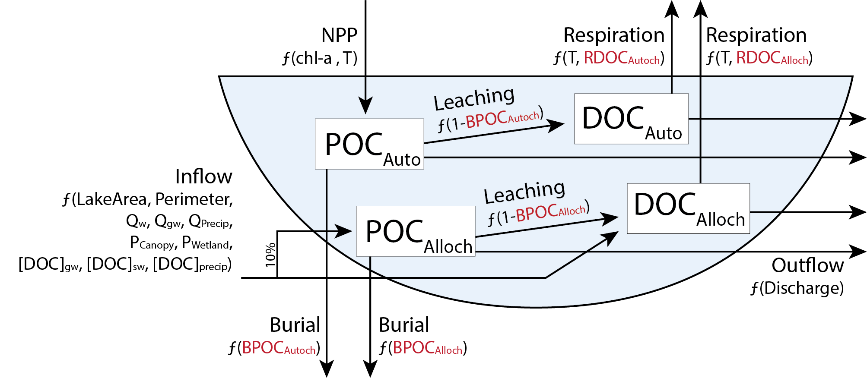

**Figure 1.**

Figure 1. Conceptual diagram of the organic carbon lake model depicting fluxes based on allocthonous (alloch; externally derived) and autochthonous (autoch; internally derived; NPP) inputs of organic carbon, long-term burial, leaching of particulate organic carbon (POC) to dissolved organic carbon (DOC), respiration of DOC to CO2, and export via outflow. Four parameters (RDOCAlloch, RDOCAlloch, BPOCAutoch, and BPOCAlloch) are calibrated for each individual lake. Parameters and equations are defined in Tables 2 and 3.

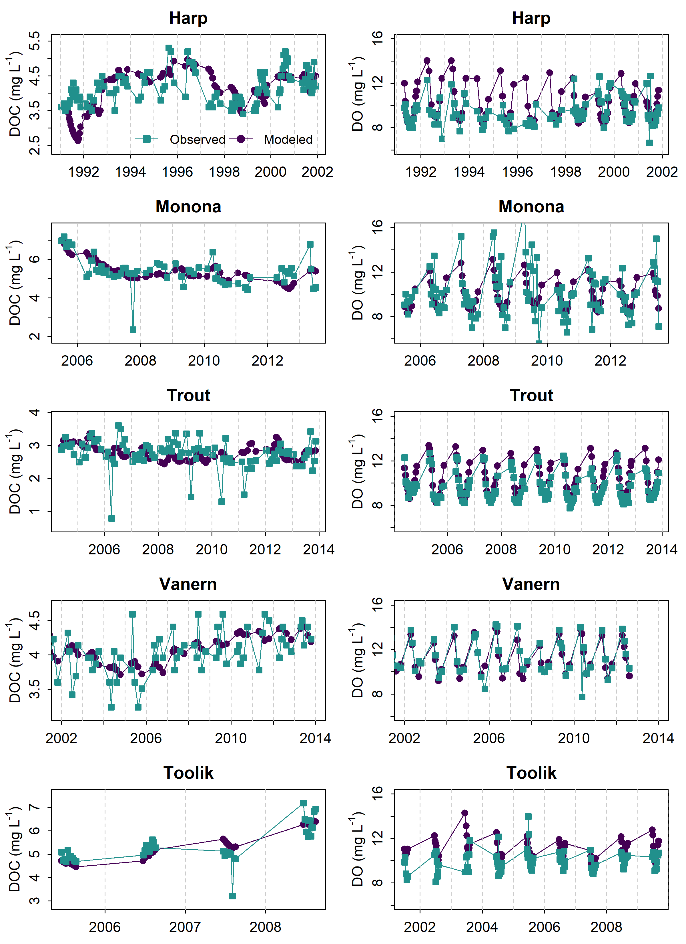

**Figure 2.**

Figure 2. Observed dissolved organic carbon (DOC) and dissolved oxygen (DO) concentrations in each lake (blue circles) compared to modeled concentrations (red squares) for the same date. For some lakes, years differed between DOC and DO based on availability of observed data (AppendixS1). Toolik data are temporally clustered due to short ice-free season.

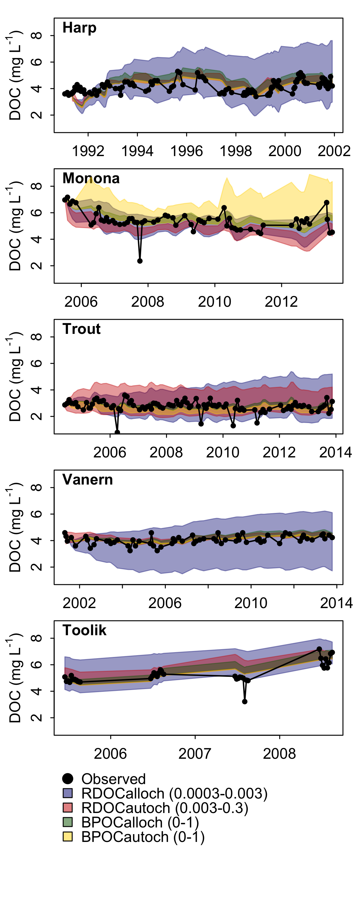

**Figure 3.**

Figure 3. Sensitivity of DOC predictions to free parameters in the model. Each parameter (d-1) was varied across a given range (RDOCAlloch 0.0003-0.003, RDOCAutoch 0.003-0.3, BPOCAlloch, 0-1, BPOCAutoch, 0-1) while the other three parameters remained fixed at their calibrated values. Shaded areas represent the range of modeled dissolved organic carbon (DOC) concentrations as each parameter is varied. Black circles represent observed in-lake DOC concentrations.

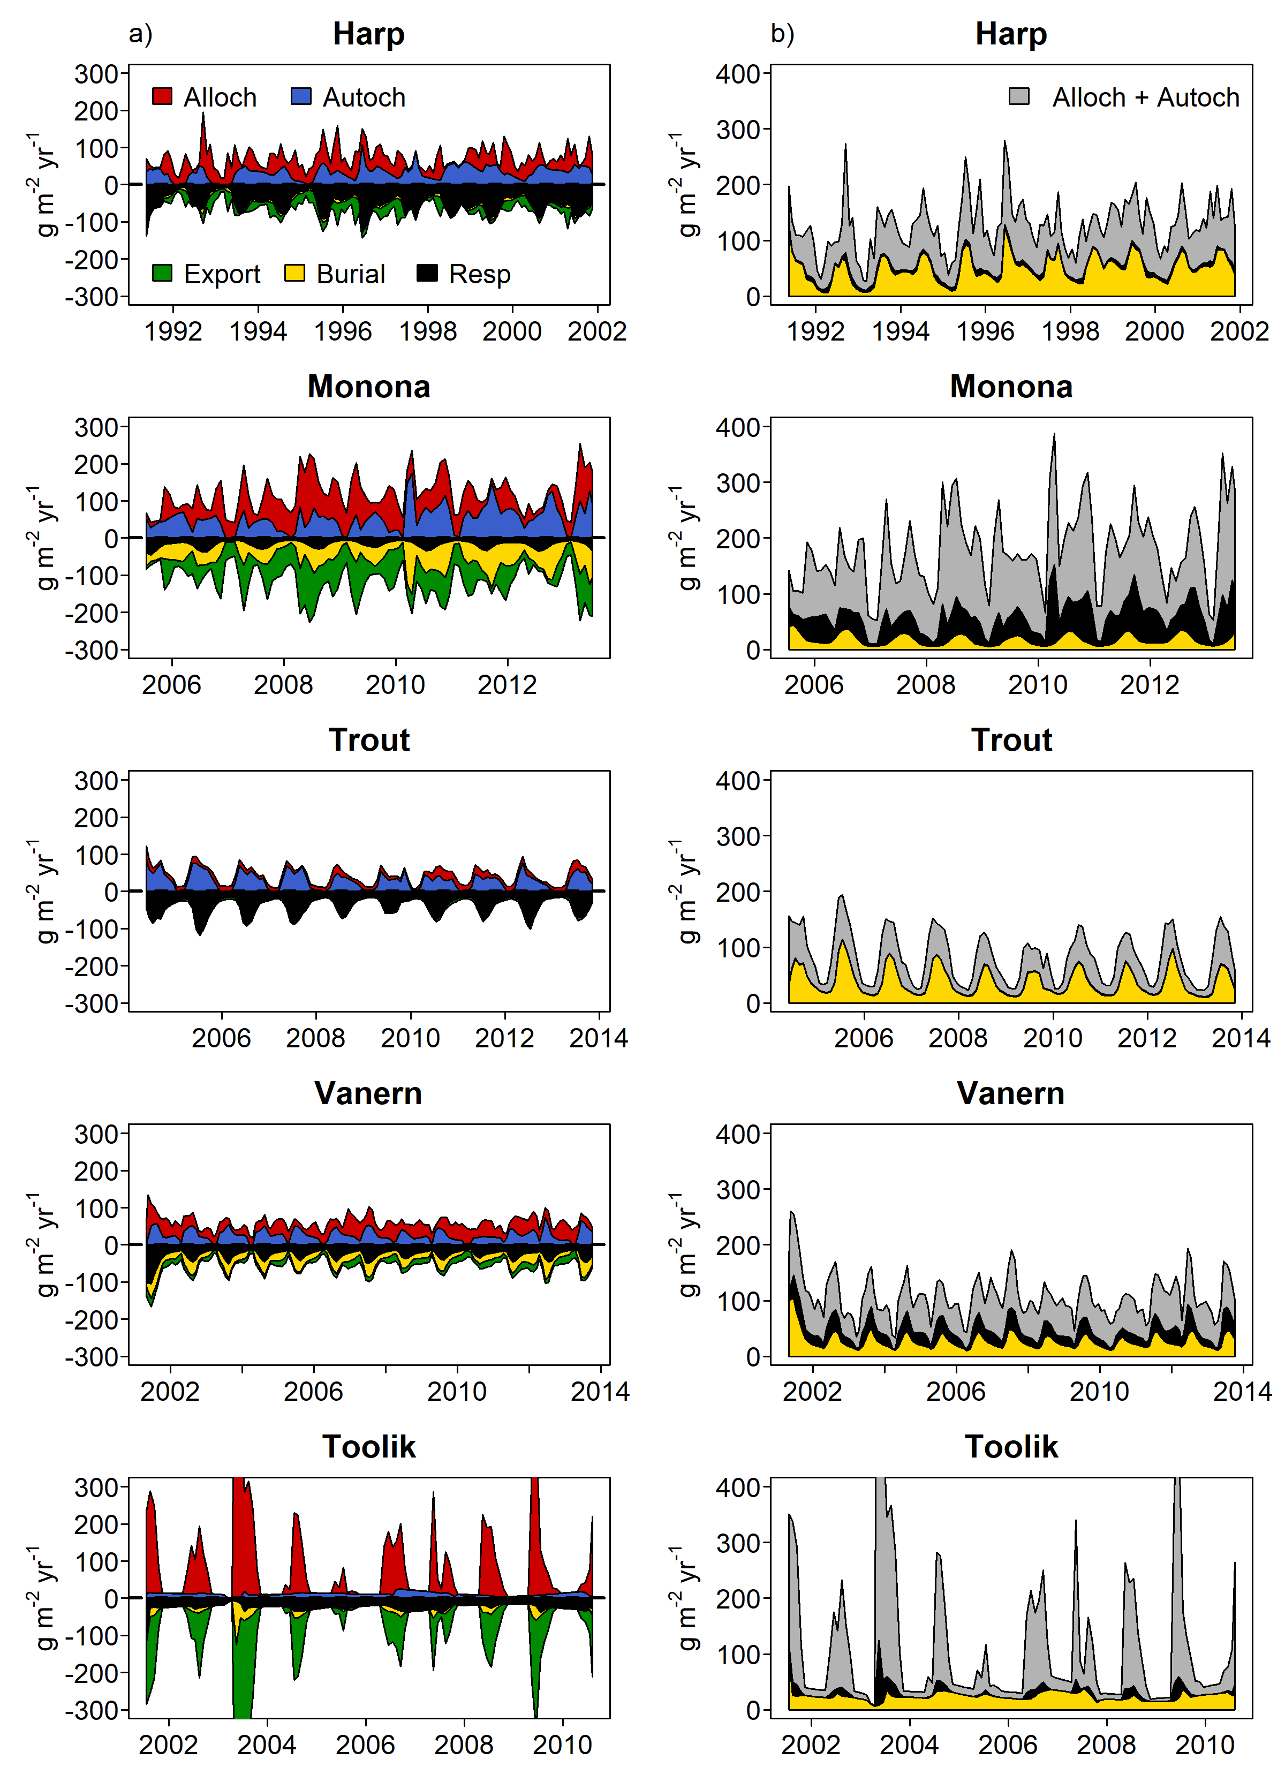

**Figure 4.**

Figure 4. Time series of organic carbon fluxes and fates. a) Colored areas represent relative magnitudes of input (allochthonous and autochthonous) and output fluxes (export, burial, and respiration). All lines are stacked to show cumulative magnitudes. b) Absolute values of burial, respiration, and input fluxes. Vertical axes for Toolik Lake plots were truncated to enable visualization of relatively lower fluxes. Maximum autochthony and export for Toolik Lake were 1369 and -848 g m-2 y-1, respectively (May 2003).

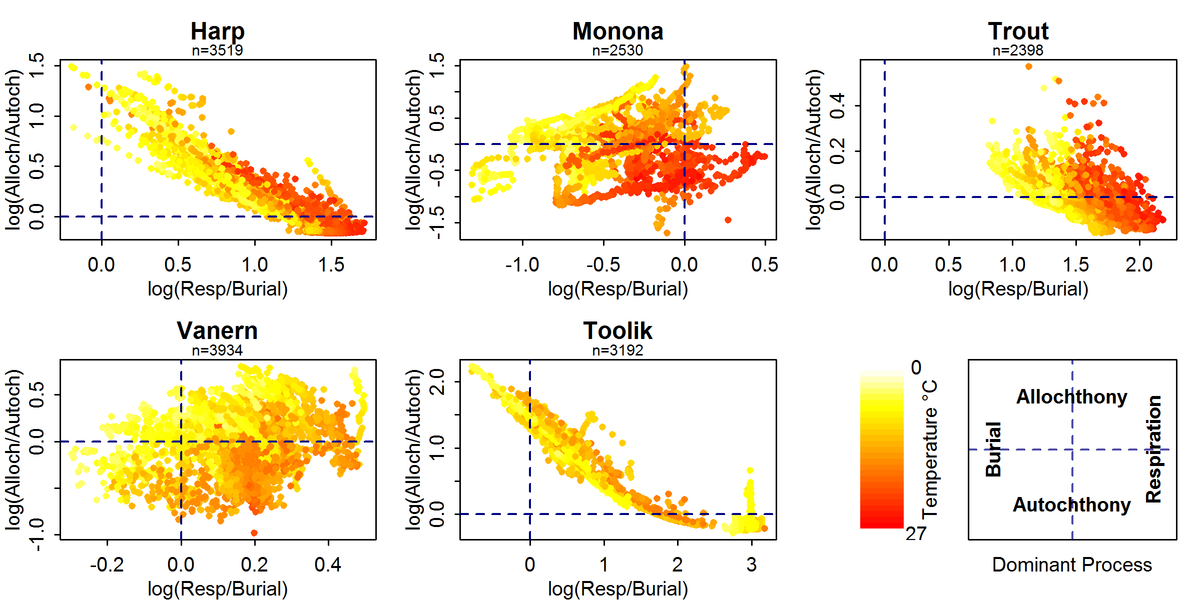

**Figure 5.**

Figure 5. Relationship between log10-transformed allochthony/autochthony and respiration/burial (g m-2 yr-1) of organic carbon, colored by epilimnion water temperature. The four quadrants in each figure represent the dominant processes (either predominantly respiration or burial, and either predominantly allochthonous driven or autochthonous driven) associated with each lake.

1. ^ Current address: Department of Biological Sciences, Virginia Tech, 926 West Campus Drive, Blacksburg, VA, 24061, US.

   ^^ Current address: Rubenstein School of Environment and Natural Resources, University of Vermont, 81 Carrigan Dr., Burlington, VT, 05405, US.