Forest harvesting intensity impacts above and below ground wood decomposition processes in a Northern Ontario Jack Pine Forest.
* Emily Smenderovac (corresponding author), Great Lakes Forestry Centre, Natural Resources Canada, emily.smenderovac@nrcan-rncan.gc.ca
Caroline Emilson, Great Lakes Forestry Centre, Natural Resources Canada, caroline.emilson@nrcan-rncan.gc.ca
Kerrie Wainio-Keizer, Great Lakes Forestry Centre, Natural Resources Canada, kerrie.wainio-keizer@nrcan-rncan.gc.ca
Dave Morris, Centre for Northern Forest Ecosystem Research, Ontario Ministry of Natural Resources and Forestry, Thunder Bay CA P7E 2V6, Dave.M.Morris@ontario.ca
Erik Emilson, Great Lakes Forestry Centre, Natural Resources Canada, erik.emilson@nrcan-rncan.gc.ca
Lisa Venier, Great Lakes Forestry Centre, Natural Resources Canada, lisa.venier@nrcan-rncan.gc.ca
2024-12-09

1 Abstract

2 Introduction
Woody debris are important components of forest ecosystems, providing important habitat and nutrient cycling services. These ecosystem services vary with the decay state of woody debris. Nutrients are known to change as woody debris decay, and the structural integrity of wood changes as well, directly relating to the habitat that it provides. It is known that harvesting activities can impact the amount of woody debris in an ecosystem (Fritts et al., 2014; Pedlar et al., 2002; Wiebe et al., 2014), and as a result, impact long term soil nutrient pools (Menichetti et al., 2021). Modern forestry operations attempt to replicate natural disturbances, but much of this replication seeks to replicate forest canopy structure, and does not replicate the woody debris patterns of natural disturbance (Pedlar et al., 2002). Moreover, current bioenergy incentives are driving interest in moving to higher intensity biomass removals that could introduce further changes. Different harvesting practices such as tree-length removal, full-tree removal, stump removal and forest floor removal are being explored in Canadian contexts to determine the closest analogues to natural disturbances, while balancing economic incentives.
There is little research on how intensified harvesting practices affect wood decay, and the projected stocks of woody debris in regenerating forests. There are many potential harvesting impacts that can affect wood decay processes. Harvesting impacts include changes to soil chemistry (Morris et al., 2019; Thiffault et al., 2011), soil moisture (Thiffault et al., 2011), microbial communities (Smenderovac et al., 2023), insect assemblages (Work et al., 2023) and woody debris contributions (Pedlar et al., 2002; gorgolewlski2020?). All of these variables have the potential to alter the amounts and decay status of woody debris components of the forest. We expect the decay of woody debris can be influenced by nutrients, moisture and temperature (Finér et al., 2016; Smyth et al., 2016; rich2022?), which have been documented to change with harvesting practices. The abundance of wood residues of different decay states contributes to these microclimate responses, as they can provide shade, and wind barriers that decrease soil temperature (Trottier-Picard et al., 2014). Biotic assemblages are also responsive to harvesting practices, and organisms like fungi and insects play large roles in the decomposition of wood(Harmon et al., 2004). The abundance and distribution of biota in wood, and how they interact with woody debris is complex: interactions depend on the scarcity of nutrients, environmental conditions and geographic connectivity. The chemical composition of woody debris changes through the process of decay(Smyth et al., 2016; vanderwal2007?), and so the rates and total pools of woody debris at different states of decay control the overall chemical contributions of the woody debris pool through time. Additionally, any alterations to the progression of decay are happening in the context of soils impacted by other physico-chemical changes that occur in managed forests related to site preparation and harvesting activities (Trottier-Picard et al., 2014). The total pool of nutrients in surrounding soils are available for import in decaying wood, and may be imported during the decay process through biological structures such as tree roots or hyphal networks (Clarholm and Skyllberg, 2013; vanderwal2007?; connoly1997?). These changes in wood chemical pools may explain some of the productivity impacts due to forest harvesting that have been reported in studies of soils, and tree growth [REF].
Similarly, the fungal community in woody debris, widely thought to be responsible for the bulk of wood decay, is not static: the decay of wood has its own successional process (Harmon et al., 2004; Harmon et al., 1986). While fungi are largely recognized as important in nutrient cycles, few studies have investigated the impacts of harvesting on the successional dynamics of wood decay fungi. The decay of wood at different stages is specialized. Early wood decay fungi compete for high-carbon substrates, and often use strategies to achieve early colonization of residues like nectrotrophy or facultative saprotrophy (Harmon et al., 2004; Harmon et al., 1986). While the complex carbon in wood is energy rich, specialized enzymes are required to break down these nutrients. Later stages of decay contain more complex assemblages of microorganisms that can break down the more diverse nutrient pool present after initial breakdown of cellulose and lignin[REF]. Throughout the process of decay, organisms are altering and responding to the changes in nutrients and physical structure of woody residues [REF]. Harvesting has the potential to influence these processes through changing the availability of woody debris and, changing other physical and chemical habitat characteristics (Brischke and Alfredsen, 2020), thereby eliminating habitat for important fungal species. While soil may be a reservoir for some of these species, there are many fungi where the lifecycles are poorly understood. Some organisms may require a persistent amount of woody debris habitats this can even lead to reduced abundance of these species after habitat is restored.
Herein, we investigate the impacts of harvesting biomass removal intensity on physical decomposition processes, nutrient differences and, fungal successional dynamics in woody debris using a wood stake decomposition experiment for above and below-ground decomposition. We also assess the comparability of harvested treatments to old-growth and fire disturbance to evaluate the comparability of these disturbances. We expect several outcomes: harvesting and biomass removal treatments will have different temporal decomposition patterns than unharvested, fire or old growth conditions; increased biomass removal intensity will result in higher decomposition as observed in a similar study(Finér et al., 2016); Higher biomass removals will result in lower nutrient content in woody residues and higher accumulation of metals important for enzymatic function (e.g., Fe); Higher biomass removal will alter fungal community successional dynamics and reduce fungal diversity.

3 Methods

3.1 Site description
This study was conducted at the Island Lake Biomass Trial sites near Chapleau, Ontario, which are previously well described (Kwiaton et al., 2014; Venier et al., 2017). In brief, the study site was established in a 40 year old second growth jack pine stand. Main treatment plots (70 m by 70 m, with a 10 m surrounding buffer to minimize edge effects) were harvested in the winters of 2010/2011 and included four increasing levels of biomass removal 1) stem-only (leaving the live branches and tops of harvested trees at the stump), 2) full-tree (removing the above ground tree biomass, including the removal of poor or undersized trees), 3) full-tree biomass with stump removal and, 4) blading (removal of all biomass including stumps, downed woody debris and forest floor). All treatments had five replicate plots, with a portion of the stand left in-tact, where uncut control plots were established (Fig 3.1 B). All treatment plots (excluding bladed plots) were site prepared using a power disc trencher. The main treatment plots were split and planted with either jack pine or black spruce container stock in May 2012. The main plots were then split again, with one half receiving glycophosate treatment. Only the portion of the plot without herbicide were used in this study.
Additional nearby plots in a recent fire disturbance that occurred in 2012 and an old (~90 year old) Jack Pine plantation were also included.
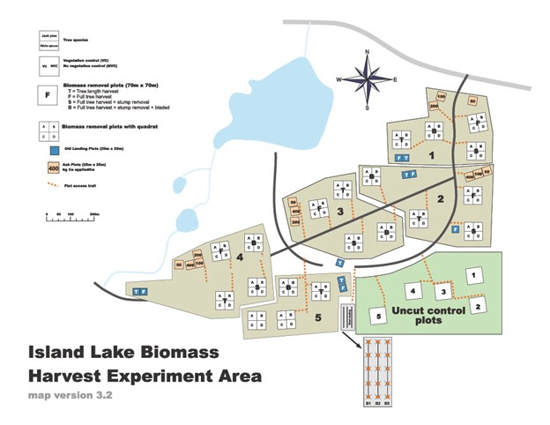
Figure 3.1: Map of the Island Lake Biomass Harvest Research and Demonstration Area, modified from Kwiaton et al, (2014) Figure 2.4. For the biomass removal plots, the numbers indicate the block number and the letters indicate the harvest treatment: T = Stem Only, F = Full-tree, S = Stump removal, B = Bladed, C = Uncut Control. The location of the sites in Ontario is provided in a map in the upper left corner.

3.2 Wood Stakes Incubation and Sample processing
We purchased untreated 1 x 1 inch 30 cm Jack pine stakes from Little John’s Sawmill in Timmins, Ontario in early September of 2016. From each independent stake, two paired 10 cm sections were cut: one stake was dried for a minimum of 48h and weighed, the other ‘sister stake’ was retained for density measurements. Fifty stakes were installed in the Jack pine planted, non-herbicide quadrant of each treatment. Twenty-five of the stakes were installed horizontally on the surface of the visible litter or moss layer of each treatment using a wire clip to hold them in place. The other twenty-five stakes were installed vertically, below-ground by creating a 1 by 1 inch hole before inserting the stake into the hole until the top of each stake was level with the forest floor surface. Ten stakes, 5 above-ground, and 5 below-ground were removed each year for a total of five years from each treatment plot, in late fall or early spring. Collection of stakes was performed using clean nitrile gloves, and clean plastic bags. For each stake, soil residues were gently removed before samples were placed in sample bags. Samples were stored in coolers at ~4˚C for up to 24h before freezing at -20˚C.
After retrieval, stakes were weighed in the lab prior to subsampling for DNA and chemistry analyses. Subsamples were collected using sterilized equipment: for less-decayed samples, a sterilized drill bit was used to remove a small amount of wood shavings; for samples where there was loss of structural integrity due to decay, the sample was collected using sterile tweezers. The remaining stake residues were used for density and wood chemistry analyses.

3.3 Wood Density and Mass loss measurements
Stake residues that reamined after subsampling were weighed and then immersed in a container filled with water, for a minimum of 48 h to achieve full saturation for volume measurements. To determine the volume of the remaining stake material, the saturated residues were then submerged into a known weight of water in a full beaker and the weight of the displaced water was recorded. After volume measurements the stakes were dried in a drying oven at 70˚C for a minimum of 48h and reweighed. These calculations were also performed for sister-stakes. Wood mass loss was calculated as in Equation (3.1). Density was calculated as (3.2). Density measurements were highly comparable to mass loss (), and so mass loss measurements were used to represent both parameters in subsequent analyses.
$$ML=1-\left(M_{t}/M_{0}\right) \left(3.1\right)$$
where ML is the proportion of mass lost from the stake, M_{t} is the dry weight after incubation in g and M₀ is the dry weight before incubation, in grams.
$$Density=D/W \left(3.2\right)$$
where Density is the density of wood stakes in g/m³, D is the dry weight after subsampling and volume measurement in g and M is volume of water displaced in mL.

3.4 DNA Extraction and Sequencing
DNA subsamples from each stake collected in years three through five were extracted in duplicate using the Qiagen QiaCube PowerPlant Pro Kit (prod #) on a Qiagen Qiacube (Ref#) with an elution volume of 100 uL, and pooled.

3.5 Bioinformatics
Extracted DNA was amplified using primers targeted to Fungi ITS2 (ITS9F = GAACGCAGCRAAIIGYGA, ITS4R= TCCTCCGCTTATTGATATGC) (Menkis et al., 2012; White et al., 1990; parada2015?). Paired-end sequencing were performed on the Illumina MiSeq platform at GenomeQuebec. A total of ~## million paired-end reads were generated (Supplemental Materials, Table S##). Data was processed into ESVs (Exact Sequence Variants) using the MetaWorks pipeline v1.11.3 (Porter and Hajibabaei, 2020). Sequence retention details are provided in Tables S## and S## of the Supplemental Materials. Samples with less than 1000 reads were removed. Taxonomic assignments with at least 80% accuracy were retained using the bootstrap cutoff values for the ITS classifier genus level for 200 bp reads. ITS sequences were classified with the UNITE v8.2 ITS reference set database(Kõljalg et al., 2019; Porter, 2020). Functional guilds were assigned through FUNGuild (Nguyen et al., 2016). A summary of the percent of ESVs identified to Genus using the appropriate cut-off values are provided in Table S## of the Supplemental Materials.

3.6 Wood Chemistry
Wood chemistry analyses were performed at the Pacific Forestry Centre Analytical Lab. A portion of each stake were ground to a particle size of 2 mm before extraction and analysis. Extractable elements (C, N, Phosphorus) extracts were prepared using the Mechlich 3 extractable elements method(zaidi2008?). Total cation digestions were performed using a 100% cHNO3 digest on an Anton Paar Multiwave 7000 Microwave Digestion system. Extractable element extracts and total cation extracts were analyzed on an Agilent 7900 ICP-MS using Masshunter Software. Total Carbon and Nitrogen were analyzed on an Elementar Vario Max Cube combustion elemental analyzer per manufacturers reccommended operating instructions. We analyzed chemistry on a subset of 461 3 year incubated stakes, 473 5 year incubated stakes, and a subset of 45 unincubated stakes to serve as a time-zero comparison for later modelling.
Chemical parameters were presented as amount of chemical remaining from the original chemical pool in the wood stake to control for changes in material volume over time. These were calculated as in Equation (3.3).
$$C_{remaining}=C_{t}M_{t}/C_{0}M_{0} \left(3.3\right)$$
where C_{t} is the concentration of the parameter after incubation, M_{t} is the dry weight after incubation in grams, C₀ was the highest measured concentration from unincubated stakes and, M₀ is the dry weight before incubation, in grams.

3.7 Statistical analyses
We created orthogonal contrasts to test specific harvesting effects from our treatments, these are outlined in table 3.1.
Table 3.1: Orthogonal contrasts used to test effects of harvesting and biomass removal intensity on decay dynamics.
Code | Contrast | Tests
TR | Uncut control vs Stem-Only, Full tree and Stumped | Effect of tree harvesting
FWD | Stem-Only vs Full tree | Effect of fine and coarse woody debris removal vs only coarse wood
BGBR | Stem-Only and Full tree vs Stumped | Effect of below-ground woody biomass removal
FFR | Stem-Only, Full tree and Stumped vs Bladed | Effect of forest floor removal
HH | Old Growth vs Control | Comparison of regenerated harvested sites to old growth
HF | Fire vs Stem-Only, Full tree and Stumped | Comparison of Harvested sites to fire disturbance
We used the established orthogonal contrasts to test ….

4 Results/Discussion

4.1 Biomass harvesting intensity impacts the progression of woody decay

4.1.1 Density

4.1.2 Mass loss
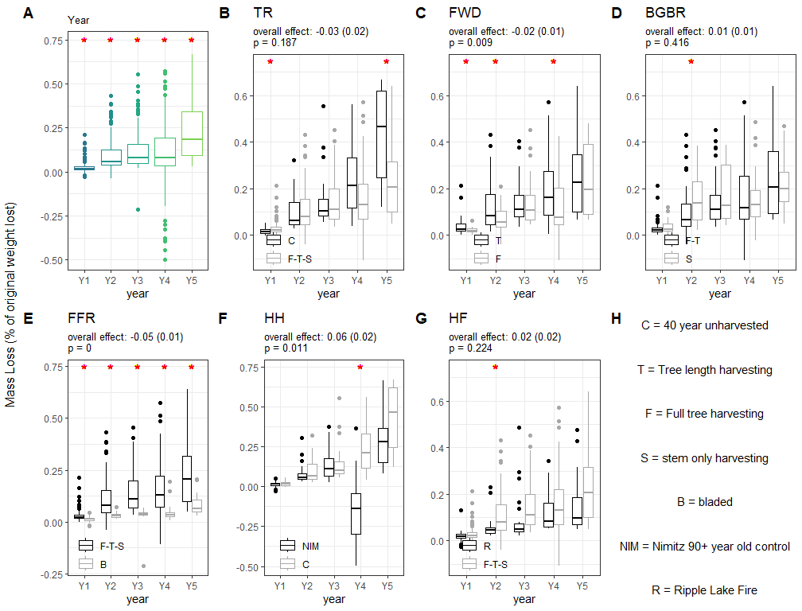
Figure 4.1: Patterns of above-ground woodstake mass loss over time. Results from a mixed model are reported in panels A-G. The significance (p < 0.05) of overall year effects are signified with red * asterix in panel A, and in text at the top of panels B-G. Significant (p < 0.05) Year-based effects of each contrast, created using orthogonal contrasts applied to each year independently, are indicated with red * asterix in panels B-G. Boxplots represent the different levels of each contrast using colour (black and grey) and boxplots show the median mass loss as a central line, two hinges at the 25th and 75th percentiles and, whiskers representing 1.5*IQR. Panel H describes the treatments used in the contrasts.
We found that the decay of woody debris was impacted by biomass harvesting intensity, demonstrating more complex interactions with treatments. Our results suggest that the type of biomass removal (i.e., fine vs coarse or, above-ground vs. below-ground biomass removal) is an important control on wood decomposition, rather than total biomass removal rates. While we expected degree of intensification to, generally, increase decomposition rates, we found that the response to intensification varied in how it impacted the temporal progression of decomposition and effects were not always additive. Generally, the processes controlling decomposition were observed to be complex, with differences dependent on the intensity of biomass harvesting, location in the soil column and time. Notably, we observed that the progression of decomposition was impacted by the intensity of biomass removals (Fig Fig 4.1-B-E, 4.2-B-E), an observation that we have not observed in the literature (Smyth et al., 2016; Tarvainen et al., 2020). Furthermore, we found that harvested sites had similar decay progression to a nearby fire disturbance, indicating that harvesting practices are resulting in similar decomposition processes for fresh wood residues.
In this study, we observed that clearcut harvesting alters decomposition processes in different ways depending on the niche in the ecosystem. All treatments and controls had increased decomposition over time, as demonstrated by the increased mass loss observed as years progressed, for all treatments (Fig 4.1-A, 4.2-A). However, the rate at which the decomposition progressed was impacted by harvesting for both above-ground and belowground decomposition (Fig 4.1-B, 4.2-B). We observed that harvesting increased below-ground decomposition (Fig 4.2-B), but no significant change to above-ground decomposition (Fig 4.1-B), even though there was slightly higher decomposition in year one and lower decomposition in year 5. These results are corroborated by findings in other studies: Finer et al (2016) observed increased below-ground mass loss in clearcuts after five years of incubation and, Tarvainen et al (2020) observed no change to above-ground wood decomposition in harvested sites. The harvesting practices employed in this study consist of many compounded disturbances: lower amounts of woody biomass, soil upheaval and mixing during site preparation; soil compaction; increased light; increased wind. All of these disturbances can contribute to lower decomposition rates by impacting temperature, oxygen, pH and moisture[REFs]. Clearcut harvesting has been reported to increase below-ground soil moisture in the short-term on the sites in this study (Webster et al., 2016) and others (whitson2005?; hynes2013?; sewell2020?), though this relationship could change in the future as the forest cover begins to mature and evapotranspiration increases.
Several studies attribute at least some of the observed in decay rates in different conditions to moisture and temperature (Finér et al., 2016; Risch et al., 2022), there is a lot of intricacy related to moisture controls on decomposition (Brischke and Alfredsen, 2020). Finer et al (2016) also found that below-ground decomposition was less influenced by moisture differences, but a strong influence on above-ground decomposition. The lack of differences in above-ground decomposition response to harvesting, and the stronger influence on below-ground decomposition could also be influenced by resource quality and availability: Woody debris may be a poorer substrate for decomposition than more easily decomposed components in the surface litter such as leaves and needles; also, a deficit of woody debris as a resource in the mineral soils that we assessed could make it a preferred resource in that niche of the soil environment. Analogues to this exist in other ecosystems, the refugia of organisms in the soil adapted to capitalize on the rare opportunity provided by a buried woodstake, similar to how whalefalls in the depths of the ocean are quickly colonized by a variety of hungry crustaceans. The lack of living trees in the site may have also influenced the decrease in decay. Ectomycorrhizae colonizing trees are recognized to have a role in decomposition of organic matter: a review by Lindahl and Tunlid (lindahl2015?) discusses the decomposition potential of ectomycorrhizal fungal associations. It is likely that a combination of different drivers are controlling the responses in the above-ground and below-ground decomposition.
Additional biomass removal stresses were likely exacerbating harvesting stresses, but on different timelines and likely, through different mechanisms. The above-ground responses to fine woody debris removal and forest floor removal resulted in significantly decreased above-ground decomposition. The likely explanation for these responses are that these treatments are somehow influencing the microenvironment of our stake installations. The patterns of decomposition we observed were the same as those of soil respiration results observed by Webster et al (webster2021c?) at the same sites. They observed increased soil respiration with higher rates of biomass retention which they attributed to lower soil temperatures at the higher biomass treatments. In the case of the forest floor removal, the above-ground stakes were desiccated and discoloured, but had little evidence of decay (Figure 4.1-E), the removal of the forest floor had resulted in exposed mineral soil lacking organic or vegetation cover, and the poor moisture retention of the upper layers of soil did not allow the wood to retain the minimum amount of moisture required for decay. It was clear that these microclimate effects extended into the soil, as below-ground decomposition was also impacted by forest floor removal. The decreased above-ground decomposition due to fine-woody debris removal and the increased above-ground decomposition due to below-ground biomass removal both dissipated by year five (Figure 4.1-C,D). Below-ground biomass removal also resulted in a temporary decrease in decomposition from years 1-3 (4.2-D). These early responses were likely due to decreased temperatures from increased biomass retention: fine woody debris can act as a physical wind and sun barrier, decreasing surface temperatures and increasing soil moisture directly, or allowing some protections and enhancement of understory regeneration[REF]. It was also possible that moisture limitations in years 1-3 were later alleviated by biological activities such as fungal water translocation, allowing decomposition after these treatments to recover [REF].
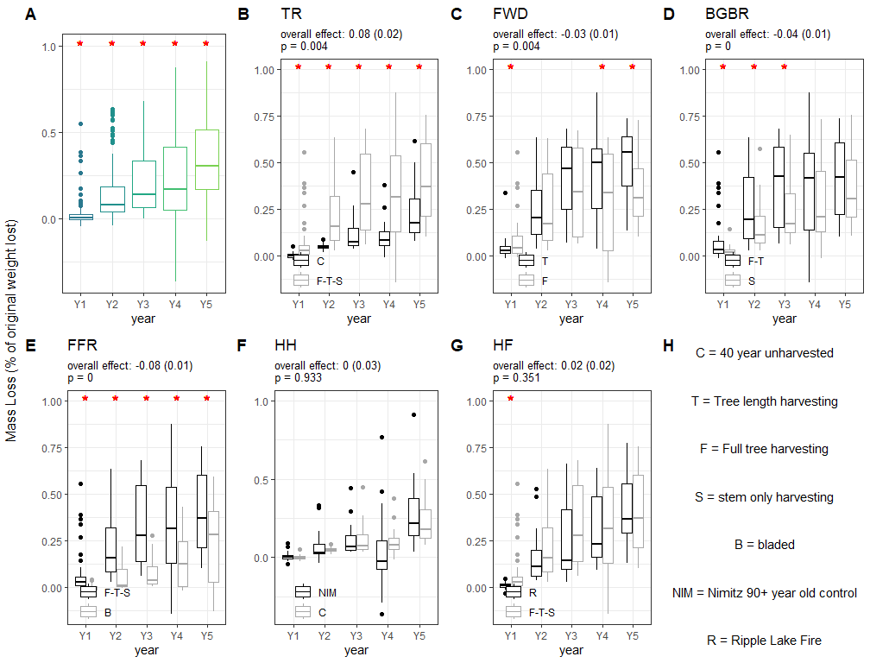
Figure 4.2: Patterns of below-ground woodstake mass loss over time. Results from a mixed model are reported in panels A-G. The significance (p < 0.05) of overall year effects are signified with red * asterix in panel A, and in text at the top of panels B-G. Significant (p < 0.05) Year-based effects of each contrast, created using orthogonal contrasts applied to each year independently, are indicated with red * asterix in panels B-G. Boxplots represent the different levels of each contrast using colour (black and grey) and boxplots show the median mass loss as a central line, two hinges at the 25th and 75th percentiles and, whiskers representing 1.5*IQR. Panel H describes the treatments used in the contrasts.

4.1.3 Chemistry
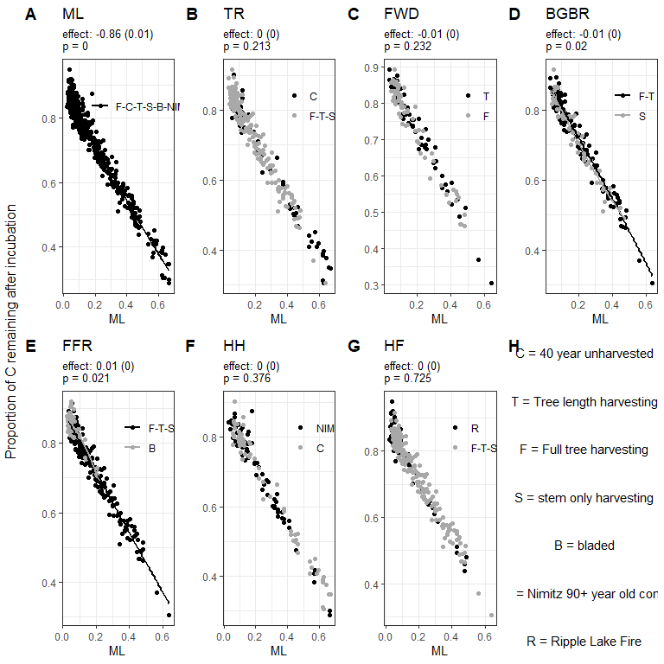
Figure 4.3: Patterns of above-ground woodstake carbon proportion over time. Results from a mixed model are reported in panels A-G. The significance (p < 0.05) of orthoganal contrasts are reported in text at the top of each panel. Points representing individual woodstakes and the linear relationship to mass loss for the levels of each contrast are displayed using colour (black and grey). linear relationships are only displayed where there was a significant (p < 0.05) difference between contrast levels. Panel H describes the treatments used in the contrasts.
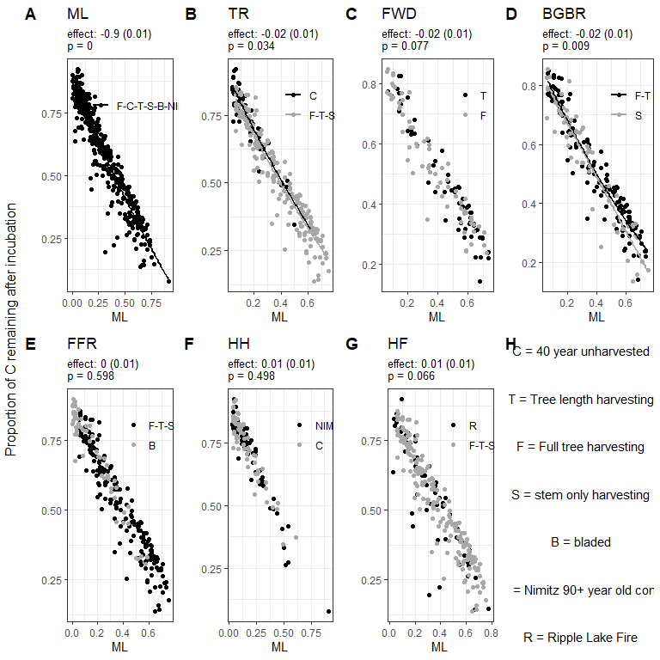
Figure 4.4: Patterns of below-ground woodstake carbon proportion over time. Results from a mixed model are reported in panels A-G. The significance (p < 0.05) of orthoganal contrasts are reported in text at the top of each panel. Points representing individual woodstakes and the linear relationship to mass loss for the levels of each contrast are displayed using colour (black and grey). linear relationships are only displayed where there was a significant (p < 0.05) difference between contrast levels. Panel H describes the treatments used in the contrasts.
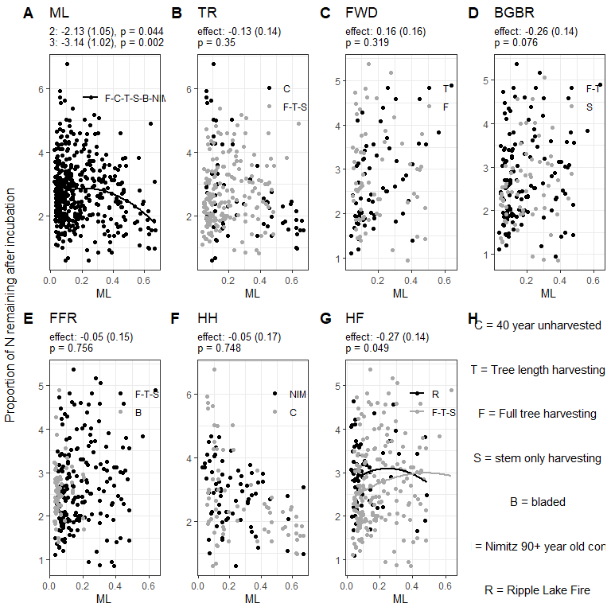
Figure 4.5: Patterns of above-ground woodstake nitrogen proportion over time. Results from a mixed model are reported in panels A-G. The significance (p < 0.05) of orthoganal contrasts are reported in text at the top of each panel. Points representing individual woodstakes and the linear relationship to mass loss for the levels of each contrast are displayed using colour (black and grey). linear relationships are only displayed where there was a significant (p < 0.05) difference between contrast levels. Panel H describes the treatments used in the contrasts.
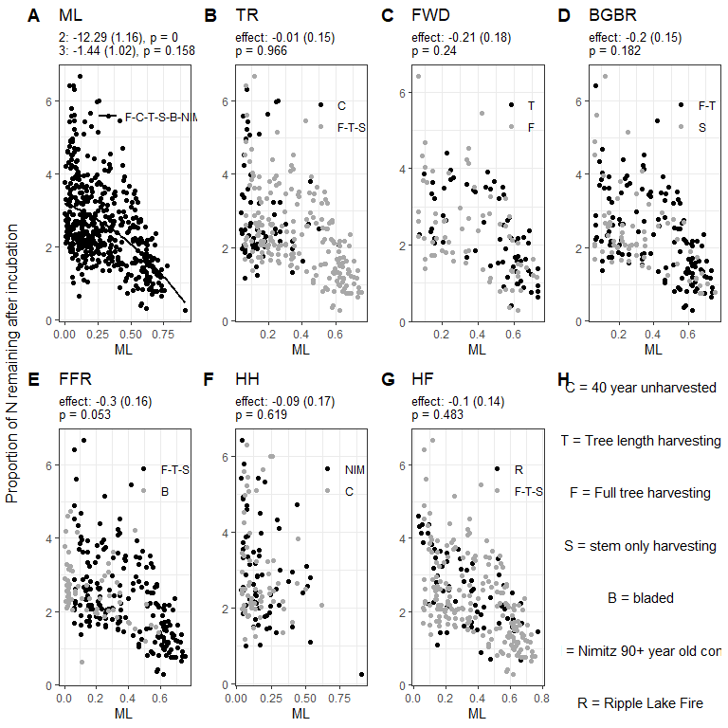
Figure 4.6: Patterns of below-ground woodstake nitrogen proportion over time. Results from a mixed model are reported in panels A-G. The significance (p < 0.05) of orthoganal contrasts are reported in text at the top of each panel. Points representing individual woodstakes and the linear relationship to mass loss for the levels of each contrast are displayed using colour (black and grey). linear relationships are only displayed where there was a significant (p < 0.05) difference between contrast levels. Panel H describes the treatments used in the contrasts.
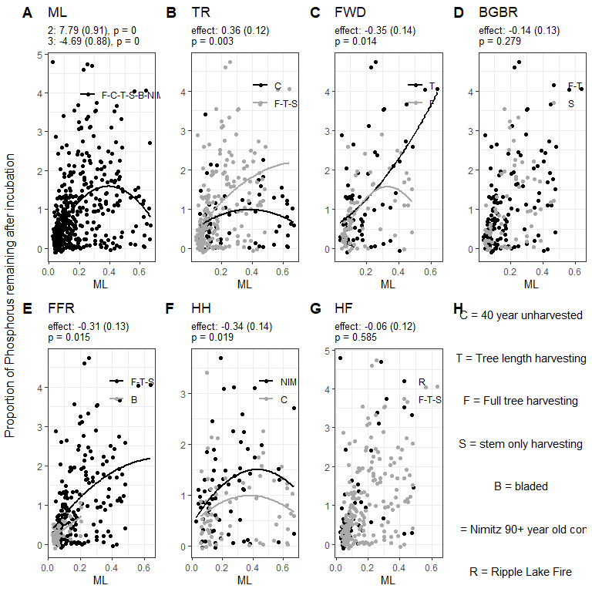
Figure 4.7: Patterns of above-ground woodstake phosphorus proportion over time. Results from a mixed model are reported in panels A-G. The significance (p < 0.05) of orthoganal contrasts are reported in text at the top of each panel. Points representing individual woodstakes and the linear relationship to mass loss for the levels of each contrast are displayed using colour (black and grey). linear relationships are only displayed where there was a significant (p < 0.05) difference between contrast levels. Panel H describes the treatments used in the contrasts.
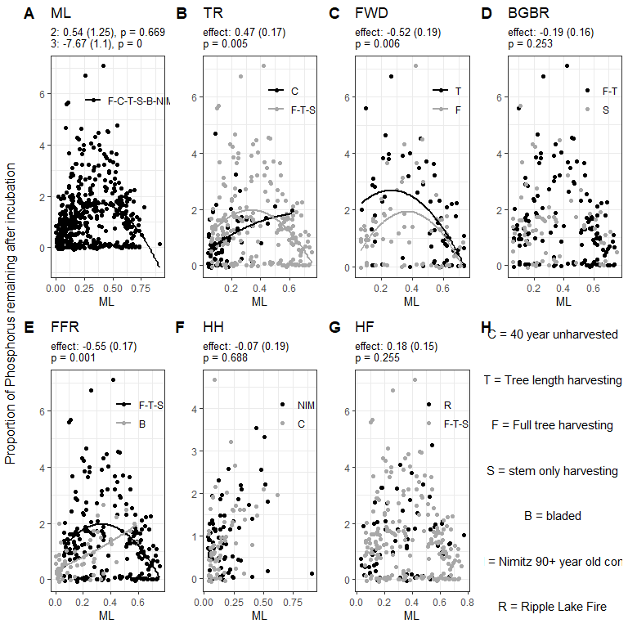
Figure 4.8: Patterns of below-ground woodstake phosphorus proportion over time. Results from a mixed model are reported in panels A-G. The significance (p < 0.05) of orthoganal contrasts are reported in text at the top of each panel. Points representing individual woodstakes and the linear relationship to mass loss for the levels of each contrast are displayed using colour (black and grey). linear relationships are only displayed where there was a significant (p < 0.05) difference between contrast levels. Panel H describes the treatments used in the contrasts.
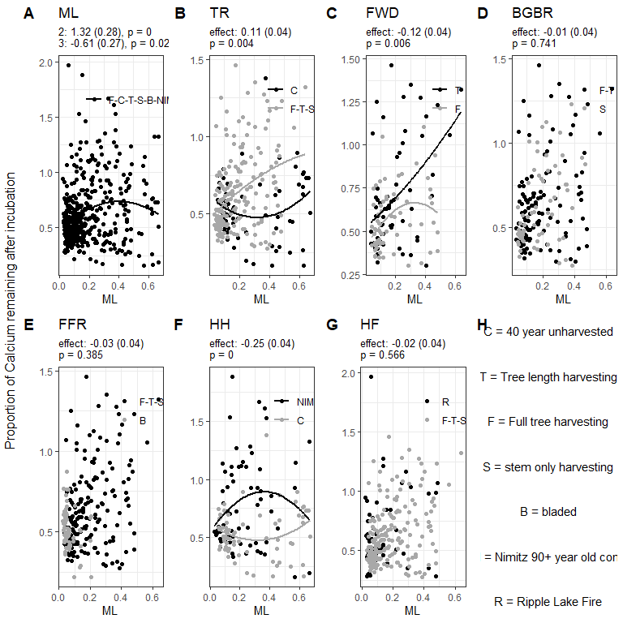
Figure 4.9: Patterns of above-ground woodstake calcium proportion over time. Results from a mixed model are reported in panels A-G. The significance (p < 0.05) of orthoganal contrasts are reported in text at the top of each panel. Points representing individual woodstakes and the linear relationship to mass loss for the levels of each contrast are displayed using colour (black and grey). linear relationships are only displayed where there was a significant (p < 0.05) difference between contrast levels. Panel H describes the treatments used in the contrasts.
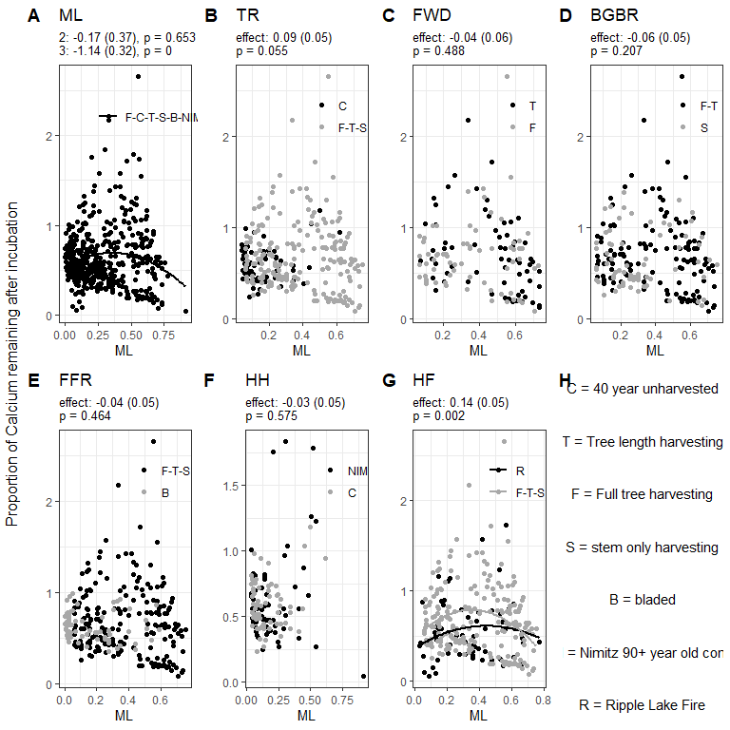
Figure 4.10: Patterns of below-ground woodstake calcium proportion over time. Results from a mixed model are reported in panels A-G. The significance (p < 0.05) of orthoganal contrasts are reported in text at the top of each panel. Points representing individual woodstakes and the linear relationship to mass loss for the levels of each contrast are displayed using colour (black and grey). linear relationships are only displayed where there was a significant (p < 0.05) difference between contrast levels. Panel H describes the treatments used in the contrasts.
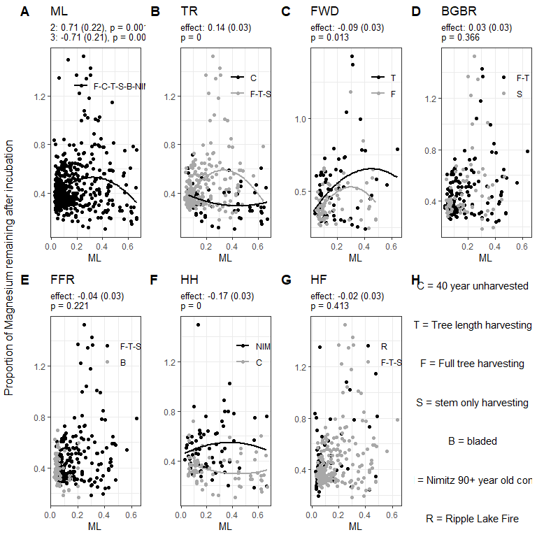
Figure 4.11: Patterns of above-ground woodstake magnesium proportion over time. Results from a mixed model are reported in panels A-G. The significance (p < 0.05) of orthoganal contrasts are reported in text at the top of each panel. Points representing individual woodstakes and the linear relationship to mass loss for the levels of each contrast are displayed using colour (black and grey). linear relationships are only displayed where there was a significant (p < 0.05) difference between contrast levels. Panel H describes the treatments used in the contrasts.
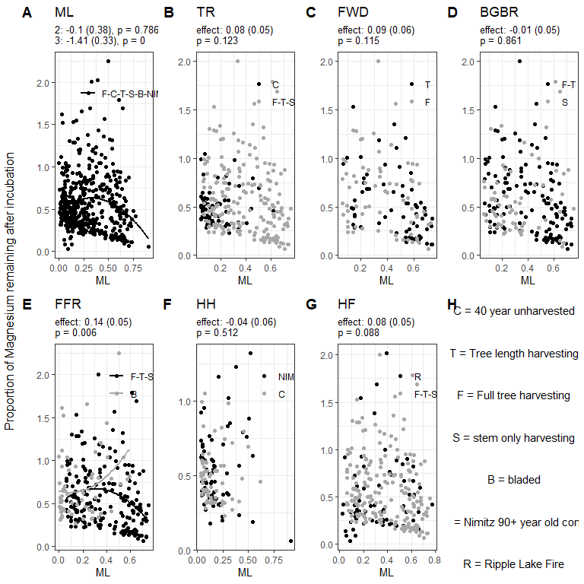
Figure 4.12: Patterns of below-ground woodstake magnesium proportion over time. Results from a mixed model are reported in panels A-G. The significance (p < 0.05) of orthoganal contrasts are reported in text at the top of each panel. Points representing individual woodstakes and the linear relationship to mass loss for the levels of each contrast are displayed using colour (black and grey). linear relationships are only displayed where there was a significant (p < 0.05) difference between contrast levels. Panel H describes the treatments used in the contrasts.
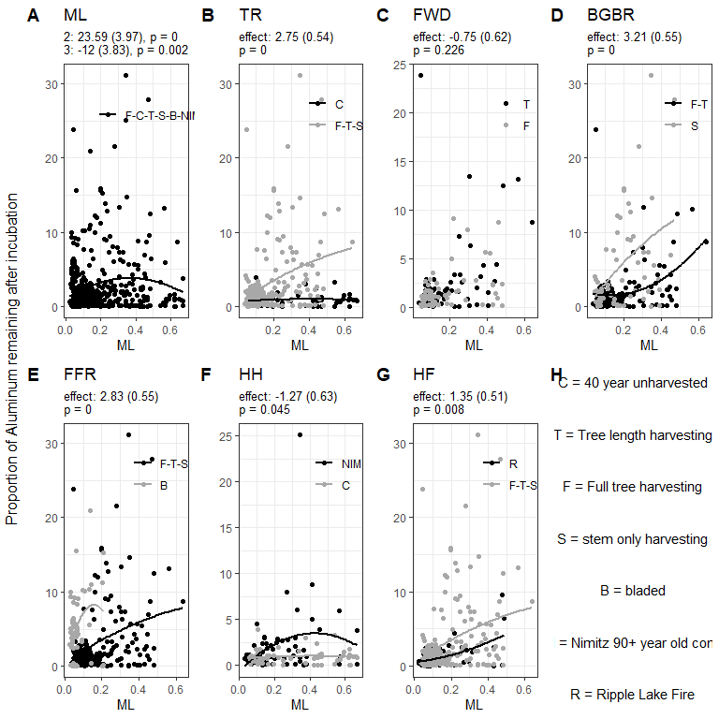
Figure 4.13: Patterns of above-ground woodstake aluminum proportion over time. Results from a mixed model are reported in panels A-G. The significance (p < 0.05) of orthoganal contrasts are reported in text at the top of each panel. Points representing individual woodstakes and the linear relationship to mass loss for the levels of each contrast are displayed using colour (black and grey). linear relationships are only displayed where there was a significant (p < 0.05) difference between contrast levels. Panel H describes the treatments used in the contrasts.
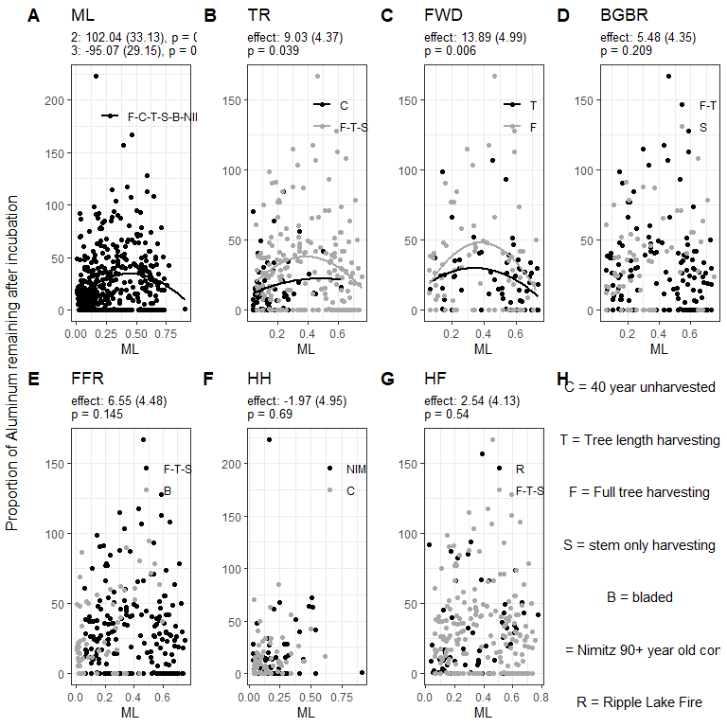
Figure 4.14: Patterns of below-ground woodstake aluminum proportion over time. Results from a mixed model are reported in panels A-G. The significance (p < 0.05) of orthoganal contrasts are reported in text at the top of each panel. Points representing individual woodstakes and the linear relationship to mass loss for the levels of each contrast are displayed using colour (black and grey). linear relationships are only displayed where there was a significant (p < 0.05) difference between contrast levels. Panel H describes the treatments used in the contrasts.
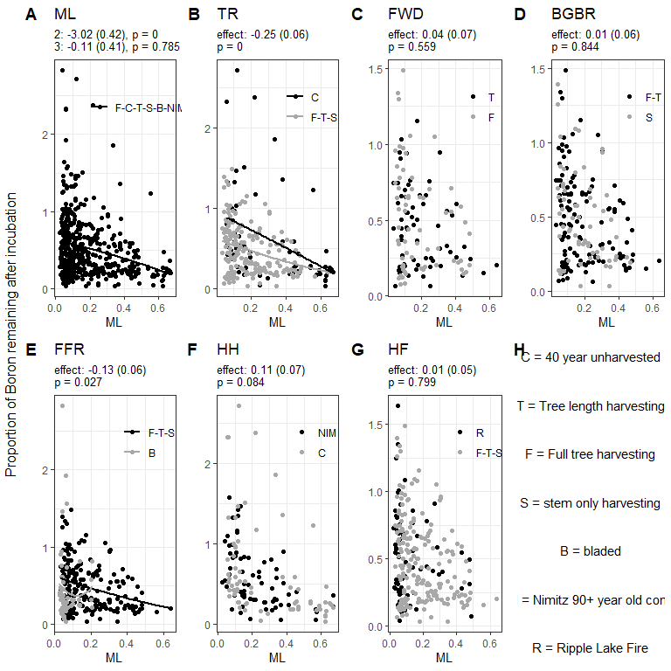
Figure 4.15: Patterns of above-ground woodstake boron proportion over time. Results from a mixed model are reported in panels A-G. The significance (p < 0.05) of orthoganal contrasts are reported in text at the top of each panel. Points representing individual woodstakes and the linear relationship to mass loss for the levels of each contrast are displayed using colour (black and grey). linear relationships are only displayed where there was a significant (p < 0.05) difference between contrast levels. Panel H describes the treatments used in the contrasts.
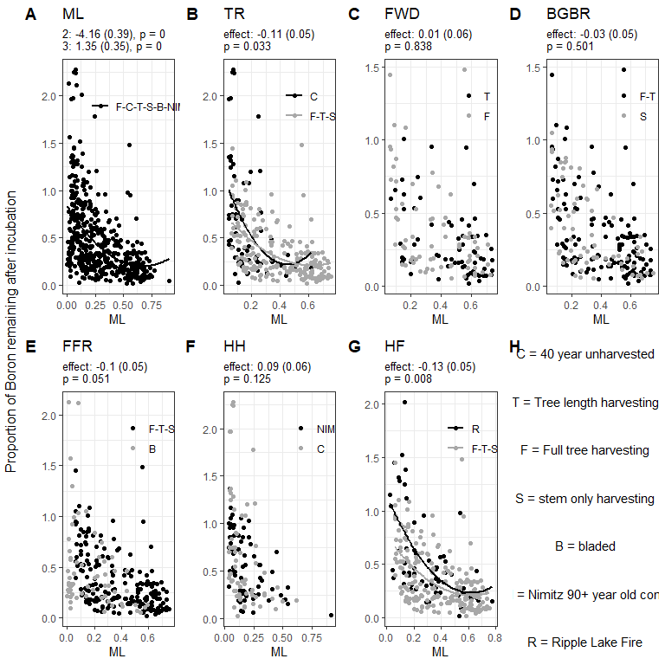
Figure 4.16: Patterns of below-ground woodstake boron proportion over time. Results from a mixed model are reported in panels A-G. The significance (p < 0.05) of orthoganal contrasts are reported in text at the top of each panel. Points representing individual woodstakes and the linear relationship to mass loss for the levels of each contrast are displayed using colour (black and grey). linear relationships are only displayed where there was a significant (p < 0.05) difference between contrast levels. Panel H describes the treatments used in the contrasts.
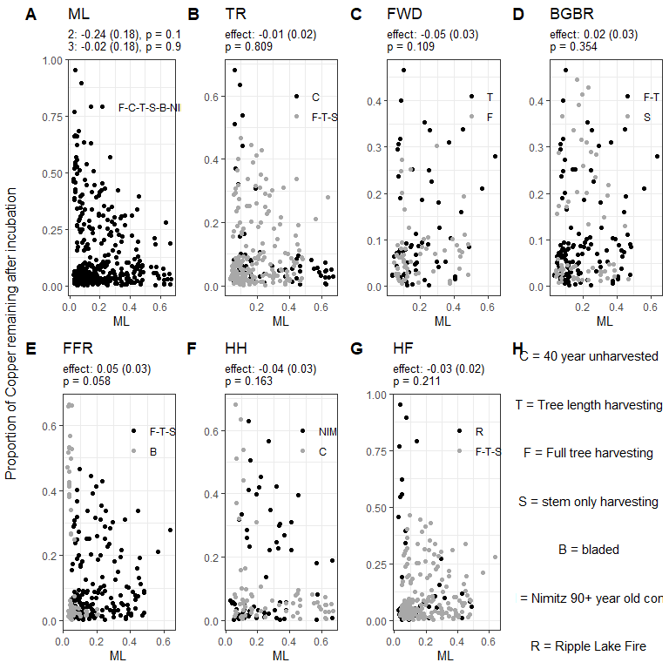
Figure 4.17: Patterns of above-ground woodstake copper proportion over time. Results from a mixed model are reported in panels A-G. The significance (p < 0.05) of orthoganal contrasts are reported in text at the top of each panel. Points representing individual woodstakes and the linear relationship to mass loss for the levels of each contrast are displayed using colour (black and grey). linear relationships are only displayed where there was a significant (p < 0.05) difference between contrast levels. Panel H describes the treatments used in the contrasts.
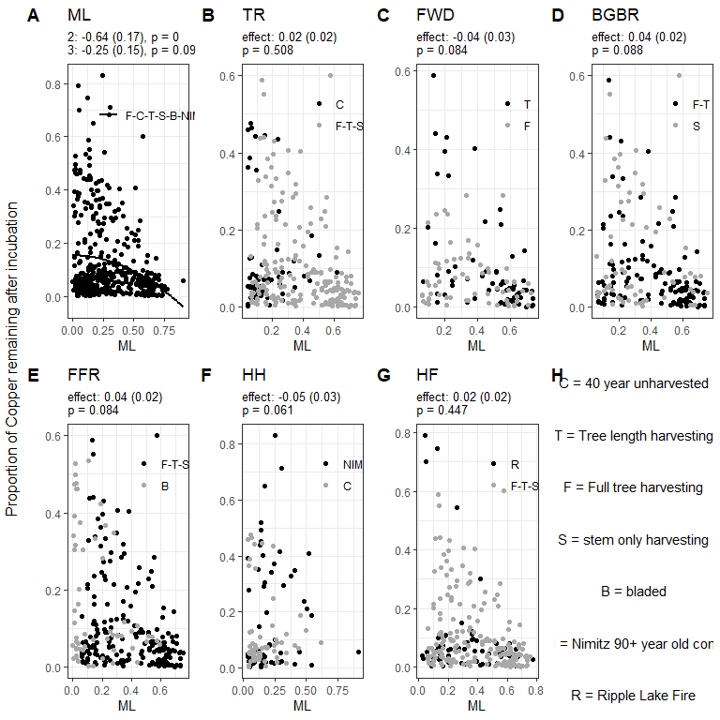
Figure 4.18: Patterns of below-ground woodstake copper proportion over time. Results from a mixed model are reported in panels A-G. The significance (p < 0.05) of orthoganal contrasts are reported in text at the top of each panel. Points representing individual woodstakes and the linear relationship to mass loss for the levels of each contrast are displayed using colour (black and grey). linear relationships are only displayed where there was a significant (p < 0.05) difference between contrast levels. Panel H describes the treatments used in the contrasts.
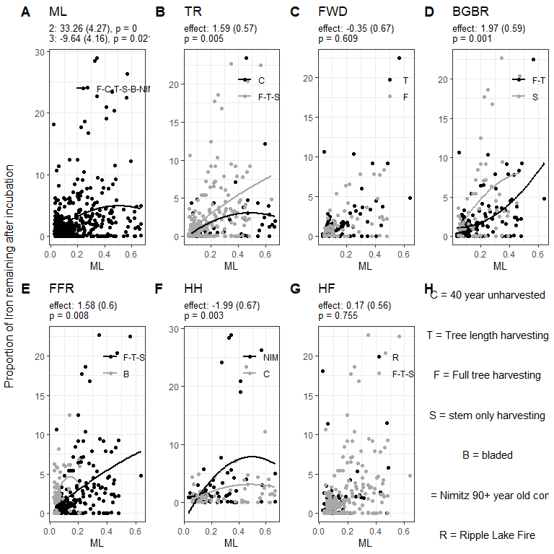
Figure 4.19: Patterns of above-ground woodstake iron proportion over time. Results from a mixed model are reported in panels A-G. The significance (p < 0.05) of orthoganal contrasts are reported in text at the top of each panel. Points representing individual woodstakes and the linear relationship to mass loss for the levels of each contrast are displayed using colour (black and grey). linear relationships are only displayed where there was a significant (p < 0.05) difference between contrast levels. Panel H describes the treatments used in the contrasts.
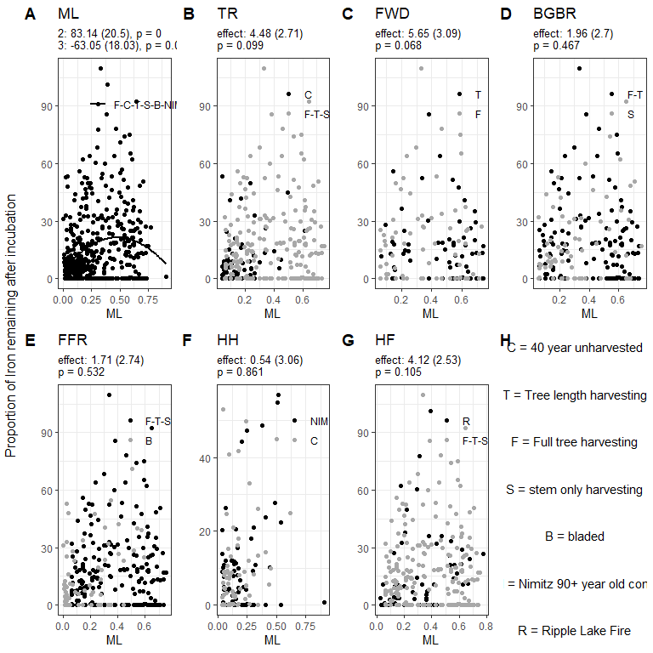
Figure 4.20: Patterns of below-ground woodstake iron proportion over time. Results from a mixed model are reported in panels A-G. The significance (p < 0.05) of orthoganal contrasts are reported in text at the top of each panel. Points representing individual woodstakes and the linear relationship to mass loss for the levels of each contrast are displayed using colour (black and grey). linear relationships are only displayed where there was a significant (p < 0.05) difference between contrast levels. Panel H describes the treatments used in the contrasts.
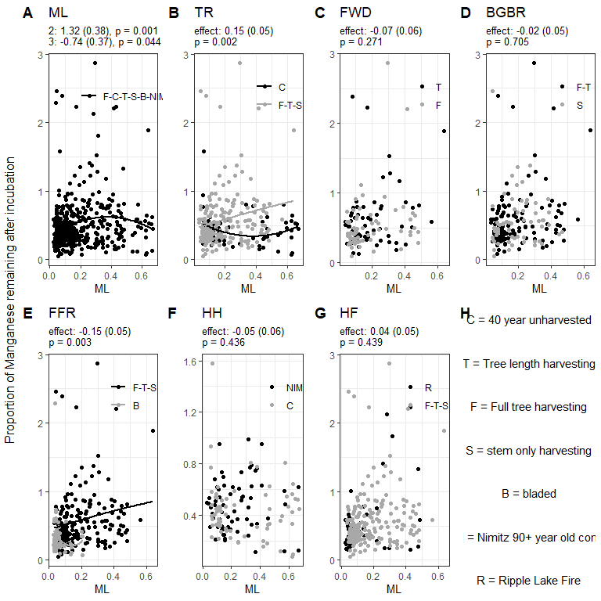
Figure 4.21: Patterns of above-ground woodstake manganese proportion over time. Results from a mixed model are reported in panels A-G. The significance (p < 0.05) of orthoganal contrasts are reported in text at the top of each panel. Points representing individual woodstakes and the linear relationship to mass loss for the levels of each contrast are displayed using colour (black and grey). linear relationships are only displayed where there was a significant (p < 0.05) difference between contrast levels. Panel H describes the treatments used in the contrasts.
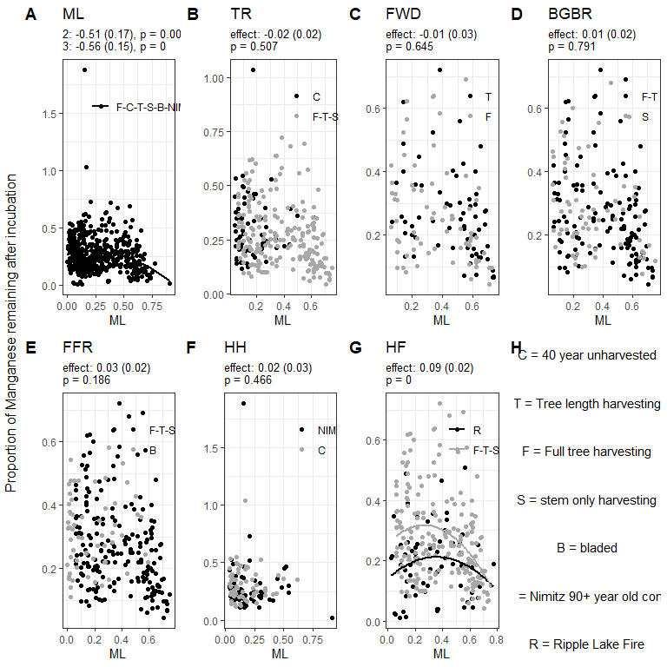
Figure 4.22: Patterns of below-ground woodstake manganese proportion over time. Results from a mixed model are reported in panels A-G. The significance (p < 0.05) of orthoganal contrasts are reported in text at the top of each panel. Points representing individual woodstakes and the linear relationship to mass loss for the levels of each contrast are displayed using colour (black and grey). linear relationships are only displayed where there was a significant (p < 0.05) difference between contrast levels. Panel H describes the treatments used in the contrasts.
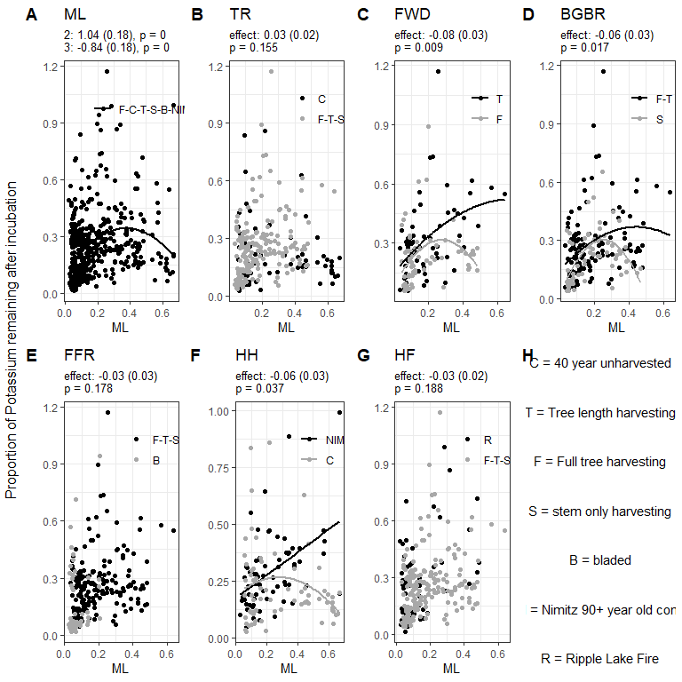
Figure 4.23: Patterns of above-ground woodstake potassium proportion over time. Results from a mixed model are reported in panels A-G. The significance (p < 0.05) of orthoganal contrasts are reported in text at the top of each panel. Points representing individual woodstakes and the linear relationship to mass loss for the levels of each contrast are displayed using colour (black and grey). linear relationships are only displayed where there was a significant (p < 0.05) difference between contrast levels. Panel H describes the treatments used in the contrasts.
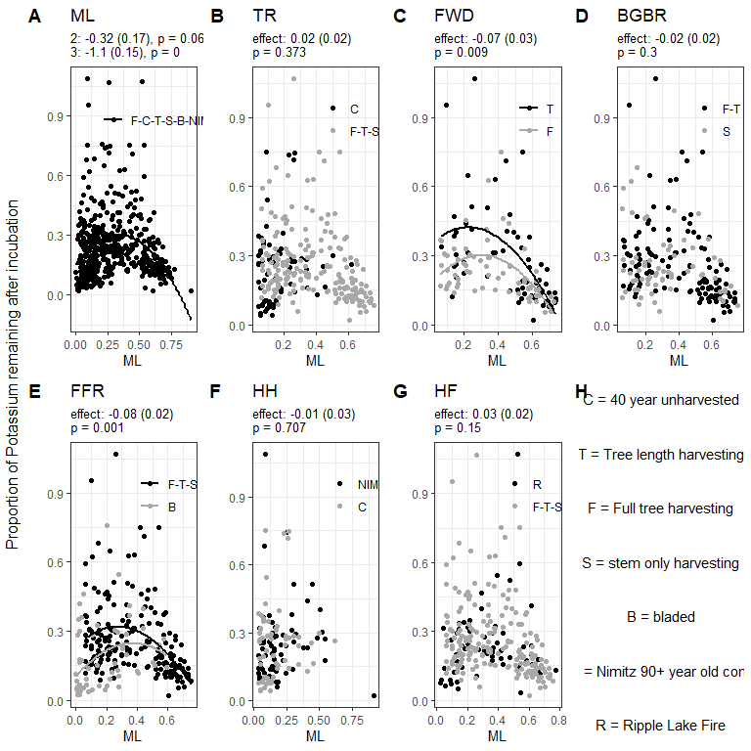
Figure 4.24: Patterns of below-ground woodstake potassium proportion over time. Results from a mixed model are reported in panels A-G. The significance (p < 0.05) of orthoganal contrasts are reported in text at the top of each panel. Points representing individual woodstakes and the linear relationship to mass loss for the levels of each contrast are displayed using colour (black and grey). linear relationships are only displayed where there was a significant (p < 0.05) difference between contrast levels. Panel H describes the treatments used in the contrasts.
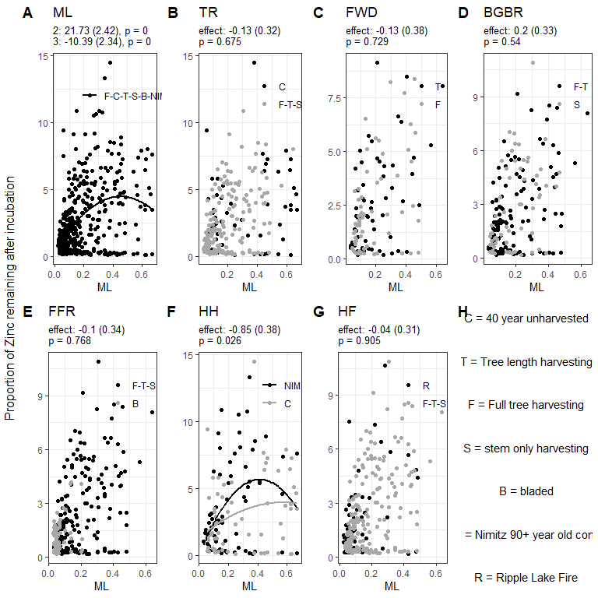
Figure 4.25: Patterns of above-ground woodstake zinc proportion over time. Results from a mixed model are reported in panels A-G. The significance (p < 0.05) of orthoganal contrasts are reported in text at the top of each panel. Points representing individual woodstakes and the linear relationship to mass loss for the levels of each contrast are displayed using colour (black and grey). linear relationships are only displayed where there was a significant (p < 0.05) difference between contrast levels. Panel H describes the treatments used in the contrasts.
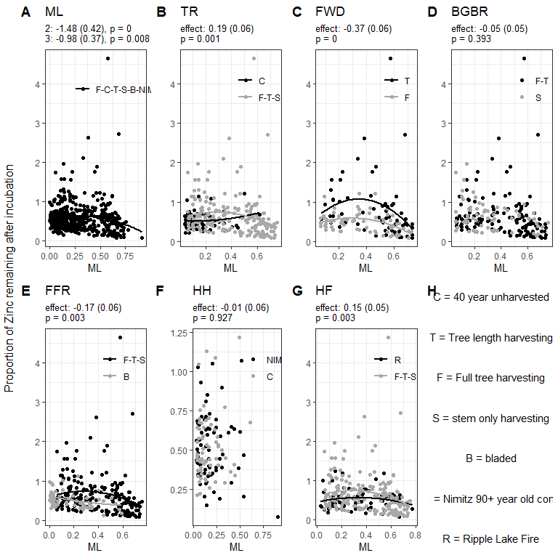
Figure 4.26: Patterns of below-ground woodstake zinc proportion over time. Results from a mixed model are reported in panels A-G. The significance (p < 0.05) of orthoganal contrasts are reported in text at the top of each panel. Points representing individual woodstakes and the linear relationship to mass loss for the levels of each contrast are displayed using colour (black and grey). linear relationships are only displayed where there was a significant (p < 0.05) difference between contrast levels. Panel H describes the treatments used in the contrasts.
We saw evidence that the progression of decay was altered insofar as the chemical content of wood was differentially impacted by treatments, even after accounting for differences in the amount of mass loss that had occurred. The treatments with significant changes in chemical content varied based on the chemical and location of the woodstake. Carbon, nitrogen and carbon-nitrogen ratios were largely unaffected by biomass harvesting intensity treatments.
Most of the mass loss in the wood stakes was due to losses of carbon. There was a significant negative relationship between the proportion of stake carbon remaining and the mass loss of the stakes, but no significant polynomial relationship, indicating a strong simple linear relationship (Figure 4.3-A, 4.4. There were some indications of differences in carbon utilization between above-ground and below-ground incubations, and also between select treatments. … Above-ground carbon losses had a slightly weaker relationship (slope = -0.86, Figure 4.3-A) to mass loss than below-ground carbon losses (slope = -0.9, Figure 4.4-A). There were small significant differences in aboveground wood stakes carbon pool in similarly decayed residues due to below-ground biomass removal (1% decrease, Figure 4.3-D) and forest floor removal (1% increase, Figure 4.3-E), and, small changes in the amount of carbon remaining in below-ground wood stake incubations due to tree-removal (2% decrease, Figure 4.4-B) and below-ground biomass removal (2% decrease, Figure 4.4-D).
Nitrogen dynamics followed the expected trajectory of nitrogen in wood residues, with an initial increase in nitrogen early decay stages, followed by subsequent declines as decay proceeded (Figure 4.5-A, 4.6-A). The proportion of nitrogen in decaying wood residues is typically found to increase over time (REF?) and is generally assumed to be a result of nitrogen fixation and import of nitrogen by fungi…. (REF?). In our study, these increases in proportion of nitrogen and the reduction of the amount of wood residues over time resulted in the decrease in nitrogen pools over time, but left them at two times the pre-incubation values in our most decomposed residues. This result suggests that decay processes involving nitrogen accumulation begin early in the decay process, possibly to facilitate growth of decay species. Generally, phosphorus pools in the decaying stakes had a significant polynomial relationship which appeared to increase to levels up to four times the original phosphorus concentrations until 40% of mass was lost, and then decrease (Figure 4.7-A, 4.8-A). The pattern of phosphorus accumulation in wood stakes incubated above-ground and below ground were affected by harvesting practices: tree removal had increased phosphorus compared to unharvested controls (Figure 4.7-B, 4.8-B); partially decayed Fine woody debris and forest floor decreased wood stake phosphorus (Figure 4.7-C,E; 4.8-C,E). We also found that the younger control sites had lower phosphorus in the wood stakes incubated above-ground than at the nearby old-growth site (Figure 4.7-F). Calcium and magnesium had similar trends and responses to harvesting treatments. Both Mg and Ca showed a slight trend of increasing to levels higher than initial wood stake amounts until approximately 40% of wood stake residues remained, and then decreasing as mass loss continued (Figure 4.9-A, 4.11-A). Tree removal treatments increased calcium and magnesium pools of the above-ground woodstakes (Figure 4.9-B, 4.11-B). Increased harvesting intensity treatments only resulted in decreased Ca and Mg from above-ground fine-woody debris removal (Figure 4.9-C, 4.11-C) and, increased Mg in below ground incubations due to forest floor removal (Figure 4.12-E). Both Ca and Mg had significant decreases in the younger island lake control sites compared to old-growth controls, suggesting potential nutrient limitation in the soils at the control sites compared to the old growth site. There was also significantly increased below-ground Ca woodstake pools in harvested sites compared to fire controls (Figure ??-G).
There were two typical behaviours of the remaining metals assessed in this study: a decrease as mass loss proceeded for boron, copper (Figure 4.15-A, 4.16-A, 4.17-A, 4.18-A); or, increases until around 40% mass loss followed by decreases for aluminum, iron, manganese, potassium, zinc (Figure 4.13-A, 4.14-A, 4.19-A, 4.20-A, 4.21-A, 4.22-A, 4.23-A, 4.24-A, 4.25-A, 4.26-A). Aluminum, iron and potassium generally had above-ground decomposition responses to harvesting treatments: tree removal, below-ground biomass removal and forest floor removal all increased Al and Fe (Figure 4.13-B,D,E; 4.19-B,D,E). The other metals that responded to treatments all had decreased above-ground quantities in response to treatments (Figure 4.15-B,E; 4.23-C,D;4.21-e).
above TR -in Al, Fe, Mn -dec B FWD -in -dec K BGBR -in Al, Fe -dec K FFR -in Al, Fe -dec B, Mn HH -in -dec Al, Fe, K, Zn HF -in Al -dec
below TR -in Al, Zn -dec B FWD -in Al -dec , Zn BGBR -in -dec FFR -in -dec K, Zn HH -in -dec HF -in Mn, Zn -dec B
Woodstakes incubated on harvested treatments had increased phosphorus compared to controls for similar stages of mass loss, which indicates that there was more import to those residues… possibly increased decay of these compared to impeded soil quality?? The increased Calcium and magnesium in only above-ground decomposition indicates that mineral soils were not impacted by these treatments, but quality of litter and organic soil may have been impacted. The increase in these nutrients in decaying wood could be due to…
The decreased nitrogen and phosphorus in woodstakes incubated on sites with increased biomass removals suggest that decomposition in higher biomass removal sites is impeded by a combination of nutrient limitations and microclimatic conditions. The notable increase of nitrogen and phosphorus through the stages of decay demonstrate that there is active active transport of these nutrients into tree residues. As all woodstakes used in this study were from the same source starting materials, the differences observed due to particular treatments would have had to come from surrounding resources. For nitrogen, the initial increases could be from a number of mechanisms… For phosphorus, fungal translocation is the most likely mechanism for the increase in the phosphorus pool. Phosphorus is important as a component of DNA, and bioenergetically, as a component of ATP. The increases in phosphorus in partially decayed residues, in particular, may be due to increased energetic demands related to increased enzymatic activity and import of difficult to break down components of wood or, due to microbial biomass with higher phosphorus concentrations representing a higher proportion of the wood stake at those stages.
The higher rate of carbon loss below ground as stake mass loss increased is indicative of more respiration of carbon in the below-ground residues than above-ground residues could indicate a slight preference of wood-derived carbon compared to soil-derived carbon in below-ground environments, while in the above-ground environments, there might be slightly less carbon utilization due to the presence of more-easily degraded sources of carbon in nearby litter materials.

4.1.4 Community Analysis
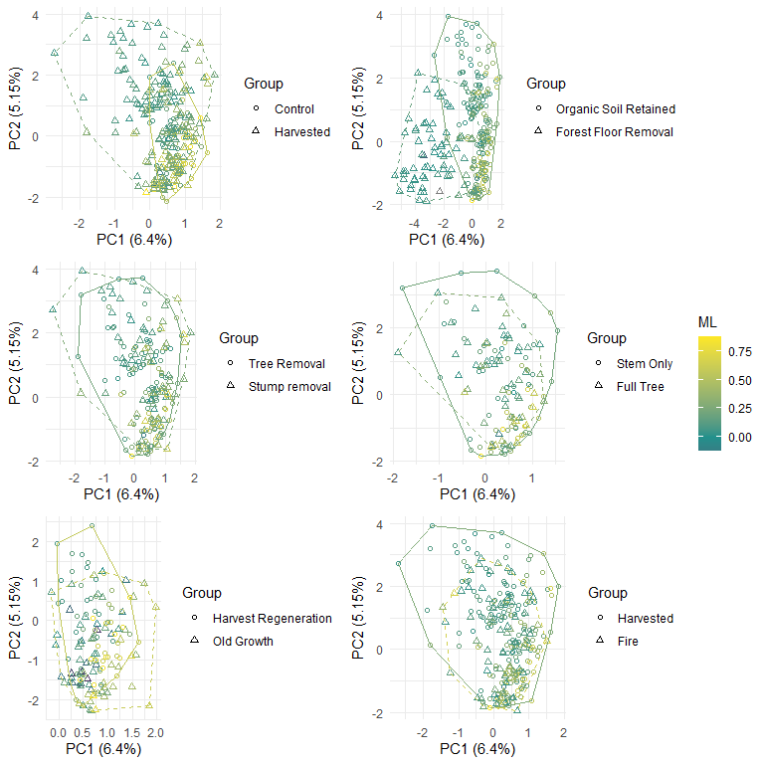
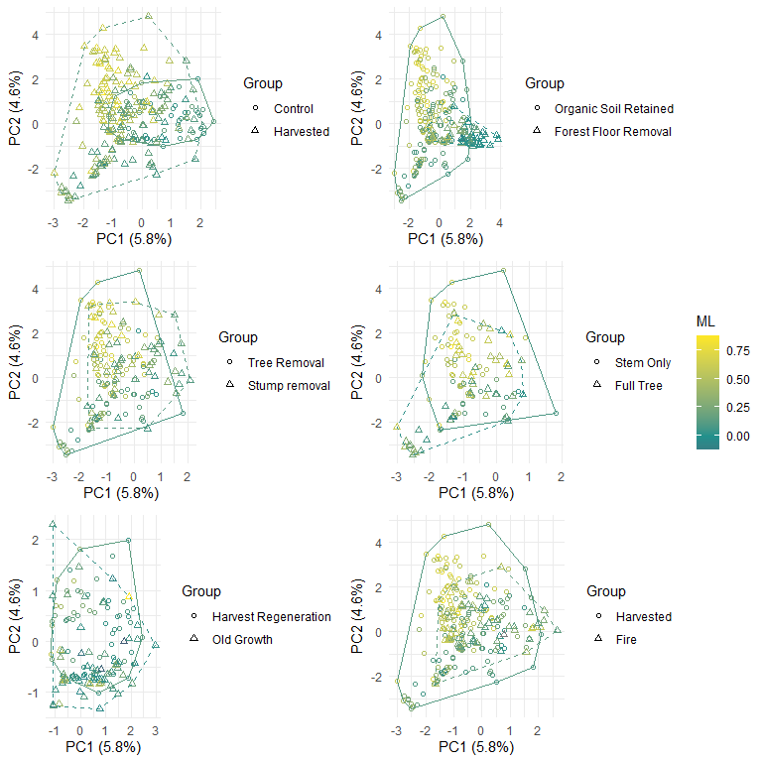
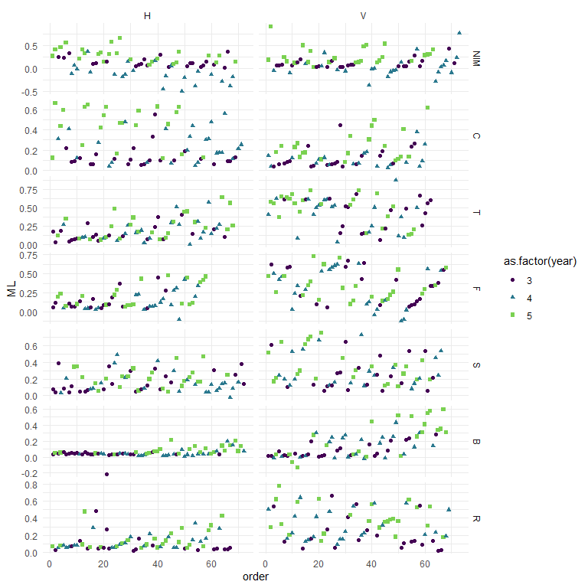
Treatment | orientation | NODF | Nestedness Rows
NIM | H | 20.86 | 22.95
C | H | 23.22 | 26.69
T | H | 20.94 | 23.37
F | H | 24.89 | 27.16
S | H | 23.46 | 32.65
B | H | 25.00 | 31.56
R | H | 19.39 | 23.37
NIM | V | 19.73 | 23.30
C | V | 25.05 | 28.05
T | V | 21.18 | 23.29
F | V | 19.36 | 20.66
S | V | 18.80 | 20.40
B | V | 33.53 | 40.84
R | V | 13.63 | 15.21
There was highest nestedness for the Bladed treatment in both There was lower nestedness on average, in the harvested plots than the controls in the Vertical there was higher nestedness on average in the harvested plots than the controls for the Horizontal Nestedness complicated by the different decomposition rates at the sites, lower nestedness had more equal distribution
Table 4.1: ESV with differences in detection based on binomial response estimates for orthogonal contrast effects. Only significant (holm-corrected p value < 0.05) results are included in the table.
orientation | parameter | Estimate | Species | trophicMode | guild | trait | growthForm
H | ML | -4.1579301 | Aequabiliella_effusa-SH1573805.08FU | Pathotroph | Plant Pathogen | NULL | Microfungus
H | HF | -0.8549109 | Aequabiliella_effusa-SH1573805.08FU | Pathotroph | Plant Pathogen | NULL | Microfungus
H | ML | 4.5520202 | Skvortzovia_furfuracea-SH1553433.08FU | Saprotroph | Undefined Saprotroph | White Rot | NULL
H | HH | -2.5956030 | Cladophialophora_sp-SH1616409.08FU | Saprotroph | Undefined Saprotroph | NULL | Microfungus
H | ML | 6.1765715 | Coniophora_olivacea-SH1505673.08FU | Saprotroph | Wood Saprotroph | Brown Rot | Corticioid
H | HH | -2.5301809 | Coniophora_olivacea-SH1505673.08FU | Saprotroph | Wood Saprotroph | Brown Rot | Corticioid
H | ML | -10.1867632 | Leotiomycetes_sp-SH1509520.08FU | na | na | na | na
H | ML | -11.0081109 | Exophiala_sp-SH1529797.08FU | Pathotroph-Saprotroph | Animal Pathogen-Undefined Saprotroph | NULL | Facultative Yeast
H | ML | -20.5740133 | Epicladonia_sp-SH1509523.08FU | Pathotroph | Lichen Parasite | NULL | Microfungus
H | ML | -6.6481757 | Cladophialophora_sp-SH1616358.08FU | Saprotroph | Undefined Saprotroph | NULL | Microfungus
H | FWD | -1.2832079 | Cladophialophora_sp-SH1616358.08FU | Saprotroph | Undefined Saprotroph | NULL | Microfungus
H | FFR | -1.6394605 | Cladophialophora_sp-SH1616358.08FU | Saprotroph | Undefined Saprotroph | NULL | Microfungus
H | HF | -1.6738322 | Cladophialophora_sp-SH1616358.08FU | Saprotroph | Undefined Saprotroph | NULL | Microfungus
H | ML | 9.3285500 | Tricholomataceae_sp-SH1542306.08FU | Pathotroph-Symbiotroph | Ectomycorrhizal-Fungal Parasite | NULL | Agaricoid
H | ML | 7.9190615 | Resinicium_bicolor-SH1509369.08FU | Saprotroph | Undefined Saprotroph | White Rot | Corticioid
H | ML | 8.6756608 | Trechispora_sp-SH1546197.08FU | Saprotroph | Wood Saprotroph | White Rot | Corticioid
H | ML | -6.1226349 | Tympanis_confusa-SH1509528.08FU | Saprotroph | Undefined Saprotroph | NULL | NULL
H | FFR | 0.8706792 | Tympanis_confusa-SH1509528.08FU | Saprotroph | Undefined Saprotroph | NULL | NULL
H | HH | 3.6848293 | Tympanis_confusa-SH1509528.08FU | Saprotroph | Undefined Saprotroph | NULL | NULL
H | HH | -2.4862200 | Fungi_sp-SH1565772.08FU | na | na | na | na
H | ML | 6.6574037 | Botryobasidium_sp-SH1173518.08FU | Saprotroph | Undefined Saprotroph | White Rot | Corticioid
H | ML | -1.4970217 | Chalara_sp-SH1522515.08FU | Pathotroph-Saprotroph-Symbiotroph | Endophyte-Plant Pathogen-Wood Saprotroph | Soft Rot | Microfungus
H | FWD | -1.1782691 | Chalara_sp-SH1522515.08FU | Pathotroph-Saprotroph-Symbiotroph | Endophyte-Plant Pathogen-Wood Saprotroph | Soft Rot | Microfungus
H | ML | -14.1568011 | Racodium_sp-SH1645867.08FU | Symbiotroph | Lichenized | NULL | Thallus
H | BGBR | 2.2119765 | Phialocephala_fortinii-SH1647282.08FU | Symbiotroph | Endophyte | NULL | Microfungus
H | ML | 4.9422210 | Teratosphaeriaceae_sp-SH2596998.08FU | Pathotroph-Saprotroph | Animal Pathogen-Plant Pathogen-Undefined Saprotroph | NULL | NULL
H | FWD | -2.0572795 | Coniophora_arida-SH1527412.08FU | Saprotroph | Wood Saprotroph | Brown Rot | Corticioid
H | BGBR | 2.2353215 | Coniophora_arida-SH1527412.08FU | Saprotroph | Wood Saprotroph | Brown Rot | Corticioid
H | ML | -5.3282826 | Ascomycota_sp-SH1176038.08FU | na | na | na | na
H | ML | 5.3253318 | Mycena_sp-SH1542306.08FU | Pathotroph-Saprotroph | Leaf Saprotroph-Plant Pathogen-Undefined Saprotroph-Wood Saprotroph | NULL | Agaricoid
H | HH | -1.6460694 | Hyaloscypha_sp-SH1523065.08FU | Saprotroph | Undefined Saprotroph | NULL | NULL
H | ML | -23.2376011 | Fungi_sp-SH1573478.08FU | na | na | na | na
H | ML | 3.3151580 | Hyaloscypha_aureliella-SH1522946.08FU | Saprotroph | Undefined Saprotroph | NULL | NULL
H | HH | -1.7556052 | Hyaloscypha_aureliella-SH1522946.08FU | Saprotroph | Undefined Saprotroph | NULL | NULL
H | ML | -10.0756883 | Phaeococcomyces_sp-SH1573475.08FU | Saprotroph | Undefined Saprotroph | NULL | Facultative Yeast
H | ML | 5.2470177 | Clavariaceae_sp-SH1510075.08FU | Saprotroph-Symbiotroph | Lichenized-Undefined Saprotroph | NULL | Clavarioid
H | HH | -2.7404367 | Clavariaceae_sp-SH1510075.08FU | Saprotroph-Symbiotroph | Lichenized-Undefined Saprotroph | NULL | Clavarioid
H | ML | 1.6419239 | Phialocephala_sp-SH1647285.08FU | Symbiotroph | Endophyte | NULL | Microfungus
H | ML | 5.8534585 | Postia_sericeomollis-SH1518087.08FU | Saprotroph | Wood Saprotroph | Brown Rot | Polyporoid
H | ML | 6.5521829 | Fungi_sp-SH1606208.08FU | na | na | na | na
H | HH | -3.5407039 | Fungi_sp-SH1606208.08FU | na | na | na | na
H | ML | -10.7871739 | Bryochiton_sp-SH1591995.08FU | Pathotroph | Plant Pathogen | NULL | NULL
H | ML | -5.2106132 | Fungi_sp-SH1542963.08FU | na | na | na | na
H | ML | 4.3099548 | Dacrymycetales_sp-SH1649097.08FU | na | na | na | na
H | ML | 9.4604010 | Fibricium_rude-SH1519579.08FU | Saprotroph | Undefined Saprotroph | White Rot | NULL
H | ML | 2.2908565 | Auriculariales_sp-SH1544119.08FU | na | na | na | na
H | ML | 4.4398245 | Fibricium_rude-SH1519579.08FU | Saprotroph | Undefined Saprotroph | White Rot | NULL
H | BGBR | 1.7171591 | Venturia_catenospora-SH1626923.08FU | Pathotroph | Plant Pathogen | NULL | NULL
H | ML | 9.5789580 | Carcinomyces_sp-SH1177270.08FU | Pathotroph-Saprotroph-Symbiotroph | Fungal Parasite-Undefined Saprotroph | NULL | Tremelloid-Yeast
H | ML | 6.5363677 | Helotiales_sp-SH1564518.08FU | na | na | na | na
H | BGBR | 1.6144003 | Pseudoplectania_sp-SH1508222.08FU | Saprotroph | Undefined Saprotroph | NULL | NULL
H | ML | 3.9119277 | Peniophorella_pallida-SH1563458.08FU | Saprotroph | Undefined Saprotroph | White Rot | Corticioid
H | FFR | -2.4660739 | Peniophorella_pallida-SH1563458.08FU | Saprotroph | Undefined Saprotroph | White Rot | Corticioid
H | HH | 1.3629849 | Peniophorella_pallida-SH1563458.08FU | Saprotroph | Undefined Saprotroph | White Rot | Corticioid
H | HF | 1.6041885 | Peniophorella_pallida-SH1563458.08FU | Saprotroph | Undefined Saprotroph | White Rot | Corticioid
H | ML | 7.9901114 | Tympanis_sp-SH1190220.08FU | Saprotroph | Undefined Saprotroph | NULL | NULL
H | ML | 3.7411278 | Hyaloscyphaceae_sp-SH1239003.08FU | Saprotroph | Plant Saprotroph-Wood Saprotroph | NULL | Microfungus
H | HH | -1.1249857 | Hyaloscyphaceae_sp-SH1239003.08FU | Saprotroph | Plant Saprotroph-Wood Saprotroph | NULL | Microfungus
H | ML | -3.9572337 | Fungi_sp-SH1515061.08FU | na | na | na | na
H | TR | -0.7045526 | Ascomycota_sp-SH1551049.08FU | na | na | na | na
H | FWD | -1.1894624 | Ascomycota_sp-SH1551049.08FU | na | na | na | na
H | FFR | -2.3153291 | Ascomycota_sp-SH1551049.08FU | na | na | na | na
H | HH | -0.8194922 | Ascomycota_sp-SH1551049.08FU | na | na | na | na
H | ML | 14.0556849 | Botryobasidium_obtusisporum-SH1646390.08FU | Saprotroph | Undefined Saprotroph | White Rot | Corticioid
H | ML | -6.4290600 | Ascomycota_sp-SH1176038.08FU | na | na | na | na
H | ML | -5.1192845 | Helotiales_sp-SH1155836.08FU | na | na | na | na
H | FFR | 1.3621713 | Helotiales_sp-SH1155836.08FU | na | na | na | na
H | ML | 48.0836832 | Dacryobolus_sudans-SH1649847.08FU | Saprotroph | Wood Saprotroph | Brown Rot | Corticioid
H | ML | -10.9566640 | Fungi_sp-SH1186446.08FU | na | na | na | na
H | ML | 5.6801845 | Piloderma_sphaerosporum-SH1544806.08FU | Symbiotroph | Ectomycorrhizal | NULL | Corticioid
H | TR | 2.9557492 | Hyaloscypha_sp-SH1522958.08FU | Saprotroph | Undefined Saprotroph | NULL | NULL
H | BGBR | 0.7793839 | Hyaloscypha_sp-SH1522958.08FU | Saprotroph | Undefined Saprotroph | NULL | NULL
H | FFR | -1.3347944 | Hyaloscypha_sp-SH1522958.08FU | Saprotroph | Undefined Saprotroph | NULL | NULL
H | HF | 2.0525649 | Hyaloscypha_sp-SH1522958.08FU | Saprotroph | Undefined Saprotroph | NULL | NULL
H | ML | 3.6448261 | Carcinomyces_polyporinus-SH1552291.08FU | Pathotroph-Saprotroph-Symbiotroph | Fungal Parasite-Undefined Saprotroph | NULL | Tremelloid-Yeast
H | ML | 7.5614964 | Chytriomyces_sp-SH3686294.08FU | Saprotroph | Undefined Saprotroph | NULL | Microfungus
H | ML | -5.3861805 | Infundichalara_minuta-SH1522516.08FU | Saprotroph | Undefined Saprotroph | NULL | NULL
H | BGBR | 1.9586793 | Infundichalara_minuta-SH1522516.08FU | Saprotroph | Undefined Saprotroph | NULL | NULL
H | ML | -2.8753918 | Mycosphaerellaceae_sp-SH1544327.08FU | Pathotroph-Saprotroph | Plant Pathogen-Undefined Saprotroph | NULL | Microfungus
H | ML | -8.1532595 | Byssochlamys_spectabilis-SH1161713.08FU | Saprotroph | Undefined Saprotroph | NULL | NULL
H | ML | -2.8202543 | Phialocephala_sp-SH1647289.08FU | Symbiotroph | Endophyte | NULL | Microfungus
H | FFR | -1.6854695 | Phialocephala_sp-SH1647289.08FU | Symbiotroph | Endophyte | NULL | Microfungus
H | HH | 1.5662479 | Phialocephala_sp-SH1647289.08FU | Symbiotroph | Endophyte | NULL | Microfungus
H | FWD | 0.8638976 | Chaetothyriales_sp-SH1186380.08FU | na | na | na | na
H | ML | 3.5849314 | Phialocephala_dimorphospora-SH1647285.08FU | Symbiotroph | Endophyte | NULL | Microfungus
H | ML | -11.5202296 | Dothideomycetidae-SH1571466.08FU | na | na | na | na
H | ML | 5.6029681 | Saccharomycetales_sp-SH1654517.08FU | Saprotroph | Undefined Saprotroph | NULL | Yeast
H | ML | 5.6478422 | Coniophora_olivacea-SH1505673.08FU | Saprotroph | Wood Saprotroph | Brown Rot | Corticioid
H | HH | -2.4003866 | Coniophora_olivacea-SH1505673.08FU | Saprotroph | Wood Saprotroph | Brown Rot | Corticioid
H | ML | 5.9700713 | Helotiales_sp-SH1523754.08FU | na | na | na | na
H | HH | -2.8947052 | Xeromphalina_cauticinalis-SH1566092.08FU | Saprotroph | Undefined Saprotroph | White Rot | Agaricoid
H | ML | 6.4908563 | Claussenomyces_atrovirens-SH1571907.08FU | Saprotroph | Undefined Saprotroph | NULL | NULL
H | TR | 0.8548473 | Claussenomyces_atrovirens-SH1571907.08FU | Saprotroph | Undefined Saprotroph | NULL | NULL
H | BGBR | 0.8750932 | Claussenomyces_atrovirens-SH1571907.08FU | Saprotroph | Undefined Saprotroph | NULL | NULL
H | HF | 2.4143326 | Claussenomyces_atrovirens-SH1571907.08FU | Saprotroph | Undefined Saprotroph | NULL | NULL
H | ML | 6.2495502 | Nectriaceae_sp-SH1606208.08FU | Pathotroph-Saprotroph-Symbiotroph | Animal Pathogen-Endophyte-Fungal Parasite-Lichen Parasite-Plant Pathogen-Wood Saprotroph | NULL | Microfungus
H | ML | 6.1847914 | Kneiffiella_sp-SH1562809.08FU | Saprotroph | Wood Saprotroph | White Rot | Corticioid
H | BGBR | 0.6807085 | Luellia_sp-SH1543990.08FU | Saprotroph | Undefined Saprotroph | White Rot | Corticioid
H | FFR | -3.5528536 | Luellia_sp-SH1543990.08FU | Saprotroph | Undefined Saprotroph | White Rot | Corticioid
H | ML | -7.8610558 | Mollisia_sp-SH1637613.08FU | Pathotroph-Symbiotroph | Endophyte-Plant Pathogen | NULL | Microfungus
H | ML | -7.4085642 | Sarcinomyces_sp-SH1538525.08FU | na | na | na | na
H | ML | 6.4369249 | Botryobasidium_subcoronatum-SH1546232.08FU | Saprotroph | Undefined Saprotroph | White Rot | Corticioid
H | ML | 4.6796821 | Carcinomyces_sp-SH1177270.08FU | Pathotroph-Saprotroph-Symbiotroph | Fungal Parasite-Undefined Saprotroph | NULL | Tremelloid-Yeast
H | BGBR | 1.4575488 | Carcinomyces_sp-SH1177270.08FU | Pathotroph-Saprotroph-Symbiotroph | Fungal Parasite-Undefined Saprotroph | NULL | Tremelloid-Yeast
H | HH | -2.2506747 | Carcinomyces_sp-SH1177270.08FU | Pathotroph-Saprotroph-Symbiotroph | Fungal Parasite-Undefined Saprotroph | NULL | Tremelloid-Yeast
H | ML | 11.3546286 | Nectriaceae_sp-SH1606208.08FU | Pathotroph-Saprotroph-Symbiotroph | Animal Pathogen-Endophyte-Fungal Parasite-Lichen Parasite-Plant Pathogen-Wood Saprotroph | NULL | Microfungus
H | ML | 4.9493894 | Botryobasidium_sp-SH1173518.08FU | Saprotroph | Undefined Saprotroph | White Rot | Corticioid
H | ML | 4.2452836 | Peniophorella_pallida-SH1563458.08FU | Saprotroph | Undefined Saprotroph | White Rot | Corticioid
H | BGBR | 1.5332187 | Helotiales_sp-SH1564437.08FU | na | na | na | na
H | ML | -13.6601500 | Dothideomycetidae-SH1571466.08FU | na | na | na | na
H | ML | 3.5291352 | Calocera_sp-SH1176476.08FU | Saprotroph | Wood Saprotroph | Brown Rot | Clavarioid
H | ML | 10.7908050 | Piloderma_olivaceum-SH1544805.08FU | Symbiotroph | Ectomycorrhizal | NULL | Corticioid
H | ML | -5.1013602 | Phialocephala_fortinii-SH1647282.08FU | Symbiotroph | Endophyte | NULL | Microfungus
H | ML | 12.5768695 | Mycena_sp-SH1542306.08FU | Pathotroph-Saprotroph | Leaf Saprotroph-Plant Pathogen-Undefined Saprotroph-Wood Saprotroph | NULL | Agaricoid
H | ML | -3.3681554 | Phialocephala_sp-SH1647289.08FU | Symbiotroph | Endophyte | NULL | Microfungus
H | FWD | 1.0453374 | Phialocephala_sp-SH1647289.08FU | Symbiotroph | Endophyte | NULL | Microfungus
H | FFR | -2.6414988 | Phialocephala_sp-SH1647289.08FU | Symbiotroph | Endophyte | NULL | Microfungus
H | HH | 1.2928810 | Phialocephala_sp-SH1647289.08FU | Symbiotroph | Endophyte | NULL | Microfungus
H | TR | -0.8134550 | Meliniomyces_sp-SH1523765.08FU | Saprotroph-Symbiotroph | Ectomycorrhizal-Endophyte-Ericoid Mycorrhizal-Litter Saprotroph-Orchid Mycorrhizal | NULL | Microfungus
H | ML | 8.0750080 | Carcinomyces_sp-SH1177270.08FU | Pathotroph-Saprotroph-Symbiotroph | Fungal Parasite-Undefined Saprotroph | NULL | Tremelloid-Yeast
H | HH | -2.7356884 | Carcinomyces_sp-SH1177270.08FU | Pathotroph-Saprotroph-Symbiotroph | Fungal Parasite-Undefined Saprotroph | NULL | Tremelloid-Yeast
H | TR | -0.9908468 | Infundichalara_minuta-SH1522516.08FU | Saprotroph | Undefined Saprotroph | NULL | NULL
H | BGBR | 0.9656755 | Infundichalara_minuta-SH1522516.08FU | Saprotroph | Undefined Saprotroph | NULL | NULL
H | FFR | -1.5826210 | Infundichalara_minuta-SH1522516.08FU | Saprotroph | Undefined Saprotroph | NULL | NULL
H | HF | 1.5116595 | Infundichalara_minuta-SH1522516.08FU | Saprotroph | Undefined Saprotroph | NULL | NULL
H | ML | 10.0746990 | Piloderma_olivaceum-SH1544805.08FU | Symbiotroph | Ectomycorrhizal | NULL | Corticioid
H | ML | -3.0340441 | Fungi_sp-SH1186446.08FU | na | na | na | na
H | TR | 1.9611288 | Fungi_sp-SH1186446.08FU | na | na | na | na
H | ML | 2.6894887 | Serpula_sp-SH1598886.08FU | Saprotroph | Wood Saprotroph | Brown Rot | Corticioid
H | ML | 3.0902770 | Mycena_purpureofusca-SH1542294.08FU | Pathotroph-Saprotroph | Leaf Saprotroph-Plant Pathogen-Undefined Saprotroph-Wood Saprotroph | NULL | Agaricoid
H | ML | 5.2120694 | Leotiomycetes_sp-SH1190230.08FU | na | na | na | na
H | FWD | -2.2000676 | Chalara_sp-SH1522486.08FU | Pathotroph-Saprotroph-Symbiotroph | Endophyte-Plant Pathogen-Wood Saprotroph | Soft Rot | Microfungus
H | ML | -11.6605883 | Helotiales_sp-SH1155836.08FU | na | na | na | na
H | ML | 3.0137070 | Helotiales_sp-SH1564576.08FU | na | na | na | na
H | BGBR | 1.2317260 | Helotiales_sp-SH1564576.08FU | na | na | na | na
H | HF | 2.0567183 | Helotiales_sp-SH1564576.08FU | na | na | na | na
H | ML | -4.1618887 | Eurotiomycetes_sp-SH1573805.08FU | na | na | na | na
V | ML | -7.0729970 | Fungi_sp-SH1637610.08FU | na | na | na | na
V | ML | 6.1203452 | Skvortzovia_furfuracea-SH1553433.08FU | Saprotroph | Undefined Saprotroph | White Rot | NULL
V | ML | -3.0974557 | Scytinostroma_sp-SH1558719.08FU | Saprotroph | Undefined Saprotroph | White Rot | NULL
V | ML | -4.6364744 | Perenniporia_subacida-SH1571973.08FU | Saprotroph | Wood Saprotroph | White Rot | Corticioid
V | ML | 5.9593712 | Fungi_sp-SH1190220.08FU | na | na | na | na
V | ML | 2.9076277 | Tricholomataceae_sp-SH1542306.08FU | Pathotroph-Symbiotroph | Ectomycorrhizal-Fungal Parasite | NULL | Agaricoid
V | TR | -1.1621188 | Gloniaceae_sp-SH1639596.08FU | na | na | na | na
V | FWD | 1.5187450 | Gloniaceae_sp-SH1639596.08FU | na | na | na | na
V | BGBR | -1.9332323 | Gloniaceae_sp-SH1639596.08FU | na | na | na | na
V | HH | -0.8310119 | Gloniaceae_sp-SH1639596.08FU | na | na | na | na
V | HF | -1.0527264 | Gloniaceae_sp-SH1639596.08FU | na | na | na | na
V | ML | -6.6159381 | Tympanis_confusa-SH1509528.08FU | Saprotroph | Undefined Saprotroph | NULL | NULL
V | ML | 3.0843688 | Serendipitaceae_sp-SH1577259.08FU | na | na | na | na
V | ML | 2.5774222 | Phialocephala_sp-SH1647285.08FU | Symbiotroph | Endophyte | NULL | Microfungus
V | ML | -1.9534816 | Chalara_sp-SH1522515.08FU | Pathotroph-Saprotroph-Symbiotroph | Endophyte-Plant Pathogen-Wood Saprotroph | Soft Rot | Microfungus
V | FWD | -1.4136159 | Chalara_sp-SH1522515.08FU | Pathotroph-Saprotroph-Symbiotroph | Endophyte-Plant Pathogen-Wood Saprotroph | Soft Rot | Microfungus
V | FFR | 1.0054896 | Chalara_sp-SH1522515.08FU | Pathotroph-Saprotroph-Symbiotroph | Endophyte-Plant Pathogen-Wood Saprotroph | Soft Rot | Microfungus
V | HH | -1.2938292 | Chalara_sp-SH1522515.08FU | Pathotroph-Saprotroph-Symbiotroph | Endophyte-Plant Pathogen-Wood Saprotroph | Soft Rot | Microfungus
V | HF | -1.6250080 | Chalara_sp-SH1522515.08FU | Pathotroph-Saprotroph-Symbiotroph | Endophyte-Plant Pathogen-Wood Saprotroph | Soft Rot | Microfungus
V | ML | 6.4245963 | Postia_guttulata-SH1612215.08FU | Saprotroph | Wood Saprotroph | Brown Rot | Polyporoid
V | ML | -6.4929570 | Trichocladium_sp-SH1645869.08FU | Saprotroph | Undefined Saprotroph | NULL | NULL
V | ML | -2.3187043 | Phialocephala_fortinii-SH1647282.08FU | Symbiotroph | Endophyte | NULL | Microfungus
V | TR | -0.8733907 | Phialocephala_fortinii-SH1647282.08FU | Symbiotroph | Endophyte | NULL | Microfungus
V | BGBR | 0.8532074 | Phialocephala_fortinii-SH1647282.08FU | Symbiotroph | Endophyte | NULL | Microfungus
V | FFR | 1.8705680 | Phialocephala_fortinii-SH1647282.08FU | Symbiotroph | Endophyte | NULL | Microfungus
V | ML | 6.2323055 | Lactarius_vinaceorufescens-SH1519116.08FU | Symbiotroph | Ectomycorrhizal | NULL | Agaricoid
V | BGBR | 1.1376075 | Helotiales_sp-SH1564463.08FU | na | na | na | na
V | ML | -4.8276125 | Scytinostroma_sp-SH1558719.08FU | Saprotroph | Undefined Saprotroph | White Rot | NULL
V | BGBR | -1.2522479 | Scytinostroma_sp-SH1558719.08FU | Saprotroph | Undefined Saprotroph | White Rot | NULL
V | ML | -2.4354153 | Phialocephala_fortinii-SH1647282.08FU | Symbiotroph | Endophyte | NULL | Microfungus
V | TR | -1.0318447 | Phialocephala_fortinii-SH1647282.08FU | Symbiotroph | Endophyte | NULL | Microfungus
V | FFR | 2.0784602 | Phialocephala_fortinii-SH1647282.08FU | Symbiotroph | Endophyte | NULL | Microfungus
V | ML | -3.9476684 | Phialocephala_fortinii-SH1647282.08FU | Symbiotroph | Endophyte | NULL | Microfungus
V | ML | -3.3014779 | Scytinostroma_sp-SH1558719.08FU | Saprotroph | Undefined Saprotroph | White Rot | NULL
V | FWD | 1.2900065 | Scytinostroma_sp-SH1558719.08FU | Saprotroph | Undefined Saprotroph | White Rot | NULL
V | BGBR | 1.4976725 | Pezizomycetes_sp-SH1508222.08FU | na | na | na | na
V | ML | 3.5278462 | Leotiomycetes_sp-SH1564826.08FU | na | na | na | na
V | HH | -1.5269517 | Phialocephala_sp-SH1647285.08FU | Symbiotroph | Endophyte | NULL | Microfungus
V | ML | 6.0604548 | Herpotrichiellaceae_sp-SH1565810.08FU | Pathotroph-Saprotroph | Animal Pathogen-Fungal Parasite-Undefined Saprotroph | NULL | Facultative Yeast-Microfungus
V | ML | 5.5988064 | Helotiales_sp-SH1523765.08FU | na | na | na | na
V | ML | 5.9170189 | Cryptosporiopsis_sp-SH1523082.08FU | Saprotroph | Undefined Saprotroph | NULL | NULL
V | ML | -10.0229703 | Fibricium_rude-SH1519579.08FU | Saprotroph | Undefined Saprotroph | White Rot | NULL
V | ML | 11.6821298 | Meliniomyces_sp-SH1544251.08FU | Saprotroph-Symbiotroph | Ectomycorrhizal-Endophyte-Ericoid Mycorrhizal-Litter Saprotroph-Orchid Mycorrhizal | NULL | Microfungus
V | ML | 3.6967975 | Peniophorella_pallida-SH1563458.08FU | Saprotroph | Undefined Saprotroph | White Rot | Corticioid
V | BGBR | 0.7856578 | Peniophorella_pallida-SH1563458.08FU | Saprotroph | Undefined Saprotroph | White Rot | Corticioid
V | HH | 1.3775193 | Peniophorella_pallida-SH1563458.08FU | Saprotroph | Undefined Saprotroph | White Rot | Corticioid
V | ML | 7.2926102 | Basidiodendron_sp-SH1549536.08FU | Saprotroph | Undefined Saprotroph | NULL | NULL
V | ML | 8.4399577 | Helotiales_sp-SH1544341.08FU | na | na | na | na
V | ML | 4.6121508 | Helotiales_sp-SH1523886.08FU | na | na | na | na
V | HH | -1.9567209 | Ascomycota_sp-SH1551049.08FU | na | na | na | na
V | ML | 4.4445240 | Botryobasidium_obtusisporum-SH1646390.08FU | Saprotroph | Undefined Saprotroph | White Rot | Corticioid
V | ML | -8.9246554 | Trichoderma_paraviridescens-SH1567966.08FU | Pathotroph-Saprotroph-Symbiotroph | Animal Pathogen-Endophyte-Epiphyte-Fungal Parasite-Plant Pathogen-Wood Saprotroph | Soft Rot | Microfungus
V | ML | 4.2862739 | Thelephora_terrestris-SH1502189.08FU | Symbiotroph | Ectomycorrhizal | NULL | Clavarioid
V | ML | -3.4050105 | Pezicula_ericae-SH1522919.08FU | Pathotroph-Saprotroph | Endophyte-Plant Pathogen-Undefined Saprotroph | NULL | NULL
V | ML | 5.5040522 | Piloderma_sphaerosporum-SH1544806.08FU | Symbiotroph | Ectomycorrhizal | NULL | Corticioid
V | FWD | -1.4789749 | Piloderma_sphaerosporum-SH1544806.08FU | Symbiotroph | Ectomycorrhizal | NULL | Corticioid
V | BGBR | 1.0722591 | Piloderma_sphaerosporum-SH1544806.08FU | Symbiotroph | Ectomycorrhizal | NULL | Corticioid
V | ML | 5.2549755 | Serendipitaceae_sp-SH1544473.08FU | na | na | na | na
V | ML | 5.5768891 | Phialocephala_sp-SH1647285.08FU | Symbiotroph | Endophyte | NULL | Microfungus
V | ML | 3.9830402 | Hyaloscypha_sp-SH1522958.08FU | Saprotroph | Undefined Saprotroph | NULL | NULL
V | TR | 3.0776849 | Hyaloscypha_sp-SH1522958.08FU | Saprotroph | Undefined Saprotroph | NULL | NULL
V | FFR | -1.3445571 | Hyaloscypha_sp-SH1522958.08FU | Saprotroph | Undefined Saprotroph | NULL | NULL
V | HF | 2.0643307 | Hyaloscypha_sp-SH1522958.08FU | Saprotroph | Undefined Saprotroph | NULL | NULL
V | ML | 4.7759048 | Helotiales_sp-SH1544340.08FU | na | na | na | na
V | ML | 5.8413930 | Chytriomyces_sp-SH3686294.08FU | Saprotroph | Undefined Saprotroph | NULL | Microfungus
V | ML | -7.9196605 | Phialocephala_sp-SH1647284.08FU | Symbiotroph | Endophyte | NULL | Microfungus
V | ML | 1.6790402 | Mycosphaerellaceae_sp-SH1544327.08FU | Pathotroph-Saprotroph | Plant Pathogen-Undefined Saprotroph | NULL | Microfungus
V | FWD | -1.2770660 | Mycosphaerellaceae_sp-SH1544327.08FU | Pathotroph-Saprotroph | Plant Pathogen-Undefined Saprotroph | NULL | Microfungus
V | ML | 5.3176164 | Xenasmatella_vaga-SH1554043.08FU | Saprotroph | Undefined Saprotroph | White Rot | NULL
V | ML | 5.2758039 | Stropharia_hornemannii-SH1639440.08FU | Saprotroph | Dung Saprotroph-Plant Parasite-Soil Saprotroph-Undefined Saprotroph-Wood Saprotroph | NULL | Agaricoid
V | TR | -1.4785572 | Phialocephala_sp-SH1647289.08FU | Symbiotroph | Endophyte | NULL | Microfungus
V | BGBR | 1.4801227 | Phialocephala_sp-SH1647289.08FU | Symbiotroph | Endophyte | NULL | Microfungus
V | HF | -1.2115913 | Phialocephala_sp-SH1647289.08FU | Symbiotroph | Endophyte | NULL | Microfungus
V | ML | 6.7167475 | Clavulina_sp-SH1546075.08FU | Symbiotroph | Ectomycorrhizal | NULL | Clavarioid
V | ML | 11.4699637 | Serendipitaceae_sp-SH1544473.08FU | na | na | na | na
V | ML | -7.6165799 | Xenochalara_sp-SH1522535.08FU | Saprotroph | Undefined Saprotroph | NULL | NULL
V | ML | 4.3269494 | Meliniomyces_sp-SH1544240.08FU | Saprotroph-Symbiotroph | Ectomycorrhizal-Endophyte-Ericoid Mycorrhizal-Litter Saprotroph-Orchid Mycorrhizal | NULL | Microfungus
V | ML | 9.5529632 | Hyaloscypha_sp-SH1523070.08FU | Saprotroph | Undefined Saprotroph | NULL | NULL
V | BGBR | 2.0215530 | Xeromphalina_cauticinalis-SH1566092.08FU | Saprotroph | Undefined Saprotroph | White Rot | Agaricoid
V | ML | -7.0512286 | Phialocephala_sp-SH1647282.08FU | Symbiotroph | Endophyte | NULL | Microfungus
V | ML | 2.6928157 | Claussenomyces_atrovirens-SH1571907.08FU | Saprotroph | Undefined Saprotroph | NULL | NULL
V | ML | 2.8902970 | Tympanis_sp-SH1190220.08FU | Saprotroph | Undefined Saprotroph | NULL | NULL
V | BGBR | 2.6228406 | Tympanis_sp-SH1190220.08FU | Saprotroph | Undefined Saprotroph | NULL | NULL
V | FFR | 3.2021598 | Tympanis_sp-SH1190220.08FU | Saprotroph | Undefined Saprotroph | NULL | NULL
V | ML | 5.3969550 | Chaetosphaeria_sp-SH1564759.08FU | Saprotroph-Symbiotroph | Endophyte-Litter Saprotroph-Wood Saprotroph | NULL | NULL
V | ML | 3.4984867 | Meliniomyces_sp-SH1523754.08FU | Saprotroph-Symbiotroph | Ectomycorrhizal-Endophyte-Ericoid Mycorrhizal-Litter Saprotroph-Orchid Mycorrhizal | NULL | Microfungus
V | ML | -37.1239246 | Chalara_sp-SH1522486.08FU | Pathotroph-Saprotroph-Symbiotroph | Endophyte-Plant Pathogen-Wood Saprotroph | Soft Rot | Microfungus
V | ML | 4.1224034 | Luellia_sp-SH1543990.08FU | Saprotroph | Undefined Saprotroph | White Rot | Corticioid
V | ML | 5.5152641 | Leotiomycetes_sp-SH1544340.08FU | na | na | na | na
V | ML | 3.5153723 | Botryobasidium_subcoronatum-SH1546232.08FU | Saprotroph | Undefined Saprotroph | White Rot | Corticioid
V | HH | -2.3693922 | Ascocoryne_sp-SH1551050.08FU | Saprotroph | Undefined Saprotroph | NULL | Tremelloid-Microfungus
V | ML | 11.0804983 | Hyaloscypha_sp-SH1522958.08FU | Saprotroph | Undefined Saprotroph | NULL | NULL
V | ML | 3.0540802 | Peniophorella_pallida-SH1563458.08FU | Saprotroph | Undefined Saprotroph | White Rot | Corticioid
V | ML | 3.4023571 | Helotiales_sp-SH1564437.08FU | na | na | na | na
V | FWD | -1.6689993 | Helotiales_sp-SH1564437.08FU | na | na | na | na
V | ML | -3.1854785 | Phialocephala_fortinii-SH1647282.08FU | Symbiotroph | Endophyte | NULL | Microfungus
V | ML | 7.0284891 | Postia_guttulata-SH1612215.08FU | Saprotroph | Wood Saprotroph | Brown Rot | Polyporoid
V | ML | 3.7373511 | Helotiales_sp-SH1544340.08FU | na | na | na | na
V | BGBR | 1.6062797 | Helotiales_sp-SH1544340.08FU | na | na | na | na
V | ML | 8.3118614 | Calocera_sp-SH1176476.08FU | Saprotroph | Wood Saprotroph | Brown Rot | Clavarioid
V | ML | -4.5716428 | Phialocephala_fortinii-SH1647282.08FU | Symbiotroph | Endophyte | NULL | Microfungus
V | TR | -0.9438319 | Phialocephala_fortinii-SH1647282.08FU | Symbiotroph | Endophyte | NULL | Microfungus
V | BGBR | 1.7896804 | Phialocephala_fortinii-SH1647282.08FU | Symbiotroph | Endophyte | NULL | Microfungus
V | FFR | 2.1462588 | Phialocephala_fortinii-SH1647282.08FU | Symbiotroph | Endophyte | NULL | Microfungus
V | HH | 0.8062047 | Phialocephala_fortinii-SH1647282.08FU | Symbiotroph | Endophyte | NULL | Microfungus
V | ML | 3.2110842 | Meliniomyces_sp-SH1523765.08FU | Saprotroph-Symbiotroph | Ectomycorrhizal-Endophyte-Ericoid Mycorrhizal-Litter Saprotroph-Orchid Mycorrhizal | NULL | Microfungus
V | TR | -1.2767648 | Meliniomyces_sp-SH1523765.08FU | Saprotroph-Symbiotroph | Ectomycorrhizal-Endophyte-Ericoid Mycorrhizal-Litter Saprotroph-Orchid Mycorrhizal | NULL | Microfungus
V | HH | 1.4231492 | Meliniomyces_sp-SH1523765.08FU | Saprotroph-Symbiotroph | Ectomycorrhizal-Endophyte-Ericoid Mycorrhizal-Litter Saprotroph-Orchid Mycorrhizal | NULL | Microfungus
V | ML | -11.2571433 | Gloniaceae_sp-SH1639596.08FU | na | na | na | na
V | FWD | -2.2736802 | Infundichalara_minuta-SH1522516.08FU | Saprotroph | Undefined Saprotroph | NULL | NULL
V | ML | 3.3389939 | Serpula_sp-SH1598886.08FU | Saprotroph | Wood Saprotroph | Brown Rot | Corticioid
V | FWD | -1.2499672 | Serpula_sp-SH1598886.08FU | Saprotroph | Wood Saprotroph | Brown Rot | Corticioid
V | ML | -2.7672863 | Scytinostroma_sp-SH1558719.08FU | Saprotroph | Undefined Saprotroph | White Rot | NULL
V | ML | -37.1239246 | Mollisia_sp-SH1524849.08FU | Pathotroph-Symbiotroph | Endophyte-Plant Pathogen | NULL | Microfungus
V | ML | 1.9597514 | Mycena_purpureofusca-SH1542294.08FU | Pathotroph-Saprotroph | Leaf Saprotroph-Plant Pathogen-Undefined Saprotroph-Wood Saprotroph | NULL | Agaricoid
V | HH | 3.1213108 | Mycena_purpureofusca-SH1542294.08FU | Pathotroph-Saprotroph | Leaf Saprotroph-Plant Pathogen-Undefined Saprotroph-Wood Saprotroph | NULL | Agaricoid
V | HH | -1.2622206 | Phialocephala_fortinii-SH1647282.08FU | Symbiotroph | Endophyte | NULL | Microfungus
V | ML | 4.2756630 | Leotiomycetes_sp-SH1190230.08FU | na | na | na | na
V | ML | -5.7259977 | Chalara_sp-SH1522486.08FU | Pathotroph-Saprotroph-Symbiotroph | Endophyte-Plant Pathogen-Wood Saprotroph | Soft Rot | Microfungus
V | ML | 7.6699066 | Hypholoma_capnoides-SH1639423.08FU | Saprotroph | Undefined Saprotroph | White Rot | Agaricoid
H | TR | 3.1189930 | NA | NA | NA | NA | NA
H | FFR | -1.7632491 | NA | NA | NA | NA | NA
H | HH | -1.6009356 | NA | NA | NA | NA | NA
H | HF | 2.5799524 | NA | NA | NA | NA | NA
H | ML | -22.3109387 | NA | NA | NA | NA | NA
H | HH | 2.0084059 | NA | NA | NA | NA | NA
H | HF | -6.6780046 | NA | NA | NA | NA | NA
H | ML:HF | 152.6345897 | NA | NA | NA | NA | NA
H | HH | -4.2677826 | NA | NA | NA | NA | NA
H | FFR | -2.6746733 | NA | NA | NA | NA | NA
H | ML | -5.7576551 | NA | NA | NA | NA | NA
H | FFR | 3.4129475 | NA | NA | NA | NA | NA
H | ML:FFR | -16.4684970 | NA | NA | NA | NA | NA
H | ML:HH | -10.3558479 | NA | NA | NA | NA | NA
H | FWD | -1.5186158 | NA | NA | NA | NA | NA
H | TR | -1.1170066 | NA | NA | NA | NA | NA
H | BGBR | 1.4084904 | NA | NA | NA | NA | NA
H | FFR | -1.8412641 | NA | NA | NA | NA | NA
H | HH | 2.2783625 | NA | NA | NA | NA | NA
H | HF | 2.6345015 | NA | NA | NA | NA | NA
H | FWD | -3.5209710 | NA | NA | NA | NA | NA
H | ML:TR | -3.7882405 | NA | NA | NA | NA | NA
H | ML:FWD | -9.0340590 | NA | NA | NA | NA | NA
H | ML | -3.6992403 | NA | NA | NA | NA | NA
H | HF | 1.2065550 | NA | NA | NA | NA | NA
H | ML:TR | -7.7602774 | NA | NA | NA | NA | NA
H | TR | 4.0228909 | NA | NA | NA | NA | NA
H | HH | -3.8275533 | NA | NA | NA | NA | NA
H | ML | -3.9454671 | NA | NA | NA | NA | NA
H | TR | 2.6861548 | NA | NA | NA | NA | NA
H | FFR | 2.0342380 | NA | NA | NA | NA | NA
H | HH | -1.3759077 | NA | NA | NA | NA | NA
H | HF | 1.0782522 | NA | NA | NA | NA | NA
H | ML:TR | -6.5034529 | NA | NA | NA | NA | NA
H | ML | -4.6156995 | NA | NA | NA | NA | NA
H | FFR | 1.9250659 | NA | NA | NA | NA | NA
H | ML | 9.0572637 | NA | NA | NA | NA | NA
H | FFR | -2.3450858 | NA | NA | NA | NA | NA
H | ML:FFR | 23.4964103 | NA | NA | NA | NA | NA
H | ML | -8.0481575 | NA | NA | NA | NA | NA
H | FWD | -2.2017989 | NA | NA | NA | NA | NA
H | FFR | 1.2403610 | NA | NA | NA | NA | NA
H | HH | 3.8717601 | NA | NA | NA | NA | NA
H | ML:FWD | 16.7237002 | NA | NA | NA | NA | NA
H | FFR | 1.1560211 | NA | NA | NA | NA | NA
H | HF | -1.3928899 | NA | NA | NA | NA | NA
H | ML:BGBR | 6.7451096 | NA | NA | NA | NA | NA
H | ML | -5.7037633 | NA | NA | NA | NA | NA
H | ML | -2.7370223 | NA | NA | NA | NA | NA
H | ML:TR | -5.0314891 | NA | NA | NA | NA | NA
H | ML:HH | -5.6701546 | NA | NA | NA | NA | NA
H | ML | -2.4069760 | NA | NA | NA | NA | NA
H | FFR | -1.7487548 | NA | NA | NA | NA | NA
H | HH | -1.2958632 | NA | NA | NA | NA | NA
H | ML | 6.8780861 | NA | NA | NA | NA | NA
H | FFR | -4.0179425 | NA | NA | NA | NA | NA
H | HF | 2.1546214 | NA | NA | NA | NA | NA
H | ML:FFR | 27.8540000 | NA | NA | NA | NA | NA
H | ML:HH | -6.9206132 | NA | NA | NA | NA | NA
H | FWD | -3.0133719 | NA | NA | NA | NA | NA
H | FFR | -2.7415357 | NA | NA | NA | NA | NA
H | HH | 3.3475012 | NA | NA | NA | NA | NA
H | ML | 5.4963629 | NA | NA | NA | NA | NA
H | FFR | -2.5809070 | NA | NA | NA | NA | NA
H | ML | -22.4625253 | NA | NA | NA | NA | NA
H | ML | -5.4481601 | NA | NA | NA | NA | NA
H | HH | -4.2815629 | NA | NA | NA | NA | NA
H | ML:HH | 8.0496296 | NA | NA | NA | NA | NA
H | ML:HH | 7.9234803 | NA | NA | NA | NA | NA
H | HH | -2.8734972 | NA | NA | NA | NA | NA
H | ML:HH | 6.9406506 | NA | NA | NA | NA | NA
H | HH | 4.6348779 | NA | NA | NA | NA | NA
V | ML | 4.2642967 | NA | NA | NA | NA | NA
V | ML:HF | 4.7696041 | NA | NA | NA | NA | NA
V | ML | -2.1768183 | NA | NA | NA | NA | NA
V | TR | -2.1337974 | NA | NA | NA | NA | NA
V | FFR | 3.5703061 | NA | NA | NA | NA | NA
V | ML:TR | 5.3016625 | NA | NA | NA | NA | NA
V | ML:FFR | -8.6510195 | NA | NA | NA | NA | NA
V | ML | -1.6079703 | NA | NA | NA | NA | NA
V | TR | -3.2877535 | NA | NA | NA | NA | NA
V | BGBR | -3.2888893 | NA | NA | NA | NA | NA
V | FFR | 1.5466023 | NA | NA | NA | NA | NA
V | HF | -1.5138485 | NA | NA | NA | NA | NA
V | ML:TR | 8.0923029 | NA | NA | NA | NA | NA
V | ML:FFR | -10.3256502 | NA | NA | NA | NA | NA
V | TR | -4.6263761 | NA | NA | NA | NA | NA
V | HF | -3.5313212 | NA | NA | NA | NA | NA
V | ML:TR | 8.5074112 | NA | NA | NA | NA | NA
V | ML:FFR | -39.4908858 | NA | NA | NA | NA | NA
V | HH | 1.5255184 | NA | NA | NA | NA | NA
V | FWD | -3.5078068 | NA | NA | NA | NA | NA
V | ML | 1.7970081 | NA | NA | NA | NA | NA
V | FWD | -3.0487985 | NA | NA | NA | NA | NA
V | BGBR | 1.4705666 | NA | NA | NA | NA | NA
V | ML:FFR | -4.4424829 | NA | NA | NA | NA | NA
V | ML | 3.6835177 | NA | NA | NA | NA | NA
V | BGBR | 3.4025742 | NA | NA | NA | NA | NA
V | ML:BGBR | -6.5530342 | NA | NA | NA | NA | NA
V | ML:HF | -9.6220395 | NA | NA | NA | NA | NA
V | HH | -1.3854981 | NA | NA | NA | NA | NA
V | FFR | 2.5986816 | NA | NA | NA | NA | NA
V | HF | -3.2476776 | NA | NA | NA | NA | NA
V | ML:FFR | -6.1891994 | NA | NA | NA | NA | NA
V | ML:HF | 4.8466277 | NA | NA | NA | NA | NA
V | ML | -16.9906077 | NA | NA | NA | NA | NA
V | HF | 7.2320833 | NA | NA | NA | NA | NA
V | HF | -3.4057130 | NA | NA | NA | NA | NA
V | ML:HF | 6.3925715 | NA | NA | NA | NA | NA
V | TR | -4.7581301 | NA | NA | NA | NA | NA
V | FFR | 4.5411616 | NA | NA | NA | NA | NA
V | ML:TR | 7.9458345 | NA | NA | NA | NA | NA
V | ML:FWD | 8.3265155 | NA | NA | NA | NA | NA
V | ML:FFR | -24.8234893 | NA | NA | NA | NA | NA
V | ML | 3.6165360 | NA | NA | NA | NA | NA
V | FWD | -3.1396692 | NA | NA | NA | NA | NA
V | ML:FWD | 6.7900923 | NA | NA | NA | NA | NA
V | HF | -9.0599568 | NA | NA | NA | NA | NA
V | HH | -3.4976500 | NA | NA | NA | NA | NA
V | TR | -1.9135960 | NA | NA | NA | NA | NA
V | BGBR | 3.9046208 | NA | NA | NA | NA | NA
V | FFR | 3.5178421 | NA | NA | NA | NA | NA
V | FFR | 2.4537701 | NA | NA | NA | NA | NA
V | HF | -2.5865864 | NA | NA | NA | NA | NA
V | ML:FFR | -5.7139887 | NA | NA | NA | NA | NA
V | ML:HF | 4.0374269 | NA | NA | NA | NA | NA
There isn’t much nestedness - this implies that there is a lot of TURNOVER

Supplemental Figures
Brischke, C., Alfredsen, G., 2020. Wood-water relationships and their role for wood susceptibility to fungal decay. Appl Microbiol Biotechnol 104, 3781–3795. https://doi.org/10.1007/s00253-020-10479-1
Clarholm, M., Skyllberg, U., 2013. Translocation of metals by trees and fungi regulates pH, soil organic matter turnover and nitrogen availability in acidic forest soils. Soil Biology and Biochemistry 63, 142–153. https://doi.org/10.1016/j.soilbio.2013.03.019
Finér, L., Jürgensen, M.F., Palviainen, M., Piirainen, S., Page-Dumroese, D., 2016. Does clear-cut harvesting accelerate initial wood decomposition? A five-year study with standard wood material. Forest Ecology and Management 372, 10–18. https://doi.org/10.1016/j.foreco.2016.03.060
Fritts, S.R., Moorman, C.E., Hazel, D.W., Jackson, B.D., 2014. Biomass Harvesting Guidelines affect downed woody debris retention. Biomass and Bioenergy 70, 382–391. https://doi.org/10.1016/j.biombioe.2014.08.010
Harmon, M.E., Anderson, N.H., Franklin, J.F., Cline, S.P., Swanson, F.J., Aumen, N.G., Sollins, P., Gregory, S.V., Sedell, R., Lienkaemper, G.W., Lattin, J.D., 1986. Ecology of Coarse Woody Debris in Temperate Ecosystems 87.
Harmon, M.E., Franklin, J.F., Swanson, F.J., Sollins, P., Gregory, S.V., Lattin, J.D., Anderson, N.H., Cline, S.P., Aumen, N.G., Sedell, J.R., Lienkaemper, G.W., Cromack, K., Cummins, K.W., 2004. Ecology of Coarse Woody Debris in Temperate Ecosystems, in: Advances in Ecological Research. Elsevier, pp. 59–234. https://doi.org/10.1016/S0065-2504(03)34002-4
Kõljalg, U., Abarenkov, K., Nilsson, R.H., Larsson, K., Taylor, A.F.S., 2019. The UNITE Database for Molecular Identification and for Communicating Fungal Species. https://doi.org/10.3897/BISS.3.37402
Kwiaton, M., Hazle, P., Morris, D., Fleming, R., Webster, K., Venier, L., Aubin, I., 2014. Island Lake Biomass Harvest Research and Demonstra on Area: Establishment Report 82.
Menichetti, L., Harri Mäkinen, Harri Mäkinen, Johan Stendahl, Stendahl, J., Göran I. Ågren, Ågren, G.I., Riitta Hyvönen, Hyvönen, R., 2021. Modeling persistence of coarse woody debris residuals in boreal forests as an ecological property. Ecosphere 12. https://doi.org/10.1002/ecs2.3792
Menkis, A., Burokienė, D., Gaitnieks, T., Uotila, A., Johannesson, H., Rosling, A., Finlay, R.D., Stenlid, J., Vasaitis, R., 2012. Occurrence and impact of the root-rot biocontrol agent Phlebiopsis gigantea on soil fungal communities in Picea abies forests of northern Europe. FEMS Microbiology Ecology 81, 438–445. https://doi.org/10.1111/j.1574-6941.2012.01366.x
Morris, D.M., Hazlett, P.W., Fleming, R.L., Kwiaton, M.M., Hawdon, L.A., Leblanc, J.‐D., Primavera, M.J., Weldon, T.P., 2019. Effects of Biomass Removal Levels on Soil Carbon and Nutrient Reserves in Conifer‐Dominated, Coarse‐Textured Sites in Northern Ontario: 20‐Year Results. Soil Science Soc of Amer J 83. https://doi.org/10.2136/sssaj2018.08.0306
Nguyen, N.H., Song, Z., Bates, S.T., Branco, S., Tedersoo, L., Menke, J., Schilling, J.S., Kennedy, P.G., 2016. FUNGuild: An open annotation tool for parsing fungal community datasets by ecological guild. Fungal Ecology 20, 241–248. https://doi.org/10.1016/j.funeco.2015.06.006
Pedlar, J.H., Pearce, J.L., Venier, L.A., McKenney, D.W., 2002. Coarse woody debris in relation to disturbance and forest type in boreal Canada. Forest Ecology and Management 158, 189–194. https://doi.org/10.1016/S0378-1127(00)00711-8
Porter, T.M., 2020. UNITE ITS Classifier.
Porter, T.M., Hajibabaei, M., 2020. METAWORKS: A flexible, scalable bioinformatic pipeline for multi-marker biodiversity assessments. bioRxiv 2020.07.14.202960. https://doi.org/10.1101/2020.07.14.202960
Risch, A.C., Page-Dumroese, D.S., Schweiger, A.K., Beattie, J.R., Curran, M.P., Finér, L., Hyslop, M.D., Liu, Y., Schütz, M., Terry, T.A., Wang, W., Jurgensen, M.F., 2022. Controls of Initial Wood Decomposition on and in Forest Soils Using Standard Material. Front. For. Glob. Change 5. https://doi.org/10.3389/ffgc.2022.829810
Smenderovac, E., Hoage, J., Porter, T.M., Emilson, C., Fleming, R., Basiliko, N., Hajibabei, M., Morris, D., Venier, L., 2023. Boreal forest soil biotic communities are affected by harvesting, site preparation with no additional effects of higher biomass removal 5 years post-harvest. Forest Ecology and Management 528, 120636. https://doi.org/10.1016/j.foreco.2022.120636
Smyth, C.E., Titus, B., Trofymow, J.A., Moore, T.R., Preston, C.M., Prescott, C.E., 2016. Patterns of carbon, nitrogen and phosphorus dynamics in decomposing wood blocks in Canadian forests. Plant Soil 409, 459–477. https://doi.org/10.1007/s11104-016-2972-4
Tarvainen, O., Saravesi, K., Pennanen, T., Markkola, A., Suokas, M., Fritze, H., 2020. Fungal communities in decomposing wood along an energy wood harvest gradient. Forest Ecology and Management 465, 118070. https://doi.org/10.1016/j.foreco.2020.118070
Thiffault, E., Hannam, K.D., Paré, D., Titus, B.D., Hazlett, P.W., Maynard, D.G., Brais, S., 2011. Effects of forest biomass harvesting on soil productivity in boreal and temperate forests — A review. Environ. Rev. 19, 278–309. https://doi.org/10.1139/a11-009
Trottier-Picard, A., Thiffault, E., DesRochers, A., Paré, D., Thiffault, N., Messier, C., 2014. Amounts of logging residues affect planting microsites: A manipulative study across northern forest ecosystems. Forest Ecology and Management 312, 203–215. https://doi.org/10.1016/j.foreco.2013.10.004
Venier, L.A., Work, T.T., Klimaszewski, J., Morris, D.M., Bowden, J.J., Kwiaton, M.M., Webster, K., Hazlett, P., 2017. Ground-dwelling arthropod response to fire and clearcutting in jack pine: implications for ecosystem management. Can. J. For. Res. 47, 1614–1631. https://doi.org/10.1139/cjfr-2017-0145
Webster, K.L., Wilson, S.A., Hazlett, P.W., Fleming, R.L., Morris, D.M., 2016. Soil CO2 efflux and net ecosystem exchange following biomass harvesting: Impacts of harvest intensity, residue retention and vegetation control. Forest Ecology and Management, Special Section: Forest Management for Climate Change 360, 181–194. https://doi.org/10.1016/j.foreco.2015.10.032
White, T., Bruns, T., Lee, S., Taylor, J., Innis, M., Gelfand, D., Sninsky, J., 1990. Amplification and Direct Sequencing of Fungal Ribosomal RNA Genes for Phylogenetics, in: PCR Protocols: A Guide to Methods and Applications,. pp. 315–322.
Wiebe, S.A., Morris, D.M., Luckai, N.J., Reid, D.E.B., 2014. The influence of coarse woody debris on soil carbon and nutrient pools 15 years after clearcut harvesting in black spruce—dominated stands in northwestern Ontario, Canada. Écoscience 21, 11–20. https://doi.org/10.2980/21-1-3647
Work, T.T., Morris, D.M., Loboda, S., Klimaszewski, J., Wainio-Keizer, K., Venier, L., 2023. Cumulative effects of biomass harvesting and herbicide application on litter-dwelling arthropod communities in jack pine-dominated forests: 7th year postharvest assessment. Can. J. For. Res. 53, 931–952. https://doi.org/10.1139/cjfr-2023-0018

