Deliverables

Repository
https://github.com/GLLPowerS/aws-training-introspective.git

Source Code Folder
Source code in folders services\order-service and services\product-service

Dockerfile
Docker files in folders services\order-service and services\product-service

Container Image pushed to ECR
Section "Build and push dockers" in readme

Kubernetes Deployment & Service YAML
Terraform ```terraform``` and Kubernetes deployment folders ```k8s```
Commands and sequence in readme file.

Dapr Components Configuration (SNS/SQS pub/sub)
In ```dapr``` folder

EKS Deployment Configuration
Terraform ```terraform``` folder

Architecture Diagram
docs/ArchitectureDiagram.png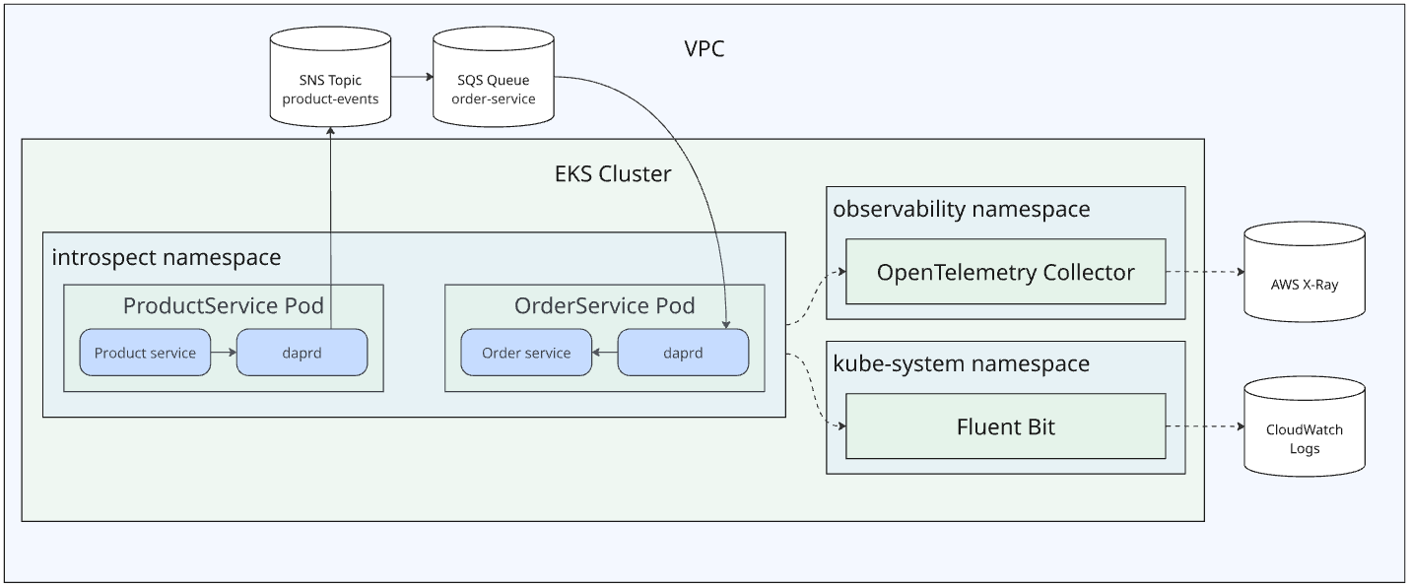

Screenshots and Logs
In ```screenshots``` folder
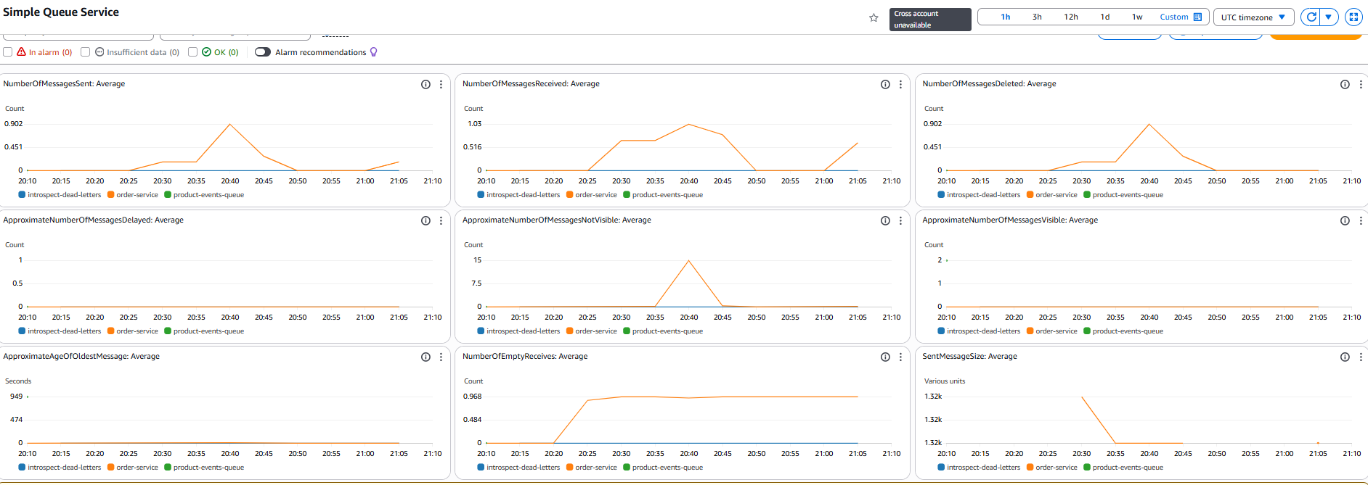
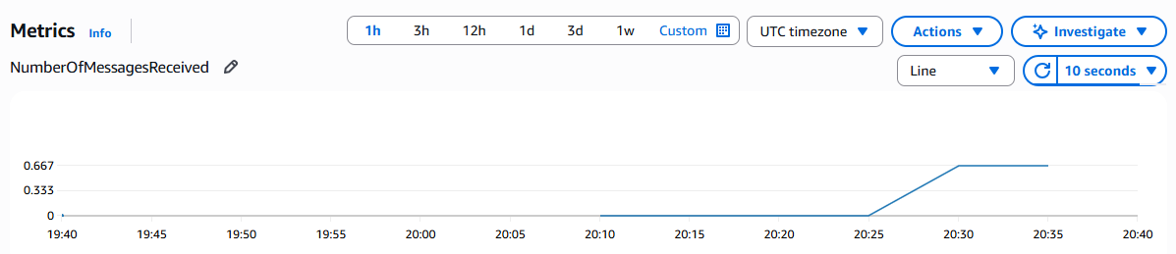
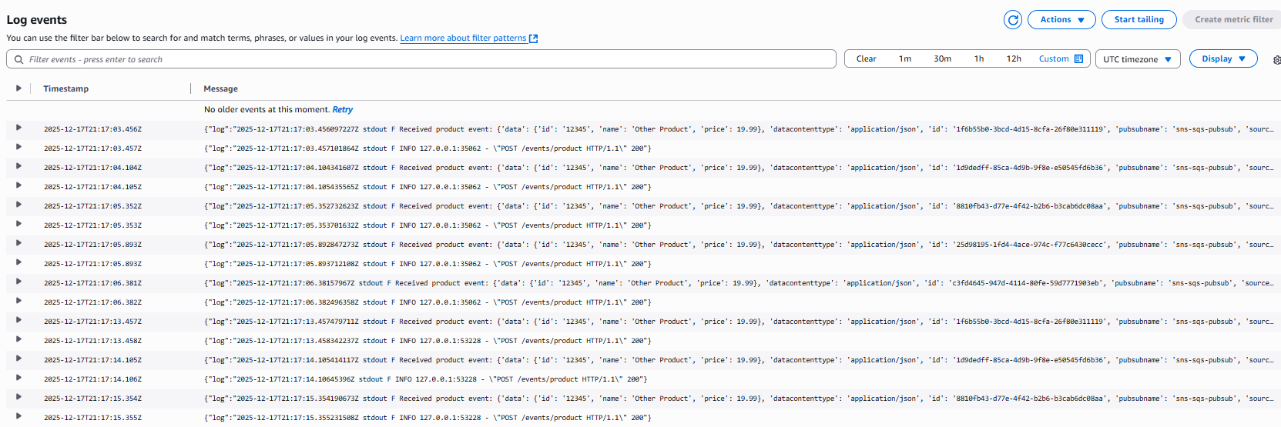
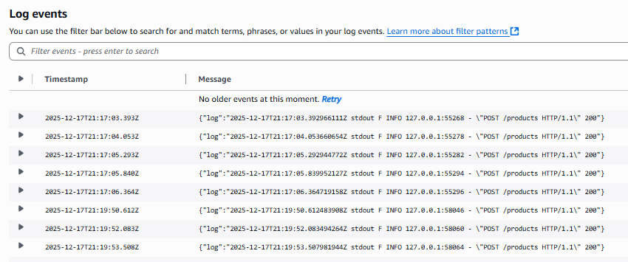

Optional: Bedrock-generated insights
In ```insights_from_bedrock.md``` folder

Suggest missing telemetry points in your microservice
Structured logs (JSON) in both services (replace print): include service, topic, pubsub, cloudevent_id, traceparent/trace_id, status, latency_ms, error.
Publish telemetry (ProductService): log publish_attempt/success/failure with Dapr HTTP status + duration; add request timeout.
Consume telemetry (OrderService): log event_received + event_processed with duration; log failures with exception + whether you expect retry.
Tracing (end-to-end): OpenTelemetry spans for inbound FastAPI requests, the httpx publish call, and the event handler; propagate traceparent from CloudEvent into logs/spans.
Metrics: counts + latency histograms for /products and /events/product, plus events_published_total, events_consumed_total, events_failed_total

Recommend retry + resiliency patterns for event-driven architecture
Retry (bounded): retry transient failures with exponential backoff + jitter; cap attempts/time.
Timeouts everywhere: set tight client timeouts (publish call) and server timeouts to avoid stuck workers.
Idempotency: treat events as “at-least-once”; dedupe by CloudEvent id (store processed IDs for a short TTL).
DLQ / poison handling: after N delivery attempts, route to a dead-letter queue (or tag + alert) instead of infinite retries.
Backpressure: limit concurrent event handlers; shed/slow when downstream is unhealthy.
Circuit breaker: stop calling downstream dependencies during sustained failures; recover with half-open probes.
Bulkhead isolation: separate resources for publish vs. consume paths (threads/concurrency) so one doesn’t starve the other.
Observability-driven: alert on retry rate, age of oldest message, and repeated same event_id.

Analyze my Dockerfile, Kubernetes manifests, and Dapr components
Dockerfiles (Dockerfile, Dockerfile): good minimal base + uv, but you’re on python:3.13 (assignment asks 3.12 LTS) and run as root; also no HEALTHCHECK.
K8s manifests (product-service.yaml, order-service.yaml, kustomization.yaml): Dapr annotations + IRSA ServiceAccounts are correct; missing readiness/liveness probes and resource requests/limits (harder to operate/debug on EKS).
Dapr config (dapr-appconfig.yaml): tracing is disabled (samplingRate: "0"), so you won’t get end-to-end visibility even if everything works.
Dapr pubsub (pubsub-sns-sqs.yaml): disableEntityManagement=true is right given your “topic exists / tags” issues; scopes is good; consider whether decodeBase64=true is actually needed (can corrupt expectations if payload isn’t base64).
Image tags (kustomization.yaml): using latest is convenient for demos but not reproducible; pin to a version/tag for consistent deployments/screenshots.

Recommend scaling patterns for SNS/SQS-based pub/sub on EKS
Scale consumers horizontally: increase order-service replicas; SQS naturally load-balances messages across pods.
Control concurrency: cap per-pod processing concurrency (worker pool) to avoid CPU/memory spikes and SQS visibility-timeout churn.
Tune SQS visibility timeout: set it > worst-case processing time; extend on long work to prevent duplicate deliveries.
Use HPA on real signals: scale on CPU/memory plus queue depth/age (CloudWatch ApproximateNumberOfMessagesVisible / ApproximateAgeOfOldestMessage).
Separate workloads: split “fast” vs “slow” topics/queues (or event types) into different Deployments so one hot path can scale independently.
Batch when safe: for high throughput, process in batches (while keeping idempotency) to reduce per-message overhead.
Provision for spikes: set SQS redrive (DLQ) + alerts; keep pod requests/limits and node autoscaling so EKS can add capacity fast.

