Admin Documentation

A simple "how to" document for Steve and Esther documenting how to do the different admin tasks in our system.

How to enter the Admin page

1. Click the URL at the top of the page
2. Add “/admin” to the end of the URL
3. Push Enter and Log in

Import Spreadsheet

1. Click “Import Spreadsheet”



1. Click “Choose File” under Import New Spreadsheet

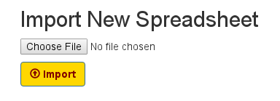

1. Choose an Excel (.xlsx) file

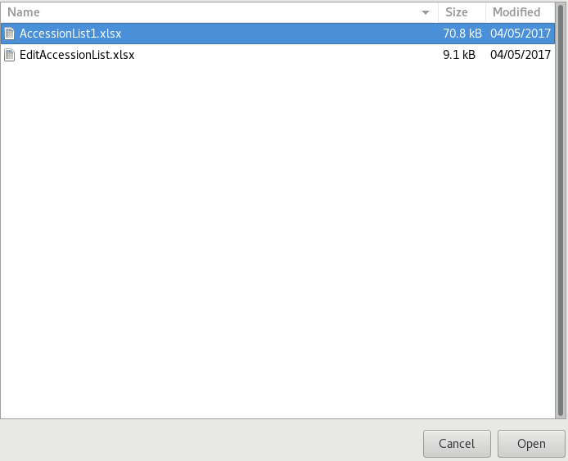

1. Click “Import”



Update Spreadsheet

1. Click “Import Spreadsheet”



1. Click “Choose File” under Update Existing Data

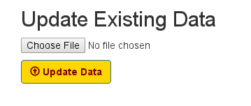

1. Choose an Excel (.xlsx) file



1. Click “Update Data”



Export Data

1. Click “Export Collected Data”

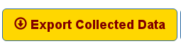

1. Find desired date and data set

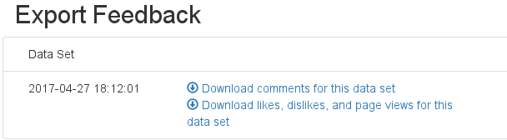

1. Click desired data set

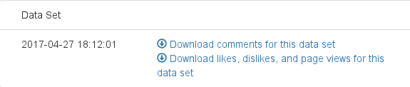

1. Wait for download to finish



1. Click downloaded data set

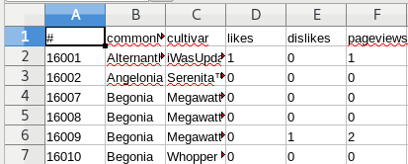

Download QR codes

1. Click “Download QR Codes”



1. Wait for QR Codes to download



1. Click Folder of downloaded QR Codes

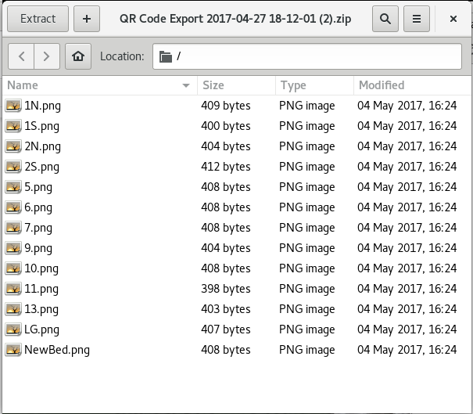

Access Graphs

1. Click “View Charts”



* 1. You can pick which bed you want to look at specifically by clicking the drop down at the top left corner

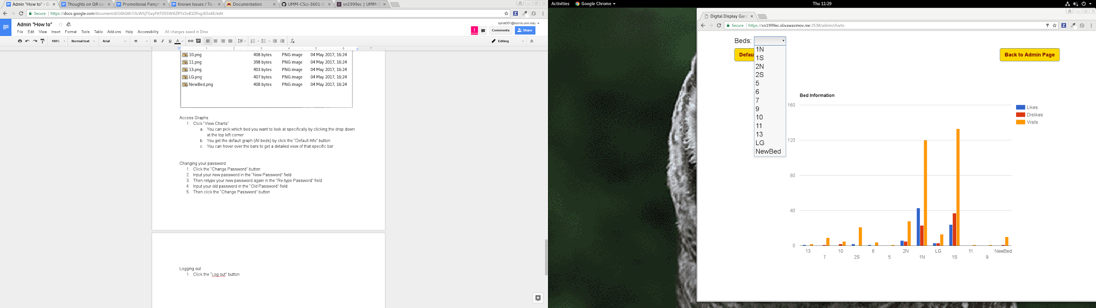

* 1. You get the default graph (All beds) by click the “Default Info” button

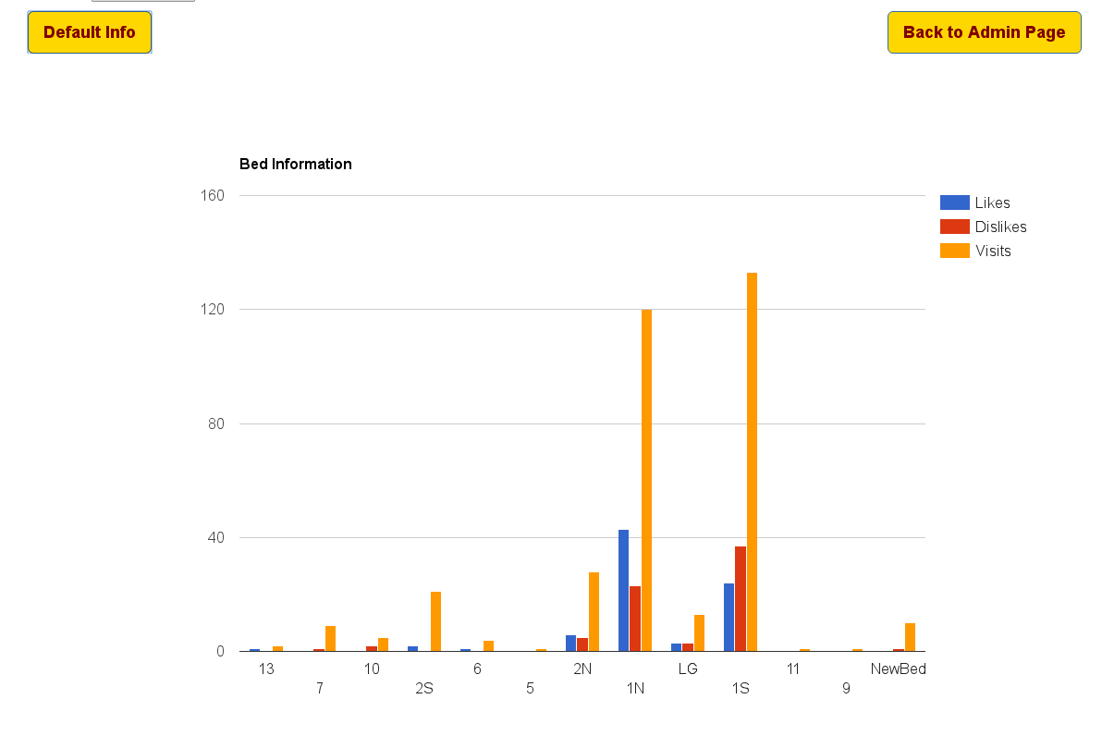

* 1. You can hover over the bars to get a detailed view of that specific bar

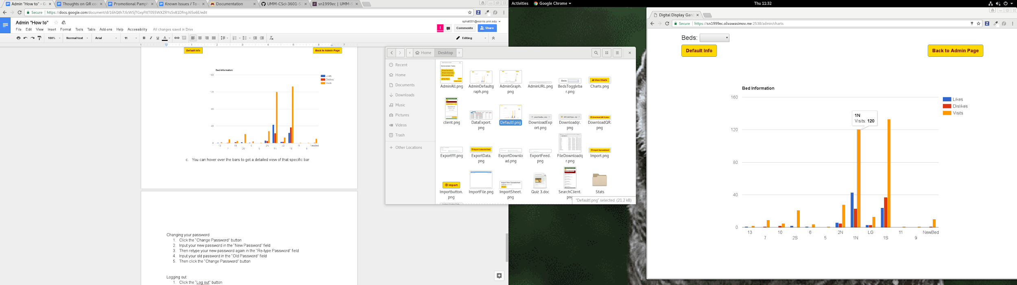

Changing your password

1. Click the “Change Password” button



1. Input your new password in the “New Password” field
2. Then retype your new password again in the “Re-type Password” field
3. Input your old password in the “Old Password” field

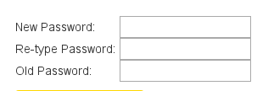

1. Then click the “Change Password” button



Logging out

1. Click the “Log out” button

