Promotional Pamphlet

What does the system do?

1. (Visitors) Records visitor feedback, such as their likes, dislikes and what they had to say while viewing the garden.  
   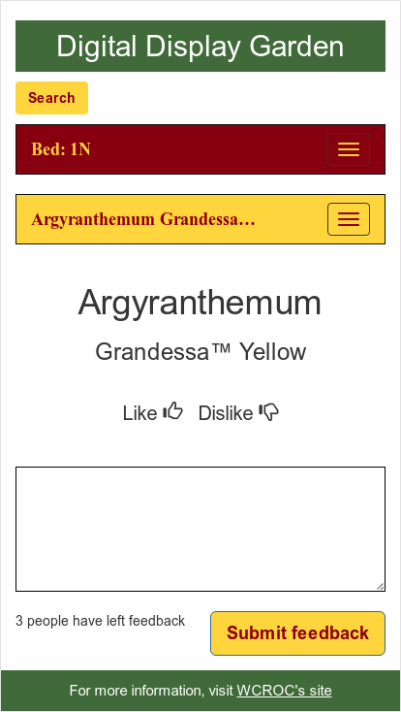
2. (Admin) Creates graphs on the data created through visitor feedback. These graphs can show data based on beds or data on specific flowers.  
   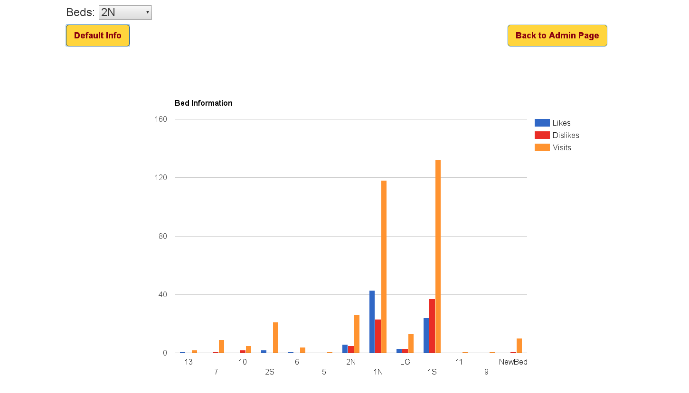
3. (Visitors) Allows for the easy input of an entire garden’s worth of flowers, including their location, common name and cultivar. Users can easily navigate through the beds to find their favorite flowers.  
   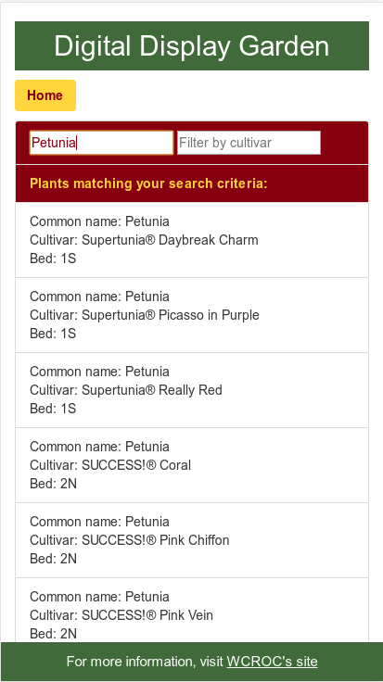

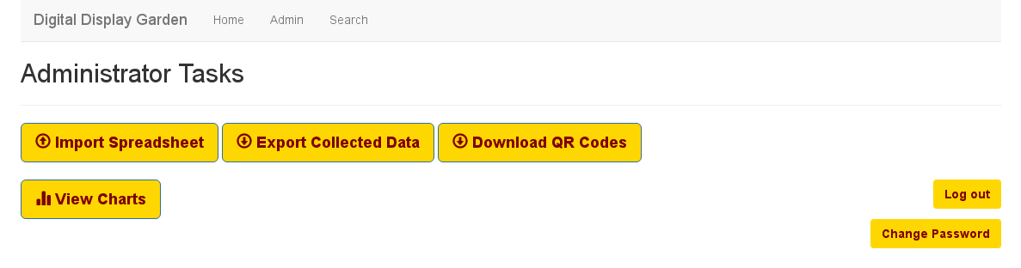

Why is this data desirable?

1. This data is desirable because many providers of experimental breeds of plants greatly value information that relates to how the public views their product prior to its release. This will lead to increased funding as increasing numbers of providers learn of the potential applications of such data.

Why should this system be used in every garden?

1. As providers come to realize the potential of highly valued visitor data, support for data collection will become an industry standard. This application is just one of many that will come to be in the next few years, but as some of the first brave pioneers in this field, our product will consistently be technologically ahead of the curve of any competition.