New-FargetProfile.yml aws awscliv2.zip bhadra-fargate.yml bhadra.yml deploy.yml eks-cluster.yml iam_policy.json kubectl kubectl.sha256 snap

root@ip-172-31-15-31:~# cat bhadra

cat: bhadra: No such file or directory

root@ip-172-31-15-31:~# cat bhadra.yml

---

apiVersion: v1

kind: Namespace

metadata:

name: bhadra

---

apiVersion: apps/v1

kind: Deployment

metadata:

namespace: bhadra

name: deployment-2048

spec:

selector:

matchLabels:

app.kubernetes.io/name: app-2048

replicas: 3

template:

metadata:

labels:

app.kubernetes.io/name: app-2048

spec:

containers:

- image: docker.io/glpskumar/mini-game:latest

imagePullPolicy: Always

name: app-2048

ports:

- containerPort: 80

---

apiVersion: v1

kind: Service

metadata:

namespace: bhadra

name: service-2048

spec:

ports:

- port: 80

targetPort: 80

protocol: TCP

type: NodePort

selector:

app.kubernetes.io/name: app-2048

---

apiVersion: networking.k8s.io/v1

kind: Ingress

metadata:

namespace: bhadra

name: ingress-2048

annotations:

alb.ingress.kubernetes.io/scheme: internet-facing

alb.ingress.kubernetes.io/target-type: ip

spec:

ingressClassName: alb

rules:

- http:

paths:

- path: /

pathType: Prefix

backend:

service:

name: service-2048

port:

number: 80

------------------------------------------------------------

deploy.yml :

apiVersion: apps/v1

kind: Deployment

metadata:

namespace: bhadra

name: dep-bhadra

spec:

selector:

matchLabels:

app.kubernetes.io/name: ttd

replicas: 5

template:

metadata:

labels:

app.kubernetes.io/name: ttd

spec:

containers:

- image: docker.io/glpskumar/ttdimage:latest

imagePullPolicy: Always

name: ttd

ports:

- containerPort: 80

--------------------------------------------------------------------------

ServiceNodeport.yml:

apiVersion: v1

kind: Service

metadata:

namespace: bhadra

name: service-bhadra

spec:

ports:

- port: 80

targetPort: 80

protocol: TCP

type: NodePort

selector:

app.kubernetes.io/name: ttd

Ingress-alb.yml :

apiVersion: networking.k8s.io/v1

kind: Ingress

metadata:

namespace: bhadra

name: ingress-bhadra

annotations:

alb.ingress.kubernetes.io/scheme: internet-facing

alb.ingress.kubernetes.io/target-type: ip

spec:

ingressClassName: alb

rules:

- http:

paths:

- path: /

pathType: Prefix

backend:

service:

name: service-bhadra

port:

number: 80



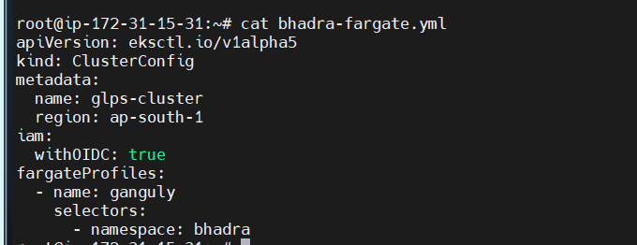

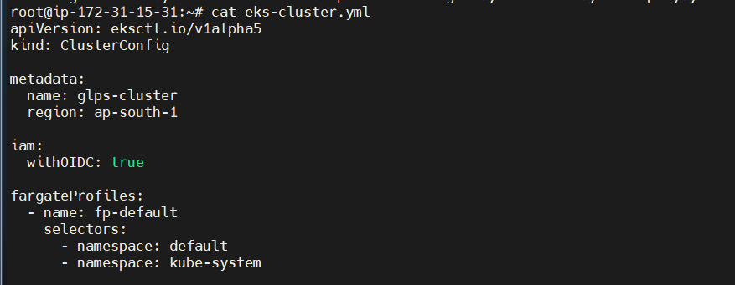

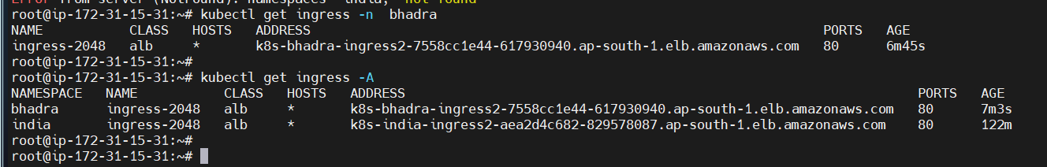

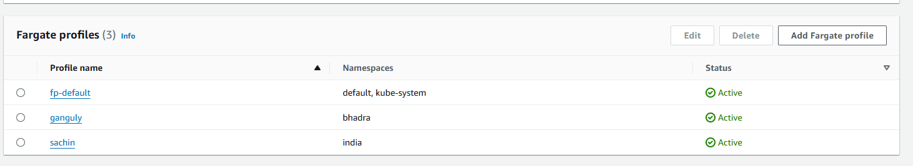

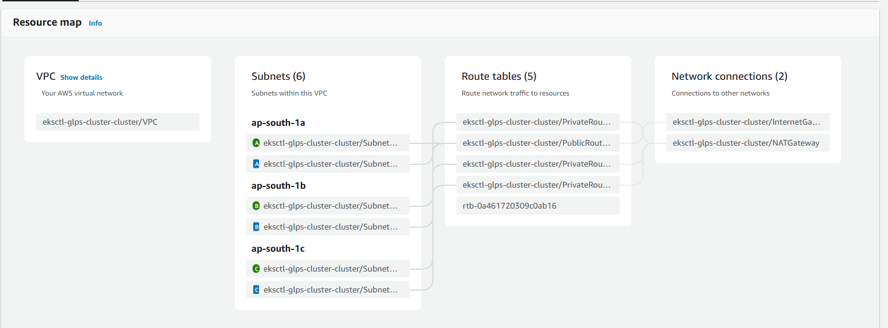

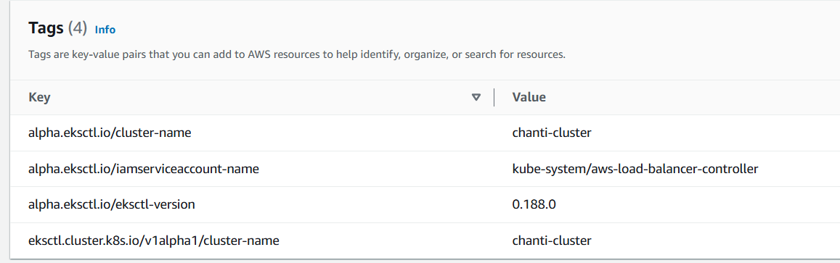

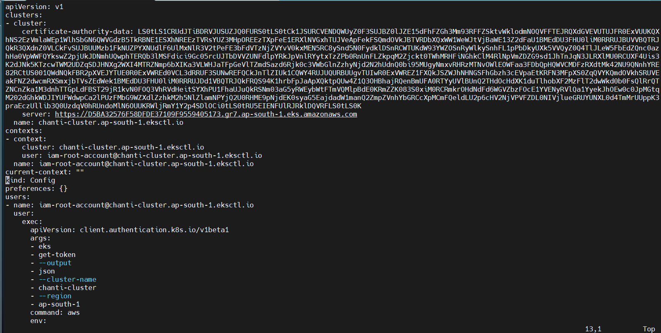

helm install aws-load-balancer-controller eks/aws-load-balancer-controller \

--set clusterName=bhadra-cluster \

--set serviceAccount.create=false \

--set region=ap-south-1 \

--set vpcId=vpc-023bdd74ed578c092 \

--set serviceAccount.name=aws-load-balancer-controller \

--namespace kube-system

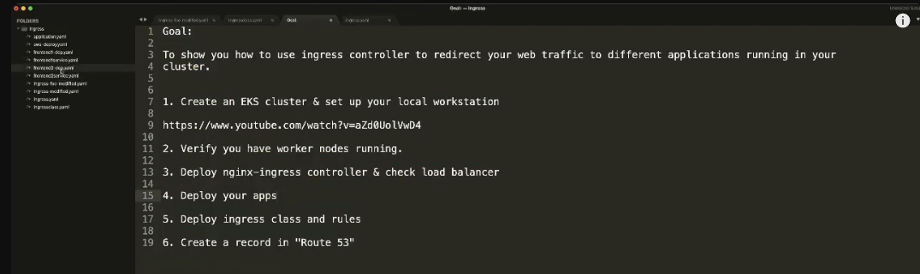

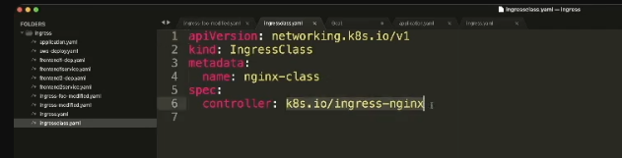

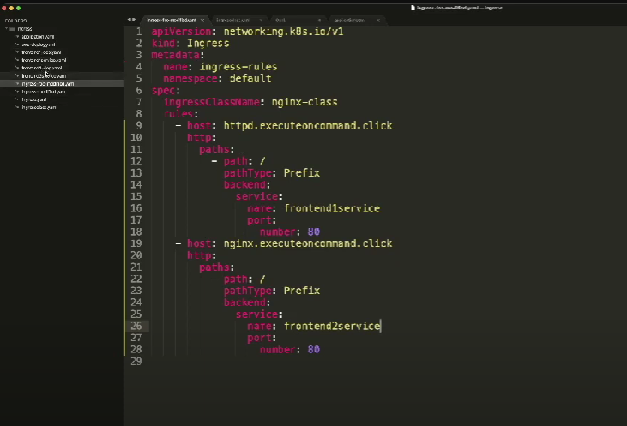

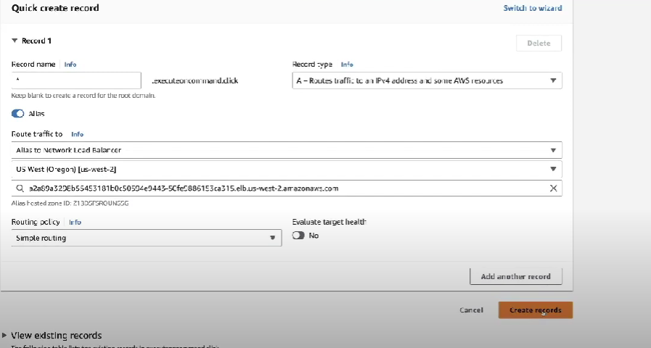

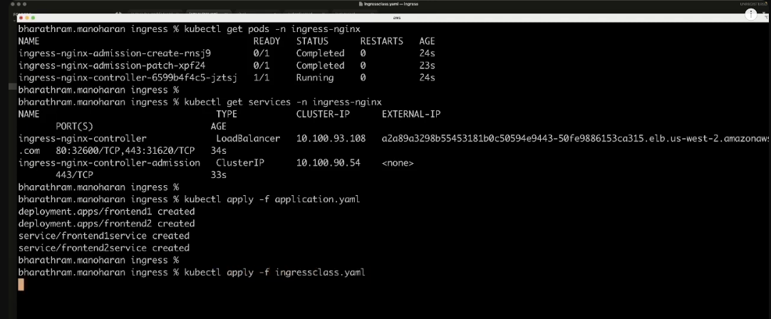

Solution for below error:

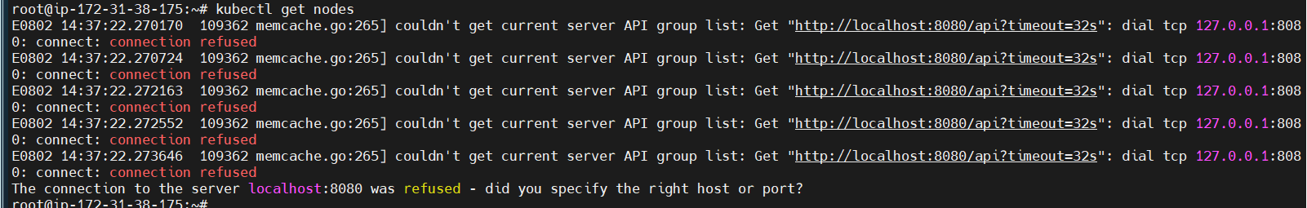

#!/bin/bash

# Variables

CLUSTER_NAME="your-cluster-name"

REGION="your-region"

# Update kubeconfig

echo "Updating kubeconfig for cluster $CLUSTER_NAME in region $REGION"

aws eks update-kubeconfig --name $CLUSTER_NAME --region $REGION

# Verify access

echo "Verifying access to the cluster"

kubectl get nodes

if [ $? -eq 0 ]; then

echo "Successfully connected to the cluster"

else

echo "Failed to connect to the cluster"

fi