Linux users can login wish ssh private key by pvt ( ansible controller /local system pvt key + ansible nodes pub key)
User login with ssh_private_key_file from 1.local system, 2.remote_Ansible_controller
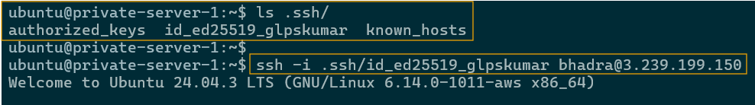
Pubkey saved as authorized_keys
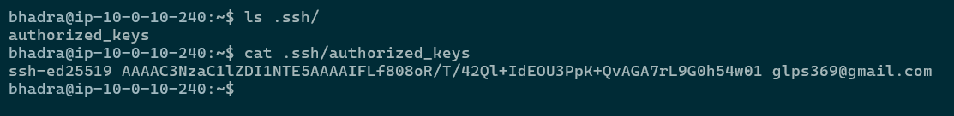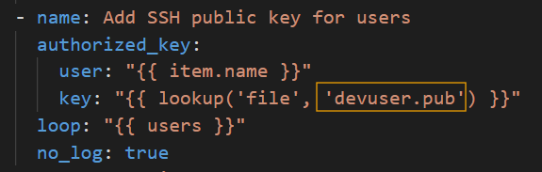
================================================================================
User created ansible node server:
cat /etc/passwd
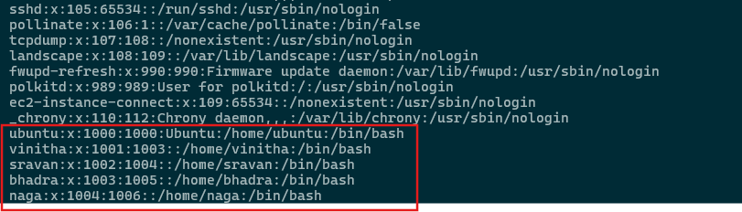
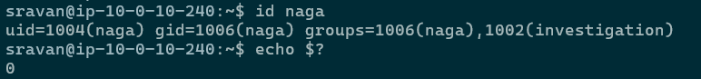
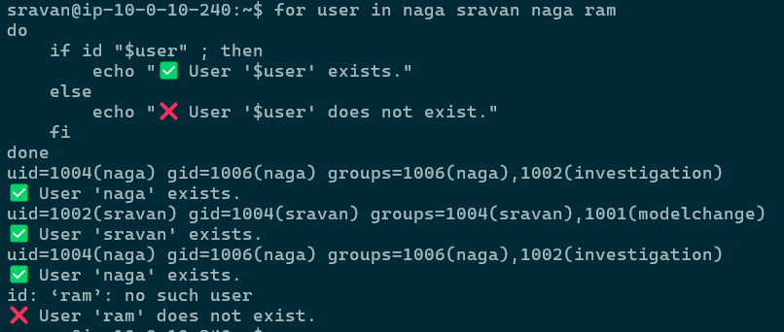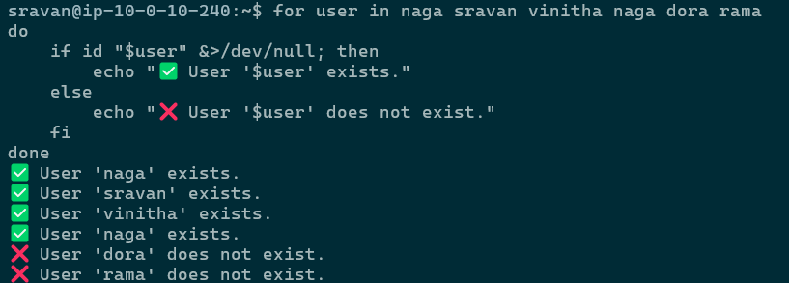

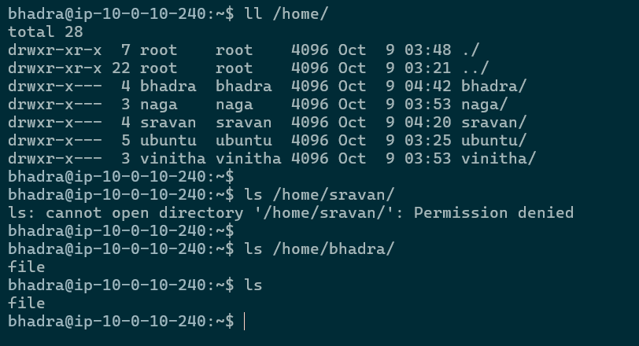
Groups created in node server:
cat /etc/group
