Date: 29-12-2025
Day 2 – Querying & Modifying Data

- Create Database Command
CREATE DATABASE InsuranceDB;
GO
USE InsuranceDB;
GO
- Create Tables: Customers, Policies, Agents, Policyassignments, Claims
CREATE TABLE CUSTOMERS (
customer_id INT IDENTITY(1,1) PRIMARY KEY,
firstname VARCHAR(50),
lastname VARCHAR(50),
date_of_birth DATE,
phone VARCHAR(10),
email VARCHAR(30)
);

CREATE TABLE Agents (
AgentID INT IDENTITY(1,1) PRIMARY KEY,
AgentName VARCHAR(50),
Phone VARCHAR(10),
City VARCHAR(30)
);
CREATE TABLE POLICIES (
policy_id INT IDENTITY(1,1) PRIMARY KEY,
policy_name VARCHAR(30),
policy_type VARCHAR(25),
premium_amount INT CHECK (PremiumAmount > 0),,
duration_years INT
);
CREATE TABLE PolicyAssignments (
AssignmentID INT IDENTITY(1,1) PRIMARY KEY,
CustomerID INT NOT NULL,
PolicyID INT NOT NULL,
AgentID INT NOT NULL,
StartDate DATE,
EndDate DATE,

CONSTRAINT fk_pa_customers
FOREIGN KEY (CustomerID)
REFERENCES Customers(CustomerID),

CONSTRAINT fk_pa_policies
FOREIGN KEY (PolicyID)
REFERENCES Policies(PolicyID),

CONSTRAINT fk_pa_agents
FOREIGN KEY (AgentID)
REFERENCES Agents(AgentID));

INSERT INTO Customers (FirstName, LastName, DateOfBirth, Phone, Email)
VALUES
('Srujana', 'GL', '2003-05-12', '9876543210', 'srujana@gmail.com'),
('Harsh', 'K', '2005-03-18', '9000023456', 'harsh@gmail.com');

INSERT INTO Agents (AgentName, Phone, City)
VALUES
('Ravi Kumar', '8888888888', 'Bangalore'),
('Anita Sharma', '7777777777', 'Hyderabad');

INSERT INTO Policies (PolicyName, PolicyType, PremiumAmount, DurationYears)
VALUES
('Life Shield', 'Life', 15000, 10),
('Health Secure', 'Health', 8000, 5);

INSERT INTO PolicyAssignments (CustomerID, PolicyID, AgentID, StartDate, EndDate) VALUES (1, 1, 1, '2024-01-01', '2034-01-01'), (2, 2, 2, '2024-02-01', '2029-02-01');

INSERT INTO Claims (AssignmentID, ClaimDate, ClaimAmount, ClaimStatus)
VALUES (1, '2024-06-10', 50000, 'Approved'), (2, '2024-07-15', 20000, 'Pending');

SELECT * FROM Customers;
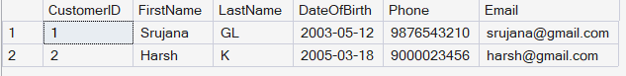

- SELECT CustomerID, PolicyID, StartDate, EndDate FROM policyAssignments;
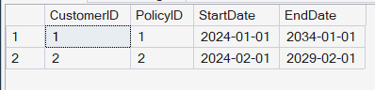

- SELECT * FROM PoliciesWHERE PolicyType = 'Health';
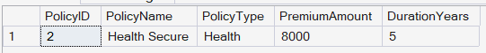

- SELECT * FROM Policies WHERE PremiumAmount > 10000 AND DurationYears = 1;

- SELECT DISTINCT City FROM Agents;
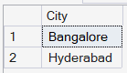
- SELECT * FROM Policies WHERE PolicyType = 'Life' OR PolicyType = 'Health' OR PolicyType = 'Motor';
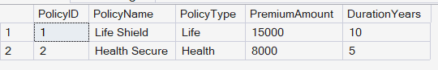

- SELECT * FROM Policies WHERE PolicyType IN ('Life', 'Health', 'Motor');
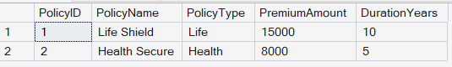
- SELECT * FROM Customers WHERE DateOfBirth >= '2001-01-01' AND DateOfBirth <= '2020-12-31';
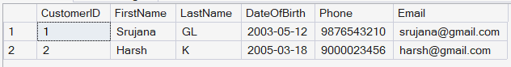

- SELECT * FROM Customers WHERE DateOfBirth BETWEEN '2001-01-01' AND '2020-12-31';
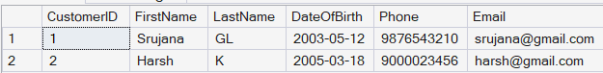

- SELECT * FROM Claims WHERE ClaimStatus = 'Rejected';
- SELECT * FROM Agents WHERE City LIKE '_a%';
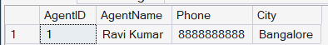

- SELECT MAX(ClaimAmount) AS HighestClaim, MIN(ClaimAmount) AS LowestClaim FROM Claims;

- SELECT TOP 1 *FROM Claims ORDER BY ClaimDate DESC;

- UPDATE Policies SET PremiumAmount = PremiumAmount * 1.10 WHERE PolicyType = 'Health';

- DELETE FROM PolicyAssignments WHERE EndDate < GETDATE();

- SELECT COUNT(*) AS RejectedClaimsCount FROM Claims WHERE ClaimStatus = 'Rejected';

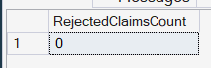

- SELECT PolicyID, PolicyName, PremiumAmount, PremiumAmount * 0.06 AS LocalTaxes, PremiumAmount + (PremiumAmount * 0.06) AS PremiumAmountWithTax, (PremiumAmount + (PremiumAmount * 0.06)) / 12 AS MonthlyPremiumAmountt FROM Policies;
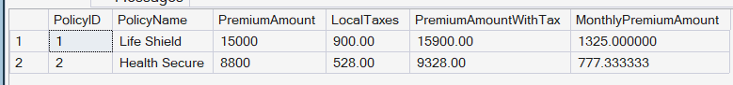

- ALTER TABLE Customers ADD Address VARCHAR(100), City VARCHAR(30);

- ALTER TABLE Agents ADD DevOfId INT;

- ALTER TABLE Agents ADD CONSTRAINT fk_agents_devofidp FOREIGN KEY (DevOfId) REFERENCES Agents(AgentID);

- SELECT p.* FROM PolicyAssignments pa JOIN Policies p ON pa.PolicyID = p.PolicyID WHERE pa.CustomerID = 5;
ii. SELECT c.FirstName, c.LastName, p.PolicyName, p.PolicyType FROM Customers c JOIN PolicyAssignments pa ON c.CustomerID = pa.CustomerID JOIN Policies p ON pa.PolicyID = p.PolicyID;
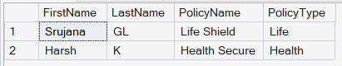
iii. SELECT c.FirstName, cl.ClaimAmount, cl.ClaimStatus, cl.ClaimDate FROM Claims cl JOIN PolicyAssignments pa ON cl.AssignmentID = pa.AssignmentID JOIN Customers c ON pa.CustomerID = c.CustomerID;
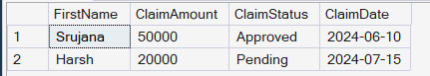
iv. SELECT c.FirstName, p.PolicyName, a.AgentName, pa.StartDate, pa.EndDate FROM PolicyAssignments pa JOIN Customers c ON pa.CustomerID = c.CustomerID JOIN Policies p ON pa.PolicyID = p.PolicyID JOIN Agents a ON pa.AgentID = a.AgentID;
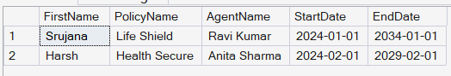
v. SELECT c.FirstName, p.PolicyName, cl.ClaimAmount, cl.ClaimStatus, cl.ClaimDate FROM Claims cl JOIN PolicyAssignments pa ON cl.AssignmentID = pa.AssignmentID JOIN Customers c ON pa.CustomerID = c.CustomerID JOIN Policies p ON pa.PolicyID = p.PolicyID;
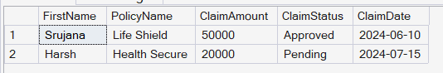
vi. SELECT c.FirstName, p.PolicyName FROM Customers c LEFT JOIN PolicyAssignments pa
ON c.CustomerID = pa.CustomerID LEFT JOIN Policies p ON pa.PolicyID = p.PolicyID;
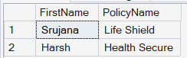
vii. SELECT DISTINCT c.FirstName FROM Customers c LEFT JOIN PolicyAssignments pa
ON c.CustomerID = pa.CustomerID LEFT JOIN Claims cl ON pa.AssignmentID = l.AssignmentID
WHERE cl.ClaimID IS NULL;
viii. SELECT c.FirstName, SUM(cl.ClaimAmount) AS TotalClaimAmount FROM Customers c
JOIN PolicyAssignments pa ON c.CustomerID = pa.CustomerID JOIN Claims cl ON pa.AssignmentID = cl.AssignmentID GROUP BY c.FirstName;
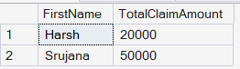
ix. SELECT c.FirstName, SUM(cl.ClaimAmount) AS TotalClaimAmount FROM Customers c
JOIN PolicyAssignments pa ON c.CustomerID = pa.CustomerID JOIN Claims cl ON pa.AssignmentID = cl.AssignmentID GROUP BY c.FirstName HAVING SUM(cl.ClaimAmount) > 50000;

x. SELECT a.AgentName, COUNT(pa.PolicyID) AS PolicyCount FROM Agents a
JOIN PolicyAssignments pa ON a.AgentID = pa.AgentID GROUP BY a.AgentName;
