ASSIGNMENT-2

1.Social media post:

v1:You are a social media content creator, so now help me generate a post for my Instagram account for my trip.
Output:
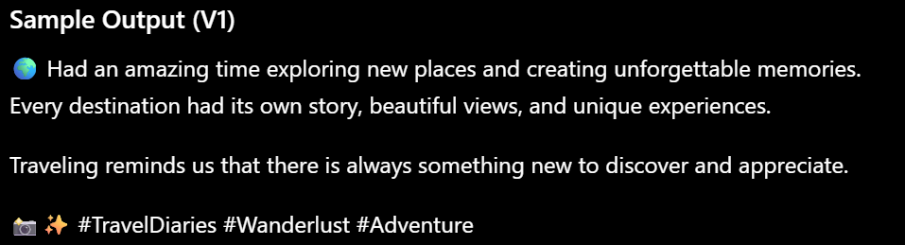

v2:You are a professional social media content creator.
Generate an Instagram post about my trip to {destination}.
Constraints:
- Maximum 80 words
- Include 3 relevant hashtags
- Add 2 emojis
Output:
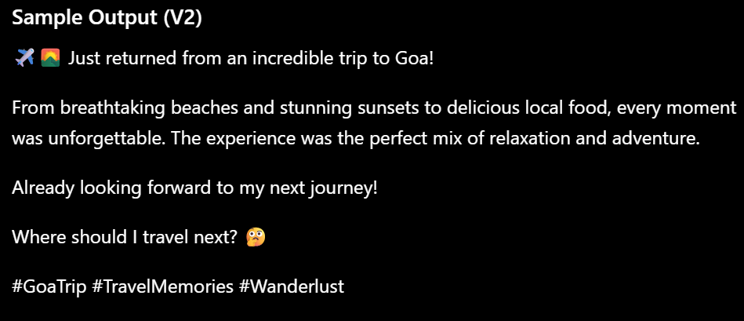

2.Follow-up email:

v1:Write a follow-up email.
Output:
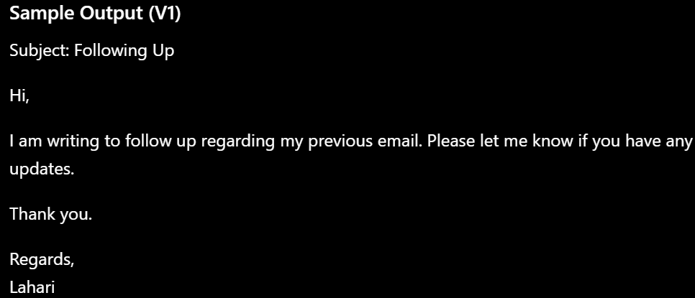

v2:You are a professional Email writter.

Write a follow-up email to {recipient_name} regarding {subject}.
Purpose:
{purpose}
Constraints:
- Maximum 100 words
- Be polite and professional
Output:
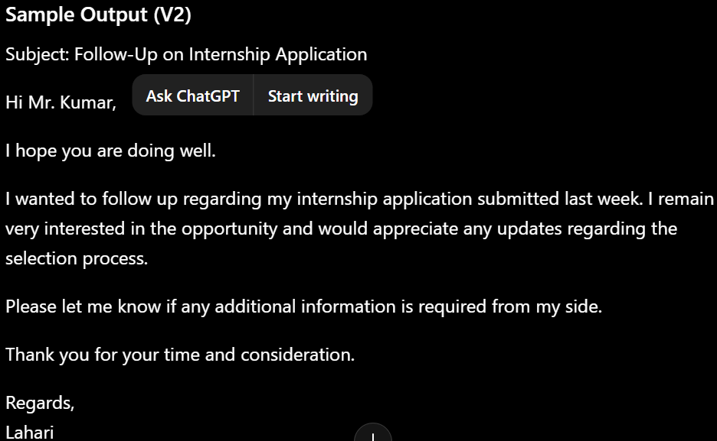

3.Article summarizer:
v1:Summarize this article.
Output:
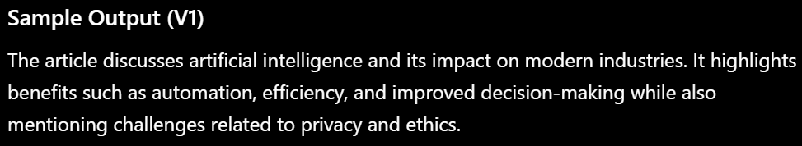
v2:You are an expert at article summarizing.
Summarize the following article about {topic}.
Requirements:
- Summarize in 5 bullet points
- Highlight key findings
- Mention the main conclusion
- Keep the summary under 150 words
Output:
