1. ER DIAGRAM:

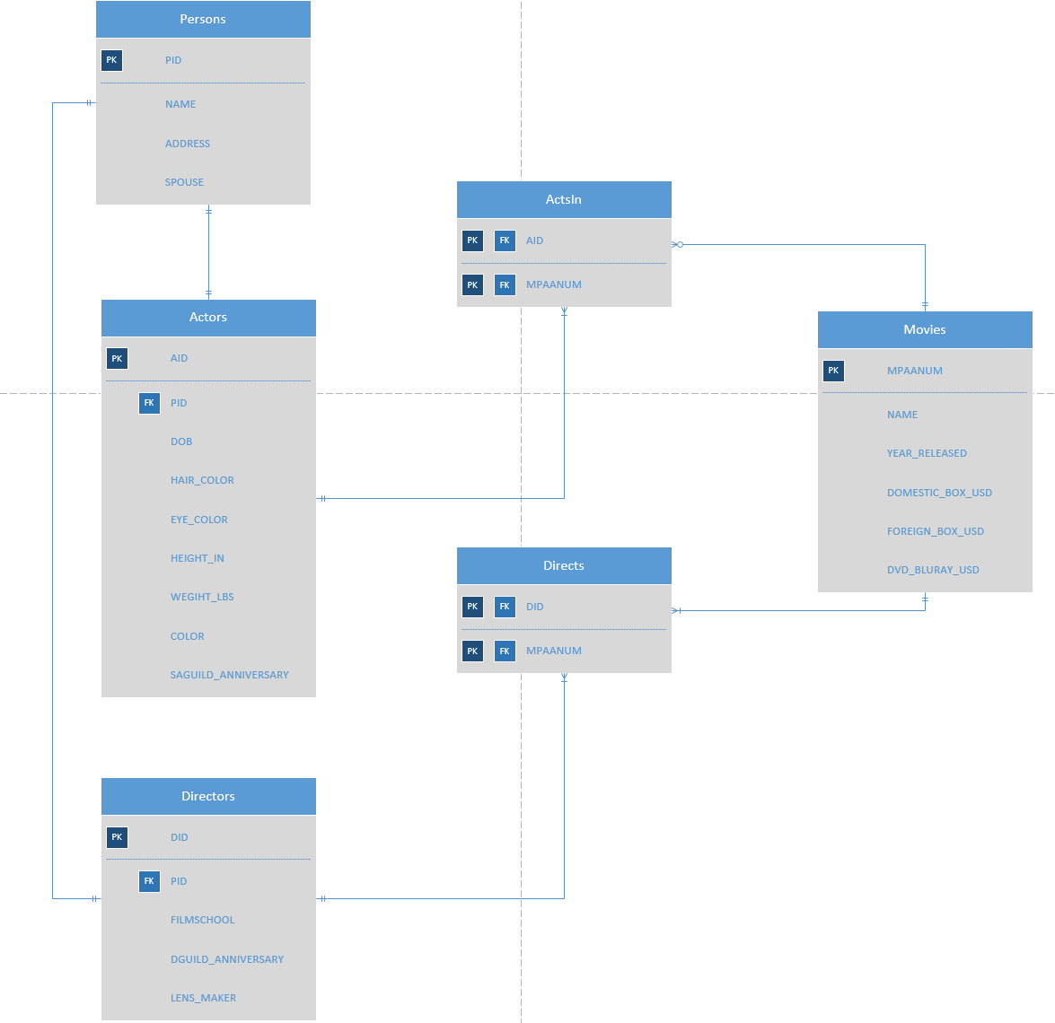

2. Create Statements:
DROP TABLE IF EXISTS Persons;
DROP TABLE IF EXISTS Actors;
DROP TABLE IF EXISTS Directors;
DROP TABLE IF EXISTS ActsIn;
DROP TABLE IF EXISTS Directs;
DROP TABLE IF EXISTS Movies;

CREATE TABLE Persons(
PID char(4) not null,
NAME text not null,
ADDRESS text,
SPOUSE text,
primary key(PID)
);

CREATE TABLE Actors(
AID char(4) not null,
PID char(4) not null references Persons(PID),
DOB date,
HAIR_COLOR text not null,
EYE_COLOR text not null,
HEIGHT_IN integer not null,
WEIGHT_LBS integer not null,
COLOR text,
SAGUILD_ANNIVERSARY date,
primary key(AID)
);

CREATE TABLE Directors(
DID char(4) not null,
PID char(4) not null references Persons(PID),
FILMSCHOOL text,
DGUILD_ANNIVERSARY date,
LENS_MAKER text,
primary key(DID)
);

CREATE TABLE ActsIn(
AID char(4) not null references Actors(AID),
MPAANUM int not null references Movies(MPAANUM),
primary key(AID,MPAANUM)
);

CREATE TABLE Directs(
DID char(4) not null references Directors(DID),
MPAANUM int not null references Movies(MPAANUM),
primary key(DID,MPAANUM)
);

CREATE TABLE Movies(
MPAANUM int not null,
NAME text not null,
YEAR_RELEASED int not null,
DOMESTIC_BOX_USD int,
FOREIGN_BOX_USD int,
DVD_BLURAY_USD int,
primary key(MPAANUM)
);

3. Functional Dependencies

- Persons
  - PID → NAME, ADDRESS, SPOUSE
- Actors
  - PID → AID
  - AID → DOB, HAIR_COLOR, EYE_COLOR, HEIGHT_IN, WEIGHT_LBS, COLOR, SAGUILD_ANNIVERSARY
- Directors
  - PID → DID
  - DID → FILMSCHOOL, DGUILD_ANNIVERSARY, LENS_MAKER
- ActsIn
  - MPAANUM → AID
- Directs
  - MPAANUM → DID
- Movies
  - MPAANUM → NAME, YEAR_RELEASED, DOMESTIC_BOX_USD, FOREIGN_BOX_USD, DVD_BLURAY_USD
4.

SELECT *
FROM Directors
WHERE DID IN (SELECT DID
FROM Directs
WHERE MPAANUM IN(
SELECT MPAANUM
FROM ActsIn
WHERE AID IN (
SELECT AID
FROM Actors
WHERE NAME='Sean Connery')))

