**KBA – GMBA scenarios**

Having not handled these data layers together, I can see the following scenarios. It seems a bit difficult and convoluted, especially case E.

I would see the following cases: for each WCMC mountain KBA (per country?), check:

* Is WCMC mountain KBA entirely covered by one mountain range (A)?: GMBA_V2_ID is attributed the KBA
* WCMC mountain KBA intersects one mountain range, but not entirely covered (B)?: GMBA_V2_IDis attributed the **entire** KBA
* WCMC mountain KBA intersects two or more ranges (D)?: KBA is split along the border between the ranges. There are new polygons: KBA / Range 1 and KBA / Range 2 (etc), each with a new area
* WCMC mountain KBA intersects two or more ranges, and some non-mountain area (E)?: KBA is split along the border between the ranges. There are new polygons: KBA / Range 1 and KBA / Range 2, each with a new area. Remaining area is proportionally / equally attributed to the intersecting mountain polygons [not sure about this last rule]
* Is WCMC mountain KBA entirely outside any GMBA mountain polygon (C)? KBA gets a code / name identifying it as non named mountain range OR gets the GMBA_V2_ID of the closest GMBA polygon (would probably be processing intensive?)Diagram, schematic

  Description automatically generated

Examples of the six options (A-F) for central Spain:

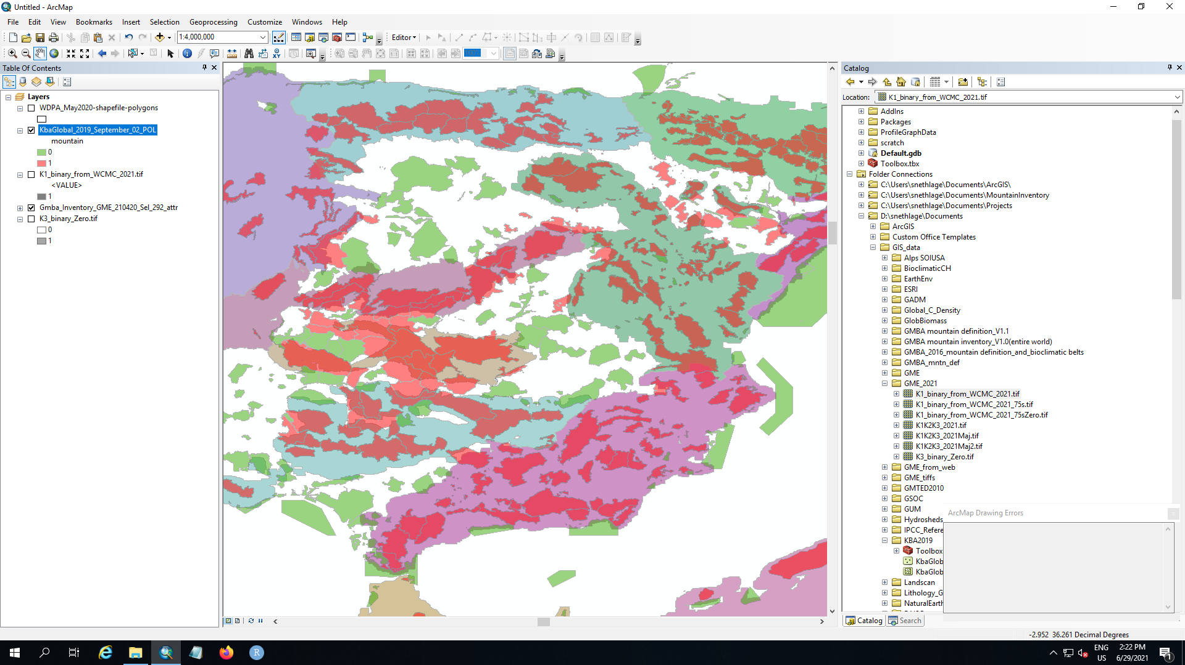

**B**

**C**

**A**

**F**

D

**E**

Light colours (not red or green): GMBA mountain polygons

Red: UNEP-WCMC mountain KBAs

Green: UNEP-WCMC non-mountain KBAs

Black rectangles with white letter: refers to cases in the schema above

**Scenario E**

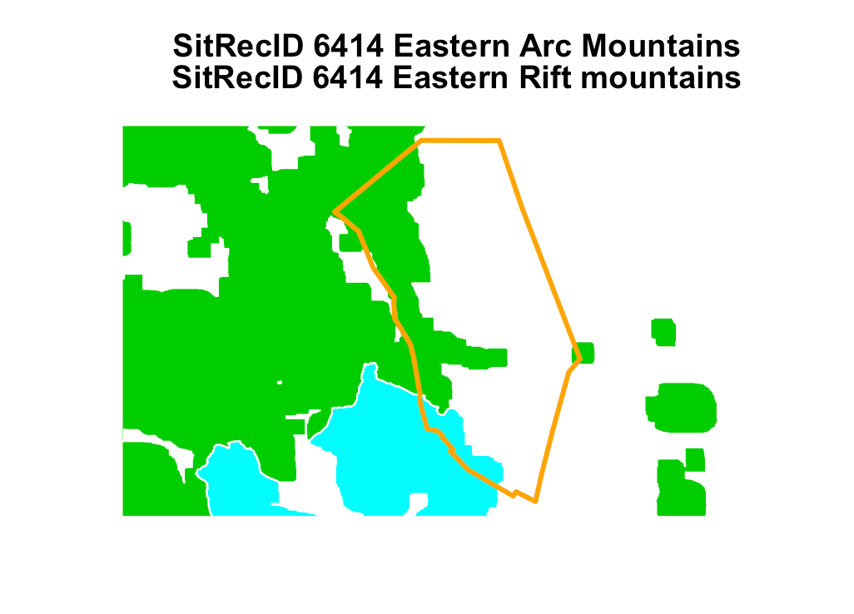

Solved with this line of code: if(sum(st_is_valid(gmba)) < nrow(gmba)) gmba <- st_make_valid(gmba)

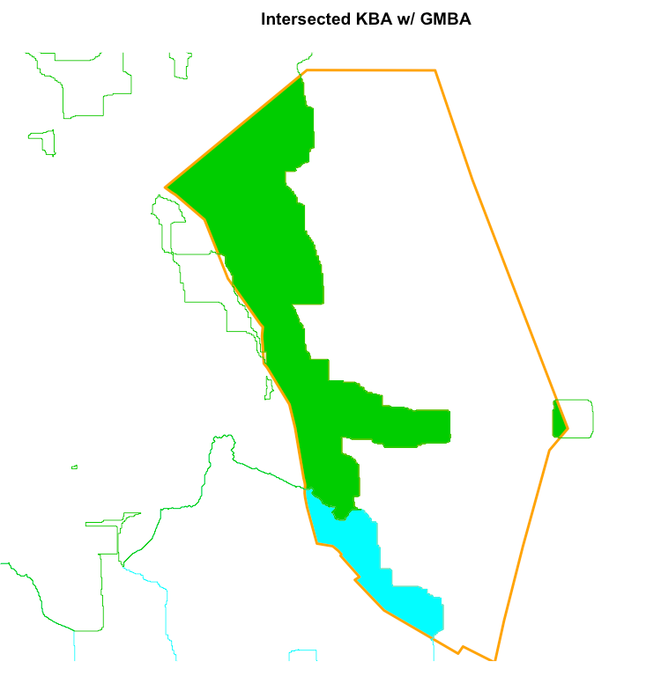

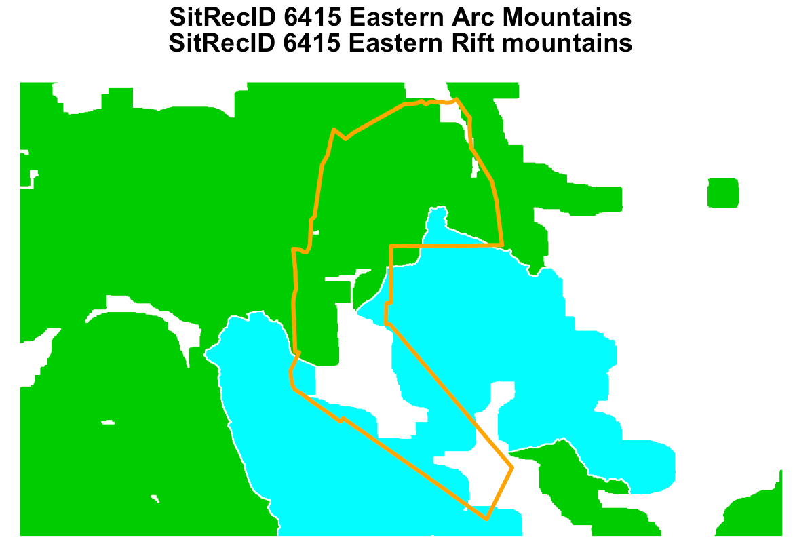

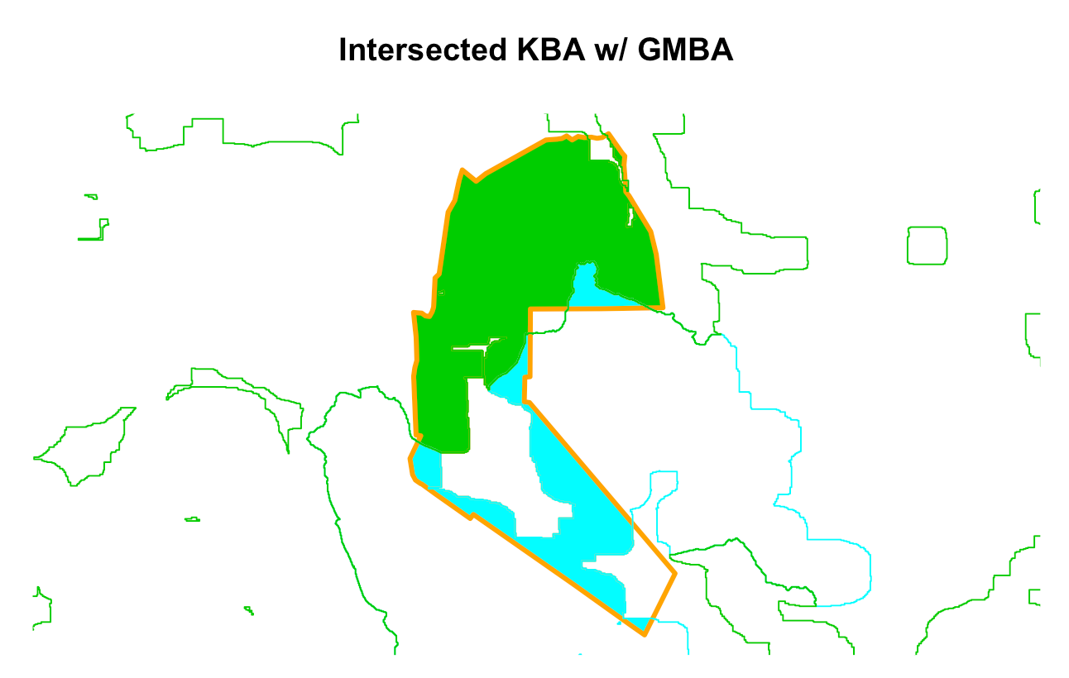

Is there an easier way to identify the area of the white space?

**Scenario C**

Since we loop by GMBA ID, these would eventually be left out of the calculation

**Code for KBA prep below**

