

NAME: WAHAJ MANZAR (SOLO)
BSSE(B) Semester 4
Subject: DATABASE (Lab)

JUDICIARY MANAGEMENT SYSTEM
Milestone | Version | Date | Remarks
ERD & DB Schema | 1.0 | 26-04-2026
Schema description | 1.1 | 3-05-2026
Normalization of Schema | 2.0 | 11-05-2026
Preparation of Dataset | 3.0 | 12-05-2026
Creating Tables | 4.0 | 13-05-2026
Loading data into database | 5.0 | 14-05-2026

ERD
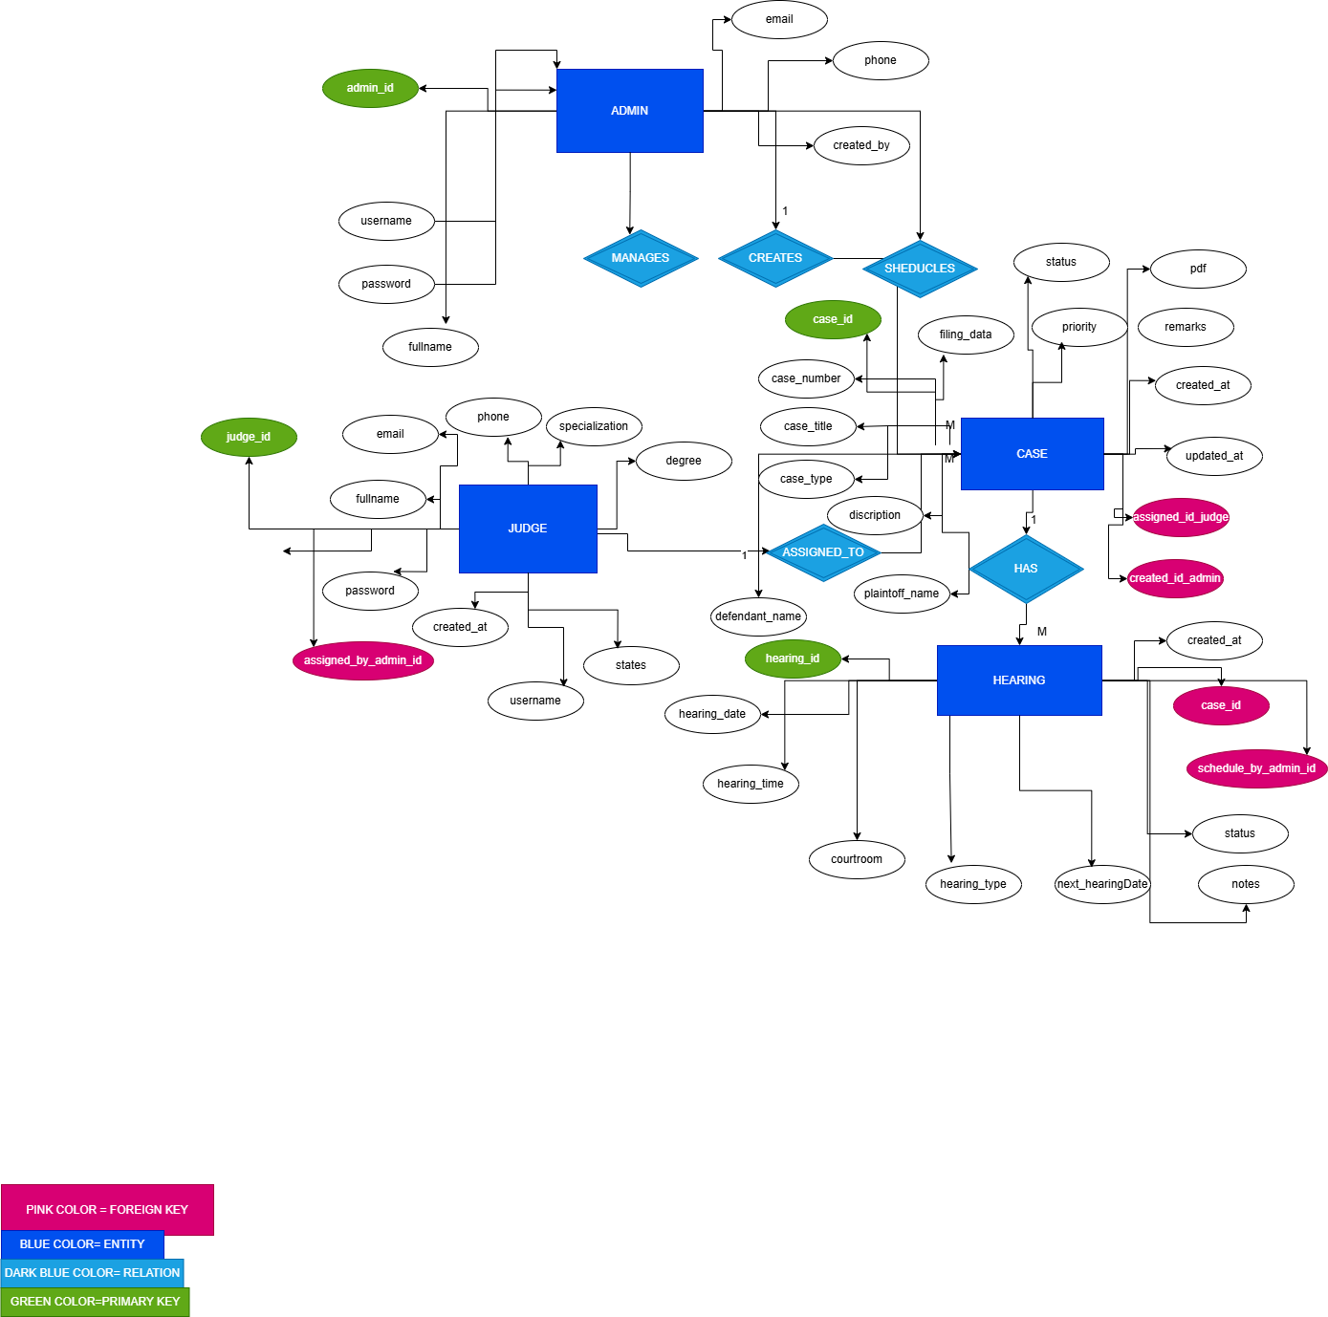

SCHEMA & DESCRIPTION
ADMIN TABLE SCHEMA
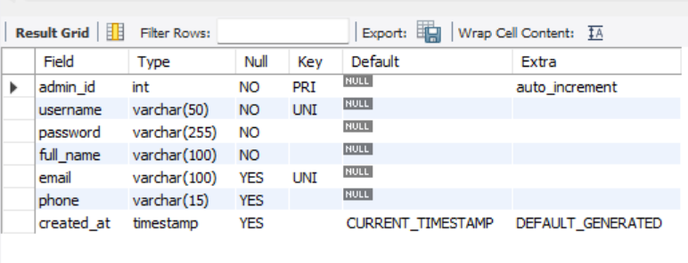
HEARING TABLE SCHEMA
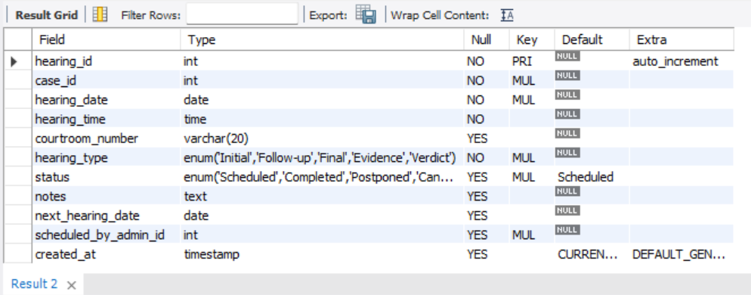

JUDGE TABLE SCHEMA
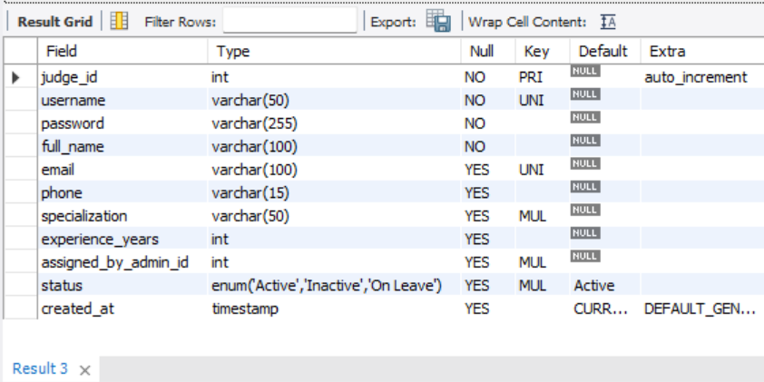
CASE TABLE SCHEMA
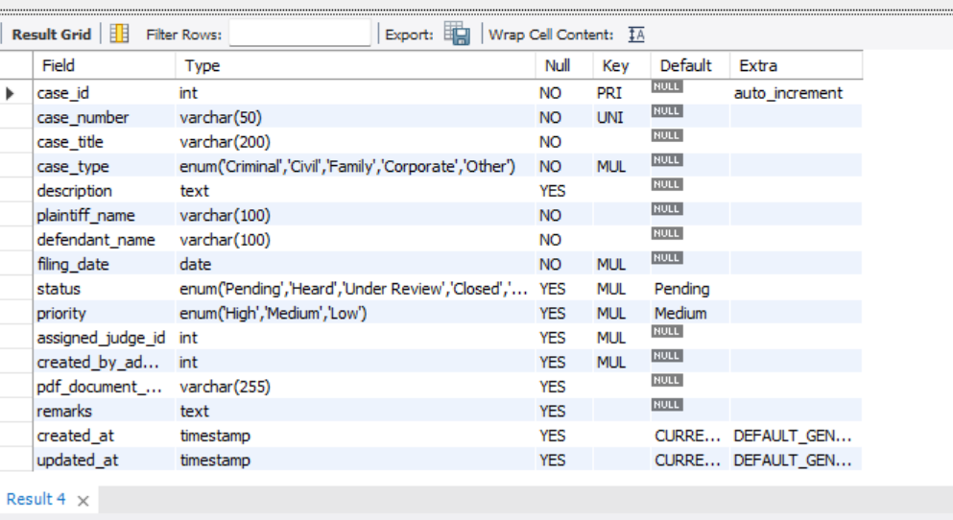

Relationships Description

1. Admin → Judge (1:M)
- Type: One-to-Many
- Description: One admin can add and manage multiple judges
- Implementation: assigned_by_admin_id in Judge table references admin_id in Admin table
- Cardinality: 1 Admin : Many Judges
- Delete Rule: ON DELETE SET NULL (if admin is deleted, judge records remain but reference is nullified)

2. Admin → Case (1:M)
- Type: One-to-Many
- Description: One admin can create multiple cases
- Implementation: created_by_admin_id in Case table references admin_id in Admin table
- Cardinality: 1 Admin : Many Cases
- Delete Rule: ON DELETE SET NULL

3. Admin → Hearing (1:M)
- Type: One-to-Many
- Description: One admin can schedule multiple hearings
- Implementation: scheduled_by_admin_id in Hearing table references admin_id in Admin table
- Cardinality: 1 Admin : Many Hearings
- Delete Rule: ON DELETE SET NULL

4. Judge → Case (1:M)
- Type: One-to-Many
- Description: One judge can be assigned multiple cases
- Implementation: assigned_judge_id in Case table references judge_id in Judge table
- Cardinality: 1 Judge : Many Cases
- Delete Rule: ON DELETE SET NULL (cases remain if judge is removed)

5. Case → Hearing (1:M)
- Type: One-to-Many
- Description: One case can have multiple hearings scheduled over time
- Implementation: case_id in Hearing table references case_id in Case table
- Cardinality: 1 Case : Many Hearings
- Delete Rule: ON DELETE CASCADE (if case is deleted, all associated hearings are deleted)

Referential Integrity Constraints
- No orphan judges: Every judge must be added by a valid admin (enforced by foreign key)
- No orphan cases: Every case must have a creator admin and can optionally have an assigned judge
- No orphan hearings: Every hearing must be linked to a valid case (CASCADE delete ensures cleanup)
- Case assignment validation: A case can only be assigned to judges who exist in the Judge table
- Hearing scheduling: Hearings can only be created for existing cases

Database Constraints Summary
Constraint Type | Application
PRIMARY KEY | All tables have auto-incrementing integer primary keys
FOREIGN KEY | Judge, Case, and Hearing tables reference Admin; Case references Judge; Hearing references Case
UNIQUE | Usernames in Admin and Judge tables; case_number in Case table; email addresses
NOT NULL | Critical fields like names, usernames, passwords, case_number, filing_date, hearing_date
DEFAULT | Timestamps, status fields, priority levels
ENUM | Controlled vocabulary for status, case_type, priority, hearing_type
CASCADE DELETE | Hearing records deleted when parent Case is deleted
SET NULL | Foreign key references set to NULL when referenced record is deleted (except Hearing→Case)

MILESTONE 2: Database Normalization (1NF to 3NF)

Normalization Analysis for Each Table

Table 1: Admin
Current Structure:
Admin (admin_id, username, password, full_name, email, phone, created_at)
Normalization Status:
1NF (First Normal Form): SATISFIED
- All attributes contain atomic values (no multi-valued attributes)
- Each column contains only one value
- No repeating groups
2NF (Second Normal Form): SATISFIED
- Table is in 1NF
- No partial dependencies (all non-key attributes depend on the entire primary key admin_id)
- Since admin_id is a single-column primary key, partial dependency cannot exist
3NF (Third Normal Form): SATISFIED
- Table is in 2NF
- No transitive dependencies (no non-key attribute depends on another non-key attribute)
- All attributes (username, password, full_name, email, phone, created_at) directly depend on admin_id
Conclusion: Admin table is fully normalized to 3NF. No further normalization needed because all attributes are atomic, directly dependent on the primary key, and there are no transitive dependencies. The table represents a single entity with simple attributes.

Table 2: Judge
Current Structure:
Judge (judge_id, username, password, full_name, email, phone, specialization,
experience_years, assigned_by_admin_id, status, created_at)
Normalization Status:
1NF: SATISFIED
- All attributes are atomic
- No multi-valued attributes
- Each field contains single values
2NF: SATISFIED
- In 1NF
- Primary key is judge_id (single column)
- All non-key attributes fully depend on judge_id
3NF: SATISFIED
- In 2NF
- No transitive dependencies exist
- assigned_by_admin_id is a foreign key (relationship), not a transitive dependency
- All other attributes directly describe the judge entity
Conclusion: Judge table is fully normalized to 3NF. The assigned_by_admin_id is a foreign key representing a relationship with Admin table, not a transitive dependency. All attributes directly relate to the judge entity without redundancy or dependency issues.

Table 3: Case
Current Structure:
Case (case_id, case_number, case_title, case_type, description, plaintiff_name,
defendant_name, filing_date, status, priority, assigned_judge_id,
created_by_admin_id, pdf_document_path, remarks, created_at, updated_at)
Normalization Status:
1NF: SATISFIED
- All attributes contain atomic values
- No repeating groups or multi-valued attributes
- Each column has single values
2NF SATISFIED
- Table is in 1NF
- Primary key case_id is single column
- All non-key attributes fully functionally depend on case_id
3NF: SATISFIED
- Table is in 2NF
- No transitive dependencies
- Foreign keys (assigned_judge_id, created_by_admin_id) represent relationships, not transitive dependencies
- All attributes (case_number, case_title, plaintiff_name, defendant_name, etc.) directly describe the case entity
Conclusion: Case table is fully normalized to 3NF. Despite having multiple attributes, each attribute directly describes properties of a legal case without creating redundancy. The plaintiff and defendant names are attributes of the case itself (not separate entities in this system scope), and all foreign keys represent valid relationships rather than transitive dependencies.

Table 4: Hearing
Current Structure:
Hearing (hearing_id, case_id, hearing_date, hearing_time, courtroom_number,
hearing_type, status, notes, next_hearing_date, scheduled_by_admin_id,
created_at)
Normalization Status:
1NF: SATISFIED
- All attributes are atomic
- Single values per field
- No repeating groups
2NF: SATISFIED
- In 1NF
- Primary key is hearing_id (single column)
- All non-key attributes depend on the complete primary key
3NF: SATISFIED
- In 2NF
- No transitive dependencies
- case_id and scheduled_by_admin_id are foreign keys (relationships)
- All other attributes (hearing_date, hearing_time, courtroom_number, etc.) directly describe the hearing event
Conclusion: Hearing table is fully normalized to 3NF. All attributes are directly related to the hearing entity without redundancy or dependency anomalies. The foreign keys establish proper relationships with Case and Admin tables without violating normalization principles.

Final Verdict: All four tables in the Judicial Case Management System are already in 3NF. The schema was designed with normalization principles in mind from the beginning, ensuring data integrity, minimal redundancy, and efficient storage. No decomposition or restructuring is required.

Data Flow Description
The Judicial Case Management System follows a structured flow of data between four main entities: Admin, Judge, Case, and Hearing. The system ensures that all records are connected through relational constraints and logical business rules.

1. Admin Data Flow
The process begins with the creation of Admin records. Admins are responsible for managing the system and performing administrative operations. Each admin can:
- Register judges
- Create and manage cases
- Schedule hearings
Admin information is stored in the Admin table and linked with other tables using foreign keys.

2. Judge Data Flow
After admins are created, judges are added to the system. Each judge:
- Is assigned by an admin
- Has a specialization such as Criminal, Civil, Family, or Corporate law
- Can be assigned multiple cases
Judge data flows from the Admin entity into the Judge table through the assigned_by_admin_id foreign key relationship.

3. Case Data Flow
Cases are created and managed by admins. During case creation:
- A unique case number is generated
- Plaintiff and defendant information is recorded
- A judge is assigned to the case
- Case status and priority are defined
- A PDF document path is attached for legal documentation
The Case table acts as the central entity of the system because it connects both judges and hearings.
The flow of data for a case is:
Admin → Case → Judge Assignment → Document Storage

4. Hearing Data Flow
Once a case is registered, hearings are scheduled for the case. Each hearing includes:
- Hearing date and time
- Courtroom information
- Hearing type
- Hearing status
- Notes and remarks
The hearing process depends on the current status of the case:
- Pending and Under Review cases receive future hearing dates
- Heard and Closed cases have completed hearings
- Dismissed cases contain cancelled hearings and no next hearing date
Each hearing record is linked to a case using the case_id foreign key.

5. PDF Document Flow
Each case contains a PDF document path that points to legal case files stored locally in the system directory:

GITHUB LINK: https://github.com/GMLOL-DEV

