Chado Schema Documentation

Chado Schema Documentation 1
Sequences and features 3
Basic concepts 3
Feature = Sequence 3
Feature types 3
Feature coordinates 3
Query: Find features in region of interest 3
Multiple locations for a feature 4
Feature Names 4
Query: find gene by name or synonym 4
Linking features to external database objects 4
Query: find feature by External DB Id 4
Feature relations 5
Reference sequences and Wild Types 5
The Central Dogma 5
Genes 6
Transcripts, Splicing, Alternative Splicing 6
Exons and Introns 7
ORFs (Open Reading Frames)/ CDSs 7
Proteins 7
Promoters, introns, regulatory elements, UTR’s 7
Linking features to External Database entries. 7
Gene Model Evidence: matches to EST, cDNA, etc. 8
Sample Query: Retrieve a gene along with its transcripts, proteins and exons. 8
Beyond the Central Dogma 9
RNA editing 9
Transplicing 9
Do alternate spliceforms with identical coding regions share a protein feature? 10
Exon outside of known transcript 10
Immature/primary RNA 10
transcript cleavage 10
Dicistronic transcript 10
Nonstandard translation 10
Stop-codon readthroughs 10
Alternative codon usage – eg. Selenocysteine 10
4-base codons, frameshifting 11
Posttranslational modifications 11
Derivatization – glycosylation, etc. 11
Cleavage 11
Inteins 11
Protein Complexes 12
Sequence Alignments 12
BLAST hits 12
Aligning ESTs/cDNA to genomic DNA 13
Multiple alignments 13
Protein Families 13
Curated 13
Computed 13
Domain-based 13
Homology, Orthology, Paralogy 13
Motifs 13
HMM hit (to protein and/or DNA) 13
Domain structure 13
Repeats 13
Genomes, Chromosomes and Assemblies 13
Multiple species’ genomes within same schema 13
Multiple variants of same genome within same schema 13
How to load a genome 13
Assemblies, scaffolds 13
REDUNDANT STORAGE OF COORDINATES ON DIFFERENT ASSEMBLY LEVELS 14
GenBank Accessions 14
Circular Chromosomes 14
Comparative Mapping / Genome Alignments 14
Synteny (= genome alignments?) 14
Annotating conserved regions 14
Sequence Variations 14
SNPs 15
Splice variants 24
Haplotypes 24
Haplotype 24
Alleles 24
Inversions 25
Rearrangements 25
Translocations 25
Transposon insertion 25
Non-wild type features in reference genome? (Eg. R3). 25
Link variants to stocks 25
Link variants to phenotypes 26
Insertion, deletion, translocation 26
Features peculiar to a nonreference variant, eg spanning insertion boundaries 26
Transposon itself 26
Insertion 26
Sample query: find all genes containing transposon insertions in their promoters 26
Sample Transactions 26
Renaming a gene 26
Splitting a gene 26
Merging two genes 26
Deleting a gene 26
Batch Delete of Computed Features 26
Maps 26
Clones and Libraries 26
Genetics 26
Expression 27
Controlled Vocabularies 27
Hierarchical queries 28
Publications 28
Data History 29
Performance, Indexes, Locking 29
XML 30
Related Work 34

Introduction
This document describes the chado schema which is a relational schema for holding model organism genomic data. Both the schema and the document are a work in progress. Caveat lector.

Sequences and features

Basic concepts

Feature = Sequence
Chado does not distinguish between a sequence and a sequence feature, on the theory that a feature is a piece of a sequence, and a piece of a sequence is a sequence. Both are represented as a row in the feature table.

Feature types
Feature types are taken from the SO controlled vocabulary (see also Controlled Vocabulary section in this document). A selection of chado-relevant types from SO are shown below:

exon | SL:0000025
intron | SL:0000027
mRNA | SL:0000037
3_utr | SL:0000029
5_utr | SL:0000028
noncoding_transcript | SL:0000040
miRNA_precursor | SL:0000043
miRNA | SL:0000044
rRNA | SL:0000042
tRNA | SL:0000041
regulatory_element | SL:0000052
transcription_factor_binding_site | SL:0000054
clone | SL:0000050
genbank_entry | SL:0000061
match | SL:0000008
nucleotide_match | SL:0000018
cross_genome_match | SL:0000074
EST_match | SL:0000021
mRNA_match | SL:0000022
protein_match | SL:0000020
translated_nucleotide_match | SL:0000019
pseudogene | SL:0000007
repeat_region | SL:0000002
direct_repeats | SL:0000005
inverted_repeat | SL:0000004
repeat_family | SL:0000006
retrotransposon | SL:0000014
transposon | SL:0000012
tandem_repeat | SL:0000003
microsatellite | SL:0000013
remark | SL:0000062
variant | SL:0000065
deletion | SL:0000067
insertion | SL:0000066
SNP | SL:0000072

Types not currently in SO but useful in chado include:
- protein
- inversion
- HSP
- EST?
- Allele? WildTypeAllele?

Feature coordinates
Features are located relative to other features using the featureloc table rows. Features can be located on more than one sequence. For example, a BLAST hit HSP can be a feature of both the query and target sequences. To locate a feature, create a featureloc row with:
- source_feature_id = the id of the sequence on which the feature is being located
- feature_id = the id of the feature being located
- Strand is 1 for the positive strand, -1 for the negative, and 0 for both or indifferent.
- Min, max – the minimum and maximum coordinates of the interval
- nbeg,nend= the natural begin and end of the feature relative to the sequence. If on the positive strand, or indifferent to strand, then nbeg < nend, if on the negative strand nend < nbeg. If the feature is a point, use nbeg=nend. Thus (nend-nbeg)*Strand >=0. Coordinates are interpreted as interbase, to allow for explicit representation of insertion sites. The position before the first base in a sequence has interbase coordinate 0. Representing both min,max and nbeg,nend is redundant; there should be a trigger to enforce this denormalization (or we should get rid of one set).
- is_nbeg_partial, is_nend_partial = true if needed to indicate that the sequence is incomplete (e.g. for ESTs or EST assemblies which are known to not go all the way to the 3’ or 5’ end.)
- Phase = 0,1, or 2 – denotes phase of first basepair in a nucleotide feature wrt a source protein, or the offset of the first nucleotide in its codon.
- Rank, Locgroup – these are used to organize groups of feature locations and can be ignored in simple cases. Their use will be described elsewhere in the document; search for Rank and Locgroup if you are curious.

Query: Find features in region of interest
Strand
Circular chromosome
Indexing (contig, min, max)?
Geometric functions, R-tree indexing?

Multiple locations for a feature
The ability to have multiple locations for a feature has many uses. For example one can locate a SNP, exon, or protein motif on the genome, on a transcript, and on a protein. A region of similarity between two sequences (HSP) can be located on both of them, so if either is viewed the “hit” is visible.

Feature Names
Feature.name is a place to store, e.g. gene or allele names. It is nullable, since not all features need names. Different communities may want to impose different naming conventions. (See e.g. Fly genetic object nomenclature document.) The primary preferred short name should be stored here (ie what a diagram would show).
Feature.uniquename is a required, unique symbol denoting the feature. Naming conventions are up to the community; however this field is intended to simplify references to the feature in XML and SQL , not for human use, so readability considerations are secondary.
Feature synonyms are found by joining to feature_synonym (and synonym?). feature_synonyms can be associated with Pubs to indicate which name an article used for an object.
Name types can be used to indicate whether a name is current or obsolete, as well as what kind of name it is – short name, long description, etc.
Any computed names for exons, etc? Stability of exon numbers is problematic. Automatic renumbering of transcripts also causes problems for curators, e.g. comments may refer to old names.

Query: find gene by name or synonym
select feature_id from feature
where name='name of interest'
union select feature_id
from feature_synonym fs, synonym s
where fs.synonym_id=s.synonym_id
and s.name='name of interest'
and fs.is_current;

name may or may not be a synonym.
What about alleles? Other species in same DB?
Is it fast?

Scott: gadfly=> create index feature_lc_name on feature (lower(name));
and
select name,feature_id,seqlen,type_id from feature
where lower(name) = '3r.3';
and it is wicked fast (that's Boston-speak, right?). I would suggest
adding this index to the chado schema.

Linking features to external database objects
Public database identifiers are stored in the DBXREF table, which holds the DB name, the accession number, and an optional version number. Note that this table holds accession numbers published by the Chado instance as well as by other databases. A feature can have a primary DBXREF, which is linked directly from the feature table. It can also have additional secondary DBXREFs linked via feature_dbxref. A feature need not have a primary DBXREF; e.g. computed features may be considered “lightweight” and not assigned accession numbers. Some groups may wish to set up a trigger to automatically assign primary DBXREFs to features of types that are locally accessioned; a sample trigger is provided with the schema.

Query: find feature by External DB Id
Union primary and secondary

Feature relations
Feature relations are used to establish relationships between features other that localizations. For example the relationship between a gene and a transcript is represented by a feature relationship of type ProducedFrom, while an allele is linked to a gene by a feature of type AlleleOf. (Verify that these are still canonical relations!)

Reference sequences and Wild Types
In this document we frequently use the term “reference sequence”. This can have several meanings which are worth distinguishing:
- The sequence that coordinates refer to, i.e., featureloc.source_feature
- A stable assembly of a genome which has been annotated and is used as a reference standard for defining sequence variations, i.e. SNP#12345 substitutes a T instead of G at position 377776 of the reference contig for chromosome IV. In this example the reference contig provides both coordinates and content. We will use the term “reference assembly” for this, and “reference contig” for the contigs.
- The reference sequence of a gene is the sequence that occurs on a reference assembly.
- Wild type sequence is the sequence of the allele that the genetic community for an organism defines as wild type. The wild type sequence of a gene may or may not be the reference sequence, depending on whether the strain that the reference assembly was based on was wild type in that particular gene. Some communities declare a particular strain wild-type by definition (e.g. E.coli K-12), so this is a non-issue for them. Other communities may want to consider creating a reference assembly which is wild type everywhere, but is an in silico chimera, created by replacing any non-WT alleles in the sequenced strain with wild type sequences from other strains.

The Central Dogma
Central dogma refers to the core representation of genes, transcripts, proteins, and the relationships between them.
In what follows we will say locate A on B as shorthand for create a featureloc row that places feature A on feature B, and relate A by term to B as shorthand for create a feature_relationship with feature A as subjfeature, feature B as objfeature, and term as the relationship type, e.g. relate A as part_of B.

(Check legibility of figs in black and white. Make sure term usage is canonical.)
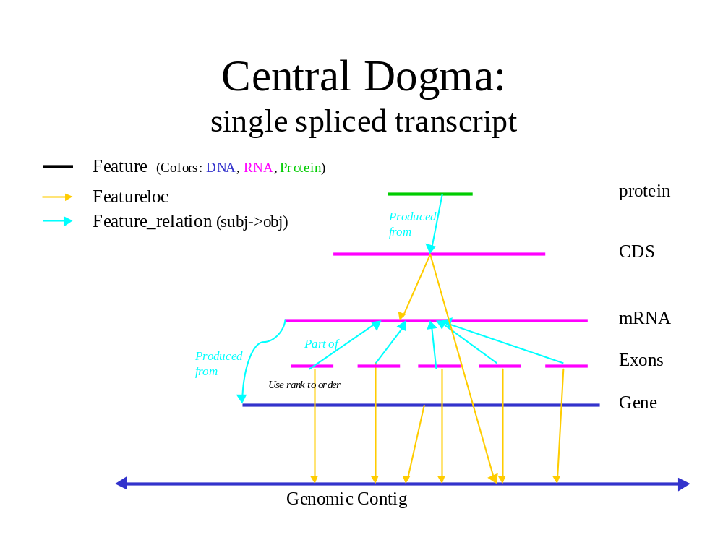

Genes
A gene is represented by a feature of type Gene, optionally located on a genomic contig (genes can be unlocalized), with coordinates spanning all of its exons and, optionally, regulatory environs. Feature name should be primary gene symbol, use Synonyms table for additional names. In FlyBase a gene is typically identical to the wild-type allele, which has an allele name; this should be indicated as a synonym. The strand should specify which strand the exons are on; use 0 if transpliced. The primary DBXREF can be to an external DB or can be assigned by the Chado instance if it accessions genes. (FlyBase assigns genes accessions of the form FBAL#).
We do not distinguish between a gene’s sequence and its locus, as some schemas do, nor between the gene and its sequence. We use the reference sequence of each gene to denote the gene, in the sense of a database object from which to hang information.

Transcripts, Splicing, Alternative Splicing
A gene may have multiple transcripts as a result of alternate splicing. Each transcript should be represented by a feature of type mRNA (SO:0000234) (or one of its subtypes, typically monocistronic messenger RNA (SO:0000633) (Use SOFA terms). Each transcript should be related by ProducedFrom to the gene it is derived from. (I.e., SubjFeatureID=the transcript, ObjFeatureID = the gene). Feature_relationship.relrank field can be used to arbitrarily order transcripts for enumeration (no biological meaning). The transcript should (?) be located on the genome using the min and max of the exon coords.

Exons and Introns
Each exon should be represented by a feature of type Exon or one of its subtypes. Introns can be created explicitly as features if desired. Exons should be related to transcripts by DerivedFrom (?). Feature_relationship.relrank is used to order exons within transcripts. Exons should be located on the genome; coding phase can be indicated here using featureloc.phase.

ORFs (Open Reading Frames)/ CDSs
A feature of type ORF (or CDS?) is used to represent the translated region(s) of a transcript. It should be located (or related?) on the transcript, and (optionally) on the genome as well.

Proteins
Each protein product of a transcript is represented by a feature of type Protein (is this in SOFA yet?). The protein is related to the ORF by DerivedFrom.
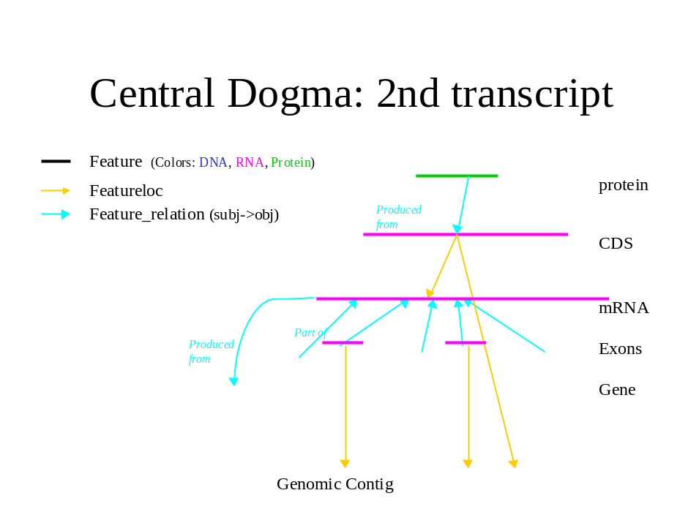

Promoters, introns, regulatory elements, UTR’s
These are optional; if desired they can be created as features of the corresponding type, and related to the gene using Contains (?). UTRs should be located on the transcript.

Linking features to External Database entries.
Create a primary DBXREF for any features for which the Chado instance assigns public accession numbers. If the feature “belongs” to another database, a primary DBXREF should be created to that accession number. Primary DBXREF can be left NULL. Secondary DBXREFs should also be created for features with multiple public accessions.

Gene Model Evidence: matches to EST, cDNA, etc.
How is a cDNA match that supports a transcript related to the transcript?

Sample Query: Retrieve a gene along with its transcripts, proteins and exons.
No transitivity operators in PostGreSQL? Could root the graph in the gene. That would make this query simple but would add a lot of rows to the feature_relationship table. Can you do this in a function?
Does the query below handle ORF between transcript and protein?
Could you write a query that would, given a feature_id (typically of a gene), get all of the subfeatures of the gene (exons and other items as well)?
Ok, at first this appears non-trivial, but I'll present a solution later
that makes things easier
First, let's make the assumption that the feature graph has 3 levels; this
assumption may be incorrect. See http://www.fruitfly.org/~cjm/chado-talk/chado-talk.html for some non-central dogma examples
If we follow this assumption:
SELECT
*
FROM
feature AS gene
INNER JOIN
feature_relationship AS fr0 ON (gene.feature_id =
fr0.objfeature_id)
INNER JOIN
feature AS subf1 ON (subf1.feature_id = fr0.subjfeature_id)
INNER JOIN
feature_relationship AS fr1 ON (subf1.feature_id =
fr1.objfeature_id)
INNER JOIN
feature AS subf2 ON (subf2.feature_id = fr1.subjfeature_id)
WHERE
gene.name = 'Dredd';
Will fetch a 3 deep graph rooted at Dredd. You will obviously need stuff like feature properties, either as a seperate query or using more joins.
There is a problem in that the depth-3 assumption may be wrong. There are other incorrect assumptions embedded in the abovequery.
You could get round this by issuing multiple SQL queries to traverse the feature graph to the leaves.
So far we have been focusing on chado as a database for managing complex sequence data - for efficient querying, I think we need to do a few more things:
define some standard views - for instance, for "gene", "gene model" and so forth. these will simplify queries such as the above. they won't make the queries faster in themselves. but it is a simple matter to materialize these views for a query database. at this point you could argue you are using a different schema from chado-core, but I think this is ok, as you have well defined transforms for getting to the denormalised one.
the other thing you have to do is compute the closure of the feature graph - this will allow you to fetch the entire graph in one non-recursive SQL call. Again this is something that would only be used in the query-db. See the talk html above for discussion of transitive closure.
There are a number of options for computing the closure - the GO code, or some pgplsql that ShengQiang Shu here at BDGP wrote.
I would say the easiest way to do it now is "in-code"; ie multiple SQL calls and build the graph/hierarchy in perl. At some point in the future we will have to come up with a set of standard denormalisations to help querying.

Beyond the Central Dogma

RNA editing
RNA editing is represented by creating two mRNAs, before and after the edit, and relating them by DerivedFrom. Further, we advocate representing the edit itself as a (fine-grained) feature located on both. (RNA editing feature types in SOFA?). (This is analogous to our representation of SNPs and other variations.) The edit feature should be located on both the pre-edit and post-edit messages. Residue_info can be used to store an explicit representation of the editing event – how?

Transplicing
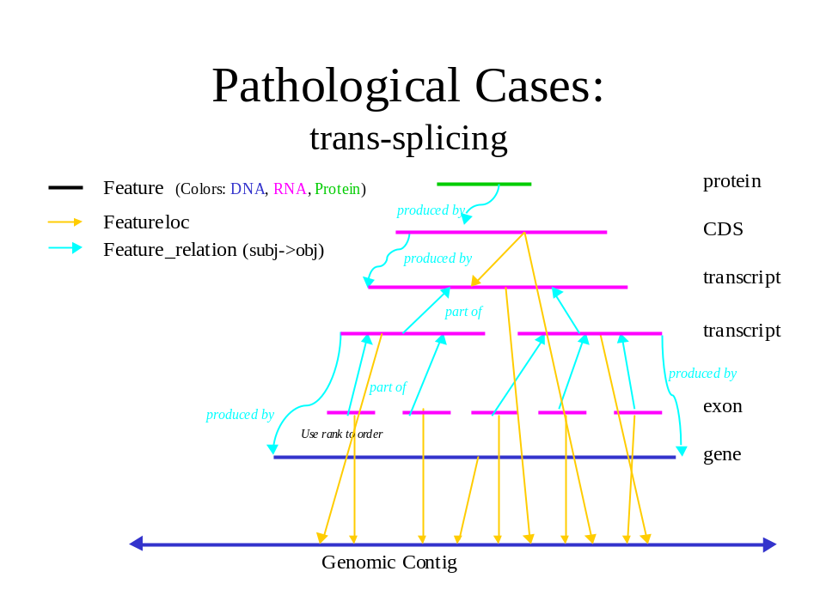
The class of transplicing events that involve ligating transcripts from different loci into a mature mRNA requires a separate feature to represent each locus transcript and one to represent the fused transcript. The fragments are located on the fused transcript; portions of the fused transcript can also be located on the genome. How do we express the fact transplicing occurred? E.g. query find transpliced genes. If one of the fragments is reused across many transcripts, as in C.elegans leader sequences, only one feature need be created for that fragment.
Another form of transplicing involves a single primary transcript that happens to have exons on both strands. The central dogma model links exons to transcripts using rank-ordered relations; there is no requirement that the exons come from any particular place, so they could be from disparate regions, on different strands, etc. The way we define gene might get torqued by distant exon fusion (case 1, remote version); I assume we make two gene features there, and frel (produced by) the transcript(s) to both.

Do alternate spliceforms with identical coding regions share a protein feature?
The chado representation provides the flexibility of representing this situation using a single shared protein feature or two identical protein features. The former seems more economical and accurate.

Exon outside of known transcript
An exon can be created outside of a central dogma and located on a contig.

Immature/primary RNA
We do not advocate explicitly representing primary RNA transcripts as a general rule, unless there is something useful to say about them. If one wants to instantiate these they would be represented as features, and the mature message would be related to the primary message with DerivedFrom.

transcript cleavage
E.g. rRNA clusters that are expressed as a single primary transcript. Create one primary transcript and multiple mature rRNA elements derived from it.

Dicistronic transcript
If multiple proteins are translated from the same transcript, the ORFs and proteins should be instantiated as separate features.

Nonstandard translation
Nonstandard translation means that the translation is different from what would have been predicted with a standard translation table. One possible solution is to supply an alternate translation table for the entire sequence, but this does not highlight the locations where the changes occur; we advocate a more fine-grained approach. Does the nonstandard translation end up being a single feature or set which can be queried for? Eg find all prots produced by read through or 4 base codon?

Stop-codon readthroughs

Alternative codon usage – eg. Selenocysteine
Nonstandard translation feature loced to tx and prot.
Translation tables for species. It's up to the software to do this. Eg with bioperl you can choose the translation table. Maybe we want an extra field hanging off of ogranism? Perhaps we want to store the actual translation table in the db, e.g. if we want to have a view layer that performs the translation. I see this as an extra layer on top of chado.
I was referring to a single nonstandard codon interpretation, such as selenocysteine or a 4-base codon. Alternate translation tables was a bad way to describe it. I would expect it to fit into the transcript editing model as well -- an explicit representation of the patch using featloc with residue_info, source being the transcript.
GenBank “exception” features are used when the coding region supplied will not produce the matching protein sequence. Because /exception is a DDBJ/EMBL/GenBank qualifier it has to follow certain rules. One rule is that it must be associated with a /citation to an article that justifies this exception. You have a number of CDS that translate to Selenocysteine instead of stop. For example this one:
2485597 2485863 CDS
2487941 2488054
2488137 2488455
2488966 2491413
product CG9884-PD
prot_desc oaf gene product from transcript
CG9884-RD
protein_id gnl|FlyBase|CG9884-PD
transl_except (pos:2489262..2489264,aa:Sec)
exception RNA editing
note A UGA codon at amino acid position 333 is
replaced by a selenocysteine allowing read through and a 487 aa protein to be produced.
citation AAC37219
Since you provide the transl_except, you should not have to also have the "exception" (and this is probably not really RNA editing anyway, is it?).
This will allow to also drop the illegal "citation" which in this case is an accession number instead of a publication. This would make the corrected CDS look like this:
2485597 2485863 CDS
2487941 2488054
2488137 2488455
2488966 2491413
product CG9884-PD
prot_desc oaf gene product from transcript
CG9884-RD
protein_id gnl|FlyBase|CG9884-PD
transl_except (pos:2489262..2489264,aa:Sec)
note A UGA codon at amino acid position 333 is
replaced by a selenocysteine allowing read through and a 487 aa protein to be produced.

(that is just drop "exception" and "citation"). So there is another small fix to make.
Jim Ostell

4-base codons, frameshifting

Posttranslational modifications

Derivatization – glycosylation, etc.

Cleavage

Inteins
see also http://www.neb.com/inteins/int_reg.html

Protein Complexes

Sequence Alignments

BLAST hits
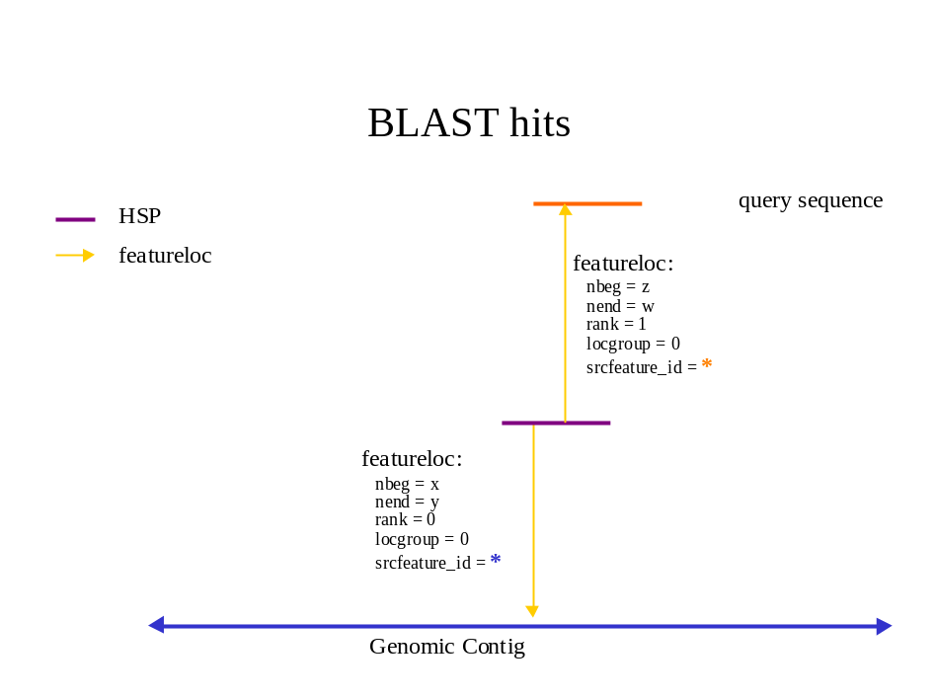
Create a feature for both the query and target sequences. If these are SwissProt or GenBank accessions, DBXREFs should also be created. Optionally include the residues of the feature.
A complex hit with multiple HSPs can be represented in one of several ways, depending on the desired granularity. Either a single feature can be created to represent the hit, or the HSPs can be represented, or both.
To represent HSPs explicitly, create a feature of type for each HSP. The organism of these features, by convention, should be that of the query sequence. Locate the HSPs on the query and target sequences, using locgroup (?) = 0 for query, 1 for target.
If you want a representation of the hit as a whole, or if there is only one HSP, create a feature of type ? and locate it on both query and target as described for HSPs, using a coordinate range that spans the HSPs, or leave the coords NULL to indicate the entire sequence (are they nullable?).
If you want to do both, you can relate relate the HSPs to the hit feature with Contains.
You can use feature.residues of the hit or HSP features to store alignment strings, such as:
ATT-CGG
| | | |
A-TAC-G
Or use featureloc.residue_info used to store the half-alignment string for HSPs and/or the entire hit: e.g. feature_loc1 ATT-CGG / feature_loc2 A-TAC-G. (Why do this?)
See also http://www.ensembl.org/Docs/ensembl9/#gapped
Match score information: Analysisfeature, scores, analysis, analysisprops. Additional parmas in feature_props.

All hsp's are part of a hit, even when there is just one hsp making up
the hit. All hsp's have featureloc's, and no hits have featurelocs.
That is what we decided on during our marathon conference calls last
fall. Does that not seem right to you?
Colin 4/16/03

Aligning ESTs/cDNA to genomic DNA
An alignment of a transcript sequence to the genome generates HSPs which are coextensive with the exons. We have tried to design the representation of alignments and central dogma to treat these two cases as similarly as possible.

Homologies, Multiple alignments & Protein Families

Curated

Computed

Domain-based

Homology, Orthology, Paralogy
Treat homology at multiple central dogma levels?

Motifs
The motif vs the hit…

HMM hit (to protein and/or DNA)

Domain structure

Repeats

Genomes, Chromosomes and Assemblies

Multiple species’ genomes within same schema

How to load a genome
Create a feature for every largest contig in dataset. Eg. Chromosome, chromosome arm. The DB assigns an ID to the contig. The contig becomes the coordinate system for all features on it.
Strand = 0 (means “both”)
Create annotation features on contig by setting their Source_feature_id to the contig ID.
Store sequence in residues field.
No coords.
Attach Genbank DBXREF

Assemblies, scaffolds
Representation of relation between fragments and contigs, contigs and scaffolds. Ordered yes/no, oriented yes/no.
Feature coordinate propagation across assembly hierarchy
Materialized or dynamic option?
How are coords propagated across assemblies?
Feature equality: how to say 2 features (eg on different assembly levels) are the same
Can override propogation of incomplete results on small contigs – eg partial gene models spanning contig ends.
Multiple coords for feature wrt diff objects?

REDUNDANT STORAGE OF COORDINATES ON DIFFERENT ASSEMBLY LEVELS
Some groups may find it advantageous to redundantly store features relative to both BACs and chromosomes (or to mini-contigs and scaffolds... choose your favourite assembly units). The approach outlined above works perfectly well with this, we would simple add another column in the location matrix (ie another wild/mutant pair with a distinct locgroup). All queries should work the same.
Assembly: materialize derived featurelocs >> API (cjm)

GenBank Accessions
350KB contigs
make a feature of larger reference contig
set feature.dbxref to accession string.

Circular Chromosomes

Comparative Mapping / Genome Alignments

Synteny (= genome alignments?)

Annotating conserved regions
Pairwise vs. Multiple

Sequence Variations
Possibilities for representing variants include represent differences relative to a reference as features, or representing the variant sequences explicitly as features, or both. We require the former, and optionally allow the latter. (If variant sequences are explicitly represented as features it is up to the implementor to decide whether to “materialize” the variant sequence, i.e., to store the variant sequence under the “residues” property of the variant feature or let that be implied by the differences plus the reference sequence.) We also provide mechanisms for constructing larger scale variants (alleles and haplotypes) from elementary changes such as SNPs or indels, as well as for representing the effects of a variation in a gene on all affected features in the central dogma model.
We assume that each gene has a reference translation model that represents the transcription and translation products of the reference sequence. There is no requirement to “clone” this model to represent the transcription and translation products of variant sequences. However in some cases this may be desirable: eg., to record a sequenced allele, or to describe a highly mutated product such as a frameshifted translation. In such cases the alternate product should be linked to its corresponding reference version by a feature_relationship of the form “CV?:Variant”, with subfeature = the variant and objfeature = the reference.??

SNPs

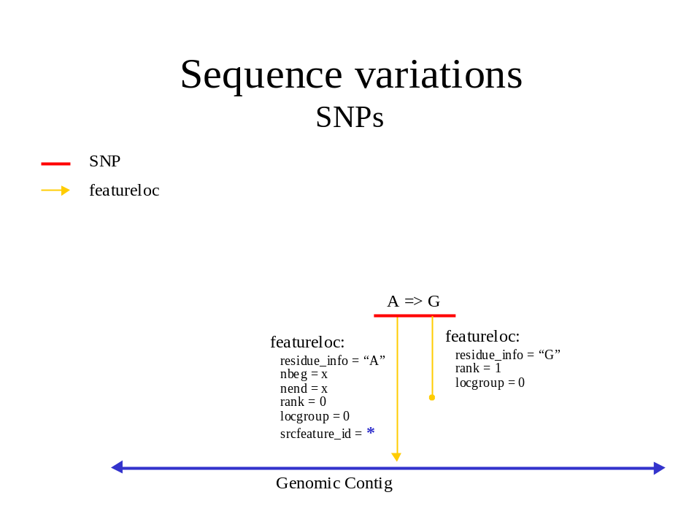

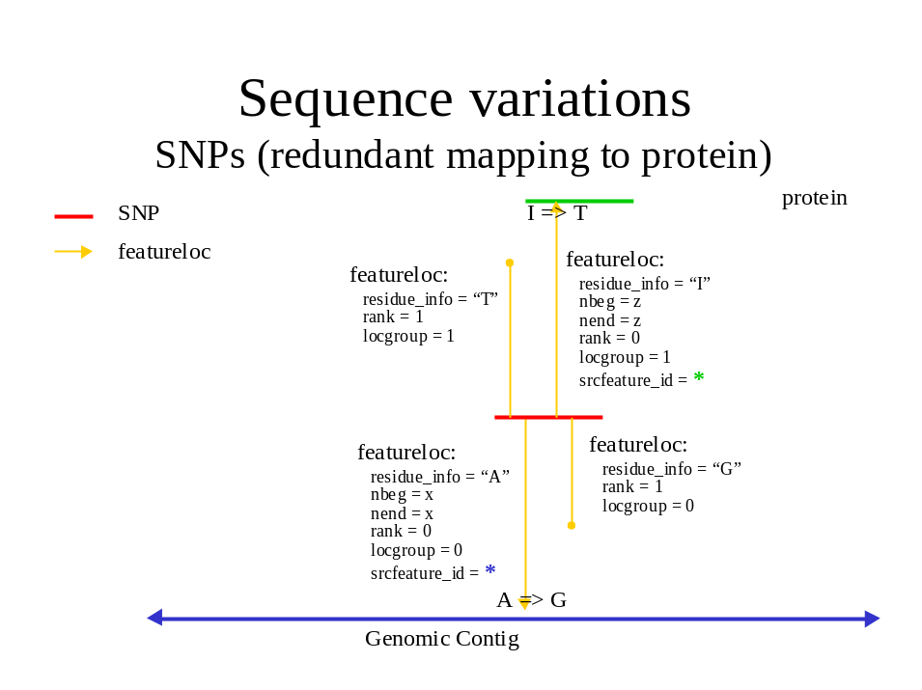
Uniqueness constraint:
locgroup and rank specify the two axes that locations for features can have. if a feature F has locations L, and L1 and L2 are in L, and L1 and L2 share the same rank and locgroup, the underlying semantics of featureloc is violated, and the uniqueness constraint is also violated.
this is what we want. see chado/doc/snps.txt for the rank/locgroup
Create a feature of type SNP, use featureloc to link to as many of reference contig, gene, transcript(s) and protein(s) as desired, use residue_info to store alternate nucleotide or AA. This gives us the option of creating different residue_info for the same SNP relative to difference source features – useful for proteins, but possibly overkill for the various nucleotide sequences. If this is the only use of residue_info I would suggest using featureprops instead, with "alternate nucleotide" and "alternative amino acid" terms. Otherwise it may not be clear which featureloc to look at for the alternates. Or SNP subtypes -
Use residue_info to store alternate content for sequences not fully instantiated – eg genotypes.
we can either store the mutant genomic residue in the feature, and leave the wild genomic residue as being implicit from the genome; or we can have two feature_locs (the mutant feature_loc may have most of the columns null). the second way requires residues in the featureloc
Rename altresidues residueinfo. Stores alignment of SNP alt content.
NULL source_feature?
This outlines one way of modeling SNPs in chado. it also illustrates use of the featureloc table. Most of this applies to other variation features, but I'll illustrate using SNPs for now to keep it simple. A SNP is represented as a single feature in chado. Let's take a basic example - a SNP that flips an A to a G on the genome. Here we would have one feature and two featurelocs.
(feature
(name "SNP_01")
(featureloc
(srcfeature "Chromosome_arm_2L") ;;; dna feature identifier
(nbeg 1000000)
(nend 1000001)
(strand 1)
(residue_info "A")
(rank 0)
(locgroup 0))
(featureloc
(residue_info "G")
(rank 1)
(locgroup 0)))

the first location is on the chromosome arm (presumably wildtype). The second location has no srcfeature (ie it is set to null). however, it is effectively paired with the first location. if we later wished to instantiate the mutant chromosome arm feature, we would fill in the second locgroup's srcfeature. Let's take another example - a SNP that has only been characterised at the protein level. This SNP flips an I to a V
(feature
(name "SNP_02")
(featureloc
(srcfeature "dpp-P1") ;;; protein feature identifier
(nbeg 23)
(nend 24)
(strand 1)
(residue_info "I")
(rank 0)
(locgroup 0))
(featureloc
(residue_info "V")
(rank 1)
(locgroup 0)))

Again, the second featureloc has no srcfeature. the mutant protein is implicit. the mutant protein sequence can be infered by taking the sequence of "dpp-P1" and substituting the 24th residue with a V. To do a query for all SNPs that switch I to V or vice versa:

SELECT snp.*
FROM
featureloc AS wildloc,
featureloc AS mutloc,
feature AS snp,
cvterm AS ftype
WHERE
snp.type_id = ftype.cvterm_id AND
ftype.termname = 'snp' AND
wildloc.feature_id = snp.feature_id AND
mutloc.feature_id = snp.feature_id AND
wildloc.locgroup = mutloc.locgroup AND
wildloc.residue_info = 'I' AND
mutloc.residue_info = 'I';

note that this query remains the same even if mutant protein features are instantiated as opposed to left implicit.

Let's look at a more complex example. If we have a SNP that has been localised to the genome, and the SNP has an effect on a protein (Isoleucine to Threonine), and we want to redundantly store the SNP effect on the genome, transcript and translation.
[note that in this example, the transcript is on the reverse strand, so the residue is reverse complemented]
(feature
(name "SNP_03")

;; position on genome
(featureloc
(srcfeature "chrom_arm_3R")
(nbeg 2000000)
(nend 2000001)
(strand 1)
(residue_info "A")
(rank 0) ;; wild
(locgroup 0))
(featureloc
(residue_info "G")
(rank 1) ;; mutant
(locgroup 0))

;; position on transcript
(featureloc
(srcfeature "blah-transcript001") ;; processed transcript ID
(nbeg 1000)
(nend 1001)
(strand 1)
(residue_info "T")
(rank 0) ;; wild
(locgroup 1))
(featureloc
(residue_info "C")
(rank 1) ;; mutant
(locgroup 1))

;; position on protein
(featureloc
(srcfeature "blah-protein001") ;;; protein feature identifier
(nbeg 23)
(nend 24)
(strand 1)
(residue_info "I")
(rank 0) ;; wild
(locgroup 2))
(featureloc
(residue_info "T")
(rank 1) ;; mutant
(locgroup 2)))

Here we have 6 locations for one SNP. The 6 locations can be imagined to be in a 2D matrix. the purpose of rank and locgroup is to specify the column and row in the matrix

| genome transcript protein
--------+-------------------------------
wild | A T I
|
mutant | G C T
rank is used to group the strain and locgroup is used for the grouping within that strain. rank=0 should be used for the wildtype, but this is not always possible; locgroup=0 should be used for primary (as opposed to derived) location, this is not always possible. The important thing is consistency within a SNP to preserve the matrix.
One can imagine rare (but entirely possible) cases where by a single SNP causes different protein level changes in two proteins (for instance, HIV carries a doubly encoded gene - ie the ORFs overlap but have different frames).
Here we would want to add another locgroup, for the second protein

| genome transcript protein1 protein2
--------+-----------------------------------------
wild | A T I Y
|
mutant | G C T H
Again, if we don't need to instantiate the 2 mutant proteins, but their sequence can be reconstructed from the wild proteins plus the corresponding mutation [remember chado is interbase, and postgresql substring counts from 1]
The following query dynamically constructs mutant feature residues based on the wildtype feature and the mutant residue changes. This should work for a variety of variation features, not just SNPs. Note that we need to use locgroup to properly group wild/mutant pairs of locations otherwise this query will give bad data.
SELECT
snp.name,
wildfeat.name,
substr(wildfeat.residues,
1,
wildloc.nbeg) ||
mutloc.residue_info ||
substr(wildfeat.residues,
wildloc.nend+1)
FROM
featureloc AS wildloc,
feature AS wildfeat,
featureloc AS mutloc,
feature AS snp,
cvterm AS ftype
WHERE
snp.type_id = ftype.cvterm_id AND
ftype.termname = 'snp'AND wildloc.feature_id = snp.feature_id AND mutloc.feature_id = snp.feature_id AND wildloc.locgroup = mutloc.locgroup AND wildloc.srcfeature = wildfeat
EXTENSIONS
==========
The above will also work if we have a polymorphic site with a number of different possibilities across multiple strains. We just extend the number of rows in the location matrix (ie we have rank > 1). We could also instantiate multiple SNPs, one per strain, and keep the locations pairwise.
SIMILARITIES TO ALIGNMENTS
==========================
You should hopefully notice the parallels between modeling SNPs and modeling pairwise (eg BLAST) and multiple alignments. The difference is, alignments would always have locgroup=0, with the rank distinguishing query from subject. Also, with an HSP feature, the residue_info is used to store the alignment string.

Create a feature of type “SO:SNP”

Assign coords of variable base relative to genomic reference contig.

Assign alternate base as Residue

To represent the effects of the SNP on translation products, make the following feature_relationships:

SNP to transcript: of type “CV?:silent SNP”, “CV?:coding SNP” or “CV?:splice_variant, from (subjfeature) to the transcript [no], ORF [yes] and/or protein features. feature_relationship_props (NEW!) of type oldres, newres to indicate changes. Will this handle indels, inversions, splice mutations?

OR JUST USE FEATURE PROPS OF SNPs – silent, coding, splice-variant, intronic, intergenic. If coding supply alt base as feature prop (term?)
A typo in this doc, I think. In the example query for all snps which change an 'I' to 'V':
> mutloc.residue_info = 'I'
should be
mutloc.residue_info = 'V'
From: Lincoln Stein [mailto:lstein@cshl.org]
Sent: Monday, January 06, 2003 12:01 PM
To: Helt,Gregg
Cc: SLetovsky@aol.com; gmod-schema@lists.sourceforge.net; Chris Mungall
Subject: Re: [Gmod-schema] Understanding feature locations
> > Finally, for SNPs, Gregg's model looks like this:
> >
> > Object: SNP
> > span 1: {id,start,start+1} on the canonical
> > span 2: {insertId,0,1} on the variant
> >
> > There are single base pair database sequences for each of "A", "G",
> > "C", and "T". They are substituted at the indicated SNP position on
> > the canonical sequence. The nice thing about this is that it works
> > uniformly with dinucleotide variants, haplotypes, etc.
> >
> > What I like about this is that it provides a uniform data model for
> > handling genome to genome alignments, protein to genome alignments,
> > variants, insertions, and deletions.
I've attached a sketch of different ways to represent SNPs using Affymetrix'
genometry models. What Lincoln describes above is basically what is
sketched out as Ib. I think there is a significant difference between I
(annotation of differences) and II (gaps in similarity). Annotating SNPs as
differences between sequences may look cleaner for a simple example. But
implying SNPs as gaps in similarity between two sequences is more in keeping
with the way I've used genometry for pretty much everything else ("standard"
annotations, alignments, sequence composition, coordinate transformations,
etc.), so it comes closer to a uniform data model with as few "moving parts"
as possible. For example, fully specifying a haplotype relative to reference sequence(s) will most likely require mixing SNPs, insertions, deletions, transpositions, and inversions, so having all of these boil down to a collection of spans of similarity starts to look more elegant (as opposed to a mixture of spans that specify similarity and spans that specify
differences).
gregg
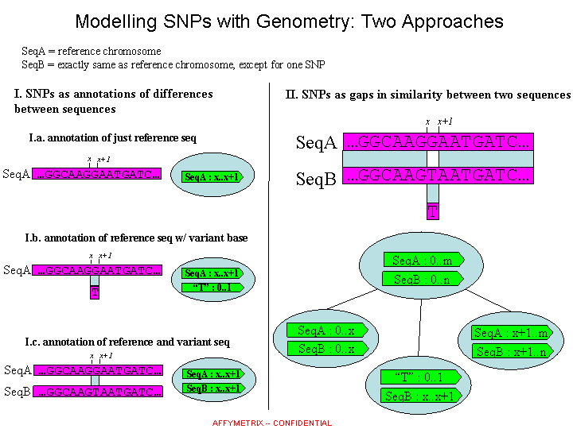

SNP Types (are these in SO?)

Coding

Silent

Substitution

Premature termination

How to indicate protein(s), tx(s) and genomic diffs

Noncoding

UTR

Promoter

Intergenic

To link to an explicit representation of the variant sequence, if desired, create a feature_relationship with type = “CV?:produced by”, subjfeature = the variant sequence feature, objfeature = the SNP. Or use source_feature_id, coords?

Splicing
Indel: create a feature of type Indel, use featurelocs with rank 0 (or equivalent using a CV term -- see below) to link to insertion sites on all affected sequences (contig, gene, tx, prot) as well as featurelocs of rank 1 to link to deletion sites.

Splice variants

Haplotypes
a feature of type haplotype located on a region of the reference contig, as well as of variant contigs. Do we need to explicitly link the haplotype feature to the SNPs, indels, etc., contained in the region, or can we simply assume that all SNPs, indels, etc., contained in that region and
> located on any of the contigs that the haplotype is located on are part of the haplotype? That seems simplest.

Haplotype

A haplotype is a nonreference sequence containing linked variations. An allele is a haplotype restricted to a single gene.

To create a haplotype, create a feature to represent it, give it type “CV?:Haplotype” or “CV?:Allele”. Set source_feature_id = the reference genomic contig; nbeg and nend to be the region convered by the haplotype. (What if rearrangements make this not well-defined?)

Create simple variants (SNPs, indels, inversions, translocations) to represent the differences between the haplotype and the reference, if desired.

Create feature_relationships linking the haplotype to all SNPs and other atomic diffs. Use relrank to order if necessary (eg if multiple inversions).

Alleles
Non-WT variants ("alleles" in genetic parlance) represented similarly, so have variant gene features. Optional whether to instantiate entire central dogma model on non-WT gene. However must create a non-WT "gene" feature for every known allele.
Allele isa sequence vs. allele isa haplotype isa grouping of diffs.
Use of rank to distinguish mutant from wt allele
Non-WT variants are linked to WT variant by allele_of feature rels.
If sequence is known and explicit representation of variants (SNPs, indels, etc.) is desired, these can be created as features and loc'ed to WT and mutant genes in accordance with standard treatment of sequence variations.
(Optional) "Genetype" feature prop - values "WT" or "allele".
1 allele feature for each allele
1 variation feature for each known seq variant
just one clarification - if a deletion completely knocks out a gene, we would still create a feature of type 'gene' to represent the allele – even though there is no actual gene there! this may seem a little odd to some but I think it is logical.
Hmm. Interesting point. I have no problem creating a feature to represent the deleted allele -- Bill just yesterdaymentioned that one of the tasks for the genetics module will be to infer implicit properties of genotypes, such as genes knocked out by a deletion, so creating explicit X-, Y-, Z- alleles for a deletion spanning X-Z seems appropriate.It is less clear what coordinates to assign if we featureloc them to a genomic contig feature carrying the deletion. I suppose the only possibility is the coordinates of the deletion point, which I think parallels our treatment of indels.
a featrel linking each allele to gene.
Can gene feature = wt allele feature? Or reference allele feature? What about symbols?
Phenotype hangs off variation features?
SO – needs complex variation. Suzi / Michael. Same as haplotype? Allele is special case – restricted to gene, requires a phenotype?
Wild type as property of (gene?) feature?
Reference vs wild type.
Summary: features are Gene, tx(s), SNPs, etc., alleles loced to variants. Featrel of type allele. Featprop of type wt allele.
Wt isolates? DE

Inversions
Create a feature of type inversion with location spanning the inverted region with rank 0; if there is a version of the sequence containing the inversion create a featureloc to the inverted region with rank 1. (The ranks serve to distinguish the two versions in case several seqs carry one or the other, but the choice of which is 0 and which is 1 is arbitrary, unless use 0 for "wild type".)

Rearrangements
Eg for a rearrangement that exchanges the ends of two chroms A and B, create two features of Afrag and Bfrag of type rearranged segment, "locate" on A and B, then create features for A' and B' (post-rearrangement) and locate on B' and A', resp. How to capture the fact that Afrag and Bfrag and A' and B' are part of same rearrangement? Use feature relations?
i think so

Translocations
create a feature of type translocation with a loc spanning the translocated region, rank 0. Rank=1 is used for insertion locs: whether
latent (ie the site of the insertion on a contig that lacks the insertion) or
explicit (the site of the insertion on a contig that carries it). The coords
are adjusted accordingly.
(Note that if CV terms are used instead of rank=0,1, etc. than we can be clearer about this.)
good point; i pondered adding a CV term to featureloc (I think it's still
useful to have rank anyway - eg for multiple alignments)

Transposon insertion
create a feature of type transposon insertion, with a loc of type 0 for insertion sites when the insertion is absent, 1 if present, and -1 (?) to link to the "template" -- generic representation of the transposon?

Non-wild type features in reference genome? (Eg. R3).

No actual genome is wild type everywhere (unless by definition).

Reference gene model may be of mutant gene.

Instantiate wt and mutant transcripts. Nomenclature?

Or go back and patch sequenced genome to make it WT. BG – do this, but in a later iteration. Meanwhile mark it with a mutation_comment. Or dbxref to wild-type.

Link variants to stocks

Alleles or haplotypes can be carried by stocks. How to link? DBXREF? Genotype of a stock is a set of variants (plus background?)

Links between variants and phenotypes

Link variants to phenotypes

Insertion, deletion, translocation

Within gene

Multigene, intergene, centromere-spanning

Features peculiar to a nonreference variant, eg spanning insertion boundaries

Transposon itself

Insertion

Sample query: find all genes containing transposon insertions in their promoters

Sample Transactions

Renaming a gene

Splitting a gene

Merging two genes

Deleting a gene
TIGR listed lack of referential integrity between genes and features as an issue – blow away annotation, unsupported gene remains. Will delete propagation along feature.source take care of this? Would it blow away curated info?

Batch Delete of Computed Features
'set enable_seqscan=0' takes care of it.

Maps
Units CV – allows maps to be stored in features. No use feature prop.
Constraint graph represents feature relationships. Can’t represent endpoint in interval rels. David.
Unlocalized gene / feature.
poorly localized / fuzzy coords
Integer vs float coords. cM maps need floats, won’t fit in featureloc? Or multiply by const to get integer resolution.
0/1 Ordered and 0/1 oriented
gaps – sized and unsized
ordering constraints only

Clones and Libraries
Clone libraries. Needed. Can be a pub linked to the features (clones)?

Genetics
Stock, stock_genotype, stock_phenotype?
Controlled vs uncontrolled phenotype descriptions (backlog). Represent “uncontrolled vocabularies”?
Does interaction store protein-protein interactions? If not clarify table name (eg genetic_interaction). Where will PPI and PDI be stored?
BG: As David well knows, there are two kinds of evidence that match
deletions to genes. The simple one are for the relatively small
subsets of deletions that have sequenced endpoints. For these, we
can simply interpolate the gene model map found between those
endpoints and we have our list of deleted genes. The more difficult
one are the larger sets of genes that have been tested by complementation
with recessive mutations in the vicinity of the deletion site. Those
genes that fail to complement are inferred to have lost some or all
of their sequences to the deleted segment of the genome. Those that
complement are inferred to have retained all *essential* sequences
on the deletion chromosome. Here, the data come from the literature
and are spotty and occasionally, contradictory. Nonetheless, these
are the kinds of evidence to draw in.
I suppose there is a third kind of evidence, which is the polytene
cytology of the deletion. This is the most problematic case, for
reasons of data quality at mapping deletions and at mapping sequences
to the polytene bands.
can link allele to strain by featureloc as well as by genotype? Or by feature.organism?

Expression
MIAME Compliance http://www.mged.org/Workgroups/MIAME/miame.html
Represent probes as features, featureloc to transcripts. Array address as featureprob of probe.

Controlled Vocabularies
Chado uses controlled vocabularies (CV’s) as the allowable values in many fields. Community standard CVs are utilized wherever possible, e.g. we try to use SO (Sequence Ontology) terms for sequence feature types. SO is a hierarchical controlled vocabulary, so wherever the documentation says to use a term from SO, you can freely use any of the ISA-subterms of that term if you want to be more precise. The schema allows queries against broader terms to retrieve data indexed under narrower terms, if the query is expressed in terms of the cv_path table, which holds all ancestor/descendent relationships in all CVs.
CV Type | Columns | CV
Feature Type | feature.type_id | SOFA (SO lite) http://sourceforge.net/projects/song/
Feature Property | featureprop.pkey_id
Feature CVTerm | feature_cvterm.cvterm_id | this one could map to at least two and possibly all 3 GO ontologies -- complicates idea that there is exactly 1 CV per field. Also are we limited to these ontologies?
Analysis Property | analysisprop.pkey_id
Semantic Relationship | feature_relationship.type_id cvpath.reltype_id  cvrelationship.reltype_id | Relationship Types (CJM developing, will go to GOBO) – includes ISA, contains, derivedfrom.
Pub Type | pub.type_id | get from TAIR? Other? Submit to GOBO?
Pub Relationship Type | pub_relationship.type_id | Examples? Chapter in book?
Synonym Type | synonym.type_id | small CV of synonym types, someone needs to write it.
Phenotype Statement | phenotype.statement_type | Examples?
Phenotype CVTerm | phenotype_cvterm.cvterm_id | presumed fly pheno CV. Does this exist yet?
Expression CVTerm | expression_cvterm.cvterm_id | Is this supposed to capture, e.g. combinations of dev stage and anatomical structure? Needs more structure.

Compounds @ GOBO; Anatomy, Dev Stage, etc.
CV integrity enforcement – need a trigger, driven by this table, to ensure right terms in field.
DBXRefs to GO, etc.
Issue: CV management
-Proposal: provide an "include" mechanism to allow a level of separation / buffering between public CVs (GO, SO) and those used in Chado, so that Chado users can add their own terms while maintaining accurate representations of public CVs.
Decision: rejected -- try to encourage Chado implementations to be fully compliant with public standards.
-Proposal: create standard CV representation on sourceforge
Decision: use external CVs where possible, create new ones as
needed, submit to GOBO as appropriate. Use GO flatfile format as standard,
write GOfff2ChadoXML converter, possibly archive (loadable) Chado XML versions of public CVs
on sourceforge.
-Document CV term usage conventions (eg contains and produces in Central Dogma)
-How to keep chado instances in synch with upgrades to externally curated CVs?

Hierarchical queries
Cvpath. Transitive closure computed outside of postgres. Need sample query.

Publications
Do we need to repeat citation details in Chado for refs with a DBREF to a bibliographic DB or just capture citation string locally?

WormBase now distinguishes authors and persons; both are objects.

Data History
Trigger granularity? Is transaction sufficient.
Does postgres do any of this internally like oid? Delete by sweep?
No uniqueness constraint on primary key in audit tables.
Id + last mod + time entered.
Audit_tablename
No explicit foreign keys or cascade deletes on audit tables? Worried about performance.
Feature splurges supported by feature_dbref.is_current set to 0; old features persist; old dbxref applies to old and new versions (whether from split or merge) with is_current =0 for all (except possibly canonical inheritor of acc#, depending on policy.) No splurge support for other types of acc#s. No support for deleting a bad feature.
Feature table adds: timeaccessioned and timelastmodified are for handling object accession/
-- modification timestamps (as opposed to db auditing info, handled elsewhere).
-- The expectation is that these fields would be available to software
-- interacting with chado.
timeaccessioned timestamp not null default current_timestamp,
timelastmodified timestamp not null default current_timestamp
Splurge History (for all externally published IDs?)
What info is retained on retired IDs
Deletions – what remains? How to implement?
Any other history needed?
Workflow Use Cases
Gene split / merge in progress
Curator notes

Performance, Indexes, Locking
Locking: none, update conflicts prevented at update time with update supplying timestamp of object being modified. If object in DB has more recent timestamp update is rejected.
See http://techdocs.postgresql.org/techdocs/fulltextindexing.php for full-text indexing in PostGres.
Could we see EXPLAIN ANALYZE, not just EXPLAIN, output for all these
alternatives? Your question boils down to "why is the planner
misestimating these queries" ... which is a difficult question to
answer when given only the estimates and not the reality.
A suggestion though is that you might need to raise the statistics
target on the indexed columns, so that ANALYZE will collect
finer-grained statistics. (See ALTER TABLE ... SET STATISTICS.)
Try booting it up to 100 (from the default 10), re-analyze, and
then see if/how the plans change.
Vacuum analyze, vacuum full analyze, analyze, set enable_seqscan =0;
1). For PostgreSQl, examine query plan (using explain) only after vacuum
and analyze have been done to the tables relevant to the query you are
analyzing. otherwise you might get inconsistent results.
2). PostgreSQL doc recommend that no more than 3 columns in a multi
column index.
3). Try to avoid OR clause in a query if possible. A multi column index
is in effect only when all the of columns (or subset of the column) in
the index are ANDed. In other words, as soon as you have the columns in
the index are ORed, the intended index will NOT be used. One way to
avoid having OR clause in your query is to use union operator.
3). For some reason, PostgreSQL will not used this index (srcfeature_id,
nbeg and nend, where nbeg <= nend is for +strand but nbeg >= nend for
-strand) properly.
This sounds like it might be the "update statistics" analog. See
http://candle.pha.pa.us/main/writings/pgsql/sgml/indexes-examine.html for more.
explain analyze
A suggestion though is that you might need to raise the statistics
target on the indexed columns, so that ANALYZE will collect
finer-grained statistics. (See ALTER TABLE ... SET STATISTICS.)
Try booting it up to 100 (from the default 10), re-analyze, and
then see if/how the plans change.
Have you looked into using a UNION ALL instead of OR to merge the two
sets of results? It sounds grotty, but might be faster... (Tom Lane)
I had the same thought. I just checked the documentation;
it appears that functional indexes cannot be multicolumn.
See
http://www.postgresql.org/docs/view.php?version=7.3&idoc=1&file=indexes-functional.html
I wonder if it would be useful to set up some documentation in the cvs
giving pg admin tips for chado.

XML
THE PROBLEM: How to refer to objects unambiguously, concisely and readably
in XML without torquing the schema to enable it (unless absolutely necessary).
We also want a straightforward mechanical mapping of the relational
schema to the XML format so we can write a generic (i.e. schema driven)
dumper and loader which will easily adapt to schema changes.
THE SOLUTION: Relational (possibly compound, not-serial-#) keys plus an
aliasing (local id) mechanism for readability and conciseness. (Options 1 and
2 from earlier message.)
BASIC OBJECT REFERENCE: Wherever you need to specify a foreign key
you can refer to an existing DB object as follows:
<foreign_key_col>
<primarytable op="lookup">
<keycol1>keyval1</keycol1>
... more key cols if needed
</primarytable>
</foreign_key_col>
E.g. for cvterm the key is (termtype, termname) so to specify featuretype exon
we would have:
<featuretype>
<cvterm op="lookup">
<termtype><cvterm op="lookup">
<termtype/>
<termname>Sequence Ontology</termname>
</cvterm>
</termtype>
<termname>exon</termname>
</cvterm>
</featuretype>
Such lookup XML's are permitted wherever foreign key references are needed.
Looks verbose, we know, but hang on, help is on the way.
ALIASING: We provide a def/ref (define/refer) mechanism that allows
object reference abbreviation as follows:
DEF: <primarytable op=lookup def="asymbol">
<keycol1>keyval1</keycol1> etc.
</primarytable>
Having thus defined "asymbol" as shorthand for the whole expression
(and thus for the primary key) we can use it in any context that
needs a foreign key as follows:
<foreignkeycol ref="asymbol"/>
Example:
<featuretype ref="exon"/>
given that we had previously defined exon in the file by:
<cvterm op="lookup" def="exon">
<termtype><cvterm op="lookup">
<termtype/>
<termname>Sequence Ontology</termname>
</cvterm>
</termtype>
<termname>exon</termname>
</cvterm>
or better yet
<cvterm op="lookup" def="SO">
<termtype/><termname>Sequence Ontology</termname>
</cvterm>
<cvterm <termtype ref="SO"/><termname>exon</termname></cvterm>
We can also use aliasing to refer to objects defined in the file,
by specifying op="insert" instead of lookup, or just leaving
op out, since insert is the default.
<primarytable def="asymbol">...</primarytable>
and later <foreign_key_col ref="asymbol"/>
We can use machinery built into XML for this sort of thing
by letting "def" attributes have ID attribute type and "ref" attributes
have "IDREF" attribute type (see O'Reilly XML book p.44-45),
in which case the aliases must adhere to the restrictions
on XML Names, meaning /^[a-Z_][a-Z0-9_-.]*$/. (see p.18)
(I believe ":" is also permitted using namespace-like syntax.)
If we use these XML attribute types, then in theory a DTD
validator will enforce the two rules that govern aliasing,
namely:
-DEF BEFORE REF: A referenced symbol must have been
defined upstream in the file.
-SINGLE DEF: It can only have been defined once.
It will also presumably enforce the well-formed alias rule.
Why is this important? The problem with the original relational
key approach to object reference was verbosity and unreadability.
Aliasing allows enormous compaction and improvement of readability.
Note that one implication of this scheme is that an app that routinely relied
on certain DB objects, eg Apollo's need to refer to SO terms for
feature types, would require every XML file it generates to repeat the aliases
for these things at the top as a kind of preamble or header.
One possible solution is some kind of include mechanism
where the preamble lives in a separate file.
UNIQUE KEYS IN SCHEMA: All of this discussion of referring to things
by relational keys has led us to review the status of keys in Chado,
something Dave is currently working on. We feel every table should have
an explicit, possibly compound key, composed of data and/or foreign keys
of major (module) types, and there should be a uniqueness constraint in the
schema that expresses this. Certain
fields that had not been thought of as keys in this sense should
probably be considered keys, including Pub.miniref (not currently
there?) and Genotype.description (constructed according to
nomenclature rules). One table which is problematic
is feature, where it is by no means clear what set of fields
currently suffices as a key. We suggest that feature.name be
unique and non-null, with a default rule generating some
random string, like type + # + id. Features are too important to
not have reliable keys. Finally we looked at secondary and
tertiary tables, briefly, and found one that is problematic:
featureprop_pub currently has (featureprop_id,pub_id) as
its key, which violates our rule because featureprop_id
is a non-object foreign key. Thus we ask that this be changed to
(feature_id, pkey_id, pub_id) -- 3 object foreign keys. One consequence
of this is that as far as the XML is concerned we don't
need nonprimary tables to have surrogate keys -- they can
if they are needed for other reasons, but we don't need them.
(Note that for consistent with the naming conventions and natural-join
friendliness, pkey_id should probably be renamed cvterm_id.)
We avoided calling for all primary tables to have single
column nonsurrogate keys, such as "CV:term" for cvterm.
Such things are convenient in that they make the lookups
more concise, but only marginally, and it was felt that this
was not enough to justify changing the schema or denormalizing
data. In particular we don't even need dbxref.dbxrefstr any more,
or for that matter feature.dbxrefstr (though we probably still
want the notion of a primary dbxref for a feature. We just don't
care if it goes through a join to dbxref.)
UPDATE & DELETE: We were also able to come up with a solution
to update and delete, as follows:
DELETE AN OBJECT:
<primary_table op="delete">
<keycol1>keyval</keycol1>
etc.
</primary_table>
UPDATE PRIMARY FIELDS OF AN OBJECT:
<primary_table op="update">
<keycol1>current keyval</keycol1>
...other keys
<modcol op="update">newval</modcol>
...other modified cols
</primary_table>
Note that if a key column is being modified it will
appear twice, once with the old value, to specify what
object is being updated, and once with the new value,
with op="update" attribute.
INSERT/UPDATE/DELETE SECONDARY (LINK) TABLES:
<primary_table op="update">
<keycol1>current keyval</keycol1>
...other keys
...primary modcols if any
<linktable op={update|insert|delete}>
<linkkey1>keyval</linkey1>
...other linkkeys
...modcols as above if update
...regular cols if insert
...nothing else if delete
</linktable>
</primary_table>
HIERARCHICAL CONTEXT RULE: We also adopted a rule
which says key columns inferrable from nesting
need not be repeated. So for example if you
are referring to a featureprop inside a feature,
you don't need to specify the feature. The general
rule is "if a foreign key field is missing, fill it in with
the id of the first outer object on the stack with the
correct type". For feature relationships, this means
no repeating the outer feature over and over in
subjfield_id or objfield_id, etc. This rule can
operate for inserts, updates, and dumps, and
significantly improves readability.
Note that context is not mandatory, in fact
updates can be flattened. For example,
<linktable op={update|insert|delete}>
<linkkey1>keyval</linkey1>
...other linkkeys
...modcols as above if update
...regular cols if insert
...nothing else if delete
</linktable>
could occur at the top level, but you have to
supply a complete key, whereas if it is nested
inside an object you can leave off repeating those
key columns implied by context. More generally, this
same XML can be used for all operations in
a relational (flat, record-oriented) or object-oriented
(hierarchical) style, according to the generator's
preference, as long as they supply the required info.
Eg. you could update featureprop_pub (a tertiary linktable)
using nesting as follows:
<feature op=update>
<featurekeycols tbd>...</>
<featureprop>
<pkey_id ref=afeaturepropalias/>
<featureprop_pub>
<pub_id ref=apubalias/>
<modcol op=update>newval</modcol>
given that we make the schema change mentioned above.
You could also update it via:
<featureprop_pub op="update">
<feature>...</feature>
<pkey_id>...</pkey_id>
<pub_id>...</pub_id>
<modcol op="update">...</modcol>
...
</featureprop>
If you use accession to represent object, you need to satisfy some requirements:
1. accession will be in the format of: DB:acc[.v]
2. For dbxref_id, you can use accesion anytime, if not in database, it will
insert it first, then select.
3. If you want refer any feature object using accesion, it will work ONLY the
feature object already exist in database, this may happen if we have all the
data intergrated into chado. For now, most case it will not work and will throw
an error. Could you fix that now ?
Insert / link to DTD
Document DTD generator

Related Work
GMOD – http://sourceforge.net/projects/gmod/, http://www.gmod.org/
GUS : http://www.gusdb.org
Ensembl
GO – www.geneontology.org , GOBO
Sequence Ontology , SOFA (SO lite) http://sourceforge.net/projects/song/
http://www.fruitfly.org/~cjm/chado-talk/chado-talk.html
GFF: http://www.sanger.ac.uk/Software/formats/GFF/GFF_Spec.shtml
Life Science Identifiers http://www.i3c.org/workgroups/technical_architecture/resources/lsid/docs/index.htm
http://bioperl.org/
http://open-bio.org/ - Open Bioinformatics Foundation
http://www.i3c.org/ Interoperable Informatics Infrastructure Consortium

