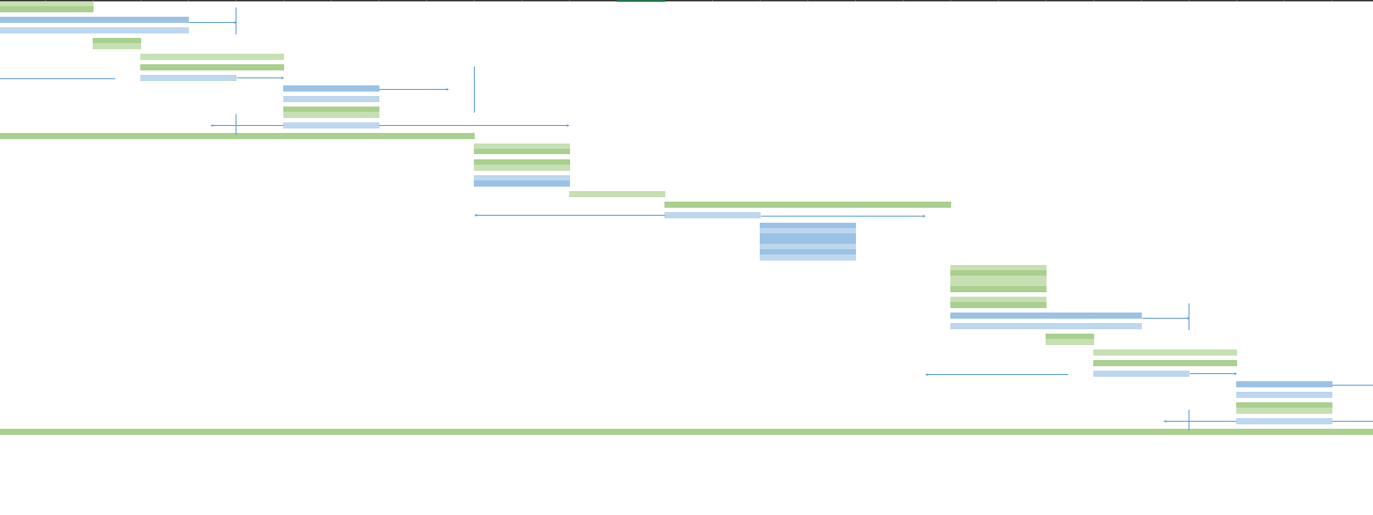

First larger scale gantt

by

Marius Johnsen Davidsen

First of I started off by planning of what needed to be done and who that would do the different tasks. After a little while I ended up with these persons:

-1 Project manager (Someone must have a leader role)  
-3 Photographers  
-2 authors  
-3 designers  
-1 Front end developers

With these persons everything would go smoothly with no collisions. Even though everything went smoothly this far, I still wouldn’t know if I could use less persons until the gantt chart was finished.

 Since I am new with gantt charts, it’s obvious that there is some trying and failing. The first version I went for, looked more like a normal timeline you’d see in a history book, where I had the persons on the *x-axis* and tasks and days on the *y-axis* (picture below)

At first this seemed like a good idea as one could easily see who did what, but after finishing the diagram it looked very messy. At the same time as it looked like a mess, it lacked the time perspective which I think is one of the key factor with this kind of diagram.

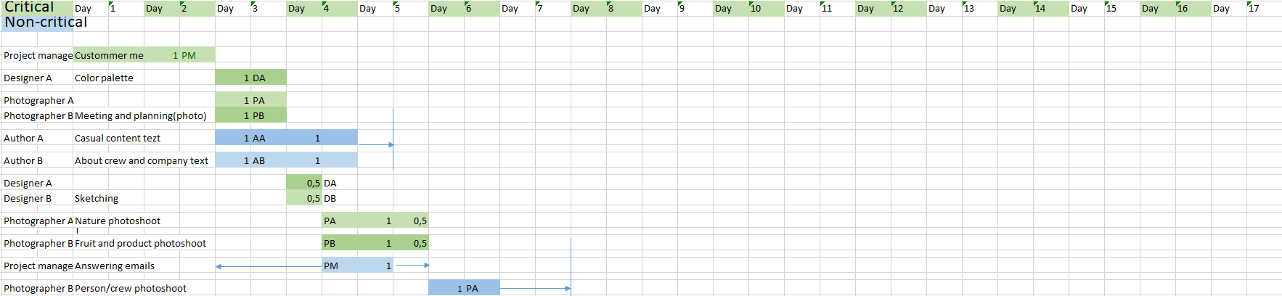Looking at the next diagram I went for the more normal *stacked* design. I kept the same colors (and shadings) from the other diagram as they are both relaxing and make a perfect pair together(picture below)

In the picture above one can see that everything just clicks together. It doesn’t look mess at all at the same time that one get everything in order. Here one can see that to the left I put both the persons involved and the tasks, but if you look at the duration of the tasks I have added a “code”. These *codes* are just codenames for the persons who are working on the current task. The reason to this is because I wanted to make a simplified way of making sure the same person doesn’t work on multiple tasks at the same time as one doesn’t need the whole name. Example: It’s much easier to remember PA than Photographer A. It’s also much better than using actuall names.

When you look at the secound gantt chart, you notice that there are two colors. These are *floating-tasks*, usually the *non-critical* ones. Looking at them, one notice they have some arrows coming out of them. This is because they are not as crucial to be done as the green(critical) ones, but they still have a dead line. I have decided to use these floating-tasks as they doesn’t put the same pressure on people since they doesn’t need to be done at once. Problem with these floating tasks is that they have a tendense to delayed, which in some cases will turn the non-critical task into the critical task. Another thing to notice on the chart is the vertical blue line where the arrow ends, this is a *deadline* for the floating tasks.

When I was done with the chart itself, I looked over it to see if I could remove some persons to reduce the costs(considering this is a medium-sized company). At first the costs was 65 000kr (if every person got 1000kr pr day of work, just to have something to calculate with). I soon realised that the project wouldn’t need both 3 designers **and** photographers. I took away designer C and photographer C and rearranged the tasks. Doing this, the project costs would be reduced to 57 000kr, equivilent of 8 days of work.

The one thing that probably seems weird about the photoshoot tasks must be the *nature* task. The reason I’ve added this is because Norway is known for it’s beautiful landscape, especially fjords. In addition to this, it would most likely fit the gerne and could give the page a harmonious feeling.

**NOTE!** Due to sizes and such, the excel file will be in a individual file.