Gabe Testa

CS 680

10/31/11

Sketchpad using Three.js

(WebGL Library)

# Goal:

The goal of this project was to create a full-featured drawing application similar to MS Paint.

# Overview:

I decided to use Three.js (<https://github.com/mrdoob/three.js/>) for this project. Three.js is javascript webGL library. The problem with using Three.js for this project is it is meant to be used in a fully 3d environment. Meaning, it doesn’t have any circle, rectangle or 2 dimensional objects in its object list. Three.js only has spheres, polygons, cubes etc. Due to this, it wasn’t easy to create a 2d drawing application.

A lot of the issues I had on this project had to do with problems getting three.js to do what I wanted. For example, in order to pick an object in three.js, you have to create a ray object and use it to determine if it intersects objects. The ray only detects 3d objects; so unfortunately, lines cannot be picked in my application because the ray does not detect them.

In total, this project took me about 25 hours to get it to it’s current level. If I had more time, I would spend it doing some cleanup.

# Manual:

Figure 1 shows the main screen for my sketchpad application. Here is where you will draw all of your images.

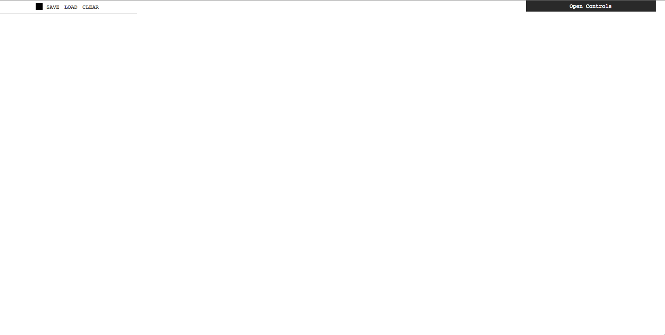

Figure Sketchpad Main Menu

Keyboard shortcuts are used extensively in my sketchpad application. Here is a list of all supported keyboard shortcuts:

* 1: Draw a point
* 2: Draw a line
* 3: Draw a circle
* 4: Draw a polygon
* 5: Draw a rectangle
* A: Move object
* S: Scale object
* D: Rotate object
* Ctrl+Z: Undo
* Ctrl+Y: Redo
* Ctrl+P: Print canvas to png image
* Ctrl+C: Copy selected object
* Ctrl+X: Cut selected object
* Ctrl+V: Paste selected object

Save and Load for my sketchpad application use the new HTML5 Local Storage API. This allows me to save and load data from the web browser.

After experimenting with my sketchpad application, I discovered that it works very well modeling space filling models. These are three-dimensional molecular models.

# Deficiencies:

1. I could not get lines to be selectable.
2. Undo/Redo do not take into account every single action.

# Extra-Credit:

1. The ability to save your image on the screen to a graphics-file that is printable.
2. Multiple levels of undo
3. Redo, and multiple levels of Redo