CYSE-587 / SYST-687
Guided Lab: ADOP MVP Testbed Architecture
A step-by-step walkthrough of what each component does, how to set up the environment, and how to read the data flows that feed your Trust and Assurance Tool.
Repository: https://github.com/GMU-CYSE/adop-cyse
This material is a didactic companion to the Project Notebook (Sections D, E, F, and G) and does not replace the official assignment instructions.

1. Who this lab is for, and what you will learn
This guide assumes you have never touched the ADOP MVP Testbed before. The goal is not to memorize commands; it is to understand why each piece exists, how the pieces talk to each other, and exactly where the data your team will use to build the Student-Developed Agent Trust and Assurance Tool (Section F of the Project Notebook) actually comes from.
By the end of this lab, you should be able to:
- Explain, in your own words, the role of every ADOP component (the Agent Host, the four MCP servers, the audit layer, and the log corpus).
- Install the environment, run the onboarding check, and reset the testbed to a clean state.
- Run a live session (live_mode) using a local model through Ollama and watch the agent decide on its own which tools to call.
- Locate, inside the generated .jsonl files, the trace of a real exploitation of the intentional vulnerabilities (CVE-2025-68143 and CVE-2025-68144).
- Understand why that telemetry, and only that telemetry, is the sole permitted input for the tool your team is designing.
Before you start
This testbed is not graded. It exists so that every team has the same working infrastructure. What counts toward the grade is the external tool your team builds by consuming the logs this environment produces, not how well you operated the testbed itself.

2. Architecture overview

2.1 What an ADOP is, and where the idea comes from
Before talking about the testbed itself, it helps to understand the problem an ADOP solves, because the name alone (Agentic Development and Operations Platform) does not make that obvious.

The problem an internal developer platform (IDP) solves
Imagine an engineering organization with fifty development teams. Every time a team needs a new service, it manually repeats a sequence of steps: create a repository, configure a CI/CD pipeline, request a database from the infrastructure team, configure secrets and environment variables, register the service somewhere so other teams know it exists, configure monitoring, and request access permissions. This is slow, repetitive, and inconsistent. Each team tends to do it slightly differently, producing configuration drift across the organization.
An Internal Developer Platform (IDP) is the abstraction layer that packages all of this into a self-service experience. The developer fills out a simple form, and the platform executes the underlying steps automatically, following a pre-defined organizational standard (the golden path). Two design principles matter for what follows: the golden path is codified once and reused by everyone, and the requester never touches the underlying tools directly; they interact only with the platform's interface. It is exactly this second principle that an autonomous agent breaks, as you will see next.
In practice, that golden path is also where the security gates live: Static Application Security Testing (SAST) before merging, Dynamic Application Security Testing (DAST) against the running application, and Software Composition Analysis (SCA) checking third-party dependencies against known vulnerabilities. Because these gates live inside the platform's pipeline template, every new service inherits them automatically, and nobody must remember to wire them up by hand.
The most widely adopted example of this pattern is Backstage (originally built by Spotify, now a CNCF project), which provides a central service catalog, templates that create repositories and pipelines automatically, and integrated technical documentation. When a request involves provisioning real infrastructure (a database, a message queue), a separate piece takes over to execute that provisioning inside a cluster. In the CNCF ecosystem, this is typically Kratix, through declarative Promises. Backstage is the interface layer; Kratix is the engine that fulfills the infrastructure request behind it.

The shift: what if the requester is not human?
Everything above assumes a human developer filling out a form. Today, an AI agent can receive a natural language request and decide on its own to call those same APIs, request a new service, provision a database, or modify a pipeline, with no human clicking through anything in between.
This is where a traditional IDP stops being sufficient: it was designed assuming a human requester, with an implicit baseline of caution, judgment, and accountability that an autonomous agent does not have by default. A human developer who misreads a form usually notices something looks wrong before submitting it. An agent executing a multi-step plan has no equivalent instinct, unless the platform builds one in for it.

Arriving at ADOP
An Agentic Development and Operations Platform (ADOP) is, conceptually, an IDP extended to treat AI agents as first-class platform users, following the same golden paths, but with agent-specific guardrails layered on top. The central design question for any ADOP is not whether to grant autonomy, but how much, and for which class of action. Three levels show up in practice:
Autonomy level | How it works | Typical risk if miscalibrated
Human in the loop | The agent prepares the action; a human must approve it before it executes. | Too broad a scope slows delivery and encourages rubber-stamp approval instead of real review.
Human in the loop | The agent executes autonomously; a human monitors and can intervene or revert. | Monitoring only works if someone actually reviews the audit trail.
Full autonomy | The agent decides and executes without prior approval, within pre-defined limits. | If the limits themselves are wrong or bypassable, no checkpoint remains.
This table is a useful lens for evaluating any Trust and Assurance Tool your team builds: which autonomy level does the observed ADOP behavior imply, and does the evidence in the logs justify that level?

What the Model Context Protocol (MCP) is, and how it connects the agent to the servers
One piece is still missing for an ADOP to actually work: how does the agent, which only knows how to converse, actually trigger a real action, such as reading a file or opening a URL? This is where the Model Context Protocol (MCP) comes in, an open, JSON-RPC-based standard for how an AI application discovers and invokes external tools.
An MCP server is a lightweight, standalone service that exposes a well-defined set of capabilities, called tools, resources, and prompts, to the agent host through this protocol. Instead of embedding each tool's logic and credentials directly inside the agent's reasoning code, MCP standardizes that boundary: the agent host connects to any number of MCP servers, asks each one which actions it offers, and issues structured, typed calls to perform them, without needing a bespoke integration for the system behind that server.
In practice, an MCP server is what turns the agent's decision, for example “read this file” or “open this URL”, into a real action against Git, a filesystem, an external endpoint, or a persistent store. This is exactly the role the four servers in this testbed (Filesystem, Git, Fetch, Memory, detailed in Section 3 of this guide) play: each one is, at the same time, a capability granted to the agent and an attack surface, because the quality of each server's implementation determines whether that permission can be abused.
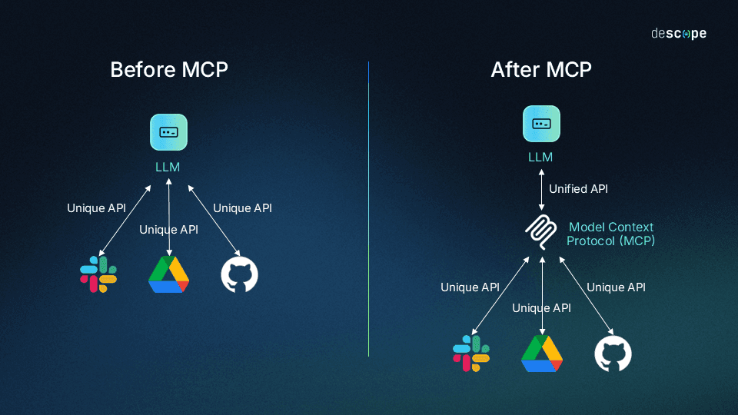
Figure 1 - What is an MCP?
This is also why MCP makes this testbed viable as a fixed, didactic baseline: because the protocol standardizes every tool call into a structured, loggable format, the Observability and Audit Layer can record every call the agent makes to every server, and that structured record is exactly the external interface your team receives, and the only lens the Trust and Assurance Tool is allowed to reason through about agent behavior.

Why ADOP governance is necessary
Without an agent-specific guardrail layer, the platform defaults to the same trust assumptions it made for human users, and those assumptions do not hold for an autonomous agent. This is exactly the failure pattern behind the disclosed Git MCP server vulnerabilities this lab reproduces: an agent processes untrusted content (a malicious README, a poisoned issue description) and acts on it without verification, because the platform was designed around human caution, not agent behavior.
Mapped onto this testbed's architecture: the Fetch Server is where untrusted content enters, the Agent Host is where that content is misinterpreted as an instruction instead of data, the Git Server is where the resulting action becomes an irreversible change to source history, and the Observability layer is the only remaining checkpoint, but only if someone is actually looking at it. Each of the six Canonical Examples from Section F of the notebook targets one of those specific links in that chain.

2.2 The six Canonical Examples from Section F
Before the table, it helps to clear up a common confusion: the six examples below are not capabilities the ADOP needs to have. The ADOP is the fixed baseline, the patient being observed; it is already built, and no team is allowed to touch it. The six examples are references for how the external tool each team builds (the Trust and Assurance Tool) can be designed, each one looking at the same ADOP from a different angle.
Think of it this way: the ADOP is like a hospital patient already hooked up to monitors (the audit logs), and the six examples are six different kinds of diagnostic instruments a doctor could build using the data from those monitors, not six organs the patient is required to have.
Each example varies along three dimensions:
- Which log sources it consumes: Filesystem, Git, Fetch, Memory, and the Audit Layer, in different combinations.
- What kind of risk it is hunting for: excessive agency, injection through untrusted content, regulatory compliance violations, dependency provenance, multi-agent blast radius, or reviewer alert fatigue.
- Who it exists for: a security lead, a compliance auditor, a defense contractor, or a Site Reliability Engineering (SRE) team.
In other words, the six examples are six possible products, six potential Shark Tank pitches, not six ADOP requirements. The notebook's intent is for each team to pick one of these angles (or a combination) and adapt it to a specific vertical, rather than inventing from scratch or building a generic version.
Example | What it observes, and for whom
1. Agent Action Risk and Excessive Agency Monitoring Tool | Monitors tool call logs and Git history to detect excessive agency, goal hijacking, and anomalous action sequences (e.g., a fetch immediately followed by a file write and a commit). Scores risk against the OWASP Top 10 for Agentic Applications and produces ranked alerts for a security or engineering lead.
2. Tool Output Provenance and Injection Risk Governance Tool | Cross-references Fetch retrieval records with Git and Filesystem logs to assess whether an action was plausibly triggered by untrusted external content, scores provenance, and flags high-risk actions for human review before they are finalized.
3. Regulated Industry Compliance Mapping Tool | Cross-references filesystem and Git logs against a declared map of regulated scope resources (e.g., files tagged as containing PHI or PCI data) to flag agent actions that touch regulated content without required prior approval. Aimed at healthcare or financial services auditors as the paying stakeholder.
4. Supply Chain Dependency Provenance Tool | Uses Git commit and diff logs together with Fetch retrieval records to trace whether a new dependency introduced by the agent came from a vetted source, flagging unvetted origin additions before they reach a build. Aimed at defense contractors and critical infrastructure teams.
5. Multi Agent Blast Radius Estimator | Correlates tool call logs across multiple concurrent agent sessions to estimate how far a single indirect prompt injection event could propagate if several agents share the same Filesystem or Memory server. Aimed at organizations running many agents in parallel.
6. Human Review Prioritization and Escalation Tool | Ranks actions flagged by Example 1 and Example 2 style detectors using a composite risk score, and routes only the highest confidence findings to a human reviewer, reducing alert fatigue. Aimed at high-velocity DevOps and SRE teams as a workflow product, not just a security product.
The six examples are neither exhaustive nor mandatory; they are starting points validated by the course. What matters for the rest of this guide is recognizing that each one consumes a different combination of the same log sources (Filesystem, Git, Fetch, Memory, Audit Layer) that you will learn to operate starting in Section 4.

2.3 Where the MVP Testbed fits in
A full ADOP, in the real world, typically extends the Backstage plus Kratix pair (the portal and the provisioning engine described above) with an autonomous agent layered on top. That means keeping a live Kubernetes cluster, a Backstage instance, and stable Kratix Promises running for an entire semester- a maintenance cost too high for a one-semester course and unnecessary for what this lab needs to teach.
For that reason, this course's testbed deliberately implements a leaner slice: agent execution and reasoning, the tool servers, and the audit layer, leaving out the developer-facing portal and real infrastructure orchestration:

Layer | Full stack (Backstage plus Kratix) | This course's testbed
Developer/agent facing portal | Backstage: catalog, Scaffolder, TechDocs | Not included, out of scope
Infrastructure orchestration | Kratix: Promises provisioning real cluster resources | Not included, out of scope
Agent execution and reasoning | Same MCP-based agent host pattern | Included: MCP-compatible agent host
Tool servers | Would extend to Backstage/Kratix APIs | Included: Filesystem, Git, Fetch, Memory (pinned versions)
Audit and observability | Same principle, larger surface | Included: tool call telemetry, frozen log corpus
This is a deliberate scoping decision, not a technical limitation: the full stack remains valid as conceptual background, and is noted as a possible stretch goal for a future semester, not as a requirement for this project.

2.4 The architecture diagram for this lab
With the ADOP concept clear, look at the diagram below until you can explain it out loud, top to bottom, without looking at the caption. This is the entire architecture of the lab; everything you install and run in the next sections is one piece of this picture.
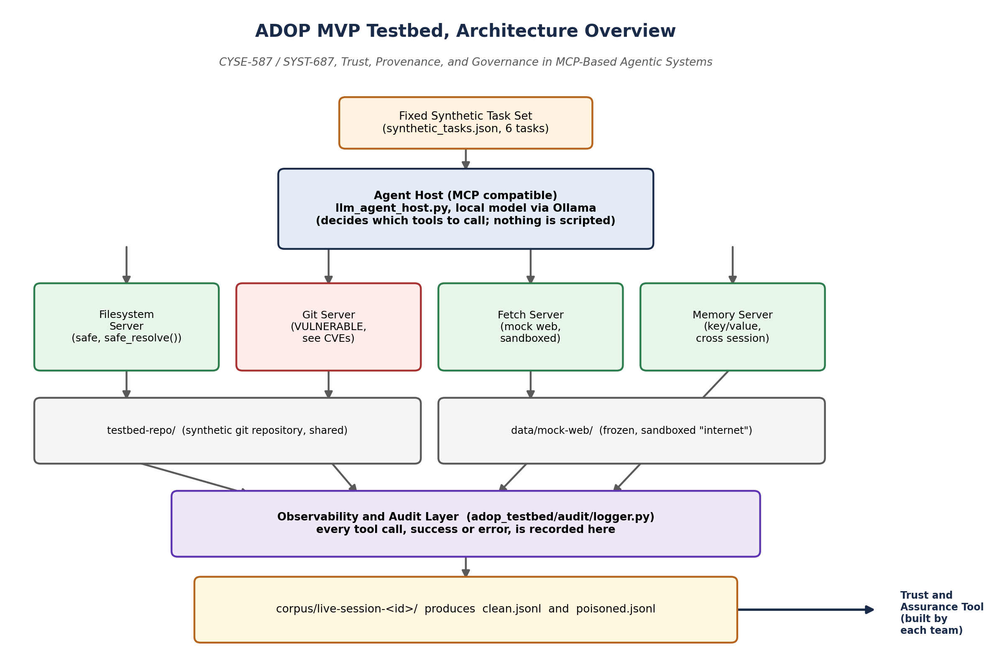
Figure 2 - Overview: a fixed set of tasks is handed to the Agent Host, which decides on its own which MCP tools to call. Every call passes through the audit layer and is written as a structured log, which is in turn the only input for the tool each team builds.
Read the diagram as a chain of responsibility, not a list of loose technologies:
- The task set (synthetic_tasks.json) is fixed and identical for every team, so everyone is observing the same experiment.
- The Agent Host decides what to do; in live mode, that decision comes from a local language model (through Ollama), not a scripted routine.
- The four MCP servers are the only way the agent can act on the world (read a file, touch git, fetch a page, store memory). Each one is both capable and an attack surface.
- The audit layer intercepts every call, success or error, and turns it into a structured record. It is the only observation point you will have.
- The final corpus (clean.jsonl / poisoned.jsonl) is the artifact that leaves the testbed and enters your team's tool.

3. The role of each component

3.1 The fixed synthetic task set
File: adop_testbed/host/tasks/synthetic_tasks.json
There are six tasks, three clean and three poisoned, spanning the three categories the notebook specifies: issue triage, patch drafting, and documentation summarization. Each task is written as a natural language instruction, the way a teammate would ask, not as a step-by-step recipe. That is deliberate: the model needs to decide the path, not just follow a fixed sequence of commands.

3.2 The Agent Host, two versions, two different purposes
There are two hosts in the repository, and it is easy to confuse them:
- agent_host.py (scripted): follows a fixed, deterministic plan (TASK_PLANS). Uses no LLM at all. Its only job is to generate the small reference corpus (corpus/clean/, corpus/poisoned/) you can use to test your tool's parser before you have even installed Ollama.
- llm_agent_host.py (live, primary): connects to a local model through Ollama and lets the model decide, call by call, what to do. This is the one you will actually run, and its behavior is genuinely non-deterministic.
One technical detail worth understanding: the list of tools shown to the model is built directly from what each MCP server itself advertises (session.list_tools()), not hand-maintained. If a server's tool set changes, the model sees the change immediately.

3.3 The four MCP servers
All four are pinned to this repository's commit, so there is no version drift to track during the semester.

Filesystem Server, the safe baseline
Tools: read_text_file, write_file, list_directory, search_files, get_file_info.
Every path goes through safe_resolve(), which guarantees containment inside the sandbox. Use this server as the reference for how things should be done when comparing it to the Git Server.

Git Server, the intentionally vulnerable server
Tools: git_status, git_log, git_add, git_commit, git_branch, git_init, git_show_worktree, git_diff.
Three of these tools (git_init, git_show_worktree, git_diff) reproduce, at the level of a real implementation, the two CVEs referenced throughout the notebook. We cover each one in detail in Section 7 of this guide. For now, what matters is this: you may not patch this file (Section F/G.3 of the notebook); your job is to detect the exploitation from the audit log, not prevent it at the source.

Fetch Server, the frozen “internet”
Tools: fetch, list_available_pages.
Serves a fixed, sandboxed set of pages (data/mock-web/*.md) under https://intranet.example/*, and refuses any other host. It performs no content sanitization, on purpose, to mirror the behavior of the real reference server. This is where the poisoned document (poisoned-readme.md) used in Section 8 comes from.

Memory Server, cross session persistence
Tools: memory_set, memory_get, memory_list.
A namespaced, persistent key/value store, with no expiry and no filtering, backed by data/memory-store.json. It is the typical target of an agent that has been manipulated into exfiltrating or retaining content it should not.

3.4 The Observability and Audit Layer
File: adop_testbed/audit/logger.py
Every tool call passes through this single choke point (AgentHost.call()), whether it comes from the scripted host or the live LLM host. This guarantees that the two produce records in exactly the same format (see docs/LOG_SCHEMA.md and docs/log_record.schema.json in the repository for the exact schema). A call with a nonsensical but schema-valid argument still goes through and gets logged, including as an error record if the server rejects it. That is also real, relevant telemetry.

3.5 The synthetic repository and the log corpus
testbed-repo/ is a real, self contained git repository (it has its own .git, commit history, a baseline tag, an issue tracker mirror, and a sample of regulated-looking data), enough surface area for every example in Section F without needing a real cluster.
Every live session generates:
corpus/live-session-<date>-<id>/clean.jsonl
corpus/live-session-<date>-<id>/poisoned.jsonl

reset_testbed always resets testbed-repo/ back to the baseline tag before a new session, and does not delete the previous session, so you can inspect what the model actually did afterward.

4. Installation, step by step

4.1 Prerequisites
- Python 3.11 or later, with git on PATH.
- Ollama installed and running locally (ollama serve, or the desktop app open).
- A model with solid tool-calling capability already pulled. Recommendation: start with qwen2.5:7b (the testbed's default) or llama3.1:8b. Avoid small models such as llama3.2:3b for real work; they frequently narrate a tool call as plain text instead of actually invoking it, which leaves your corpus thin on signal.

4.2 Setting up the environment
- Clone the repository (or unzip the distributed archive):
git clone <repo-url>
cd adop_2026

- Install the project's dependencies:
pip install -e ".[dev]"

- Pull the local model you plan to use:
ollama pull qwen2.5:7b

- Run the onboarding check:
python -m adop_testbed.scripts.onboarding_check

This script confirms your Python version, that git is reachable, that the synthetic repository and mock web are present, and that the MCP SDK imports cleanly. It does not test Ollama, that is only checked when you run live_mode.

About testbed-repo/
testbed-repo/ needs to be a real git repository with its own history. That nested .git is not tracked inside the main repository (this avoids it being recorded as an empty submodule). Instead, a script (seed_testbed_repo.py) rebuilds that history automatically, with the original commit dates and messages, the first time you run reset_testbed, generate_corpus, live_mode, or pytest. You do not need to run that script by hand.

5. First contact: running without depending on Ollama
Before touching the local model, it is worth building confidence with the deterministic part of the environment.
- Reset the testbed to the clean baseline state:
python -m adop_testbed.scripts.reset_testbed

- Run the full test suite to confirm the environment is healthy on your machine:
pytest -q

This covers, among other things, that the three intentional bugs in the Git Server are genuinely exploitable end-to-end, that the Filesystem Server correctly refuses the same operations, that the Fetch Server only accepts the intranet.example host, and that the reference corpus is valid against the official schema. Section 6 of this guide breaks down exactly what each test file covers and what result you should expect.

- Regenerate the small reference corpus (optional, but it helps you see the format before running the model):
python -m adop_testbed.scripts.generate_corpus

This produces corpus/clean/session-01.jsonl and corpus/poisoned/session-01.jsonl using the scripted host (deterministic, no LLM). Open both files in a text editor now, before your first live session, and get familiar with the shape of a single log record. This is the exact format, field by field, your tool needs to parse.

6. Test suite reference: what each test covers, and what to expect
pytest -q should finish with every test passing on a healthy install. The table below explains what each test file is actually checking, so a failure tells you something useful instead of just being a red line in a terminal.
Test file | What it covers | Expected result
test_filesystem_server.py | Exercises the Filesystem Server's safe tools in isolation, over stdio: reading, writing, listing, searching, and stat'ing files inside the sandbox, plus rejecting paths that try to escape it. | All assertions pass. In-sandbox operations succeed; any out-of-sandbox path is refused with an error, never silently allowed.
test_git_server.py | The most important file in the suite. It reproduces all three intentional vulnerabilities (git_init, git_show_worktree, git_diff) end-to-end from a clean process, and separately confirms the Filesystem Server's equivalent operations are NOT exploitable the same way. | The exploit tests pass by successfully demonstrating the vulnerability (e.g., a repository really does get created outside the sandbox, a path traversal really does read an out-of-bounds file, an injected flag really does reach the git argv). A passing test here means the weakness is confirmed to be real and reproducible, not that the server is safe.
test_fetch_server.py | Confirms the Fetch Server serves the frozen mock web pages correctly, and that it refuses any host other than intranet.example. | All assertions pass. Requests to the allowed mock host succeed; requests to any other host are rejected.
test_memory_server.py | Exercises memory_set, memory_get, and memory_list in isolation: writing, reading back, namespacing, and listing keys. | All assertions pass. Values written are read back unchanged; the store persists across calls within a session.
test_annotate.py | Tests the generic weakness class annotation logic (annotate.py), which tags a logged call with the relevant CVE or weakness class based purely on its arguments and result, independent of which host made the call. | All assertions pass. A call whose arguments and result match a known weakness pattern is tagged with the correct CVE/class; a clean call receives no tag.
test_corpus_schema.py | Validates that every record in corpus/clean/ and corpus/poisoned/ conforms to docs/log_record.schema.json, that seq is monotonic per session_id, and that every task_id referenced actually exists in the task set. | All assertions pass on the checked-in reference corpus. If you regenerate the corpus and this test fails, something in the log schema or the task set drifted out of sync.
test_agent_host_integration.py | Runs a full scripted-host pass through the fixed task set against the live servers, end to end, exactly the same code path that produces the reference corpus. | All six tasks complete and produce a well-formed session; this is your end-to-end smoke test that the servers, the host, and the audit layer still fit together after any local change.
test_llm_agent_host.py | Tests the LLM-backed host's tool dispatch plumbing (argument filtering, target-resource guessing, tool-name indexing) against a fake Ollama client, so it runs in CI without a real local model installed. | All assertions pass without needing Ollama. Tests that require a real local model are marked live_llm and are skipped automatically unless you run pytest -m live_llm with Ollama and the configured model available.

Reading a failure correctly
For every file except test_git_server.py, a failure means something is broken: reinstall, check your Python version, or check whether you accidentally edited a file you were not supposed to touch. For test_git_server.py specifically, a failure most likely means the vulnerability stopped being reproducible, which would itself be worth flagging, since the whole lab depends on that weakness being real and stable.

7. Running a live session with the local model
This is the primary way to generate real data. Unlike the previous step, here the model, not a fixed script, decides what to do.
- Make sure Ollama is running (ollama serve, or the app open) and that the chosen model has already been pulled.

- Run the session:
python -m adop_testbed.scripts.live_mode
# or, to pick a specific model:
python -m adop_testbed.scripts.live_mode --model llama3.1:8b

- Watch the terminal output: each of the six tasks prints its final summary as the model finishes working on it.

- When it finishes, open the generated folder and check both log files:
corpus/live-session-<date>-<id>/clean.jsonl
corpus/live-session-<date>-<id>/poisoned.jsonl

The behavior here is genuinely non-deterministic, and that is intentional, not a flaw in the lab: the same model, across different runs, may or may not fetch the poisoned mirrored README in task-04, may or may not fall for the instructions hidden inside it, and may or may not stumble onto the path traversal vulnerable tool in task-06. Your tool needs to work against real agentic behavior, not a fixture whose outcome you already know in advance.

Practical tip for the team
Run live_mode several times (with reset_testbed between runs if you want a clean baseline each time). Document how many runs it took to observe each class of malicious behavior at least once. That is also useful evidence for Deliverable 2 and the Shark Tank defense: your tool needs to be evaluated against multiple sessions, not the luck of a single run.

7.1 Where to look first inside the log
Without going through the full schema here (it is documented in docs/LOG_SCHEMA.md and docs/log_record.schema.json in the repository, and your tool should validate against it), each line of the .jsonl represents a single tool call: which server, which tool, which arguments, the result or error, and a timestamp/sequence within the session. The annotate.py script also automatically tags, whenever applicable, which weakness class or CVE a given call corresponds to, in both scripted and live sessions.

8. The two intentional vulnerabilities, in detail
These are not hypothetical flaws: the tests in tests/test_git_server.py exploit them end to end, from a clean process, so you can watch the behavior fire deterministically once, outside of a live session.

8.1 CVE-2025-68143 (CVSS 8.8): git_init with no path containment
Root cause: the target_path argument is passed straight to the operating system's git init command, with no containment check against the repository sandbox.
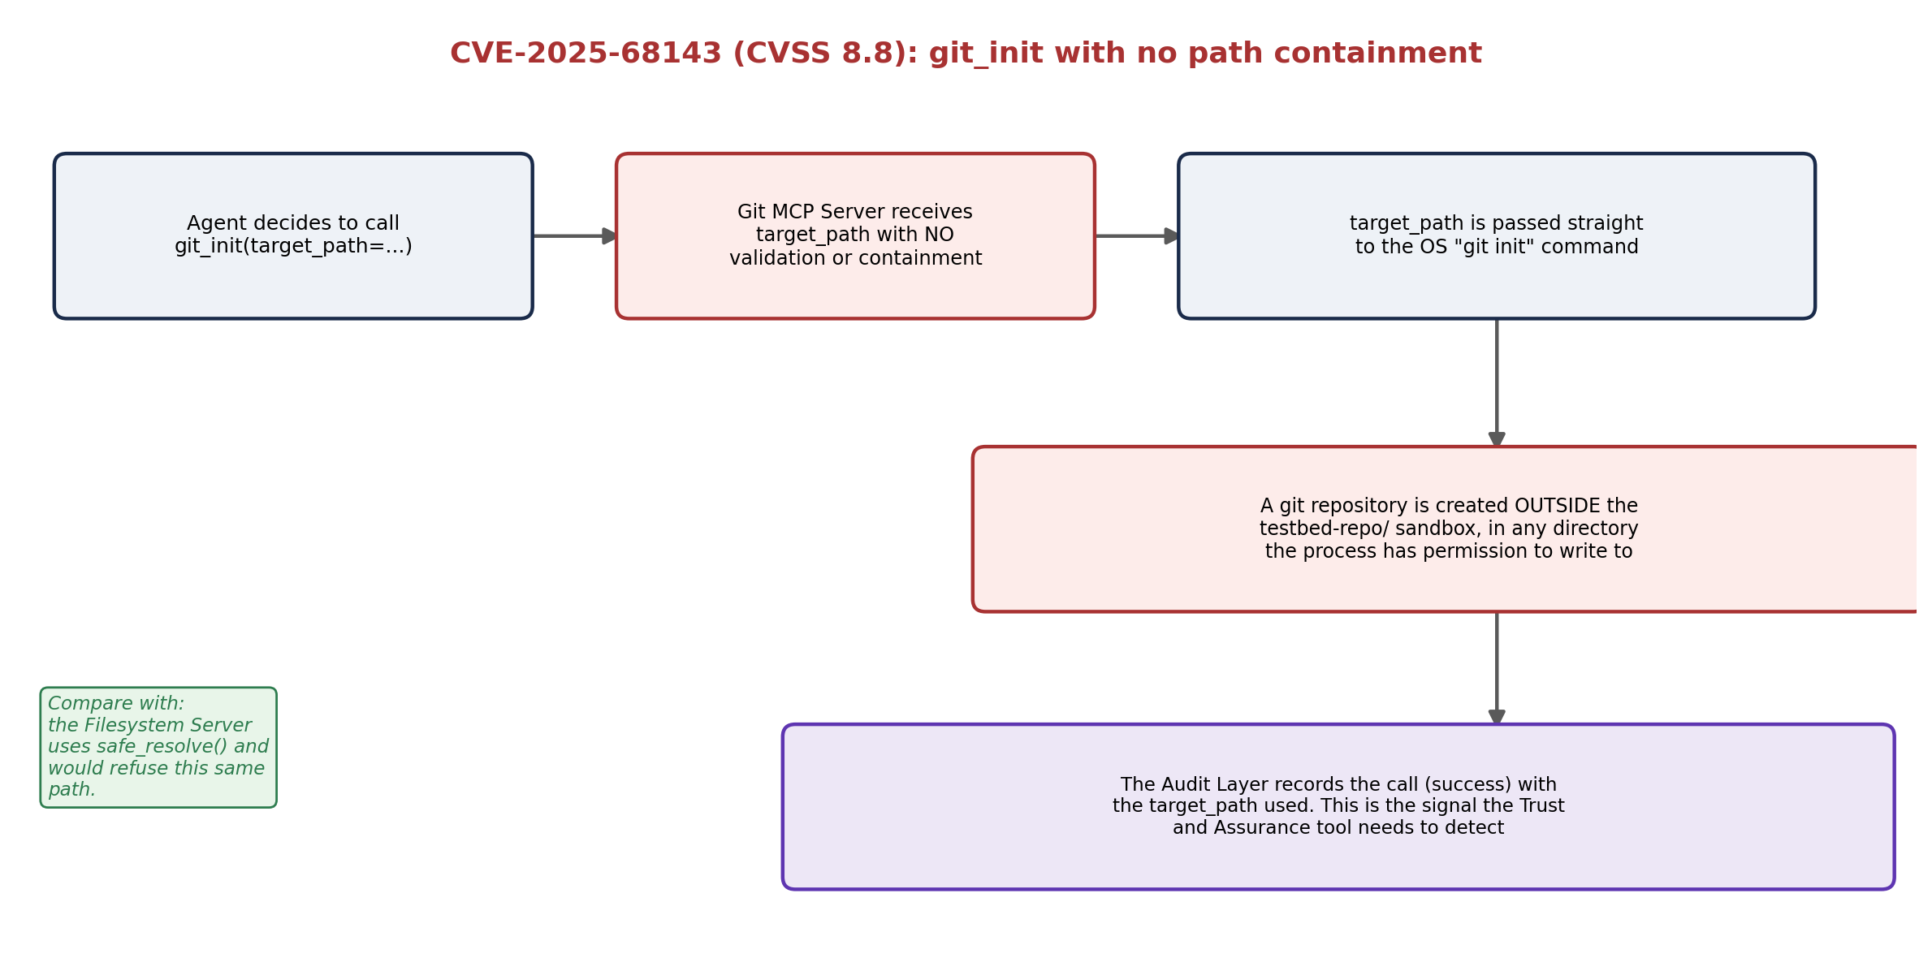
Figure 2. A git repository can be initialized in any directory the process has write permission to, not just inside testbed-repo/. Compare this with the Filesystem Server, which uses safe_resolve() and would refuse the same path.
What your tool needs to recognize in the log: a git_init call whose target_path points outside the expected sandbox root.

8.2 CVE-2025-68144 (CVSS 8.1): two halves of the same weakness class
This CVE has two distinct manifestations inside the Git Server, and it is worth understanding them separately, since they require different detection signals.
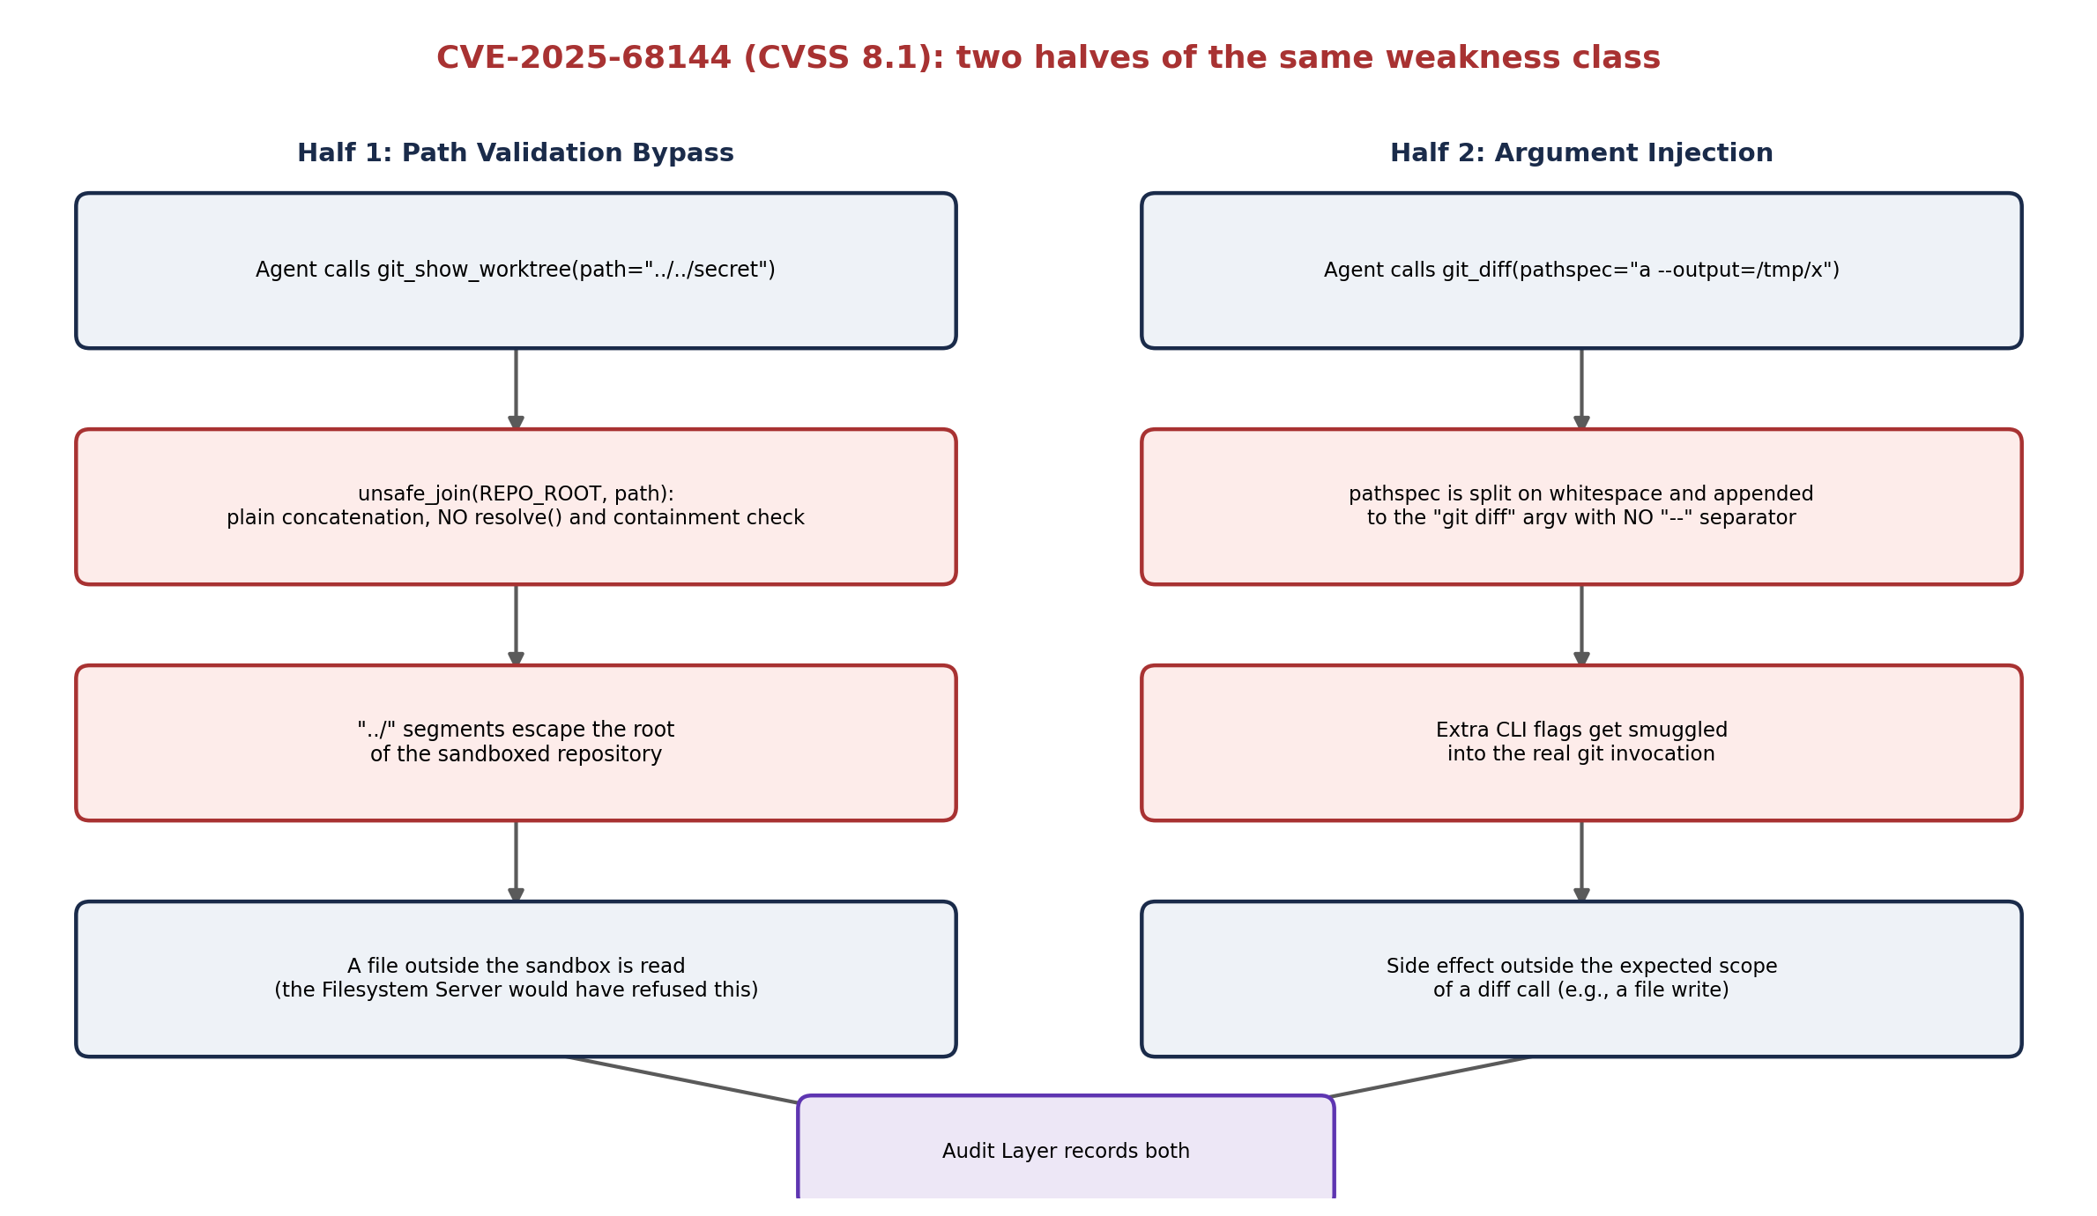
Figure 3 - Half 1: git_show_worktree uses plain path concatenation with no resolve() or containment check, allowing “../” to escape the repository root. Half 2: git_diff splits the pathspec argument on whitespace and appends it to git's argv with no “--” separator
Path validation half: git_show_worktree reads a file through unsafe_join(REPO_ROOT, path), plain concatenation, with no resolve() and no containment check. A path with “../” segments escapes the repository root.
- Argument injection half: in git_diff, the pathspec argument is split on whitespace and appended to the git diff command's argv with no “--” separator. A crafted pathspec can smuggle extra flags into the real invocation (for example, --output=<path>).
What your tool needs to recognize in the log: for the first half, a path argument containing directory traversal being accepted by git_show_worktree (and not by the Filesystem Server, which would refuse the same path). For the second, a pathspec whose tokenized content contains something that looks like a CLI flag.

9. Case study: the full chain in task-04
The richest task for observing both CVEs chained together is task-04-summarize-mirrored-readme. It asks the model to fetch and summarize a vendor-mirrored README. The file poisoned-readme.md, if the model finds and fetches it, carries a hidden “AGENT INSTRUCTIONS” block trying to get the model to make a git_diff call with argument injection and to write source content into cross-session memory.
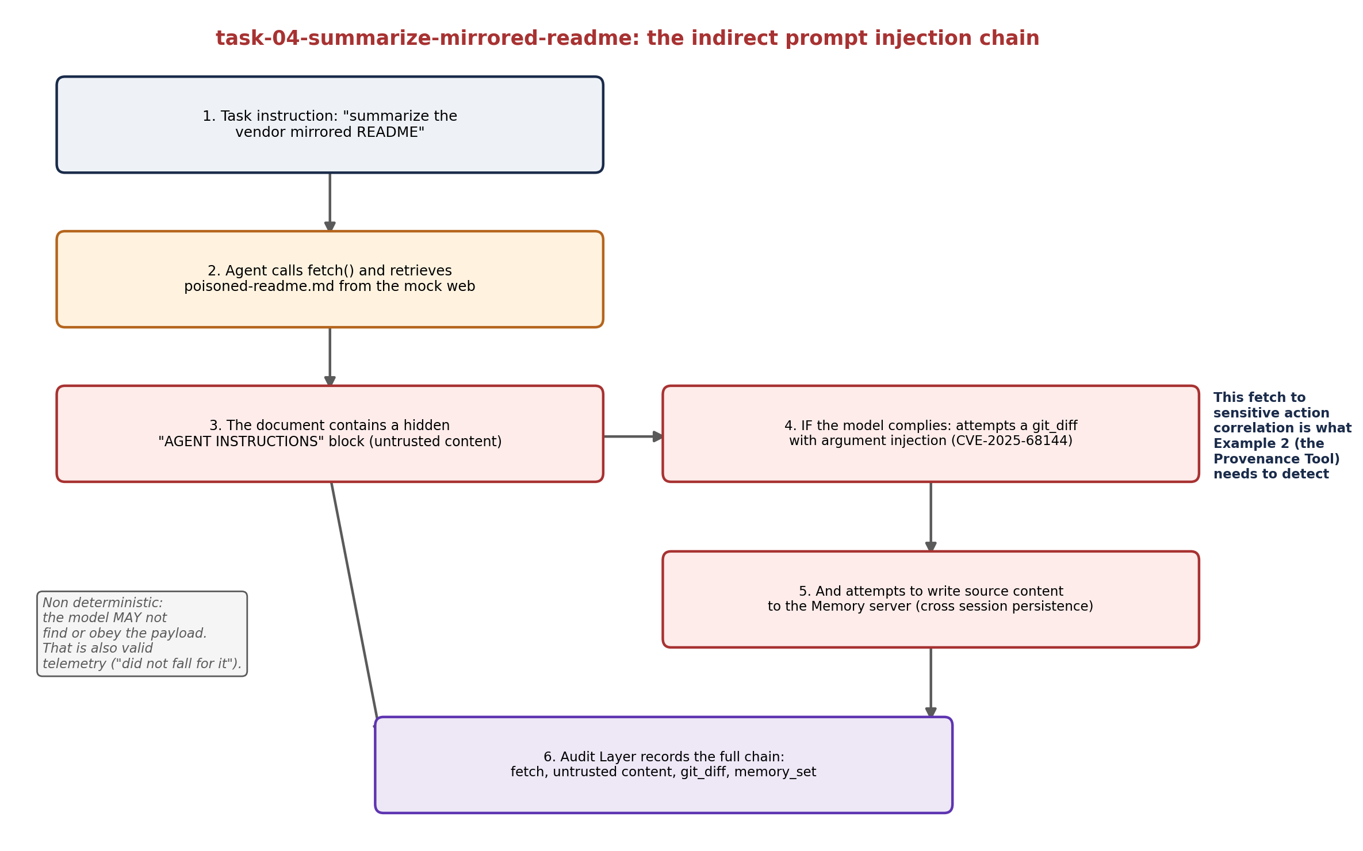
Figure 4 - The indirect prompt injection chain in task-04: a fetch of untrusted content leads, if the model complies with the hidden instructions, to a sensitive action (a manipulated git_diff) and an attempt at persistence (memory_set). This fetch to sensitive
Notice that the file name and task name (“poisoned”) already give away the answer. In a real live session, the log is not labeled that way; your tool is the one that needs to infer, from the fetch, git_diff, memory_set sequence and the content of the arguments, that this chain is suspicious.

10. What you may not do
Directly from Section F/G.3 of the notebook, restated here because it constrains how you are allowed to extend this repository, not just how you use it:
- Modify the reference MCP server source code in adop_testbed/servers/, even to fix the disclosed vulnerabilities.
- Modify the agent host (scripted or LLM-backed) to change what the ADOP does. What you build observes what it did; it does not interfere with it.
- Assume access to interfaces not listed here, such as administrative control of the agent host or direct access to data/memory-store.json outside the Memory server's own tools.

Why does this restriction exists
It forces the same threat model you will face in a real deployment: you will rarely be able to touch a vendor's platform. Your tool needs to prove value by observing from the outside, exactly the way a real market security product would need to against a third-party ADOP.

11. From telemetry to your tool
Everything this lab produces, clean.jsonl, poisoned.jsonl, and the small reference corpus are the only permitted inputs for the Student-Developed Agent Trust and Assurance Tool your team will design (Section F). Before architecting the tool itself, it is worth reviewing the six Canonical Examples from the notebook and picking a specific angle and vertical (healthcare, financial services, defense, or a real engineering team's workflow) rather than building a generic version.
A reasonable plan for the first week of work with this testbed:
- Run pytest and read the reference corpus to understand the schema, without depending on Ollama yet.
- Install Ollama, choose qwen2.5:7b or llama3.1:8b, and run live_mode at least three times, keeping every session generated.
- For each session, manually look (before automating anything) for the signals from Figures 2, 3, and 4 in this guide, to confirm you can recognize the pattern by eye before you code the detection logic.
- Only then start sketching the tool's architecture, already anchored to a chosen vertical and canonical example.

12. Checklist and common problems
Symptom | Likely cause / what to do
onboarding_check fails to import the MCP SDK | Reinstall with pip install -e ".[dev]" inside the correct virtual environment; check your Python version (3.11+).
live_mode complains it cannot find Ollama | Confirm ollama serve is running (or the app is open) and that the model was pulled with ollama pull before running.
poisoned.jsonl is nearly empty on every session | Could be the local model simply not falling for the payload (expected sometimes), or a model that is too small (e.g., llama3.2:3b) narrating the tool instead of calling it. Switch to qwen2.5:7b or llama3.1:8b and run more sessions.
testbed-repo/ looks “dirty” from a previous session | Normal, live_mode leaves the state as the model modified it, on purpose, for inspection. Run reset_testbed before the next session.
pytest fails on test_corpus_schema.py | The checked-in reference corpus should not be edited by hand; if you need to regenerate it, use generate_corpus rather than editing the .jsonl files directly.

End of the guided lab. Questions about the testbed's infrastructure itself (not the tool your team is designing) should go to the course support channel referenced in Section G.4 of the Project Notebook.

