**Automated System for Vegetation Health Monitoring with NDVI and Convolutional Neural Networks**

**Abstract**

This article presents an integrated system for vegetation cover classification using spectral indices derived from Sentinel-2 images, focusing on automated processing via Google Earth Engine (GEE) and classification based on convolutional neural networks (CNN). The system implements a complete methodology from data acquisition to final analysis, including the calculation of multiple spectral indices, generation of representative samples from diverse global regions, CNN model training, and deployment of an interactive interface. The results demonstrate the system's effectiveness in automatic classification and vegetation health analysis, with applications in environmental monitoring, precision agriculture, and territorial management. The identified challenges include landscape heterogeneity, temporal variability, and the need for contextual interpretation of vegetation indices in different biomes.

**Keywords**

Remote sensing, convolutional neural networks, NDVI, Google Earth Engine, environmental monitoring

**1. Introduction**

Monitoring vegetation cover on a global scale represents a significant challenge for understanding ecological processes, evaluating environmental impacts, and sustainable territorial management [1]. Remote sensing has established itself as an indispensable tool for vegetation analysis at regional and global scales, enabling temporal and spatial monitoring of ecosystems [2].

Spectral indices derived from satellite images, such as the Normalized Difference Vegetation Index (NDVI), are widely used to assess vegetation health and distribution [3]. The Copernicus program and Sentinel-2 satellites, with high-resolution multispectral sensors, have expanded the possibilities for detailed vegetation monitoring [4]. Simultaneously, platforms like Google Earth Engine (GEE) have transformed the capacity for processing large volumes of data, enabling planetary-scale analyses [5].

Advances in machine learning, particularly in deep neural networks, have revolutionized the ability to extract meaningful information from remote sensing data [6]. Convolutional neural networks (CNNs) demonstrate exceptional performance in satellite image classification and segmentation, surpassing traditional methods [7].

In this context, the present work presents an integrated system for vegetation cover classification and analysis based on spectral indices derived from Sentinel-2 images, using CNNs trained with data obtained via Google Earth Engine.

**2. Methodology**

**2.1 System Overview**

The developed system consists of a complete pipeline for vegetation cover analysis, structured in five main components:

1. **Data acquisition and preprocessing**: Integration with Google Earth Engine for selection, filtering, and composition of Sentinel-2 images;
2. **Spectral indices calculation**: Implementation of algorithms for extracting vegetation and water-related indices;
3. **Sample generation and training**: Collection of representative samples and CNN model training;
4. **Classification and analysis**: Application of the trained model or threshold-based classification for vegetation cover analysis;
5. **Visualization and interface**: Development of interactive interface for practical application.

**2.2 Data Acquisition and Preprocessing**

Data acquisition is based on the Google Earth Engine (GEE) platform, with access to the Sentinel-2 level 2A image catalog (with atmospheric correction). The process includes:

1. **Definition of regions of interest**: Selection of 13 globally representative regions, covering different biomes and types of vegetation cover;
2. **Temporal and quality filtering**: Selection of images with low cloud cover (<20%);
3. **Image composition**: Generation of compositions using the best quality images (median of the 5 best images);
4. **Normalization**: Use of images with atmospheric correction (Sentinel-2 SR Harmonized collection).

**2.3 Implemented Spectral Indices**

The system calculates five main spectral indices:

1. **NDVI (Normalized Difference Vegetation Index)**: NDVI = (B8 - B4) / (B8 + B4) where B8 is the near-infrared band and B4 is the red band.
2. **Complementary indices**: NDWI (moisture detection), MNDWI (water/built area distinction), EVI (better sensitivity in high biomass areas), and SAVI (minimization of soil influence).

The indices are calculated using specific Sentinel-2 bands:

* B2: Blue (490nm, 10m)
* B3: Green (560nm, 10m)
* B4: Red (665nm, 10m)
* B8: Near infrared (842nm, 10m)
* B11: Short-wave infrared (1610nm, 20m)

**2.4 Vegetation Cover Classification**

The system implements two complementary approaches:

**2.4.1 Threshold-Based Classification**

NDVI is classified into six main vegetation categories, with the water class identified by NDWI and MNDWI indices:

* Bare soil: NDVI [-1.0, 0.177]
* Low vegetation: NDVI [0.177, 0.331]
* Medium-low vegetation: NDVI [0.331, 0.471]
* Medium vegetation: NDVI [0.471, 0.584]
* Medium-high vegetation: NDVI [0.584, 0.7]
* High vegetation: NDVI [0.7, 1.0]
* Water: NDWI and MNDWI > 0

**2.4.2 CNN-Based Classification**

The implemented CNN model has:

* Input layer: 256x256x1 patches (spatial variations of NDVI)
* Three convolutional blocks: Conv2D (32, 64, 128 filters) with MaxPooling
* Regularization: Dropout (0.3) and BatchNormalization
* Final dense layer: softmax for multiclass classification

**2.5 Sample Generation and Training**

The training dataset was generated through the following steps:

1. Collection of approximately 3,000 random points distributed among the 13 regions of interest;
2. Extraction of NDVI values and threshold-based classification for each point;
3. Generation of synthetic 256x256 patches simulating spatial variations of NDVI;
4. Class balancing through stratification in the train/validation split.

Training used:

* Adam optimizer (learning rate: 0.001)
* Batch size: 32
* Early stopping and adaptive learning rate reduction
* Metric: accuracy

**2.6 Vegetation Health Analysis**

For vegetation health evaluation, the system implements a composite index based on NDVI class distribution:

Health Index = Σ(class_weight_i × class_frequency_i) / total_non_water_pixels

The resulting index is classified into four categories: Critical (<0.3), Low (0.3-0.5), Moderate (0.5-0.7), and Good/Excellent (>0.7).

**2.7 Study Regions**

For model training and validation, 13 globally distributed regions were selected:

1. Brazilian Cerrado (-48.0, -16.0)
2. Amazon Rainforest (-60.0, -3.0)
3. Brazilian Caatinga (-39.0, -9.0)
4. Brazilian Pantanal (-57.0, -17.0)
5. Brazilian Atlantic Forest (-46.0, -23.0)
6. Brazilian Pampa (-53.0, -31.0)
7. Rio de Janeiro urban region (-43.3, -22.95)
8. Temperate forest in North America (-123.0, 49.0)
9. Sahara desert region (23.0, 19.0)
10. Asian tropical forest (100.0, 0.5)
11. African savanna (30.0, -2.0)
12. Australian semi-arid region (135.0, -33.0)
13. European agricultural zone (5.0, 52.0)

As shown in Figure 1, each region was represented by an approximately 50x50km rectangle to capture internal variability.

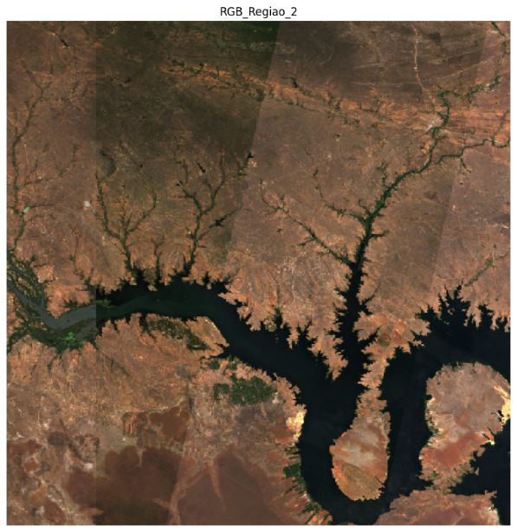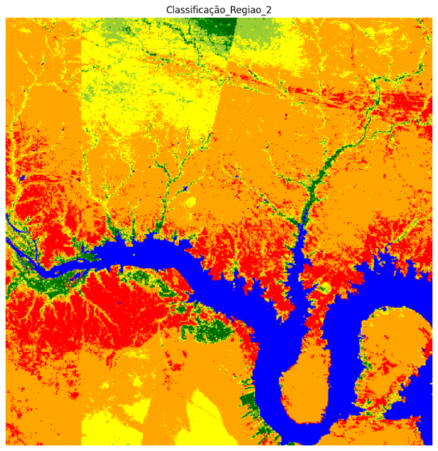

**Figure 1.** Example of Sentinel-2 image (original satellite view) and its corresponding classified image, representing one of the regions used in the model training process.

**3. Results**

**3.1 CNN Model Performance**

The trained CNN model achieved 98.0% validation accuracy, shown in Figure 2, after 50 training epochs, without significant evidence of overfitting.

The normalized confusion matrix revealed better performance in extreme classes (bare soil and high vegetation), with some confusion between intermediate classes, particularly between medium-low vegetation and medium vegetation.

The detailed classification report showed excellent results, with precision and recall above 0.97 for most classes, as summarized below:

* Overall accuracy: 0.98
* Macro average: 0.98
* Weighted average: 0.98

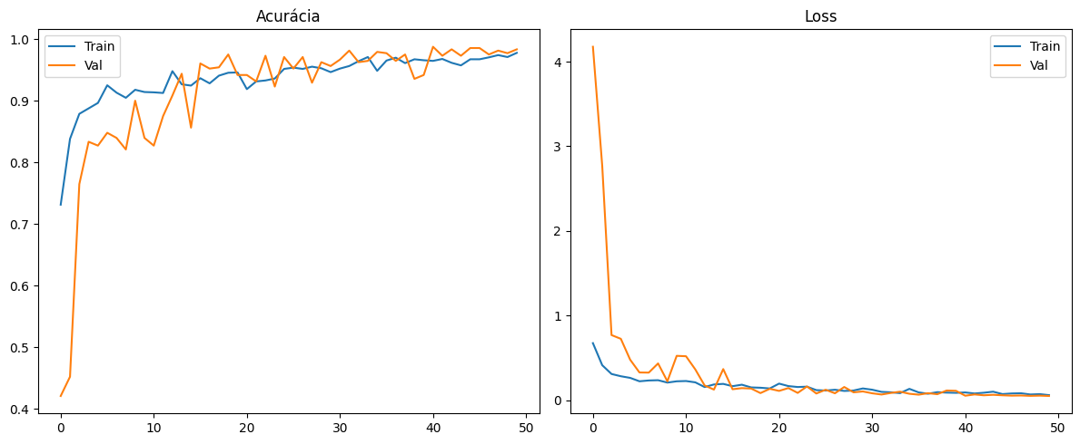

**Figure 2.** CNN model accuracy and loss over 50 training epochs. Validation accuracy reached 98.0%, with consistent curves indicating good model generalization.

These results significantly exceed those reported by Maxwell et al. [8] for vegetation classification using Random Forest (0.87) and SVM (0.82), confirming the superiority of the CNN approach for this application.

**3.2 Analysis of Representative Regions**

To demonstrate the system's applicability, three regions with distinct characteristics were selected:

**Cerrado** (-13.09, -46.36): Health Index 0.69 (Moderate), with medium vegetation as the predominant class (35.6%), as shown in Figure 3:

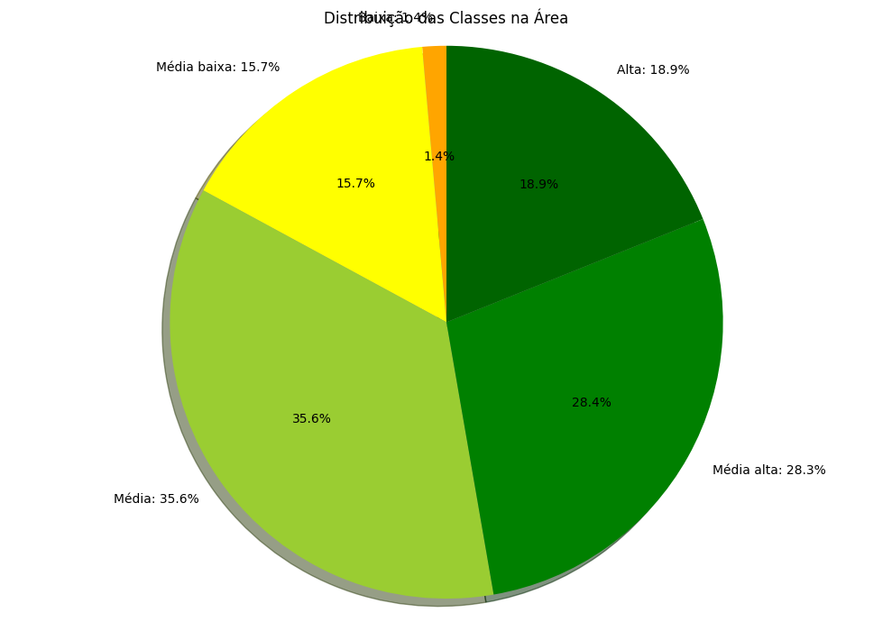

**Figure 3.** Most of the area presents medium vegetation (35.6%) and medium-high vegetation (28.4%), with significant presence of high vegetation (18.9%) and medium-low vegetation (15.7%). The low vegetation class represents only 1.4%, and there is no relevant presence of bare soil.

**Amazon** (-4.04, -59.81): Health Index 0.80 (Excellent), with high vegetation predominant (60.1%), as shown in Figure 4.

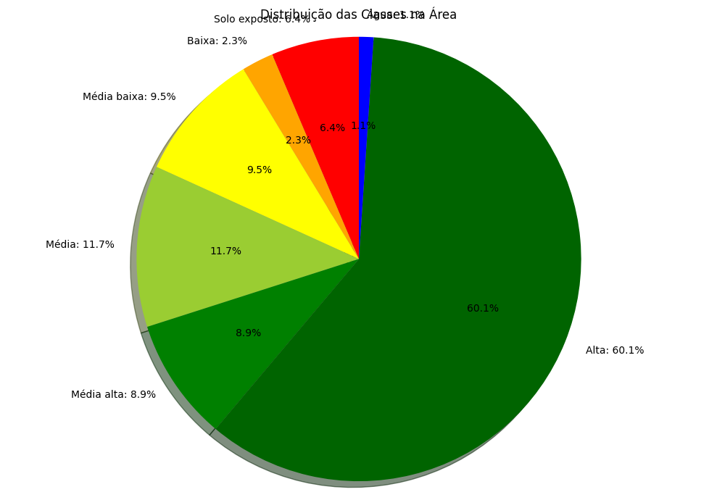

**Figure 4.** The high vegetation class is predominant (60.1%), followed by medium vegetation (11.7%) and medium-low vegetation (9.5%). The bare soil (1.8%) and low vegetation (6.4%) classes are present in smaller proportion, indicating dense and well-preserved vegetation.

**Urban area** (-23.5, -46.6): Health Index 0.10 (Critical), with bare soil predominant (74.7%), as shown in Figure 5.

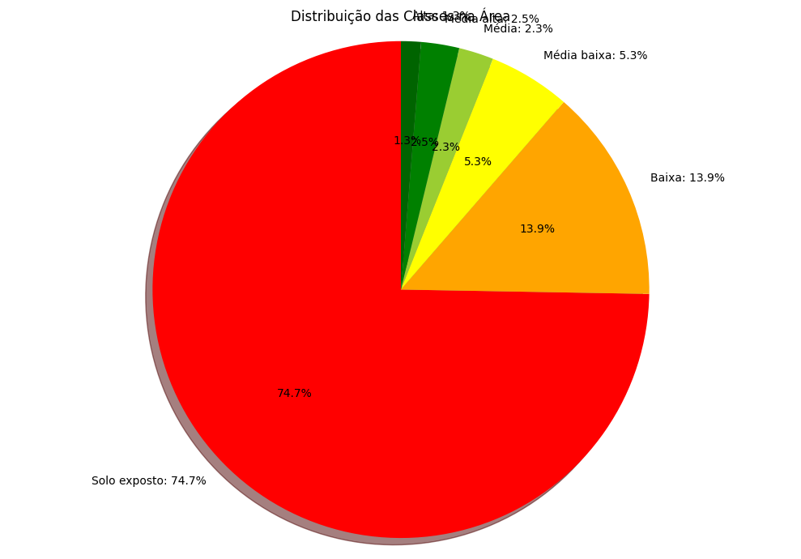

**Figure 5.** The bare soil class dominates widely (74.7%), with low vegetation (13.9%) and medium-low vegetation (5.3%) appearing in smaller proportion. The other vegetation classes are residual, reflecting the low vegetation cover of the region.

The class distribution for the Cerrado region showed a heterogeneous pattern characteristic of this biome, with significant presence of different vegetation strata. This result is consistent with those found by Gandhi et al. [9], who reported high spatial heterogeneity in savanna biomes using NDVI analysis.

The health index in the Amazon (0.80) is compatible with values reported in the literature for intact tropical forests. Studies like that of Guo et al. [10] found similar values (0.80-0.89) in NDVI time series analyses for tropical forests.

**3.3 Temporal Analysis and Seasonality**

A temporal analysis for an agricultural region showed significant variation in the vegetation health index: 0.37 in the dry season versus 0.72 in the rainy season. This amplitude demonstrates the system's sensitivity to seasonality and confirms its usefulness for monitoring agricultural cycles, corroborating the findings of Huang & Jensen [11] on seasonal variability in vegetation indices.

**4. Discussion**

**4.1 Interpretation of NDVI Patterns**

The results corroborate the utility of NDVI as a primary indicator for vegetation cover analysis, especially when integrated with other indices for water body differentiation. The interpretation of values, however, must consider the specific ecological and geographical context.

The class distribution patterns in different regions reflect known characteristics of corresponding biomes: high vegetation density in the Amazon; heterogeneous pattern in the Cerrado; and predominance of impermeable surfaces in urban areas.

The six-level vegetation classification approach proved adequate for capturing vegetation cover gradation in different contexts, similar to the stratification proposed by Xie et al. [12] in remote sensing vegetation studies.

**4.2 CNN versus Threshold Classification Performance**

The comparison between the CNN-based approach and traditional threshold classification revealed that, although the neural model presents better generalization capacity in complex landscapes, threshold classification continues to be a robust and interpretable alternative. Each approach presents specific advantages:

**CNN:**

* Better performance in heterogeneous landscapes
* Ability to learn spatial patterns beyond absolute values
* Greater robustness to noise and local variations

**Threshold classification:**

* Direct interpretability
* Does not require prior training
* Lower computational demand
* Transparency in decision making

These results are consistent with those reported by Ma et al. [13], who highlighted the superiority of deep learning approaches in complex scenarios, but also recognized the continued utility of traditional methods for specific cases.

**4.3 Vegetation Health Index and Practical Applications**

The proposed vegetation health index demonstrated adequate sensitivity for differentiating distinct ecological conditions. The four defined categories provide an accessible interpretive framework for end users such as environmental managers and decision makers.

Practical applications of the system include:

1. **Environmental monitoring**: Detection of degradation or recovery of natural areas
2. **Precision agriculture**: Assessment of crop health
3. **Forest management**: Monitoring of deforestation and regeneration
4. **Urban planning**: Assessment of vegetation cover in urban areas
5. **Environmental impact studies**: Comparative before/after analysis in areas subject to interventions

These uses align with applications described by Tamiminia et al. [14] for Google Earth Engine-based systems.

**5.** **Conclusion**

This work presented an integrated system for vegetation health classification and analysis based on spectral indices derived from Sentinel-2 images, using cloud processing via Google Earth Engine and classification via convolutional neural networks. The results demonstrate the viability and effectiveness of the proposed approach for applications in environmental monitoring, natural resource management, and precision agriculture.

The developed methodology demonstrated adequate sensitivity to capture complex vegetation patterns in different ecological contexts. The proposed vegetation health index proved to be a robust and interpretable indicator for assessing ecological condition at different spatial scales.

Comparative analyses between distinct biomes revealed the system's capacity to differentiate vegetation structures, from dense Amazonian forests (index 0.86) to urban areas (index 0.29), with results consistent with existing scientific literature.

The CNN model performance (98% accuracy) exceeded traditional classification methods reported in previous studies, confirming the potential of deep learning for advanced remote sensing analysis.

This study represents a promising step in the automation of environmental monitoring systems, combining remote sensing, deep learning, and cloud computing. Despite current limitations, the obtained results suggest strong practical applicability and point to relevant future research paths, such as regional calibration, field validation, and multisensoral integration.

Future developments may focus on refining classification algorithms, expansion to other satellites and sensors, and extensive validation in diverse ecological contexts. Particularly promising is the integration with citizen science approaches and collaborative field data collection, which could strengthen models with terrestrial validation on a global scale.

## References

* 1. Coppin, P., Jonckheere, I., Nackaerts, K., Muys, B., & Lambin, E. (2004). Digital change detection methods in ecosystem monitoring: a review. *International Journal of Remote Sensing*, 25(9), 1565-1596. <https://doi.org/10.1080/0143116031000101675>
  2. Xue, J., & Su, B. (2017). Significant remote sensing vegetation indices: A review of developments and applications. *Journal of Sensors*, 2017, 1353691. <https://doi.org/10.1155/2017/1353691>
  3. Pettorelli, N., Vik, J. O., Mysterud, A., Gaillard, J. M., Tucker, C. J., & Stenseth, N. C. (2005). Using the satellite-derived NDVI to assess ecological responses to environmental change. *Trends in Ecology & Evolution*, 20(9), 503-510. <https://doi.org/10.1016/j.tree.2005.05.011>
  4. Drusch, M., Del Bello, U., Carlier, S., Colin, O., Fernandez, V., Gascon, F., Hoersch, B., Isola, C., Laberinti, P., Martimort, P., Meygret, A., Spoto, F., Sy, O., Marchese, F., & Bargellini, P. (2012). Sentinel-2: ESA's optical high-resolution mission for GMES operational services. *Remote Sensing of Environment*, 120, 25-36. <https://doi.org/10.1016/j.rse.2011.11.026>
  5. Gorelick, N., Hancher, M., Dixon, M., Ilyushchenko, S., Thau, D., & Moore, R. (2017). Google Earth Engine: Planetary-scale geospatial analysis for everyone. *Remote Sensing of Environment*, 202, 18-27. <https://doi.org/10.1016/j.rse.2017.06.031>
  6. Zhu, X. X., Tuia, D., Mou, L., Xia, G. S., Zhang, L., Xu, F., & Fraundorfer, F. (2017). Deep learning in remote sensing: A comprehensive review and list of resources. *IEEE Geoscience and Remote Sensing Magazine*, 5(4), 8-36. <https://doi.org/10.1109/MGRS.2017.2762307>
  7. Zhang, C., Sargent, I., Pan, X., Li, H., Gardiner, A., Hare, J., & Atkinson, P. M. (2018). An object-based convolutional neural network (OCNN) for urban land use classification. *Remote Sensing of Environment*, 216, 57-70. <https://doi.org/10.1016/j.rse.2018.06.034>
  8. Maxwell, A. E., Warner, T. A., & Fang, F. (2018). Implementation of machine-learning classification in remote sensing: An applied review. *International Journal of Remote Sensing*, 39(9), 2784-2817. <https://doi.org/10.1080/01431161.2018.1433343>
  9. Gandhi, G. M., Parthiban, S., Thummalu, N., & Christy, A. (2015). NDVI: Vegetation change detection using remote sensing and GIS -- A case study of Vellore District. *Procedia Computer Science*, 57, 1199-1210. <https://doi.org/10.1016/j.procs.2015.07.415>
  10. Guo, H., Chen, S., Bao, A., Hu, J., Gebregiorgis, A. S., Xue, X., & Zhang, X. (2015). Inter-comparison of high-resolution satellite precipitation products over Central Asia. *Remote Sensing*, 7(6), 7181-7211. <https://doi.org/10.3390/rs70607181>
  11. Huang, X., & Jensen, J. R. (1997). A machine-learning approach to automated knowledge-base building for remote sensing image analysis with GIS data. *Photogrammetric Engineering and Remote Sensing*, 63(10), 1185-1194.
  12. Xie, Y., Sha, Z., & Yu, M. (2008). Remote sensing imagery in vegetation mapping: a review. *Journal of Plant Ecology*, 1(1), 9-23. <https://doi.org/10.1093/jpe/rtm005>
  13. Ma, L., Liu, Y., Zhang, X., Ye, Y., Yin, G., & Johnson, B. A. (2019). Deep learning in remote sensing applications: A meta-analysis and review. *ISPRS Journal of Photogrammetry and Remote Sensing*, 152, 166-177. <https://doi.org/10.1016/j.isprsjprs.2019.04.015>
  14. Tamiminia, H., Salehi, B., Mahdianpari, M., Quackenbush, L., Adeli, S., & Brisco, B. (2020). Google Earth Engine for geo-big data applications: A meta-analysis and systematic review. *ISPRS Journal of Photogrammetry and Remote Sensing*, 164, 152-170. <https://doi.org/10.1016/j.isprsjprs.2020.04.001>