**Assignment 5 (group)**

**Team Name: WE-4**

**Team Members: Harshitha Chitturi, Manichandana Gopireddy, Srigeetha Devi Vegi, GGLN Pavan Kumar Kandulapati**

**Class Diagrams:**

Class 1: Data Processor

Class 2: Data Visualizer

Class 3: Data Preprocessor

Class 4: Model Trainer

Class 5: Model Evaluator

Class 6: Diabetes Predictor

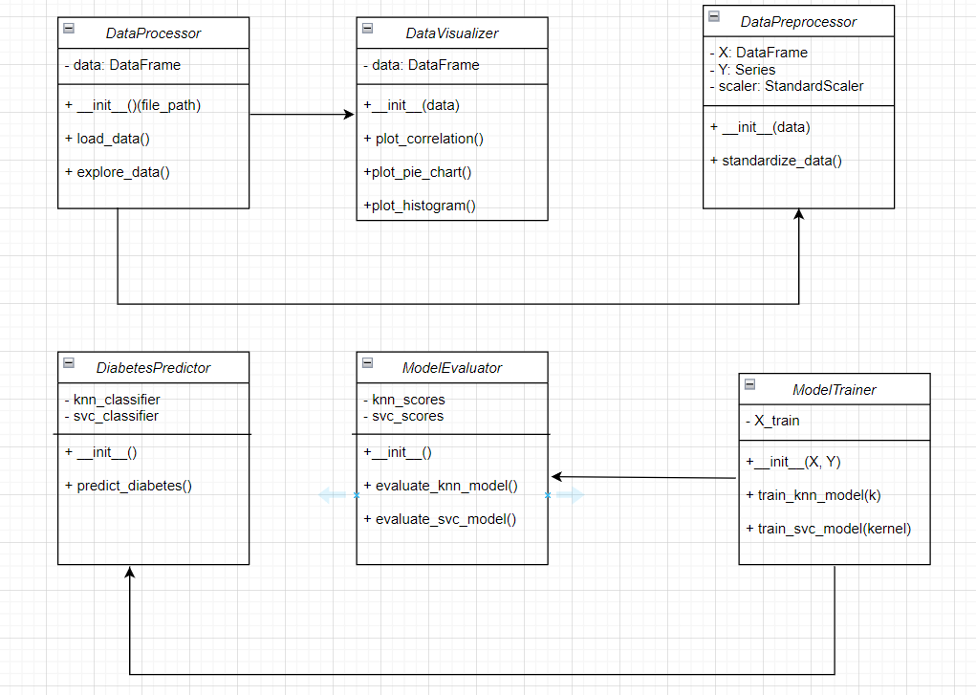

**Class 1: DataProcessorAttributes:**data (Type: DataFrame, Privacy: Private)**Methods:**__init__(self, file_path: str) -> NonePreconditions: file_path is a valid CSV path.Postconditions: Initializes the object with an empty DataFrame.load_data(self) -> NonePreconditions: None.Postconditions: Loads the dataset into the data attribute.explore_data(self) -> NonePreconditions: data is loaded.Postconditions: Prints dataset information, shape, and basic statistics.

**Class 2: DataVisualizerAttributes:**data (Type: DataFrame, Privacy: Private)**Methods:**__init__(self, data: DataFrame) -> NonePreconditions: data is a valid DataFrame.Postconditions: Initializes the object with the provided dataset.plot_correlation(self) -> NonePreconditions: data is loaded.Postconditions: Plots the correlation matrix.plot_pie_chart(self) -> NonePreconditions: data is loaded.Postconditions: Plots a pie chart representing the distribution of outcomes.plot_histogram(self) -> NonePreconditions: data is loaded.Postconditions: Plots histograms for each feature.

**Class 3: DataPreprocessorAttributes:**X (Type: DataFrame, Privacy: Private)Y (Type: Series, Privacy: Private)scaler (Type: StandardScaler, Privacy: Private)**Methods:**__init__(self, data: DataFrame) -> NonePreconditions: data is a valid DataFrame.Postconditions: Initializes the object with features and labels.standardize_data(self) -> NonePreconditions: X and Y are set.Postconditions: Standardizes the feature data using a scaler.

**Class 4: ModelTrainerAttributes:**X_train, X_test, Y_train, Y_test (Type: DataFrame/Series, Privacy: Private)**Methods:**__init__(self, X: DataFrame, Y: Series) -> NonePreconditions: X and Y are valid.Postconditions: Initializes the object with training and testing data.train_knn_model(self, k: int) -> NonePreconditions: X_train and Y_train are set.Postconditions: Trains a KNN model with specified neighbors.train_svc_model(self, kernel: str) -> NonePreconditions: X_train and Y_train are set.Postconditions: Trains an SVC model with specified kernel.

**Class 5: ModelEvaluatorAttributes:**knn_scores, svc_scores (Type: List, Privacy: Private)**Methods:**__init__(self) -> NonePreconditions: None.Postconditions: Initializes the object with empty score lists.evaluate_knn_model(self) -> NonePreconditions: knn_scores is empty.Postconditions: Evaluates and stores KNN model scores for different neighbors.evaluate_svc_model(self) -> NonePreconditions: svc_scores is empty.Postconditions: Evaluates and stores SVC model scores for different kernels.

**Class 6: DiabetesPredictorAttributes:**knn_classifier, svc_classifier (Type: KNeighborsClassifier, SVC, Privacy: Private)**Methods:**__init__(self) -> NonePreconditions: None.Postconditions: Initializes the object with empty classifiers.predict_diabetes(self, input_data: Tuple) -> strPreconditions: knn_classifier and svc_classifier are trained.Postconditions: Returns a prediction for the given input data.

**Relationships:**DataProcessor has a dependency on DataVisualizer and DataPreprocessor.DataPreprocessor is related to ModelTrainer for providing preprocessed data.ModelTrainer interacts with ModelEvaluator to evaluate different models.DiabetesPredictor uses models trained by ModelTrainer for making predictions.

**Descriptions:DataProcessor:** Responsible for loading and exploring the dataset.**DataVisualizer:** Handles visualization tasks related to the dataset.**DataPreprocessor:** Prepares the dataset for training models.**ModelTrainer:** Trains KNN and SVC models.**ModelEvaluator:** Evaluates the performance of trained models.**DiabetesPredictor:** Uses trained models to make predictions.

**Object Diagrams:**

**Object Diagram 1: Data Processor**

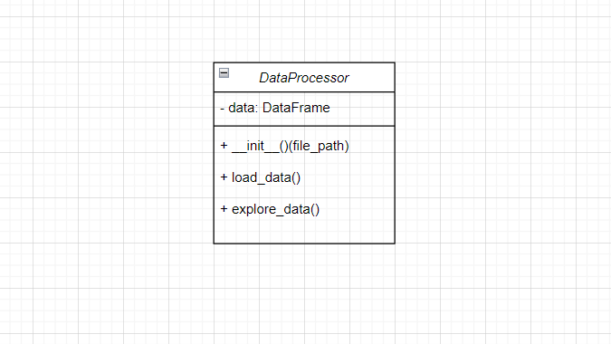

**Object Diagram 2: Data Visualizer**

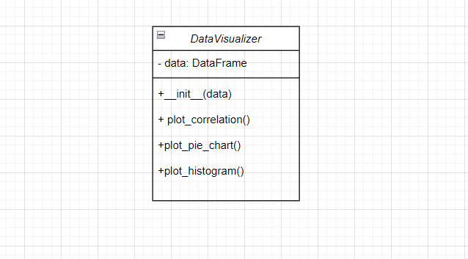

**Object Diagram 3: Data Preprocessor**

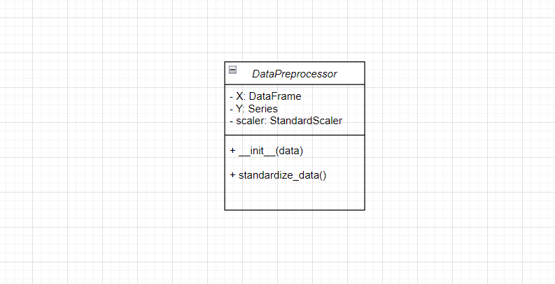

**Object Diagram 4: Model Trainer**

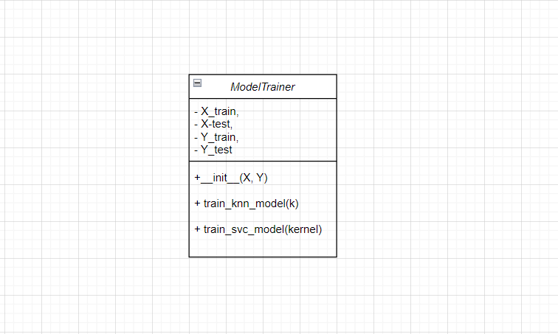

**Object Diagram 5: Model Evaluator**

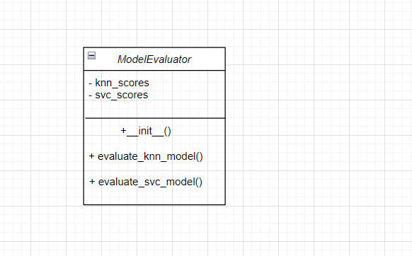

**Object Diagram 6: Diabetes Predictor**

