**GMvCell Help**

**Overview:**

GMvCell simulates single molecule dynamics in a virtual cell producing sequences of fluorescent images built according to the simulated imaging conditions (illumination and camera settings). It is a development of GMcellModel, which simulates molecular dynamics in a simple volume).

The model contains arbitrary number of molecules belonging to 3 major classes:

* *Cytoplasmic molecules (“CytoA” and “CytoB” class)*

objects move by a 3-dimenional random walk inside the solution-type voxels. They can bind to and dissociate from objects belonging to “Memb” or “Stat” classes. If binding occurs the pair move together with mobility determined by the slowest object (usually in membrane-type voxels).

* *Membrane localised molecules (“Memb” class (A, B, and C)*

objects are localised in the membrane-type voxels and can move by a 3-dimensional random walk (in correct type voxels) or can be immobile. They can bind/unbind Cyto and other Memb-type class objects.

* *Static molecules (“StatA” class)*

Usually located inside the cell as groups of immobile objects forming fibres. They can bind/unbind Cyto class objects.

Each object may have up to 4 green and 4 red fluorophores. At each time point (virtual video frame) all object positions are computed according to a random walk, calculated knowing the properties of each individual object. Object collisions are recorded and binding/unbinding events are computed based on Monte Carlo first order kinetics. The new object positions are then used to compute the number of photons emitted by each fluorophore, depending on the level of illumination at that particular point in the cell. All of the emitted photons are collected by a virtual CCD camera according to simple geometric optics so that a virtual image of the cell is formed by the emission from all active (non-bleached) fluorophores illuminated under the chosen imaging conditions (including counts due to additional noise). The sequences of images, generated during the model run, can be saved for future analysis as sequences of BMP files or as GMV files – a proprietary file format used in the partner software for single molecule detection and tracking “GMimPro” [www.mashanov.uk](http://www.mashanov.uk) <https://github.com/GMashanov>

Detailed information about this model is published in xxxx.yyyy.zzzz (2024)

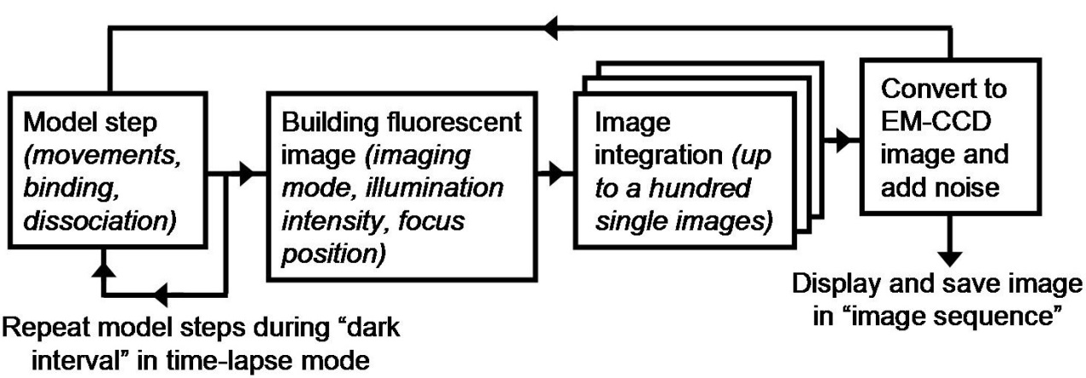

**Settings (F2):**

The Settings dialog window contains several tabbed pages that are used to set the properties of each class of objects the virtual cell parameters and the simulated imaging conditions.

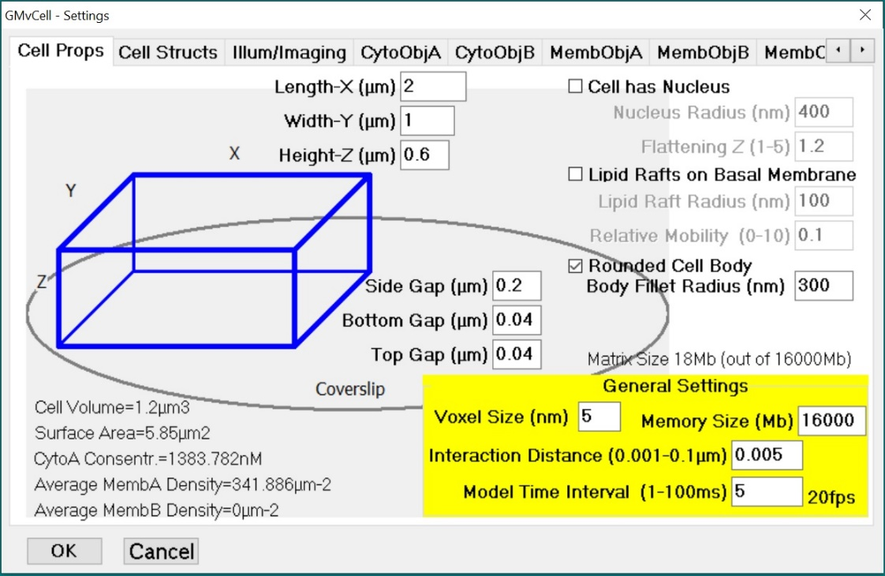

**Cell Props**:

The virtual cell can be a rectangular cuboid of a set cell size of length, width, and height, (x, y, z) dimensions (in μm). The lower or basal surface is composed of plasma membrane, is closest to the microscope objective and is set to be at the focal plane (defined as ζ=0). Cell is placed in voxelated 3D matrix with outside gaps defined by corresponding Gap value. Constructed cell can have rounded body edges with set Body Fillet Radius (in nm). Membrane-type molecules (see MembObjectABC below) move freely within membrane-type voxels forming cell shell and Cell Structures defined on next tab.

Call can include ellipsoidal Nucleus with a radius Rad (in nm) in x-y plane and an extended or flattened radius in the z plane, Flattening (scaling factor of 0.05 to 2). The user should avoid using nucleus sizes bigger than cell sizes.

Cell membrane may contain round “Lipid Rafts” on cell membrane, which are formed of coded “raft voxels”. Membrane molecules moving in these voxels slow down according to “Relative Mobility” coefficient.

**General Settings** are used to set cubical Voxel Size in nm and allocated memory size in Megabytes (you need to close the “Settings” window by clicking “OK” to set this value. Interaction Distance (i.e. averaged size of the interacting objects (molecules), given in µm (e.g. 3-8 nm for protein molecules)

for general calculations – bigger the sizes -bigger the probability of binding (also depends on mobility values). Model Time Step is a time for each calculation cycle, Δt. Many time-steps can be summed to build one fluorescent image/frame (see Illum/Imaging Tab). Note that if the model simulates fast moving molecules (e.g., diffusion rate 2-20 um2 s-1) and frame rate is slow (<50 fps) it is advised to sum a few short time-steps (e.g., sum of 100 time-steps 0.5 ms each) to create one fluorescent image (see Illumination/Imaging page N of Steps summed in One Image).

In the left corner of Cell Props tab you can see some statistics: Approximate cell volume and surface area (all 6 sides of the cell), concentration of CytoA objects, and density of membrane (A/B) objects.

**Cell Structs**:

Constructed cell can have few filopodia or a body-wide lamella protruding from the cell on the right side at bottom level. Filopodia diameter or lamella height are set in “Tube/Lamella rad” and length in “Filopodia/Lamella/Tube Length”. The number of filopodia is set in “Number of Tubes/Vesicles” edit window. A number of elongated vesicles (enclosed tubes) separated by “Distance between Tubes” can be constructed inside the cell oriented from left to right, tilted upwards according to tilting/bending coefficient. Randomly oriented interconnected tube network can be constructed in 2D (at Z=2*tubeRad+tubeGap height) or in 3D. Tubes will be randomly bend according to “Bending Coef.” value. “Moving Round Vesicles” are placed either inside the cell body or above the body in case of “Extracellular Vesicles” (make sure that “Top Gap” value is bigger “Vesicle Radius” * 2). Vesicle mobility is set manually, the estimated mobility, D is shown for a sphere of given radius, moving in water at 25°C. “Pore External” diameter is used for Exocytosis simulation when vesicle is fused to cell body (either from the inside or outside), except the situation of “Instant Transfer to Cell Membrane” – in this case vesicle membrane molecules are instantly moved to nearest membrane voxels and molecules in vesicle lumen moved to nearest extracellular/cytoplasm voxels (depending from which side vesicle fusing). Empty vesicle is removed from the matrix (replaced by cytoplasm or extaCell voxels).

**CytoObjA**:

This page sets properties of objects moving in cytoplasm: Number of CytoA objects, number of Green Fluorophores per CytoA object and Fraction of CytoA objects with active fluorescent tag. Note if an object has more than one green fluorophore per molecule and fraction is set to <100%, some CytoA objects will have different number of active fluorescent tags at the beginning of the model run. The same rule applies to the Red Fluorophores on CytoA objects (and to the MembA&B&C and StatA objects, see below). The user cannot alter the number of objects or fluorescent tags number in the middle of a model run (the model will restart) but can change the Diffusion Rate. CytoA objects are placed at random positions in voxel matching type of Initial Distribution, which can be cytoplasm, nucleoplasm, tubes or vesicles lumen, and in extracellular space. **Note:** make sure that you created corresponding structures before you run the model and click “Reset”. CytoA objects can polymerize into static filaments using Polymerize / Depolymerize rate constants.

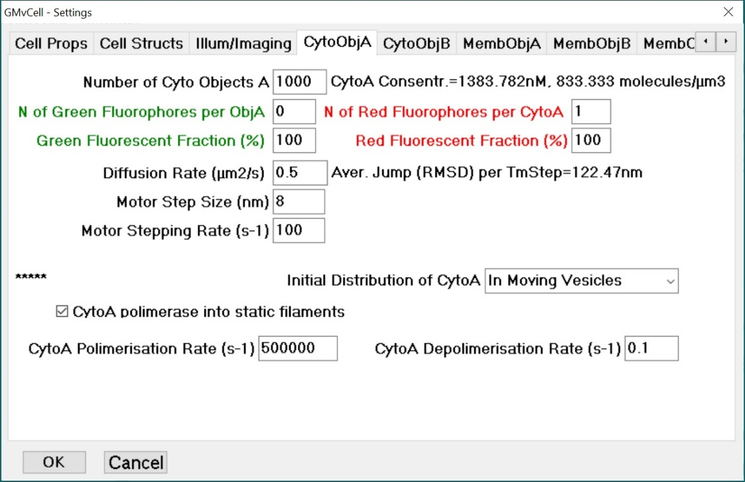

**CytoB**

This object class is similar to CytoA, but have fewer Initial distribution options (cytoplasm, outside cell, and in cell center). CytoB can bind/dissociate from CytoA molecules according to Bind / Dissociate rate constants. Fluorescent CytoB can be added to simulate background noise that adds in addition to sources of camera noise (see below).

**MembObjA/B/C**

These three pages contain settings analogous to the CytoA page (see above), but its Initial Distribution ComboBox has selection corresponding to membrane structures (cytoplasm, nucleoplasm, tube and vesicle membranes). There are also tick-boxes which control binding of Cyto and Memb molecules to each other. MembA molecules also can polymerize (up to 16 monomers). The binding and dissociation events are determined by Binding Rate and Dissociation Rate coefficients. For the binding events, the model checks the Average Interaction Time (AIT) for every eligible pair of molecules. AIT depends on the distance between molecules, their mobility, and Interaction Distance (set on CellProps page). The AIT is multiplied by Binding Rate and used as an input for RNG determining the outcome of binding test. The Dissociation Rate is used as a parameter in RNG testing possible dissociation event for every bound pair of molecules every time step.

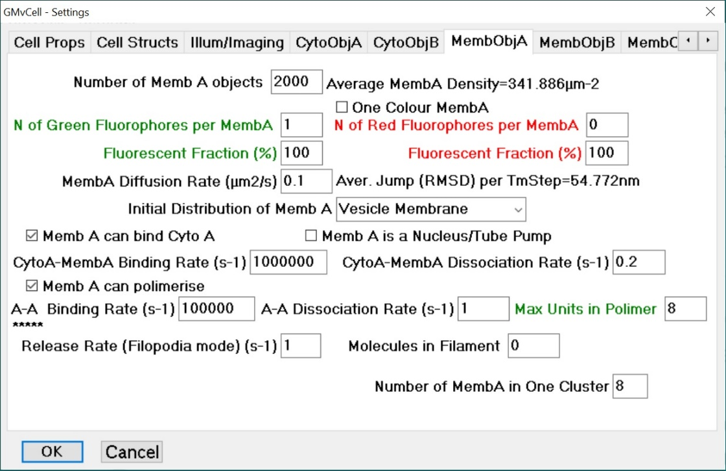

**StaticObjA:**

Static objects remain stationary and cannot change position inside cell during the model run. The “StatA” objects can form “Straight Fibres”, and “Curved Fibres” (laying in horizontal plane at ζ=100nm), “Fibres Curved in 3D”, and specific case of filament bundles in filopodia (6 monomers place at the center of filopodia core (see **CellStructs** tab). The length of the fibers depend on the **Distance between Objects in fiber** and **Monomers per Filament** value. The length of the filament will be limited if it grows into an obstacle (membrane structure). CytoA molecules bound to StatA filaments can move to the left along the fibres with the Velocity set on this page. Both tick-boxes CytoA can Bind StatA and CytoA can Move to the right along StatA should be checked. Set **Motor Step Size** and **Motor Step Rate** in **CytoAobj** tab.

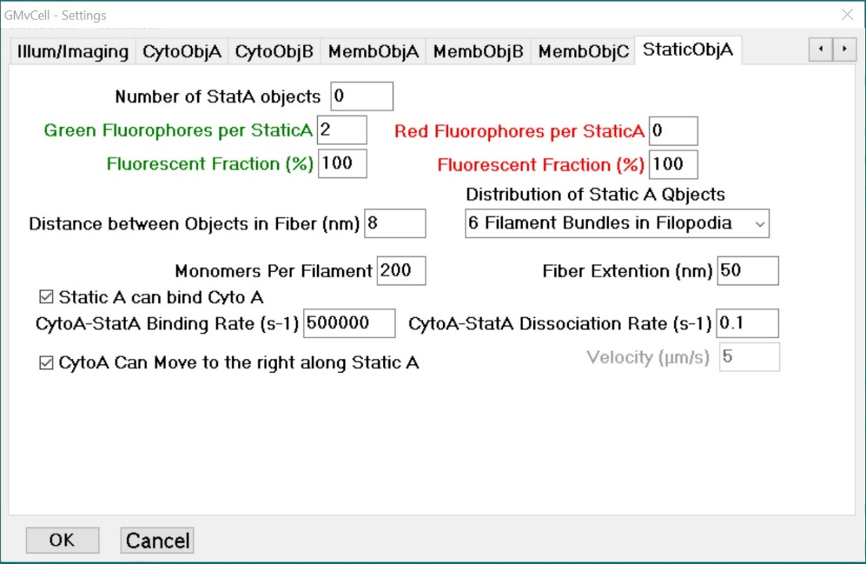

**Illumination/Imaging:**

This page contains a group of parameters. First group controls the emission of single fluorophores. Full Width at Half Maximum (FWHM) of a single molecule image placed at the focal plane of an objective lens can be set close to the theoretical limit for given wavelength (~1/2 of the wavelength of emitted light). There is also Emission Rates and Photobleaching Rates for both Green and Red fluorophores. NOTE - these rates set for the fluorophores placed in the centre of the image at coordinates = (x/2, y/2, ζ=0); where illumination is brightest. Fluorophores placed in other parts of the cell could receive much weaker illumination (depends on the illumination pattern) and as consequence emit proportionally smaller number of photons. The bleaching rate for Green and Red fluorophores is also set for the molecules in the centre of the image (x/2, y/2, ζ=0). It will be proportionally smaller for the weakly illuminated molecules. The image of single fluorophore (2-D Gaussian spot) placed above or below current focal plane will be increased (blurred), while the number of emitted photons remains the same. Ideally the relation between fluorophore FWHM and distance from the focal plane is described by simple hyperbolic function FWHM(z)=Kobj*(ζ-ζfocal)2+FWHMfocal, where ζ is the z-position of a molecule (above coverslip level), ζfocal is a current position of focal plane of the objective lens (usually ζfocus is defined as 0), FWHMfocal is the size of a fluorophore image at the focal plane (see above). The measured relation between FWHM of single fluorescent molecule (Cy3B) and movements along the z-axis of the objective lens 100X1.45NA resulted in Kobj ≈0.6 um-1.

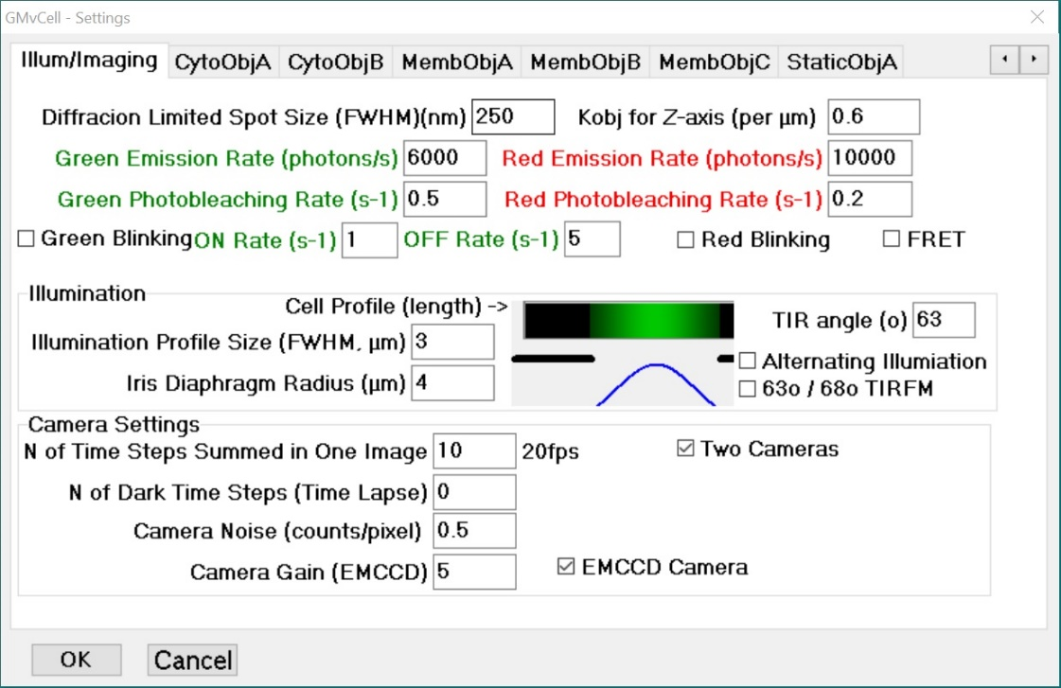

There are 3 modes of illumination used in this model: Epi-illumination, Total Internal Reflection Fluorescence Microscopy (TIRFM), and confocal imaging. It is assumed that in two first modes laser beam has a 2D Gaussian shape profile determined by its FWHM, The user can set Laser Beam FWHM to control the pattern of illumination. The FWHM can be increased (e.g., >> Cell Length and Width) to make the nearly-flat illumination pattern in x-y plane. The illuminated area can be shaped by a circular iris Diaphragm. In “EpiIllum” and “Confocal” modes the whole cell volume will be illuminated within the limits of the size of Iris Diaphragm. The cell profile (along cell length) is shown next to these Edit Controls. The TIR angle parameter can be changed between 63 and 75 degrees to control the depth of TIR illumination. NOTE – It also depends on the wavelength of the illumination (488nm for Green fluorescence and 561 nm for Red fluorescence simulation).

**Camera Settings.**

Few model steps can be summed to create one camera image. It gives realistic images of the fluorescent objects moving considerable distances during one image acquisition. For example if we set model time step (see above) to 5 ms and set N of Model Steps summed in One Image to 10 we will get camera rate of 20 fps which is achievable by many sensitive cameras. At this rate slow moving molecules will look like sharp spots of light, while fast randomly moving molecules look like dim clouds. If the Number of Dark Time Steps is set above zero, the model will run in a time-lapse mode when one illuminated image is followed by specified number of dark time-steps. For example if we use above settings (summing 10 images) and set N of Dark Time-Steps to 90, the model will display (and record) one fluorescent image (50ms exposure time) every 0.5 s giving 2fps (The photobleaching rate will be reduced accordingly). The model will add few “noise” counts to every pixel on the image which simulate camera and photon noise. The noise counts have Gaussian random distribution which sigma value is set as a Camera Noise. EMCCD cameras multiply every registered photon by an average number determined by Camera Gain. This multiplier has some degree of variation which, in this model, was set as a square root of pixel value. The EMCCD mode can be switched ON/OFF using EMCCD camera check-box. If two colours are used in the model run the results can be displayed / recorded in few modes – Two Camera mode used to display Green and Red images side by side (NOTE - make sure that both lasers are switched ON in the main menu). Alternating Illumination mode is used to illuminate one frame with one colour and next one with another (Green-Red-Green-Red and so on). The results can be displayed and recorded as one image (.gmv) or as double (.gmG and .gmR) if Two Camera box is checked.

*Tip: In order to visualise the above structures during the model run the user should run the model for a few tens of frames to allow “Cyto” molecules to equilibrate across the cell volume then by pressing the “C” key “Cyto” objects are marked as white dots. It is recommended to use a short time steps (e.g. 1 ms) to model “CytoA” dynamics within the tubular structures and around the nucleus because molecular movements are limited in the narrow spaces. It is also advised to limit the cell height (z) so that the tubular network can be illuminated by the evanescent wave. By pressing “C” again the white dots are hidden.*

**The Main Window menus.**

User can start and stop model run but pressing “**RUN/STOP**” menu item or by using “F9” / “Esc” keys.

**File submenu:**

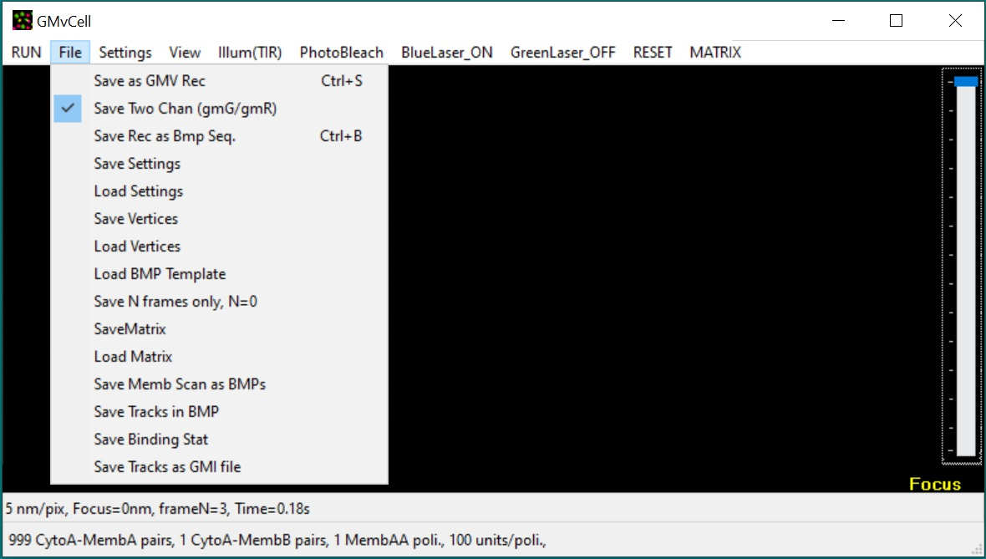at any moment before or during model run user can start recording “sequence of fluorescent images” in the specific GMV file format used in Single Molecule Detection and Tracking software GMimPro (see separate GMimPro help files and recommended papers to learn this software). GMimPro can be used to display, analyse, and save as sequences of BMP or binary files original GMV files generated by the model. GMimPro webpage ([www.mashanov.uk](http://www.mashanov.uk)) also contains ImageJ plug-ins for importing GMV files into ImageJ. In case of two colour Two Camera recording, image sequences can be saved in two separate files Save Two Chan (gmG/gmR). The results also can be saved as 24-bit BMP files using Save Rec. as BMP Seq. Please specify the file name for the first frame. WARNING – file name should not have number or “.bmp” string at the end of the filename because the index specifying image number will be added to the filename automatically. It is strongly advised to create a separate folder for each BMP image sequence created at the model run. In both record modes the recording is terminated by pressing ESC key. WARNING – make sure that the fluorescence (‘F’ key) and at least one of the lasers is switched ON before you start recording.

Most initial conditions in the Settings menu can be stored for future model runs using Save Settings option. The current settings will be stored in a data file with default extension “gms”. These settings can be loaded using Load Settings line in the File menu. NOTE – if the numbers of objects of any class or cell sizes loaded from settings file do not match the current settings, the model will start a new run using initial distributions of membrane and static objects stored in loaded file. If a set of vertices was created in MATRIX menu (Set Membrane Vertices), it can be saved as a file (Save Vertices) for future download (Load BMP template). A template **8-bit** BMP file, containing 2D projection of 3D membrane structure can be stored as a template of membrane shell, which would have the Z-height of CellHeight. The bmp x and y sizes will be stetched/shrink according to CellLength and CellWidth.

The number of recorded frames can be limited to N, if it is set above 0 (Save N frames only). Constructed matrix can be saved to disk and loaded back to model (Save Matrix / Load Matrix) to save time required to construct large size structures. The operator has to check that cell and surrounding sizes are the same when matrix is saved / loaded into program. Non-destructive compression is used to reduce the size of the matrix on disk.

**View submenu**

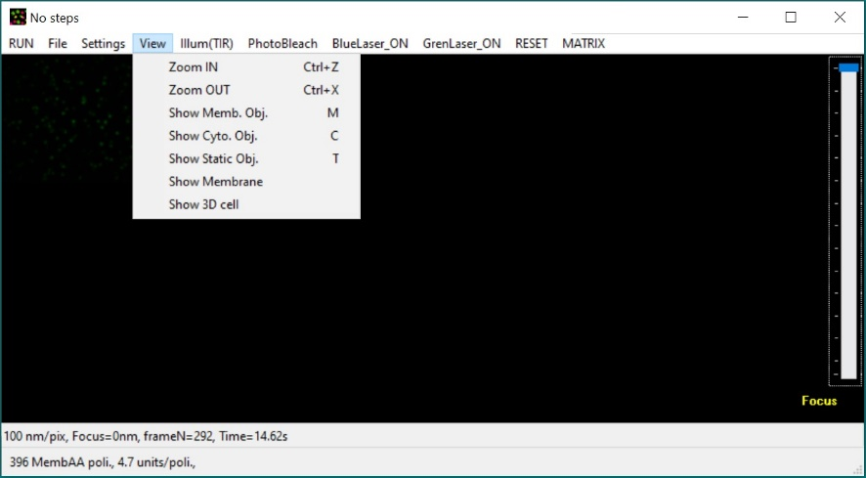The user can change camera pixel sizes used in the model (default value 100 nm/pixel) using “Ctrl+Z” and “Ctrl+Z” key combinations (current scale is shown in status bar at the bottom of main window). NOTE – These changes will affect the sizes and brightness of the images of fluorescent objects projected on camera CCD. Normally, objective lens x100 would increase image size 100 times to the size of CCD pixels (e.g., Andor iXon897BV has CCD pixel sizes 16 um, so an objective lens x100 would give camera scale 160 nm/pixel). The current XY positions of “Cyto” objects can be shown on CCD image using ‘C’ key (white dots), “memb” objects using ‘M’ key (red/yellow dots), “stat” objects using ‘T’ key (blue dots). You can see membrane structures at current Z plane, if you select Show Membrane in a View menu – use “grey” “+” / “-“ keys to move Z-plane up and down. Make sure that model is not “running” otherwise membrane image will be overwritten by fluorescent image. You can see 3D cubical representation of membrane structures and molecular objects in a separate “Cell3D” window.

**Illumination** submenu

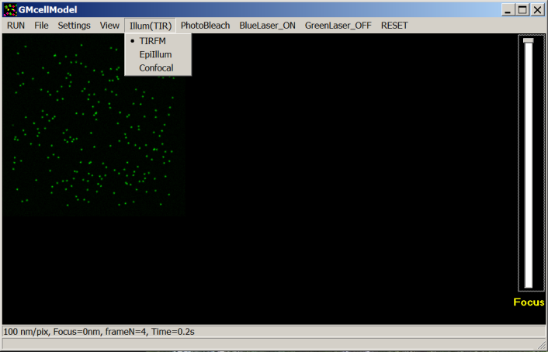TIRFM (Total Internal Reflection Fluorescence Microscopy) – cell is illuminated according to the rules of optics for Evanesce Wave propagation at the interface between mediums with high and low refractive indices (See Axelrod et. al., 1992). The profile of illumination is determined by the colour of illumination, TIR angle, and laser beam profile settings (see Settings->Illum/Imaging menu).

EpiIllum. – The laser beam penetrates the whole cell. Its XY intensity profile depends on the Laser Beam FWHM and Iris Diaphragm settings (see Settings Menu).

Confocal illumination – It is a simulation of scanning method of illumination / imaging where intensity of illumination is constant at any XY point in the current focal plane (laser beam focused in the focal plane of the objective lens). The intensity of illumination decreases dramatically above and below focal plane (outside the focused laser beam) due to a sharp increase in the size of laser beam cone. It is also assumed that a “virtual pinhole” blocks most of the emission from the fluorescent objects placed above or below current focal plane.

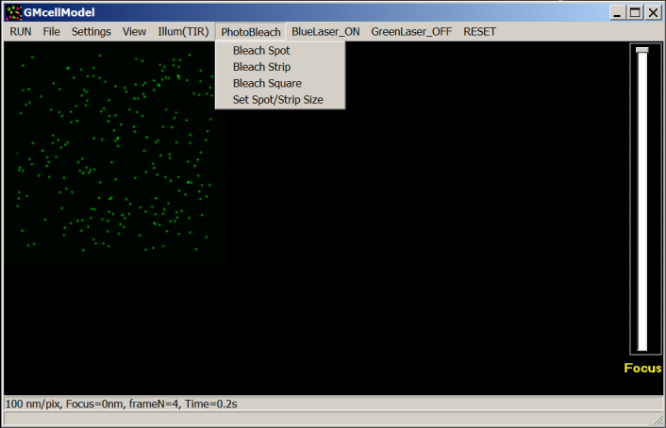**Photobleach**: The user can bleach all the fluorescent molecules within chosen spot (circle), square, or strip area. NOTE - If bleaching is done in TIRFM mode “Cyto” and “Stat” molecules will not be affected by the bleach (only molecules at basal cell membrane (“Memb” objects)), but in the “EpiIllum” or “Confocal” modes molecules of all types will be bleached. Make sure that the one or both lasers (Blue, Green) are ON at the moment of bleaching to bleach one or both colours. The size/diameter of bleaching area can be set in Set Spot/Strip Size Edit control. The Round Spot or Square is placed in the middle of the cell, while bleached Strip is placed at the right edge of the cell.

**BlueLaser** and **GreenLaser** menu items allow to switch Blue or Green illumination ON and OFF. These controls will not work if Alternating Illumination check-box is checked in the Settings menu. NOTE – make sure that Illumination is ON (key ‘F’) to bleach molecules.

**RESET** - click this menu item to reset the model – all the objects will be placed according to the initial distributions and all available fluorophores (see Settings) will be reactivated (made fluorescent again if they were bleached in the previous run).

**MATRIX** menu.

It is required to make all the cell structures in a matrix space (Make Geom. Shape) before user resets (**RESET**) all the molecule objects in 3D space and model run (**F9**). This can take substantial time, if the size of the matrix is bigger 1 Giga voxel (see general Settings on CellProps Tab). Cell structures can be made of 2D .bmp template loaded in File menu. You need to load such file, check Make shell from BMP line and Make Geom. Shape out of it – it will extrude 3D shape out of 2D shape and hollow it to create membrane structures.

Membrane vertices can be set out of membrane voxels (connected to nearest membrane voxels). The position of these vertices can be rounded (Rounding) to smooth sharp membrane corners/edges in the matrix. Then membrane can re reconstructed in matrix space (Membrane from Vertices) with new coordinates. It is important to thicken membrane when you use rounded structures (e.g., tube network, rounded cell, filopodia and so on) to avoid membrane voxels connected to other voxels only at edges to prevent solution molecules leak though the membrane ant ensure free movements of membrane molecules.

Add 10 Lipid Rafts – will add 10 round membrane rafts (see CellProps Tab) at random position to basal cell membrane by changing membrane voxel properties. Membrane molecules, moving in these voxels, will slow down according to the ratio set in CellProp Tab.

**List of Key Combinations**

**/ Shortcuts Start/Stop/Reset:**

1. F2 – Launch Settings dialog Window.
2. F4 – Reset time (t=0s)
3. F9 – Run
4. Esc – stop run / stop recording
5. ‘Space’ make one model step. Note: more than one step may be required to form a new image on the screen.

**Action Controls:**

1. Ctrl+’S’ - Save GMV record
2. Ctrl+’B’ – Save record as Sequence of BMP files
3. Ctrl+’Z’ – Zoom In – Decrease size of CCD pixel
4. Ctrl+’X’ – Zoom Out – Increase size of CCD pixel
5. Ctrl+’N’ – Reset the model – go to initial state and distribution of present objects.
6. ‘F’ – Switch ON/OFF illumination. Note: make sure that one or both lasers are ON to be able to illuminate “the cell”.

**Display Modifiers:**

1. ‘C’ – Show/Hide white dots marking x-y positions of CytoA objects
2. ‘M’ – Show/Hide red and yellow dots marking x-y positions of MembA and MembB objects
3. ‘T’ - Show/Hide blue dots marking x-y positions of StatA objects