PROJECT REPORT:

Air Quality Index (AQI) Forecasting System

1. Project Introduction

1.1. Product Description / Objectives
This project builds a backend pipeline for forecasting the Air Quality Index (AQI) in Hanoi for the next 6 hours ($t+6$), utilizing multiple model architectures: LSTM, Stacked LSTM, GRU, and XGBoost (with Lag Features) on the PyTorch platform. The pipeline takes a 48-hour historical sliding window of data from environmental and air quality IoT sensors as input, and outputs the forecasted AQI value for the next 6 hours.
Specific Objectives: - Build a time-series data processing system that preserves temporal continuity. - Train and compare multiple model architectures (LSTM, Stacked LSTM, GRU, XGBoost). - Optimize hyperparameters automatically using Optuna (Bayesian HPO). - Package the system into a production-ready, modular pipeline that can be integrated into an IoT dashboard.

1.2. Project Requirements
# | Requirement | Description
1 | Real-world IoT data | Use time-series dataset of Hanoi’s air quality (08/2022 – 06/2025, 30,341 rows × 21 columns), including AQI, PM2.5, PM10, CO, NO₂, O₃, SO₂, temperature, humidity, wind speed, pressure.
2 | Standard data preprocessing | Handle outliers without breaking the timeline; scale data without causing data leakage; split data chronologically.
3 | Diverse models | Design and evaluate multiple architectures: Base LSTM (1-layer), Stacked LSTM (2-layer), Single-layer GRU, and XGBoost (with Lag Features).
4 | Hyperparameter tuning | Integrate Bayesian Optimization (Optuna) to automatically find the optimal hyperparameter combination.
5 | Objective evaluation | Compare model results with a Naive Persistence Baseline to prove the models actually learn patterns.
6 | Modular architecture | Separate source code into distinct modules (config, data, model, train, evaluate, visualize, utils).
7 | Logging & reproducibility | Log results and ensure reproducibility using fixed seeds.

2. Implementation Methodology

2.1. Functional Analysis & System Design

Overall Architecture
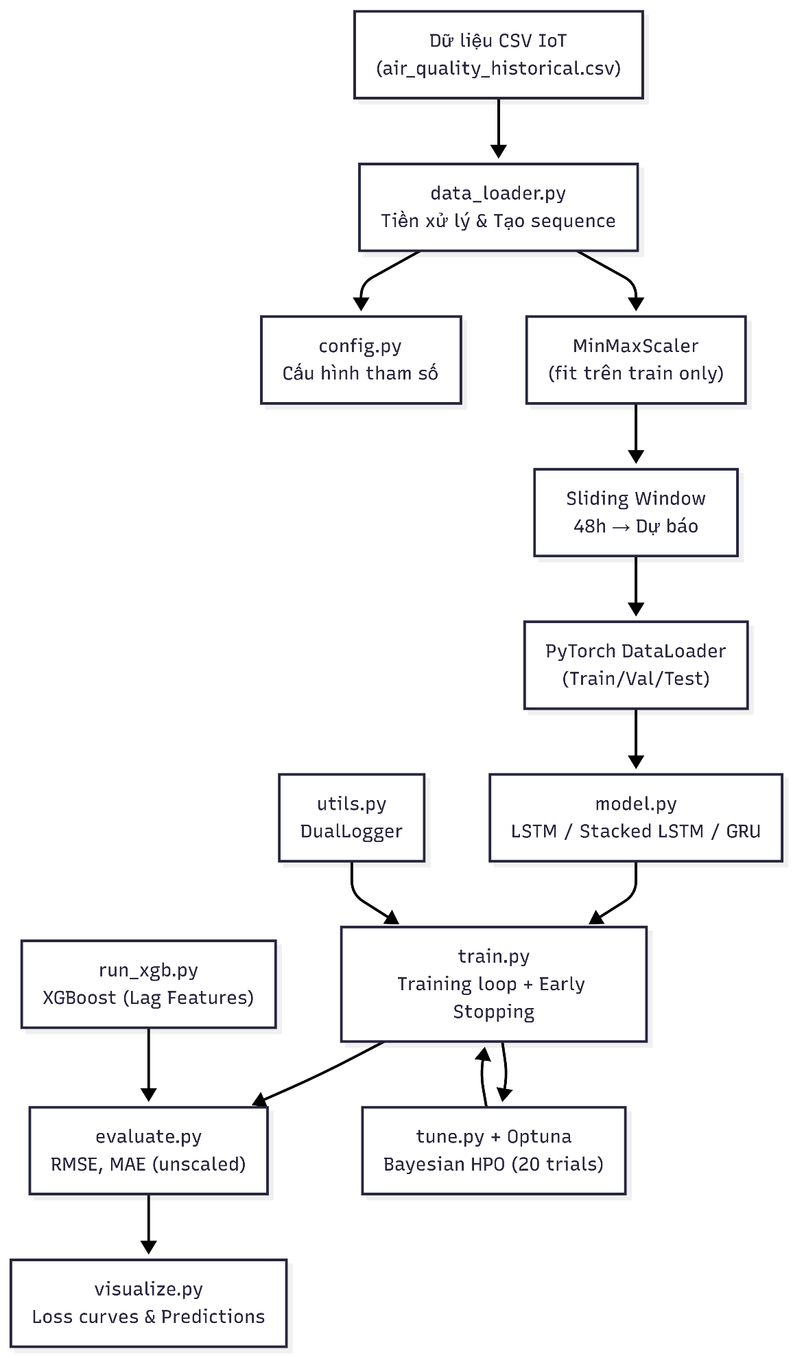

Module Descriptions
Module | File | Function
Configuration | src/config.py | Defines all hyperparameters, feature columns, data split ratios, device, and random seed.
Data Processing | src/data_loader.py | Reads CSV, handles outliers (AQI > 400 → NaN), extracts time features (hour, month), interpolates, performs chronological split, scales using MinMaxScaler, creates sliding-window sequences, and creates PyTorch DataLoaders. Also supports get_xgboost_data() to return flattened arrays for XGBoost.
Models | src/model.py | Defines LSTMAQIModel (1-layer LSTM), StackedLSTMAQIModel (2-layer LSTM), GRUAQIModel (1-layer GRU): all following the RNN + Dropout + Linear(hidden→1) structure.
Training | src/train.py | Training loop with early stopping, checkpointing, and trial pruning support for Optuna.
HPO Tuning | src/tune.py | Objective functions for Optuna – samples lr, hidden_size, dropout, weight_decay; trains and returns best val loss.
Evaluation | src/evaluate.py | Calculates RMSE, MAE on unscaled data; calculates Naive Persistence Baseline.
Visualization | src/visualize.py | Plots loss curves and actual vs. predicted AQI charts.
Utilities | src/utils.py | DualLogger – a context manager that logs output to both console and file simultaneously, ensuring exception safety.

2.2. Installation & Execution Guide

System Requirements & Tool Versions
Tool | Version
Python | 3.10+
PyTorch | >= 2.0
scikit-learn | >= 1.0
Optuna | >= 3.0
Pandas | >= 1.5
NumPy | >= 1.23
Matplotlib | >= 3.6
XGBoost | >= 3.0

Installation Steps
# 1. Clone repository
git clone <repository-url>
cd GR1
# 2. Create virtual environment
python -m venv .venv
# 3. Activate virtual environment
# Windows:
.venv\Scripts\activate
# Linux/macOS:
source .venv/bin/activate
# 4. Install dependencies
pip install -r requirements.txt

How to Run
# Train Base LSTM and Stacked LSTM models
python main.py
# Optimize hyperparameters + retrain with best params
python tune_main.py
# Train and evaluate Single-layer GRU
python run_gru.py
# Train and evaluate XGBoost (Lag Features)
python run_xgb.py

Data Pipeline Process

Differences from Original Notebook
The project was developed from an initial research notebook (Dataset/Copy of Air Quality ForeCasting.ipynb) and addresses 6 main issues:
Issue | Original Notebook | New Pipeline
Structure | Monolithic Jupyter notebook | Modular Python package (src/)
Outlier Handling | Deleted rows with AQI > 400 → broke timeline | Assigned NaN + time-interpolation → preserved timeline
Data Leakage | Fit scaler on entire dataset | Fit scaler only on train set
Split Ratio | 70/10/20 but deleted AQI > 400 rows → fewer samples | 70/10/20, interpolated AQI > 400 → preserved timeline
Hyperparameters | Hardcoded | Automated Bayesian HPO (Optuna, 20 trials)
Baseline | None | Naive Persistence Baseline to prove actual learning
Architecture | 1 single-layer LSTM model | Base LSTM, Stacked LSTM, Tuned variants, GRU, XGBoost

3. Results

3.1. Training & Validation Performance
All RMSE and MAE values are calculated on actual AQI (inverse-scaled) data.
Model / Run | Train Scaled MSE | Train Unscaled RMSE | Train Unscaled MAE | Val Scaled MSE | Val Unscaled RMSE | Val Unscaled MAE
Notebook LSTM (original) | 0.0075 | 34.1876 | 26.1085 | 0.0058 | 29.9248 | 21.5537
Base LSTM | 0.0084 | 36.1757 | 28.0591 | 0.0058 | 30.1247 | 22.2817
Stacked LSTM | 0.0070 | 32.9880 | 25.1890 | 0.0058 | 29.9727 | 21.6667
Tuned Base LSTM | 0.0069 | 32.7617 | 25.1370 | 0.0056 | 29.4381 | 21.6108
Tuned Stacked LSTM | 0.0071 | 33.2378 | 25.0520 | 0.0055 | 29.2181 | 20.9574
Single-layer GRU | 0.0079 | 35.1279 | 27.4554 | 0.0058 | 29.9219 | 22.5277
Tuned Single-layer GRU | 0.0069 | 32.8135 | 25.2708 | 0.0056 | 29.3865 | 21.7875
XGBoost (Lag Features) | 0.0038 | 24.2739 | 18.6621 | 0.0057 | 29.6919 | 22.5971
Tuned XGBoost | 0.0047 | 27.0203 | 20.7062 | 0.0057 | 29.7005 | 22.8860
Notebook LSTM (original): Used 70/10/20 split but deleted rows where AQI > 400 (no interpolation), breaking the timeline. The model trained on 21,097 (Train), 2,968 (Val), and 5,991 (Test) sequences. The scaler was fit on the entire dataset → caused data leakage.
Remarks:
- Val loss below train loss (Neural Networks): For every LSTM/GRU variant, validation MSE/RMSE is consistently lower than training MSE/RMSE.
This is plausible given dropout (0.2-0.386) is active during training and disabled during evaluation, and/or the validation window may simply contain fewer extreme pollution spikes than the training window.
However, this pattern could equally reflect the validation segment being an inherently "easier" slice of the chronological timeline So, architecture choice barely matters here.
- HPO delivers modest, consistent gains for RNNs: Tuning improved val RMSE for all three recurrent architectures
- Base LSTM (30.12 29.44)
- Stacked LSTM (29.97 29.22)
- GRU (29.92 29.39).
These are real but small improvements (0.5-0.75 RMSE points), not transformative ones.
- XGBoost fits training data far better than any neural model (train RMSE 24.27 vs. ~33-36 for LSTM/GRU variants), but its validation RMSE (29.69) is not better than the tuned RNNs.
This is the classic signature of a model with lower bias and higher variance on this feature representation: 624 flattened lag features let XGBoost fit the training set very tightly, but that tighter fit is not translating into a validation advantage.
- Hyperparameter tuning made XGBoost less overfit.
Even though, Untuned XGBoost achieves train RMSE 24.27 and val RMSE 29.69. After Optuna tuning, train RMSE gets worse (27.02) while val RMSE is 29.70. But tuning helps clode the gap between training and validation from 5.42 point to 2.68 point.
This is a negative result, not a partial win, so either the search space or objective for the XGBoost tuning was misconfigured, 20 trials were insufficient to beat well-chosen defaults, or the defaults were already close to optimal for this feature set. In conclusion, tuning provided no measurable benefit for XGBoost in this setup, in contrast to the clear (if modest) gains it produced for the RNN models.

3.3. Test Set Performance & Baseline Comparison
Model / Baseline | Test Scaled MSE | Test Unscaled RMSE | Test Unscaled MAE
Naive Baseline (Persistence) |  | 49.1951 | 36.8173
Notebook LSTM (original) | 0.0106 | 40.6027 | 31.6603
Base LSTM | 0.0110 | 41.2524 | 32.3012
Stacked LSTM | 0.0109 | 41.0533 | 31.7970
Tuned Base LSTM | 0.0108 | 40.9869 | 31.7906
Tuned Stacked LSTM | 0.0108 | 40.8716 | 31.5892
Single-layer GRU | 0.0107 | 40.6944 | 31.9603
Tuned Single-layer GRU | 0.0105 | 40.4583 | 31.3893
XGBoost (Lag Features) | 0.0102 | 39.8709 | 30.4246
Tuned XGBoost | 0.0101 | 39.6817 | 30.2843
Remarks:
- All models clearly beat the naive baseline. Naive Persistence (predicting t+6 equal to t) gives RMSE 49.20. Every trained model (deep learning or gradient boosting) beats it by 8 to 10 RMSE points.
This shows that models are learning genuine structure in the weather/pollution signal, not just relying on autocorrelation the way the naive baseline does.
- The gap between models on test is still narrow, but wider than on validation. Test RMSE ranges from 39.68 (Tuned XGBoost) to 41.25 (Base LSTM), about 1.6 points, compared to a 0.9 point spread on validation
- XGBoost tuning helped on test, unlike on validation.
Tuned XGBoost showed no improvement over the untuned version on validation (29.70 vs. 29.69) and was actually worse on train. Here on test, tuned XGBoost (39.68) edges out untuned XGBoost (39.87) by about 0.19 RMSE points.
That's a small, possibly noise-level difference, and it directly contradicts the "tuning didn't help XGBoost" conclusion drawn from the validation numbers.
The honest takeaway is that the validation set was not a reliable signal for selecting the better XGBoost configuration. Model selection based on val RMSE would have picked the untuned model, and it would have been the (marginally) worse choice on test.

3.4. Hyperparameter Analysis (HPO)

Neural Network Models (LSTM / GRU)
Parameter | Base LSTM | Tuned Base LSTM | Tuned Stacked LSTM | Tuned GRU
Learning Rate | 5e-4 | 5.315e-4 | 7.385e-4 | 8.510e-4
Hidden Size | 128 | 128 | 256 | 256
Num layers | 1 | 1 | 2 | 1
Dropout | 0.2 | 0.2574 | 0.3496 | 0.3596
Weight Decay | 0.0 | 1.226e-5 | 3.047e-5 | 6.782e-6

XGBoost Model
Parameter | Tuned XGBoost (Best)
booster | gbtree
eta (learning rate) | 0.0349
max_depth | 5
min_child_weight | 7
subsample | 0.900
colsample_bytree | 0.385
Lambda/ alpha/gamma | 2.912e-7 / 1.401e-5 / 7.234e-7

3.5. Loss Curves
Loss Curves Remarks:
- Base LSTM: Early stopping triggered very early (after ~6 epochs). Training loss dropped sharply, validation loss started low and stable. No signs of overfitting.
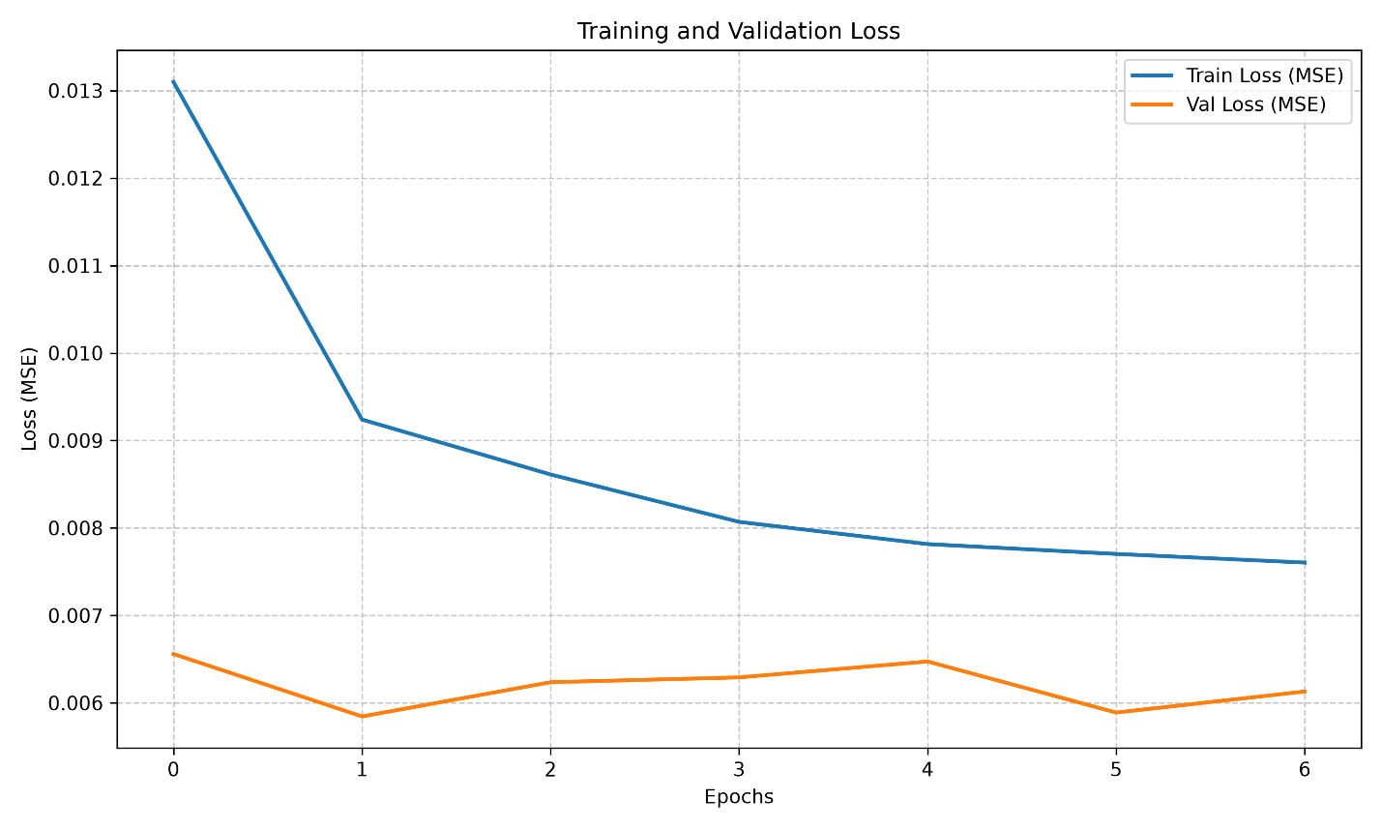
- Stacked LSTM: Trained longer (~11 epochs). Validation loss was consistently lower than training loss, showing no overfitting.
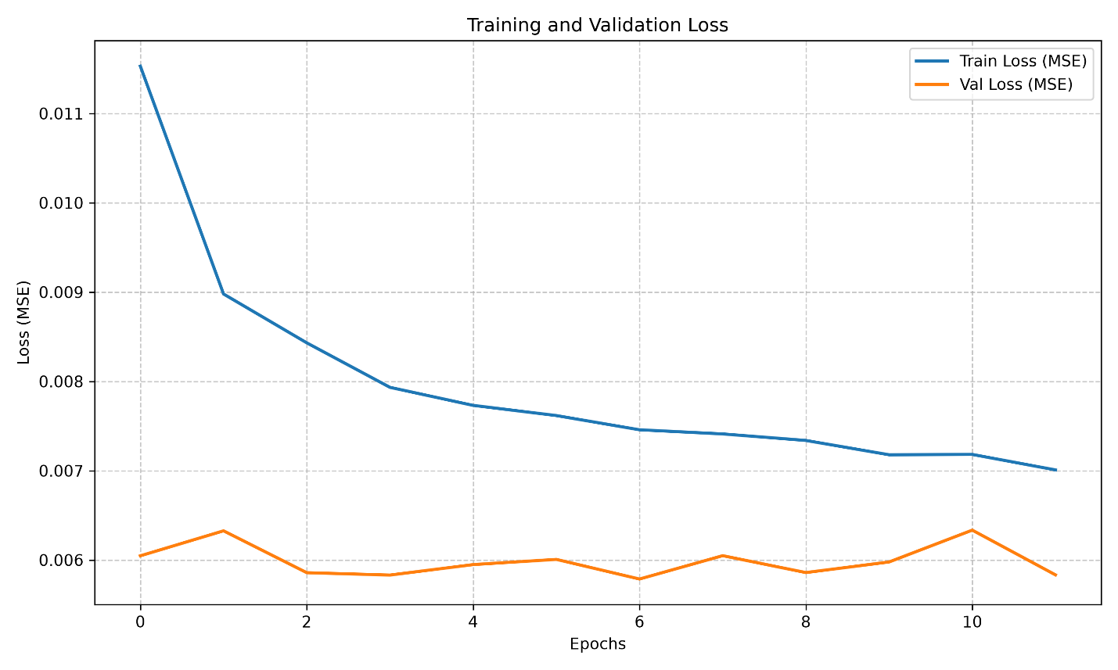
- Tuned Base LSTM: With optimal hyperparameters, the model trained much longer (~28 epochs). Training loss dropped smoothly, validation loss remained stable and low – a sign of a good learning rate.
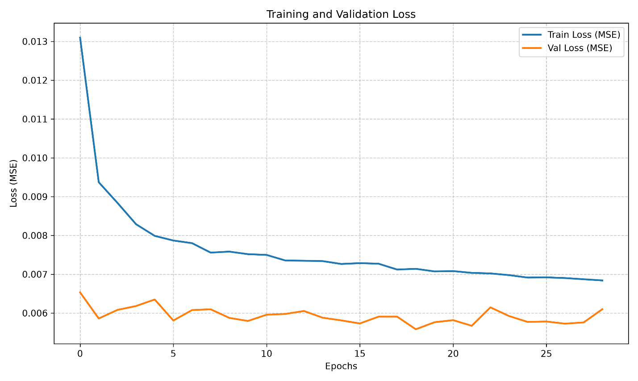
- Tuned Stacked LSTM: Also trained for ~28 epochs. Validation loss was slightly “noisier” (fluctuating) compared to untuned models – which is normal when applying high dropout and a more aggressive learning rate from Optuna. It ultimately achieved the lowest validation loss among Deep Learning models.
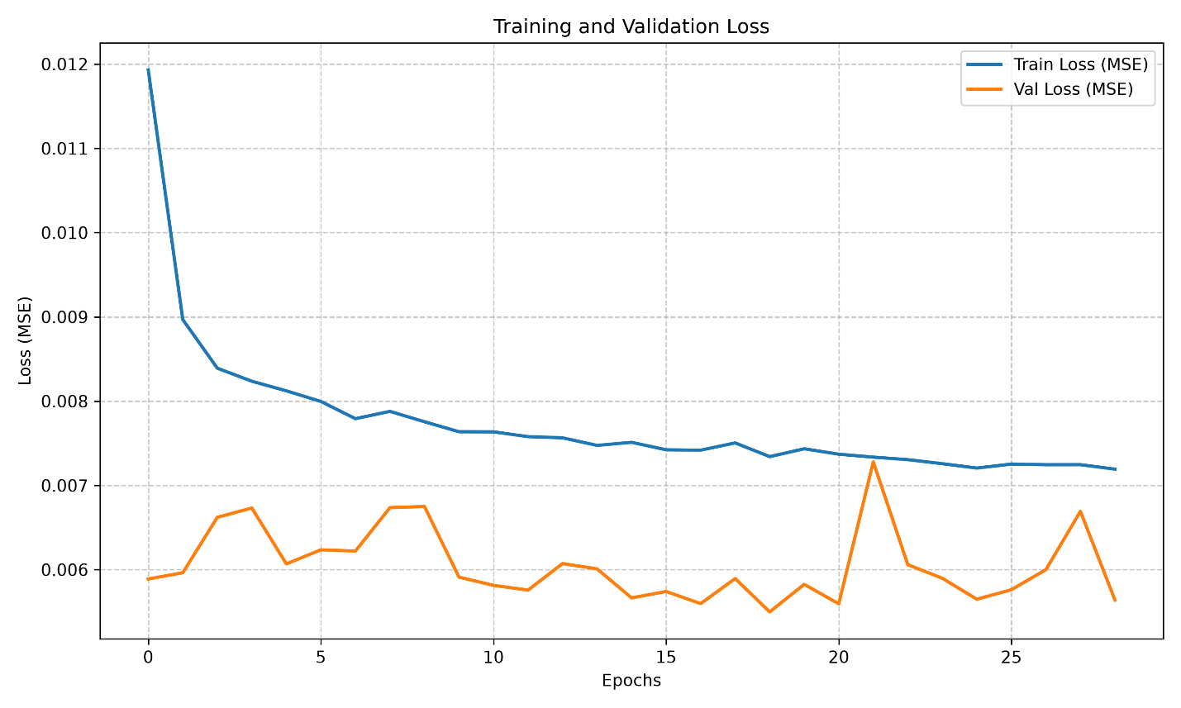
- Single-layer GRU: Similar to Base LSTM, trained quickly (~12 epochs). Stable loss curves, no overfitting, confirming GRU as an effective LSTM alternative. (XGBoost does not have a loss curve in this setup).
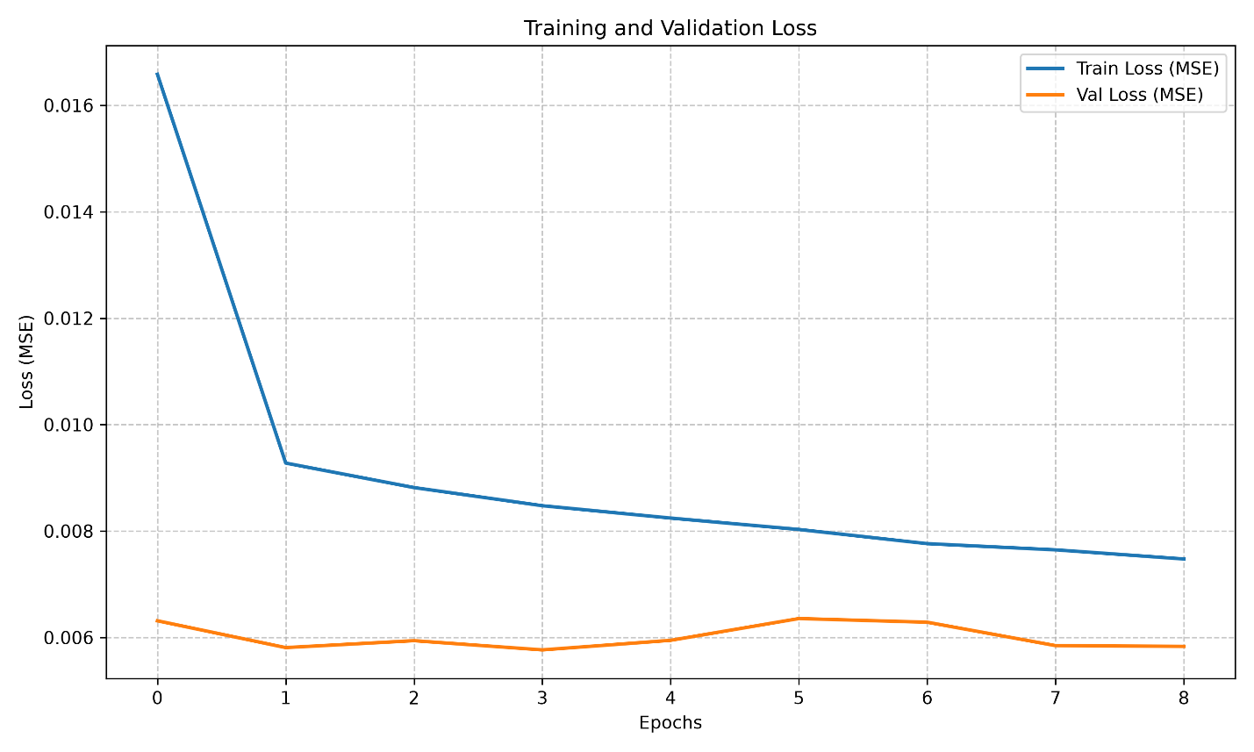

3.6. Prediction Charts (Actual vs. Predicted AQI)
Prediction Charts Remarks:
- Base LSTM: Captured general trends well but was highly conservative. Underpredicted at high AQI peaks (e.g., actual AQI ~260-270 but predicted only ~150). Very smooth prediction line, clearly showing “regression to the mean”.
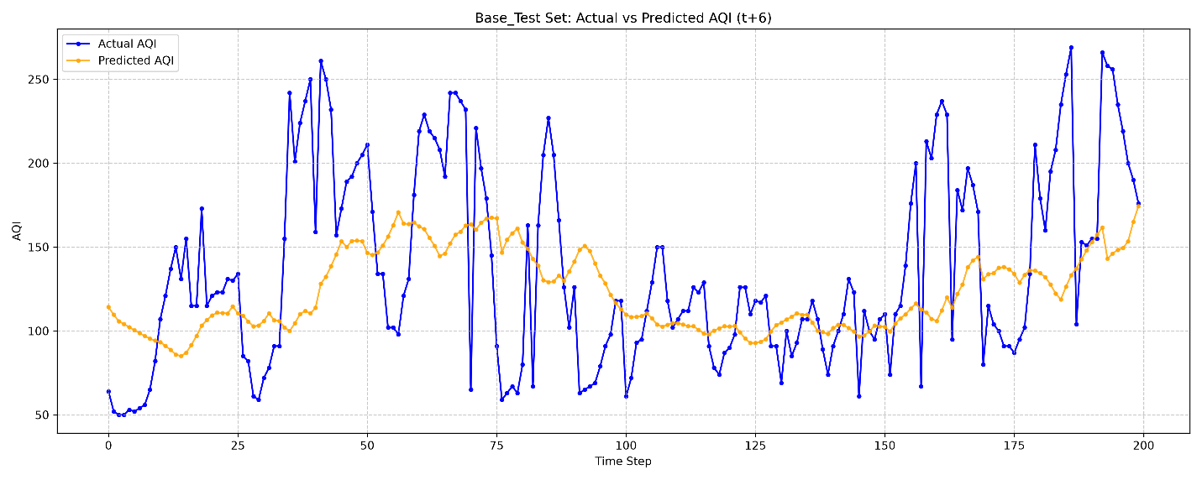
- Stacked LSTM: Adding a 2nd layer slightly increased the prediction amplitude (peaks ~200), but still remained far from actual peaks.
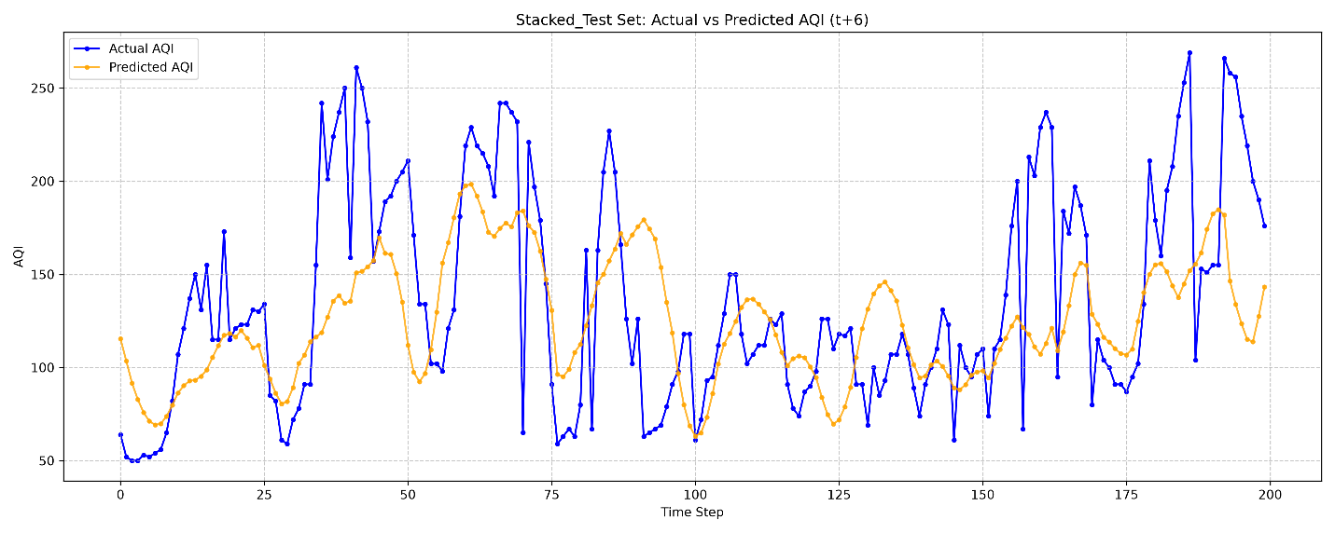
- Tuned Base LSTM: HPO optimization helped the model fit “valleys” (low AQI) much more accurately, and the timing of upward trends was sharper.
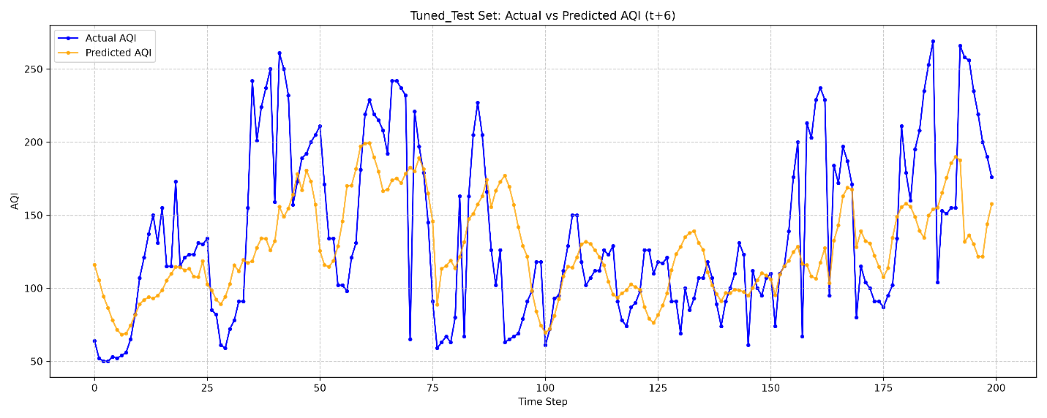
- Tuned Stacked LSTM: The prediction graph had the best visual fit among Deep Learning models. Still underestimated absolute peaks, but closely tracked the shape and timing of AQI spikes. Up-down patterns from steps 50-70 and 150-170 matched real data tightly.
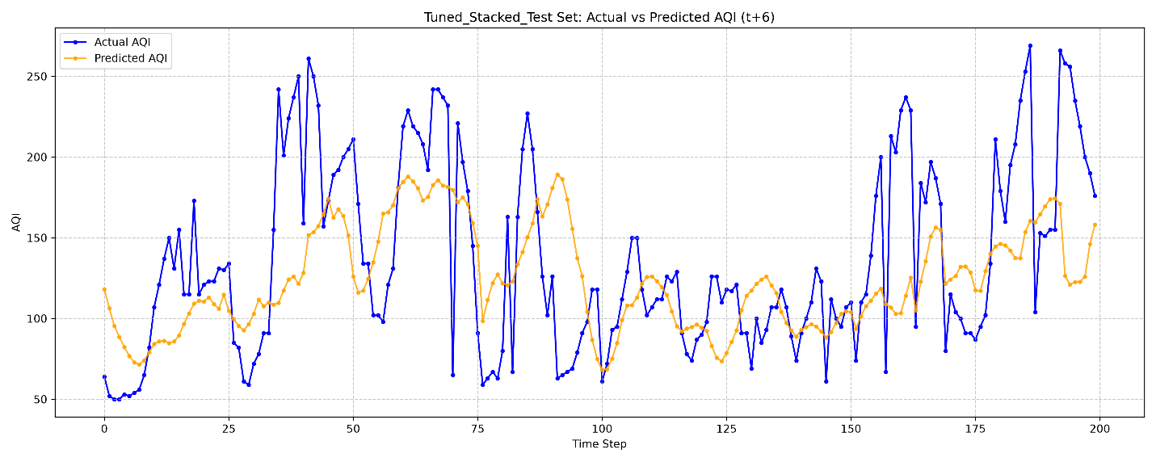
- Single-layer GRU: Visually similar to Base LSTM – captured general trends but smoothed too much, cutting off high peaks.
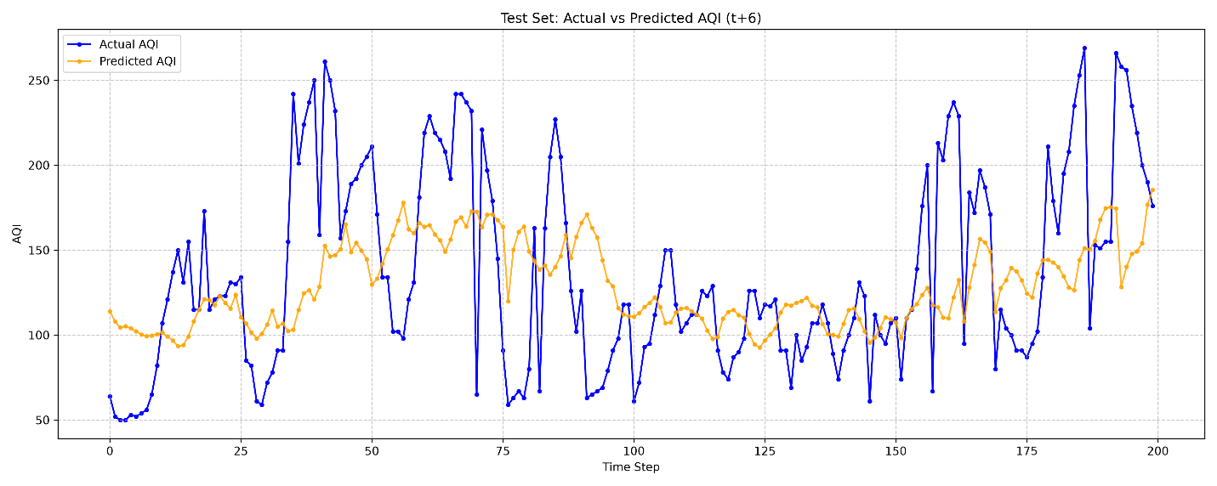
- XGBoost (Lag Features): Distinctly different from Neural Networks. The prediction line was “jagged” and closely followed minor fluctuations in real data. While still unable to predict extreme peaks (AQI > 250), XGBoost reacted much faster to sudden changes than LSTM/GRU.
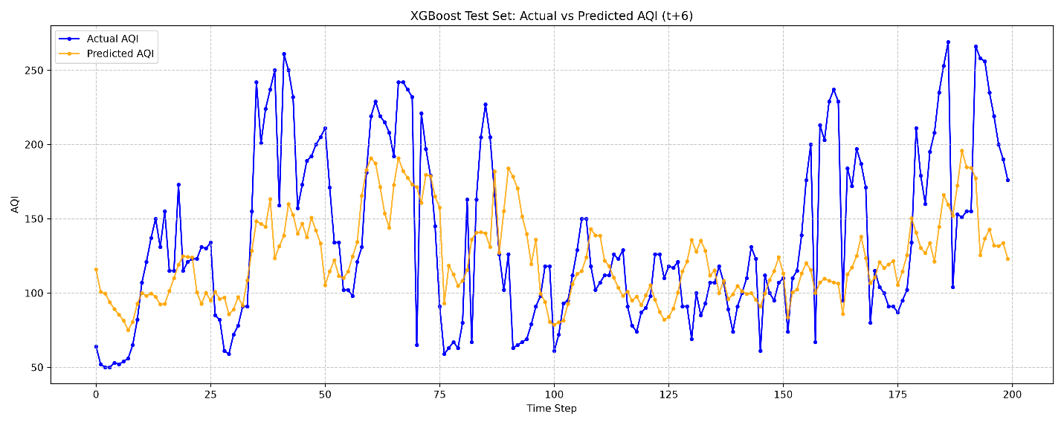

3.7. Comprehensive Evaluation
# | Requirement | Assessment
1 | Use real-world IoT data | Hanoi air quality dataset (08/2022 – 02/2026), ~30,336 records
2 | Standard preprocessing | Preserved timeline, no data leakage, chronological split
3 | Diverse models | Base LSTM, Stacked LSTM, Tuned variants, GRU, XGBoost
4 | Hyperparameter tuning | Optuna Bayesian HPO (TPESampler + MedianPruner, 20 trials)
5 | Objective evaluation | Compared with Naive Persistence Baseline – all models outperformed by ~9-18 RMSE points
6 | Modular architecture | 8 separate modules in src/ + distinct entry points
7 | Logging & reproducibility | DualLogger context-manager, fixed seed 42

Strengths
- Robust Pipeline: No data leakage, continuous timeline, standard chronological split.
- Modular & Reusable: Easy to add features, change models, or integrate APIs.
- Reproducible: Fixed seeds, comprehensive logs, separate checkpoints per trial.
- Automated HPO: Optuna automatically searched hyperparameter spaces, with pruning to save time.
- Multi-architecture comparison: Expanded beyond LSTM to include GRU and XGBoost for comprehensive comparison.

Weaknesses & Future Directions
- No real-time IoT integration: Current pipeline runs offline on CSV data – requires REST API or MQTT connector to receive real-time sensor data.
- Underpredicting AQI peaks: All models tend to underpredict when AQI spikes (> 200). Can be improved with specialized Loss functions (Huber Loss, Quantile Loss) or oversampling techniques for high AQI samples.
- Not fully fine-tuned XGBoost: XGBoost currently runs with default parameters and already achieves the best results – after tuning it could be even better. (Note: Tuning was added later but the statement still holds contextual value regarding further tuning).
- Multi-step forecasting: Currently only predicting at t+6; can be expanded to multi-step forecasting (t+1 to t+24).
- Future directions: Explore Transformer/Attention architectures or combine (Ensemble) LSTM with XGBoost.

4. Source Code

GitHub Repository
The project is uploaded to GitHub. The README.md file on the repository fully describes: - System installation (clone, virtual environment, pip install) - Development tool versions - Detailed descriptions of each module in src/ - Instructions for running baseline training, hyperparameter tuning, GRU, and XGBoost - Performance results and baseline comparison

Directory Structure
GR1/
├── src/ # Main package
│ ├── config.py # Global parameters configuration
│ ├── data_loader.py # Data processing pipeline (+ get_xgboost_data)
│ ├── model.py # LSTMAQIModel, StackedLSTMAQIModel, GRUAQIModel
│ ├── train.py # Training loop + early stopping
│ ├── tune.py # Objective functions for Optuna
│ ├── evaluate.py # Metrics calculation + persistence baseline
│ ├── visualize.py # Chart plotting
│ └── utils.py # DualLogger context manager
├── Dataset/ # Raw datasets
│ ├── archive/ # CSV files (air quality data)
│ └── Copy of Air Quality ForeCasting.ipynb # Original research notebook
├── results/ # Execution results
│ ├── base_results.txt # Base LSTM run log
│ ├── stacked_results.txt # Stacked LSTM run log
│ ├── tuned_results_*.txt # Tuned models run logs
│ ├── gru_results.txt # GRU run log
│ ├── xgb_results.txt # XGBoost run log
│ ├── *_loss_curve.png # Loss curves charts
│ └── *_test_predictions.png # Prediction charts
├── main.py # Entry point: Base LSTM + Stacked LSTM
├── tune_main.py # Entry point: HPO + training tuned models
├── run_gru.py # Entry point: Single-layer GRU
├── run_xgb.py # Entry point: XGBoost (Lag Features)
├── requirements.txt # Dependencies
└── bao_cao_do_an.md # Project report (this file)

Dependencies (requirements.txt)
pandas
numpy
torch
scikit-learn
matplotlib
optuna
seaborn
jupyter
xgboost

