ThreatCast — System Architecture Document
AI-based Network Attack Forecasting · SIH26153 · Team Foresight · Smart India Hackathon 2026
1. Overview
ThreatCast forecasts network attacks a few time-windows before they fully unfold, instead of only detecting them once in progress. It reads network traffic, groups it into short time-windows, and a temporal LSTM predicts the attack probability and likely MITRE ATT&CK stage for the next windows, with a SHAP reason for each alert. It runs fully offline on open-source tools and free public data, and is measured honestly against a logistic-regression baseline.
2. System architecture
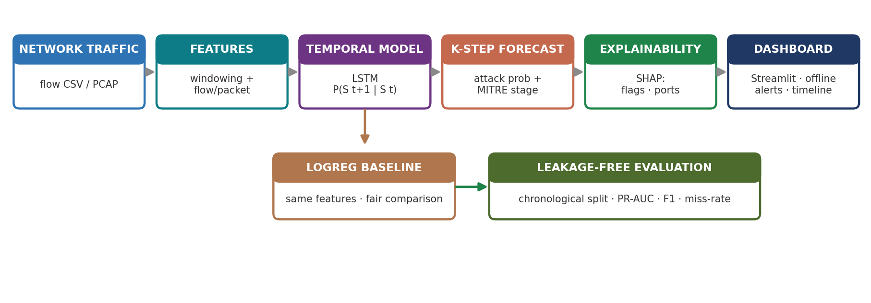
Data flow: raw traffic → windowing + feature extraction (flow and packet level) → LSTM reads the recent window sequence → K-step forecast (attack probability + MITRE stage) → SHAP explanation → offline dashboard. A logistic-regression baseline runs on the same features for a fair comparison, and all metrics come from a leakage-free evaluation.
3. Components
- Ingestion & windowing — reads flow CSVs (and PCAP via Scapy/PyShark) and groups records into fixed time-windows (default 10s).
- Feature extraction — flow-level features (ports, TCP flags, bytes, packets, timing) today; packet-level features (TTL, port-scan, retransmissions) on the roadmap.
- Temporal model (LSTM) — reads the last H windows (default 8) and forecasts the next K windows (default 3 = 30s ahead).
- Forecast head — outputs attack probability and the likely MITRE ATT&CK stage.
- Explainability (SHAP) — ranks the driving features per flagged window (e.g. uniq_dport, flow_count).
- Offline dashboard (Streamlit) — probability timeline, top-risk windows, and per-alert reasons — no cloud.

4. Evaluation methodology
Evaluation is leakage-free: the model trains on earlier traffic and is tested on later traffic (chronological split), and the alert threshold is chosen on a validation split only — so the model cannot peek into the future. Measured on CIC-IDS-2018 (Infiltration day).

Metric | Baseline (LogReg) | ThreatCast (LSTM)
PR-AUC @ 30s ahead | 0.76 | 0.89 (+0.13)
F1 (best threshold) | — | 0.69
Horizon held | — | up to 120s (PR-AUC ~0.87)
Honest limitation: at a usable operating point (~0.5% false-alarm target) the current model misses ~47% of attacks. We report the real number and are reducing it (see roadmap).
5. Technology stack
Layer | Tool | Why
Traffic ingestion | Scapy / PyShark | read flow CSV + PCAP
Temporal model | PyTorch LSTM | learn the time pattern P(Sₜ₊₁|Sₜ)
Baseline | scikit-learn (LogReg) | fair, same-feature comparison
Explainability | SHAP | reason for every alert (no black box)
Dashboard | Streamlit | offline SOC view, no cloud
Framework | MITRE ATT&CK | standard attack-stage taxonomy
6. Deployment & compliance
- Offline / air-gapped — trains and runs on a normal laptop (CPU); no cloud, suitable for sensitive government networks.
- Add-on, not a replacement — acts as an early-warning layer alongside existing IDS/NDR.
- Sponsor mandate — protecting Critical Information Infrastructure is NCIIPC's remit; NCIIPC is a unit of NTRO (the problem sponsor), IT Act §70A. Early warning + evidence also support CERT-In (§70B) reporting.
7. Roadmap
- Lead-time metric — median seconds of early warning + recall-vs-lead-time curve (highest priority).
- Packet-level features — TTL, port-scan, retransmissions (named in the PS); also lowers miss rate.
- Concrete MITRE stage mapping — map dataset labels to the 5 stages for a real stage output.
- Second-dataset validation — another attack day / CTU-13 to show it generalizes.
- Packaging — demo video, cleaner repo, and this document kept current.
Repository: github.com/GMinnu/SIH26153_AI-based-Network-Attack-Forecasting-from-Network-Traffic-Data

