Introduction

Nearly all helicopters share the same basic e2 (made by great coder named Badger) for flying. Basic controls for every helicopter are the same:

On startup:
- Hold Alt (Default walkbutton) – camera will change to 1st person
- Center the camera
- Hold Alt again to 3rd person
- Press F (Flashlight) to startup

Mouse – General control. Look left to turn helicopter left, look down to nose down etc
W/S – Ascend/Descend
A/D – Strafe left/right
Space – Autohover (Hold altitude and derection)

The same rule works for all planes. All planes use great E2 named MPFC by redreaper2020.
For plane controls watch this video: https://www.youtube.com/watch?v=ME7bGVOLtgI
and look inside E2 code.
For each aircraft I’ll mention if it is helicopter or plane (sometime it’s really weird) and its extra controls
Also, to move plane/helicopter, you need to move base prop. The screenshot of it will be below controls. The base prop will be colored red.
Usually all props are parented to wire gate on base prop, not directly to base prop. By doing it HL2 RPG rockets and ACF shells can hit parented props.

AC 5 Super Galaxy
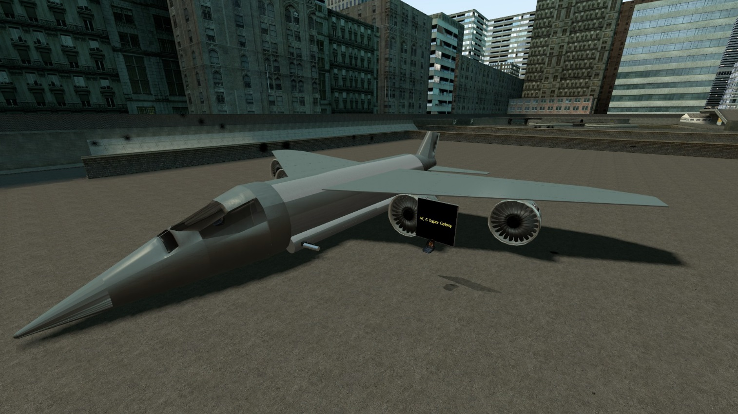

Description:
Huge AC-130 like plane. Has a gunner seat outside plane
Controls:

For pilot: MPFC plane
For gunner: LMB – guns, RMB - rockets

Base prop:
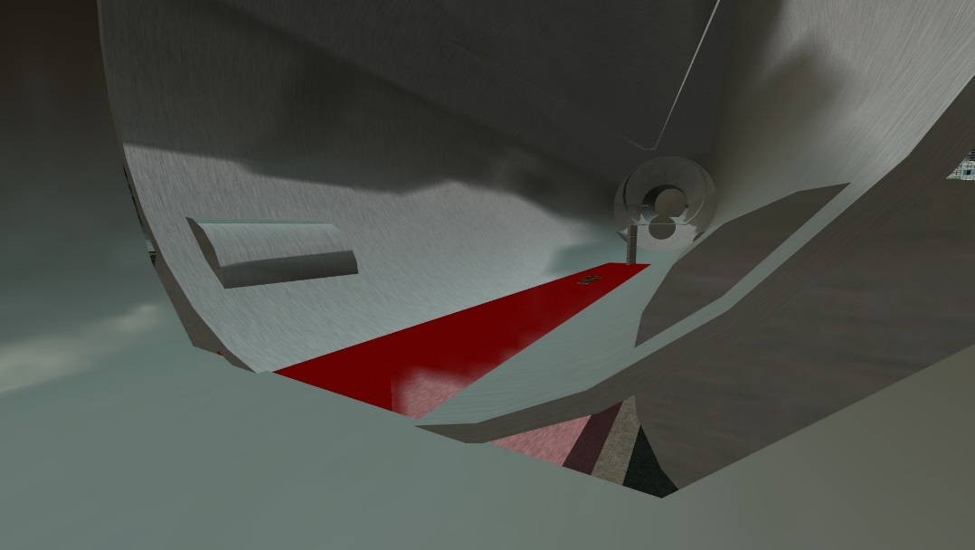
Adeptus Custodes
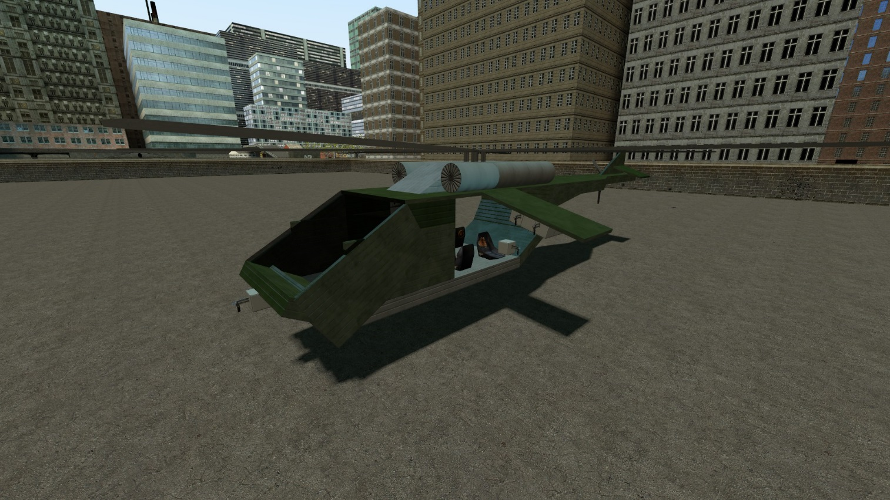

Description:
Transport helicopter. Was the 1st helicopter to be made from vanilla props. Front left seat is gunner, front right is pilot.
Controls:

Basic helicopter
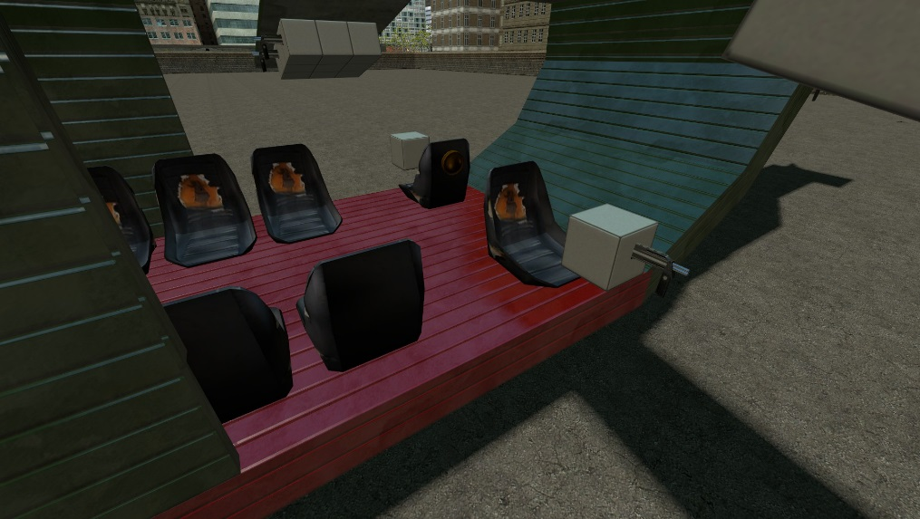
Base prop:

Blackbird
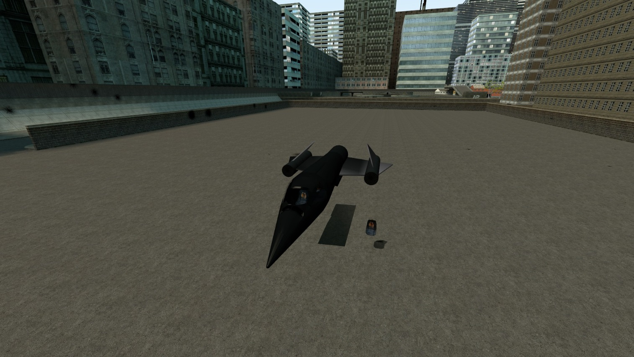

Description:
Fast plane. Spy version has a camera below the plane. Gunship has a controlled turret. Operator seat is outside of the plane
Controls:
For pilot: MPFC plane
For gunner: LMB – guns, RMB – rockets
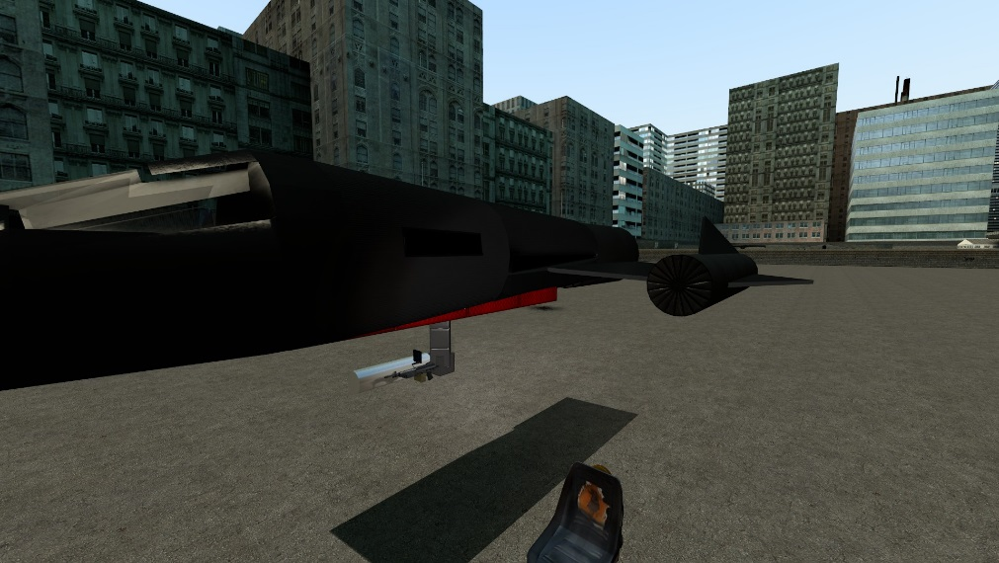
Base prop:

Mi-28
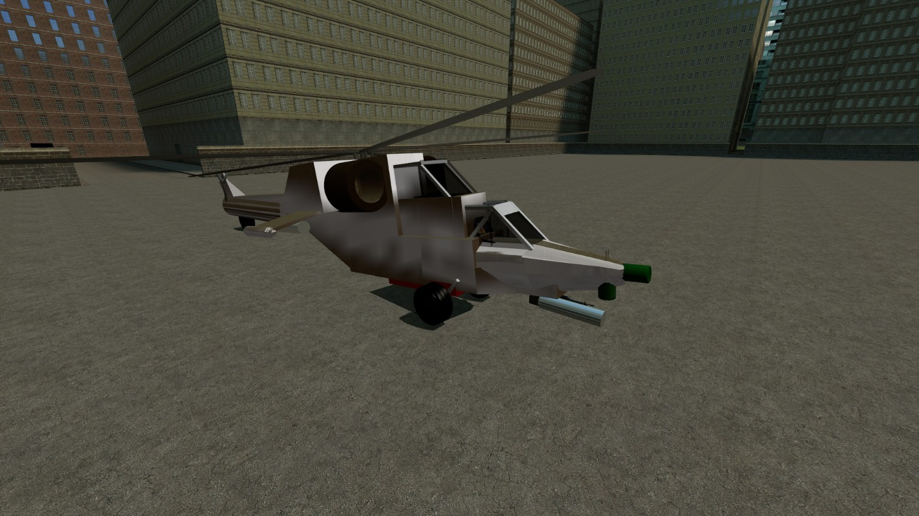

Description:
Based on original mi-28 by other player. Pilot is at back, gunner at front.
Controls:
Default Helicopter
For pilot: LMB - rockets
For gunner: LMB – gun, RMB – rockets

Light Helicopter (transport)
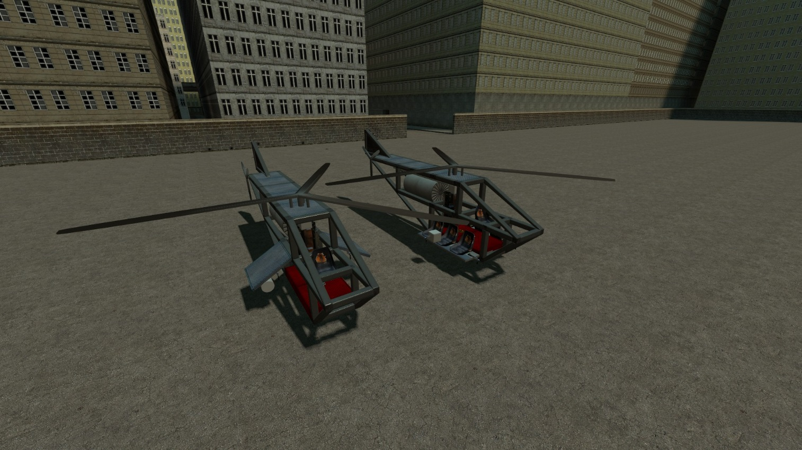

Description:
Light helicopter. The nontransport version has rocket pods.
Controls:
Default Helicopter
LMB – guns
RMB – rockets

Mi-24
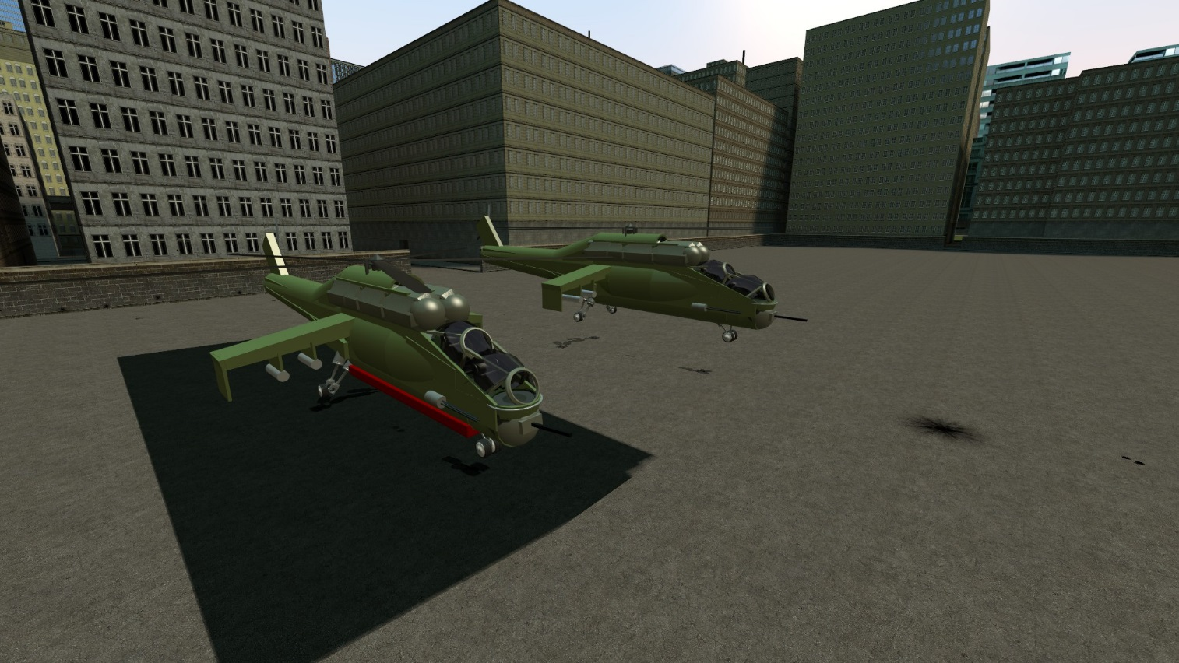

Description:
Based on the hull by other player (sorry mate, do not remember your nick), armed and enchanted by me.
Backseat is pilot seat, front is gunner. For solo version gunner seat is disabled (but still accessible) and the gun control is linked to pilot’s crosshair position
Controls:

Default helicopter
LMB – fixed high-damage side cannon
RMB – rocket pods
R (Solo only) – gunner turret

MV Cloud car
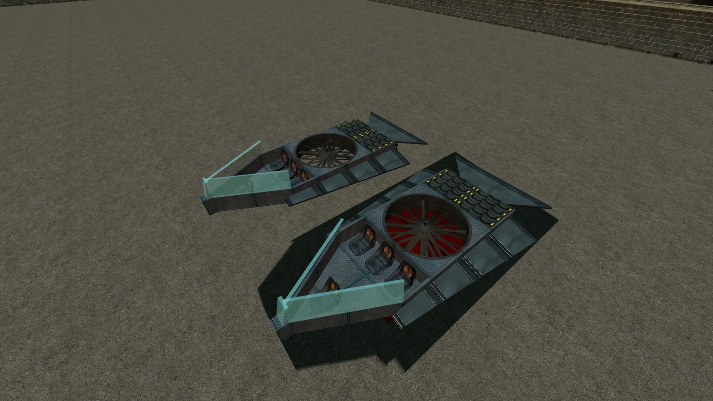

Description:
Armed. Pilot is the front seat
Controls:
Basic helicopter
LMB – guns
RMB – rockets

MV Orca Big (Transport)
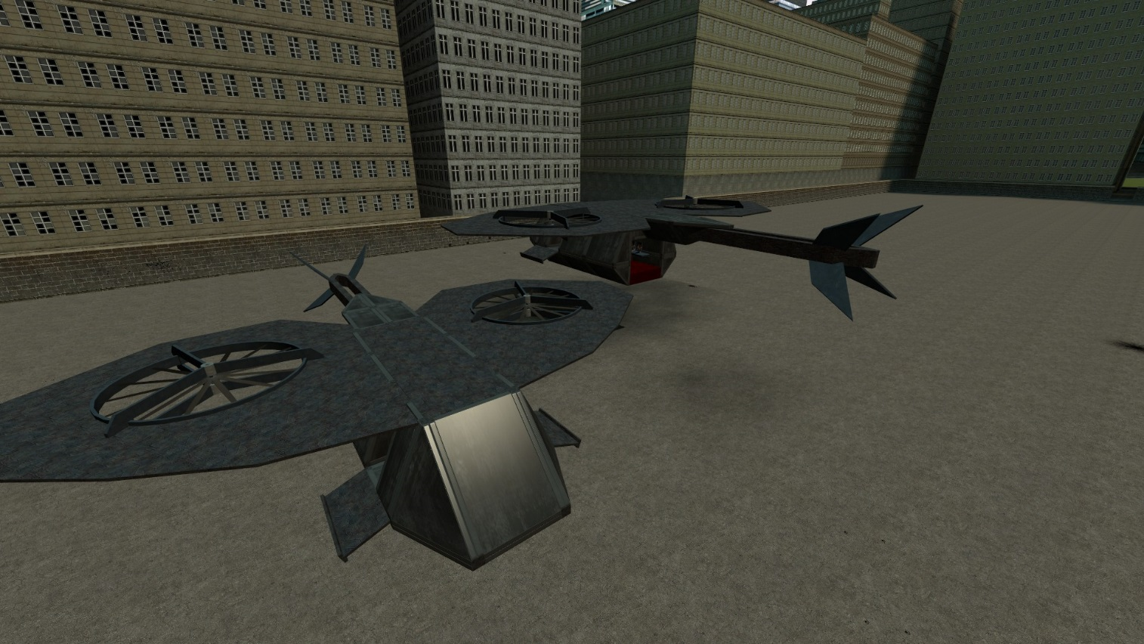

Description:
Huge transport aircraft from Orca series
Controls:
Basic helicopter
LMB – guns
RMB – rockets

MV Orca Light
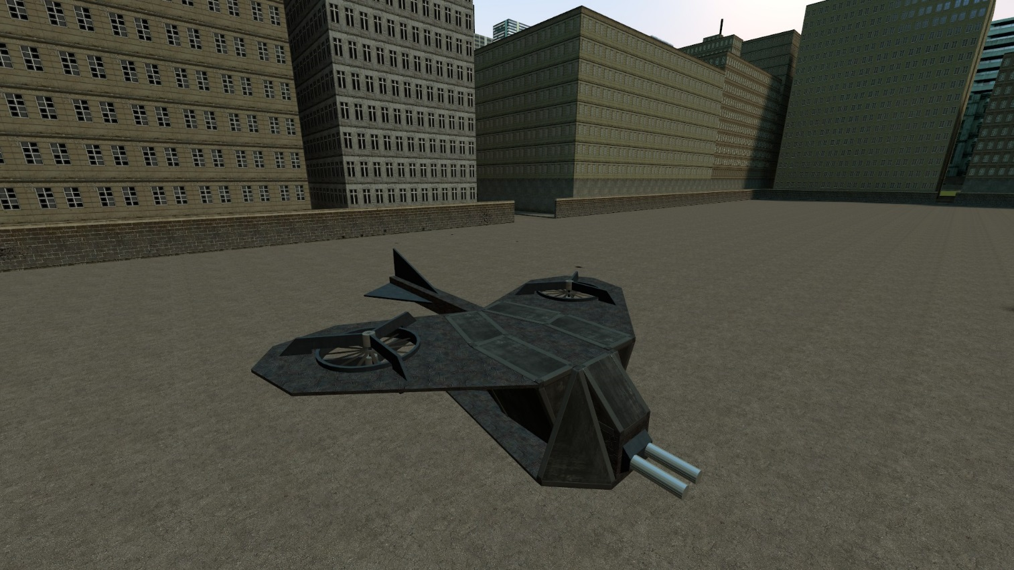

Description:
Very fast and agile Orca-series aircraft. Armed with a pair of explosive launchers
Controls:
Basic helicopter
LMB – Shoot

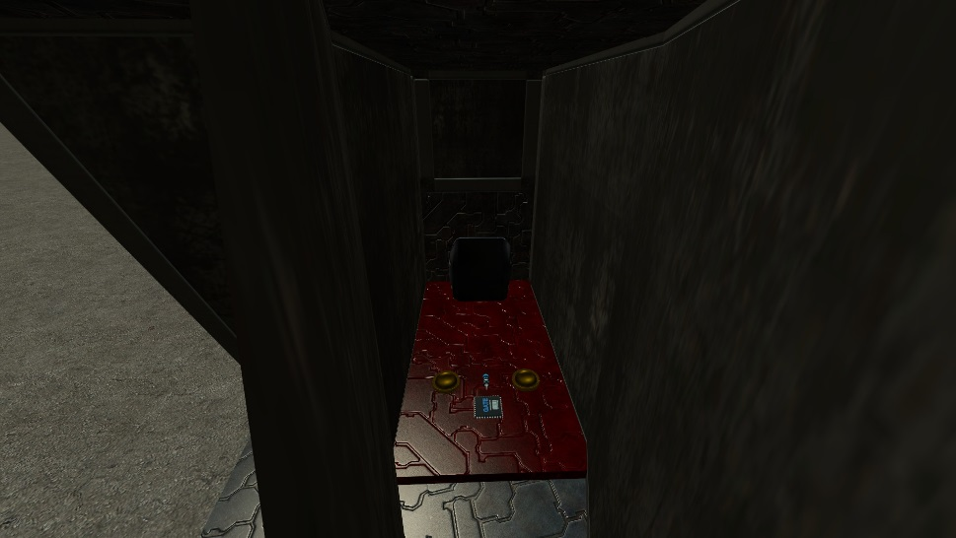
Basic prop:

MV Orca Pixy
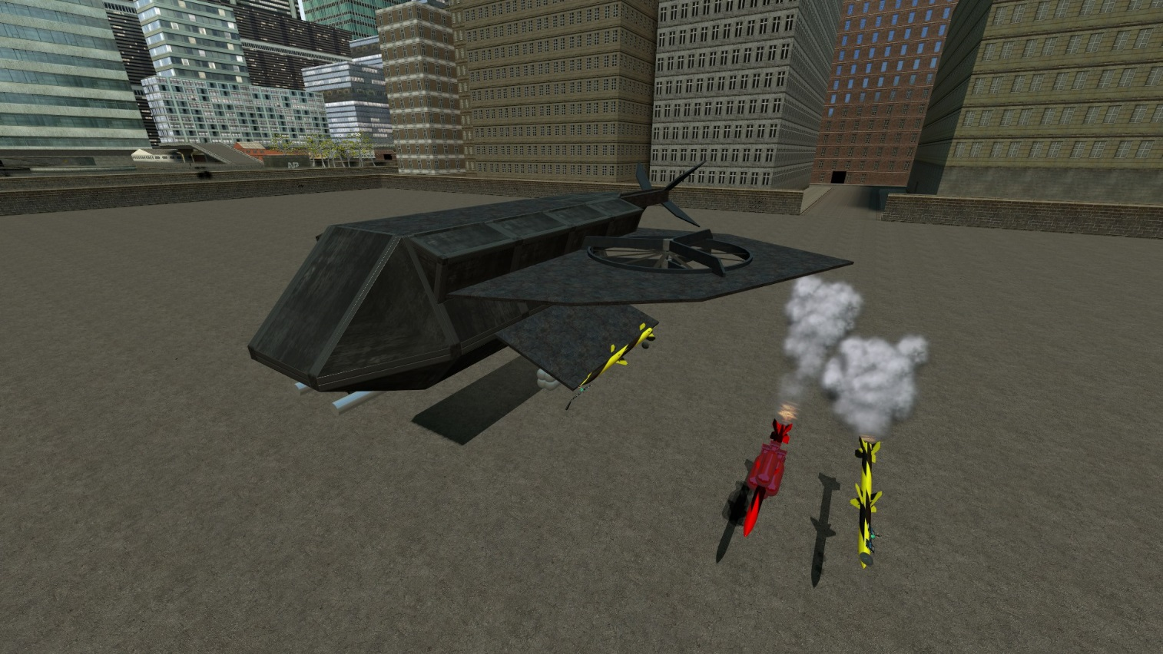

Description:
Heavy attack Orca-series aircraft. Has poor agility but high speed. Press shift to boost forward
Controls:
Basic helicopter. Bu do not fly it like a helicopter. Accelerate forward pressing Shift
R – Bombs
ScrollWheelUP and ScrollWheelDOWN – launch guided rockets from left/right pylon. Locks on the nearest vehicle to missile
LMB – guns
RMB – unguided rockets

MV 88
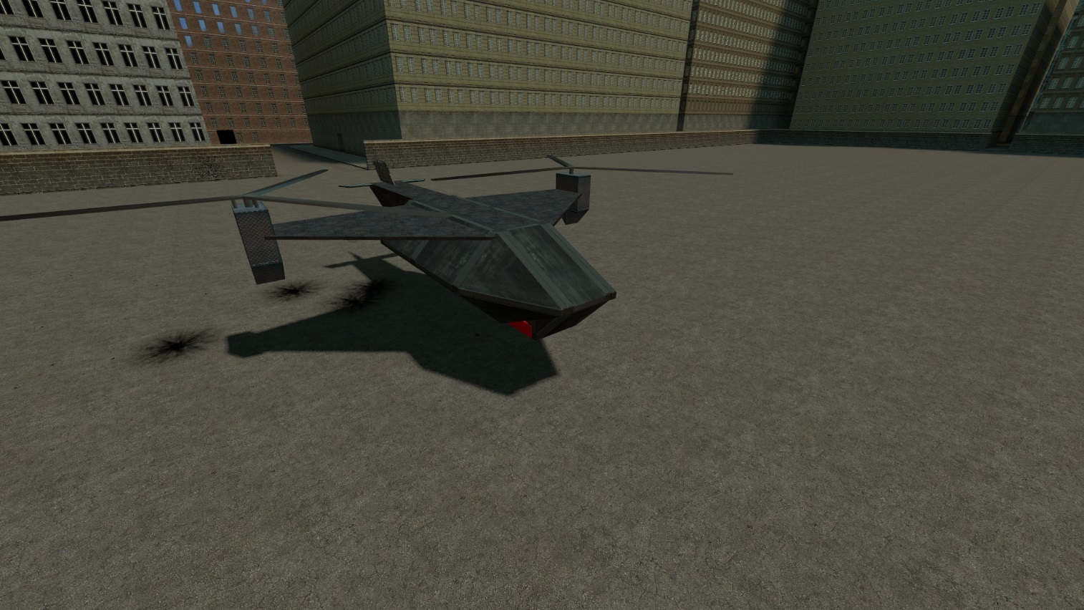

Description:
La Classique. Balanced attack craft
Controls:
Basic helicopter
LMB – guns
RMB – rockets

Pitbull
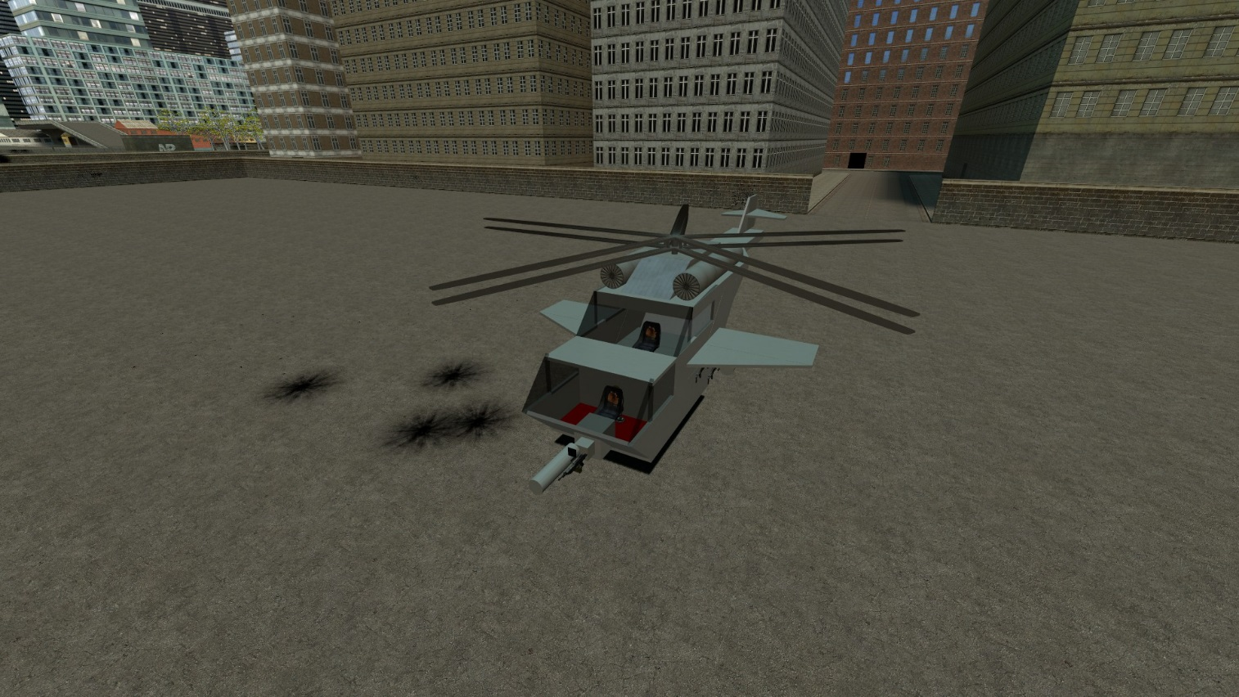

Description:
Attack helicopter. Gunner is at front, pilot is behind
Controls:
Basic helicopter
Pilot:
LMB – guns
RMB – rockets
Gunner: same

Spaceship
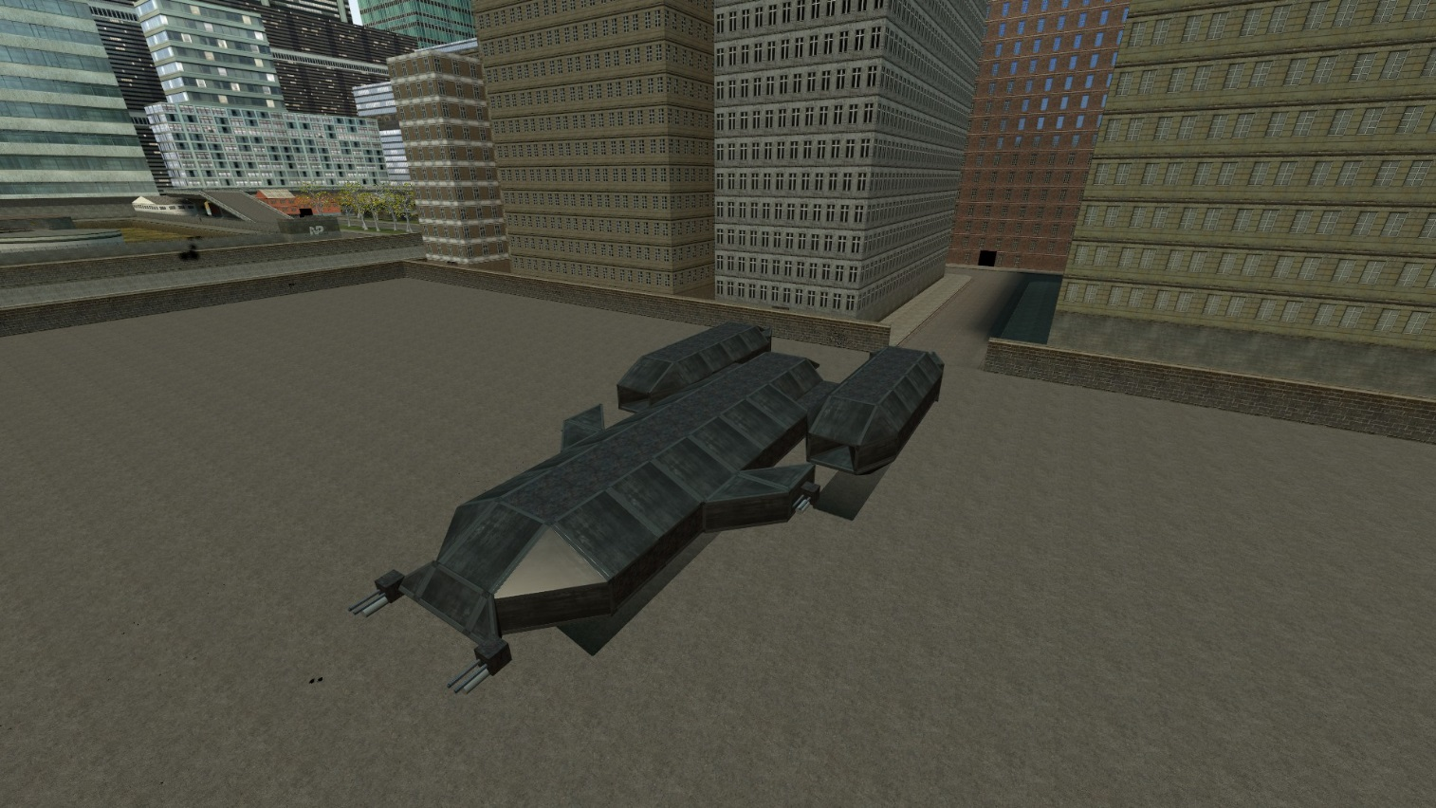

Description:
This bastard is made to rekt anything. Duo/Trio versions have extra gunner seats.
Be advised: It uses helicopter E2, but to move forward you need to hold Shift. If you have good position and want to soot – press Space to autohover.
Controls:
Basic helicopter
LMB – guns
RMB – rockets
Shift – Fly forward

