**Computer Architecture II Assignment 3**

**Gerard Moylan 21364007**

**Q1:**

I:

|  |  |  |  |  |  |  |  |  |  |  |
| --- | --- | --- | --- | --- | --- | --- | --- | --- | --- | --- |
|  | CC1 | CC2 | CC3 | CC4 | CC5 | CC6 | CC7 | CC8 | CC9 | CC10 |
| LW R1, 0(R2) | IF | ID | EX | MEM | WB |  |  |  |  |  |
| SUB R1, R3, R2 |  | IF | ID | EX | MEM | WB |  |  |  |  |
| SUB R3, R1, R2 |  |  | IF | ID | EX | MEM | WB |  |  |  |
| ADD R2, R1, R2 |  |  |  | IF | ID | EX | MEM | WB |  |  |
| SUB R1, R1, R2 |  |  |  |  | IF | ID | EX | MEM | WB |  |
| ADD R3, R1, R2 |  |  |  |  |  | IF | ID | EX | MEM | WB |

Where:

The value for R1 calculated in EX in CC4 is forwarded to EX in CC5 and EX in CC6.

The value for R2 calculated in EX in CC6 is forwarded to EX in CC7 and CC8.

The value for R1 calculated in EX in CC7 is forwarded to EX in CC8.

It would take 10 clock cycles as shown in the table above.

There would be no stalls. This is because after the first instruction where R1 = MemContent[R2], R1 is immediately overwritten to be R3-R2.

Lines 3 and 4 which use R1 as a parameter get this R1 value from line 2 via forwarding, and by the time any subsequent lines need R1, the correct value for R1 is already finished being written into memory by line 2.

To calculate the final values of R1, R2 and R3, we can just calculate the code line by line.

Doing it out manually, showing the values of each register after each step:

R1 = MemContent[R2] -> R1=2, R2=3, R3=1

R1 = R3 - R2 -> R1=-2, R2=3, R3=1

R3 = R1 - R2 -> R1=-2, R2=3, R3=-5

R2 = R1 + R2 -> R1=-2, R2=1, R3=-5

R1 = R1 - R2 -> R1=-3, R2=1, R3=-5

R3 = R1 + R2 -> R1=-3, R2=1, R3=-2

Final answer: R1 = -3, R2 = 1, R3 = -2

II:

No, the number of clock cycles cannot be optimised by employing out-of-order instruction scheduling because there are no stalls.

III:

It would now take 16 clock cycles.

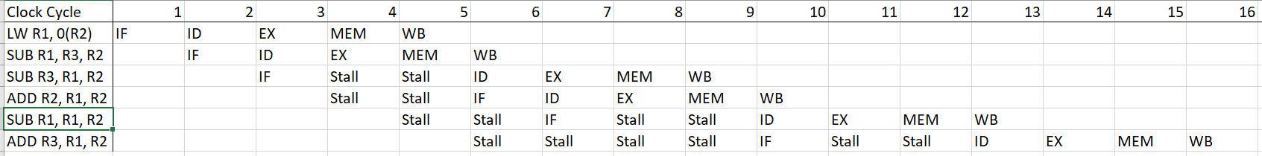

The stall on line 3 is because ID needs to wait for line 2 to finish writing the value for R1.

The stalls on line 4 are waiting for line 3 to finish IF so that line 4 can IF.

The first 2 stalls on line 5 are waiting for line 4 to finish IF so line 5 can IF. The last 2 stalls are because line 5 needs to wait for line 4 to finish writing the value for R2 before line 5 then reads that value on the ID step.

The first few stalls on line 6 are waiting for line 5 to finish its IF so that line 6 can IF.

The last few stalls on line 6 are because it needs to wait for the value of R1 to finish being written on line 5 before it reads that value on the ID step.

The final values for R1, R2 and R3 would be the same as part 1. The whole reason it is stalling is to ensure that it is taking the correct values for registers AFTER they are finished being written.

The reason there is no stall when IF and MEM are on the same cycle is because it is assumed there are caches for data and instructions.

IV:

In this case the pipeline table would look exactly the same as for part I except without any forwarding whatsoever. So the number of clock cycles would be 10 but the values of R1, R2, and R3 would be different.

The execution in pseudocode would be as follows

R1 = MemContent[R2]

R1 = R3 - R2 (1 - 3 = -2)

R3 = R1 - R2 (5 - 3 = 2)

R2 = R1 + R2 (2 + 3 = 5)

R1 = R1 - R2 (-2 - 3 = -5)

R3 = R1 + R2 (-2 + 3 = 1)

So:

R1 = -5, R2 = 5, R3 = 1

Where the brackets correspond to the values that are being used for each operand respectively, and the result.

For line 3, R1 is taken as 5 because none of the above computations on R1 have finished being written yet.

For line 4, R1 is taken as 2 because the computation from line 1 has just finished being written

For line 5, R1 is taken as -2 since the computation from line 2 is finished being written. R2 is taken as 3 because the computation from line 4 is not finished being written.

For line 6, R1 is taken as -2 because the computation on line 5 is not done being written. Similarly, R2 is taken as 3 because the computation on line 4 is not finished being written.

**Task 2:**

I:

For the 1st configuration, since the offset is 12 bits long the pages are 2^12 = 4kB

Similarly, the 2nd configuration is 2^13 = 8kB

II:

The following assumes each table entry is 4 bytes.

Configuration 1:

1st level: (2^8) * 4 = 1kB

2nd level: (2^7) * 4 = 512B

3rd level: (2^5) * 4 = 128B

Configuration 2:

1st level: (2^7) * 4 = 512B

2nd level: (2^7) * 4 = 512B

3rd level: (2^5) * 4 = 128B

III:

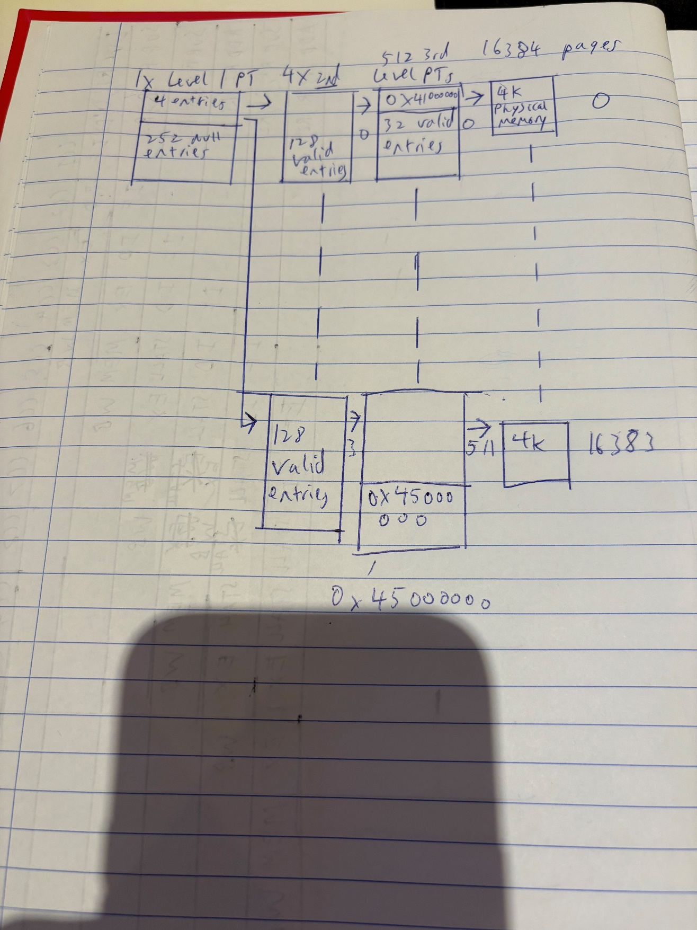

Since there is 64MB of physical memory and each page is 4kB, that means there are 67108864 / 4096 = 16384 pages to be mapped.

Since each level 3 page table has 2^5 = 32 entries, it takes 16384 / 32 = 512 level 3 page tables to map all the pages.

Since each level 2 page table has 128 entries, it takes 512 / 128 = 4 level 2 page tables.

The level 1 page table has 256 entries and it takes 4 entries to map the 4 level 2 page tables.

Since it starts at address 0x41000000, the 64MB spans until address 0x45000000

IV:

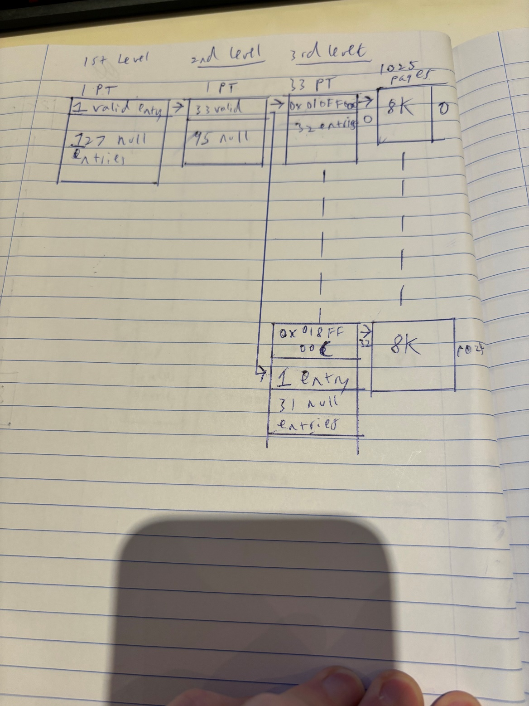

So since each page is 8192B, the number of pages is

8MB / 8192B = 1024 + 1 page to account for the 12B so in total 1025 pages.

3rd level:

There are 1024/32 = 32 full page tables + 1 page table with 1 valid entry pointing to the 1025th page.

So in total there are 33 pages.

2nd level:

There is 1 page table with 33 valid entries that points to the 33 3rd level page tables and 128-33 = 95 null entries.

1st level:

There is 1 page table with 1valid entry pointing to the 1 2nd level page table and 128-1 = 127 null entries.