C++的调试工具gdb介绍

本地调试gdb

C:\Users\GMshuS>gdb --help
This is the GNU debugger. Usage:

gdb [options] [executable-file [core-file or process-id]]
gdb [options] --args executable-file [inferior-arguments ...]

Options:

--args Arguments after executable-file are passed to inferior
-b BAUDRATE Set serial port baud rate used for remote debugging.
--batch Exit after processing options.
--batch-silent As for --batch, but suppress all gdb stdout output.
--return-child-result
GDB exit code will be the child's exit code.
--cd=DIR Change current directory to DIR.
--command=FILE, -x Execute GDB commands from FILE.
--eval-command=COMMAND, -ex
Execute a single GDB command.
May be used multiple times and in conjunction
with --command.
--init-command=FILE, -ix Like -x but execute it before loading inferior.
--init-eval-command=COMMAND, -iex Like -ex but before loading inferior.
--core=COREFILE Analyze the core dump COREFILE.
--pid=PID Attach to running process PID.
--dbx DBX compatibility mode.
--directory=DIR Search for source files in DIR.
--exec=EXECFILE Use EXECFILE as the executable.
--fullname Output information used by emacs-GDB interface.
--help Print this message.
--interpreter=INTERP
Select a specific interpreter / user interface
-l TIMEOUT Set timeout in seconds for remote debugging.
--nw Do not use a window interface.
--nx Do not read any .gdbinit files.
--nh Do not read .gdbinit file from home directory.
--quiet Do not print version number on startup.
--readnow Fully read symbol files on first access.
--se=FILE Use FILE as symbol file and executable file.
--symbols=SYMFILE Read symbols from SYMFILE.
--tty=TTY Use TTY for input/output by the program being debugged.
--version Print version information and then exit.
-w Use a window interface.
--write Set writing into executable and core files.
--xdb XDB compatibility mode.

At startup, GDB reads the following init files and executes their commands:

For more information, type "help" from within GDB, or consult the
GDB manual (available as on-line info or a printed manual).
Report bugs to "<http://www.gnu.org/software/gdb/bugs/>".

- debug：调试源代码，调试时会自动编译源代码并生成名字debug的exe，需要指定包含main函数的源文件或者包名进行调试，示例：
1）go debug c/go/src/hello/hello.go；
2）go debug c/go/src/hello/；
- attach：附加到进程调试；

远程调试gdb+gdbserver

C:\Users\GMshuS>gdbserver --help
Usage: gdbserver [OPTIONS] COMM PROG [ARGS ...]
gdbserver [OPTIONS] --attach COMM PID
gdbserver [OPTIONS] --multi COMM

COMM may either be a tty device (for serial debugging), or
HOST:PORT to listen for a TCP connection.

Options:
--debug Enable general debugging output.
--remote-debug Enable remote protocol debugging output.
--version Display version information and exit.
--wrapper WRAPPER -- Run WRAPPER to start new programs.
--once Exit after the first connection has closed.
Report bugs to "<http://www.gnu.org/software/gdb/bugs/>".

- 开启远程调试服务
远程调试的服务端可以使用debug、attach、exec模式启动，一般使用attach模式，例：
dlv attatch --headless --listen “:2345” --log --api-version 2 进程ID

- 连接调试服务进行调试
connect：远程调试时，调试客户端连接到调试服务器进行调试，示例：
1）dlv connect 192.168.1.31:2345；

VSCode调试C++
跨平台的强大IDE，可以用于编写与调试c++代码。在VSCode下，使用delve调试C++代码的配置示例：
{
// Use IntelliSense to learn about possible attributes.
// Hover to view descriptions of existing attributes.
// For more information, visit: https://go.microsoft.com/fwlink/?linkid=830387
"version": "0.2.0",
"configurations": [
// 远程调试
{
"name": "(gdb) 远程",
"type": "cppdbg",
"request": "launch",
"program": "${workspaceFolder}/main.exe",
"cwd": "${workspaceFolder}",
"MIMode": "gdb",
"miDebuggerPath": "D:\\MinGW\\bin\\gdb.exe",
"setupCommands": [
{
"description": "为 gdb 启用整齐打印",
"text": "-enable-pretty-printing",
"ignoreFailures": true
}
],
"miDebuggerServerAddress": "192.168.3.59:2345",
},
// 调试本地进程
{
"name": "(gdb) 附加",
"type": "cppdbg",
"request": "attach",
"program": "${workspaceFolder}/main.exe",
"processId": "${command:pickProcess}",
"MIMode": "gdb",
"miDebuggerPath": "D:\\MinGW\\bin\\gdb.exe",
"setupCommands": [
{
"description": "为 gdb 启用整齐打印",
"text": "-enable-pretty-printing",
"ignoreFailures": true
}
]
},
// 调试可执行文件
{
"name": "(gdb) 启动",
"type": "cppdbg",
"request": "launch",
"program": "${workspaceFolder}/main.exe",
"args": [],
"stopAtEntry": false,
"cwd": "${workspaceFolder}",
"environment": [],
"externalConsole": false,
"MIMode": "gdb",
"miDebuggerPath": "D:\\MinGW\\bin\\gdb.exe",
"setupCommands": [
{
"description": "为 gdb 启用整齐打印",
"text": "-enable-pretty-printing",
"ignoreFailures": true
}
],
"preLaunchTask": "g++ build",
}
]
}

本地调试

不同调试模式对应的参数设置
调试模式/属性 | attach | debug exe | debug dmp
type | 调试插件类型，必须为cppdbg | 调试插件类型，必须为cppdbg | 调试插件类型，必须为cppdbg
request | attach | launch | launch
args | 传给正在调试程序命令行参数数组 | 传给正在调试程序命令行参数数组 | 传给正在调试程序命令行参数数组
environment | 调试时需要的环境变量 | 调试时需要的环境变量 | 调试时需要的环境变量
program | - 要调试的包（绝对路径）；  - 要调试的具体文件（绝对路径）； | × | 要调试的exe文件（绝对路径）
cwd | 对应的调试模式，设置为debug | 对应的调试模式，设置为local | 对应的调试模式，设置为exec
MIMode
miDebuggerPath | 调试器的绝对路径 | 调试器的绝对路径 | 调试器的绝对路径
miDebuggerArgs | 传给调试器的参数 | 传给调试器的参数 | 传给调试器的参数
processId | × | 要调试的进程ID | ×
preLaunchTask
postDebugTask
windows
linux
osx

远程调试

远程调试服务端gdbserver
远程调试的服务端可以使用debug、attach模式，具体的调试模式由服务端决定。

debug模式
- 用法:
dlv attatch --headless --listen “:端口” --log --api-version 2 [package] [flags]
- 实例：
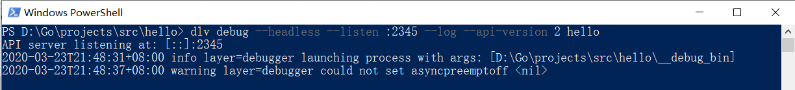

注意：服务端需要拥有跟客户端一样的源代码代码。

attach模式
用法:
dlv attach --headless --listen “:端口” --log --api-version 2 pid [executable] [flags]
实例：
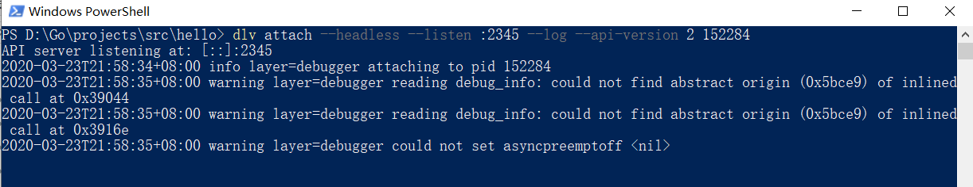

远程调试客户端

调试模式/属性 | remote
type | 调试插件类型，必须为go
request | launch
args | 传给正在调试程序命令行参数数组
env | 调试时需要的环境变量，如："GOPATH": "D:/Go/Projects"
program | 要调试的包（绝对路径）；
mode | remote
host | 调试服务端的IP，如：192.168.179.128
port | 调试服务端的端口，如：:2345
remotePath | 调试服务端的源码位置，只有服务端设置debug调试模式需要设置，其它情况设置为空就可以，如：d:/hello

高级篇

跨平台调试
首先得有一个跨平台的调试器（如：能在Windows运行，调试Linux上程序的gdb）
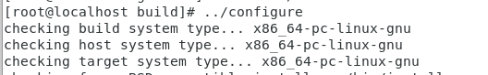
--target=x86_64-pc-linux-gnu

Unable to open 'main.cpp': Unable to read file '\cygdrive\d\gcc Projects\test_linux\main.cpp' (Error: Unable to resolve non-existing file '\cygdrive\d\gcc Projects\test_linux\main.cpp').

编译跨平台调试器gdb
https://www.cnblogs.com/my_life/articles/10675094.html

