Exploratory Data Analysis (EDA) Summary
Report Template

1. Introduction
This report aims to assess the quality and charac teristics of Geldium’s customer dataset. The goral is to identify the missing data , inconsistencies and early risk indicators to enhance predictive accuracy .

2. Dataset Overview
This section summarizes the dataset, including the number of records, key variables, and data types. It also highlights any anomalies, duplicates, or inconsistencies observed during the initial review.
Key dataset attributes:
- Number of records: 500 (500 rows X 19 columns)
- Key variables:
- Customer_ID – A Unique identifier for each customer is recorded
- Age - age of the customer in years
- Income – The reported annual or monthly income of the customer
- Credit_Score – Numerical value representing the customer’s creditworthiness.
- Credit_Utilization – The ratio of the current balance to the total credit limit
- Missed_Payment – The total count of the payments missed by the customer
- Delinquent_Account – The target variable indicates whether the account is currently delinqueny(1) or not(0).
- Loan_Balanace – The total outstanding amount on the customer’s loan
- Debt_to_Income_Ratio – The proportion of monthly debt payments to gross monthly income
- Employment_Status – The current employment category (eg ; Self-employed , Unemployed )
- Account_Tenure – Duration (in months) the account has been held
- Credit_Card_Type – The type of credit card ( eg; Student , Standard , Platinum , Business)
- Location - the geographic city or region of the customer
- Month_1 to Month_6 – Historical payment status record recent 6 months(eg; “Late” , “Missed” , “ On-time”)

- Data types:
- Categorical : Customer_ID , Employment_Stauts , Credit_Card_Type, Location , Month_1,Month_2, Month_3, Month_4, Month_5, Month_6.
- Numerical : Age , Income, Credit_score , Credit_Utilization , Missed_Payments , Delinquent_Account, Loan_balance, Debt_to_Income_Ratio,Account_Tenure.

3. Missing Data Analysis
Identifying and addressing missing data is critical to ensuring model accuracy. This section outlines missing values in the dataset, the approach taken to handle them, and justifications for the chosen method.
Key missing data findings:
- Variables with missing values:
- Loan_Balance – 29 missing value
- Income-39 missing values s
- Credit_Score – 2 missing values
- Missing data treatment:
- Imputation : Income , Loan_Balnace
- Standardized : Employment_Status
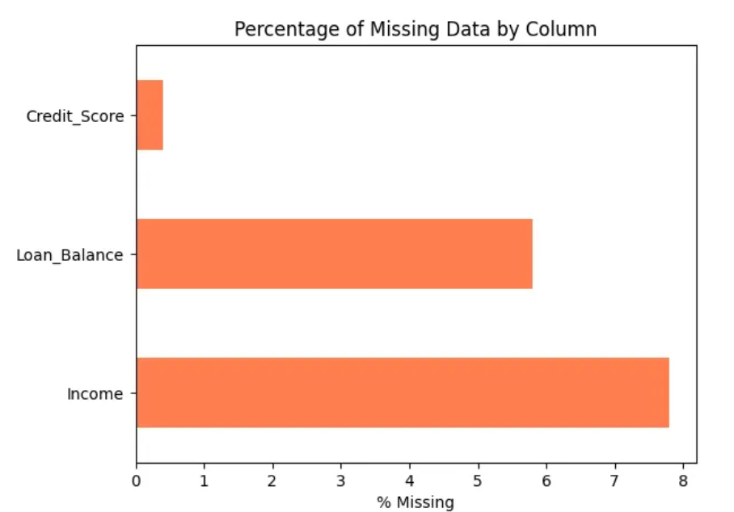

4. Key Findings and Risk Indicators
This section identifies trends and patterns that may indicate risk factors for delinquency. Feature relationships and statistical correlations are explored to uncover insights relevant to predictive modeling.
Key findings:
- Correlations observed between key variables:
- Debt-to-Income (DTI) & Delinquency - A positive correlation was observed where higher DTI ratios (>0.40) correlate with a nearly 23% increase in delinquency probability compared to low-DTI borrowers.
- Credit Utilization: While the overall correlation coefficient is moderate, a "cliff effect" is visible; delinquency risk rises sharply once utilization crosses the 70% threshold.
- Account Tenure: A negative correlation exists between tenure and delinquency (-0.039), indicating that established accounts (tenure >12months) are statistically more stable than "new" accounts (<3months).
- Behavioral Persistence: Customers who recorded a "Missed" status in at least 5 out of the 6 previous months showed the highest delinquency rate (25\%), suggesting that recent behavior is a more potent predictor than static credit scores.
- Unexpected anomalies:
- Zero-Tenure Debt: 28 records show an Account_Tenure of 0 months but carry significant loan balances (some exceeding 80,000). These require investigation to determine if they are "bust-out" risks or simply data migration artifacts.
- Impossible Utilization: 4 data points report Credit_Utilization over $100%. These could represent accounts that have exceeded their credit limits or errors in the denominator used for calculation.
- Employment Coding Inconsistency: The presence of multiple labels for the same status (e.g., "EMP", "employed", and "Employed") suggests manual data entry or merging from different systems, which could mislead categorical analysis if not unified.
- Counter-intuitive Payment Loops: A small segment of users with 6 "Missed" payment statuses in the history columns are not flagged as "Delinquent_Account," suggesting a possible lag in how the "Delinquent" status is updated in the system.

5. AI & GenAI Usage
Generative AI tools were used to summarize the dataset, impute missing data, and detect patterns. This section documents AI-generated insights and the prompts used to obtain results.
Key Contributions of GenAI:
- Imputation Strategy Support : GenAI was consulted to evaluate different missing value treatment methods. Based on its suggestions and aligned with industry best practices, I applied median imputation to the Income and Loan_Balance columns. This choice helped preserve central tendency without being skewed by outliers.
- Feature Prioritization for Risk Analysis: GenAI assisted in identifying and validating which variables — such as Credit_Utilization, Employment_Status, and Location—were most likely to contribute to delinquency, allowing me to focus the analysis on high-impact factors.
- Data Consistency Resolution : It helped flag inconsistent categorical values in the Employment_Status column (e.g., 'EMP', 'employed', 'Employed') and advised consolidation into standardized categories. This improved the reliability of grouped insights.

- OUTCOME : This allowed for a more focused and interpretable EDA, without over-reliance on automation.

6. Conclusion & Next Steps
The Exploratory Data Analysis (EDA) of the Geldium dataset identified key delinquency drivers and critical data quality issues.
Risk Drivers: High Debt-to-Income (DTI) ratios and recent "Missed" payment flags are the main predictors of delinquency.
Data Integrity: Missing values in financial fields and anomalies like >100% credit utilization indicate the need for significant data transformation.
Segment Stability: Older accounts exhibit higher repayment stability, while newer, high-balance accounts need closer monitoring.

Recommended Next Steps:

1. Finalize Data Cleaning: Implement imputation strategies and standardize categorical labels.
2. Feature Engineering: Create a "Payment Volatility Score" and develop a binary "Over-utilization" flag for Utilization > 0.9.

3. Model Selection: Test classification algorithms like Random Forest or XGBoost to address non-linear relationships.

4. Threshold Optimization: Conduct sensitivity analysis to find the best probability threshold for flagging "Delinquent_Account."

