1. Subject: Gun Shop
2. Documentation

2.1 Title / Gun Shop Project

PGKPI Burgas

Project name: Gun Shop

Participants:

- Georgi Georgiev GNGeorgiev18@codingburgas.bg

- Mihail Atanasov MKAtanasov18@codingburgas.bg

- Martin Bakalov MTBakalov18@codingburgas.bg

- Angel Zhelyazkov AVZhelyazkov18@codingburgas.bg

Mentor:

-Petur Georgiev PGeorgiev@codingburgas.bg

2.2 Short description of our projects and objectives

Our project’s main purpose is to allow a gun dealer to use our program as much as comfortable as possible. It works with manageable menus that help the program to look easy to use and better to understand.

2.3 A diagram that explains the menu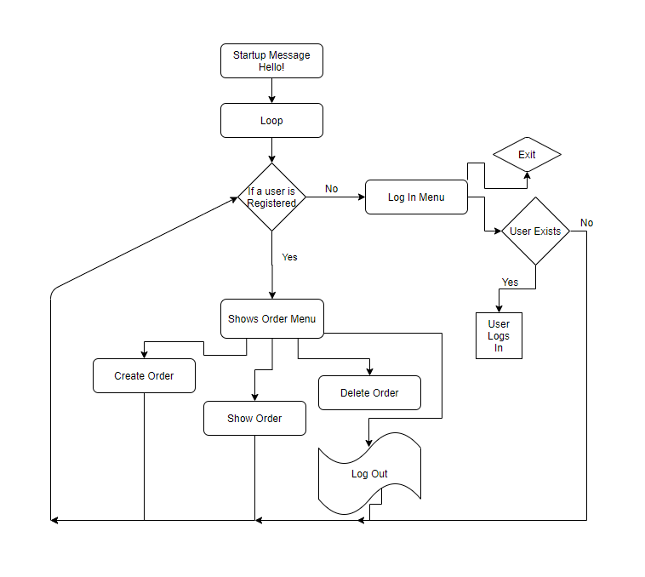

2.4 Description of the used functions.

One of the three main functions we used in this console app was the “createOrder” void function. It does everything in itself. It gets some inputs and after that using them to add, delete guns as well as get their total cost.

Another function that we've made was the "checkLicense" void function which is called at the beginning of the program and when a user has logged out. When the function is called the gun seller will need to check the user if he exists in a small "database" (Note that by database I mean an array variable from type GUN which is a structure) and if he has got a firearms license.

2.5.1 Arguments

We haven’t added many parameters in our functions. Clearly, all main function is from type void and do not need any parameters since we used global variables to save orders’ and guns’ data.

2.5.2 Final Statement

We’ve also got functions that need to return some kind of value. For instance, our function "getUserbyNames" is used in the check license function where you have to input the three names of the user (and also their USN), search all of the users' names and if it is found it would return the existing user.