MACHINE LEARNING PROJECT PHASE 1

Data Preprocessing:

- Importing Necessary Libraries and loading the dataset.
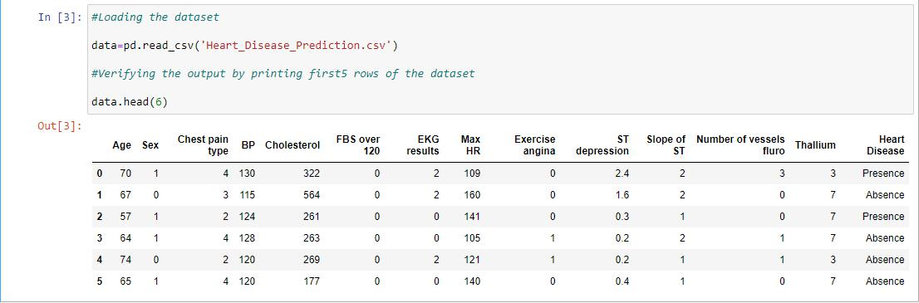

- Checking the size of the dataset

Inference: This dataset contains 270 rows and 14 columns including the target variable.

- Checking the type of each feature in the dataset

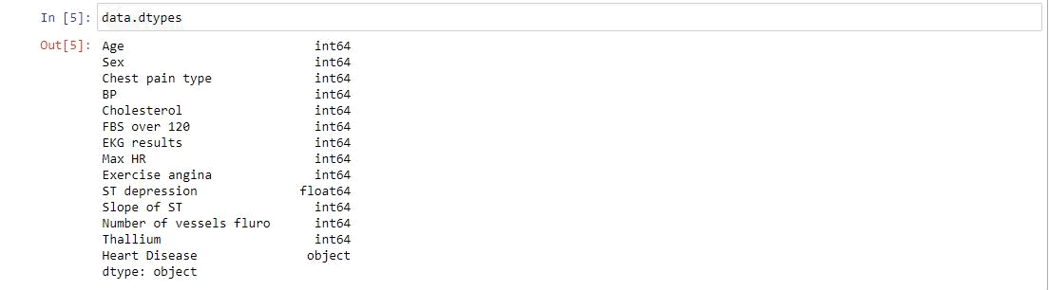

Inference: Out of the 14 features 12 features are of int types , 1 feature (ST Depression) is of float type and the target variable is of type string

- Checking if the dataset contains any missing data
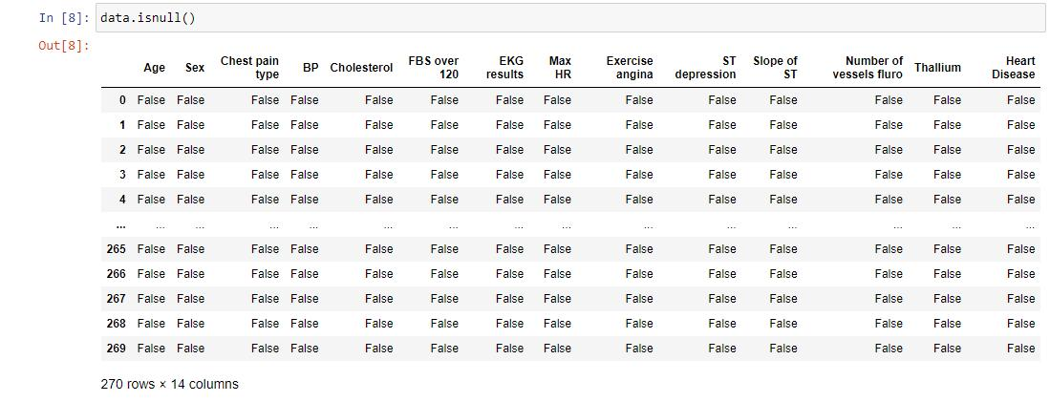

Inference: The dataset does not contain any missing data.

- Converting target label to binary values using one hot encoding
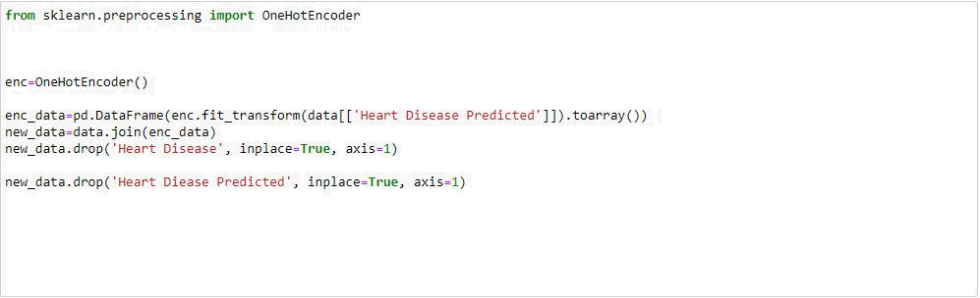

Output:
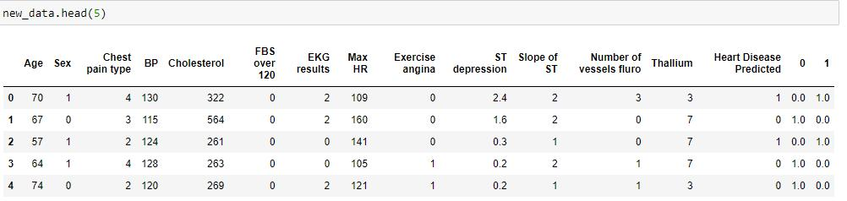

Type of each feature after one hot encoding:
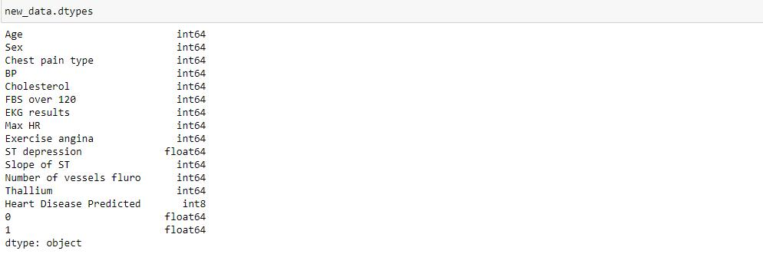

Data Summarization:

- Checking the correlation between various features of the dataset.

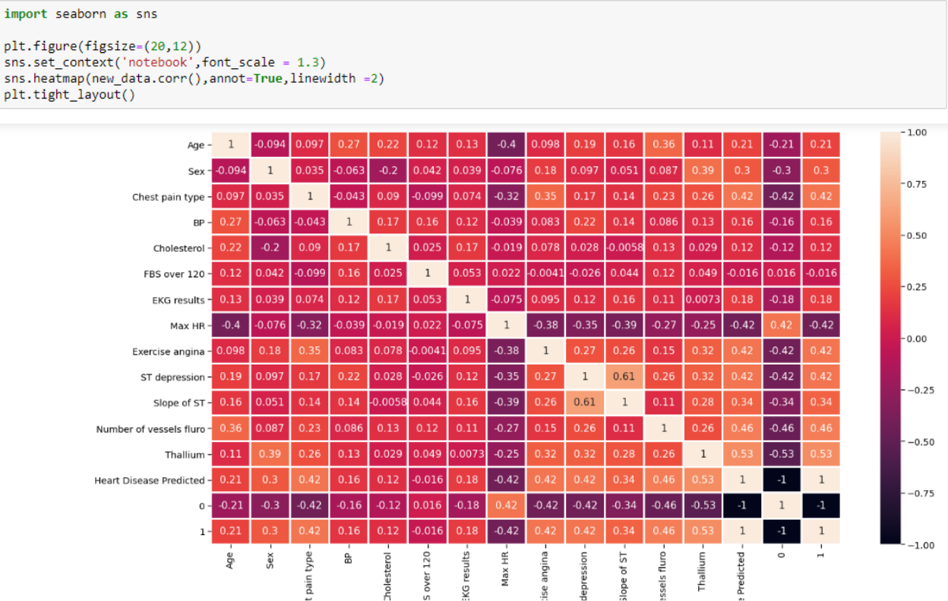

- Checking the correlation of the target variable
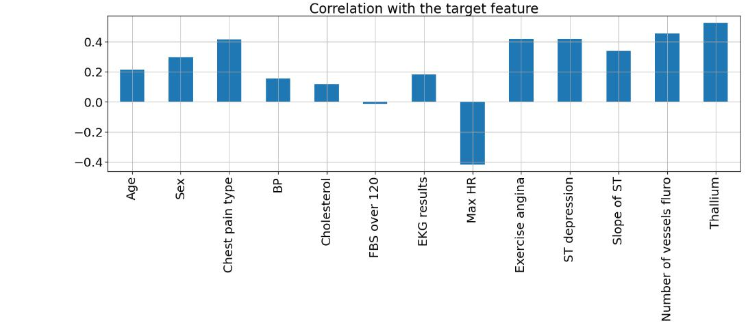

Inference: 1 feature (“Max Hr” ) is negatively correlated with the target feature and all other features are positively correlated with the target feature.

- Understanding the statistical details of the data
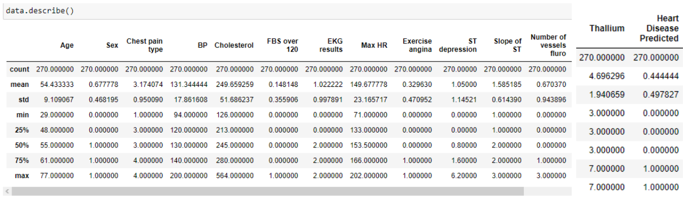

Data Visualization:

- Analyzing Individual features of the dataset.

- “Age” Feature Analysis (Checking 10 ages with their counts)
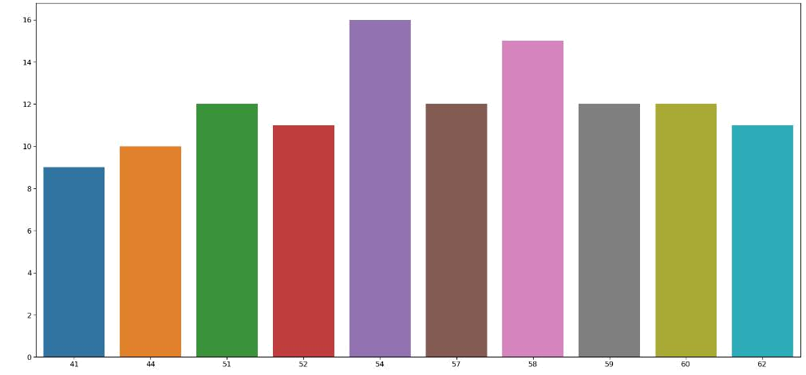

Inference: 58 Age column has the highest frequency

- Checking the range of ages in the dataset

- Dividing Age feature into three different categories and plotting the graph
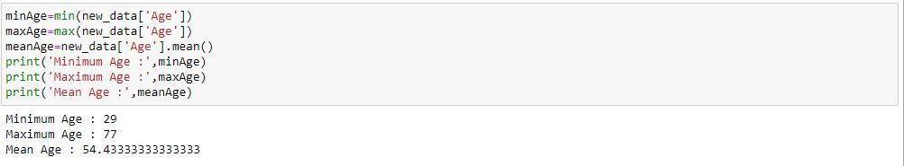
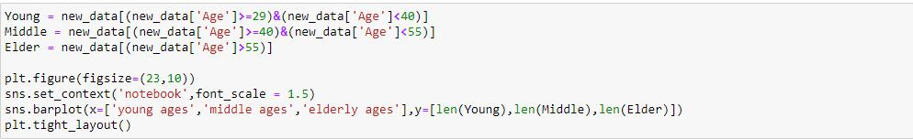
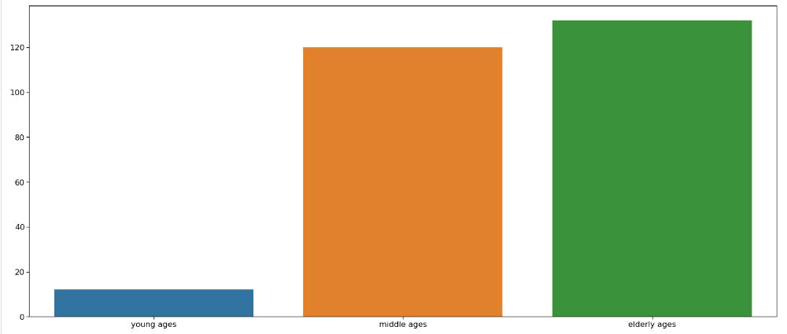

Inference: From the above graph we can infer that elder people are the most affected by the heart disease and the younger ones are the least affected,

- Plotting pie chart of people belonging to different age categories
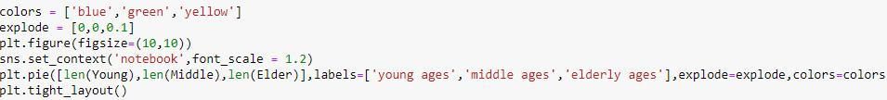
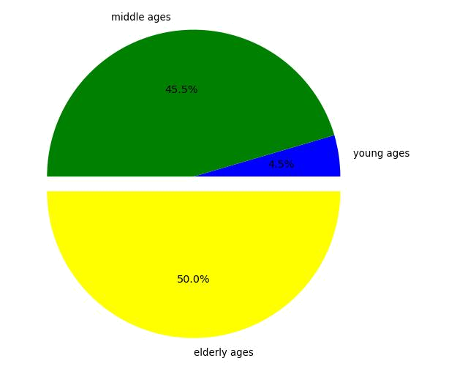

- “Sex” Feature Analysis
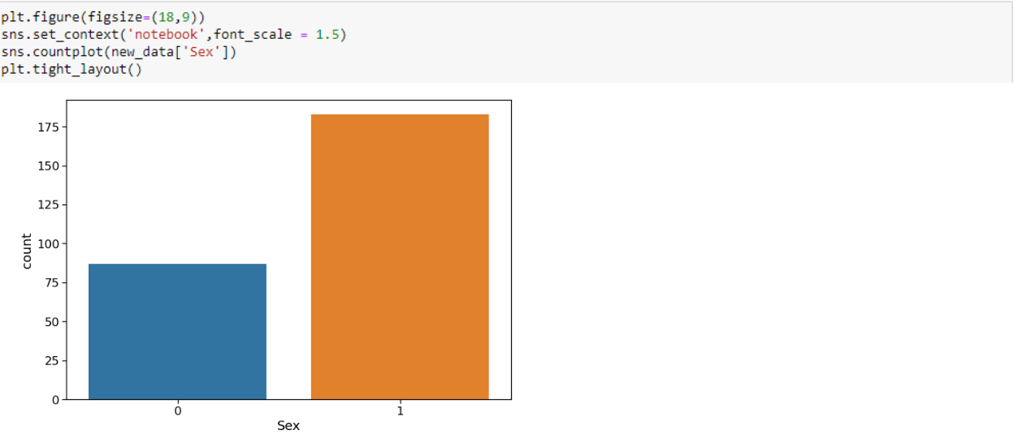
Inference: Ratio of male to female is approximately 2:1

- Plotting the relation between “Sex” and “Slope”
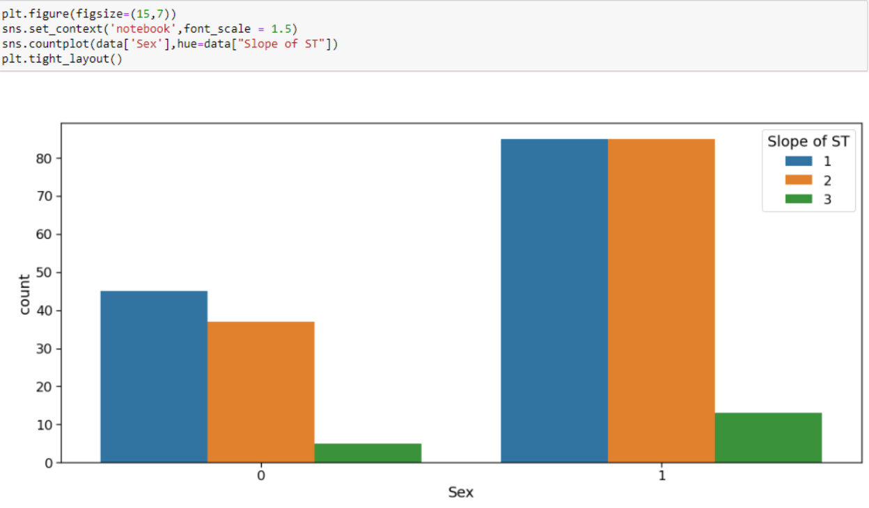

Inference: Slope value is higher as in the case of Males(1)

- “Chest Pain Type” Feature Analysis
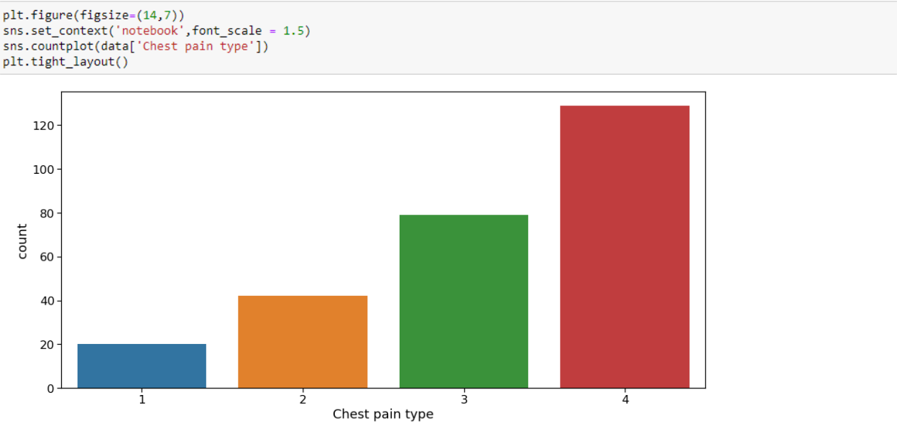
Inference: As seen above, there are 4 types of chest pain

- Status at least

- Condition slightly distressed

- Condition medium problem

- Condition too bad

- Analyzing “Chest Pain” vs Target Label
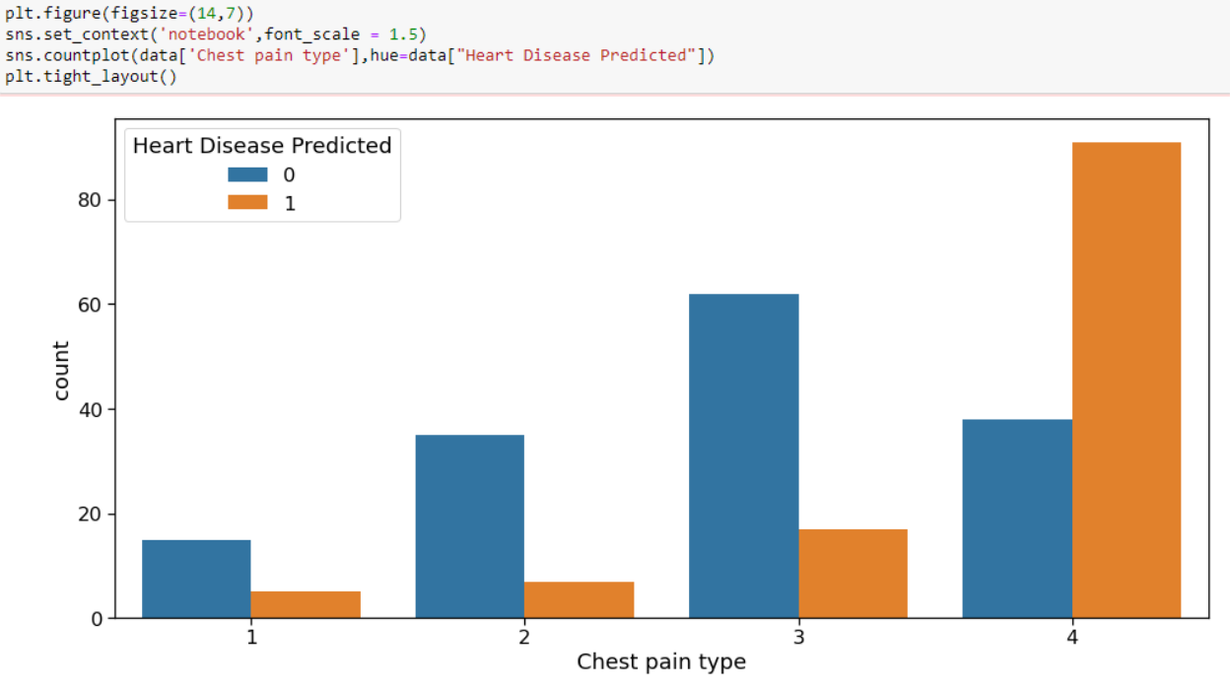

Inference:

- People having the least chest pain are not likely to have heart disease.

- People having severe chest pain are likely to have heart disease.

- Elderly people are most likely to have chest pain.

- Analyzing Target Variable

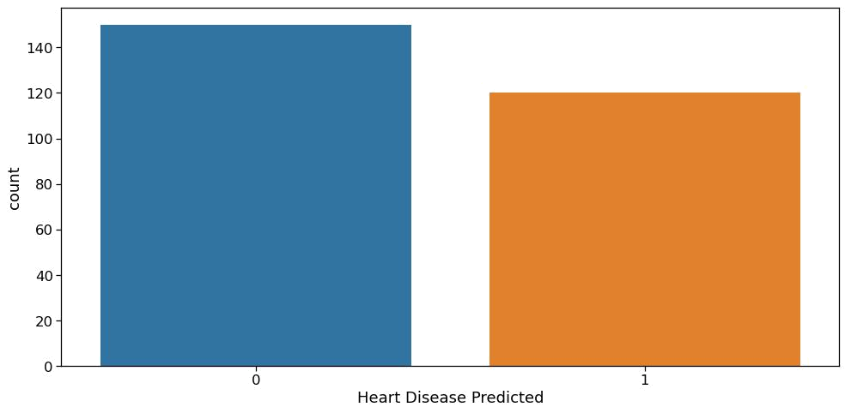

Inference: The ratio between 1 and 0 is much less than 1.5 which indicates that the target label is not imbalanced.

Links:

Original dataset: https://1drv.ms/u/s!AkrIeHMjcOiBmFnCn5MRdjarUnlD?e=7N6S5B

Cleaned dataset: https://1drv.ms/u/s!AkrIeHMjcOiBmFoGANVkIWR8bTMe?e=feEznZ

Pynb file: https://1drv.ms/u/s!AkrIeHMjcOiBmF4Ipxxh68KdtT15?e=CV2k7M

__________________________________________________________________

Submitted By: AFLAH SEDHIQUE

Roll No: AM.EN.U4CSE20105

GOURINATH
AM.EN.U4CSE20129

AKSHAY G SREE
AM.EN.U4CSE20107

C P GHANSHYAM
AM.EN.U4CSE20118

PRANAV B NAIR
AM.EN.U4CSE20152

