**Project -6**

**Configuration through Ansible**



**Name: Nikhil Reddy Gundeti**

**Tutor: Raham Shaik**

**Batch: June 2022**

**Steps:**

1. Created 3 instances (Amazon linux (Master node), RedHat-Node1, Ubuntu-Node2)
2. Connected to the instances and switched to root and ran UPDATE command
3. Installed ansible on master node and updated the hosts file and then uncommented inventory and sudo user
4. Created ansible user in all the servers and added them to sudoers file
5. Enabled password authentication and restarted sshd
6. Generated ssh keys and paired them to nodes and checked for connections to servers

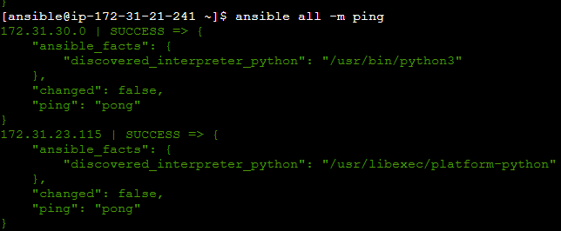

1. Wrote a playbook task.yml

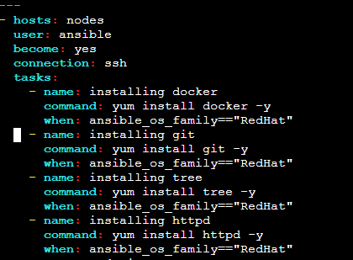

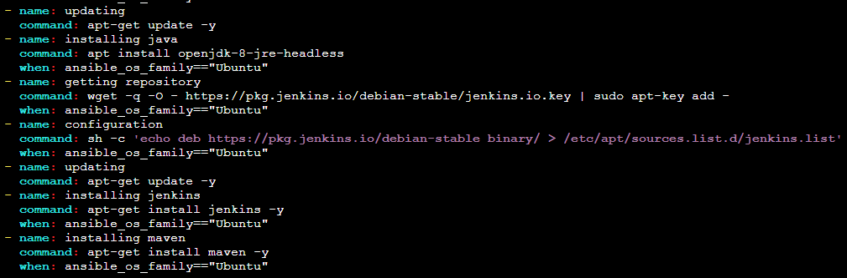

Executed the playbook



Installations in RedHat

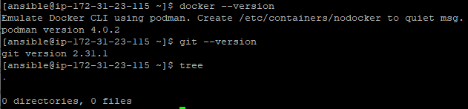

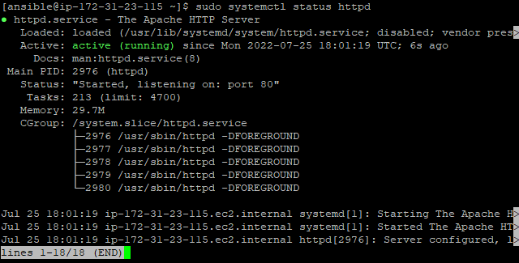

Installations in Ubuntu

