**Project -7**

**Infrasetup through Terraform**



**Name: Nikhil Reddy Gundeti**

**Tutor: Raham Shaik**

**Batch: June 2022**

**Steps:**

1. Created an ec2 instance and installed terraform using folowing commands

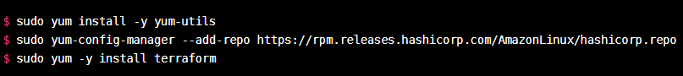

1. Installed version of terraform is as shown below

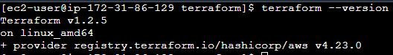

1. Created a terraform directory and wrote main.tf as shown below

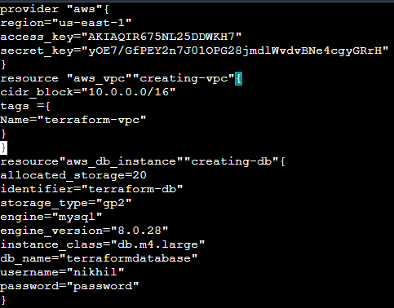

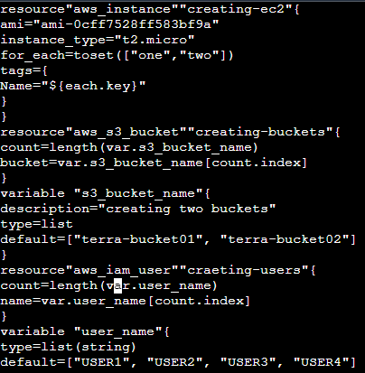

1. Once done saved it and exited
2. Ran terraform init, terraform validate , terraform plan
3. Then terraform apply
4. The following resources are added



VPC created from terraform

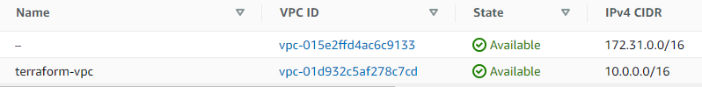

Data base created from terraform

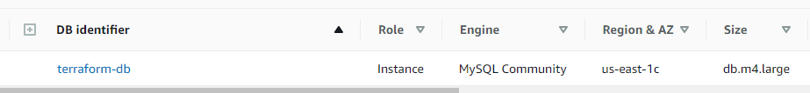

Instances created from terraform

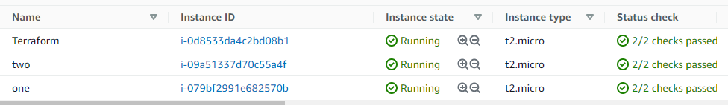

S3_buckets created from terraform

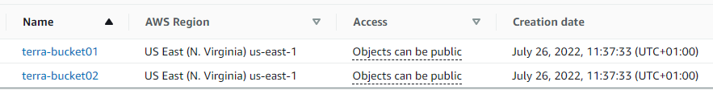

Users created from terraform

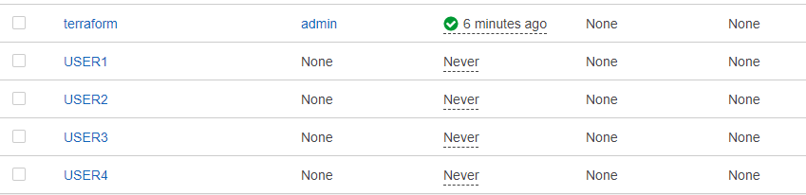

Finally destroyed all the resources using terraform destroy command.