**Project -3**

**Code & Artifactory Tools**



**Name: Nikhil Reddy Gundeti**

**Tutor: Raham Shaik**

**Batch: June 2022**

**Steps:**

Created ec2 instance with a type t2.medium and installed all the prerequisites and sonarqube by using the given commands in lms

After editing all the required files got the sonarqube UP as shown below

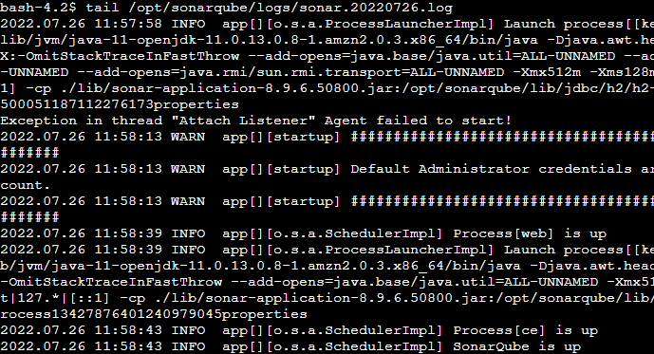

Then logged into it using publicip:9000

Signed in as an admin

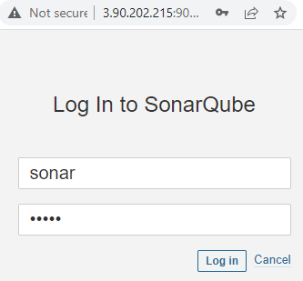

Then changed the password and logged into sonarqube dashboard

