**Project -2**

**Software installations**

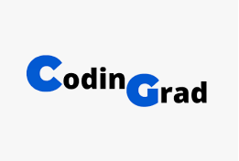

**Name: Nikhil Reddy Gundeti**

**Tutor: Raham Shaik**

**Batch: June 2022**

**Steps:**

Installed various softwares by following the given steps by using amazon linux instance

**Apache on ubuntu**

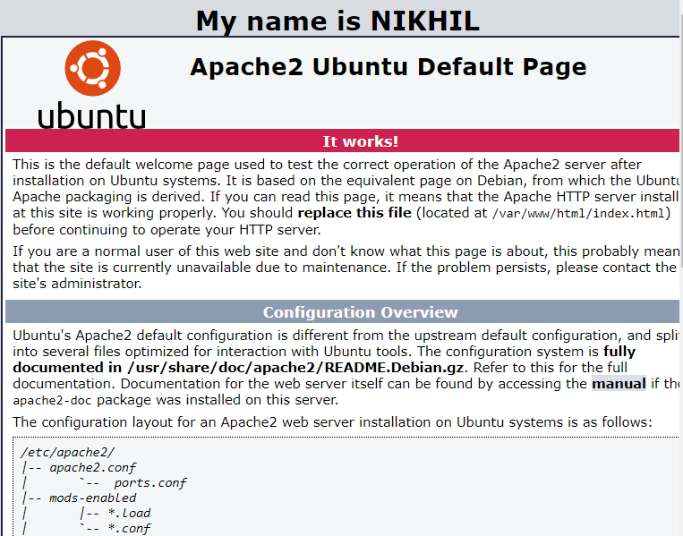

**NGINX installation on amazon linux**

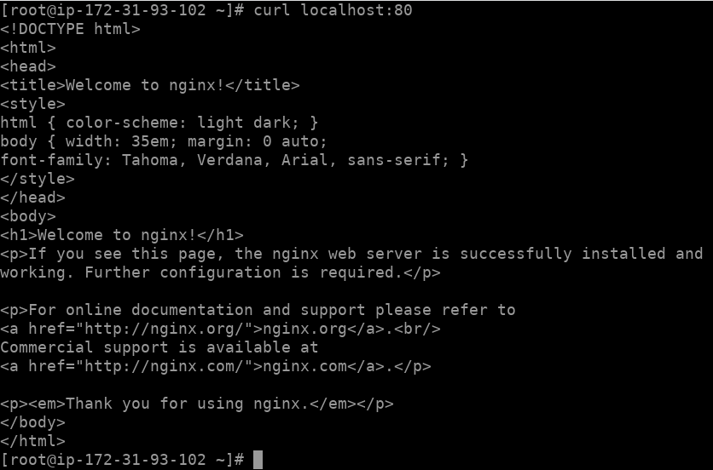

**IIS Installation**

Used Microsoft windows server 2012 RS Base AMI with t2.micro instance type and followed all the given steps in the LMS and successfully opened web page in chrome using public IP address of the instance.

